Speech Processing Lab Assignment 4
# 1(a)
import numpy as np
import matplotlib.pyplot as plt
import librosa
import librosa.display
file_path = "LJ025-0076.wav"
signal, fs = librosa.load(file_path, sr=16000)
duration = 20
samples = duration * fs
signal_20 = signal[:samples]
time = np.arange(len(signal_20)) / fs
plt.figure(figsize=(12,4))
plt.plot(time, signal_20)
plt.title("Waveform of First 20 Seconds")
plt.xlabel("Time (seconds)")
plt.ylabel("Amplitude")
plt.grid()
plt.show()
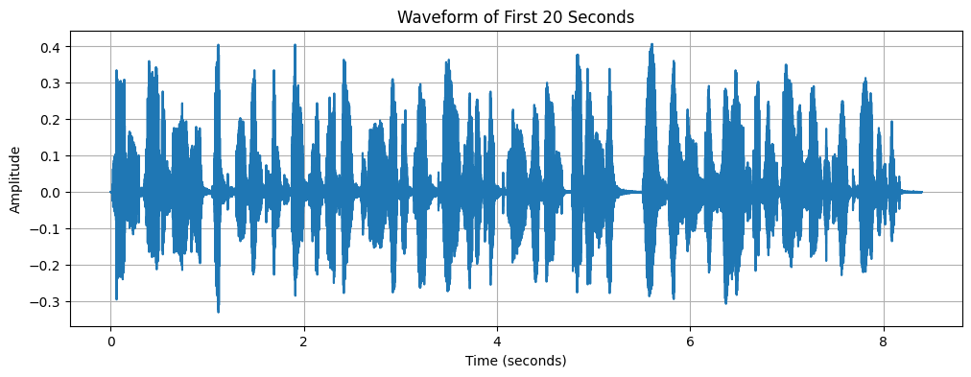
# 1(b)
frame_length_ms = 25
frame_shift_ms = 10
frame_length = int(frame_length_ms * fs / 1000)
frame_shift = int(frame_shift_ms * fs / 1000)
num_frames = int((len(signal_20) - frame_length) / frame_shift) + 1
print(frame_length)
print(frame_shift)
print(num_frames)
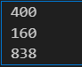
# 1(c)
frames = []
for i in range(num_frames):
start = i * frame_shift
end = start + frame_length
frame = signal_20[start:end]
frames.append(frame)
frames = np.array(frames)
print(frames.shape)

# 1(d)
import numpy as np
hamming_window = np.hamming(frame_length)
STE = []
STM = []
ZCR = []
AUTOCORR = []
AMDF = []
AMSDF = []
max_lag = frame_length // 2
for frame in frames:
windowed = frame * hamming_window
ste = np.sum(windowed ** 2)
STE.append(ste)
stm = np.sum(np.abs(windowed))
STM.append(stm)
zcr = np.sum(np.abs(np.diff(np.sign(windowed)))) / (2 * len(windowed))
ZCR.append(zcr)
autocorr_frame = []
amdf_frame = []
amsdf_frame = []
for lag in range(max_lag):
autocorr_val = np.sum(windowed[:len(windowed)-lag] * windowed[lag:])
autocorr_frame.append(autocorr_val)
amdf_val = np.sum(np.abs(windowed[:len(windowed)-lag] - windowed[lag:]))
amdf_frame.append(amdf_val)
amsdf_val = np.sum((windowed[:len(windowed)-lag] - windowed[lag:]) ** 2)
amsdf_frame.append(amsdf_val)
AUTOCORR.append(autocorr_frame)
AMDF.append(amdf_frame)
AMSDF.append(amsdf_frame)
STE = np.array(STE)
STM = np.array(STM)
ZCR = np.array(ZCR)
AUTOCORR = np.array(AUTOCORR)
AMDF = np.array(AMDF)
AMSDF = np.array(AMSDF)
print(STE.shape)
print(STM.shape)
print(ZCR.shape)
print(AUTOCORR.shape)
print(AMDF.shape)
print(AMSDF.shape)
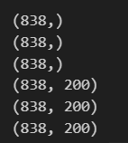

# 1(e)
import numpy as np
frame_length_ms = 25
frame_shift_ms = 10
frame_length = int(frame_length_ms * fs / 1000)
frame_shift = int(frame_shift_ms * fs / 1000)
num_frames_rect = int((len(signal_20) - frame_length) / frame_shift) + 1
rect_window = np.ones(frame_length)
frames_rect = []
for i in range(num_frames_rect):
start = i * frame_shift
end = start + frame_length
frame = signal_20[start:end]
windowed_frame = frame * rect_window
frames_rect.append(windowed_frame)
frames_rect = np.array(frames_rect)
print("Frame length:", frame_length)
print("Frame shift:", frame_shift)
print("Total number of frames using rectangular window:", num_frames_rect)
print("Shape of rectangular window frames:", frames_rect.shape)
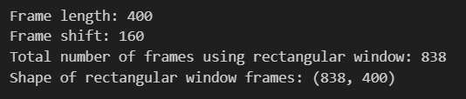
# 1(f)
plt.figure(figsize=(10,6))
plt.plot(STE)
plt.plot(STE_rect)
plt.show()
plt.figure()
plt.plot(STM)
plt.show()
plt.figure()
plt.plot(ZCR)
plt.show()
plt.figure()
plt.plot(AUTOCORR)
plt.show()
plt.figure()
plt.plot(AMDF)
plt.show()
plt.figure()
plt.plot(AMSDF)
plt.show()

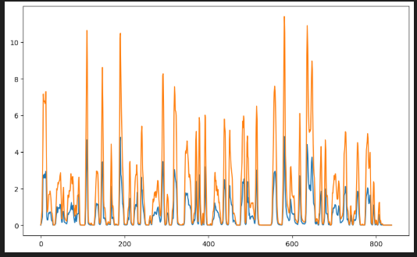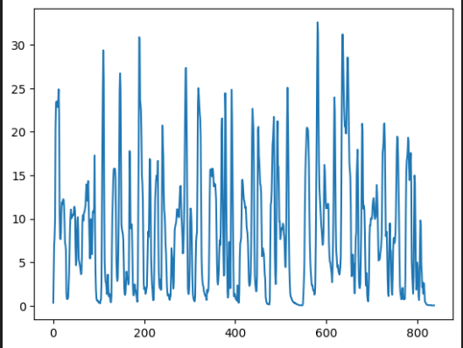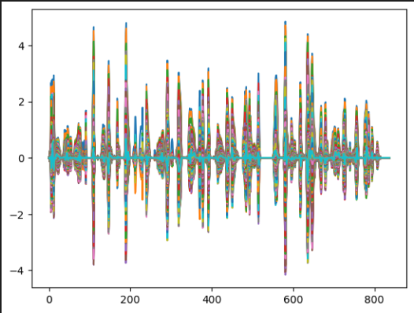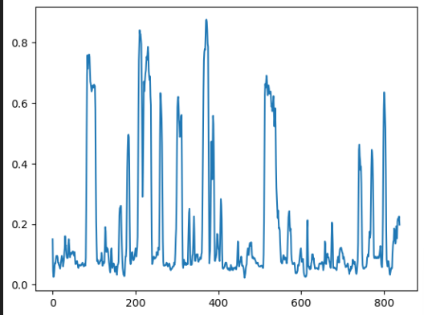
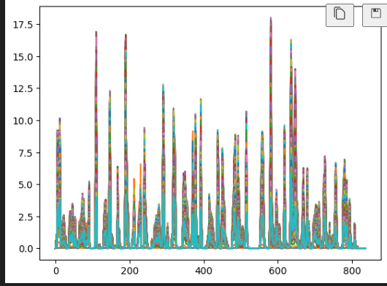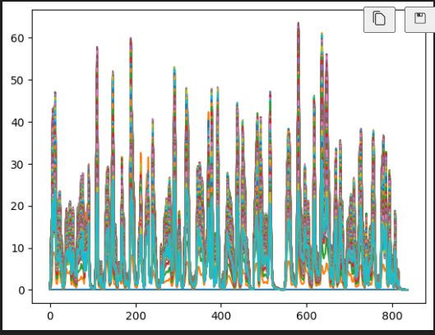
# 1(g)
Voiced speech has high energy, low ZCR, strong autocorrelation, low AMDF and AMSDF. Unvoiced speech has low energy, high ZCR, weak autocorrelation, high AMDF and AMSDF.
# 1(h)
Hamming window provides smoother features and better discrimination. Rectangular window produces less smooth features.
# TASK -2
# 2(a)
threshold = np.mean(AUTOCORR)
periodic_frames = AUTOCORR > threshold
periodic_indices = np.where(periodic_frames == True)[0]
periodic_values = AUTOCORR[periodic_indices]
final_periodic_frames = frames[periodic_indices]
print("Threshold value:", threshold)
print("Periodic frame indices:", periodic_indices)
print("Number of periodic frames:", len(periodic_indices))
print("Autocorrelation values of periodic frames:", periodic_values)
print("Shape of periodic frames:", final_periodic_frames.shape)

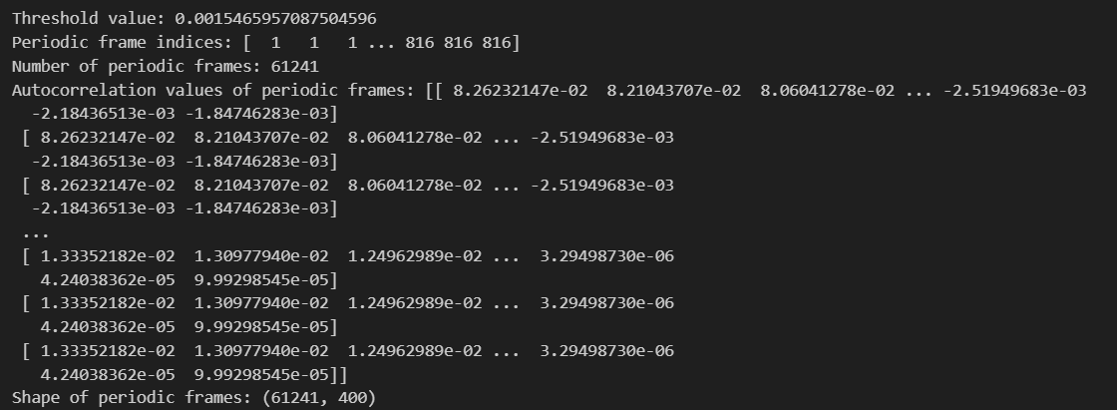
# 2(b)
Periodicity appears as peaks in autocorrelation and minima in AMDF and AMSDF.
# 2(c)
Voiced frames have higher energy and lower ZCR. Unvoiced frames have lower energy and higher ZCR.
energy_threshold = np.mean(STE)
zcr_threshold = np.mean(ZCR)
voiced_indices = np.where((STE > energy_threshold) & (ZCR < zcr_threshold))[0]
unvoiced_indices = np.where((STE <= energy_threshold) & (ZCR >= zcr_threshold))[0]
voiced_frames = frames[voiced_indices]
unvoiced_frames = frames[unvoiced_indices]
print("Energy threshold:", energy_threshold)
print("ZCR threshold:", zcr_threshold)
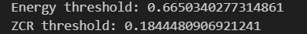
print("Voiced frame indices:", voiced_indices)
print("Number of voiced frames:", len(voiced_indices))
print("Unvoiced frame indices:", unvoiced_indices)
print("Number of unvoiced frames:", len(unvoiced_indices))
print("Shape of voiced frames:", voiced_frames.shape)
print("Shape of unvoiced frames:", unvoiced_frames.shape)
# TASK - 3
# 3(a)
pitch_period_autocorr = []
pitch_period_amdf = []
pitch_period_amsdf = []
max_lag = frame_length // 2
for frame in frames:
autocorr = np.correlate(frame, frame, mode='full')
autocorr = autocorr[len(autocorr)//2:]
search_region_autocorr = autocorr[1:max_lag]
peak_index = np.argmax(search_region_autocorr) + 1
pitch_period_autocorr.append(peak_index)
amdf = []
amsdf = []
for lag in range(1, max_lag):
diff = frame[:-lag] - frame[lag:]
amdf.append(np.sum(np.abs(diff)))
amsdf.append(np.sum(diff**2))
amdf = np.array(amdf)
amsdf = np.array(amsdf)
min_index_amdf = np.argmin(amdf) + 1
min_index_amsdf = np.argmin(amsdf) + 1
pitch_period_amdf.append(min_index_amdf)
pitch_period_amsdf.append(min_index_amsdf)
pitch_period_autocorr = np.array(pitch_period_autocorr)
pitch_period_amdf = np.array(pitch_period_amdf)
pitch_period_amsdf = np.array(pitch_period_amsdf)
print("Pitch period using Autocorrelation:")
print(pitch_period_autocorr)
print("Pitch period using AMDF:")
print(pitch_period_amdf)
print("Pitch period using AMSDF:")
print(pitch_period_amsdf)
# 3(b)
pitch_frequency = fs / pitch_periods
print(pitch_frequency)
# TASK - 4
# 4(a)
Voiced speech has high energy, low ZCR and periodic structure. Unvoiced speech has low energy, high ZCR and noise-like structure.
# 4(b)
Autocorrelation detects repeating patterns. AMDF and AMSDF detect minimum difference corresponding to pitch period.
# 4(c)
Autocorrelation and AMSDF are most reliable. AMDF is moderately reliable. Energy and ZCR are less reliable.

