SPPECH PROCESSING LAB – 2
ROLL NO : BL.EN.U4AIE23057

1.Load a speech signal
Code:
import torchaudio
import matplotlib.pyplot as plt
import torch

audio_path = "LJ025-0076.wav"
waveform, sr = torchaudio.load(audio_path)

print("Waveform shape:", waveform.shape)
print("Sampling rate:", sr)
print("Duration (sec):", waveform.shape[1] / sr)

OUTPUT:
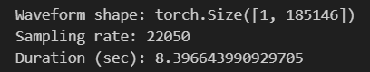
2. Preprocess the audio (convert to mono, resample to 16kHz).
CODE:

import librosa
import numpy as np
import soundfile as sf

audio_path = "LJ025-0076.wav"

audio, sr = librosa.load(audio_path, sr=None, mono=True)

print("Before preprocessing:")
print("Sampling rate:", sr)
print("Duration (sec):", len(audio) / sr)

target_sr = 16000
if sr != target_sr:
audio = librosa.resample(audio, orig_sr=sr, target_sr=target_sr)
sr = target_sr

print("\nAfter preprocessing:")
print("Sampling rate:", sr)
print("Duration (sec):", len(audio) / sr)

output_path = "/content/Audio_Python_16kHz_mono.wav"
sf.write(output_path, audio, sr)

print("\n Saved preprocessed audio at:", output_path)

OUTPUT:

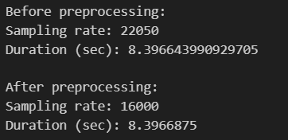

3. Use a pre-trained deep learning model (Wav2Vec2) to recognize phonemes.

CODE:
import numpy as np
import torch
import librosa
import nltk
from transformers import Wav2Vec2Processor, Wav2Vec2ForCTC
from g2p_en import G2p

nltk.download("punkt", quiet=True)
nltk.download("averaged_perceptron_tagger", quiet=True)
nltk.download("averaged_perceptron_tagger_eng", quiet=True)
nltk.download("cmudict", quiet=True)

audio_path = "LJ025-0076.wav"
audio, sr = librosa.load(audio_path, sr=16000, mono=True)

assert sr == 16000, "Sampling rate must be 16kHz"

print("Expected outputs")
print("Loaded audio path:", audio_path)
print("Sampling rate:", sr)
print("Input audio samples:", len(audio))
print("Input duration (sec):", round(len(audio) / sr, 3))

model_name = "facebook/wav2vec2-base-960h"
processor = Wav2Vec2Processor.from_pretrained(model_name)
model = Wav2Vec2ForCTC.from_pretrained(model_name)

device = "cuda" if torch.cuda.is_available() else "cpu"
model = model.to(device)
model.eval()

print("\nModel loaded:", model_name)
print("Device:", device)

inputs = processor(audio, sampling_rate=sr, return_tensors="pt", padding=True)
input_values = inputs.input_values.to(device)

print("Model input tensor shape:", tuple(input_values.shape))

with torch.no_grad():
logits = model(input_values).logits

print("Logits shape:", tuple(logits.shape))

pred_ids = torch.argmax(logits, dim=-1)
transcript = processor.batch_decode(pred_ids)[0].strip()

print("\nRecognized text (ASR output):")
print(transcript)

g2p = G2p()
phonemes = [p for p in g2p(transcript) if str(p).strip()]

print("\nRecognized phonemes (phoneme sequence):")
print(" ".join(phonemes))

print("\nRecognized phonemes (token list):")
print(phonemes)
print("Total phoneme tokens:", len(phonemes))

OUTPUT :
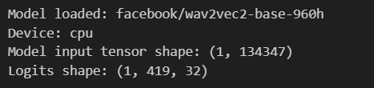

4. Estimate phoneme time intervals.

CODE :

duration_sec = len(audio) / sr
num_tokens = len(phonemes)

assert num_tokens > 0, "No phoneme tokens found. Run Step 3 again."

time_per_token = duration_sec / num_tokens

print("Expected outputs")
print("Total duration (sec):", round(duration_sec, 3))
print("Total phoneme tokens:", num_tokens)
print("Estimated time per token (sec):", round(time_per_token, 4))

phoneme_intervals = []
for i, ph in enumerate(phonemes):
start_t = i * time_per_token
end_t = (i + 1) * time_per_token
phoneme_intervals.append((ph, start_t, end_t))

print("\nFirst 15 estimated phoneme time intervals (phoneme, start, end):")
for row in phoneme_intervals[:15]:
ph, s, e = row
print(ph, "|", round(s, 4), "to", round(e, 4))

print("\nLast 5 estimated phoneme time intervals (phoneme, start, end):")
for row in phoneme_intervals[-5:]:
ph, s, e = row
print(ph, "|", round(s, 4), "to", round(e, 4))

OUTPUT :

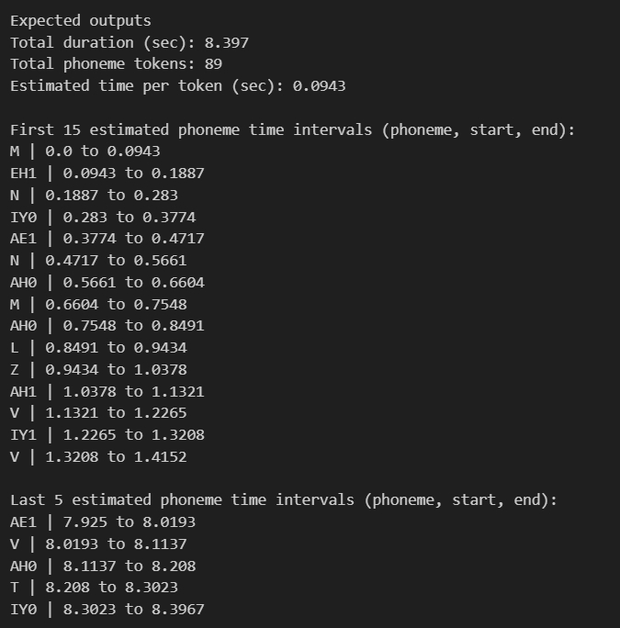

5. Extract a phoneme segment from the speech signal based on time intervals.

CODE:

import numpy as np
import soundfile as sf

assert sr == 16000, "Sampling rate must be 16kHz"
assert len(phoneme_intervals) > 0, "phoneme_intervals is empty. Run Step 4."

target_index = 5

ph, start_t, end_t = phoneme_intervals[target_index]

start_sample = int(start_t * sr)
end_sample = int(end_t * sr)

start_sample = max(0, min(start_sample, len(audio) - 1))
end_sample = max(start_sample + 1, min(end_sample, len(audio)))

segment = audio[start_sample:end_sample]

out_path = f"/content/extracted_phoneme_{target_index}_{ph}.wav"
sf.write(out_path, segment, sr)

print("Expected outputs")
print("Selected phoneme index:", target_index)
print("Selected phoneme label:", ph)
print("Start time (sec):", round(start_t, 4))
print("End time (sec):", round(end_t, 4))
print("Start sample:", start_sample)
print("End sample:", end_sample)
print("Extracted segment samples:", len(segment))
print("Extracted segment duration (sec):", round(len(segment) / sr, 4))
print("Saved extracted phoneme to:", out_path)

OUTPUT:

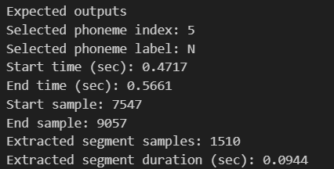

6. Save extracted phoneme and visualize each selected phoneme segment from the speech waveform

CODE:

import numpy as np
import soundfile as sf
import matplotlib.pyplot as plt

assert sr == 16000, "Sampling rate must be 16kHz"
assert len(phoneme_intervals) > 0, "phoneme_intervals is empty. Run Step 4 first."

selected_indices = [5, 10, 15]

print("Expected outputs")
print("Total phoneme intervals:", len(phoneme_intervals))
print("Selected indices:", selected_indices)

for idx in selected_indices:
if idx < 0 or idx >= len(phoneme_intervals):
print(f"Skipping index {idx} (out of range)")
continue

ph, start_t, end_t = phoneme_intervals[idx]

start_sample = int(start_t * sr)
end_sample = int(end_t * sr)

start_sample = max(0, min(start_sample, len(audio) - 1))
end_sample = max(start_sample + 1, min(end_sample, len(audio)))

segment = audio[start_sample:end_sample]

out_path = f"/content/extracted_phoneme_{idx}_{ph}.wav"
sf.write(out_path, segment, sr)

seg_t = np.arange(len(segment)) / sr

plt.figure(figsize=(10, 3))
plt.plot(seg_t, segment)
plt.title(f"Extracted phoneme segment: {ph} (index {idx})")
plt.xlabel("Time (sec)")
plt.ylabel("Amplitude")
plt.grid(True)
plt.show()

print("\nSegment output")
print("Index:", idx)
print("Phoneme label:", ph)
print("Start time (sec):", round(start_t, 4))
print("End time (sec):", round(end_t, 4))
print("Segment duration (sec):", round(len(segment) / sr, 4))
print("Saved file:", out_path)

OUTPUT:

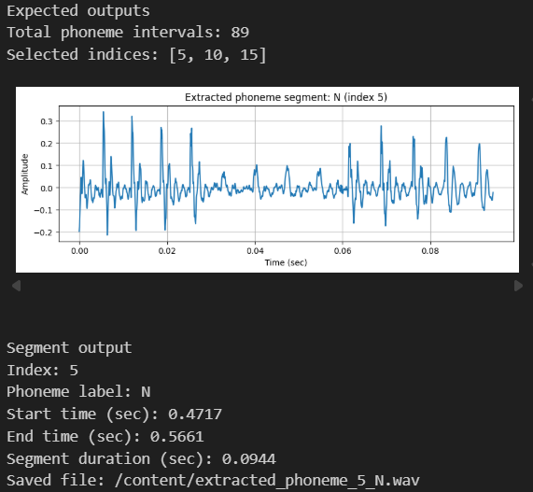

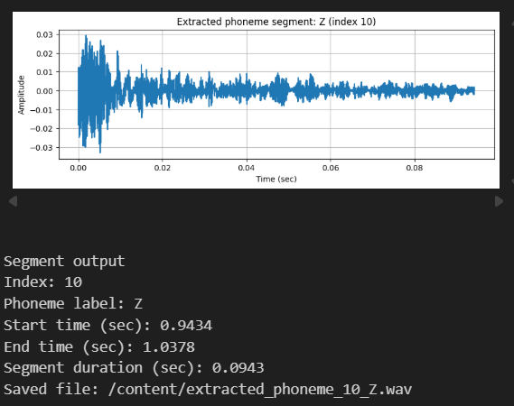

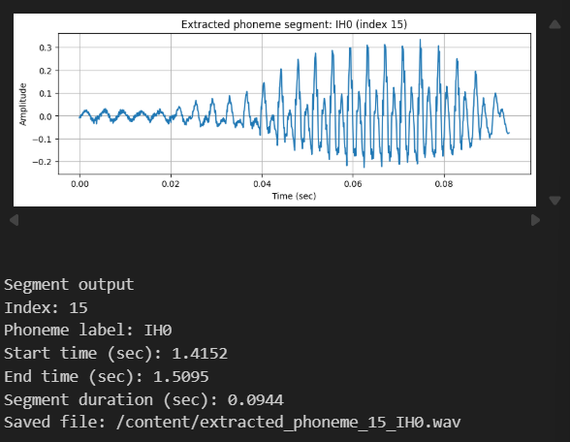

7. Infer about the nature of source of sound for each phoneme.

CODE:
import numpy as np

assert sr == 16000, "Sampling rate must be 16kHz"
assert len(phoneme_intervals) > 0, "phoneme_intervals is empty. Run Step 4 first."

selected_indices = [5, 10, 15]

def zero_crossing_rate(x):
if len(x) < 2:
return 0.0
return float(np.mean(x[:-1] * x[1:] < 0))

def rms_energy(x):
if len(x) == 0:
return 0.0
return float(np.sqrt(np.mean(x ** 2)))

def is_vowel_like(phoneme_label):
if len(phoneme_label) >= 2 and phoneme_label[-1].isdigit():
return True
vowel_set = {"AA","AE","AH","AO","AW","AY","EH","ER","EY","IH","IY","OW","OY","UH","UW"}
return phoneme_label in vowel_set

print("Expected outputs")
print("Selected indices:", selected_indices)
print("For each selected phoneme: RMS energy, ZCR, voiced/unvoiced, phoneme-type inference\n")

for idx in selected_indices:
if idx < 0 or idx >= len(phoneme_intervals):
print(f"Skipping index {idx} (out of range)")
continue

ph, start_t, end_t = phoneme_intervals[idx]
start_sample = int(start_t * sr)
end_sample = int(end_t * sr)

start_sample = max(0, min(start_sample, len(audio) - 1))
end_sample = max(start_sample + 1, min(end_sample, len(audio)))

segment = audio[start_sample:end_sample]

seg_rms = rms_energy(segment)
seg_zcr = zero_crossing_rate(segment)

voiced_flag = seg_zcr < 0.12

vowel_like = is_vowel_like(ph)

if vowel_like and voiced_flag:
source = "Voiced (likely vowel; periodic vocal-fold vibration)"
elif (not vowel_like) and voiced_flag:
source = "Voiced (likely voiced consonant/nasal/approximant)"
elif (not vowel_like) and (not voiced_flag):
source = "Unvoiced (likely fricative/stop; turbulent noise or burst)"
else:
source = "Mixed/uncertain (vowel-like label but unvoiced features; may be alignment/noise)"

print("Phoneme index:", idx)
print("Phoneme label:", ph)
print("Time (sec):", round(start_t, 4), "to", round(end_t, 4))
print("Segment duration (sec):", round(len(segment) / sr, 4))
print("RMS energy:", round(seg_rms, 6))
print("Zero Crossing Rate:", round(seg_zcr, 4))
print("Voiced/Unvoiced (heuristic):", "Voiced" if voiced_flag else "Unvoiced")
print("Vowel-like label:", "Yes" if vowel_like else "No")
print("Inference:", source)
print("-" * 60)

OUTPUT:

