SIMATS ENGINEERING
ASSESSMENT TOOL 2: Problem Solving Assignment
COURSE NAME: ARTIFICIAL INTELLIGENCE COURSE CODE: MLA01
AND EXPERT SYSTEMS

COURSE OUTCOME COVERED
CO2: Analyze and select appropriate agent strategies for different types of environments and problem settings. (BTL 3)
Assessment Tool Weightage: 40 %

Total Marks: 100 Time: 60 Mins
No. of Questions: 5
Annexure A
Problem Solving Assignment

Code of Conduct:

I ______A.Akhil(192525283)______________ (Name / Reg No) certify that this submission is my original work and that I have adhered to the guidelines specified for this assessment. I understand that any violation of academic integrity rules will result in disciplinary action.

Signature of the student:
Criterion | Weightage | Marks Obtained
Problem Analysis and Understanding | 15%
AI Algorithm Selection & Justification | 15%
Algorithm Design / Pseudocode | 25%
Application of AI Concepts (Greedy, A*, CSP,  Minimax, etc.) | 15%
Diagram / State Space / Search Tree  Representation | 10%
Complexity Analysis and Solution Efficiency | 10%
Originality, Critical Thinking, and Presentation | 10%
Total | 100%
Signature of the Faculty Total Marks Awarded

Answer All the Questions
Q.No | Application-Based Question | Major CO2  Concepts
1 | Smart Ambulance Navigation:  An ambulance must travel from a hospital to an emergency location through a city road network. Some roads have higher travel costs, and an estimated distance to the destination is available for each junction. Design a search-based solution to identify the best route. Using the given road network and heuristic values, determine the route selected by your algorithm, show the sequence of junctions explored, calculate the relevant evaluation values, and justify whether the route is optimal.  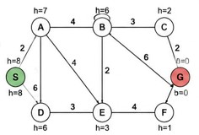 | Informed Search,  A*, Heuristic  Function
2 | Autonomous Warehouse Robot:  A robot has to move from a charging station to a target shelf in a warehouse. The robot does not know all obstacles initially and discovers some obstacles only when it reaches nearby locations. Design an intelligent search strategy for the robot. Demonstrate the robot's decisions for the given grid, explain how it reacts when a new obstacle is discovered, and compare the approach with an offline search strategy.  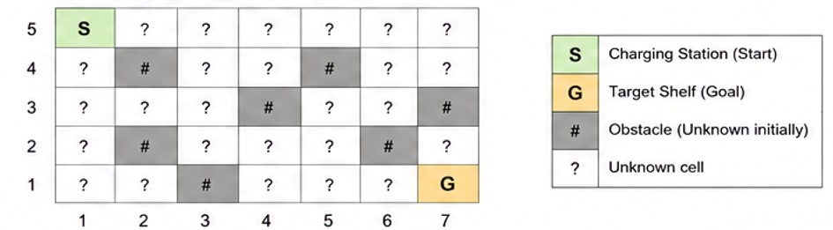 | Online Search  Agents,  Informed Search
3 | University Examination Scheduling:  A university needs to schedule six examinations (E1, E2, E3, E4, E5, and E6) into four available time slots (T1, T2, T3, and T4). Some examinations have common students and therefore cannot be conducted in the same time slot. | CSP, MRV,  Forward  Checking,  Constraints

The following constraints must be satisfied:
- E1 and E2 have common students.
- E1 and E3 have common students.
- E2 and E4 have common students.
- E3 and E5 have common students.
- E4 and E6 have common students.
- E2 and E5 have common students.
The university has three examination halls with the following capacities:

 |  | Examination Hall |  |  |  | Capacity
 |  | Hall A |  |  |  | 120 students
 |  | Hall B |  |  |  | 90 students
 |  | Hall C |  |  |  | 60 students
 |  | Examination | E1 | E2 | E3 | E4 | E5 | E6 | CSP) by  (MRV) timetable.  provide  hall-capacity
 |  | Number of  Students | 100 | 80 | 70 | 60 | 90 | 50
Tasks:
- Formulate the problem as a Constraint Satisfaction Problem ( clearly defining the variables, domains, and constraints.
- Use Backtracking with the Minimum Remaining Values heuristic and Forward Checking to obtain a valid examination
- Show the domain of each variable after every assignment and the final timetable, ensuring that all student-conflict and constraints are satisfied.
4 |  | Game-Playing AI:  You are developing an AI opponent for a board game. The current game position produces the following possible moves and terminal scores in the supplied game tree. Determine the move the AI should make by applying Minimax. Then apply Alpha-Beta Pruning and identify the branches that do not need to be evaluated. Explain how pruning improves the efficiency of the game-playing agent. |  |  |  |  |  |  |  | Game Playing,  Minimax,  Alpha-Beta  Pruning
 | 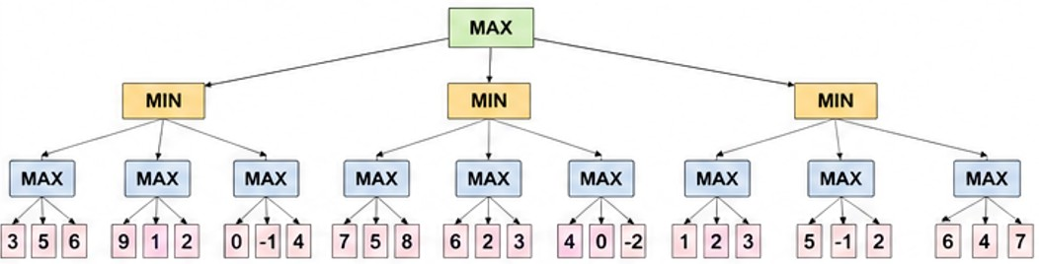
5 | Delivery Route Optimization:  A logistics company wants to minimize the total distance travelled by a delivery vehicle visiting multiple customers. An initial route and several neighboring routes are provided. Design an optimization strategy to improve the route. Apply the strategy step-by-step to the given routes, determine the final route, explain whether it represents a global optimum, and suggest how the algorithm could escape a local optimum.  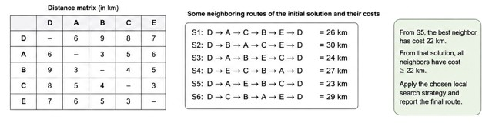 |  |  |  |  |  |  |  |  |  | Local Search,  Optimization,  Hill Climbing

Question 1 — Smart Ambulance Navigation

Source requirement: design a search-based solution, use the supplied road network and heuristic values, show the explored junction sequence, calculate evaluation values, and justify optimality. The assignment identifies Informed Search, A* and the heuristic function as the major concepts. fileciteturn0file0L40-L49

1. Problem Analysis

The state is the current road junction. The initial state is S (hospital) and the goal state is G (emergency location). Each road has a positive travel cost. A heuristic h(n) estimates the remaining distance to G. A* ranks a frontier node using:
f(n) = g(n) + h(n)
where g(n) is the accumulated road cost from S to n and h(n) is the supplied heuristic value.

2. Algorithm Selection and Justification

A* is selected because the problem provides both actual road costs and heuristic estimates. It combines the cost already travelled with an estimate of the remaining cost, unlike Greedy Best-First Search, which considers only h(n).

3. Road Network and Heuristic Values

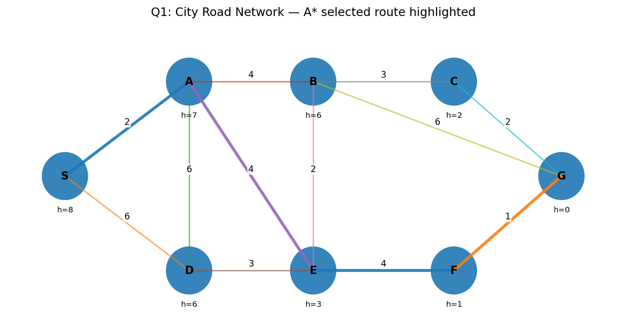
Figure 1. Supplied road network redrawn for clarity. The highlighted path is the A* route obtained using the visible network and an F–G cost of 1.
Heuristic values read from the supplied diagram are: h(S)=8, h(A)=7, h(D)=6, h(B)=6, h(E)=3, h(C)=2, h(F)=1 and h(G)=0. The printed diagram does not show a numeric label on edge F–G; a value of 1 is used here so that the required numeric A* calculation can be completed. If a different F–G cost was intended, the corresponding g(F)+cost(F,G) value should be substituted.

4. A* Evaluation Trace

Junction | g(n) | h(n) | f(n) | Decision
S | 0 | 8 | 8 | Start
A | 2 | 7 | 9 | Selected after expanding S
E | 6 | 3 | 9 | Selected after expanding A
F | 10 | 1 | 11 | Selected after expanding E
G | 11 | 0 | 11 | Goal reached

Important frontier values during the search:
- After expanding S: A has f=2+7=9; D has f=6+6=12.
- After expanding A: E has f=6+3=9; B has f=6+6=12; D can be reached through A with g=8, giving f=14, so the earlier D entry with g=6 remains better.
- After expanding E: F has f=10+1=11; B can be reached with g=8 and f=14; D would have f=15.
- F is selected next, giving G a cost g=11 and f=11. G is then selected.

5. Selected Route and Optimality
Selected route:
S → A → E → F → G
Total cost = 2 + 4 + 4 + 1 = 11.
A second low-cost route visible in the supplied network is S → A → B → C → G with cost 2 + 4 + 3 + 2 = 11. Other direct alternatives such as S → A → B → G cost 12, while S → D → E → F → G costs 14. Thus the selected 11-cost route is optimal for the visible graph; another route also attains the same minimum cost.
The supplied heuristic is not uniformly admissible: for example, h(B)=6 while B→C→G has actual remaining cost 5. Therefore, optimality should be justified from the graph/path costs rather than by claiming that the supplied heuristic alone guarantees A* optimality.

6. Pseudocode
A*(start, goal):
1. OPEN ← priority queue ordered by f=g+h; insert start.
2. Set g(start)=0 and parent(start)=NULL.
3. While OPEN is not empty:
4. Remove node n with minimum f(n).
5. If n = goal, reconstruct and return the path.
6. For each neighbor m of n:
7. tentative_g ← g(n) + cost(n,m).
8. If tentative_g improves g(m), update parent(m), g(m), f(m)=g(m)+h(m), and insert/update m in OPEN.
9. Return failure if OPEN becomes empty.

7. Complexity

With a binary-heap priority queue, the practical graph-search cost is commonly expressed as O((V+E) log V) for a standard implementation with appropriate decrease-key/update handling. Space usage is O(V). In the supplied small graph, the search is easily tractable.
Answer: S → A → E → F → G, total cost 11, and the route is optimal for the supplied visible graph (tied with S → A → B → C → G).

Question 2 — Autonomous Warehouse Robot

The supplied question describes a robot that does not initially know all obstacles, discovers obstacles near visited locations, and must react to discoveries. It asks for an intelligent search strategy, decisions on the supplied grid, obstacle reaction, and comparison with an offline strategy. The major concepts are Online Search Agents and Informed Search. fileciteturn0file0L51-L60

1. Problem Analysis
The warehouse is a 7×5 grid. S=(1,5) and G=(7,1). Cells marked # in the supplied diagram are obstacles that are unknown to the robot initially; ? cells are initially unexplored. The robot senses nearby cells, updates its internal map, and replans whenever a newly discovered obstacle invalidates the current plan.

2. Algorithm Selection
Online informed search with repeated A* replanning is appropriate. At each stage, A* uses the robot's current map, moves only one step or a short safe segment, senses the local neighborhood, and replans when the map changes. Manhattan distance is suitable for four-directional unit-cost movement:
h(x,y) = |x−7| + |y−1|

3. Online Search Strategy
Online-A* / Replanning procedure:
1. Start with the partial map and the current location S.
2. Treat unknown cells as traversable candidates until sensing provides evidence otherwise.
3. Run A* using the currently known map.
4. Move toward the best next cell on the current plan.
5. Sense neighboring cells.
6. If a new obstacle is detected, mark it blocked, discard the invalid portion of the plan, and rerun A* from the current cell.
7. Continue until G is reached.

4. Demonstration on the Given Grid

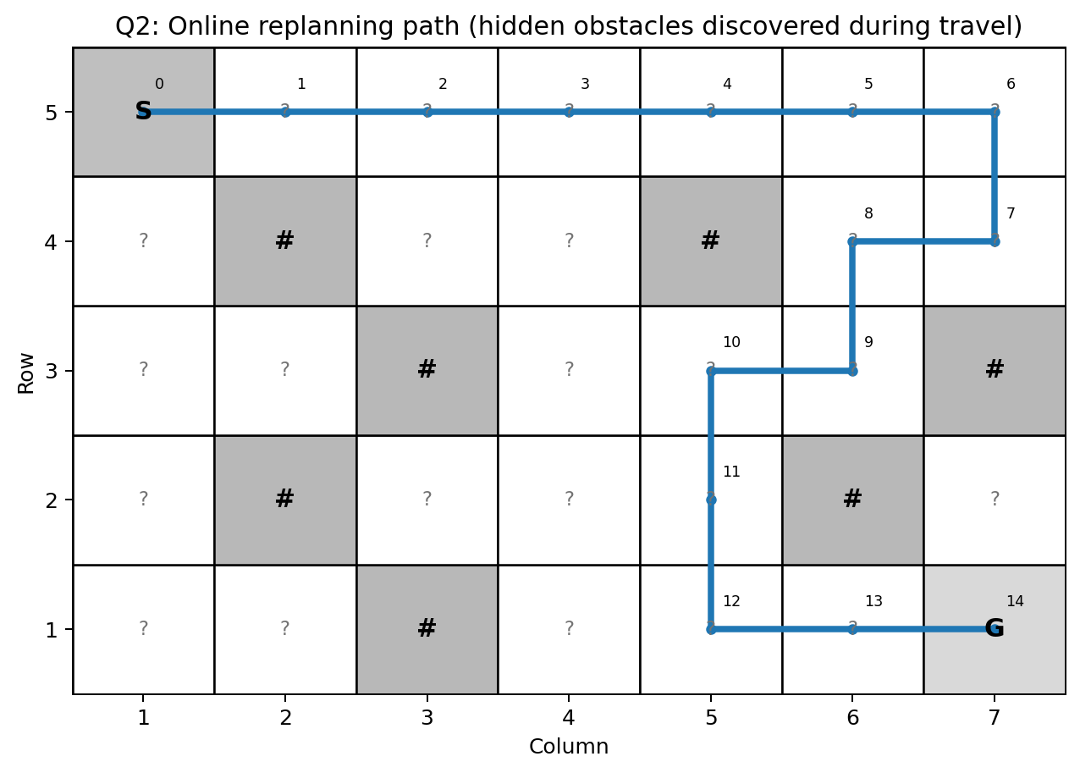

Figure 2. One valid online decision sequence on the supplied 7×5 grid. Numbers indicate movement order.
Step | Cell | Decision / Observation
Step | Current cell | Decision / observation
0 | (1,5) | Move right to (2,5); no blocking obstacle encountered.
1 | (2,5) | Obstacle (2,4) is discovered below; continue right.
2 | (3,5) | Continue toward the goal; lower alternatives remain available.
3 | (4,5) | Continue right.
4 | (5,5) | Obstacle (5,4) is discovered below; continue right.
5 | (6,5) | Continue right.
6 | (7,5) | Move down to (7,4).
7 | (7,4) | Obstacle (7,3) is discovered; current downward plan is blocked, so replan left.
8 | (6,4) | Move down to (6,3).
9 | (6,3) | Obstacle (6,2) is discovered; replan left to (5,3).
10 | (5,3) | Move down to (5,2).
11 | (5,2) | Move down to (5,1).
12 | (5,1) | Move right to (6,1).
13 | (6,1) | Move right to goal (7,1).

Resulting online path:
(1,5) → (2,5) → (3,5) → (4,5) → (5,5) → (6,5) → (7,5) → (7,4) → (6,4) → (6,3) → (5,3) → (5,2) → (5,1) → (6,1) → (7,1)
This particular tie-breaking sequence takes 14 moves. The purpose is to demonstrate online adaptation: the robot does not need the complete obstacle map before starting.

5. Reaction to a New Obstacle

- Sense the neighboring cells before committing to the next move.
- Mark a newly detected obstacle as blocked in the internal map.
- Remove any planned path segment that enters the blocked cell.
- Recompute the route from the current location using the updated map.
- Continue execution until the goal is reached.

6. Online Search versus Offline Search

Feature | Online Search | Offline Search
Initial knowledge | Partial/incomplete map | Complete map available before movement
Obstacle handling | Discover and replan during execution | Obstacles are incorporated before planning
Planning | Repeated planning/interleaved with action | Plan can be computed once
Risk of detours | Higher when hidden obstacles appear | Lower when the map is accurate
Adaptability | High | Lower if the map changes unexpectedly
Given grid example | 14-step demonstration path | Full-map shortest path can be 10 steps

7. Complexity and Efficiency

Each A* replanning episode has graph-search complexity dependent on the number of reachable cells; with a binary heap, a common bound is O((V+E) log V). Online search may run A* multiple times, so total computation can exceed one offline A* run. The benefit is robustness to incomplete information.
Answer: Use online informed search with repeated A* replanning. When an obstacle is discovered, update the map and immediately replan rather than continuing along an invalid route.

Question 3 — University Examination Scheduling

The supplied problem requires six examinations E1–E6 to be placed into four slots T1–T4, subject to student-conflict and examination-hall-capacity constraints. The explicit tasks are CSP formulation, Backtracking with MRV and Forward Checking, domain updates after every assignment, and a final valid timetable. fileciteturn0file0L61-L69 fileciteturn0file0L72-L94

1. CSP Formulation
Variables:
- E1, E2, E3, E4, E5, E6 — one variable per examination.
Domains:
- D(E1)=D(E2)=D(E3)=D(E4)=D(E5)=D(E6)={T1,T2,T3,T4} initially.
Student-conflict constraints from the assignment:
- E1 ≠ E2
- E1 ≠ E3
- E2 ≠ E4
- E3 ≠ E5
- E4 ≠ E6
- E2 ≠ E5
Hall-capacity constraints from the supplied data:
Hall | Capacity
Hall A | 120
Hall B | 90
Hall C | 60

Exam | Students | Permitted halls
E1 | 100 | A
E2 | 80 | A or B
E3 | 70 | A or B
E4 | 60 | A or B or C
E5 | 90 | A
E6 | 50 | A or B or C

A second capacity constraint follows from simultaneous use: a hall can host only one examination in a slot. Thus two examinations that both require Hall A (E1 and E5) cannot occupy the same slot even though they have no student-conflict edge.

2. Constraint Graph

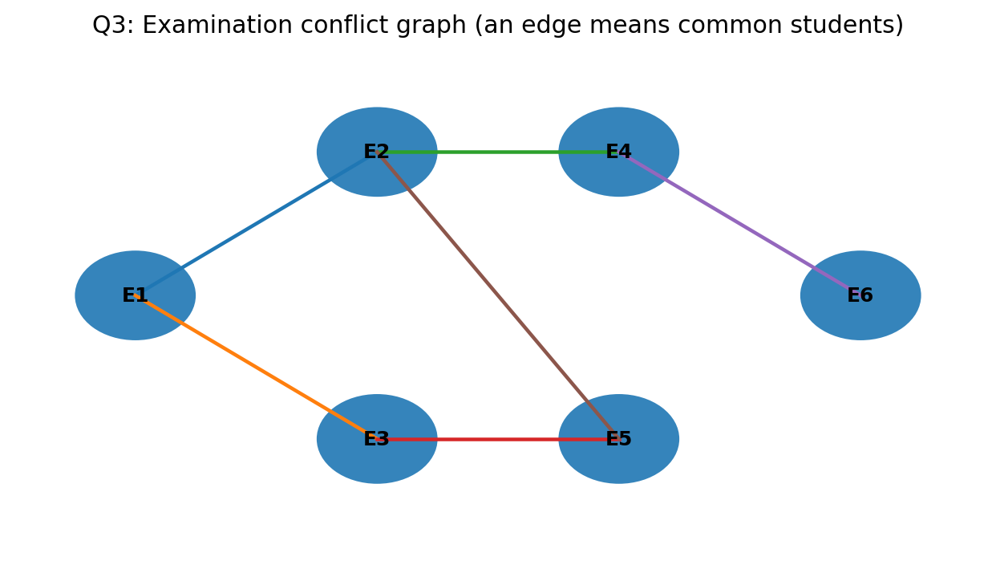
Figure 3. Conflict graph. An edge means the two examinations cannot share a time slot.

3. MRV and Forward Checking

Initially all variables have four values, so MRV has a tie. The tie is resolved by selecting the examination with the larger conflict degree, then by examination order. The resulting sequence is E1, E2, E3, E4, E5, E6. Each assignment removes the chosen time slot from the domains of its conflict neighbors.

4. Step-by-Step Domain Trace

Step | Assignment | Remaining domains after Forward Checking
0 — Initial | — | E1 {T1,T2,T3,T4}; E2 {T1,T2,T3,T4}; E3 {T1,T2,T3,T4}; E4 {T1,T2,T3,T4}; E5 {T1,T2,T3,T4}; E6 {T1,T2,T3,T4}
1 | E1=T1 | E2 {T2,T3,T4}; E3 {T2,T3,T4}; E4 {T1,T2,T3,T4}; E5 {T1,T2,T3,T4}; E6 {T1,T2,T3,T4}
2 | E2=T2 | E3 {T2,T3,T4}; E4 {T1,T3,T4}; E5 {T1,T3,T4}; E6 {T1,T2,T3,T4}
3 | E3=T2 | E4 {T1,T3,T4}; E5 {T1,T3,T4}; E6 {T1,T2,T3,T4}
4 | E4=T3 | E5 {T1,T3,T4}; E6 {T1,T2,T4}
5 | E5=T3 | E6 {T1,T2,T4}
6 | E6=T1 | All variables assigned.

5. Hall Assignment and Capacity Check

Time slot | Hall A | Hall B | Hall C
T1 | E1 — Hall A (100) | E6 — Hall B (50) | Hall C unused
T2 | E3 — Hall A (70) | E2 — Hall B (80) | Hall C unused
T3 | E5 — Hall A (90) | — | E4 — Hall C (60)
T4 | — | — | —

Capacity verification:
- E1 has 100 students and uses Hall A (capacity 120).
- E2 has 80 students and uses Hall B (capacity 90).
- E3 has 70 students and uses Hall A (capacity 120).
- E4 has 60 students and uses Hall C (capacity 60).
- E5 has 90 students and uses Hall A (capacity 120).
- E6 has 50 students and uses Hall B (capacity 90).

6. Final Timetable

Exam | Slot | Hall | Students | Conflict Check
E1 | T1 | A | 100 | E2/E3 are in T2
E2 | T2 | B | 80 | E1/E4/E5 are not in T2
E3 | T2 | A | 70 | E1/E5 are not in T2
E4 | T3 | C | 60 | E2/E6 are not in T3
E5 | T3 | A | 90 | E2/E3 are not in T3
E6 | T1 | B | 50 | E4 is not in T1

The timetable is valid: every student-conflict pair is separated, no hall contains two examinations in the same slot, and every examination fits its assigned hall capacity.

7. Backtracking Pseudocode

BACKTRACK(assignment):
1. If every exam is assigned, return assignment.
2. Select an unassigned exam using MRV; break ties using highest conflict degree.
3. For each slot in the variable's current domain:
4. If the slot satisfies student-conflict and hall-capacity feasibility:
5. Assign the slot.
6. Apply Forward Checking to all unassigned neighboring exams.
7. If no domain becomes empty, recursively call BACKTRACK.
8. If recursion succeeds, return the solution.
9. Undo the assignment and restore domains.
10. Return failure.

8. Complexity

For n variables and d possible values, basic CSP backtracking has worst-case O(d^n) search. MRV reduces branching by selecting the most constrained variable, while Forward Checking detects many dead ends early. Here n=6 and d=4, so the raw upper bound is 4^6=4096 assignments before pruning; the heuristics make the practical search much smaller.
Answer: E1=T1/A, E2=T2/B, E3=T2/A, E4=T3/C, E5=T3/A, E6=T1/B.

Question 4 — Game-Playing AI

The supplied question asks for the move selected by Minimax, then Alpha–Beta pruning, identification of branches that do not need evaluation, and an explanation of the efficiency improvement. The major concepts are Game Playing, Minimax and Alpha–Beta Pruning. fileciteturn0file0L95-L105

1. Minimax Evaluation
The root is a MAX node. Its three children are MIN nodes. Each MIN node has three MAX children, each ending in three terminal scores.
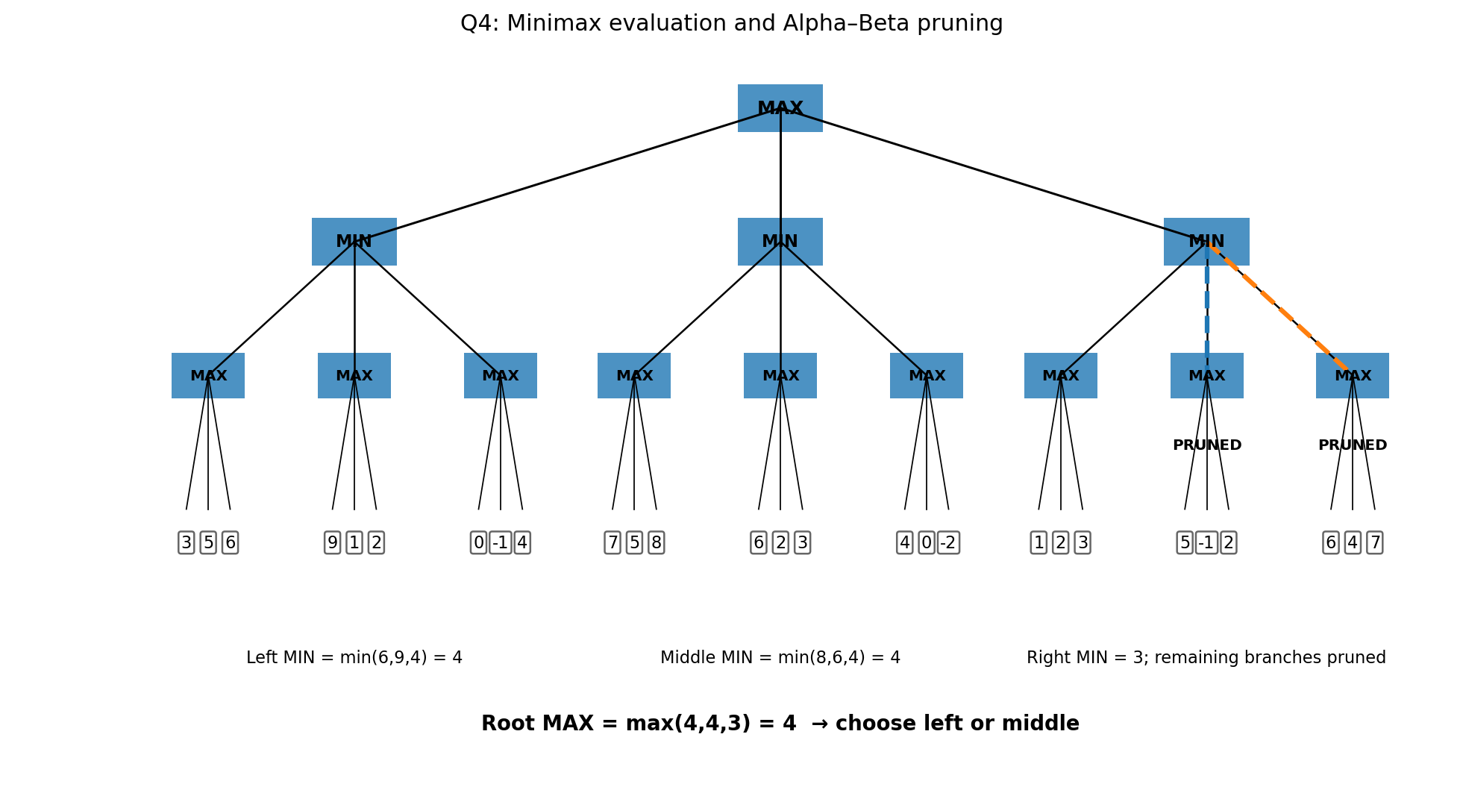
Figure 4. Supplied game tree evaluated left-to-right; dashed branches are pruned by Alpha–Beta.

2. Bottom-Up Minimax Calculation

Root branch | MAX child values | MIN result
Left MIN | max(3,5,6)=6; max(9,1,2)=9; max(0,-1,4)=4 | min(6,9,4)=4
Middle MIN | max(7,5,8)=8; max(6,2,3)=6; max(4,0,-2)=4 | min(8,6,4)=4
Right MIN | max(1,2,3)=3; max(5,-1,2)=5; max(6,4,7)=7 | min(3,5,7)=3

Therefore:
MIN branches = 4, 4, 3 → ROOT MAX = max(4,4,3) = 4
The AI should choose either the left MIN branch or the middle MIN branch, because both have minimax value 4. With left-to-right tie-breaking, the left branch is selected.

3. Alpha–Beta Pruning

Evaluation is assumed left-to-right, matching the natural order of the supplied tree.
- Evaluate the left MIN subtree completely. Its value is 4, so the root MAX obtains α=4.
- Evaluate the middle MIN subtree. Its value is 4, so α remains 4.
- At the right MIN node, the first MAX child returns 3. Thus β at that MIN node becomes 3.
- Because β=3 ≤ α=4, the MIN node cannot possibly improve the root's choice. Its remaining two MAX children are therefore pruned.
Pruned branches:
- MAX branch with terminal leaves [5, −1, 2].
- MAX branch with terminal leaves [6, 4, 7].

4. Why Pruning Improves Efficiency
Minimax may evaluate every leaf in a game tree. Alpha–Beta keeps two bounds: α, the best value MAX can already guarantee, and β, the best value MIN can already guarantee. When β≤α, further exploration of that branch cannot change the final decision and is skipped.
For the supplied tree there are 27 terminal leaves. Alpha–Beta pruning avoids evaluating 6 terminal leaves in the right subtree, so 21 terminal leaves are evaluated under the shown left-to-right order.

5. Complexity

Plain Minimax has time complexity O(b^d), where b is branching factor and d is search depth, with O(bd) stack space in a depth-first implementation. Alpha–Beta has the same worst-case time O(b^d), but with ideal move ordering it can approach O(b^(d/2)), effectively allowing roughly twice the searchable depth for the same computational budget.
Answer: minimax value = 4; choose the left or middle root move (left under left-to-right tie-breaking). Alpha–Beta prunes the two remaining MAX branches under the right MIN node after obtaining β=3 while α=4.

Question 5 — Delivery Route Optimization

The supplied problem asks for a local-search strategy to minimize total delivery distance, a step-by-step application to the provided routes, a statement about global optimality, and a method for escaping a local optimum. The major concepts are Local Search, Optimization and Hill Climbing. fileciteturn0file0L108-L117

1. Problem Analysis
A route is a candidate solution. The objective is to minimize its total travel cost. Hill climbing evaluates neighboring routes and moves to a better neighbor. For a minimization problem, a lower route cost is better.

2. Supplied Route Costs

Route | Route shown in assignment | Stated cost
S1 | D → A → C → B → E → D | 26 km
S2 | D → B → A → C → E → D | 30 km
S3 | D → A → B → E → C → D | 24 km
S4 | D → E → C → B → A → D | 27 km
S5 | D → A → E → B → C → D | 23 km
S6 | D → C → B → A → E → D | 29 km

The green instruction box in the supplied figure additionally states: from S5, the best neighbor has cost 22 km, and from that solution all neighbors have cost ≥22 km. fileciteturn0file0L108-L117

3. Hill-Climbing Strategy

Steepest-descent hill climbing for minimization:
1. Start with the current route S5.
2. Generate the neighboring routes.
3. Evaluate each neighbor.
4. Select the lowest-cost neighbor if it is strictly better than the current route.
5. Move to that neighbor.
6. Repeat until no neighbor has a lower cost.
7. Return the current route as a local optimum.

4. Step-by-Step Application

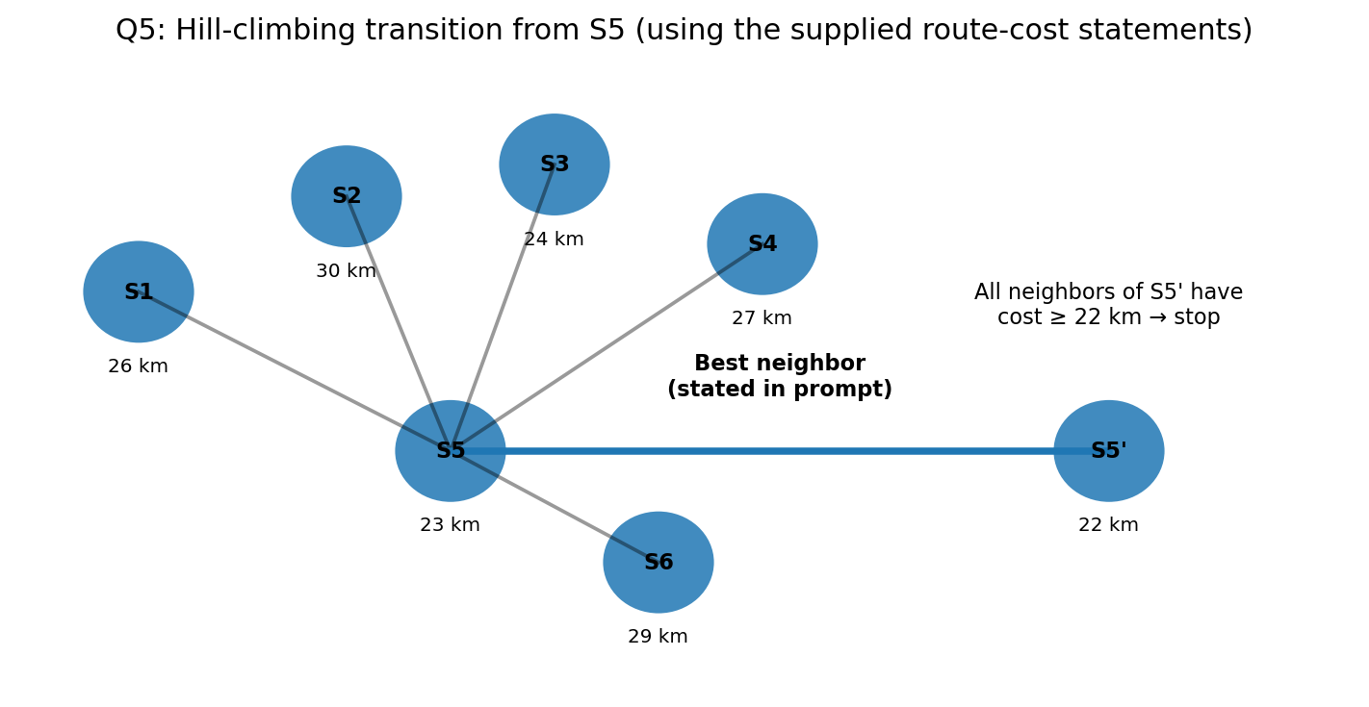
Figure 5. Hill-climbing transition using the explicit 23 km → 22 km statement in the supplied question.
Iteration | Current solution | Cost | Decision
0 | S5 | 23 km | Evaluate neighbors
1 | Best neighbor of S5 = S5′ | 22 km | Accept because 22 < 23
2 | S5′ | 22 km | All neighbors have cost ≥22 km; stop

5. Local versus Global Optimum

The final 22 km solution is guaranteed to be a local optimum under the stated neighborhood because every neighbor has cost at least 22 km. It is not guaranteed to be a global optimum: hill climbing checks only the local neighborhood and can stop at a basin that is not globally best.

6. Escaping a Local Optimum

- Random-restart hill climbing: restart from several different initial routes and retain the best final solution.
- Stochastic hill climbing: sometimes select a non-best improving neighbor to diversify the search.
- Simulated annealing: occasionally accept a worse move, especially early in the search, to cross local barriers.
- Tabu search: maintain a short-term memory of recent moves to avoid cycling and explore new regions.

7. Important Data-Consistency Note

The numerical route costs printed in the supplied figure do not fully agree with the distance matrix printed beside them. For example, directly summing the displayed matrix for S5 gives 29 km, while the route list labels S5 as 23 km. Also, no explicit route sequence for the stated 22 km best neighbor is printed. Therefore, the solution above deliberately follows the assignment's explicit stated route costs and its explicit 22 km local-search instruction rather than silently replacing them with recomputed values. If the faculty expects the matrix to be authoritative, the route-cost data should be clarified before submission.

8. Complexity

If N neighboring routes are evaluated at each iteration and a route has n stops, evaluating a route from scratch is O(n). Thus one hill-climbing iteration is O(Nn). The overall cost is O(kNn) for k iterations, ignoring the cost of generating neighbors.
Answer: S5 (23 km) → best stated neighbor S5′ (22 km) → stop because every neighbor of S5′ has cost ≥22 km. The result is a local optimum, not a proof of a global optimum.

EVALUATION RUBRICS

Criteria | Weightage  (%) | Excellent (Full Marks) | Good | Average | Poor
CSP Problem  Formulation | 20% | 4% – Clearly defines all variables, domains, and problem objectives correctly. | 3% – Defines most variables and domains with minor errors. | 2% – Partial formulation with some missing components. | 0–1% –  Incorrect or incomplete formulation.
Constraint  Identification  &  Representatio n | 20% | 4% –  Accurately  identifies all student-confli ct and hall-capacity constraints and represents them correctly. | 3% –  Identifies most constraints with minor errors. | 2% –  Identifies some  constraints but misses important relationships. | 0–1% –  Constraints are largely incorrect or missing.
Application of  Backtracking,  MRV &  Forward  Checking | 30% | 6% –  Correctly applies  Backtracking,  MRV, and  Forward  Checking with clear and logical steps. | 4.5% – Applies the techniques correctly with minor mistakes. | 3% – Partial application with unclear or inconsistent steps. | 0–1.5% –  Incorrect or inappropriate application of  CSP  techniques.
Step-by-Step  Execution &  Domain  Updates | 20% | 4% – Provides a complete, logical execution trace and correctly updates domains after every assignment. | 3% – Mostly correct execution with minor gaps. | 2% – Provides limited steps with some incorrect domain updates. | 0–1% –  Incomplete or incorrect execution.
Final  Timetable,  Accuracy &  Justification | 10% | 2% – Produces a valid conflict-free timetable satisfying all constraints and capacity requirements with clear justification. | 1.5% – Valid timetable with minor errors in justification. | 1% – Partially valid timetable with some  constraint violations. | 0–0.5% – Invalid or missing timetable.

