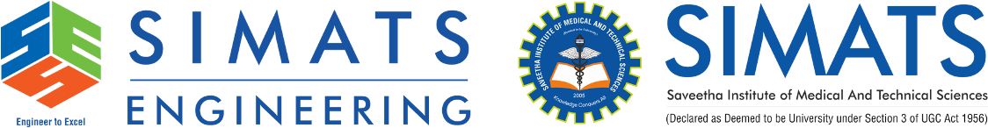

AI-Based Student Support Assistant
Design&Implementation using Google Dialog-flow ES

Professional Project Report:

Table of Contents:
1. Abstract
2. Introduction
3. Problem Statement
4. Objectives
5. Existing System
6. Proposed System
7. Software Requirements
8. System Architecture
9. Functional Modules
10. Intent Design
11. Entity Design
12. Conversation Flow
13. Sample Conversation
14. Testing
15. Advantages
16. Limitations
17. Future Enhancements
18. Conclusion

Abstract:
Artificial Intelligence has transformed university support services by enabling conversational agents that provide instant, accurate responses to student queries. This report presents the design and implementation of an AI-Based Student Support Assistant using Google Dialogflow ES. The assistant uses Natural Language Processing (NLP), intent recognition, entities, and conversational contexts to answer questions related to course registration, timetables, examinations, attendance, and campus services. The solution reduces administrative workload while providing 24/7 support.

Introduction:
Universities handle thousands of repetitive student enquiries every semester. Manual support is time-consuming and may lead to inconsistent responses. A Dialogflow-powered chatbot automates these interactions using machine learning and natural language understanding.

Problem Statement:
Students experience delays in obtaining information related to registration, examinations, attendance, fees, and campus services due to dependence on manual help desks.

Objectives:
• Develop an intelligent chatbot using Dialogflow ES.
• Understand natural language queries.
• Provide instant responses.
• Reduce administrative workload.
• Improve student satisfaction.

Existing System:
Traditional help desks rely on manual interaction, resulting in slower response times, limited availability, and higher operational costs.
Proposed System:
The proposed system employs Dialogflow ES to classify intents, extract entities, maintain conversational context, and generate relevant responses. Optional webhook integration enables retrieval of real-time information from university databases.

Software Requirements:
Google Dialogflow ES
Google Cloud Platform
Python/Node.js (Webhook)Firebase/MySQL (Optional)
Modern Web Browser

System Architecture:
Student → Chat Interface → Dialogflow Agent → Intent Detection → Entity Extraction → Context Management → Webhook/Knowledge Base → Response

Functional Modules:
1. Welcome
2. Course Registration
3. Timetable
4. Examination Schedule
5. Attendance
6. Campus Services
7. FAQ
8. Fallback Intent

Intent Design:
Welcome, Course Registration, Timetable, Examination Schedule, Attendance, Campus Services, Goodbye, Default Fallback.

Entity Design:
Department, Semester, Course, Faculty, Campus Service, Examination.

Conversation Flow:
User Query → Intent Recognition → Entity Extraction → Context Check → Response Generation → User

Sample Conversation:
Student: Show my timetable.
Bot: Which semester?
Student: Semester 5.
Bot: Here is your Semester 5 timetable.

Testing:Verify greeting, registration, timetable, attendance, examination, fallback, and goodbye intents using multiple training phrases.

