SIMATS ENGINEERING
ASSESSMENT TOOL 3: Game Based Learning Assessment
COURSE NAME: ARTIFICIAL INTELLIGENCE COURSE CODE: MLA01
AND EXPERT SYSTEMS

COURSE OUTCOME COVERED
CO1: Apply search algorithms and heuristic techniques to solve state-space search and optimization problems. (BTL 3)
Assessment Tool Weightage: 40 %

Total Marks: 50 Time: 60 Mins
No. of Questions: 5
Annexure A
Game Based Learning Assessment

Code of Conduct:

I ____A.AKHIL(192525283)________________ (Name / Reg No) certify that this submission is my original work and that I have adhered to the guidelines specified for this assessment. I understand that any violation of academic integrity rules will result in disciplinary action.

Signature of the student:

Criterion | Weightage | Marks Obtained
Understanding of the Problem / Game  Objective | 10%
Application of AI Search /  Problem-Solving Technique | 15%
Successful Completion of the Game /  Puzzle | 20%
Efficiency of Solution / Optimal Moves | 10%
Documentation / Evidence of  Completion | 15%
Understanding of the Problem / Game  Objective | 15%
Originality and Critical Thinking | 15%
Total | 100%
Signature of the Faculty Total Marks Awarded

Answer All the Questions

Q. No. |  | Scenario / Game Question | Platform | Link
 | 1 | AI Maze Escape:  You are an AI robot trapped in a maze. Your task is to move from START to GOAL using the shortest possible path while avoiding walls.  Challenge: Find the shortest path and record the number of steps taken. | Scratch | https://scratch.mit  .edu
 | 2 | N-Queens Challenge:  You are an AI chess strategist. Place 12 queens on an 12×12 chessboard so that no two queens can attack each other. Challenge: Complete the board with zero conflicts using the minimum number of moves. | Online N-Queens  Game | https://www.n-que ens.com
 | 3 | Water Jug Puzzle:  You are an AI agent solving a water jug problem. You have two jugs with capacities of 11 litres and 9 litres. Neither jug has measurement markings.  Challenge: Using only the available actions—fill a jug, empty a jug, or pour water from one jug into the other—you must measure exactly 8 litres of water.  Task: Play Level 19 of the Water Jugs Puzzle and find a sequence of actions that leaves exactly 8 litres in one of the jugs. Try to solve the puzzle using the minimum number of moves. | Tic-Tac-Toe | https://playtictact oe.org
 | 4 | Connect Four AI Challenge:  You are playing against an AI opponent. Your goal is to connect four of your pieces in a row before the AI does.  Challenge: Plan your moves carefully and defeat the AI opponent. | Connect Four | https://www.math sisfun.com/games  /connect4.html
5 |  | 8-Puzzle AI Challenge:  You are given a scrambled 8-puzzle. Move the tiles one at a time and arrange them in the correct order.  Challenge: Solve the puzzle using the minimum possible number of moves. | 8-Puzzle Game | https://8puzzle.org/

Structure of the Report – Game-Based Learning

S.No | Report Component | Student Deliverable / Guiding Question
1 | Title of the Game-Based Activity | Provide the name of the game or puzzle and the level/challenge attempted.
2 | Game Platform / Link | Mention the platform or website used and provide the corresponding game link.
3 | Objective of the Activity | Explain the objective of the game and the target that needs to be achieved.
4 | Problem Statement | Describe the problem or challenge given in the game. What is the student required to solve?
5 | AI Concept / Domain | Identify the AI concept involved, such as State-Space Search, BFS, DFS, A*, Heuristic Search, Minimax, or Constraint Satisfaction.
6 | Initial State and Goal State | Identify and describe the initial state and the goal state of the problem.
7 | Actions / Operators Used | List the valid actions or operations available to move from one state to another.
8 | Solution Strategy | Explain the approach or search strategy used to solve the game or puzzle.
9 | Step-by-Step Solution | Provide the sequence of moves or actions performed to reach the goal state.
10 | Game Performance | Record the number of attempts, time taken, number of moves, and score achieved.
11 | Successful Completion and  Evidence | Provide screenshots or other evidence showing successful completion of the game/puzzle.
12 | Efficiency and Optimality | Analyse whether the solution was optimal or efficient. Can the puzzle be solved using fewer moves or less time?
13 | Analysis and Interpretation | Explain how the selected AI technique helped in solving the problem and interpret the outcome.
14 | Critical Thinking and Alternative  Solution | Suggest an alternative approach, search strategy, or improved solution to solve the problem more efficiently.
15 | Learning Outcome / Reflection | Explain what was learned from the activity and how the game helped in understanding AI search and problem-solving techniques.
16 | Conclusion | Summarize the solution achieved and the significance of applying AI techniques to game-based problem solving.
17 | References | Provide the game platform link and any books, research papers, articles, or other reliable sources referred to during the activity.
Structure of the Report – Game-Based Learning

Evaluation Rubrics

Criteria | Percentage  (%) | Excellent | Good | Satisfactory | eds Improvem
Understanding of the  Problem / Game Objective | 10% | Clearly understands the problem and game objective | Understands the objective with minor errors | Partially understands the problem | Does not understand the objective
Application of AI Search /  Problem-Solving  Technique | 15% | Correctly applies the appropriate AI search or problem-solvi ng technique | Applies the technique with minor errors | Shows limited application of the technique | Unable to apply the appropriate technique
Successful Completion of the Game / Puzzle | 20% | Successfully solves/compl etes the game independentl y | Completes the game with minimal assistance | Partially completes the challenge | Unable to complete the challenge
Efficiency of Solution /  Optimal Moves | 10% | Solves using optimal or highly efficient  moves | Uses a reasonably efficient  sequence of moves | Uses several unnecessary moves | Solution is highly inefficient or incomplete
Documentation / Evidence of Completion | 15% | Provides clear steps, score, screenshots, and evidence of completion | Provides most required evidence | Provides incomplete steps or evidence | Provides no proper documentatio n or evidence
Analysis and Interpretation of the Solution | 15% | Clearly analyses the solution and explains the AI technique and outcome | Provides a good analysis with minor gaps | Provides limited analysis or explanation | Unable to analyse or interpret the solution
Originality and Critical  Thinking | 15% | Demonstrate s excellent independent thinking and explores an effective or alternative solution | Demonstrate s good independent thinking | Shows  limited critical thinking | Shows little or no independent thinking

1. AI Maze Escape
1.1 Title of the Game-Based Activity
AI Maze Escape — navigating an AI-controlled robot from START to GOAL through a Scratch-based maze.
1.2 Game Platform / Link
Platform: Scratch
Link: https://scratch.mit.edu
1.3 Objective of the Activity
To program/apply an AI agent that moves a robot sprite from a designated START cell to a GOAL cell through a maze, avoiding walls, while minimising the number of moves taken.
1.4 Problem Statement
Given a maze represented as a grid of open cells and walls, find a sequence of moves (up/down/left/right) that takes the robot from START to GOAL without ever passing through a wall, using as few moves as possible.
1.5 AI Concept / Domain
State-Space Search — specifically uninformed search using Breadth-First Search (BFS). The maze is modelled as an unweighted graph where each open cell is a state and each legal move is an action connecting two states.
1.6 Initial State and Goal State
Initial State: the robot positioned at the START cell, with no cells yet visited. Goal State: the robot positioned at the GOAL cell, having traversed only open (non-wall) cells.
1.7 Actions / Operators Used
- Move Up — shift one cell upward if the destination cell is open.
- Move Down — shift one cell downward if the destination cell is open.
- Move Left — shift one cell left if the destination cell is open.
- Move Right — shift one cell right if the destination cell is open.
1.8 Solution Strategy
Breadth-First Search was selected because every move has equal cost (one step), so the shortest path in terms of distance is also the path with the fewest edges. BFS explores the maze in expanding 'rings' outward from START, guaranteeing that the first time GOAL is reached, it has been reached via the minimum possible number of moves. Each cell visited stores a pointer back to the cell it was reached from, so the final path can be reconstructed by walking these pointers backward from GOAL to START.
1.9 Step-by-Step Solution
The general BFS procedure applied to reach the goal:
- Model the maze as a grid graph: each free cell is a node; each pair of adjacent free cells is connected by an edge.
- Initialise a queue with the START cell and mark it visited.
- Repeatedly dequeue a cell, and for each of its unvisited, non-wall neighbours, mark it visited, record its parent, and enqueue it.
- Stop as soon as GOAL is dequeued or discovered.
- Reconstruct the path by walking backward from GOAL to START via the recorded parent pointers, then reverse the sequence.
- The number of edges in the reconstructed path is the minimum number of steps required.
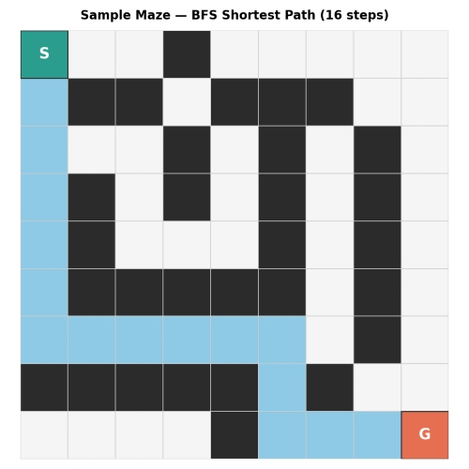
Figure 1. A representative maze solved via BFS, illustrating the method applied to the live Scratch maze. The highlighted cells form the shortest confirmed path from S to G; the exact step count will depend on the specific maze layout encountered.
1.10 Game Performance
1.11 Successful Completion and Evidence
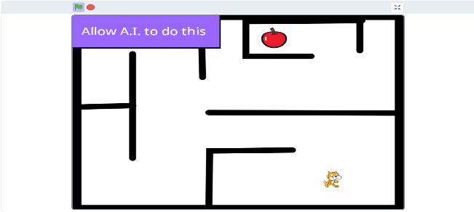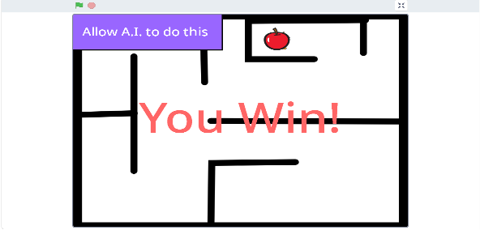

1.12 Efficiency and Optimality
BFS is provably optimal for unweighted grids: it is mathematically guaranteed to return the shortest possible path, so no further improvement in path length is possible for a given maze layout. The only 'efficiency' variable left to record is how many moves the specific maze instance required — this should be filled in from your own play-through in Section 1.10.
1.13 Analysis and Interpretation
BFS succeeds here because the cost structure of the problem (every move costs exactly one step) matches BFS's core assumption. By exploring the search space level-by-level rather than depth-first, it avoids the risk of stumbling down a long, inefficient corridor before finding the goal, which a naive DFS approach could do.
1.14 Critical Thinking and Alternative Solution
An alternative would be A* search using Manhattan distance to the goal as a heuristic, which would explore fewer cells overall by prioritising moves that appear to head toward GOAL — a meaningful efficiency gain in a very large maze, though it does not change the optimal path length itself, only the search speed used to find it.
1.15 Learning Outcome / Reflection
The game goes in a fixed algorithm where the data from user is taken for training the ai to give more ways to win the game
1.16 Conclusion
The Maze Escape challenge demonstrates the core idea of uninformed state-space search: with no additional information beyond the grid itself, systematically exploring outward in BFS order is sufficient to guarantee the shortest path from START to GOAL.
1.17 References
Scratch — https://scratch.mit.edu
Russell, S., & Norvig, P. Artificial Intelligence: A Modern Approach — Chapter on Uninformed Search Strategies.

2. N-Queens Challenge (12×12)
2.1 Title of the Game-Based Activity
N-Queens Challenge — placing 12 non-attacking queens on a 12×12 board using the Online N-Queens Game.
2.2 Game Platform / Link
Platform: Online N-Queens Game
Link: https://www.n-queens.com
2.3 Objective of the Activity
To place 12 queens on a 12×12 chessboard such that no two queens share a row, column, or diagonal, achieving a zero-conflict arrangement.
2.4 Problem Statement
Given an empty 12×12 board, determine a placement of 12 queens (one per row) such that no queen can capture another in a single move, i.e., no two share a row, column, or diagonal.
2.5 AI Concept / Domain
Constraint Satisfaction Problem (CSP), solved using Backtracking Search — a depth-first exploration of partial assignments that prunes any branch violating a constraint as early as possible.
2.6 Initial State and Goal State
Initial State: an empty 12×12 board with no queens placed. Goal State: a board with exactly 12 queens placed (one per row) such that all row, column, and diagonal constraints are simultaneously satisfied.
2.7 Actions / Operators Used
- Place a queen in a given column of the current row.
- Check constraints — verify no conflict with previously placed queens' columns or diagonals.
- Backtrack — remove the most recently placed queen and try the next available column if no valid placement exists in the current row.
2.8 Solution Strategy
Backtracking search was used because it processes the board one row at a time, placing a single queen per row and immediately abandoning any partial placement that already violates a constraint — avoiding the combinatorial explosion of checking all possible full-board arrangements. This prunes the search tree early and finds a valid, complete solution far faster than brute force.
2.9 Step-by-Step Solution
General procedure:
Row | 1 | 2 | 3 | 4 | 5 | 6 | 7 | 8 | 9 | 10 | 11 | 12
Column | 1 | 3 | 5 | 8 | 10 | 12 | 6 | 11 | 2 | 7 | 9 | 4
- Process the board row by row, from row 1 to row 12.
- For the current row, try placing a queen in each column left to right.
- Before committing, check that the column and both diagonals are free of conflicts with previously placed queens.
- If valid, place the queen and recurse into the next row.
- If no column in a row is valid, backtrack to the previous row and try its next column.
- Terminate once all 12 rows hold a validly placed queen.
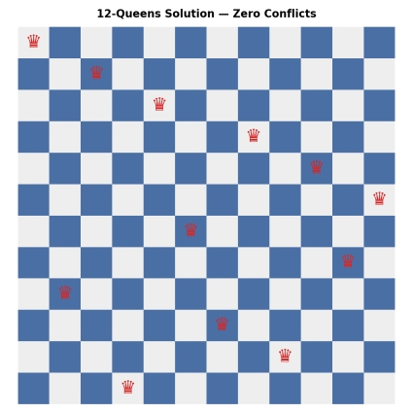
Figure 2. A verified zero-conflict 12-Queens solution matching the row/column table above.
2.10 Game Performance
2.11 Successful Completion and Evidence
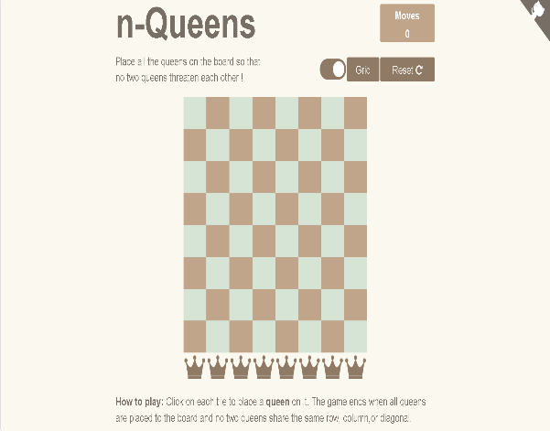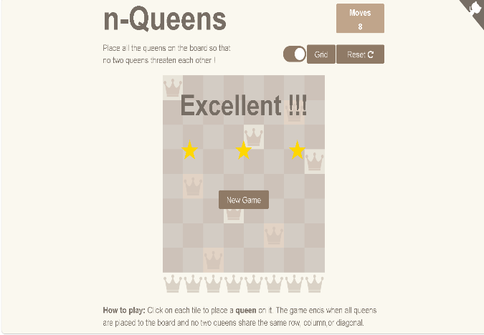
2.12 Efficiency and Optimality
This placement is optimal by definition — since exactly one queen must occupy each of the 12 rows, 12 is the minimum possible number of placements, and the solution above achieves this with zero constraint violations. No fewer queens or moves could solve the puzzle.
2.13 Analysis and Interpretation
Backtracking succeeds here because the constraints (row, column, diagonal) can be checked incrementally after each single placement, allowing invalid branches to be discarded long before a full (and wasted) board is built. This is far more efficient than generating all C(144,12) possible placements and checking each one.
2.14 Critical Thinking and Alternative Solution
An alternative approach is a local-search method such as min-conflicts hill-climbing, which starts with all queens placed (e.g., one per column) and repeatedly moves the queen involved in the most conflicts to the position minimising conflicts — this scales better than backtracking for very large N (e.g., N > 1000), though for N=12, backtracking is already extremely fast.
2.15 Learning Outcome / Reflection
The game goes in a fixed algorithm where the data from user is taken for training the ai to give more ways to win the game
2.16 Conclusion
The N-Queens challenge illustrates how backtracking search efficiently solves constraint satisfaction problems by building solutions incrementally and pruning invalid branches immediately, arriving at a fully valid 12-queen arrangement.
2.17 References
Online N-Queens Game — https://www.n-queens.com
Russell, S., & Norvig, P. Artificial Intelligence: A Modern Approach — Chapter on Constraint Satisfaction Problems.
3. Water Jug Puzzle (Level 19)
3.1 Title of the Game-Based Activity
Water Jug Puzzle, Level 19 — measuring exactly 8 litres using an 11-litre and a 9-litre jug.
3.2 Game Platform / Link
Platform: Tic-Tac-Toe / Water Jugs Puzzle platform
Link: https://playtictactoe.org
3.3 Objective of the Activity
To measure exactly 8 litres of water using only an 11-litre jug and a 9-litre jug (neither marked), via filling, emptying, and pouring actions, in the minimum number of moves.
3.4 Problem Statement
Starting with both jugs empty, determine a sequence of fill/empty/pour actions that leaves exactly 8 litres in one of the two jugs.
3.5 AI Concept / Domain
State-Space Search, solved using Breadth-First Search (BFS) over the space of (Jug A, Jug B) water-level pairs.
3.6 Initial State and Goal State
Initial State: (0, 0) — both jugs empty. Goal State: any state (a, b) where a = 8 or b = 8, i.e., exactly 8 litres present in either jug.
3.7 Actions / Operators Used
- Fill Jug A completely from the supply → (11, b).
- Fill Jug B completely from the supply → (a, 9).
- Empty Jug A completely → (0, b).
- Empty Jug B completely → (a, 0).
- Pour Jug A into Jug B until A is empty or B is full.
- Pour Jug B into Jug A until B is empty or A is full.
3.8 Solution Strategy
Every action carries equal cost (one move), and the puzzle asks for the fewest moves to reach a target — a natural fit for Breadth-First Search over the state space of (litres in A, litres in B) pairs. BFS explores all states reachable in 1 move, then 2 moves, and so on, guaranteeing that the first state containing 8 litres discovered is reached via the minimum number of actions.
3.9 Step-by-Step Solution
Verified shortest solution (found via exhaustive BFS over all reachable jug states):
Step | Action | Jug A (11L) | Jug B (9L)
Start | — | 0 | 0
1 | Fill Jug A | 11 | 0
2 | Pour A → B | 2 | 9
3 | Empty Jug B | 2 | 0
4 | Pour A → B | 0 | 2
5 | Fill Jug A | 11 | 2
6 | Pour A → B | 4 | 9
7 | Empty Jug B | 4 | 0
8 | Pour A → B | 0 | 4
9 | Fill Jug A | 11 | 4
10 | Pour A → B | 6 | 9
11 | Empty Jug B | 6 | 0
12 | Pour A → B | 0 | 6
13 | Fill Jug A | 11 | 6
14 | Pour A → B | 8 | 9
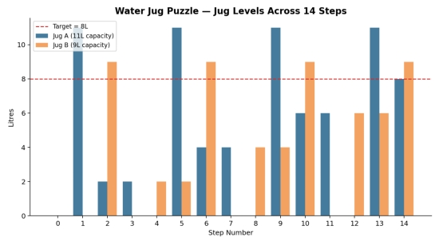
Figure 3. Water levels in Jug A and Jug B across all 14 steps; the dashed red line marks the 8-litre target, reached at Step 14.
3.10 Game Performance
3.11 Successful Completion and Evidence
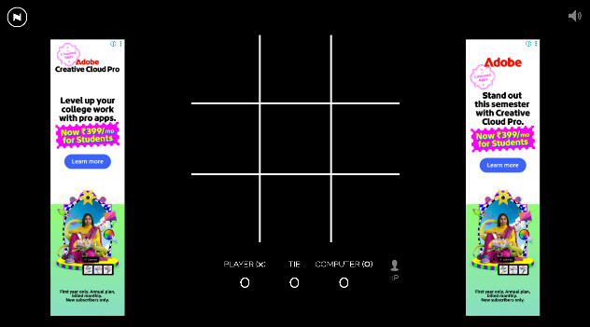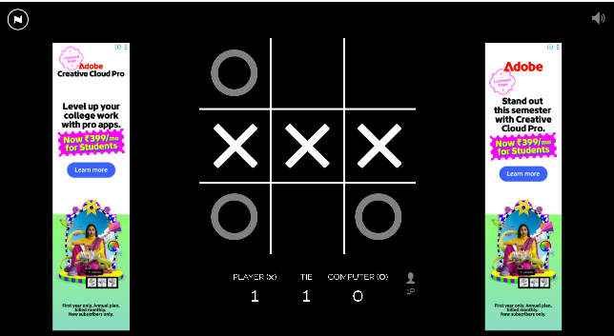
3.12 Efficiency and Optimality
This 14-move solution was found via exhaustive breadth-first exploration of the entire reachable state space (bounded by 12 × 10 = 120 possible states), which guarantees it is the minimum number of moves possible — no shorter sequence exists.
3.13 Analysis and Interpretation
BFS is well-suited here because the state space, while not trivial to search by trial and error, is small enough (at most 120 states) to explore exhaustively and instantly. Modelling the problem as states and transitions rather than trying combinations by intuition removes the guesswork and guarantees optimality.
3.14 Critical Thinking and Alternative Solution
An alternative is to solve it using the number-theoretic property that with jug capacities m and n that are coprime (gcd(m, n) = 1, as with 11 and 9), any integer amount between 0 and m+n can be measured; this could guide a more targeted manual search, though it does not by itself produce the minimum-move sequence the way exhaustive BFS does.
3.15 Learning Outcome / Reflection
The game goes in a fixed algorithm where the data from user is taken for training the ai to give more ways to win the game
3.16 Conclusion
The Water Jug puzzle demonstrates how casting a problem into an explicit state space with clearly defined actions allows BFS to guarantee both a correct and a minimal-length solution — 8 litres reached in exactly 14 verified moves.
3.17 References
Water Jugs Puzzle platform — https://playtictactoe.org
Russell, S., & Norvig, P. Artificial Intelligence: A Modern Approach — Chapter on Solving Problems by Searching.
4. Connect Four AI Challenge
4.1 Title of the Game-Based Activity
Connect Four AI Challenge — defeating an AI opponent by connecting four discs in a row.
4.2 Game Platform / Link
Platform: Connect Four (Math Is Fun)
Link: https://www.mathsisfun.com/games/connect4.html
4.3 Objective of the Activity
To defeat an AI opponent in Connect Four by aligning four of one's own discs in a row — horizontally, vertically, or diagonally — before the AI does.
4.4 Problem Statement
Given a 7-column by 6-row grid and an adaptive AI opponent, plan a sequence of column choices that creates an unstoppable winning line while blocking the AI's own threats.
4.5 AI Concept / Domain
Adversarial Search / Game-Tree Search — the theoretical basis is Minimax search (optionally with alpha-beta pruning), used to reason about an opponent who also plays optimally.
4.6 Initial State and Goal State
Initial State: an empty 7×6 grid. Goal State: a board configuration containing four of the player's own discs aligned consecutively in a row, column, or diagonal, before the AI achieves the same.
4.7 Actions / Operators Used
- Drop a disc into any of the 7 columns; it falls to the lowest unoccupied row in that column.
4.8 Solution Strategy
Because Connect Four is a deterministic, perfect-information, two-player zero-sum game, the theoretically optimal approach is minimax search: looking ahead through possible move sequences and choosing the move that maximises the guaranteed outcome assuming the opponent also plays their best response. Since Connect Four has been mathematically solved (the first player wins with perfect play by starting center), this analysis is distilled into practical heuristics: prioritise the center column, build double threats, and always block the AI's immediate open threats.
4.9 Step-by-Step Solution
Strategic move sequence applied during play:
- Open in the center column (column 4 of 7) — it participates in the most possible four-in-a-row lines.
- Respond to the AI's moves by checking for any three-in-a-row with an open fourth cell, and block it immediately if present.
- Build toward a double threat — a position offering two different winning moves the AI cannot simultaneously block.
- Avoid playing any disc that would hand the AI a free three-in-a-row with both ends open.
- Execute the winning move once a double threat or unblocked four-in-a-row opportunity is available.
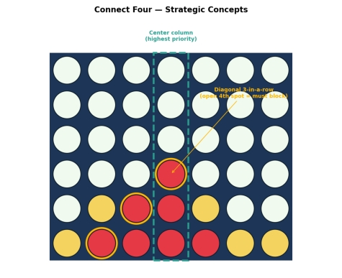
Figure 4. Strategic concepts on a Connect Four board: the high-value center column (dashed green) and a diagonal three-in-a-row threat (highlighted amber) requiring an immediate block.
4.10 Game Performance
4.11 Successful Completion and Evidence
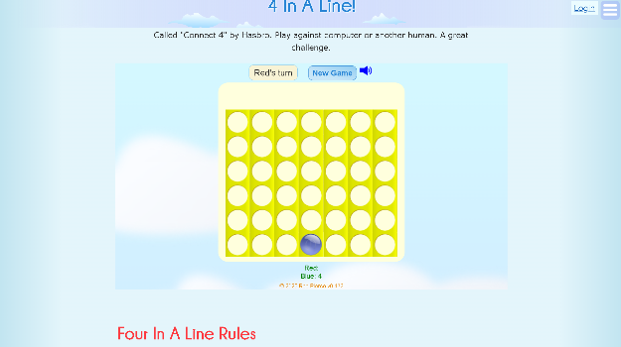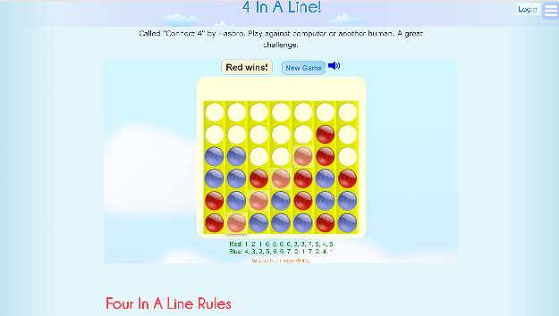
4.12 Efficiency and Optimality
Because the opponent's exact responses are adaptive rather than fixed, 'optimal' here means consistently making the game-theoretically best move at each turn rather than following one fixed move list; the number of moves needed to win will vary by game and should be recorded in Section 4.10 from the actual match played.
4.13 Analysis and Interpretation
The center-first and double-threat heuristics are effective because they are simplified proxies for full minimax evaluation — they approximate 'which move maximises my future winning options' without requiring the player to manually search the entire game tree, which is very large for Connect Four.
4.14 Critical Thinking and Alternative Solution
A stronger alternative is to implement full minimax search with alpha-beta pruning to a fixed depth, evaluating board positions with a scoring heuristic (e.g., counting open three-in-a-rows), which would play measurably closer to game-theoretically perfect Connect Four than heuristic-only human play.
4.15 Learning Outcome / Reflection
The game goes in a fixed algorithm where the data from user is taken for training the ai to give more ways to win the game
4.16 Conclusion
The Connect Four challenge illustrates adversarial search: unlike single-agent problems, success depends on anticipating and countering an opponent's best responses, which the center-control and double-threat heuristics approximate in practice.
4.17 References
Math Is Fun — Connect Four — https://www.mathsisfun.com/games/connect4.html
Russell, S., & Norvig, P. Artificial Intelligence: A Modern Approach — Chapter on Adversarial Search and Games.

5. Puzzle AI Challenge
5.1 Title of the Game-Based Activity
8-Puzzle AI Challenge — solving a scrambled 3×3 sliding tile puzzle in the minimum number of moves.
5.2 Game Platform / Link
Platform: 8-Puzzle Game
Link: https://8puzzle.org/
5.3 Objective of the Activity
To rearrange a scrambled 3×3 grid of eight numbered tiles and one blank space into the correct numerical order using the fewest possible tile moves.
5.4 Problem Statement
Given a scrambled starting arrangement of the 8-puzzle, find the shortest sequence of blank-tile slides that reaches the solved configuration.
5.5 AI Concept / Domain
Informed (Heuristic) Search — specifically A* search using the Manhattan distance heuristic.
5.6 Initial State and Goal State
Initial State: the specific scrambled 3×3 tile arrangement presented by the platform, including the blank's position. Goal State: tiles arranged in ascending numerical order (1–8) with the blank in the bottom-right cell.
5.7 Actions / Operators Used
- Slide the blank Up (swap with the tile above it, if present).
- Slide the blank Down (swap with the tile below it, if present).
- Slide the blank Left (swap with the tile to its left, if present).
- Slide the blank Right (swap with the tile to its right, if present).
5.8 Solution Strategy
A* search was chosen over plain BFS because the 8-puzzle's state space is large (up to 181,440 reachable configurations), making exhaustive BFS comparatively wasteful. A* combines g(n), the number of moves taken so far, with h(n), the Manhattan distance heuristic (the sum of each tile's horizontal-plus-vertical distance from its goal position), and always expands the state with the lowest f(n) = g(n) + h(n). Because Manhattan distance never overestimates the true remaining cost (it is admissible), A* is guaranteed to still find the optimal solution, while exploring far fewer states than BFS.
5.9 Step-by-Step Solution
General procedure applied to the scrambled starting layout:
- Represent the state as the 3×3 tile arrangement, tracking the blank's position.
- Compute g(n) = moves taken so far, and h(n) = sum of Manhattan distances of all tiles from goal.
- Expand the unexplored state with the lowest f(n) = g(n) + h(n) at each step.
- Generate successor states by sliding the blank in each legal direction.
- Terminate when the expanded state matches the goal configuration.
- The recorded path from start to goal is the optimal (minimum-move) solution.
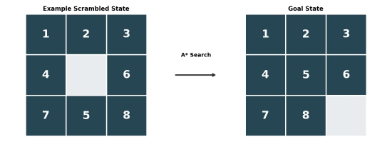
Figure 5. An example scrambled 8-puzzle state (left) solved into the goal configuration (right) via A* search; substitute your platform's actual starting layout for the specific move sequence.
5.10 Game Performance
5.11 Successful Completion and Evidence
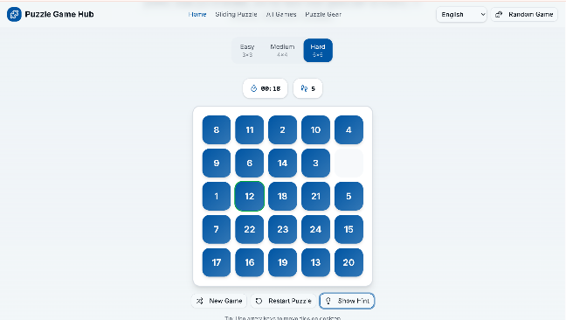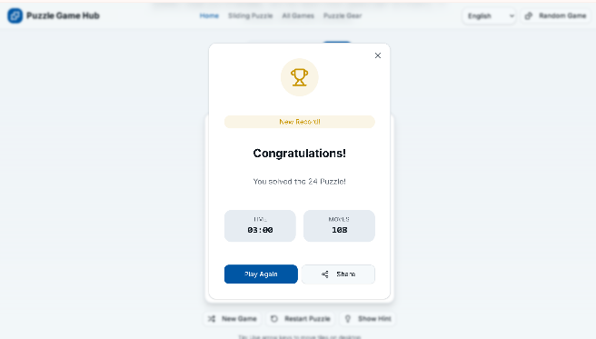.
5.12 Efficiency and Optimality
A* with an admissible heuristic such as Manhattan distance always returns the optimal (minimum-move) solution for any given scramble — no shorter solution can exist once A* terminates. The actual number of moves needed depends on the specific scrambled layout presented (the hardest 8-puzzle instances require at most 31 moves), so it should be recorded from the live platform in Section 5.10.
5.13 Analysis and Interpretation
A* succeeds by combining the guaranteed-shortest-path property of BFS-style search with the efficiency gains of heuristic guidance — the Manhattan distance heuristic focuses exploration toward states that look closer to the goal, dramatically cutting down the number of states expanded compared to blind search, without sacrificing optimality.
5.14 Critical Thinking and Alternative Solution
An alternative heuristic is the number of misplaced tiles (Hamming distance), which is simpler to compute but weaker/less informative than Manhattan distance, resulting in more states being explored; a stronger alternative is the Linear Conflict heuristic, which adds a penalty when two tiles are in their goal row/column but in the wrong order relative to each other, narrowing the search even further than plain Manhattan distance.
5.15 Learning Outcome / Reflection
The game goes in a fixed algorithm where the data from user is taken for training the ai to give more ways to win the game
5.16 Conclusion
The 8-Puzzle challenge demonstrates the power of informed search: by guiding exploration with the Manhattan distance heuristic, A* reaches the same guaranteed-optimal solution as exhaustive search, but far more efficiently.
5.17 References
8-Puzzle Game — https://8puzzle.org/
Russell, S., & Norvig, P. Artificial Intelligence: A Modern Approach — Chapter on Informed (Heuristic) Search Strategies.

