SIMATS ENGINEERING
ASSESSMENT TOOL 2: Research Review & Analysis
COURSE NAME: ARTIFICIAL INTELLIGENCE COURSE CODE: MLA01
AND EXPERT SYSTEMS

COURSE OUTCOME COVERED
CO4: Develop intelligent software agents using suitable agent architectures and learning techniques.(BTL 3)
Assessment Tool Weightage: 30%

Total Marks: 100 Time: 90 Mins
No. of Questions: 1
Annexure A
Research Review & Analysis

Code of Conduct:
I ____A.Akhil(192525283)________________ (Name / Reg No) certify that this submission is my original work and that I have adhered to the guidelines specified for this assessment. I understand that any violation of academic integrity rules will result in disciplinary action.
Signature of the student:
Criterion | Weightage | Marks Obtained
1. Problem Analysis and Domain Understanding | 10%
2. Literature Search and Source Selection | 10%
3. Literature Review and Synthesis | 15%
4. Comparative Analysis of AI Techniques | 10%
5. Critical Analysis of Research Findings | 10%
6. Research Gap Identification | 10%
7. Proposed Research Direction | 10%
8. Research Methodology / Analysis Framework | 5%
9. Experimental / Evidence-Based Validation | 10%
10. Result Analysis and Interpretation | 5%
11. Research Paper Quality and Referencing | 10%
12. Technical Presentation and Research Defense | 5%
Total | 100%
Signature of the Faculty Total Marks Awarded ANSWER ANY ONE QUESTION

S.No. | Research Review & Analysis Question | Primary Topic
1 | Decision Tree Learning:  Review recent research on ID3, C4.5, and CART. Compare their attribute-selection methods, pruning strategies, interpretability, computational complexity, and classification performance. Identify a research gap and suggest a possible improvement. | Decision Trees
2 | Neural Networks vs Statistical Learning:  Review and compare research on neural-network and statistical-learning approaches for prediction and classification. Analyze their performance, data requirements, generalization, interpretability, computational cost, and suitability for different applications. | Statistical  Learning &  Neural Networks
3 | Kernel Methods:  Analyze research on SVM and kernel methods for non-linear classification. Compare linear, polynomial, and RBF kernels and evaluate their advantages and limitations compared with neural-network-based approaches. | Kernel Methods
4 | Reinforcement Learning:  Review research on Q-Learning, SARSA, and Deep Q-Networks. Compare their learning mechanisms, exploration strategies, convergence, computational requirements, and real-world applications. Identify challenges and research gaps. | Reinforcement  Learning
5 | Explainable and Generalizable AI:  Review research on Inductive Learning and Explanation-Based Learning and analyze how these approaches contribute to generalization and explainability in AI. Identify current limitations and propose future research directions. | Inductive &  Explanation-Base d Learning

Structure of the Report:

S.No. | Paper Section | Expected Content
1 | Title | Specific and concise title related to the selected research question/topic.
2 | Abstract | Brief summary of the research problem, review methodology, major findings, research gap, and conclusion.
3 | Keywords | 4–6 important keywords related to the selected topic.
4 | 1. Introduction | Introduce the AI topic, background, importance, motivation, and scope of the review.
5 | 2. Research  Problem and  Objectives | Clearly state the research problem and specific objectives of the review.
6 | 3. Literature  Review | Review relevant research papers and summarize major approaches, methodologies, findings, and contributions.
7 | 4. Comparative  Analysis | Compare the reviewed approaches based on suitable parameters such as accuracy, complexity, interpretability, computational cost, scalability, and generalization.
8 | 5. Critical  Analysis | Discuss strengths, weaknesses, limitations, assumptions, and practical challenges identified across the reviewed studies.
9 | 6. Research  Gap | Identify unresolved problems, limitations in existing research, and areas requiring further investigation.
10 | 7. Proposed  Research  Direction | Suggest possible solutions, improvements, or future research directions based on the identified gap.
11 | 8. Discussion | Discuss the overall insights obtained from the review and their implications for AI research and applications.
12 | 9. Conclusion | Summarize the major findings, key insights, research gap, and future direction.
13 | References | List all research papers, books, datasets, websites, and other sources using a consistent citation style.

Comparative Analysis of ID3, C4.5 and CART for Interpretable Decision-Tree Learning
Research Review and Evidence-Based Analysis
Student Name | Register Number
Department / Program, SIMATS Engineering
Course: Artificial Intelligence and Expert Systems (MLA01)
Academic integrity declaration: I certify that this submission is my original work and follows the assessment guidelines.
Abstract
Decision trees provide transparent predictive models by representing classification decisions as hierarchical rules. This research review compares ID3, C4.5 and CART with respect to split selection, pruning, interpretability, computational cost and classification performance. Foundational algorithmic studies are synthesized with comparative research published in recent years. ID3 selects attributes using information gain but is susceptible to many-valued-attribute bias. C4.5 addresses this limitation using gain ratio and additionally supports continuous attributes, missing values and pruning. CART uses Gini impurity with binary splitting and also supports regression. Evidence from a twelve-dataset comparative study shows that no single method dominates every evaluation criterion: ID3 achieved the highest average accuracy among the three classic methods, whereas CART produced more compact trees and faster construction. A controlled five-fold experiment on Iris further showed that ID3 and C4.5 achieved 94.67% mean test accuracy before validation-based pruning; pruning increased ID3 to 95.33% while reducing tree complexity. The review identifies a gap in fixed split criteria and separate complexity control. An Adaptive Split-and-Prune Decision Tree is therefore proposed to combine predictive separation with cardinality, stability and complexity penalties. The study concludes that decision-tree selection should be multi-objective and data-dependent rather than based on accuracy alone.
Keywords— decision trees, ID3, C4.5, CART, information gain, gain ratio, Gini impurity, pruning, interpretability
1. Introduction

A. Background and Motivation
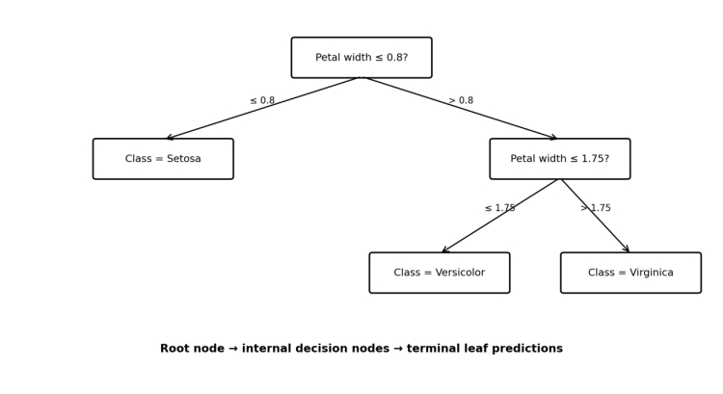
Fig. 1. Conceptual decision-tree structure showing a root decision, internal split and terminal class predictions.
Decision-tree learning is a supervised learning technique in which recursive partitioning converts observations into a hierarchy of tests and predictions. The resulting paths can be interpreted as decision rules, which makes trees useful in expert systems, decision support and applications where model transparency is important. The classic algorithms ID3, C4.5 and CART remain important because many modern tree-based methods build on their ideas.
ID3, introduced by Quinlan, uses information gain to choose the attribute that most reduces class uncertainty. C4.5 extends the approach through gain ratio, continuous-value handling, missing-value treatment and pruning. CART takes a different route by using binary recursive partitioning and impurity reduction, commonly through the Gini criterion. These differences produce distinct trade-offs in accuracy, complexity, computational cost and interpretability.

B. Research Problem and Objectives
The research problem is to determine how the design choices of ID3, C4.5 and CART influence classification performance and practical usefulness, and to identify an improvement that addresses limitations common to the three approaches.
• Compare information gain, gain ratio and Gini impurity as split-selection criteria.
• Compare pruning strategies and their effect on model complexity and generalization.
• Evaluate interpretability, computational cost, scalability and application suitability.
• Synthesize findings across foundational and recent comparative studies.
• Identify a research gap and propose a technically feasible improvement.
• Validate key observations through a small reproducible experiment.

C. Scope
The review focuses on classification-oriented decision trees. CART's regression capability is noted but not experimentally evaluated. The evidence base combines foundational publications, peer-reviewed comparative research and authoritative technical documentation.
The visual figures in this paper are included to make the algorithmic structures, selection criteria, pruning mechanisms and proposed framework easier to interpret alongside the textual analysis.

2. Related Work and Literature Review

A. Literature Search and Source Selection
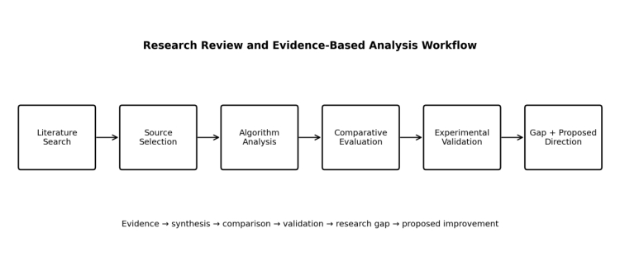
Fig. 2. Research workflow used to move from literature search and source selection to comparison, validation and research-gap identification.
Sources were selected using focused searches for ID3 information gain, C4.5 gain ratio and pruning, CART Gini splitting, decision-tree complexity and comparative decision-tree performance. Priority was given to original algorithm publications and peer-reviewed studies, supplemented by UCI dataset documentation and scikit-learn technical documentation. The review deliberately combines foundational and recent sources so that original algorithm definitions are separated from later empirical observations.

B. ID3
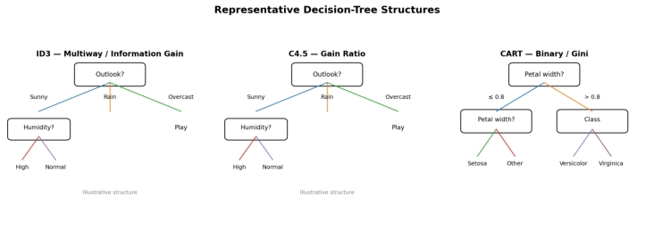
Fig. 5. Representative tree structures illustrating the multiway structure of ID3/C4.5 and binary structure of CART. The trees are schematic, not benchmark results.
ID3 uses entropy to measure uncertainty:
H(S) = − Σᵢ pᵢ log₂(pᵢ)
The information gain of attribute A is:
Gain(S,A) = H(S) − Σᵥ (|Sᵥ|/|S|)H(Sᵥ)
The highest-gain attribute is selected recursively. The main limitation is selection bias toward attributes with many distinct values. The original formulation is also oriented toward categorical attributes, so continuous features normally require an additional treatment.

C. C4.5
C4.5 replaces raw information gain with gain ratio:
GainRatio(S,A) = Gain(S,A) / SplitInfo(S,A)
Split information measures the intrinsic fragmentation produced by an attribute. C4.5 also supports continuous attributes, missing values and pruning. These additions make it more general than ID3, but they also introduce additional processing and do not completely eliminate selection effects.

D. CART
For classification, CART commonly uses Gini impurity:
Gini(S) = 1 − Σᵢ pᵢ²
CART evaluates binary splits and chooses the split that gives the greatest impurity reduction. The same framework extends to regression. Cost-complexity pruning provides a formal mechanism for controlling tree size.

E. Synthesis of Previous Studies
Study | Main focus | Key finding | Limitation / implication
Quinlan (1986) | ID3 | Information-gain tree induction | Many-valued bias motivates later extensions
Quinlan (1993) | C4.5 | Gain ratio, numeric data, missing values, pruning | More general but more complex
Breiman et al. (1984) | CART | Binary partitioning and impurity reduction | Single trees may be unstable
Hssina et al. (2014) | Tree comparison | Highlights practical differences and pruning | Older benchmark context
Aaboub et al. (2023) | 12-dataset comparison | ID3 led average accuracy; CART was compact and fast | Results remain dataset-dependent
Gajowniczek & Dudziński (2024) | Impurity measures | Feature distributions affect impurity behavior | Supports context-aware selection

3. Comparative Analysis
Criterion | ID3 | C4.5 | CART
Attribute selection | Information gain | Gain ratio | Gini impurity
Tree structure | Multiway | Multiway / thresholds | Binary
Numeric attributes | Limited in original | Supported | Supported
Missing values | Limited in original | Supported | Implementation-dependent
Pruning | Usually external | Error-based | Cost-complexity
Regression | No | No in classic form | Yes
Interpretability | High for small trees | High | High
Typical computational profile | Simple | More processing | Efficient binary search
Primary weakness | Many-valued bias | Potentially larger trees | Instability of single trees

A. Attribute Selection
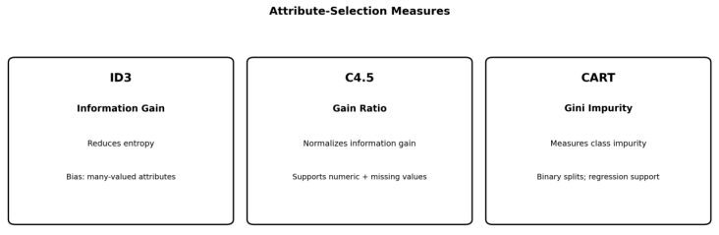
Fig. 6. Visual comparison of the three principal attribute-selection criteria and their practical characteristics.
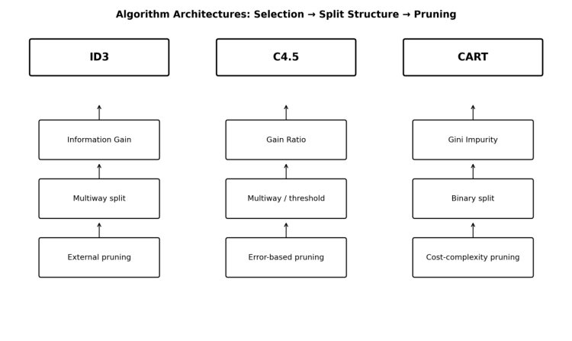
Fig. 3. Comparative architecture of ID3, C4.5 and CART, emphasizing their split criteria, tree structure and pruning strategy.
Information gain directly measures uncertainty reduction and is easy to compute, but it can favor high-cardinality features. Gain ratio normalizes this effect and therefore improves the selection behavior of C4.5 in many settings. Gini impurity is computationally convenient and works naturally with binary CART splits. None of the criteria should be regarded as universally optimal because their behavior depends on the feature distribution and task.

B. Pruning and Interpretability
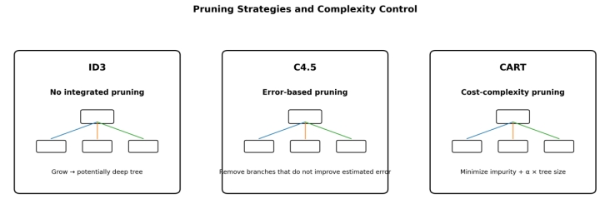
Fig. 7. Conceptual comparison of pruning approaches. The diagrams illustrate the role of pruning in controlling tree complexity.
Pruning controls the tendency of a tree to fit noise. C4.5 uses error-based pruning, while CART uses cost-complexity pruning. ID3 does not define the same integrated pruning mechanism in its original form. For all three methods, depth and leaf count are practical indicators of explanation burden: a tree with similar accuracy but fewer leaves is generally easier to audit.

C. Computational Cost and Scalability
All three methods rely on greedy local decisions rather than globally optimal tree search. Modern CART implementations are efficient for many practical workloads. C4.5 incurs additional processing for continuous values, missing values and gain-ratio evaluation. Actual runtime depends on implementation, feature cardinality, sample size and stopping/pruning rules.

D. Classification Performance
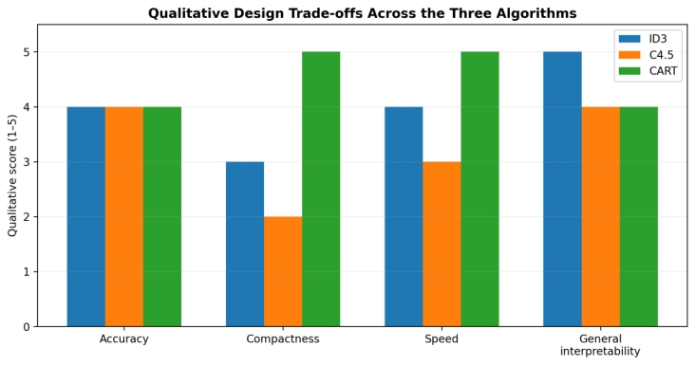
Fig. 8. Conceptual qualitative trade-off map. Scores are explanatory, not additional experimental measurements; quantitative claims are reported separately in Section 7.
Aaboub et al. (2023) reported average accuracies of 84.74% for ID3, 82.93% for C4.5 and 84.01% for CART across twelve UCI datasets. Their reported average depth was 9.75, 46.53 and 9.06, respectively, while average leaf counts were 5.38, 29.86 and 5.04. The results show that the method with the highest average accuracy is not necessarily the method with the most compact or fastest model.

4. Critical Analysis

A. Strengths

ID3 is a clear baseline for information-theoretic induction; C4.5 provides a broader and more practical extension; and CART combines binary splitting, regression support and efficient implementations. All three produce explicit decision paths and therefore have strong interpretability compared with many black-box models.

B. Limitations

• Greedy splitting does not guarantee a globally optimal tree.
• Feature cardinality can influence split criteria.
• Single trees can change substantially under small changes in training data.
• Pruning strength can create an underfitting–overfitting trade-off.
• Accuracy alone can hide poor minority-class performance.
• Deep trees reduce the practical value of interpretability.

C. Critical Synthesis
The literature suggests that decision-tree quality is inherently multi-objective. Accuracy, depth, leaf count, runtime and stability can rank algorithms differently. Consequently, choosing a tree learner solely because it has the highest accuracy on one benchmark is not a reliable general strategy.

5. Research Gap and Proposed Research Direction

A. Research Gap
Three gaps are especially relevant. First, classic learners generally use a fixed split criterion even though recent evidence indicates that impurity behavior can depend on feature distributions. Second, split selection and pruning are often optimized separately, despite both controlling final tree complexity. Third, comparative studies frequently emphasize accuracy more than stability and explanation cost. These gaps motivate a data-adaptive approach.

B. Proposed Adaptive Split-and-Prune Decision Tree
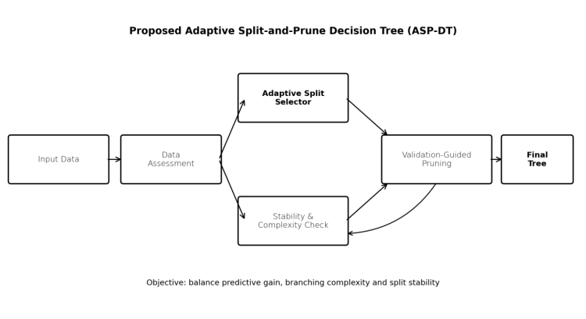
Fig. 4. Proposed ASP-DT architecture combining adaptive split selection, stability/complexity assessment and validation-guided pruning.
The proposed approach, termed Adaptive Split-and-Prune Decision Tree (ASP-DT), would evaluate candidate splits using predictive separation together with penalties for unnecessary branching and instability. The framework would first estimate feature cardinality, class imbalance, sample size and split stability; it would then select a criterion or weighted combination of information gain, gain ratio and Gini reduction. A validation-guided pruning stage would subsequently remove subtrees whose predictive contribution does not justify their complexity.
Score(split) = PredictiveGain − λ₁·BranchPenalty − λ₂·InstabilityPenalty
The proposed contribution is therefore not a new standalone tree family but an adaptive decision mechanism that makes the classic criteria context-sensitive. The expected benefit is competitive accuracy with smaller and more stable explanations.

6. Methodology

A. Review Method
The review was organized around five dimensions: split selection, pruning, interpretability, computational cost and classification performance. Foundational sources established the algorithms; recent comparative studies supplied empirical evidence; the synthesis was then used to identify a research gap and formulate ASP-DT.

B. Experimental Design
A small validation experiment was conducted on the Iris dataset (150 observations, four features and three classes). Five stratified folds were used. Because original ID3 is categorical, quartile discretization was fitted on each training fold and then applied to the corresponding validation and test portions. ID3 and C4.5 were evaluated with categorical split criteria; CART used binary Gini splitting on the same representation. A validation subset was used for reduced-error post-pruning of the custom ID3 and C4.5 implementations.

C. Evaluation Measures
Measure | Purpose
Accuracy | Predictive performance
Tree depth | Interpretation and complexity
Leaf count | Model size
Training time | Computational cost
Before/after pruning | Effect of complexity control
Visual Interpretation of the Model Design

7. Results

A. Literature-Based Results
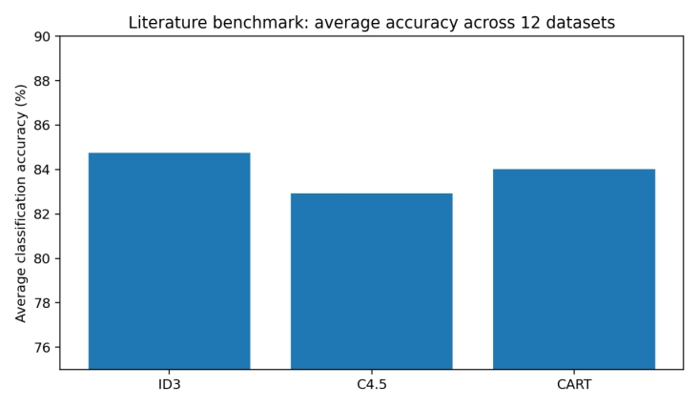
Fig. 1. Average classification accuracy reported in the multi-dataset comparison of Aaboub et al. (2023).

B. Controlled Experimental Results
Algorithm | Mean test accuracy | Post-pruning accuracy | Pre-depth | Post-depth | Post-leaves | Mean fit time (s)
ID3 | 94.67% | 95.33% | 3.6 | 2.6 | 9.0 | 0.0086
C4.5 | 94.67% | 94.67% | 3.8 | 2.8 | 8.8 | 0.0064
CART | 92.67% | — | 8.2 | 8.2 | 12.2 | 0.0014
Table 1. Five-fold Iris experiment. Post-pruning was applied only to the custom ID3 and C4.5 implementations.
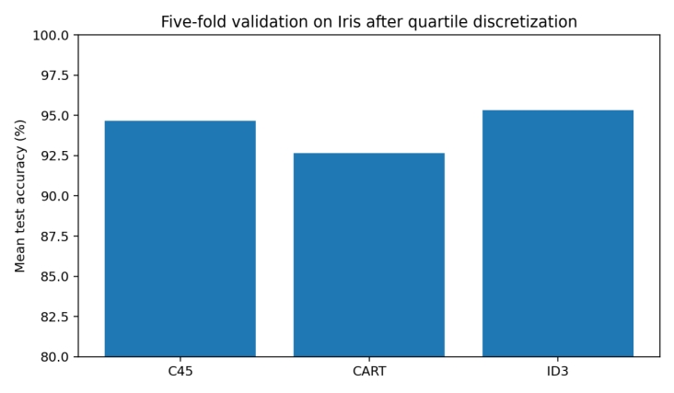
Fig. 2. Mean test accuracy in the controlled experiment.
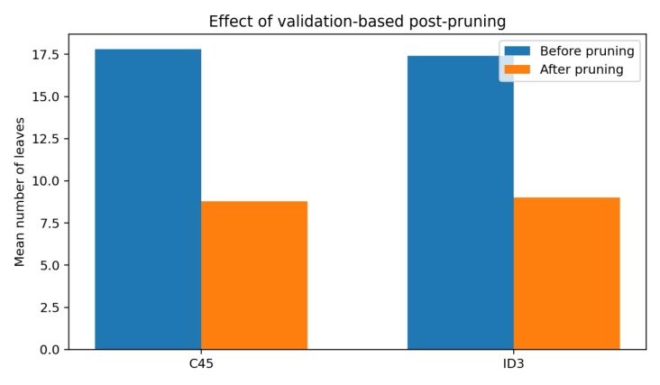
Fig. 3. Effect of validation-based post-pruning on tree size.

8. Discussion
The literature and experiment point to the same general conclusion: decision-tree evaluation should not be reduced to accuracy. In the literature benchmark, ID3 had the highest average accuracy, whereas CART was more compact and faster. In the controlled experiment, ID3 and C4.5 achieved the same pre-pruning accuracy, but validation-based pruning improved ID3 slightly while reducing its depth and leaf count. CART trained fastest in the local experiment but produced lower accuracy on the discretized representation.
These findings support the proposed ASP-DT direction. A criterion that performs well under one feature distribution may not be optimal under another, and pruning can reduce explanation complexity without necessarily harming predictive performance. However, the Iris experiment is small and the discretization changes the original continuous problem. Therefore, the findings should be interpreted as evidence supporting the research direction rather than as proof of universal superiority.

A. Limitations of the Study
• The experimental validation uses only one small dataset.
• The categorical discretization required for ID3 may affect the comparison.
• Local training times are implementation- and hardware-dependent.
• The proposed ASP-DT framework is a research direction, not a fully validated new algorithm.

9. Conclusion
This research review compared ID3, C4.5 and CART across split selection, pruning, interpretability, computational cost and classification performance. ID3 is simple and transparent but vulnerable to many-valued-attribute bias. C4.5 extends ID3 with gain ratio, numeric and missing-value handling and pruning. CART uses binary Gini-based splitting, supports regression and is computationally efficient.
Recent comparative evidence and the controlled experiment show that no single algorithm is best on every criterion. The principal research gap is the limited use of adaptive, multi-objective split and pruning decisions. The proposed ASP-DT framework addresses this gap by combining predictive gain with penalties for branching and instability, followed by validation-guided pruning. Future research should evaluate the approach on larger, noisy, imbalanced and mixed-type datasets using accuracy, macro-F1, depth, leaf count, runtime and stability.

References
[1] J. R. Quinlan, “Induction of decision trees,” Machine Learning, vol. 1, pp. 81–106, 1986, doi: 10.1007/BF00116251.
[2] J. R. Quinlan, C4.5: Programs for Machine Learning. San Mateo, CA, USA: Morgan Kaufmann, 1993.
[3] L. Breiman, J. H. Friedman, R. A. Olshen, and C. J. Stone, Classification and Regression Trees. Belmont, CA, USA: Wadsworth, 1984.
[4] B. Hssina, A. Merbouha, H. Ezzikouri, and M. Erritali, “A comparative study of decision tree ID3 and C4.5,” International Journal of Advanced Computer Science and Applications, 2014.
[5] F. Aaboub, H. Chamlal, and T. Ouaderhman, “Statistical analysis of various splitting criteria for decision trees,” Journal of Algorithms & Computational Technology, vol. 17, 2023, doi: 10.1177/17483026231198181.
[6] K. Gajowniczek and M. Dudziński, “Influence of explanatory variable distributions on the behavior of the impurity measures used in classification tree learning,” Entropy, vol. 26, no. 12, 2024, Art. no. 1020, doi: 10.3390/e26121020.
[7] UCI Machine Learning Repository, “Iris dataset,” University of California, Irvine. [Online]. Available: https://archive.ics.uci.edu/dataset/53/iris
[8] scikit-learn Developers, “Decision Trees,” scikit-learn documentation. [Online]. Available: https://scikit-learn.org/stable/modules/tree.html

Evaluation Rubrics:

Criterion | Weightage  (%) | Excellent | Good | Average | Poor
1. Research  Problem  Identification and  Understanding | 10% | 9–10% – Clearly identifies the research problem, objectives, scope, and relevance to AI learning approaches. | 7–8% – Research problem and objectives are clearly identified with minor omissions. | 5–6% – Basic understanding of the research problem with some gaps. | 0–4% – Problem  is unclear, inappropriate, or poorly understood.
2. Literature  Search and  Source Selection | 10% | 9–10% – Uses diverse, highly relevant, recent, and credible research papers, journals, conferences, and technical sources. | 7–8% – Uses relevant and credible sources with minor limitations. | 5–6% – Uses a limited number of relevant sources. | 0–4% – Sources are insufficient, unreliable, or largely irrelevant.
3. Literature  Review and  Synthesis | 15% | 13–15% – Provides a comprehensive review and synthesizes findings across multiple studies rather than merely summarizing them. | 10–12% – Good review with meaningful comparison of major studies. | 7–9% – Basic review with limited synthesis and comparison. | 0–6% –  Superficial review with  little  understanding of existing research.

4. Analysis of AI  Techniques /  Methods | 15% | 13–15% – Provides technically accurate and in-depth analysis of relevant methods such as decision trees, statistical learning, neural networks, kernel methods, or reinforcement learning. | 10–12% – Provides good technical analysis with minor gaps. | 7–9% –  Provides basic technical description with limited analysis. | 0–6% – Methods are poorly understood or inaccurately described.
5. Comparative  Analysis of  Research  Approaches | 10% | 9–10% –  Critically compares approaches based on accuracy, complexity, interpretability, scalability, computational cost, and application suitability. | 7–8% – Provides meaningful comparison using several parameters. | 5–6% – Basic comparison with limited criteria. | 0–4% – Little or no meaningful comparison.
6. Critical  Evaluation of  Research  Findings | 10% | 9–10% –  Critically evaluates strengths, weaknesses, assumptions, experimental methods, and findings of existing studies. | 7–8% –  Provides good  critical evaluation with minor gaps. | 5–6% – Some  critical observations are provided but analysis is limited. | 0–4% – Mostly descriptive with little critical evaluation.
7. Identification of Research Gaps | 10% | 9–10% – Clearly identifies significant research gaps, limitations, unresolved issues, and opportunities for further investigation. | 7–8% –  Identifies relevant research gaps with reasonable justification. | 5–6% –  Identifies basic gaps but provides limited justification. | 0–4% – Research gaps are missing or incorrectly identified.
8. Research  Insights and  Recommendation  s | 5% | 5% – Provides insightful conclusions and technically feasible recommendations for future research or applications. | 4% – Provides relevant conclusions and recommendatio ns. | 2–3% – Basic conclusions with limited recommendatio ns. | 0–1% –  Conclusions or recommendation  s are absent or inappropriate.
9. Technical Report and Referencing | 10% | 9–10% – Report is well structured, technically accurate, professionally written, and uses a consistent citation/reference style. | 7–8% –  Well-structured report with minor writing or referencing issues. | 5–6% –  Adequate report but contains several structural or referencing issues. | 0–4% – Poorly structured, inadequately referenced, or incomplete report.
10. Originality,  Academic Integrity and Use of Sources | 5% | 5% –  Demonstrates  original synthesis, proper citation, and strong academic integrity with no inappropriate copying. | 4% – Good  originality and proper citation with minor issues. | 2–3% – Some  original analysis but significant  dependence on sources. | 0–1% – Evidence of substantial copying, poor citation, or academic-integrity concerns.

