SIMATS ENGINEERING
ASSESSMENT TOOL 2: Logic Reasoning & Mapping Exercise
COURSE NAME: ARTIFICIAL INTELLIGENCE COURSE CODE: MLA01
AND EXPERT SYSTEMS

COURSE OUTCOME COVERED
CO3: Implement propositional and first-order logic using resolution, unification, and inference techniques for knowledge representation and reasoning.(BTL 3)
Assessment Tool Weightage: 15%

Total Marks: 100 Time: 60 Mins
No. of Questions: 5
Annexure A
Logic Reasoning & Mapping Exercise

Code of Conduct:

I __A.Akhil(192525283)__________________ (Name / Reg No) certify that this submission is my original work and that I have adhered to the guidelines specified for this assessment. I understand that any violation of academic integrity rules will result in disciplinary action.
Signature of the student:

Criterion | Weightag e | Marks Obtained
1. Problem Analysis and Knowledge Identification | 15%
2. Logical Representation and Mapping | 20%
3. Predicates, Variables, Constants and Quantifiers | 15%
4. Logical Connectives and Formula Construction | 10%
5. Inference and Logical Reasoning | 15%
6. Unification and Substitution | 10%
7. Resolution and Proof Construction | 10%
8. Mapping Diagram / Clarity and Presentation | 5%
Total | 100%

ANSWER ANY ONE OF THE FOLLOWING

Q.No | Use Case Scenario
1 | Smart Healthcare  Diagnosis |  | A hospital uses an AI system to identify possible diseases from patient symptoms. Ravi has fever, cough, and body pain. Patients with fever and cough may have flu. Patients with flu and body pain may have viral infection. Patients with viral infection require medical attention.  Tasks:  - Identify facts, entities, predicates, variables, and constants.  - Represent the knowledge using Propositional Logic.  - Represent the knowledge using FOL with suitable quantifiers.  - Perform unification for two relevant predicates.  - Apply resolution to prove whether Ravi has a viral infection.  - Show the complete inference sequence and final conclusion.
2 | Student  Advising | Academic | A university AI system recommends academic support based on attendance and examination performance. Priya has attendance below 75% and has failed two courses. Students with low attendance require attendance counseling. Students who fail two or more courses require academic counseling. Students requiring both types of counseling need academic support.  Tasks:  - Identify the knowledge components.  - Convert the statements into Propositional Logic.  - Develop FOL representations using predicates and quantifiers.  - Identify suitable substitutions and perform unification.  - Use resolution to prove whether Priya requires academic support.  - Explain the reasoning steps leading to the conclusion.
3 | Intelligent Loan  Approval |  | A bank wants to use an AI knowledge-based system for preliminary loan approval. Arun has stable employment, sufficient income, a high credit score, and good repayment history. Customers with stable employment and sufficient income qualify for preliminary approval. Customers with a high credit score and preliminary approval are classified as low-risk. Low-risk customers with good repayment history can be recommended for loan approval.  Tasks:  - Identify entities, facts, predicates, and rules.  - Map the scenario into Propositional Logic.  - Represent the rules using FOL.
- Demonstrate unification and substitution.
- Use resolution to prove or disprove LoanApproved(Arun).
- Provide the final inference with justification.

4 | Vehicle Fault  Diagnosis |  | An automobile service center uses an expert system to diagnose vehicle faults. Car101 does not start and its headlights are dim. Vehicles that do not start and have dim headlights may have a battery problem. Vehicles with a battery problem require battery inspection. Vehicles requiring battery inspection are marked for service.  Tasks:  (i) Extract the facts and rules from the scenario. (ii) Represent them using Propositional Logic.  - Develop suitable FOL predicates and rules.  - Perform unification for the vehicle-related predicates.  - Apply resolution to determine whether Car101 has a battery problem. (vi) Derive whether Car101 should be marked for service and explain the inference.
5 | Cybersecurity  Threat Detection |  | An organization uses an AI system to identify cyber threats. User101 has five failed login attempts and logged in from an unusual location. Multiple failed login attempts indicate a possible brute-force attack. A brute-force attack combined with an unusual login location indicates suspicious activity. Suspicious activity combined with unauthorized access to confidential files indicates a possible security breach.  Tasks:  - Identify the facts, entities, predicates, and rules.  - Map the knowledge into Propositional Logic.  - Represent the rules using FOL.  - Demonstrate unification and substitution.  - Apply resolution to determine whether User101 is involved in a possible security breach.  - Present the complete reasoning chain and final inference.

1. Problem Understanding & Knowledge Identification
Smart Healthcare Diagnosis knowledge base

1.1 Scenario Interpretation
A hospital uses an AI system to identify possible diseases from patient symptoms. Ravi has fever, cough, and body pain. The supplied rules state that patients with fever and cough may have flu; patients with flu and body pain may have a viral infection; and patients with viral infection require medical attention.

1.2 Knowledge Components
Component | Representation | Role in reasoning
Entity | Ravi | The patient being evaluated by the knowledge-based system.
Constant | Ravi | A specific named individual in the knowledge base.
Variable | x | Represents an arbitrary patient in general rules.
Predicates | Fever(x), Cough(x), BodyPain(x) | Symptom conditions used as antecedents.
Derived predicates | Flu(x), ViralInfection(x), RequiresMedicalAttention(x) | Conclusions produced by the rule base.
Facts | Fever(Ravi), Cough(Ravi), BodyPain(Ravi) | Ground facts supplied directly by the scenario.
Rules | R1, R2, R3 | Relationships connecting symptoms to derived conclusions.
Primary query | ViralInfection(Ravi) | Question explicitly required for the resolution proof.
Secondary consequence | RequiresMedicalAttention(Ravi) | Follows from the third rule after viral infection is derived.

1.3 Assumptions and Scope
- The rules supplied in the exercise are treated as logical implications within the knowledge base.
- The phrase “may have” is represented as an inference rule for this exercise; no probabilistic confidence value is modeled.
- Ravi is represented by the constant Ravi, while x is a universally quantified variable over patients.
- The conclusion is a logical consequence of the stated knowledge base; it is not a real-world clinical diagnosis.
Reasoning objective
Determine whether ViralInfection(Ravi) is entailed by the given facts and rules, and then determine whether RequiresMedicalAttention(Ravi) follows.

2. Logical Notation & Propositional Representation
Ground representation for the specific patient Ravi

2.1 Logical Connectives Used
Symbol | Meaning | Interpretation
¬ | NOT | Negation of a proposition
∧ | AND | Both conditions must hold
∨ | OR | At least one condition holds
→ | Implication | If antecedent is true, consequent follows
IFF | Biconditional | Both directions are logically equivalent; included here as notation, although not needed by the three rules

2.2 Proposition Mapping
Proposition | Predicate form | Meaning
P | Fever(Ravi) | Ravi has fever.
Q | Cough(Ravi) | Ravi has cough.
R | BodyPain(Ravi) | Ravi has body pain.
S | Flu(Ravi) | Ravi has flu.
T | ViralInfection(Ravi) | Ravi has a viral infection.
U | RequiresMedicalAttention(Ravi) | Ravi requires medical attention.

2.3 Propositional Knowledge Base
Given facts: P, Q, R
Rule R1: (P ∧ Q) → S
Rule R2: (S ∧ R) → T
Rule R3: T → U

2.4 Propositional Inference
From P and Q, Rule R1 yields S. Once S is known, S and R satisfy Rule R2, yielding T. Finally, T satisfies Rule R3, yielding U.
Compact propositional chain
P ∧ Q → S; S ∧ R → T; T → U.
Therefore, from the initial facts P, Q, R, the system derives S, then T, then U.

2.5 Interpretation
The propositional model is concise and appropriate for one fixed patient. Its limitation is that each proposition already refers to Ravi, so it does not express the general “for every patient” structure captured naturally by First-Order Logic.

3. First-Order Logic Representation
General rules over patients using predicates and quantifiers

3.1 Predicates and Argument Structure
Unary predicates are sufficient because each fact describes one patient at a time. The variable x ranges over patients in the domain of discourse.
Predicate | Intended meaning
Fever(x) | x has fever
Cough(x) | x has cough
BodyPain(x) | x has body pain
Flu(x) | x has flu
ViralInfection(x) | x has a viral infection
RequiresMedicalAttention(x) | x requires medical attention

3.2 Universally Quantified Rules
R1: ∀x [(Fever(x) ∧ Cough(x)) → Flu(x)]
R2: ∀x [(Flu(x) ∧ BodyPain(x)) → ViralInfection(x)]
R3: ∀x [ViralInfection(x) → RequiresMedicalAttention(x)]

3.3 Ground Facts
Fever(Ravi)
Cough(Ravi)
BodyPain(Ravi)

3.4 Query and Consequence
Primary query: ViralInfection(Ravi)
Further consequence: RequiresMedicalAttention(Ravi)
Why the universal quantifier matters
The rules are not specific only to Ravi. The quantifier ∀x states that the same logical pattern applies to any patient for whom the antecedent conditions are satisfied.

3.5 FOL to Ground Instance
Substituting x = Ravi in R1 produces (Fever(Ravi) ∧ Cough(Ravi)) → Flu(Ravi). Substituting x = Ravi in R2 produces (Flu(Ravi) ∧ BodyPain(Ravi)) → ViralInfection(Ravi). This grounding step prepares the rules for concrete inference.

4. Unification & Substitution
Matching general rule variables with the constant Ravi

4.1 Unification 1 — Rule R1
Rule antecedent: Fever(x) ∧ Cough(x)
Known facts: Fever(Ravi) and Cough(Ravi)
The matching substitution is θ₁ = {x / Ravi}.
Applying θ₁ to R1 gives: (Fever(Ravi) ∧ Cough(Ravi)) → Flu(Ravi). Because both antecedent facts are known, Flu(Ravi) is derived.

4.2 Unification 2 — Rule R2
Rule antecedent: Flu(x)
Derived fact: Flu(Ravi)
The matching substitution is θ₂ = {x / Ravi}.
Applying θ₂ to R2 gives: (Flu(Ravi) ∧ BodyPain(Ravi)) → ViralInfection(Ravi). Since BodyPain(Ravi) is already known, ViralInfection(Ravi) is derived.

4.3 Most General Unifiers
Unifier | Substitution | Matched expressions | Result
θ₁ | {x / Ravi} | Fever(x), Cough(x) matches Fever(Ravi), Cough(Ravi) | Flu(Ravi)
θ₂ | {x / Ravi} | Flu(x) matches Flu(Ravi) | ViralInfection(Ravi)

4.4 Why the Substitution is General
The substitution changes only the variable x into the constant Ravi. No unnecessary assumptions about other patients are introduced. The same rule templates could later be applied to different constants by changing the substitution.
Unification checkpoint
Unification succeeds because the predicate names and argument structures match, and the same variable x can consistently be replaced by Ravi.

5. Conversion to Clause Form (CNF)
Preparing the knowledge base for resolution

5.1 General Transformation
Resolution operates on clauses. The implication form A → B is therefore rewritten as ¬A ∨ B. For conjunctions in the antecedent, each conjunct is negated inside the resulting clause.

5.2 Ground Clauses for the Query ViralInfection(Ravi)
Clause | Source form | CNF clause
C1 | (Fever(Ravi) ∧ Cough(Ravi)) → Flu(Ravi) | ¬Fever(Ravi) ∨ ¬Cough(Ravi) ∨ Flu(Ravi)
C2 | (Flu(Ravi) ∧ BodyPain(Ravi)) → ViralInfection(Ravi) | ¬Flu(Ravi) ∨ ¬BodyPain(Ravi) ∨ ViralInfection(Ravi)
C3 | Fact | Fever(Ravi)
C4 | Fact | Cough(Ravi)
C5 | Fact | BodyPain(Ravi)

5.3 Negating the Goal
To prove ViralInfection(Ravi) by refutation, add the negation of the goal:
Negated goal
C6: ¬ViralInfection(Ravi)

5.4 Refutation Principle
If the knowledge base together with the negated goal leads to a contradiction, the original goal is entailed. The contradiction is represented by the empty clause, written NIL or □.

5.5 Resolution-ready Set
{C1, C2, C3, C4, C5, C6} is the clause set used in the proof. The next section resolves complementary literals until NIL is obtained.

6. Resolution Proof — Viral Infection
Proof by refutation using complementary literals

6.1 Resolution Sequence
Step | Clauses | Complementary literal | Result
R1 | C1 + C3 | Resolve Fever(Ravi) | C7: ¬Cough(Ravi) ∨ Flu(Ravi)
R2 | C7 + C4 | Resolve Cough(Ravi) | C8: Flu(Ravi)
R3 | C2 + C8 | Resolve Flu(Ravi) | C9: ¬BodyPain(Ravi) ∨ ViralInfection(Ravi)
R4 | C9 + C5 | Resolve BodyPain(Ravi) | C10: ViralInfection(Ravi)
R5 | C10 + C6 | Resolve ViralInfection(Ravi) with its negation | NIL (empty clause)

6.2 Detailed Derivation
1. C1 and C3 resolve on Fever(Ravi), leaving C7: ¬Cough(Ravi) ∨ Flu(Ravi).
2. C7 and C4 resolve on Cough(Ravi), producing C8: Flu(Ravi).
3. C2 and C8 resolve on Flu(Ravi), producing C9: ¬BodyPain(Ravi) ∨ ViralInfection(Ravi).
4. C9 and C5 resolve on BodyPain(Ravi), producing C10: ViralInfection(Ravi).
5. C10 and C6 contain complementary literals ViralInfection(Ravi) and ¬ViralInfection(Ravi), so resolution yields NIL.
Resolution conclusion
Because the set {Knowledge Base, ¬ViralInfection(Ravi)} is inconsistent, ViralInfection(Ravi) is logically entailed by the knowledge base.

6.3 Why NIL Matters
NIL represents an impossible clause containing no remaining literals. Its derivation shows that the negated goal cannot coexist with the original facts and rules. This is the formal contradiction required by proof by refutation.

7. Resolution Tree & Extension to Medical Attention
Visual proof structure and proof of the secondary consequence
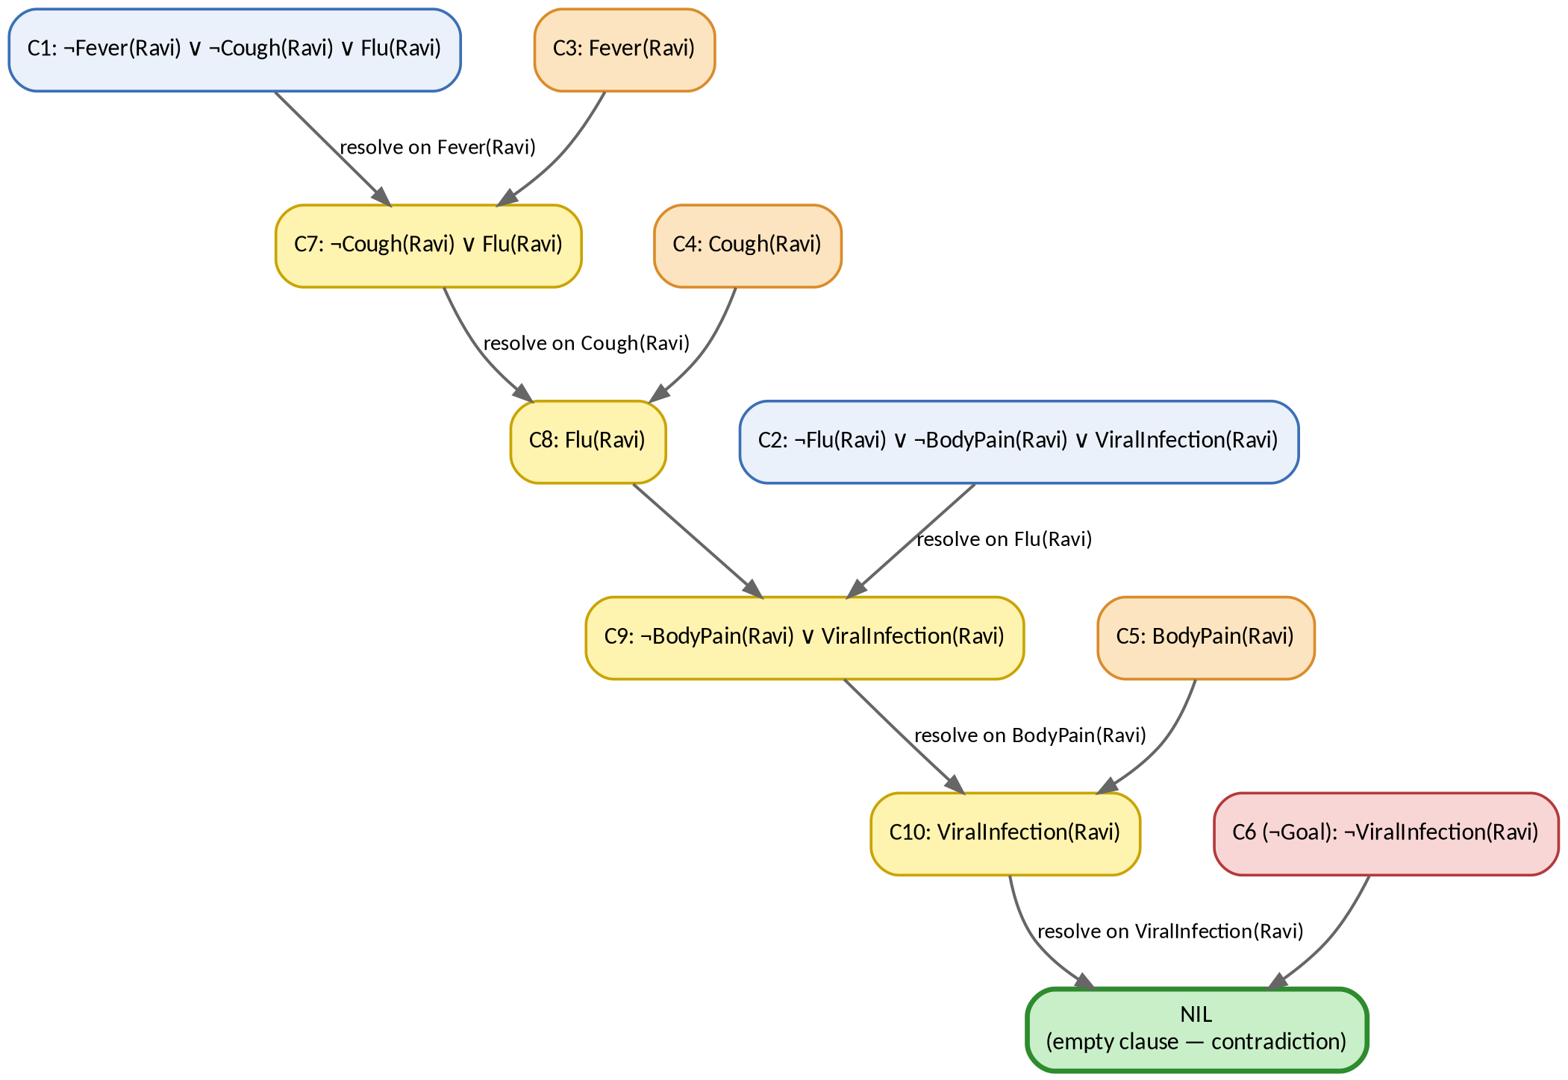
Fig. 1 — Resolution refutation tree for ViralInfection(Ravi)

7.1 Reading the Resolution Tree
The upper branches begin with the rule clause and its corresponding fact. Each downward connection represents a resolution step. The tree converges on C10: ViralInfection(Ravi), which then resolves with the negated goal C6 to produce NIL.

7.2 Additional Resolution Step — Medical Attention
The third rule can be written in clause form as ¬ViralInfection(Ravi) ∨ RequiresMedicalAttention(Ravi). After ViralInfection(Ravi) is derived, resolving these complementary literals yields RequiresMedicalAttention(Ravi). Thus the secondary consequence follows by the same resolution principle.

8. Forward Chaining & Complete Inference Sequence
Data-driven inference from the initial symptom facts

8.1 Forward-Chaining Principle
Forward chaining begins with known facts and repeatedly applies rules whose antecedents are satisfied. Each newly derived fact is added to the working knowledge base and can trigger another rule.
Step | Rule / substitution | Satisfied antecedent and application | Result
1 | Initial facts | Fever(Ravi), Cough(Ravi), BodyPain(Ravi) | Known before inference
2 | R1 + θ₁ = {x/Ravi} | Fever(Ravi) ∧ Cough(Ravi) → Flu(Ravi) | Flu(Ravi) [new fact]
3 | R2 + θ₂ = {x/Ravi} | Flu(Ravi) ∧ BodyPain(Ravi) → ViralInfection(Ravi) | ViralInfection(Ravi) [new fact]
4 | R3 + {x/Ravi} | ViralInfection(Ravi) → RequiresMedicalAttention(Ravi) | RequiresMedicalAttention(Ravi) [new fact]

8.2 Modus Ponens View
Rule R1: If Fever(Ravi) and Cough(Ravi), then Flu(Ravi). Since both antecedents are true, Flu(Ravi) follows.
Rule R2: If Flu(Ravi) and BodyPain(Ravi), then ViralInfection(Ravi). Since both are now true, ViralInfection(Ravi) follows.
Rule R3: If ViralInfection(Ravi), then RequiresMedicalAttention(Ravi). Since viral infection has been derived, medical attention follows.
Cross-check with resolution
Forward chaining derives the conclusions constructively, while resolution proves the primary query by contradiction. Agreement between the two methods strengthens the logical verification of the final result.

8.3 Derived Knowledge Set
After saturation of the rule chain, the relevant derived facts are: Flu(Ravi), ViralInfection(Ravi), and RequiresMedicalAttention(Ravi).

9. End-to-End Knowledge Mapping
From patient symptoms to the final logical consequence
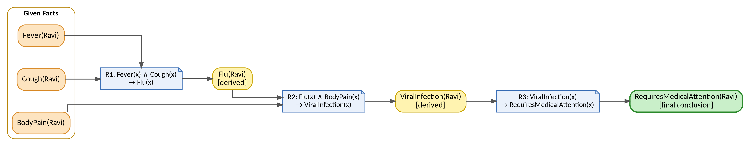
Fig. 3 — End-to-end knowledge mapping and forward-chaining inference flow

9.1 Interpretation of the Mapping
The mapping diagram traces the information flow from the three given symptom facts. Fever(Ravi) and Cough(Ravi) activate R1, producing Flu(Ravi). Flu(Ravi) together with BodyPain(Ravi) activates R2, producing ViralInfection(Ravi). R3 then maps ViralInfection(Ravi) to RequiresMedicalAttention(Ravi).

9.2 Color Legend
Visual category | Meaning | Use in the diagram
Orange | Input facts | Facts directly supplied in the scenario.
Yellow | Intermediate derived fact | A conclusion that becomes available for the next rule.
Green | Final conclusion | The terminal inference in the chain.

9.3 Knowledge Flow Summary
Fever(Ravi) + Cough(Ravi) → Flu(Ravi) → with BodyPain(Ravi) → ViralInfection(Ravi) → RequiresMedicalAttention(Ravi).
Core reasoning chain
Observed symptoms are represented as facts; rules transform those facts into progressively more specific conclusions. The resulting chain is monotonic: previously established facts remain available for later inference.

EVALUATION RUBRICS:

Criterion |  | Weightage  (%) | Excellent | Good | Average | Poor
Problem  Understanding  & Knowledge  Identification |  | 15% | 13–15% –  Clearly identifies entities, facts, relationships, assumptions, and reasoning requirements from the given scenario. | 10–12% –  Identifies most relevant knowledge with minor omissions. | 7–9% –  Identifies basic knowledge but misses several important elements. | 0–6% – Poor or  incorrect identification of the given knowledge.
Logical  Representation  & Mapping |  | 20% | 17–20% –  Accurately maps real-world statements into appropriate propositional and first-order logic representations. | 13–16% –  Provides mostly correct logical mappings with minor errors. | 9–12% –  Provides partial mappings with several logical errors. | 0–8% – Logical mapping is largely incorrect or missing.
Predicates,  Variables,  Constants  Quantifiers | & | 15% | 13–15% –  Correctly identifies and applies predicates, variables, constants, universal and  existential quantifiers. | 10–12% – Uses the  concepts correctly  with minor errors. | 7–9% –  Demonstrates partial understanding  with some  incorrect usage. | 0–6% – Concepts are incorrectly applied or missing.
Logical  Connectives &  Formula  Construction |  | 10% | 9–10% –  Correctly  applies AND,  OR, NOT,  implication, and equivalence to | 7–8% –  Mostly correct use  of connectives with minor errors. | 5–6% – Basic use of connectives but several errors occur. | 0–4% – Incorrect or incomplete  formula construction.
 |  |  | construct valid logical formulas.
Inference  Logical  Reasoning | & | 15% | 13–15% –  Performs accurate step-by-step reasoning and derives valid conclusions from the given knowledge. | 10–12% –  Reasoning is mostly correct with minor gaps. | 7–9% –  Provides partial reasoning with some incorrect conclusions. | 0–6% –  Reasoning is  incorrect,  unsupported, or missing.
Unification  Substitution | & | 10% | 9–10% –  Correctly identifies substitutions  and Most  General Unifier  (MGU) and applies them accurately. | 7–8% –  Correctly performs most unification  steps with minor errors. | 5–6% –  Demonstrates basic understanding but has several errors. | 0–4% – Unable to perform  unification correctly.
Resolution  Proof  Construction | / | 10% | 9–10% –  Correctly applies resolution and presents a clear, logically valid proof of the query. | 7–8% –  Resolution is mostly correct with minor errors. | 5–6% – Shows  partial understanding  but proof contains gaps. | 0–4% –  Resolution is incorrect or not demonstrated.
Clarity,  Mapping  Diagram  Presentation | & | 5% | 5% – Provides a clear,  well-organized mapping/logic diagram with  accurate  notation and  excellent presentation. | 4% –  Presentation is clear with minor formatting or diagram issues. | 3% – Basic  presentation  with limited clarity. | 0–2% – Poorly  organized,  unclear, or  incomplete presentation.

