SIMATS ENGINEERING
ASSESSMENT TOOL 1: AI Model Design Exercise
COURSE NAME: ARTIFICIAL INTELLIGENCE COURSE CODE: MLA01
AND EXPERT SYSTEMS

COURSE OUTCOME COVERED
CO4: Develop intelligent software agents using suitable agent architectures and learning techniques.(BTL 3)
Assessment Tool Weightage: 40 %

Total Marks: 100 Time: 90 Mins
No. of Questions: 1
Annexure A
AI Model Design Exercise

Code of Conduct:
I ____A.Akhil(192525283)________________ (Name / Reg No) certify that this submission is my original work and that I have adhered to the guidelines specified for this assessment. I understand that any violation of academic integrity rules will result in disciplinary action.
Signature of the student:
Criterion | Weightage | Marks Obtained
1. Problem Analysis and Domain Understanding | 10%
2. Dataset Selection and Data Understanding | 10%
3. Data Preprocessing and Feature Engineering | 10%
4. AI Technique Selection and Justification | 10%
5. Model Design / Architecture | 10%
6. Algorithm / Pseudocode Development | 5%
7. Model Implementation and GitHub Repository | 15%
8. Experimental Design and Results | 10%
9. Performance Evaluation and Metrics | 10%
10. Result Analysis and Interpretation | 5%
11. Limitations and Future Enhancements | 5%
12. Documentation and Technical Presentation | 10%
Total | 100%
Signature of the Faculty Total Marks Awarded

ANSWER ANY ONE QUESTION

S.No. | Scenario / Problem Statement | AI Model /  Technique to be  Developed | Expected Development Outcome
1 | Smart Loan Approval:  A bank wants to automatically determine whether a customer is eligible for a loan using income, credit score, employment status, loan amount, and repayment history. | Decision Tree | Design and implement a  decision-tree-based AI model and determine the most suitable attribute-selection measure such as Information Gain, Gain Ratio, or Gini Index.
2 | Student Performance  Prediction:  A university wants to predict whether a student is likely to pass or fail a course using attendance, internal marks, assignment performance, study hours, and previous academic performance. | Inductive  Learning | Construct a predictive model from training examples and derive generalized decision rules from the learned patterns.
3 | Disease Risk Prediction:  A healthcare system needs to classify patients into low-risk and high-risk categories based on clinical measurements. | Statistical  Learning | Design a statistical learning model, train it using patient data, and evaluate its generalization ability on unseen data.
4 | Image Recognition System:  An organization wants to automatically classify images into categories such as vehicles, animals, and buildings. | Neural Network | Design and implement a neural-network classifier by specifying the network architecture, activation functions, loss function, optimizer, and training procedure.
5 | Handwritten Character  Recognition:  A system must recognize handwritten characters from scanned images. | Multilayer Neural  Network | Develop a multilayer neural network and demonstrate how backpropagation updates weights to minimize classification error.
6 | Non-Linear Classification:  A dataset contains two classes that cannot be separated using a straight-line decision boundary. | SVM with Kernel  Method | Design an SVM-based classifier using an appropriate kernel function and justify the selected kernel based on the characteristics of the dataset.
7 | Intelligent Recommendation Agent:  An online platform wants an agent that learns which recommendations to provide based on user responses. | Reinforcement  Learning | Design an RL model by defining the states, actions, rewards, policy, and learning strategy, and demonstrate how the agent learns from user feedback.
8 | Autonomous Game Agent:  An AI agent must learn to play a game where successful actions receive positive rewards and unsuccessful actions receive penalties. | Reinforcement  Learning | Develop an RL-based game agent and demonstrate how its policy and performance improve through repeated interaction with the environment.
9 | Explainable Diagnosis System:  A medical AI system predicts a disease but must also provide an explanation for its prediction. | Explanation-Base d Learning | Design an explanation-based learning approach using domain knowledge and training examples to generate an understandable justification for the prediction.
10 | AI Model Selection Challenge:  A company provides a dataset for predicting customer churn. | Comparative AI  Model Design | Design and compare at least two learning approaches from decision trees, statistical learning, neural networks, or kernel methods. Select the best model based on accuracy, interpretability, computational requirements, and generalization ability.

Structure of the Report:

S.No. | Report Component | What the Student Should Include
1 | Problem Statement | Clearly describe the real-world problem, input data, expected output, and AI task to be solved.
2 | Objectives | State the specific goals of developing the AI model and expected outcomes.
3 | Dataset Description | Provide dataset source, number of instances, features, target variable, data types, and important attributes.
4 | Data Preprocessing | Explain data cleaning, missing-value handling, encoding, normalization/scaling, feature selection, and train-test splitting.
5 | Selected AI  Technique and  Justification | Identify the selected AI technique and justify its suitability for the problem.
6 | Model Design /  Architecture | Present the model structure, components, input/output, parameters, hyperparameters, and architecture/flow diagram.
7 | Algorithm /  Pseudocode | Provide the algorithmic steps or pseudocode showing model training and prediction/decision-making.
8 | Implementation | Provide programming language, libraries/tools, important code sections, and implementation details.
9 | Experimental  Results | Present results using tables, graphs, sample predictions, learning curves, confusion matrices, or other relevant outputs.
10 | Performance  Evaluation | Evaluate the model using appropriate performance metrics such as accuracy, precision, recall, F1-score, MSE, RMSE, or cumulative reward.
11 | Result Analysis | Interpret results, identify important patterns, compare actual and predicted outcomes, and discuss strengths and weaknesses.
12 | Limitations | Discuss limitations related to dataset, model complexity, computational resources, accuracy, generalization, or deployment.
13 | Future  Enhancements | Suggest improvements such as additional data, feature engineering, hyperparameter tuning, alternative algorithms, or deployment.
14 | Conclusion | Summarize the problem, methodology, major findings, model performance, and overall effectiveness.
15 | References | List datasets, research papers, books, websites, documentation, libraries, and other sources used.
16 | GitHub Repository  Link | Provide the public GitHub repository URL containing the complete source code, dataset information/source, implementation, results, README, and supporting files.

MODEL DESIGN EXERCISE
SMART LOAN APPROVAL
Decision-Tree-Based Loan Eligibility Prediction
1. Problem Statement
A bank wants to automatically determine whether a customer is eligible for a loan. The proposed AI system accepts income, credit score, employment status, requested loan amount, and repayment history as inputs and predicts whether the loan should be approved or rejected. The task is a supervised binary classification problem. The expected output is loan_approved = 1 for approval and 0 for rejection. The assessment specifically requires a decision-tree-based AI model and selection of a suitable attribute-selection measure.

2. Objectives
- Develop a decision-tree classifier for automatic loan approval.
- Prepare and preprocess customer loan data for model training.
- Compare Gini Index and Information Gain (Entropy) as attribute-selection measures.
- Evaluate the model using accuracy, precision, recall, F1-score, and a confusion matrix.
- Identify the most influential attributes and interpret the model decisions.
- Provide reproducible implementation files suitable for a GitHub repository.

3. Dataset Description
For this assignment, a reproducible synthetic dataset was generated specifically for the Smart Loan Approval scenario. This avoids using confidential banking information while preserving the required variables. A fixed random seed (42) is used so that the dataset and results can be reproduced.
Attribute | Type | Description | Role
income | Numerical | Annual customer income | Input
credit_score | Numerical | Creditworthiness score | Input
employment_status | Categorical | Salaried, self-employed, contract or unemployed | Input
loan_amount | Numerical | Requested loan amount | Input
repayment_history | Numerical | Historical repayment ratio (0–1) | Input
loan_approved | Binary | 0 = rejected, 1 = approved | Target
Number of instances: 1500. Approval rate: 56.73%.

4. Data Preprocessing and Feature Engineering
- The dataset was checked for missing values; the generated dataset contains no missing values.
- Numerical variables are retained in numerical form because decision trees do not require feature scaling.
- Employment status is categorical, so One-Hot Encoding is applied to convert it into machine-readable binary features.
- No unnecessary identifier columns are used.
- The data is split into 80% training data and 20% testing data using stratification to preserve the class distribution.
- A fixed random state of 42 is used for reproducibility.

5. Selected AI Technique and Justification
The selected technique is a Decision Tree Classifier. A decision tree is suitable because the problem contains a small number of interpretable customer attributes and requires a clear approval/rejection decision. The learned model can be represented as a sequence of if–then rules, making it easier for a bank to inspect than a highly complex black-box model.
The Gini Index is selected as the primary attribute-selection measure. Gini impurity is computationally simple and is widely used for classification trees. In the experiment, Gini and Information Gain produced the same test accuracy, precision, recall, and F1-score to three decimal places. Therefore, Gini was retained as the simpler primary criterion for the final model.

6. Model Design / Architecture
Model flow:
Customer Data → Preprocessing → One-Hot Encoding → Decision Tree (Gini) → Loan Approval / Rejection
Final hyperparameters:
- Criterion: Gini Index
- Maximum depth: 6
- Minimum samples per leaf: 5
- Random state: 42
- Train/Test split: 80% / 20%
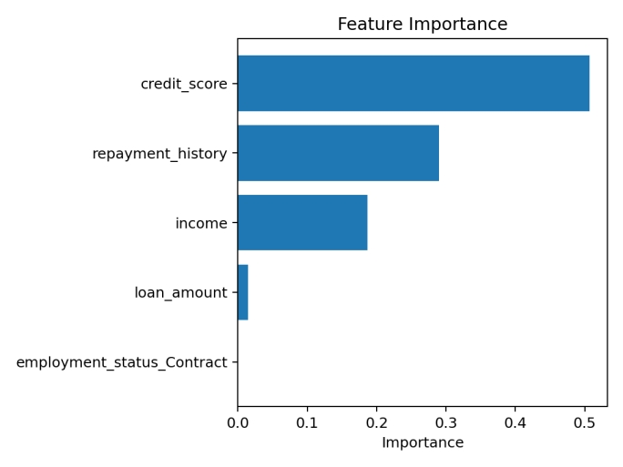
Figure 1. Feature importance of the trained decision tree.

7. Algorithm / Pseudocode
BEGIN
Load loan approval dataset
Separate input features X and target y
Encode employment_status using one-hot encoding
Split data into training (80%) and testing (20%)
Create Decision Tree with Gini Index
Set max_depth = 6 and min_samples_leaf = 5
Train the tree using training data
Predict approval/rejection for test data
Calculate accuracy, precision, recall and F1-score
Generate confusion matrix
Output the prediction and evaluation results
END

8. Implementation
The implementation uses Python with pandas, NumPy, scikit-learn and matplotlib. The complete executable source is included in train_loan_model.py, together with the dataset, requirements file and README in the accompanying project folder.
import pandas as pd
from sklearn.model_selection import train_test_split
from sklearn.tree import DecisionTreeClassifier
from sklearn.compose import ColumnTransformer
from sklearn.preprocessing import OneHotEncoder
from sklearn.pipeline import Pipeline
from sklearn.metrics import accuracy_score, precision_score, recall_score, f1_score, confusion_matrix
df = pd.read_csv("loan_approval_dataset.csv")
X = df.drop(columns="loan_approved")
y = df["loan_approved"]
categorical_features = ["employment_status"]
numeric_features = ["income", "credit_score", "loan_amount", "repayment_history"]
preprocessor = ColumnTransformer([
("cat", OneHotEncoder(handle_unknown="ignore"), categorical_features)
], remainder="passthrough")
model = Pipeline([
("preprocessor", preprocessor),
("tree", DecisionTreeClassifier(
criterion="gini",
max_depth=6,
min_samples_leaf=5,
random_state=42
))
])
X_train, X_test, y_train, y_test = train_test_split(
X, y, test_size=0.20, random_state=42, stratify=y
)
model.fit(X_train, y_train)
pred = model.predict(X_test)
print("Accuracy :", accuracy_score(y_test, pred))
print("Precision:", precision_score(y_test, pred))
print("Recall :", recall_score(y_test, pred))
print("F1-score :", f1_score(y_test, pred))
print("Confusion Matrix:\n", confusion_matrix(y_test, pred))
9. Experimental Results
The model was evaluated on 300 previously unseen test records. The comparison below shows the effect of the attribute-selection measure under the same tree depth, minimum leaf size and train/test split.
Measure | Accuracy | Precision | Recall | F1-score
Gini Index | 0.913 | 0.909 | 0.941 | 0.925
Information Gain (Entropy) | 0.913 | 0.909 | 0.941 | 0.925

Both criteria produced 91.3% accuracy, 90.9% precision, 94.1% recall and 92.5% F1-score on the test set. The final Gini-based tree therefore achieves strong and balanced classification performance for this synthetic scenario.
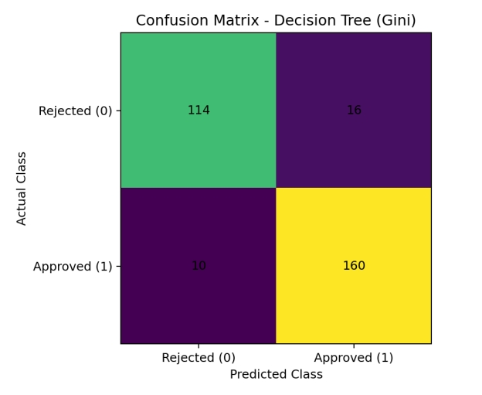
Figure 2. Confusion matrix for the final Gini-based decision tree.

10. Performance Evaluation
Accuracy = 0.913 (91.3%). Precision = 0.909. Recall = 0.941. F1-score = 0.925.
Confusion matrix: True Negatives = 114, False Positives = 16, False Negatives = 10, True Positives = 160.

11. Result Analysis and Interpretation
The model correctly identifies most approved applications, with 160 true positives and 10 false negatives. The recall of 94.1% indicates that the model captures a high proportion of genuinely approvable customers in the synthetic test set. Precision of 90.9% indicates that most applications predicted as approved are actually approved according to the dataset labels.
Credit score is the most influential feature (approximately 50.7% of tree feature importance), followed by repayment history (29.0%) and income (18.7%). Loan amount has a much smaller contribution, while employment status contributes very little in the final tree. This suggests that creditworthiness, repayment behavior and income are the dominant decision factors in the generated dataset.

12. Limitations
- The dataset is synthetic and therefore does not represent the full complexity of real banking data.
- Only five customer attributes are considered; real lending decisions may use many additional variables.
- Decision trees can become unstable or overfit when the tree is allowed to grow excessively.
- The results should not be used for real loan decisions without validation on genuine, representative and legally compliant banking data.
- Fairness and bias analysis is not performed because the dataset does not contain protected demographic attributes.

13. Future Enhancements
- Use a larger real-world or institution-approved dataset.
- Perform hyperparameter tuning using cross-validation.
- Compare the decision tree with Random Forest, Gradient Boosting and other classifiers.
- Add explainability using rule extraction and feature-level explanations.
- Perform fairness, bias and subgroup performance analysis before deployment.
- Deploy the model as a secure API with monitoring for data drift and model performance.

14. Conclusion
A decision-tree-based Smart Loan Approval model was designed and implemented using the attributes specified in the assessment scenario. The preprocessing pipeline encoded the categorical employment feature and preserved the numerical variables without unnecessary scaling. Gini Index was selected as the final attribute-selection measure because it matched Information Gain performance while providing a simple and efficient criterion. The final model achieved 91.3% accuracy and an F1-score of 0.925 on the held-out test set. The experiment demonstrates that a decision tree can provide both predictive performance and interpretable decision logic for a loan-approval classification task.

15. References
- SIMATS Engineering, Assessment Tool 1: AI Model Design Exercise, Artificial Intelligence and Expert Systems (MLA01), Annexure A.
- Scikit-learn documentation: DecisionTreeClassifier.
- Scikit-learn documentation: ColumnTransformer and OneHotEncoder.
- Scikit-learn documentation: classification metrics.
16. GitHub Repository Link:
https://github.com/Akhil-Arthimalla

Evaluation Rubrics:

Criterion | Weightage (%) | Excellent | Good | Average | Poor
1. Problem  Analysis and  Understanding | 10% | 9–10% – Clearly analyzes the real-world problem, objectives, inputs, outputs, constraints, and expected AI outcome. | 7–8% – Understands the problem and objectives with minor omissions. | 5–6% – Shows  partial understanding with some important elements missing. | 0–4% – Problem is poorly understood or incorrectly defined.
2. Dataset  Selection and  Understanding | 10% | 9–10% – Selects a highly relevant dataset and clearly explains features, target, source, size, and characteristics. | 7–8% – Appropriate dataset with adequate description and minor omissions. | 5–6% – Dataset is usable but description or relevance is limited. | 0–4% – Dataset is inappropriate, poorly described, or missing.
3. Data Preprocessing and Feature Engineering | 10% | 9–10% – Performs appropriate cleaning, transformation, encoding, scaling, feature selection, and data splitting with clear justification. | 7–8% – Performs most required preprocessing correctly with minor issues. | 5–6% – Basic preprocessing is performed but important steps are missing. | 0–4% – Preprocessing is inadequate, incorrect, or absent.
4. AI Technique  Selection and  Justification | 10% | 9–10% – Selects the most appropriate AI technique and provides strong technical justification based on the problem and dataset. | 7–8% – Appropriate technique selected with reasonable justification. | 5–6% – Technique is acceptable but justification is limited. | 0–4% – Inappropriate technique or no meaningful justification.
5. Model Design  / Architecture | 10% | 9–10% – Develops a clear, technically sound model architecture with appropriate components, parameters, and workflow. | 7–8% – Model  is well designed with minor omissions. | 5–6% – Basic model design is presented but lacks technical depth. | 0–4% – Model design is unclear, incomplete, or inappropriate.

6. Algorithm /  Pseudocode | 5% | 5% –  Algorithm/pseudocod e is complete, logically correct, structured, and clearly represents the model development process. | 4% – Mostly correct with minor omissions. | 2–3% – Basic algorithm provided but contains gaps. | 0–1% – Algorithm is missing or substantially incorrect.
7.  Implementation and GitHub Repository | 15% | 13–15% – Fully functional implementation with clean, organized, reproducible code and a complete GitHub repository with  README and  supporting files. | 10–12% – Functional implementatio n and well-organized repository with minor issues. | 7–9% – Partially functional implementation or incomplete repository documentation. | 0–6% –  Implementation is incomplete/non-functi onal or GitHub repository is missing.
8. Experimental  Design and  Results | 10% | 9–10% – Conducts meaningful experiments with appropriate test cases and clearly presents results using tables, graphs, or visualizations. | 7–8% – Appropriate experiments with clearly presented results. | 5–6% – Limited experiments or basic result presentation. | 0–4% – Insufficient, incorrect, or missing experimental results.
9. Performance  Evaluation | 10% | 9–10% – Uses appropriate evaluation metrics and provides comprehensive quantitative analysis of model performance. | 7–8% – Uses suitable metrics and provides adequate evaluation. | 5–6% – Basic evaluation with limited metrics or analysis. | 0–4% – Inappropriate metrics or performance evaluation is missing.
10. Result  Analysis and  Interpretation | 5% | 5% – Provides insightful analysis of results, identifies patterns, errors, strengths, weaknesses, and explains model behavior. | 4% – Provides good interpretation with minor gaps. | 2–3% – Basic interpretation with limited analysis. | 0–1% – Results are not meaningfully analyzed.
11. Limitations and Future  Enhancements | 5% | 5% – Clearly  identifies realistic limitations and proposes technically relevant and feasible improvements. | 4% – Identifies relevant limitations and reasonable improvements. | 2–3% – Provides basic limitations and future suggestions. | 0–1% – Missing, unrealistic, or poorly explained.
12.  Documentation and Technical Presentation | 10% | 9–10% – Report is comprehensive, well organized, technically accurate, professionally presented, and properly referenced. | 7–8% – Well documented with minor presentation or referencing issues. | 5–6% – Adequate documentation with several gaps. | 0–4% – Poorly documented, unclear, or incomplete report.
Total | 100%

