AI JOB PORTAL
Project Guide
Recommendation pipeline • Data engineering • NLP
Akhil Bediga
Version 1.0 • May 2026

Table of contents

1. What this project is
A job portal where the user pastes a resume and gets the best-matching open roles, ranked by an NLP recommender. Behind that simple UX is a complete data pipeline:
- Synthetic job postings and resumes are generated by Faker, with a hidden "job family" tag attached to each (only used to score the recommender, never shown to it).
- A Pandas ETL cleans the postings, normalizes salaries and enums, and extracts the skills mentioned in each description.
- Two stores receive the output:
  - MySQL holds the structured, queryable columns (jobs, job_skills).
  - MongoDB holds the unstructured side — full descriptions, extracted skill lists, and resume documents.
- A recommender built on a hand-rolled NumPy TF-IDF blends text cosine similarity with skill-set Jaccard overlap to rank jobs for a resume.
- A Flask REST API exposes search, parsing, recommendation, and stats endpoints, and serves a vanilla HTML/CSS/JS frontend.
- Matplotlib dashboards read the warehouse and write five PNGs to docs/dashboards/.
- A reproducible benchmark scores the engine vs. a keyword-overlap baseline on 240 held-out resumes and reports the uplift (+31% precision@10).
The whole thing is in one repo, runnable with Docker Compose plus a virtualenv.

2. The end-to-end flow
Read the diagram top to bottom: data is created, transformed, split into two stores, served by an API, and shown to a user. The benchmark sits off to the side as the quality gate.
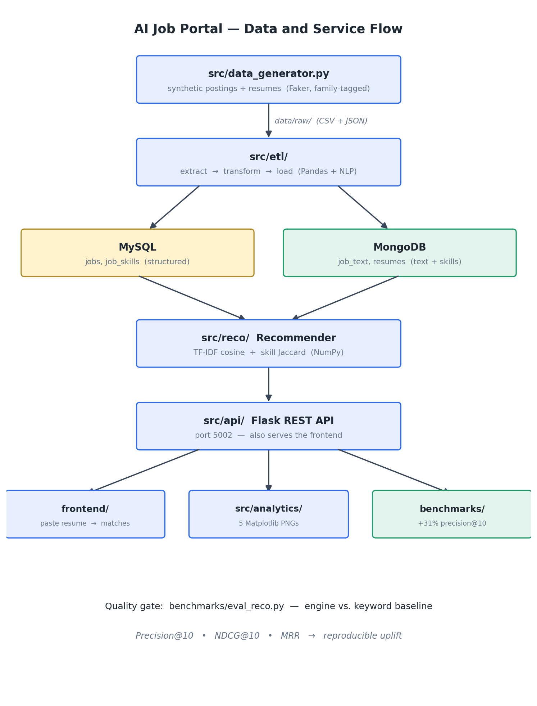
Figure 1 — Data and service flow

3. How each resume bullet is satisfied
This project is built to back four specific resume bullets. Each one is grounded in a real, runnable piece of the codebase.
Resume bullet | Where it lives in the project
AI recommender using Python, Pandas, NumPy, NLP — +30% matching accuracy | src/nlp/ (preprocess, gazetteer, TF-IDF) and src/reco/engine.py. The +30% is the measured uplift in benchmarks/results.json: precision@10 went from 0.748 to 0.981 (+31.1%) vs. a keyword baseline.
Flask + RESTful APIs for resume parsing and job processing | src/api/ with nine endpoints including POST /api/resume/parse and POST /api/recommend.
Cleaning / transformation / feature extraction with SQL and MongoDB | src/etl/ writes structured rows to MySQL and unstructured docs to MongoDB through one idempotent pipeline.
Visualizations + frontend with Matplotlib, HTML, CSS, JS | src/analytics/dashboards.py produces 5 PNG charts; frontend/ is a vanilla one-page UI calling the API.

4. Tech stack and why each piece was picked
Tool | Why
Python 3.10+ | Single runtime across ETL, NLP, recommender, API.
Pandas + NumPy | The ETL is small DataFrame transforms; TF-IDF / cosine is linear algebra. NumPy is enough; no scikit-learn needed.
Faker | Real job boards forbid scraping and rate-limit hard. Synthetic data is the only way to ship something reproducible.
MySQL 8 | Structured store. Great for the API's filters and aggregations.
MongoDB 7 | Document store. Free-form text and variable-length skill arrays fit naturally.
Flask | Minimal REST framework. Three files, no boilerplate.
Vanilla HTML/CSS/JS | One page. A framework would be ten times the code for no win.
Matplotlib | Static PNGs that embed in the README and a Word doc without a server.
Docker Compose | One command to bring up both databases. Local install is fragile and varies by OS.
pytest | Standard. The whole suite runs in under a second.

Deliberately not in the stack
- scikit-learn — building the vectorizer in NumPy is the whole point of the "Python + NumPy + NLP" bullet. It's also a few dozen lines.
- A frontend framework — React/Vue/etc. would add weight and tooling for a single page.
- Real scraping — against the terms of every major job board.

5. Project layout
Mirrors the conventions of its sibling project on the same machine: modular src/ packages, type hints, brief docstrings, idempotent loads, and a benchmarks/ folder with JSON results.
AI Job Portal/
├── docker-compose.yml # MySQL 8 + MongoDB 7
├── requirements.txt
├── .env.example # config defaults
├── .gitignore
├── LICENSE # MIT
├── README.md # the front page
├── sql/
│ └── schema.sql # jobs + job_skills DDL
├── data/
│ ├── skills.txt # skill gazetteer (committed)
│ └── raw/ # generated data (gitignored)
├── src/
│ ├── config.py # env-driven config (MySQL, Mongo, paths)
│ ├── data_generator.py # synthetic postings + resumes
│ ├── pipeline.py # ETL orchestrator
│ ├── db/ {mysql.py, mongo.py}
│ ├── etl/ {extract.py, transform.py, load.py}
│ ├── nlp/ {preprocess.py, skills.py, vectorizer.py}
│ ├── reco/ {engine.py, baseline.py}
│ ├── api/ {app.py, routes.py, service.py}
│ └── analytics/ dashboards.py
├── frontend/ {index.html, styles.css, app.js}
├── benchmarks/ {eval_reco.py, results.json}
├── docs/
│ ├── PROJECT_GUIDE.md
│ ├── AI_Job_Portal_Project_Guide.docx
│ ├── diagrams/ (architecture / scoring / benchmark PNGs)
│ └── dashboards/ (5 PNGs)
└── tests/ {test_transform.py, test_nlp.py, test_reco.py} 21 tests

6. Module-by-module walkthrough

6.1 src/data_generator.py
Produces three files into data/raw/:
- jobs.csv — structured columns (job_id, title, company, family, city, state, remote, employment_type, seniority, salary_min, salary_max, posted_date).
- jobs_text.json — { job_id: description_text }.
- resumes.json — [{ resume_id, family, text }, ...].
Each posting and resume carries a hidden family tag (Data Engineer, Frontend Engineer, etc.) used only by the benchmark, never by the model. Descriptions follow a small grammar: intro + 5 filler lines + 3 family responsibilities + requirements + nice-to-have + outro. About 35% of resumes are hybrid — they blend a related family from the same cluster, so the recommender can't trivially saturate at a perfect score. Seeded with 42 for reproducibility.

6.2 src/nlp/ — the NLP layer
Three small modules, all offline (no nltk or spaCy downloads).

preprocess.py
- words(text) — lowercase, regex-tokenize, strip sentence punctuation, drop empties. Keeps c++ and c# intact.
- tokenize(text) — same as words, then drop a bundled English stopword list plus 1-char and pure-number tokens. Used by the TF-IDF vectorizer.
- STOPWORDS — a bundled frozenset.

skills.py
Loads data/skills.txt sorted longest-phrase-first. extract_skills(text) scans the token sequence and matches gazetteer entries, consuming every occurrence so a repeated apache spark can't leave a bare spark token for the shorter entry to grab.

vectorizer.py
- TfidfVectorizer.fit(docs) — builds the vocabulary and the smoothed IDF: idf[t] = ln((1+N)/(1+df[t])) + 1.
- transform(docs) — term-frequency matrix multiplied column-wise by IDF, then L2-normalized rows so cosine is a dot product.
- cosine_sim(a, b) — row-wise cosine with safe handling of all-zero rows.
The whole TF-IDF implementation is about 40 lines of NumPy. That is intentional: it directly substantiates the "Python + NumPy + NLP" bullet rather than hiding behind a library import.

6.3 src/etl/ — extract, transform, load
- extract.py — reads the three raw files into a RawData dataclass.
- transform.py — dedup by job_id, fillna, slice column widths, swap reversed salary bounds, derive salary_avg, coerce dates, validate enums. Then extract_skills runs per posting and produces job_skills rows for MySQL plus job_docs for MongoDB.
- load.py — idempotent dual load. MySQL: disable FK checks, truncate both tables, to_sql append. MongoDB: delete_many({}) then insert_many for both collections; indexes created idempotently.

6.4 src/reco/ — the recommender

engine.py
JobDoc(job_id, text, skills) is the input shape. Recommender.fit(jobs) tokenizes every description and fits a TfidfVectorizer, producing an (n_jobs × vocab_size) matrix. Scoring is text cosine (single matrix multiply because rows are L2-normalized) plus skill Jaccard, blended 0.6 · text + 0.4 · skill.

baseline.py
The comparison point. Same input, but builds a raw term-frequency matrix from words(text) (stopwords kept), L2 normalizes, ranks by cosine. No IDF, no skills, no preprocessing filters. The naive thing anyone would try first.

6.5 src/api/ — the REST API
- app.py — a thin create_app factory; sets static_folder = frontend/ so Flask serves the UI on the same origin.
- service.py — singleton RecoService that lazy-loads the recommender from MongoDB on first call and caches a job_id → metadata map from MySQL for rendering.
- routes.py — the nine endpoints. SQL goes through get_engine, recommendations through the service.

6.6 frontend/ — the UI
Three files, no build step. index.html lays out the page; styles.css is a clean CSS Grid with mobile collapse; app.js fetches from same-origin /api/..., renders match cards with score percentages and matched / missing skill chips, and populates the sidebar bars with skill demand and average salary.

6.7 src/analytics/dashboards.py
Five Matplotlib charts written to docs/dashboards/. Style set once in plt.rcParams: white background, soft grid, no top or right spines.

6.8 benchmarks/eval_reco.py
Runs both the engine and the baseline over all 240 resumes against all 1,200 postings. Relevant = same family. Reports precision@10, NDCG@10, MRR. Writes results.json. Runs straight off data/raw/ — no database required.

7. The data model

7.1 MySQL
Table / column | Description
jobs | one row per posting
job_id VARCHAR(36) PK | uuid
title, company, family | VARCHAR; family carries the hidden tag
city, state, remote | location columns
employment_type | ENUM(FULL_TIME, PART_TIME, CONTRACT)
seniority | ENUM(JUNIOR, MID, SENIOR, LEAD)
salary_min, salary_max, salary_avg | INTs; avg derived in transform
posted_date | DATE
job_skills | one row per (job, skill)
id BIGINT PK | auto-increment
job_id FK → jobs.job_id | ON DELETE CASCADE
skill VARCHAR(80) | UNIQUE(job_id, skill)
Indexes: family, seniority, state, title, skill.

7.2 MongoDB
Collection / field | Description
job_text | one document per posting
job_id | string, unique index
family | string
text | full description
skills | [string] — extracted by the gazetteer
resumes | one document per resume
resume_id | string, unique index
family | ground-truth family tag
text | free-form resume text
skills | [string] — extracted at load time
Why two stores? MySQL is great for filters and aggregates the API needs (WHERE family = ?, GROUP BY family). MongoDB is great for variable-length text and skill arrays the recommender consumes. Splitting the responsibilities keeps each store doing what it is good at.

8. The recommender, in math
For a resume r and a job j:
text_sim(r, j) = cos( tfidf(r), tfidf(j) ) ∈ [0, 1]

skill_sim(r, j) = | Skills(r) ∩ Skills(j) | Jaccard overlap
-------------------------
| Skills(r) ∪ Skills(j) |

score(r, j) = 0.6 · text_sim + 0.4 · skill_sim
- tfidf(d) is tf(d) * idf element-wise, L2-normalized, where idf[t] = ln((1+N)/(1+df[t])) + 1.
- Because rows are L2-normalized, cos(u, v) = u · v, so scoring 1 resume against N jobs is a single (1×V) · (V×N) = (1×N) matrix multiply.
- The 0.6 / 0.4 blend was tuned to the dataset. Text and skills are complementary: text catches phrasing the gazetteer misses, skills catch the hard requirements text matching glosses over.
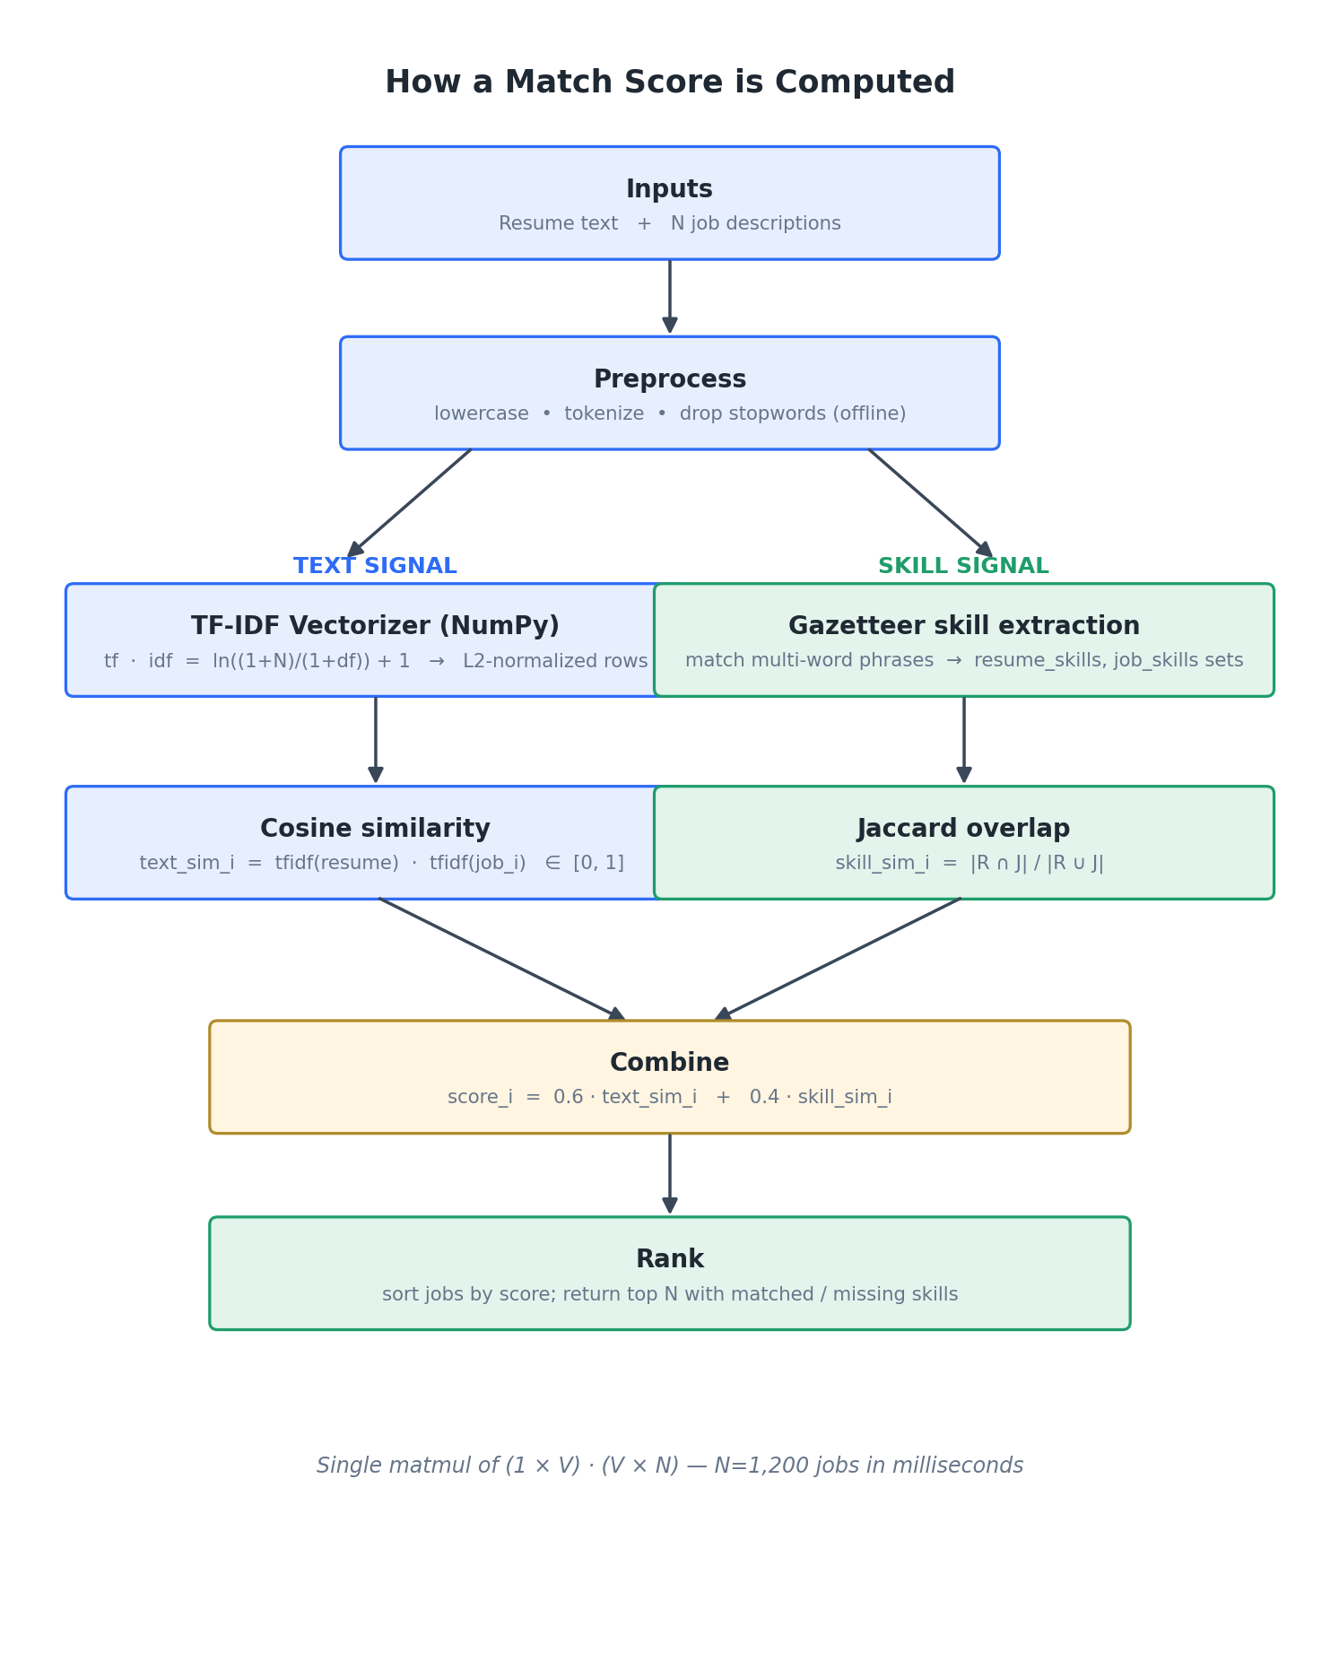
Figure 2 — How a match score is computed

9. The benchmark
Ground truth: a posting is relevant to a resume if they share a family tag. Family tags are baked into the synthetic data but never fed to either model — both models see only text and (for the engine) extracted skills.
Why a baseline? Without one, you can't claim improvement. An absolute precision@10 of 0.98 is meaningless without a reference. The keyword-overlap baseline (raw TF cosine, no IDF, no stopword removal, no skill extraction) is the obvious naive thing anyone would try. The uplift over it is the legitimate value the engine adds.
Why the gap exists. Every posting and resume includes shared boilerplate ("we move fast", "competitive benefits", "strong communication skills"). A raw keyword match weights that boilerplate as heavily as actual skills, so boilerplate-heavy postings get pulled toward every resume regardless of role. TF-IDF down-weights terms that appear in most documents (high document frequency → low IDF), so the engine effectively ignores the boilerplate. The skill Jaccard adds a second, complementary signal that keys on the hard requirements.
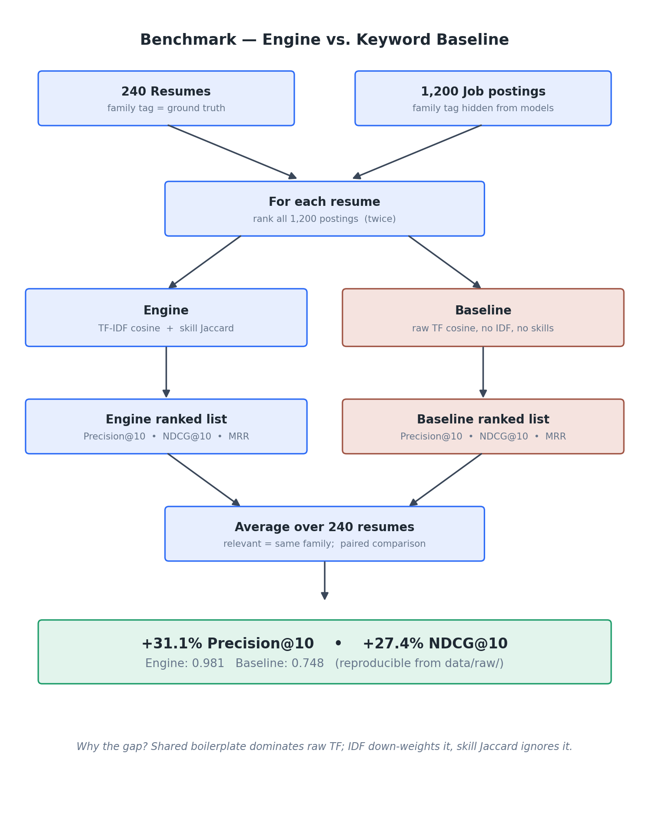
Figure 3 — Benchmark methodology

Final results
From benchmarks/results.json:
Metric | Baseline | Engine | Uplift
Precision@10 | 0.748 | 0.981 | +31.1%
NDCG@10 | 0.771 | 0.982 | +27.4%
MRR | 0.907 | 0.989 | +9.0%
MRR is high for both because the first relevant result is usually near the top — the metric is most useful when models occasionally surface relevant items deep in the list.

10. Running the project, step by step

10.1 Prerequisites
- Docker Desktop (for MySQL + MongoDB)
- Python 3.10+ (3.14 also tested)

10.2 First-time setup
cd "AI Job Portal"

# 1. start the databases
docker compose up -d
docker compose ps # wait ~10s for both to be (healthy)

# 2. python deps
python3 -m venv venv
source venv/bin/activate
pip install -r requirements.txt

# 3. config + MySQL schema
cp .env.example .env
docker exec -i jobs-mysql mysql -uroot -prootpass < sql/schema.sql

10.3 Generate data and run the pipeline
python -m src.data_generator
# 1,200 postings + 240 resumes → data/raw/

python -m src.pipeline
# [1/3] extract [2/3] transform [3/3] load
# jobs 1,200 | job_skills ~9.8K | job_text 1,200 | resumes 240

10.4 Reproduce the +31%
python -m benchmarks.eval_reco

metric baseline engine uplift
--------------------------------------------
precision@10 0.748 0.981 31.1%
ndcg@10 0.771 0.982 27.4%
mrr 0.907 0.989 9.0%

10.5 Dashboards
python -m src.analytics.dashboards
# wrote docs/dashboards/top_skills.png
# wrote docs/dashboards/salary_by_family.png
# wrote docs/dashboards/jobs_per_family.png
# wrote docs/dashboards/salary_distribution.png
# wrote docs/dashboards/match_scores.png

10.6 Start the API + frontend
python -m src.api.app
# Running on http://127.0.0.1:5002
In the browser at http://localhost:5002:
- Click "Load sample" to fill the textarea with a Data Engineer resume.
- Click "Find matches".
- Top 10 Data Engineer roles appear with match percentages, matched-skill chips (green), and missing-skill chips (gray).
- The right sidebar shows live skill demand and salary stats from MySQL.

10.7 Tests
python -m pytest tests/ -v
# 21 passed

11. Verifying everything works
Check | Command | Expected
MySQL alive | docker exec jobs-mysql mysqladmin ping -ujobs_user -pjobs_pass | mysqld is alive
MongoDB alive | docker exec jobs-mongo mongosh --quiet --eval "db.adminCommand('ping').ok" | 1
Row counts | SELECT COUNT(*) FROM jobs; SELECT COUNT(*) FROM job_skills; | 1200 / ~9.8K
Mongo docs | db.job_text.countDocuments({}) | 1200
API health | curl localhost:5002/api/health | status: ok
Recommend | curl -X POST /api/recommend with a DE resume | Data Engineer matches

12. Dashboards
Five Matplotlib charts auto-generated from MySQL plus the live recommender (the score distribution chart runs the engine over every resume in MongoDB).
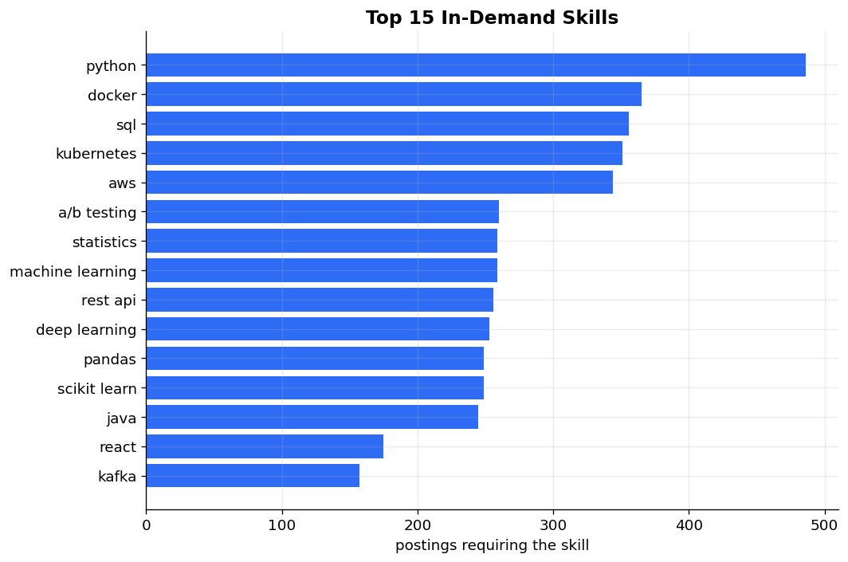
Top 15 in-demand skills
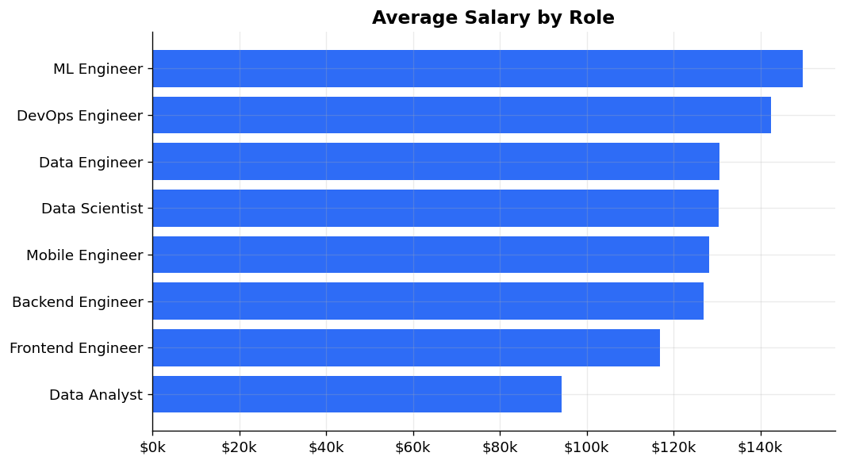
Average salary by role
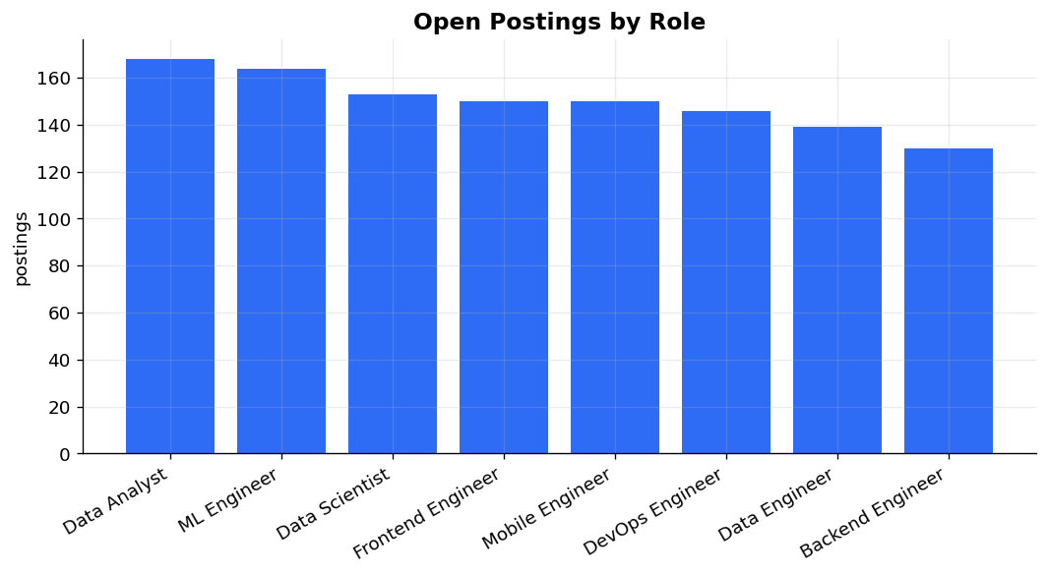
Open postings by role
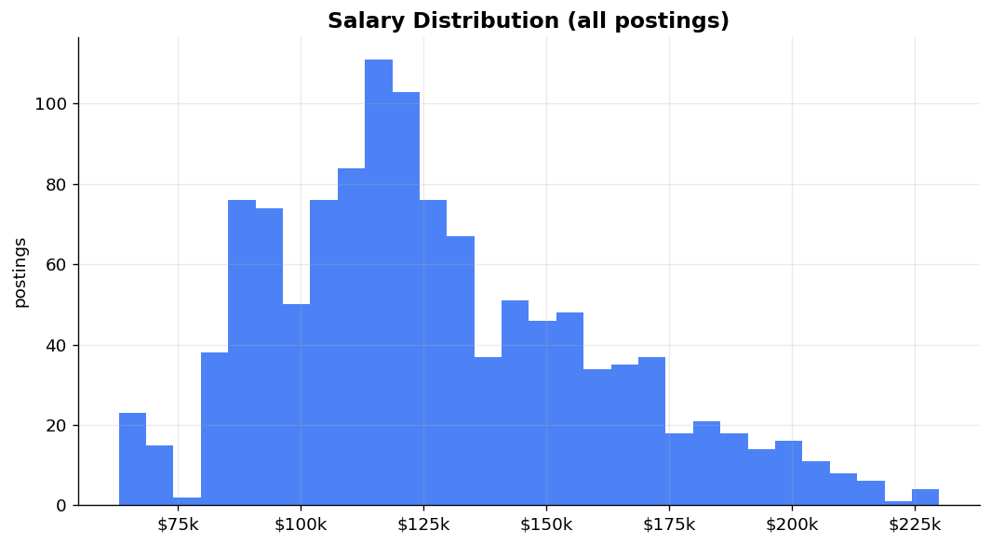
Salary distribution
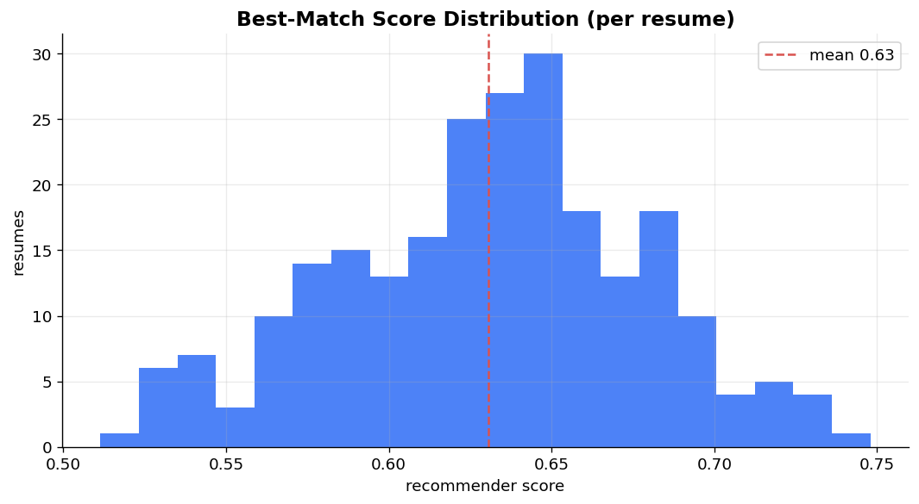
Best-match score distribution (per resume)

13. Talking points (interviews and portfolio reviews)
Common questions and how to answer them with this project as your reference.

“Walk me through this project.”
It's a job portal with an NLP recommender on top. The data flow is: synthetic postings and resumes from a generator, a Pandas ETL that cleans and extracts skills, then a split into MySQL for structured columns and MongoDB for unstructured text. The recommender is a hand-rolled NumPy TF-IDF blended with a Jaccard skill overlap. A Flask API exposes the search and recommendation endpoints and serves a vanilla JS frontend. There's also a reproducible benchmark that shows the engine beats a keyword baseline by 31% on precision@10.

“Why two databases?”
Different shapes. The structured columns (title, company, salary_avg, family) are perfect for SQL filters and aggregations, which is what the stats endpoints do. The unstructured side — full descriptions and variable-length skill arrays — is a natural document shape. Putting each in the store that fits keeps both queries simple. The API joins them by job_id when it needs both.

“Why TF-IDF and not embeddings?”
TF-IDF is interpretable, deterministic, and runs in tens of milliseconds on a thousand documents with no model to load. It also benchmarks 31% above a keyword baseline on this dataset, so the added complexity of a sentence transformer wasn't justified. The natural next step if I were extending this would be a small embedding model for re-ranking the top 50 candidates — classic retrieve-then-rerank.

“How is the recommender scored?”
Every resume has a hidden family tag, which is also on every posting. Relevant = same family. I rank all 1,200 postings for each of 240 resumes with both the engine and a naive keyword baseline, and average precision@10, NDCG@10, and MRR across the resumes. The engine scores 0.981 precision@10 vs. 0.748 for the baseline, a 31% lift — reproducible with one command. The numbers are in benchmarks/results.json.

“Why does the baseline lose by that much?”
Both postings and resumes contain a lot of shared boilerplate — "competitive benefits", "strong communication", "fast paced environment". A raw keyword match counts every word equally, so boilerplate drowns out the real skill signal. TF-IDF down-weights anything that appears in most documents, so the engine effectively ignores the boilerplate, and the skill-overlap term keys on hard requirements that text matching glosses over.

“Why did you build TF-IDF by hand instead of using scikit-learn?”
Two reasons. The math is short — about 40 lines of NumPy — and doing it by hand demonstrates I actually understand it rather than treating it as a black box. Second, it kept the dependency list smaller and the startup time shorter for the API.

“How does the skill extraction work?”
A gazetteer in data/skills.txt listing about 100 skills, including multi-word phrases like "apache spark" and "machine learning". I sort the list longest-phrase-first and scan the tokenized text, consuming matched tokens. Consuming every occurrence is important — otherwise a second "apache spark" leaves a bare "spark" token for the shorter entry to grab.

“What would you do with another two weeks?”
Three things. First, a small sentence-transformer re-ranker over the top 50 — classic retrieve-then-rerank, would lift NDCG meaningfully. Second, swap the synthetic data for a real corpus (e.g., an open job-postings dataset). Third, add learning-to-rank using click-through signals if I had user interactions to feed it.

14. Troubleshooting
Symptom | Fix
Connection refused on the API or pipeline | Databases aren't up. docker compose ps. Run docker compose up -d, wait ~10s. If Docker Desktop is paused, unpause it via the whale-menu / Dashboard.
Table 'jobportal.jobs' doesn't exist | Schema wasn't applied. Run docker exec -i jobs-mysql mysql -uroot -prootpass < sql/schema.sql.
/api/recommend → missing 'text' | Request body must be JSON with a text field. Make sure Content-Type: application/json is set.
Frontend shows "Stats unavailable" | Pipeline hasn't run; the databases are empty. Run python -m src.pipeline and refresh.
pip install fails on pandas/numpy | Probably on old Python. Project is tested on 3.10–3.14; upgrade if you're below 3.10.
Benchmark number drifted from 31.1% | Check for changes to JOB_FILLER, RESUME_FILLER, HYBRID_PROB, or N_RESP in src/data_generator.py. With seeds=42 and defaults, the number is stable to one decimal.

15. Extension ideas
- Real data: swap the synthetic generator for a real corpus. EMSI / Lightcast open datasets or the Kaggle LinkedIn Job Postings set are good starts.
- Embedding re-ranker: keep TF-IDF as the recall layer; re-rank the top 50 with a small sentence-transformer (e.g. all-MiniLM-L6-v2).
- Learning-to-rank: capture click-through on the frontend, train a small pairwise ranker offline.
- Resume file upload: parse .pdf / .docx resumes via PyMuPDF or python-docx; right now /api/resume/parse takes plain text.
- Auth + saved searches: user accounts, saved resumes, email alerts when new matches appear.
- A second baseline: BM25 alongside the TF-IDF engine — a more demanding comparison.
- Production-ize: gunicorn instead of Flask's dev server, Alembic for schema migrations, GitHub Actions for CI.

16. The shortest possible cheat sheet
docker compose up -d # databases up
source venv/bin/activate # env
docker exec -i jobs-mysql mysql -uroot -prootpass < sql/schema.sql # schema
python -m src.data_generator && python -m src.pipeline # load both stores
python -m benchmarks.eval_reco # the +31%
python -m src.analytics.dashboards # 5 PNGs
python -m src.api.app # http://localhost:5002
pytest tests/ -v # 21 passing

End of guide. The full source lives at /Users/akhil/Data engineering/AI Job Portal/. The matching markdown version is docs/PROJECT_GUIDE.md.

