**Web Application and AI**

**Report**

### Student Name: Akhil Chopra

### Student ID: 14546895

### Submitted to: Manizheh Montazerian

**Table of Contents**

Introduction 2

1. Design Pattern 3

1.1 Signup Page 3

1.1 Signin Page 4

1.2 Home Page 5

1.3 Exchange Page 6

1.4 MySell Page 7

1.5 Cart Page 8

2. ER Diagram 10

3. Sketches 11

3. Wireframes 13

5. Evaluation of Development Process and Technologies 15

Conclusion 17

# Introduction

This report provides an in-depth overview of the design, development, and evaluation process for a web application designed to facilitate user registration, authentication, product management, and e-commerce functionalities. The aim of the application is to deliver a seamless and intuitive user experience by leveraging a combination of advanced frontend and backend technologies to ensure robust performance and scalability.

The web application is built with the user in mind, offering essential features such as user registration and login, product browsing, management, and an interactive shopping cart system. The development process began with a thorough requirements analysis, followed by iterative design and implementation phases to ensure a comprehensive and user-friendly final product.

The frontend was developed using Java Server Pages (JSP) along with HTML, CSS, and JavaScript to provide dynamic content rendering and interactive user interfaces. The backend infrastructure utilizes Java Servlets for handling HTTP requests, session management, and server-side logic. Efficient data handling and storage are achieved using Java Database Connectivity (JDBC) and MySQL, while Maven facilitates project management and dependency handling.

Eclipse IDE was chosen for its robust support for Java development and integrated debugging tools. The application was deployed on Apache Tomcat 9, selected for its reliability and compatibility with Java-based applications.

The report details the specific functionalities of the signup, signin, home, exchange, MySell, and cart pages, outlining user interactions and backend processes. Additionally, it includes an Entity-Relationship Diagram (ERD) to illustrate the database schema and relationships.

The evaluation section assesses the development process and technologies used, emphasizing the strengths and advantages of the chosen tools and methodologies. This structured approach ensured the creation of a scalable, maintainable, and user-friendly web application that successfully meets the project's objectives.

# Design Pattern

## Signup Page

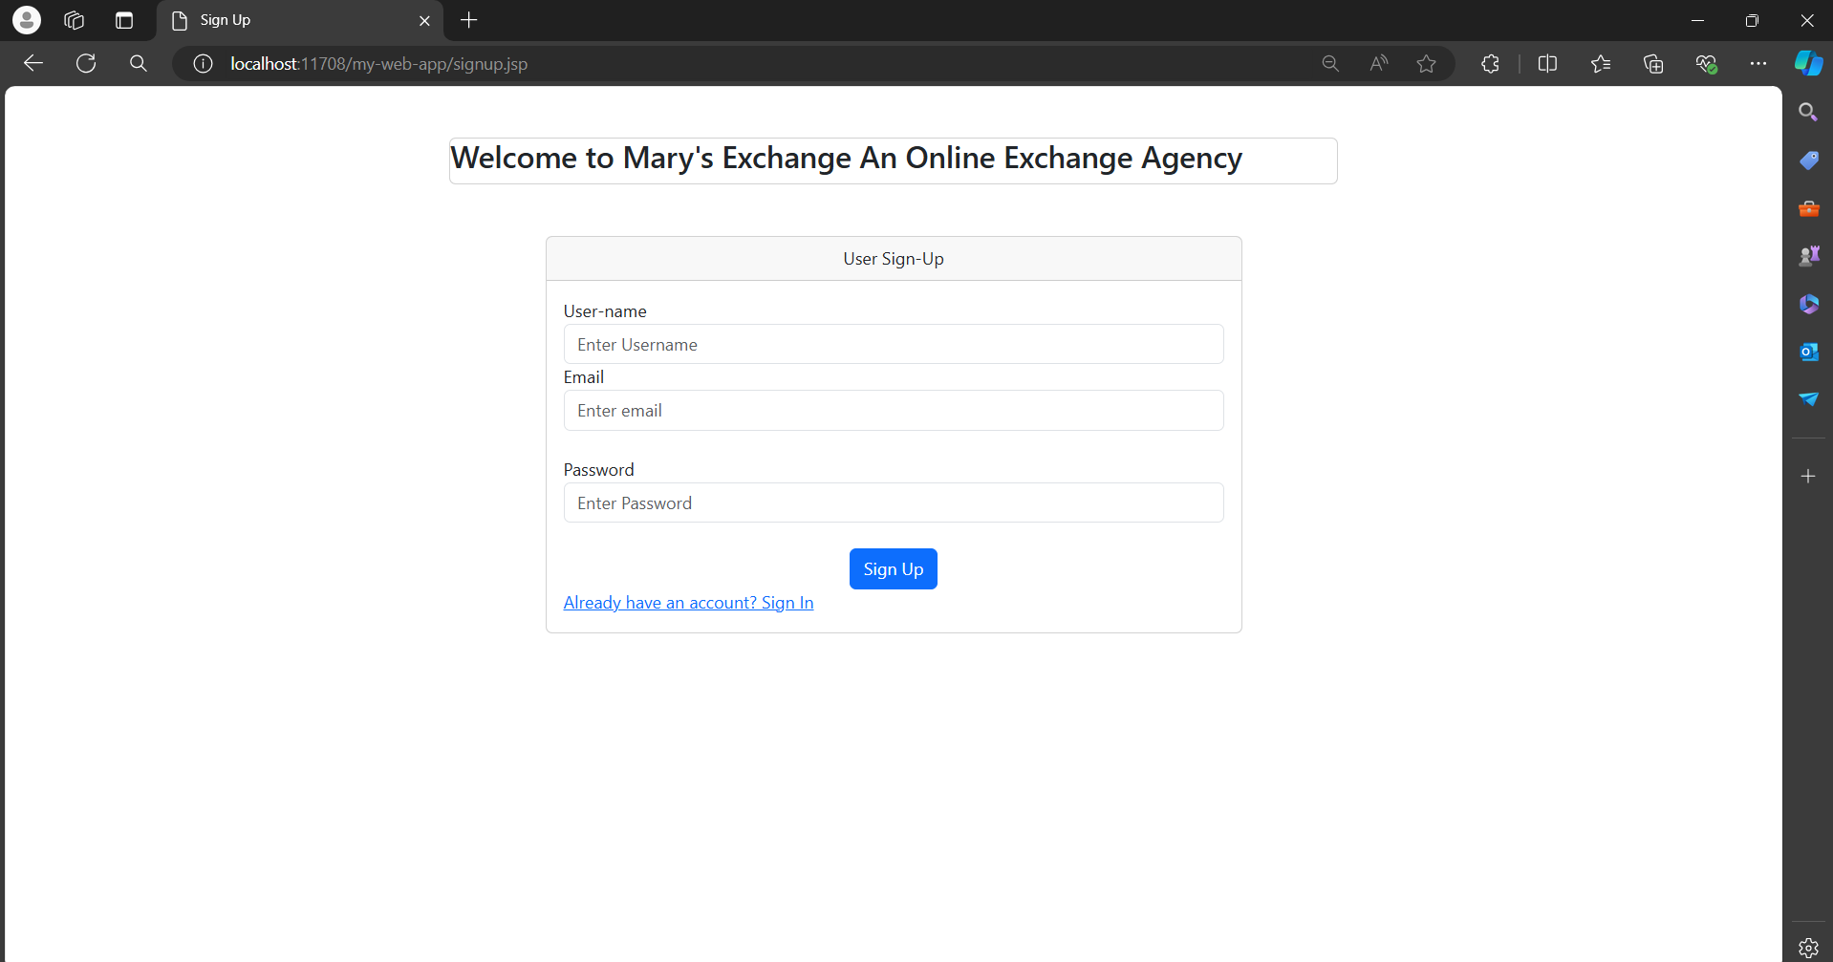

**Functionality:**

* **User Registration:**
  + Allows new users to create an account by entering their username, email, and password.
  + Implements form validation to ensure all required fields are correctly filled.
  + Checks password strength for security.
  + Validates the email format.
* **Form Submission:**
  + Sends user data to the backend server for processing and storage upon submission.
  + Redirects successful registrations to the signin page or a welcome page.
  + Displays error messages for issues like existing usernames or weak passwords.
* **Navigation Link:**
  + Provides a link below the registration form for existing users.
  + Redirects users to the signin page.

## Signin Page

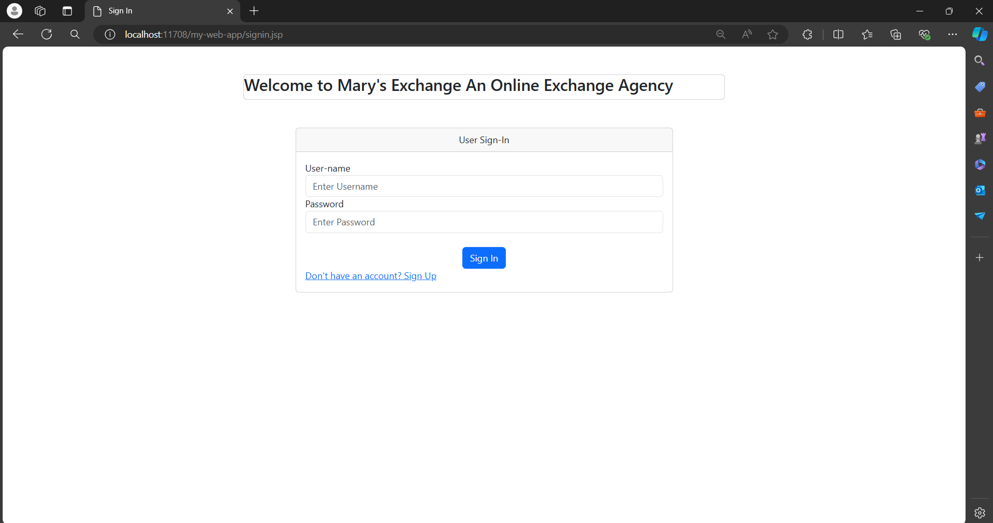

**Functionality:**

* **User Authentication:**
  + Allows registered users to log in by entering their username and password.
  + Ensures form validation for all required fields.
* **Form Submission:**
  + Sends credentials to the backend server for authentication upon submission.
  + Redirects users to the home page if credentials are correct.
  + Displays error messages for incorrect credentials.
* **Navigation Link:**
  + Provides a link below the login form for new users.
  + Redirects users to the signup page.

## Home Page

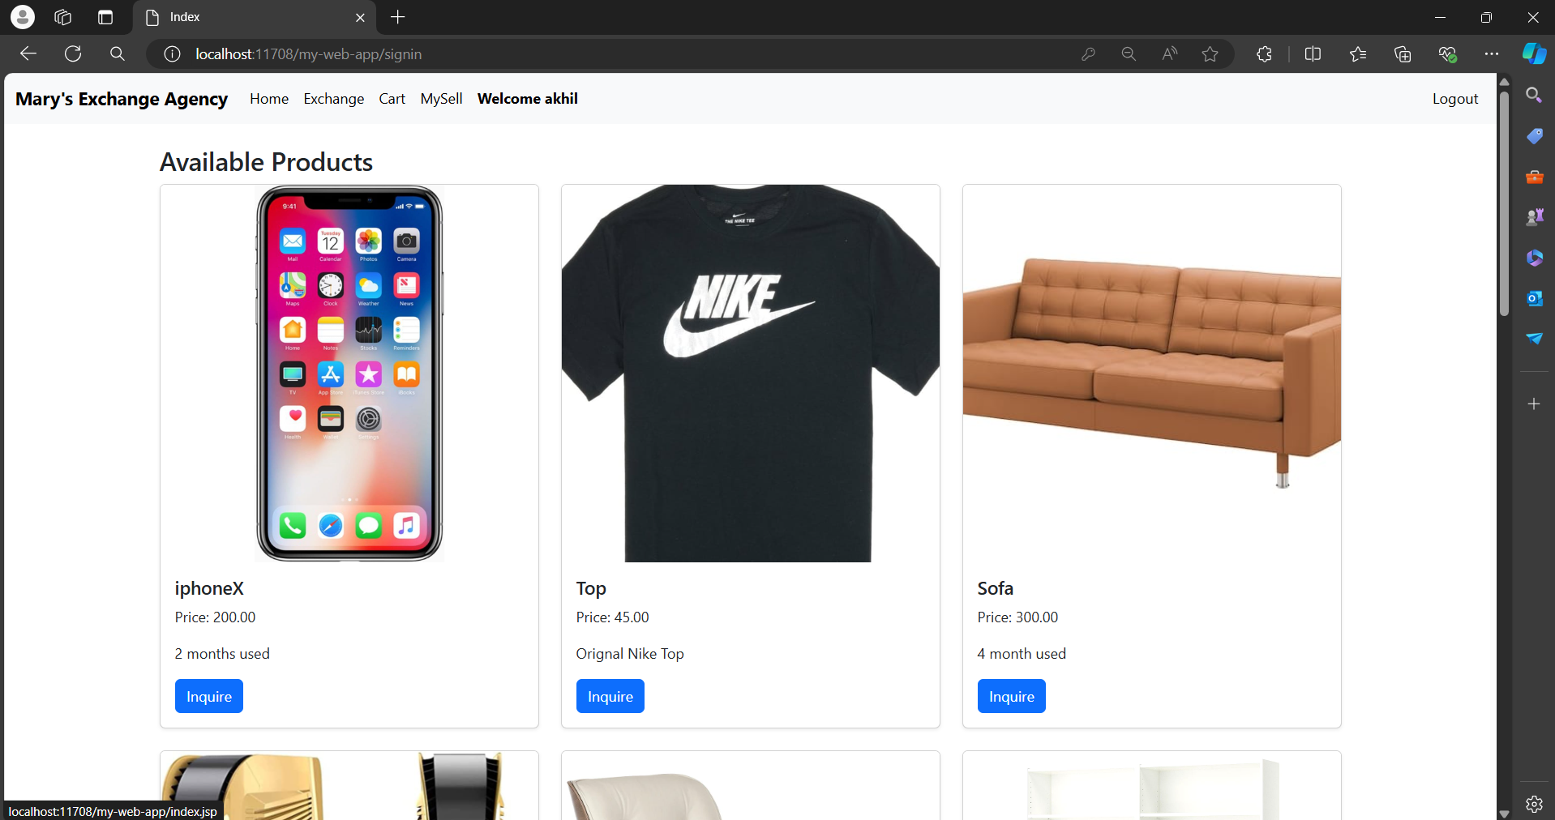

**Functionality:**

* **Product Display:**
  + Displays all products being sold by other users.
  + Categorizes products into Electronics, Furniture, and Clothing for easy browsing.
* **Navigation Bar:**
  + Provides quick access to different pages:
    - Exchange: View and manage exchange items.
    - Cart: Shows items in the user's shopping cart.
    - MySell: Manage products the user is selling.
  + Displays the signed-in user's username.
  + Includes a Logout button to sign out and return to the signin page.
* **User Interaction:**
  + Allows users to click on products for more details, add to cart, or express interest in exchange.
  + Dynamically updates based on user interactions and backend data.

## Exchange Page

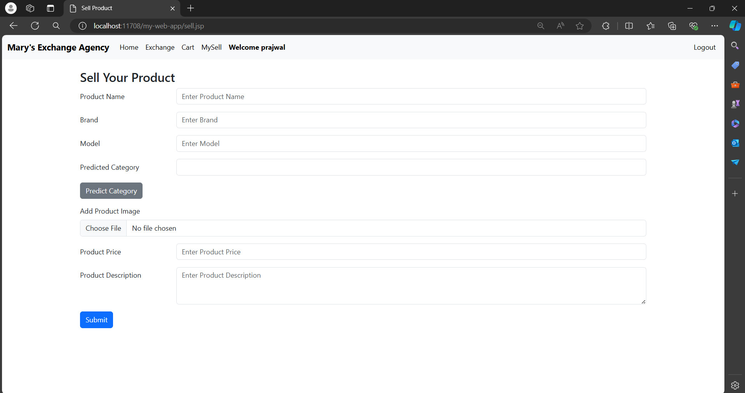

**Functionality:**

* **Product Entry:**
  + Allows users to enter details of the product they want to sell, including name, brand, and model.
* **Category Prediction:**
  + Predicts the product category (Electronics, Furniture, Clothing) based on entered details.
* **Additional Details:**
  + Allows users to upload a product image.
  + Requires users to enter the price and description.
* **Form Submission:**
  + Submits product details to the backend server for processing and storage.
  + Notifies users upon successful submission and redirects appropriately**.**

## MySell Page

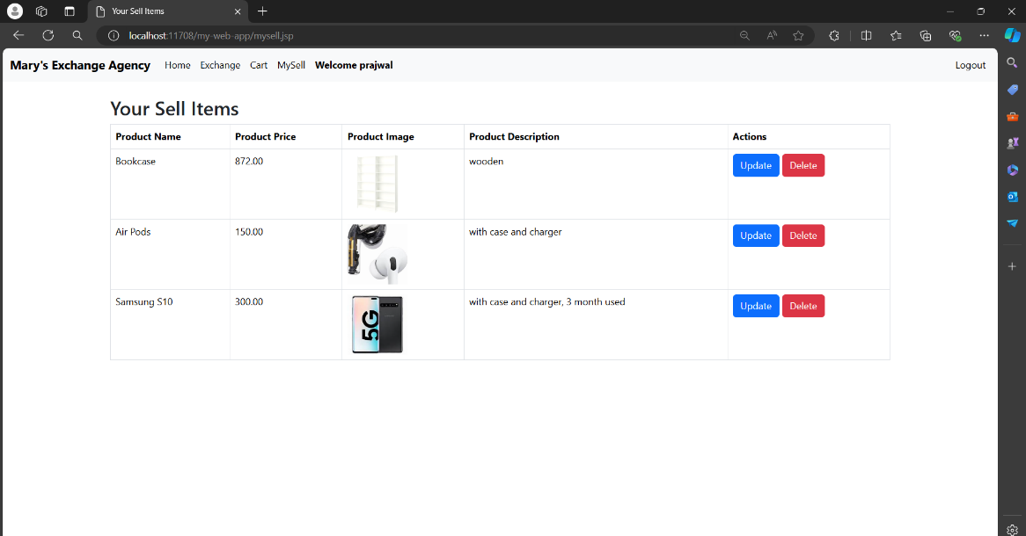

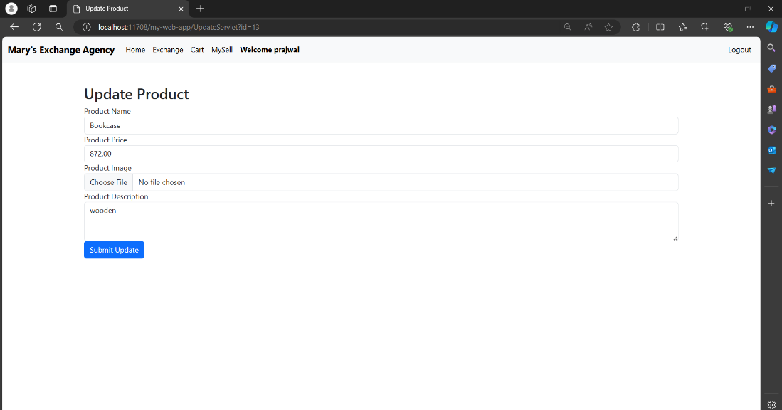

**Functionality:**

* **Product Listing:**
  + Displays a list of products the user has listed for sale.
* **Update and Delete Options:**
  + Each product entry includes buttons to update or delete the product.
* **Update Product:**
  + Redirects users to an Update page to modify product details.
  + Allows changes to name, brand, model, image, price, and description.
  + Submits updates to the database.
* **Delete Product:**
  + Prompts users to confirm before deleting a product.
  + Removes the product from the list and database upon confirmation.

## Cart Page

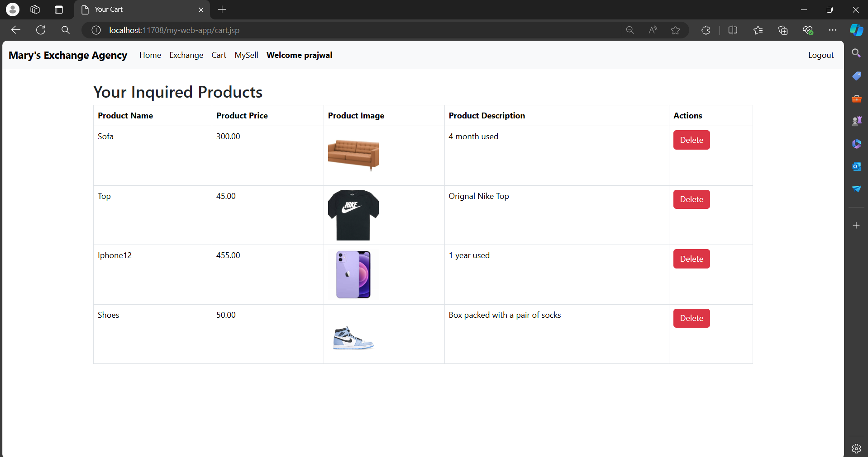

**Functionality:**

* **Product Storage:**
  + Stores and displays products the user is interested in purchasing or exchanging.
* **Delete Option:**
  + Each product entry includes a Delete button.
  + Allows users to remove products from the cart, dynamically updating the list.
* **User Interaction:**
  + Provides a summary of products for easy review and management.

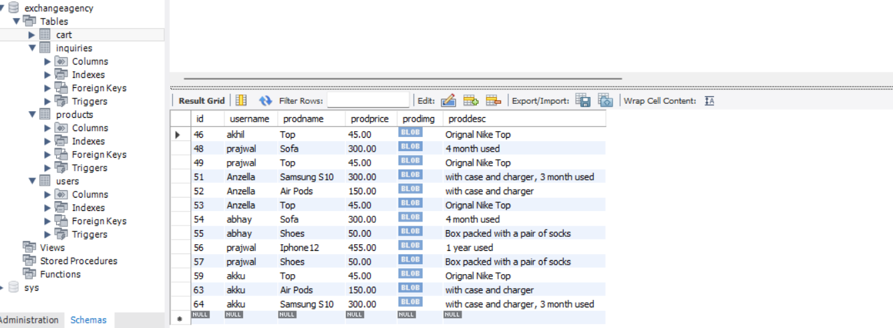

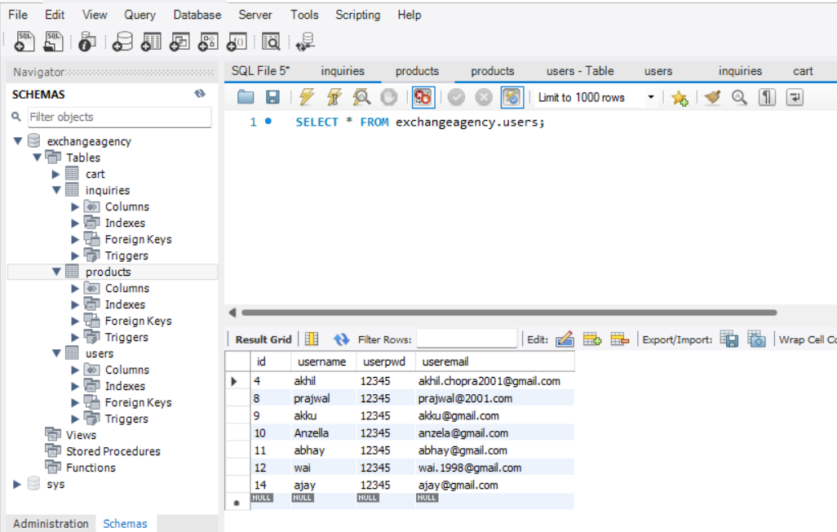

# ER Diagram

**Users**

id INT

username VARCHAR(50) PK

userpwd VARCHAR(50)

useremail VARCHAR(100)

**products**

id INT

prodname VARCHAR(50)

brand VARCHAR(50)

category VARCHAR(50)

model VARCHAR(50)

prodprice VARCHAR(50)

prodimg BLOB

proddes Text

username VARCHAR(50) FK

One to many





One to many

**Inquiries**

id INT

username VARCHAR(50) FK

prodname VARCHAR(50)

prodprice VARCHAR(50)

prodimg BLOB

proddes Text

One to many



**Entity-Relationship Diagram (ER Diagram or ERD)**

# 3. Sketches

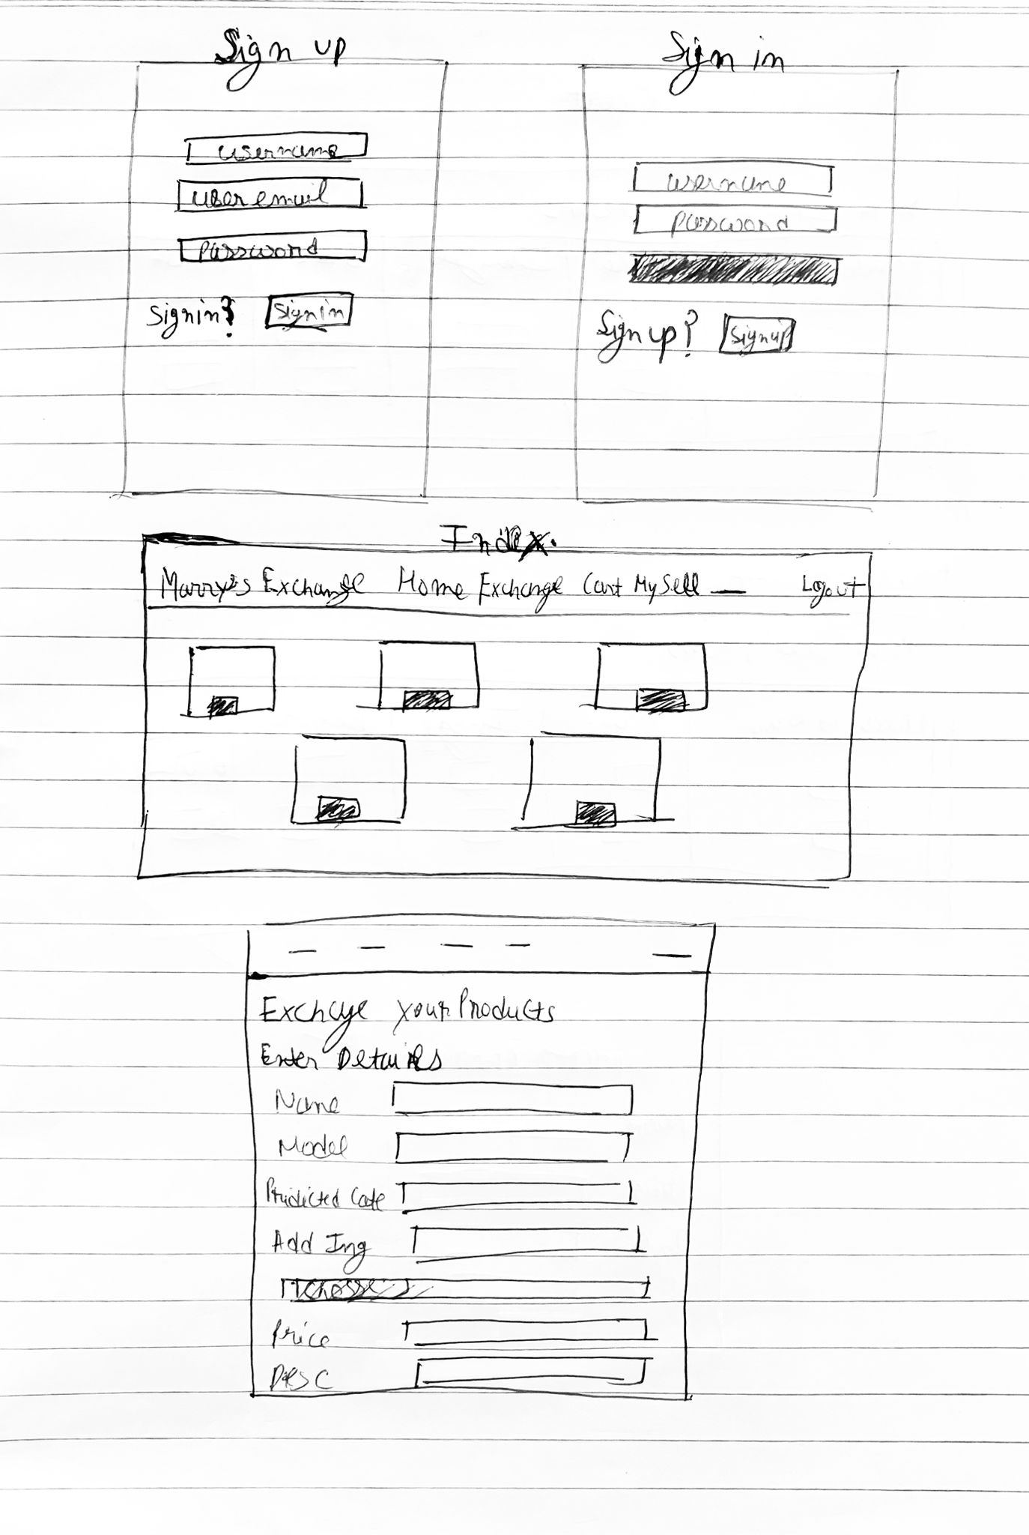

**Sketches**

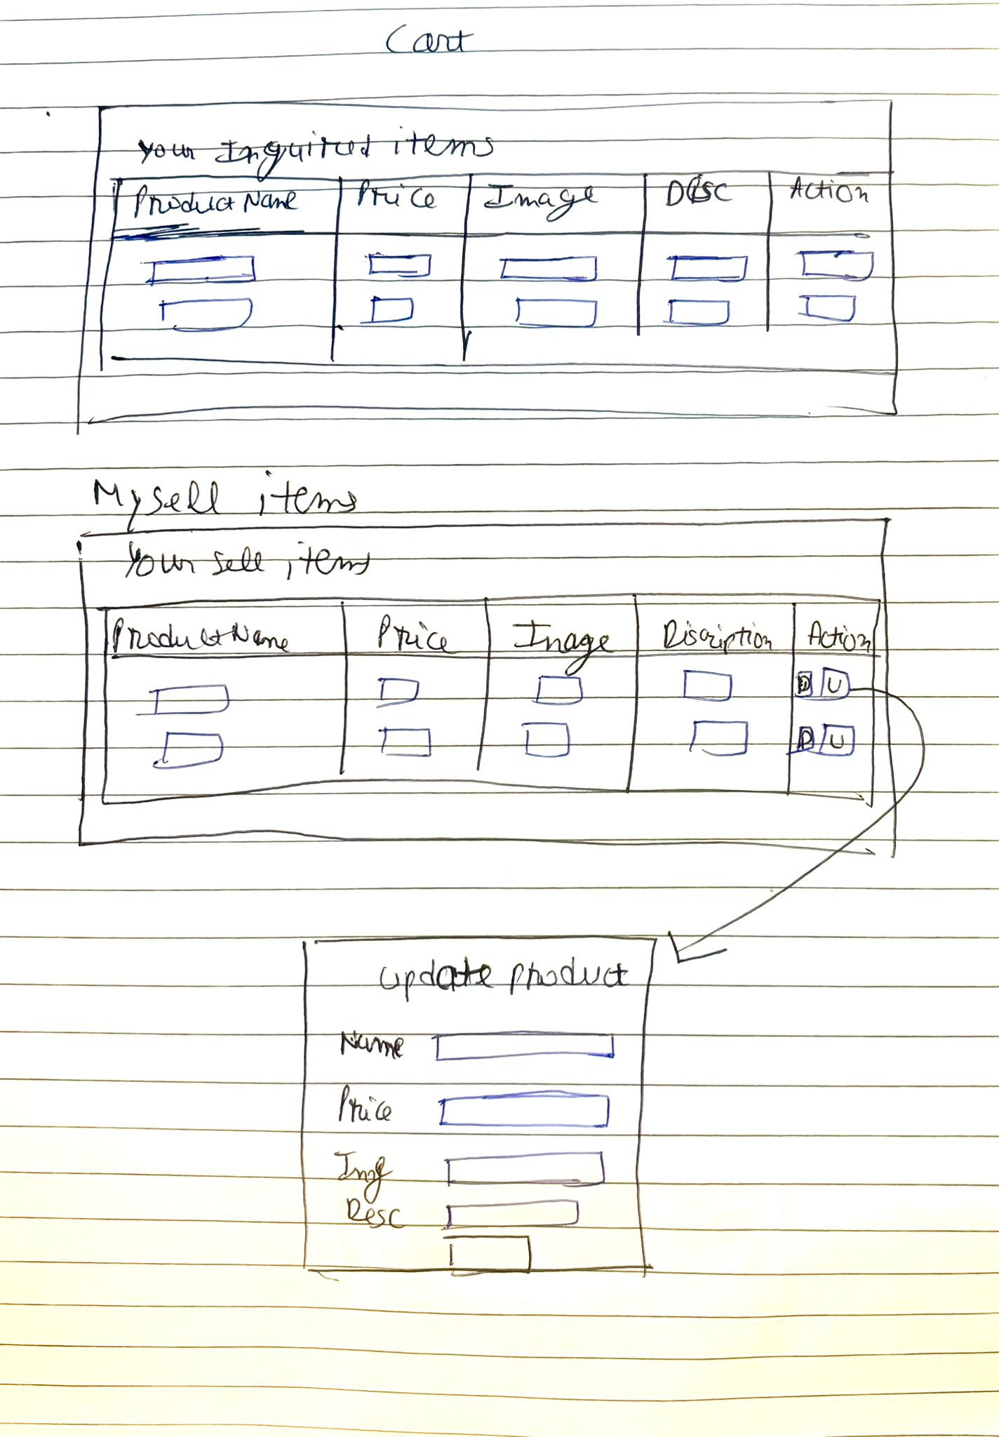

# Wireframes

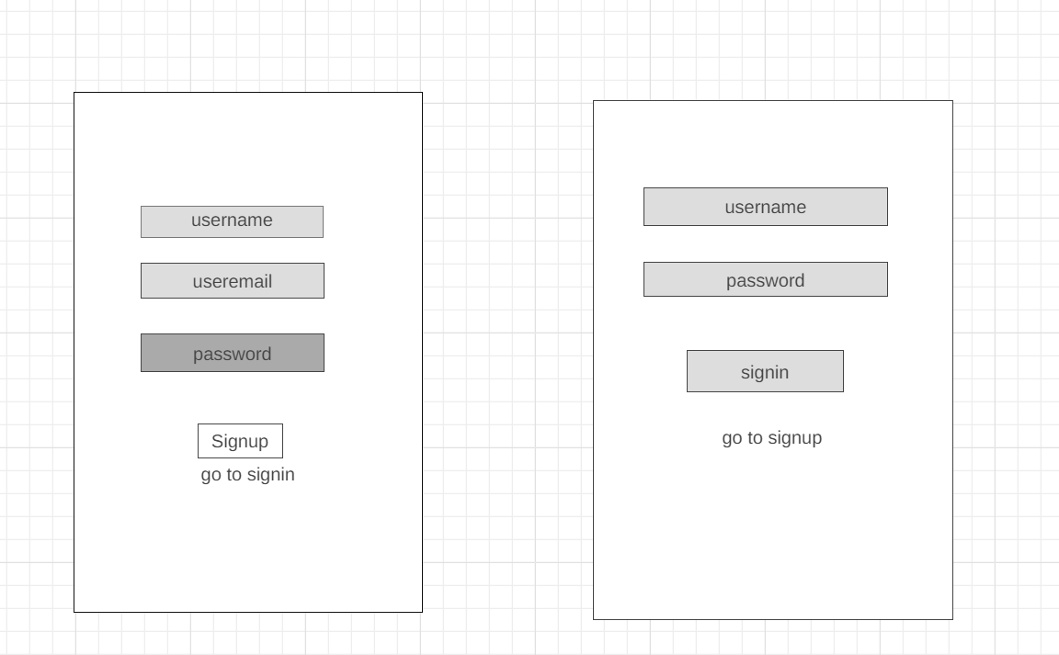

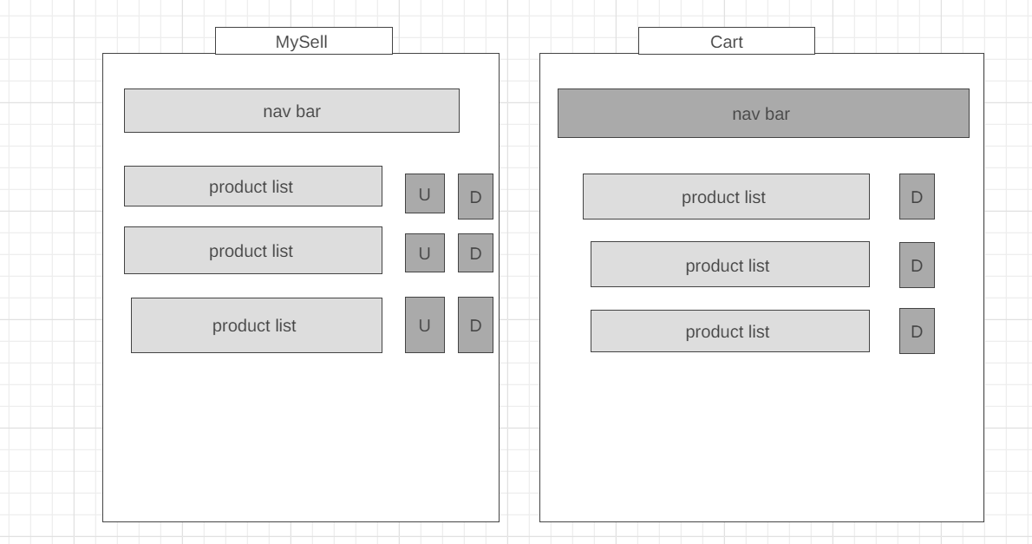

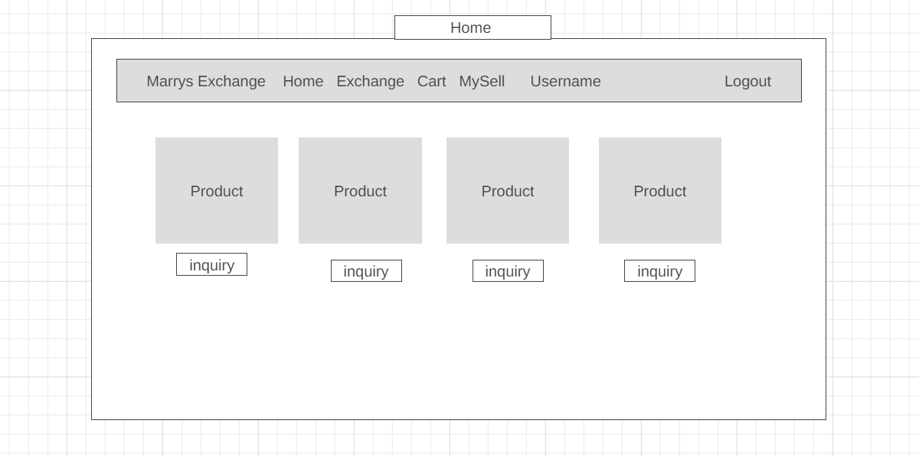

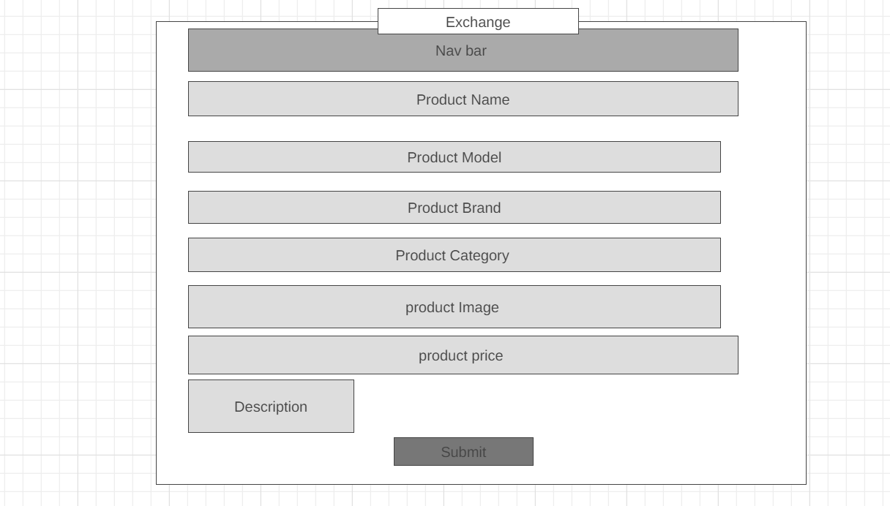

# 5. Evaluation of Development Process and Technologies

The development of the web application followed a structured and iterative methodology, utilizing a diverse set of technologies to create a robust and user-friendly platform. Below is an evaluation of the development process and the technologies employed:

**Development Process**

The development began with an extensive requirements analysis to understand user needs and the necessary functionalities of the application. During the design phase, we created detailed blueprints for the user interface and database schema. Development was conducted in stages, starting with essential features like user authentication and product management, and subsequently integrating additional functionalities such as cart management and error handling.

**Frontend Technologies**

Java Server Pages (JSP) was chosen for generating dynamic web content. JSP’s seamless integration with Java Servlets facilitated efficient handling of user requests and dynamic content rendering. HTML, CSS, and JavaScript were used to structure, style, and add interactivity to the web pages, ensuring a responsive and engaging user experience.

**Backend Technologies**

The backend infrastructure was built on Java Servlets, which managed HTTP requests, session management, and server-side logic. Java Database Connectivity (JDBC) was used for database interactions, enabling efficient data handling and query execution with MySQL. Maven was employed for project management, which streamlined dependency management and build processes, enhancing the overall development workflow and maintainability.

**Database Technologies**

MySQL was selected due to its reliability and robustness in handling relational data. The database schema was designed to efficiently manage user accounts, product listings, and inquiries. MySQL Workbench proved invaluable for database design and administration, offering a graphical interface for modelling and query management.





**Development Tools**

Eclipse Integrated Development Environment (IDE) was used for its comprehensive support for Java development and integrated debugging tools. Apache Tomcat 9 served as the web server, chosen for its compatibility with Java-based applications, providing a reliable environment for deploying and running the web application.

**Overall Assessment**

The chosen technologies and development practices resulted in a well-architected application with clear separation between frontend and backend functionalities. The use of JSP and Servlets enabled dynamic content management and efficient request handling, while JDBC and MySQL facilitated robust data management. Maven and Eclipse streamlined the development process, and Apache Tomcat ensured a stable deployment environment. Collectively, these technologies contributed to creating a scalable, maintainable, and user-friendly web application that effectively met the project’s objectives.

# Conclusion

The development of the web application was executed through a structured and iterative methodology, ensuring a comprehensive understanding of user needs and application requirements. The systematic approach began with a detailed requirements analysis, followed by careful design, and phased development focusing on core functionalities like user authentication and product management, before integrating additional features such as cart management and error handling.

Frontend development leveraged Java Server Pages (JSP) for dynamic content generation, seamlessly integrated with Java Servlets to handle user requests and dynamic rendering. The combination of HTML, CSS, and JavaScript ensured that the web pages were structured, styled, and interactive, providing a responsive and engaging user experience.

The backend was built on Java Servlets for managing HTTP requests, session management, and server-side logic, with Java Database Connectivity (JDBC) facilitating efficient interaction with the MySQL database. Maven streamlined project management, ensuring effective dependency management and build processes, while Eclipse IDE provided a robust development environment with integrated debugging tools. Apache Tomcat 9 was chosen for its reliability and compatibility with Java-based applications, ensuring a stable deployment platform.

Database management was handled by MySQL, selected for its robustness and reliability in managing relational data. The schema was designed to efficiently handle user accounts, product listings, and inquiries, with MySQL Workbench aiding in database design and administration through its graphical interface.

Overall, the integration of these technologies resulted in a well-architected application with a clear separation between frontend and backend functionalities. The chosen tools and development practices ensured a scalable, maintainable, and user-friendly web application that met the project's objectives effectively. The use of JSP and Servlets for dynamic content management, combined with robust data handling through JDBC and MySQL, streamlined development via Maven and Eclipse, and stable deployment on Apache Tomcat, all contributed to the successful realization of a comprehensive and functional web platform.

**Video link -** [**webappDemoVideo.mp4**](https://livecoventryac-my.sharepoint.com/:v:/g/personal/chopraa5_uni_coventry_ac_uk/EesjQY2vgdVKvngurN38IsEBJkBsNP-dW4gIcPkXwLpzHw?nav=eyJyZWZlcnJhbEluZm8iOnsicmVmZXJyYWxBcHAiOiJPbmVEcml2ZUZvckJ1c2luZXNzIiwicmVmZXJyYWxBcHBQbGF0Zm9ybSI6IldlYiIsInJlZmVycmFsTW9kZSI6InZpZXciLCJyZWZlcnJhbFZpZXciOiJNeUZpbGVzTGlua0NvcHkifX0&e=WpV7GO)