Major Project Proposal
Project Title
Automated Knee MRI Abnormality Detection using Deep Learning for Clinical Decision Support
Project Domain
Artificial Intelligence | Deep Learning | Medical Image Analysis | Healthcare

Project Overview
Magnetic Resonance Imaging (MRI) is one of the most reliable imaging techniques for diagnosing knee injuries and abnormalities. A single knee MRI examination contains hundreds of image slices, making manual interpretation both time-consuming and dependent on specialist expertise. Radiologists must carefully examine each slice to identify abnormalities such as ligament tears, meniscus injuries, cartilage damage, bone fractures, bone marrow edema, joint effusion, and osteoarthritis.
This project proposes an AI-powered clinical decision support system that automatically analyzes knee MRI scans using deep learning techniques. The system predicts multiple clinically important abnormalities, generates confidence scores, provides visual explanations using Explainable AI (Grad-CAM), and creates a structured diagnostic report. The objective is to assist radiologists in improving diagnostic speed, consistency, and efficiency while supporting—not replacing—their clinical judgment.

Problem Statement
Manual interpretation of knee MRI examinations is complex because a single scan contains numerous slices and multiple abnormalities may occur simultaneously. In hospitals with heavy patient workloads or limited radiology expertise, diagnosis can be delayed or inconsistent.
The proposed system aims to develop an intelligent deep learning framework capable of detecting multiple knee abnormalities automatically and providing decision support to healthcare professionals.

Objectives
- Develop a deep learning model for multi-abnormality detection in knee MRI.
- Detect abnormalities such as ACL tear, PCL tear, meniscus tear, cartilage damage, bone fracture, bone marrow edema, joint effusion, and osteoarthritis.
- Generate confidence scores for each detected abnormality.
- Provide visual explanations using Grad-CAM.
- Generate a structured medical report.
- Build a user-friendly dashboard for MRI upload, prediction, visualization, and report generation.

Proposed Methodology
- MRI Scan Upload
- Image Preprocessing (Normalization, Resizing, Noise Reduction)
- Feature Extraction using EfficientNet-B3 (or similar deep learning architecture)
- Multi-label Classification
- Explainable AI using Grad-CAM
- Automated Report Generation
- Dashboard Visualization

Technology Stack
- Python
- PyTorch
- OpenCV
- FastAPI / Flask
- React.js or Streamlit
- PostgreSQL / SQLite
- Docker (Deployment)

Proposed System Architecture and Workflow
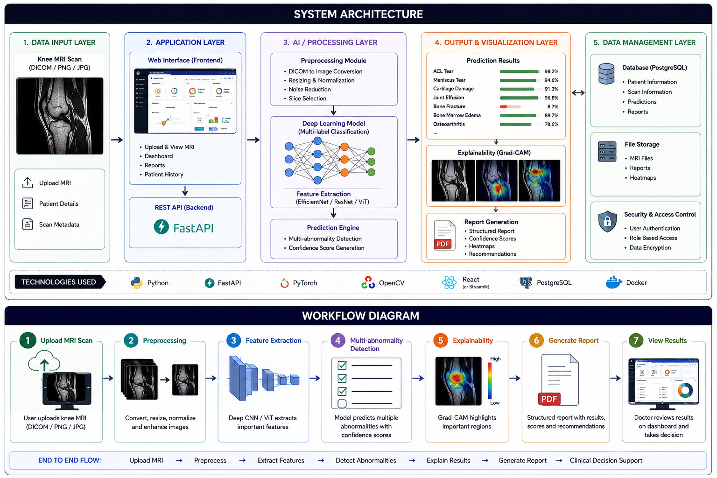

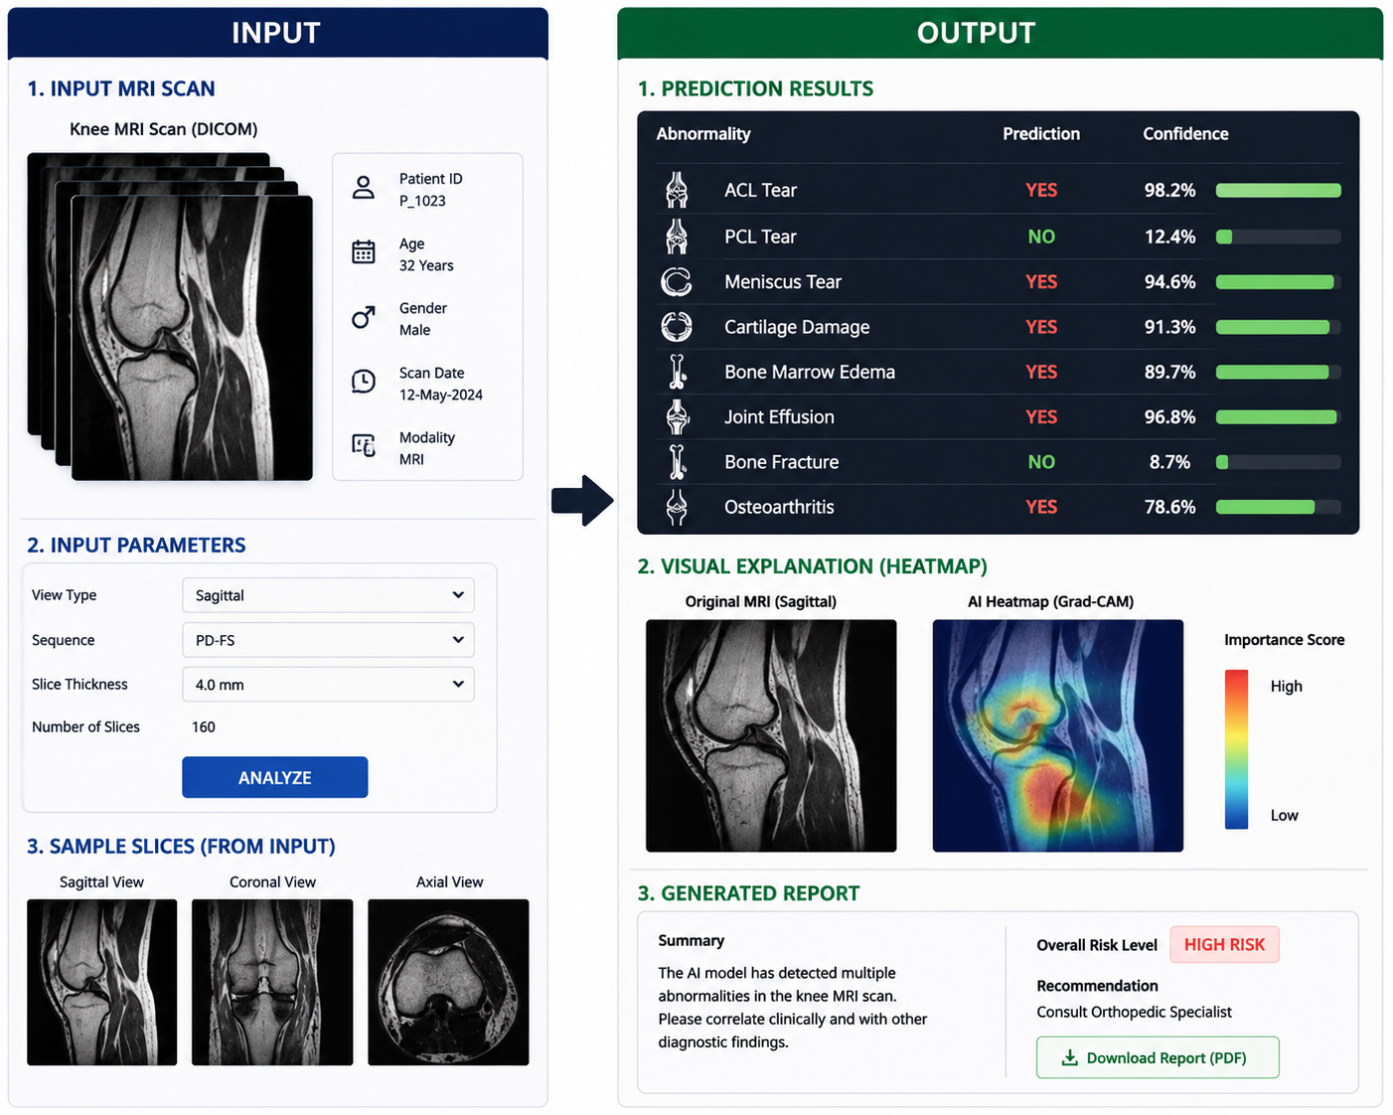

Algorithm Used
This section is very important.
Module | Algorithm Used
Image Loading | pydicom
Image Preprocessing | OpenCV, CLAHE, Gaussian Blur
Feature Extraction | EfficientNet-B3
Classification | Multi-label Classification
Activation Function | Sigmoid
Loss Function | Binary Cross Entropy
Optimizer | Adam
Explainability | Grad-CAM
Report Generation | Rule-based PDF Generator

Expected Outcomes
- Automatic detection of multiple knee abnormalities.
- Interactive web-based dashboard.
- AI-assisted diagnostic report generation.
- Improved efficiency in MRI interpretation.
- Explainable AI visualizations to increase clinician confidence.

Expected Deliverables
- Trained Deep Learning Model
- Web Application Dashboard
- MRI Analysis Module
- Automated PDF Report Generator
- Project Documentation
- Final Presentation and Demonstration

Applications
- Hospitals
- Diagnostic Centers
- Orthopedic Clinics
- Medical Colleges
- Tele-radiology Platforms
- AI-assisted Healthcare Systems

Future Scope
- 3D MRI Analysis
- Disease Severity Assessment
- Hospital PACS Integration
- Cloud-Based Deployment
- Mobile Application Support

Conclusion
This project addresses a real-world healthcare challenge by applying deep learning to assist in the interpretation of knee MRI examinations. By integrating multi-label abnormality detection, explainable AI, and automated report generation into a single clinical decision support system, the project offers both academic value and practical relevance. The proposed work aligns with current advancements in Artificial Intelligence and Medical Imaging and is suitable as a B.Tech major project with potential for future research and publication.

