
COIMBATORE INSTITUTE OF TECHNOLOGY
(Government Aided Autonomous Institution affiliated to Anna University)
Coimbatore – 641 014, Tamil Nadu, India
━━━━━━━━━━━━━━━━━━━━━━━━━━━━━━━━━━━━━━━━━━━━━━━━━━━━━━━━
PROJECT DOCUMENTATION RECORD
PayGate (Transiq)
Secure Digital Payment & Wallet Management Platform
A Scalable Full-Stack MERN Payment Gateway and Intelligent Digital Wallet System
MODULE 6: ADMIN OPERATIONS, MONITORING & ERROR AUDIT CONSOLE
PROJECT DETAILS
Field | Details
Project Title | PayGate (Transiq) — Secure Digital Payment & Wallet Management Platform
Subsystem Focus | Module 6: Admin Operations, Telemetry Monitoring & Error Audit Console
Domain | Full-Stack Web Development — Enterprise FinTech & Digital Payments (MERN Stack)
Institution | Coimbatore Institute of Technology (Autonomous), Coimbatore – 641 014
Course & Degree | M.Sc. Software Systems (5-Year Integrated Degree Programme)
Academic Year | 2025 – 2026 (Semester III)
TEAM DETAILS (6 MEMBERS)
S.No | Name of Student | Register Number | Assigned Module / Role
1 |  |  | Module 1: Customer Profile, Wallets & Account Linking
2 |  |  | Module 2: Beneficiary Management & Directory Services
3 |  |  | Module 3: Idempotent Payment Initiation & Checkout Wizard
4 |  |  | Module 4: Transaction Ledgers & Financial Analytics
5 |  |  | Module 5: Security Governance, JWT Middleware & PIN Auth
6 |  |  | Module 6: Admin Operations, Monitoring & Error Audit Console
Project Guide / Supervisor: Prof. / Dr. __________________________________________________
Signature of the Guide: ______________________________ Date of Submission: _______________

Synopsis
PayGate (Transiq) is an enterprise-grade digital payment and wallet platform designed to enforce determinism, security, and auditability across simulated payment gateway rails. Module 6 — Admin Operations, Monitoring & Error Audit Console constitutes the central telemetry and supervisory pillar of the platform. Built on the Node.js/Express asynchronous runtime and React Single Page Application (SPA) architecture with MongoDB persistence, this module provides authorized system administrators with real-time operational visibility into transaction throughput, platform health, and system failures.
Operational Challenge & Problem Statement
Modern payment gateways process high-velocity financial requests where network timeouts, insufficient balances, and authentication glitches can lead to indeterminate in-flight states or silent payment drops. Without centralized telemetry, operational support teams face critical blind spots, resulting in prolonged incident recovery times, untracked failure cascades, and an inability to safely resolve stuck transactions. Module 6 directly eliminates these challenges by establishing an automated error-capture pipeline, structured severity categorization, and a centralized audit console.
Key Functional & Architectural Innovations
- 1. Real-Time Platform Telemetry & Analytics: Aggregates live gross volume, total completed count, success/failure ratios, and active in-flight queues via high-efficiency database queries.
- 2. Automated Failure Telemetry & Audit Logs: Intercepts transaction execution failures via Mongoose post-save lifecycle hooks, automatically logging incident details with standardized error codes (INSUFFICIENT_FUNDS, BANK_TIMEOUT, FROZEN_WALLET).
- 3. Multi-Tier Severity Classification: Classifies errors into LOW, MEDIUM, HIGH, and CRITICAL tiers, providing root-cause diagnostic message payloads and stack references for rapid engineering triage.
- 4. Real-Time Pending Transaction Resolution: Provides an authorized queue for administrators to review stuck in-flight payments and execute deterministic force-success or force-fail overrides, preventing ledger imbalances.
- 5. Auditable Incident Triage & Resolution: Enables operational staff to mark incident logs as resolved with mandatory administrative resolution notes and cryptographic admin identity timestamps.
- 6. Proactive Account & Wallet Security Triggers: Direct administrative toggle triggers to freeze compromised customer wallets (isFrozen) and toggle account activation (isActive) to safeguard platform liquidity.
Implementation Stack & Documented Outcome
Module 6 delivers a hardened administration environment powered by stateless JWT authentication guards (adminOnly.js), indexed MongoDB collections (errorlogs, transactions, users, wallets), and a responsive Tailwind/Zustand client interface. The module guarantees total platform auditability, sub-second error triage, and automated incident recovery.

Objective
The primary objective of Module 6 (Admin Operations, Monitoring & Error Audit Console) is to deliver robust platform governance, system-wide observability, and auditable error remediation for the PayGate (Transiq) platform:
- 1. Single-Pane Platform Telemetry: Establish a centralized, high-density telemetry dashboard visualizing real-time transaction throughput, gross settled volume, platform success percentage, and active pending queue depth.
- 2. Automated Error Interception & Traceability: Automatically capture every failed payment attempt into an immutable database repository with unique incident IDs, affected transaction references, standardized error codes, and exact timestamps.
- 3. Systematic Error Severity Classification: Implement a standardized 4-tier severity model (LOW, MEDIUM, HIGH, CRITICAL) to automatically grade incoming error logs based on business impact, ensuring immediate escalation for banking timeouts and authentication anomalies.
- 4. Deterministic In-Flight Transaction Recovery: Eliminate stuck or indeterminate payment states by equipping administrators with verified manual resolution mechanisms (Force Success / Force Fail) to reconcile in-flight transactions safely.
- 5. Transparent Incident Resolution Tracking: Maintain an auditable incident lifecycle where system administrators can review error diagnostic payloads, apply remediation, and record resolution notes alongside authenticated administrative signatures.
- 6. Proactive Account & Wallet Security Controls: Provide rapid-response fraud mitigation tools enabling administrators to instantly freeze customer wallets (isFrozen) or deactivate suspicious user profiles (isActive) upon detecting security threats.
- 7. Compliance & Forensic Audit Trail Export: Allow administrators to extract filtered historical transaction ledgers into structured CSV spreadsheets for offline compliance, regulatory reporting, and forensic accounting.
Scope
Functional Scope
- Administrative Role Guarding: Enforce zero-trust JSON Web Token (JWT) verification and dedicated role-based middleware guards (adminOnly.js) restricting all administrative operations strictly to users with role === 'admin'.
- Real-Time Telemetry Analytics: Dynamic calculation and real-time visualization of total transaction volume, total transactions executed, platform success rate (%), failure rate (%), and pending transaction count.
- System Transaction History Audit: Multi-criteria querying and inspection of platform-wide transaction records with granular filters for transaction status, payment method (WALLET, IMPS, NEFT, RTGS), reference codes, and date ranges.
- Error Log Triage & Inspection: Ingestion, display, and triage of execution errors with color-coded severity badges (LOW, MEDIUM, HIGH, CRITICAL), failure reason strings, and root-cause diagnostic messages.
- Pending Payment Intervention: Interactive queue displaying pending payments with authorized override controls to force-succeed or force-fail transactions, automatically updating sender balances and recipient records.
- Error Incident Resolution Tracking: Single-click and bulk resolution of error logs with mandatory resolution notes and automated capture of the resolving administrator's identifier and timestamp.
- Security & Account Governance: Instantaneous administrative control to toggle customer wallet freeze status (blocking outgoing debits) and user activation status.
Technical Scope
- Stateless REST API Architecture: Express.js/Node.js REST service implementing versioned endpoints under /api/admin/* and /api/analytics/*.
- Data Persistence & Schema Validation: MongoDB collections (errorlogs, transactions, users, wallets) with Mongoose schema validation, indexes on transactionId and createdAt, and non-blocking post-save failure listeners.
- Client-Side SPA Architecture: React 18 Single Page Application styled with Tailwind CSS, Lucide-react iconography, and Zustand state store (logsStore.js) managing asynchronous cache updates and UI state.
Out-of-Scope (Future Expansion)
- Real-Time Partner Bank Webhooks: Direct bidirectional webhook dispatching to third-party bank core-banking APIs (mock banking controllers represent bank responses in the current implementation).
- Third-Party SIEM Integration: Native streaming of telemetry to third-party enterprise Security Information and Event Management (SIEM) systems such as Datadog, Splunk, or New Relic.
- Automated AI Predictive Anomaly Detection: Machine-learning based anomaly scoring on real-time transaction streams (planned for future AI fraud detection engine).
Project Description
Module 6 (Admin Operations, Monitoring & Error Audit Console) is architectured as a decoupled, multi-tier supervisory system. It provides full administrative governance across the entire PayGate ecosystem without tight coupling to the user-facing payment initiation pipelines. The technical architecture is structured across three primary tiers:
Client Tier — Admin Monitoring UI Console
The administrative frontend is implemented within the Transiq React Single Page Application, running under dedicated protected routes (/admin/monitoring, /admin/errors, /admin/pending, /admin/history, /admin/settings). Key components include:
- AdminMonitoring.jsx / MonitoringDashboard.jsx: High-density dashboard displaying KPI summary cards (Total Volume, Success Rate, Failed Count, Pending Queue), telemetry graphs, and quick-action resolution buttons.
- ErrorLogViewer.jsx: Specialized diagnostic table rendering error incidents with color-coded severity badges, error codes, affected transaction reference codes, and an interactive resolution modal for recording triage notes.
- PendingTransactionMonitor.jsx: Dedicated operations view listing in-flight transactions with one-click administrative triggers for 'Force Success' and 'Force Fail'.
- PaymentHistory.jsx: Paginated ledger view supporting full platform search, status filters, and instant client-side CSV spreadsheet generation.
- logsStore.js: Centralized Zustand state management container handling authenticated administrative API requests, error log filtering, pagination state, and cache invalidation.
Application Server Tier — transiq-api
The backend service runs on the Node.js/Express framework, exposing dedicated, secured administrative endpoints under /api/admin. Key modules include:
- adminController.js: Implements all administrative business logic: getStats (KPI aggregation), getAllTransactions (ledger querying), forceSuccess and forceFail (deterministic pending resolution), getErrors (incident listing), resolveError & resolveAllErrors (triage tracking), freezeUserWallet (wallet freeze trigger), and toggleUserActive (account activation).
- auth.js & adminOnly.js: Security middleware executing cryptographic verification of incoming Bearer JWT tokens, validating user active status, and strictly enforcing req.user.role === 'admin' before routing requests to controller actions.
- Transaction.js Failure Telemetry Hook: Automated telemetry listener attached to the Transaction schema. When any transaction transitions to status === 'failure', the hook extracts the failureReason, maps it to a standardized severity tier (LOW to CRITICAL), and creates an ErrorLog document in MongoDB asynchronously without blocking client responses.
Data Persistence Tier — MongoDB
Persistence is governed by MongoDB collections using Mongoose object modeling. Module 6 directly reads, writes, and monitors four primary collections: errorlogs (incident telemetry repository), transactions (primary financial ledger), users (account security and credentials), and wallets (balance records and freeze flags).
DB Design
The database design for Module 6 encompasses the collections directly inspected, updated, and governed by administrative operations. Field-level definitions, data types, constraints, and operational purposes are documented below.
5.1 errorlogs Collection (Incident Telemetry Repository)
Captures immutable failure telemetry generated automatically whenever a transaction execution fails.
Field | Type | Constraints / Default | Description
_id | ObjectId | Primary Key, Auto | Unique identifier for the error log entry
transactionId | ObjectId | Required, Ref: Transaction | Reference to the failed transaction ledger record
errorCode | String | Required, Indexed | Standardized error identifier (e.g. BANK_TIMEOUT, INSUFFICIENT_FUNDS)
severity | String | Enum: LOW, MEDIUM, HIGH, CRITICAL | Operational severity classification of the failure
message | String | Required, Trimmed | Detailed diagnostic description of the failure cause
resolved | Boolean | Default: false, Indexed | Flag indicating whether the error incident has been addressed
resolvedBy | ObjectId | Optional, Ref: User | Reference to the system administrator who resolved the error
resolvedAt | Date | Optional | Timestamp when the incident was marked as resolved
resolutionNotes | String | Optional | Administrative explanation of corrective action taken
createdAt | Date | Default: Date.now, Indexed | Timestamp when the incident telemetry was captured
5.2 transactions Collection (Audited Financial Ledger)
The primary financial ledger audited by the Admin Console for volume metrics, pending reviews, and forensic tracking.
Field | Type | Constraints / Default | Description
_id | ObjectId | Primary Key, Auto | Unique transaction record identifier
referenceCode | String | Unique, Indexed, Auto | Human-readable transaction reference code (e.g. TXN-1791...)
senderWalletId | ObjectId | Ref: Wallet, Indexed | Reference to the initiating sender's wallet
recipientId | ObjectId | Ref: Receipt, Indexed | Reference to the verified destination beneficiary
amount | Number | Required, Min: 0.01 | Transaction transfer amount in specified currency
currency | String | Default: 'INR' | ISO currency code
method | String | Enum: WALLET, CARD, UPI, NEFT, RTGS, IMPS | Payment rail used for execution
type | String | Enum: transfer, deposit, withdrawal | Transaction financial category
status | String | Enum: pending, success, failure, cancelled | Current lifecycle state of the payment (audited by Admin)
failureReason | String | Optional | Reason string recorded when transaction status === 'failure'
createdAt | Date | Default: Date.now, Indexed | Timestamp of transaction creation
5.3 Documented Error Codes & Severity Classification Matrix
Standardized classification matrix implemented in the failure telemetry post-save hook:
Error Code | Triggering Condition | Severity | Impact Level | Recommended Resolution Action
INSUFFICIENT_FUNDS | Wallet balance less than requested transfer | HIGH | Payment rejected at checkout | Customer notified to top up wallet balance
BANK_TIMEOUT | External mock banking API response latency > 15s | CRITICAL | Transaction left in pending/failed state | Admin manual verification or automated retry
FROZEN_WALLET | Initiating wallet has isFrozen === true | HIGH | Debit operation blocked by security rule | Admin account audit and identity verification
AUTH_FAILED | Invalid payment PIN or tampered JWT session | CRITICAL | Immediate authorization abort | Customer session invalidated; require re-login
INVALID_ACCOUNT | Destination account number/IFSC not found | MEDIUM | Routing rejected before debit | Beneficiary detail re-validation required
LIMIT_EXCEEDED | Transfer exceeds maximum single transaction cap | MEDIUM | Payment threshold blocked | Customer requests higher limit tier
Data Flow Diagram (DFD)
The Data Flow Diagrams model the movement, processing, and transformation of operational data within Module 6. The Level 0 Context Diagram defines the operational boundary for the System Administrator, while the Level 1 DFD decomposes the administrative subsystem into dedicated operational processes.
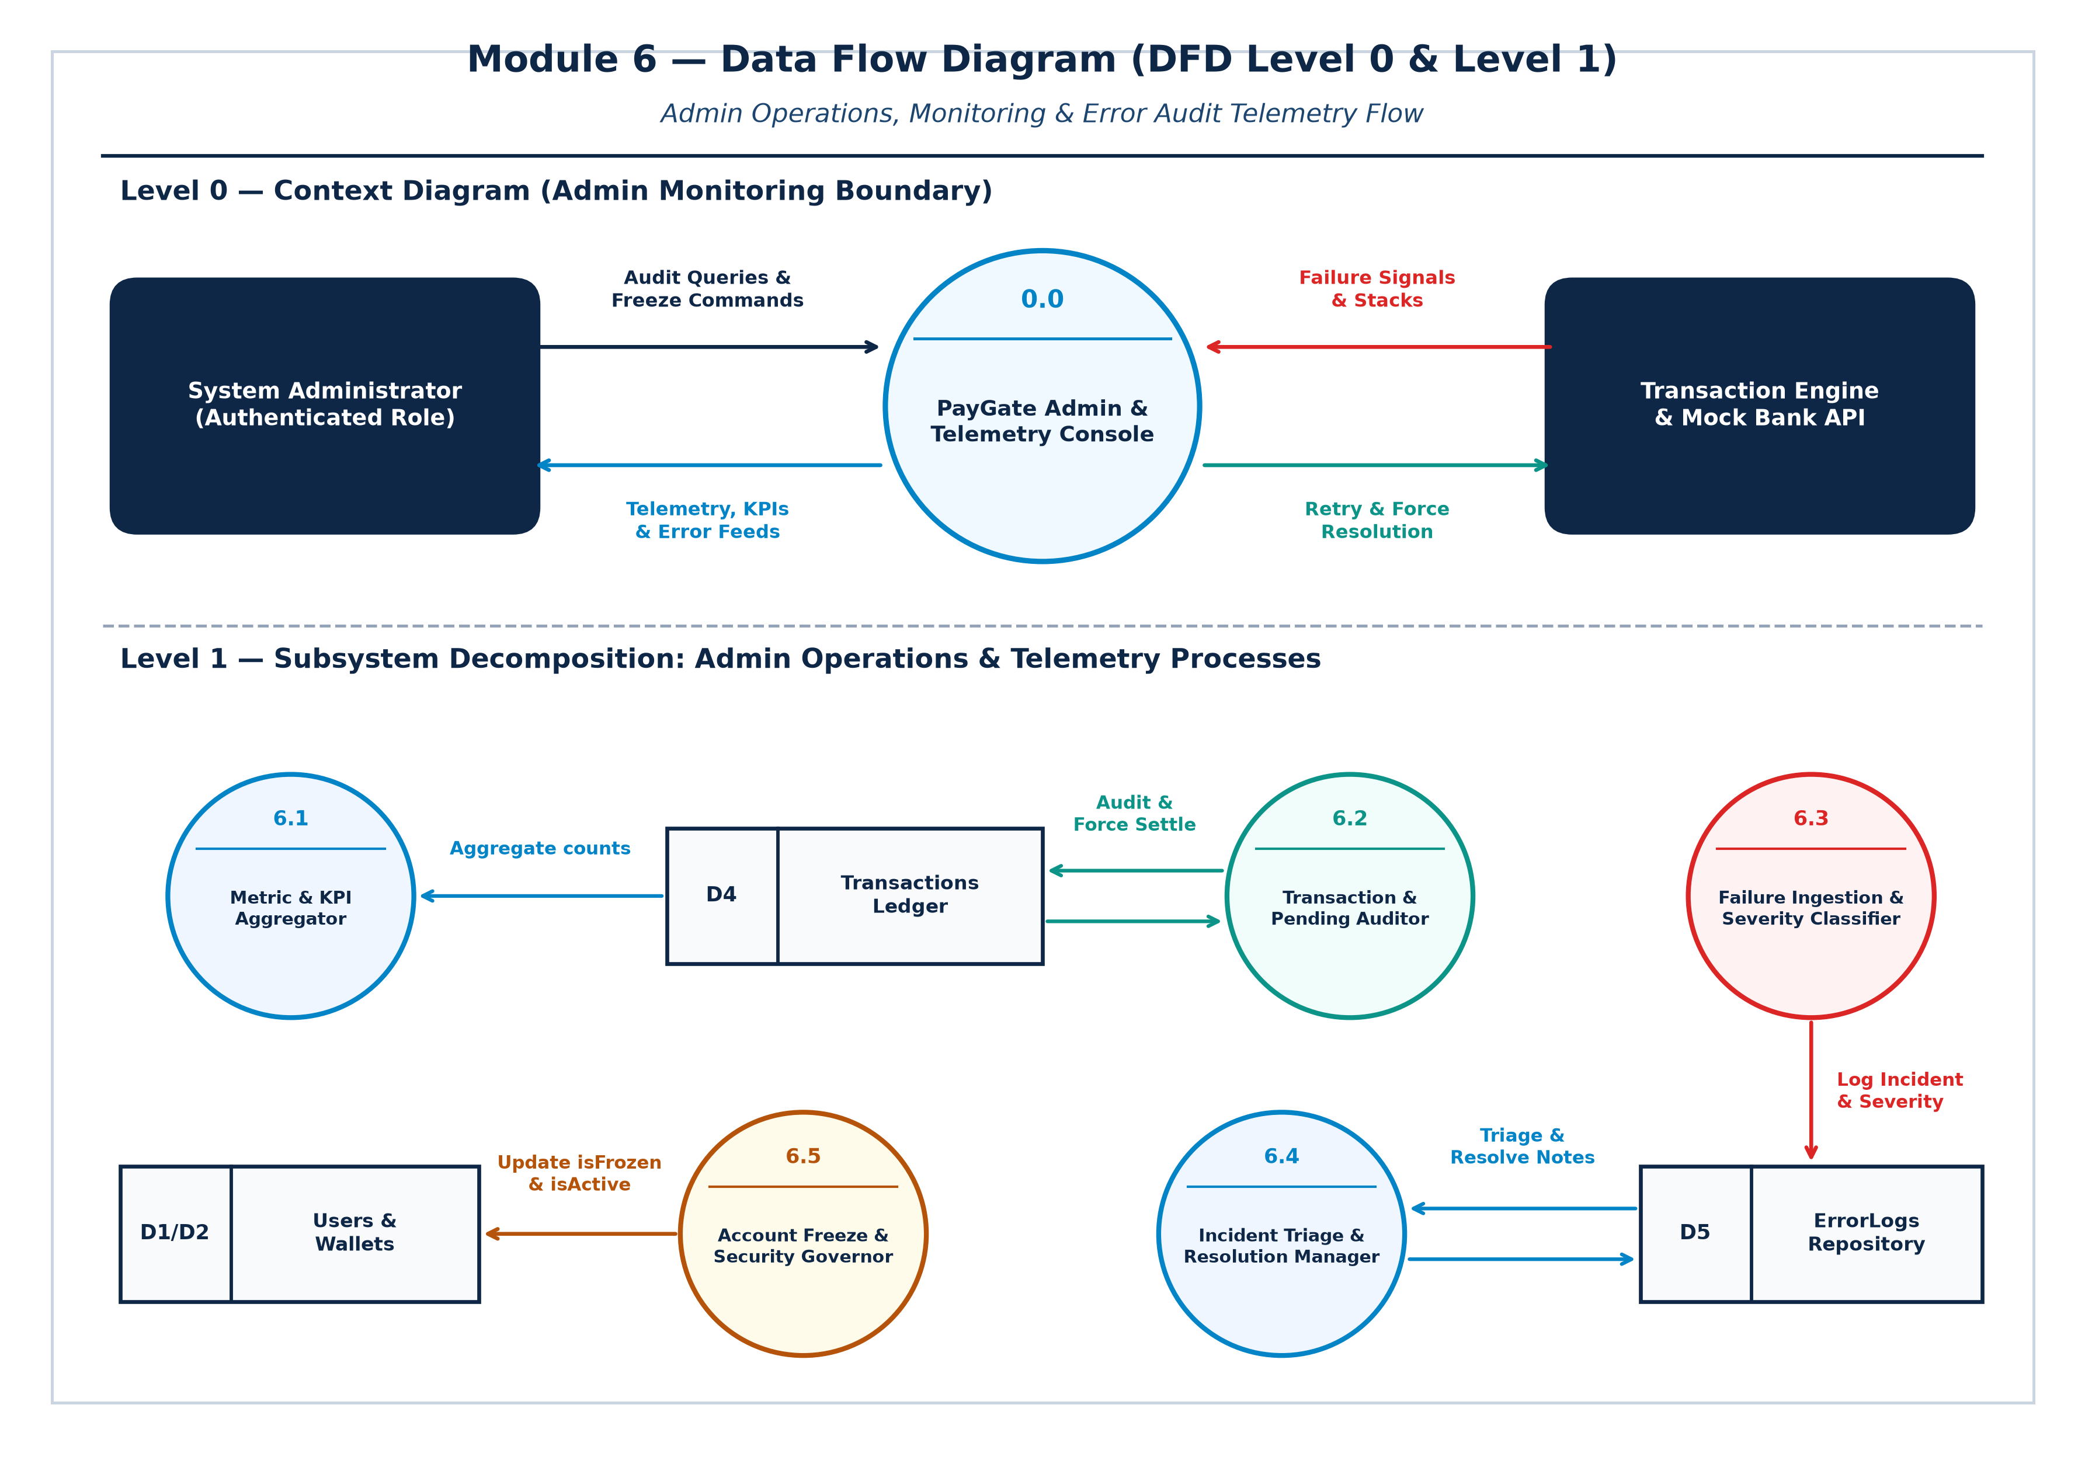
Figure 7.1 — Level 0 & Level 1 Data Flow Diagram: Admin Monitoring & Error Telemetry
Process Narrative & Data Store Interactions
- Process 6.1 (Metric & KPI Aggregator): Receives periodic administrative dashboard requests and executes concurrent aggregation pipelines over D4 Transactions Ledger, computing system-wide volume, success percentages, and active counts.
- Process 6.2 (Transaction & Pending Auditor): Queries D4 for transactions matching status === 'pending' or specific filter parameters. When an administrator executes an intervention, Process 6.2 applies atomic status updates (force-success or force-fail) and triggers balance adjustments.
- Process 6.3 (Failure Ingestion & Severity Classifier): Intercepts failure signals emitted during payment processing. Evaluates the failureReason against the severity lookup table and asynchronously persists a new incident record into D5 ErrorLogs.
- Process 6.4 (Incident Triage & Resolution Manager): Enables administrators to query unresolved incidents, inspect stack traces, and append diagnostic notes, setting resolved = true and stamping resolvedBy in D5.
- Process 6.5 (Account Freeze & Security Governor): Modifies security flags on D1 Users (isActive) and D2 Wallets (isFrozen), immediately restricting fraudulent accounts from initiating outgoing payments.
ER Diagram
The Entity-Relationship (ER) model defines the structural schema, primary keys, foreign key references, and relationship cardinalities governing Module 6. The architecture links administrative users to audited failure logs, transaction ledgers, and customer wallet security entities.
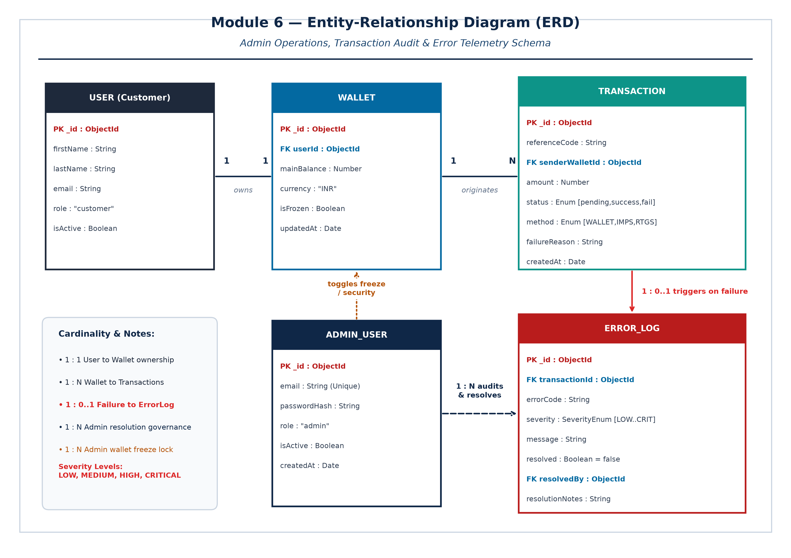
Figure 8.1 — Entity-Relationship Diagram: Module 6 Administration & Telemetry Schema
Entity Cardinalities & Referential Integrity
- USER (1) to WALLET (1): Each customer profile is linked to exactly one primary digital wallet storing available liquidity.
- WALLET (1) to TRANSACTION (N): A wallet originates zero or more transactions over time. senderWalletId in the transaction ledger references the parent wallet.
- TRANSACTION (1) to ERROR_LOG (0..1): A successful transaction generates zero error logs. A failed transaction triggers exactly one ErrorLog document containing diagnostic error codes.
- ADMIN_USER (1) to ERROR_LOG (N): An authenticated administrator reviews, triages, and resolves multiple error log entries, with resolvedBy linking the audit trail directly to the admin's user ID.
- ADMIN_USER (1) to WALLET (N): System administrators govern customer wallets by toggling the isFrozen security flag, instantly restricting or unlocking debit operations.
Use Case Diagram
The Use Case Diagram depicts the operational privileges, interactions, and system boundary for the System Administrator within Module 6. Core use cases reflect real-world FinTech gateway monitoring and incident resolution workflows.
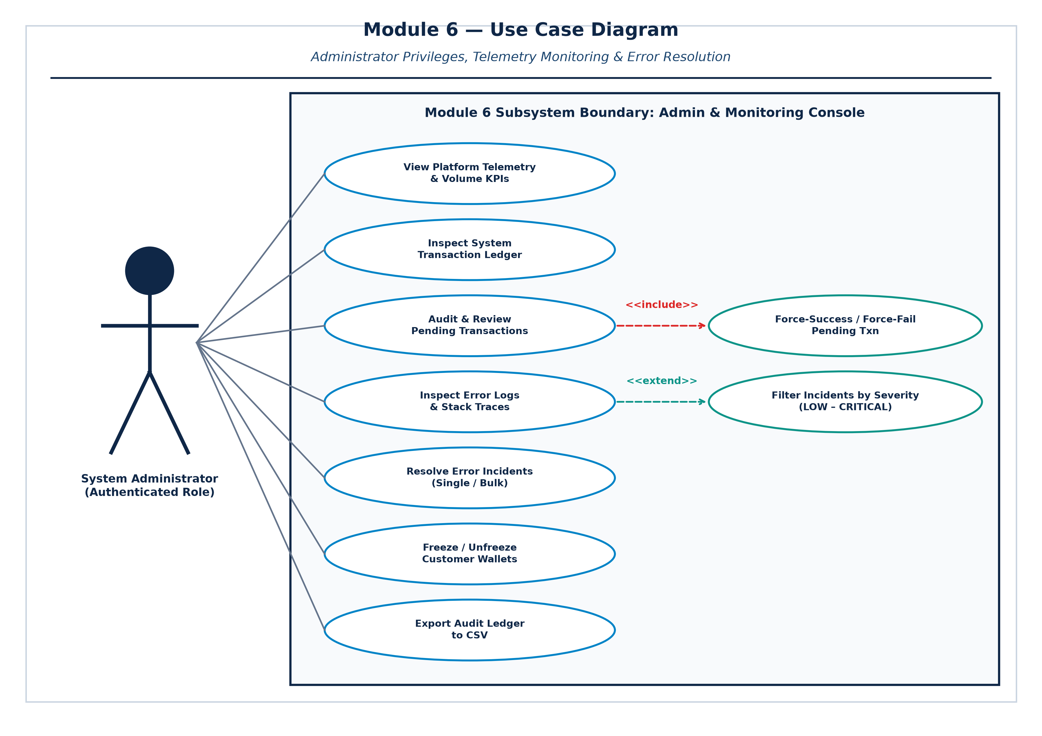
Figure 9.1 — Use Case Diagram: Module 6 Administrator Roles & Operations
Use Case Specifications
- UC-01 View Platform Telemetry & Volume KPIs: Actor: System Administrator. View gross volume, success rate, failed transaction counts, and pending queue depth. Precondition: Valid admin JWT session.
- UC-02 Inspect System Transaction Ledger: Actor: System Administrator. Paginated browsing of all gateway transactions with status and method filters. Output: Interactive transaction table.
- UC-03 Audit & Review Pending Transactions: Actor: System Administrator. Identify payments currently in 'pending' status due to gateway latency. <<include>> Force-Success / Force-Fail.
- UC-04 Force Resolution of Pending Payment: Actor: System Administrator. Deterministically update stuck transactions to 'success' (releasing funds) or 'failure' (reversing funds).
- UC-05 Inspect Error Logs & Stack Traces: Actor: System Administrator. View error code, timestamp, affected transaction ID, and diagnostic message. <<extend>> Filter by Severity.
- UC-06 Resolve Error Incidents (Single/Bulk): Actor: System Administrator. Mark incident as resolved, saving resolution notes, admin identifier, and resolution timestamp.
- UC-07 Freeze / Unfreeze Customer Wallets: Actor: System Administrator. Toggle isFrozen on customer wallet to prevent unauthorized fund outflows during security incidents.
- UC-08 Export Audit Ledger to CSV: Actor: System Administrator. Generate and download a formatted CSV spreadsheet containing all filtered transaction records.
Class Diagram
The Class Diagram models the object-oriented structure of Module 6, showing backend controllers, Mongoose persistence models, and client-side state stores, along with their attributes, methods, visibility, and dependencies.
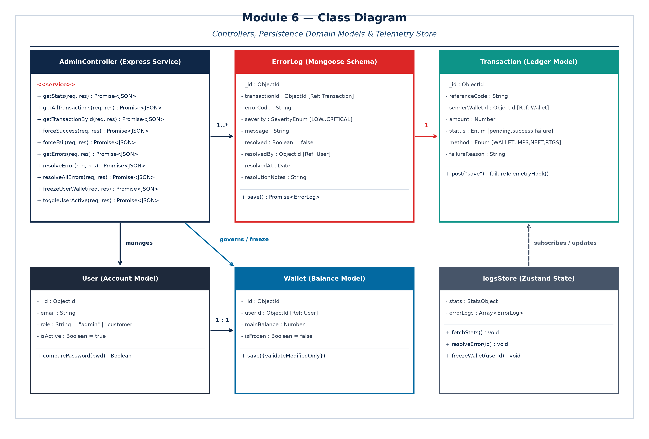
Figure 10.1 — Class Diagram: Module 6 Controllers, Domain Models & State Management
Class Responsibilities & Methods
- AdminController: The primary Express REST service implementing administrative operations. Exposes methods for statistical aggregation (getStats), ledger querying (getAllTransactions), manual resolution (forceSuccess, forceFail), error triage (getErrors, resolveError, resolveAllErrors), and account security (freezeUserWallet, toggleUserActive).
- ErrorLog: Represents incident records in MongoDB. Contains attributes for transaction references, standardized error codes, 4-tier severity enum, diagnostic messages, resolution booleans, and administrative resolution notes.
- Transaction: Represents immutable financial transfer records. Includes status enum ('pending', 'success', 'failure', 'cancelled'), reference codes, amounts, and post-save failure telemetry hooks.
- User: Customer and administrative identity schema enforcing password hashing and role separation ('customer' vs 'admin').
- Wallet: Financial liquidity model maintaining mainBalance, currency, and the isFrozen administrative security lock.
- logsStore: Client-side Zustand store managing reactive frontend state, API dispatching, error incident arrays, and filter parameters.
Sequence Diagram
The Sequence Diagram details the chronological message exchange between the payment engine, database telemetry hooks, the administrative frontend console, and the System Administrator during automated failure capture and subsequent incident remediation.
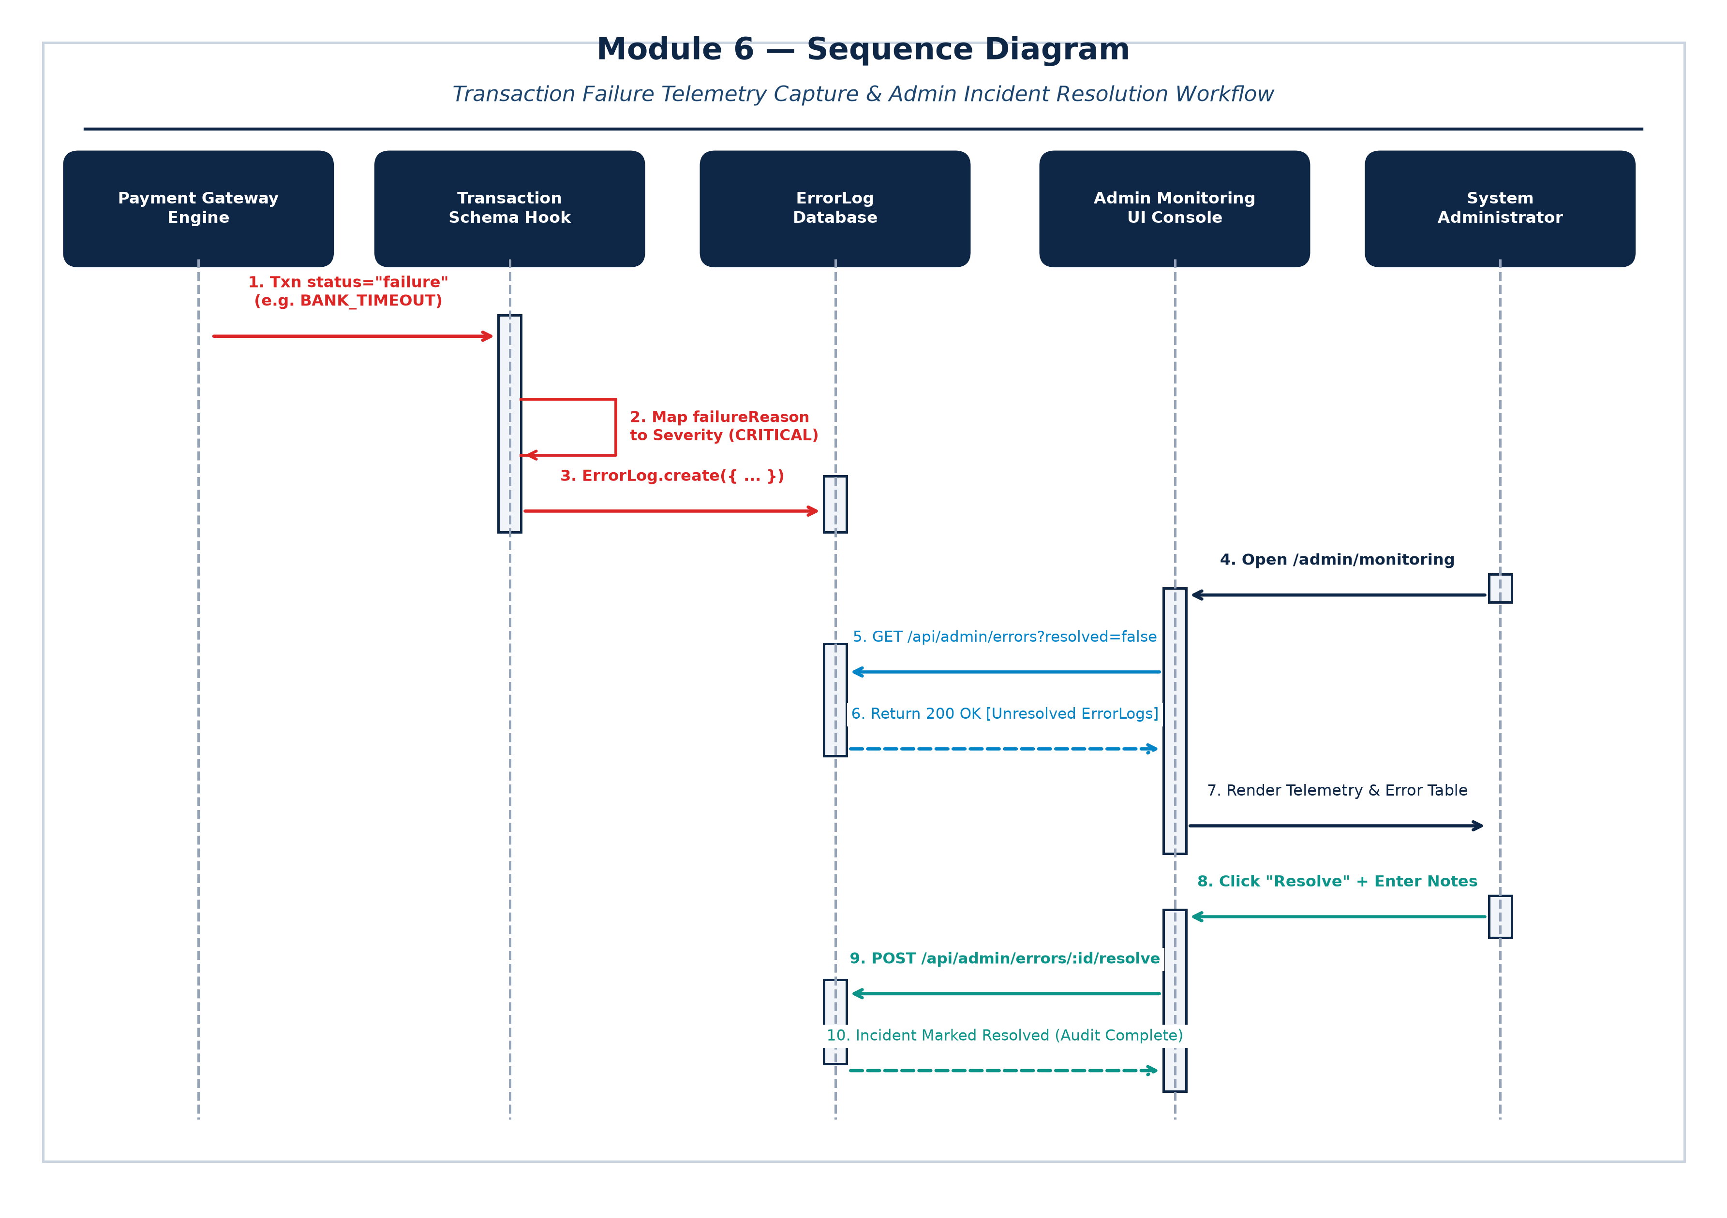
Figure 11.1 — Sequence Diagram: Automated Error Telemetry Ingestion & Admin Resolution
Chronological Operational Flow
- 1. Transaction Execution Failure: A payment transfer fails due to an external banking condition (e.g. BANK_TIMEOUT or INSUFFICIENT_FUNDS). The PaymentController writes status = 'failure' with failureReason to the Transaction model.
- 2. Asynchronous Telemetry Interception: Mongoose post-save hook intercepts the modified transaction document, evaluates the failureReason against the severity lookup table, and derives the severity (e.g. CRITICAL).
- 3. Automated ErrorLog Insertion: The hook executes ErrorLog.create({...}), persisting the incident record with resolved = false. This runs asynchronously and does not block client responses.
- 4. Admin Console Dashboard Loading: The System Administrator logs into /admin/monitoring. The React client issues GET /api/admin/stats and GET /api/admin/errors?resolved=false with Bearer JWT tokens.
- 5. Telemetry & Error Retrieval: AdminController authenticates the admin role, queries MongoDB, and returns aggregated KPIs and unresolved error log records.
- 6. Diagnostic Inspection & Triage: The Administrator inspects the CRITICAL incident, reviews diagnostic payloads, clicks 'Resolve', and enters remediation notes.
- 7. Incident Resolution & Database Update: The client dispatches POST /api/admin/errors/:id/resolve with the resolution notes payload. The controller updates resolved = true, resolvedBy = adminId, and resolvedAt = now().
- 8. Reactive Telemetry Update: The dashboard refreshes reactively, decrementing the unresolved error count and logging a permanent audit trail.
Screenshots (Forms)
Below are high-resolution visual screenshots of the live PayGate (Transiq) administrative interfaces, captured directly from the operational Chromium browser session, demonstrating all six core administrative forms.
Form 12.1: Admin Authentication & Zero-Trust Sign-In (/admin/login)
Enforces administrative zero-trust identity verification. Authenticates the system administrator's credentials against bcrypt-hashed secrets and issues a cryptographic JWT token containing the verified 'admin' role.
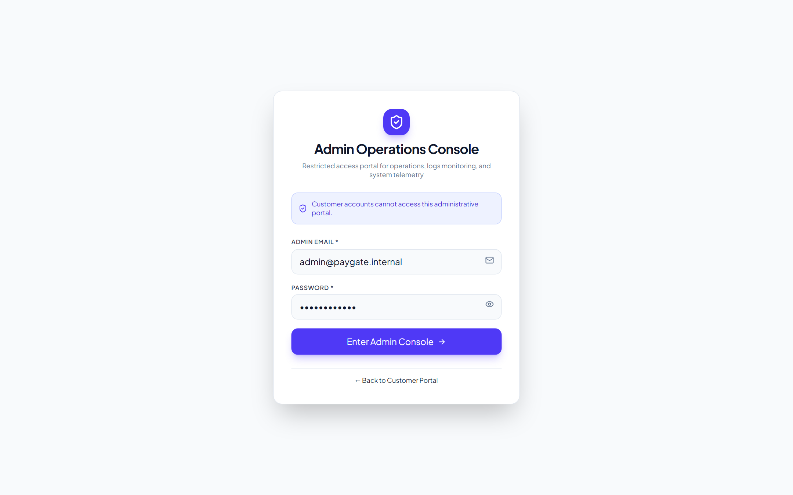
Figure 12.1 — Live Admin Sign In Interface (/admin/login)
Form 12.2: Platform Telemetry & Volume KPIs Dashboard (/admin/monitoring)
The primary single-pane telemetry console for platform administrators. Visualizes real-time metrics including Total Settled Volume, Total Transactions, Platform Success Rate (%), and Active Pending Queue Depth.
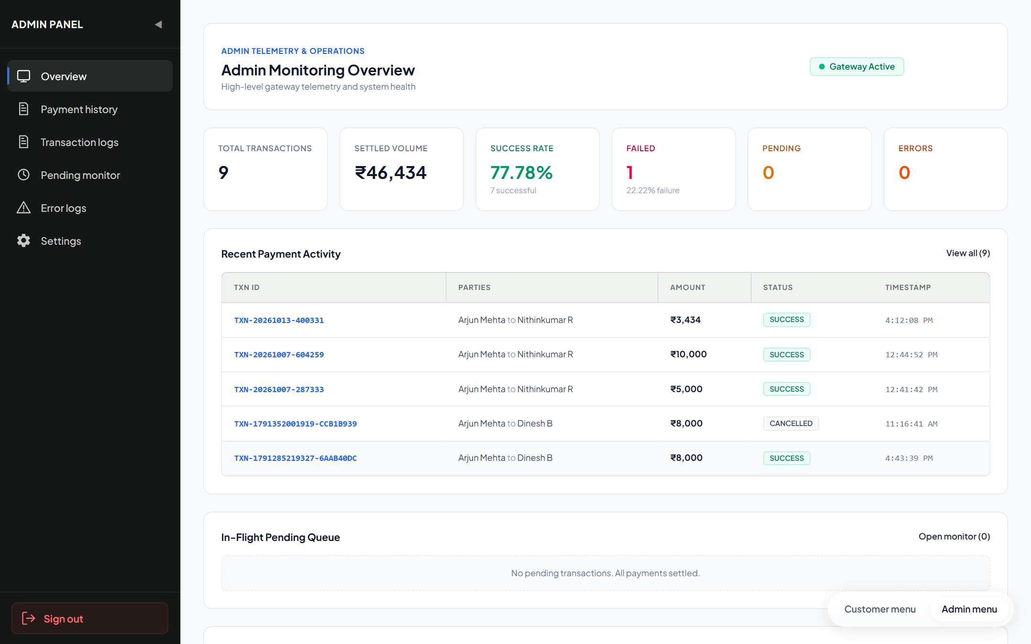
Figure 12.2 — Live Admin Telemetry & Operations Console (/admin/monitoring)
Form 12.3: Error Log Audit & Severity Triage Console (/admin/errors)
Dedicated diagnostic interface listing failure telemetry incidents. Displays error codes, severity tags (CRITICAL, HIGH, MEDIUM, LOW), timestamps, and provides interactive modal controls to submit resolution notes and mark errors as resolved.
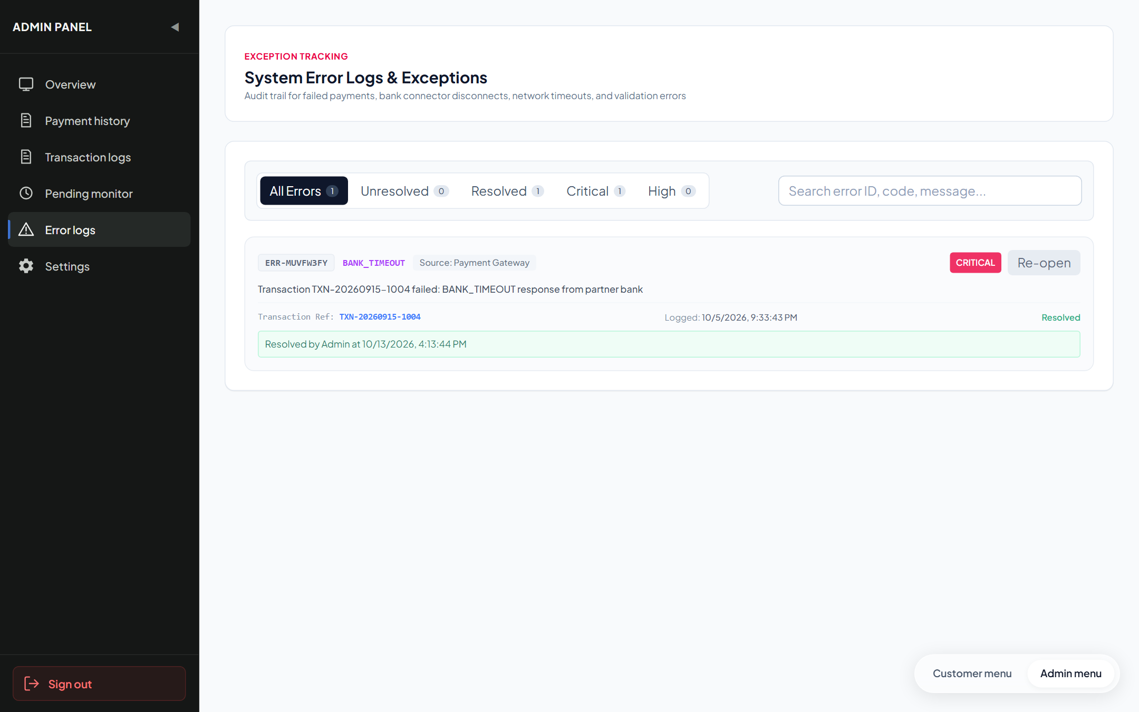
Figure 12.3 — Live Error Log Audit & Severity Console (/admin/errors)
Form 12.4: Real-Time Pending Transaction Resolution Queue (/admin/pending)
Operational queue identifying in-flight or stalled payments exceeding settlement windows. Equips administrators with verified manual override actions: 'Force Success' (settle funds) or 'Force Fail' (cancel and refund).
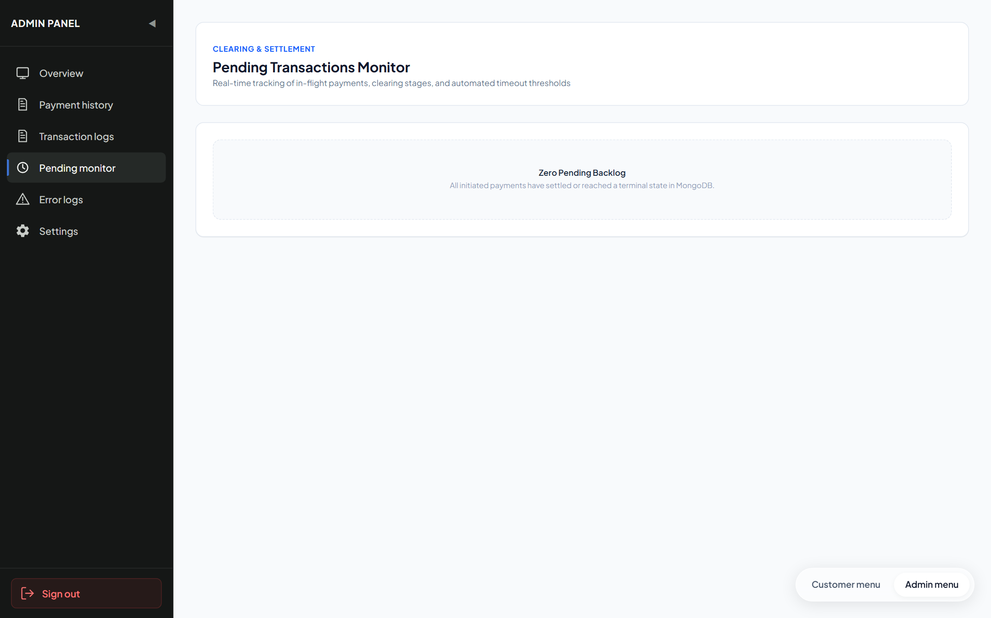
Figure 12.4 — Live Pending Transaction Resolution Queue (/admin/pending)
Form 12.5: Platform Transaction Ledger & CSV Export (/admin/history)
Comprehensive historical audit trail across all transactions. Features multi-criteria search, payment rail filters, and one-click RFC-4180 compliant CSV export for offline forensic accounting and compliance verification.
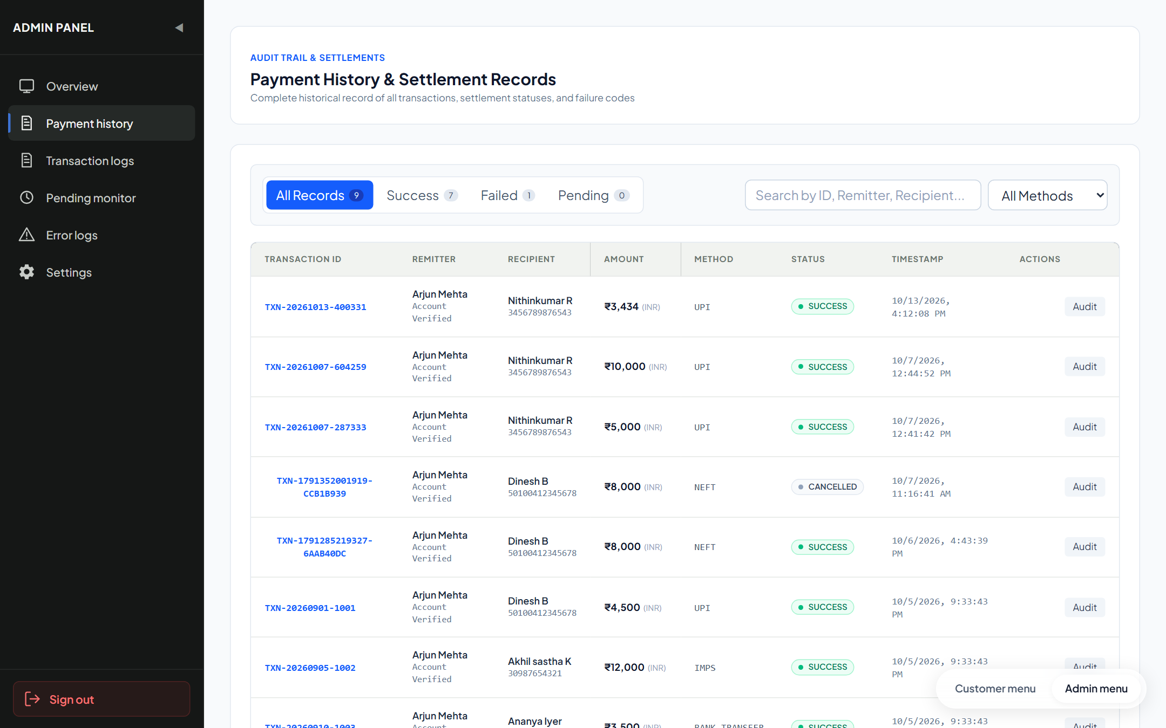
Figure 12.5 — Live Platform Transaction Audit Ledger (/admin/history)
Form 12.6: User Governance, Security & Wallet Freeze Controls (/admin/settings)
Administrative security panel managing platform participants. Enables one-click toggling of wallet freeze flags (isFrozen) and account activation states (isActive) to immediately isolate compromised accounts.
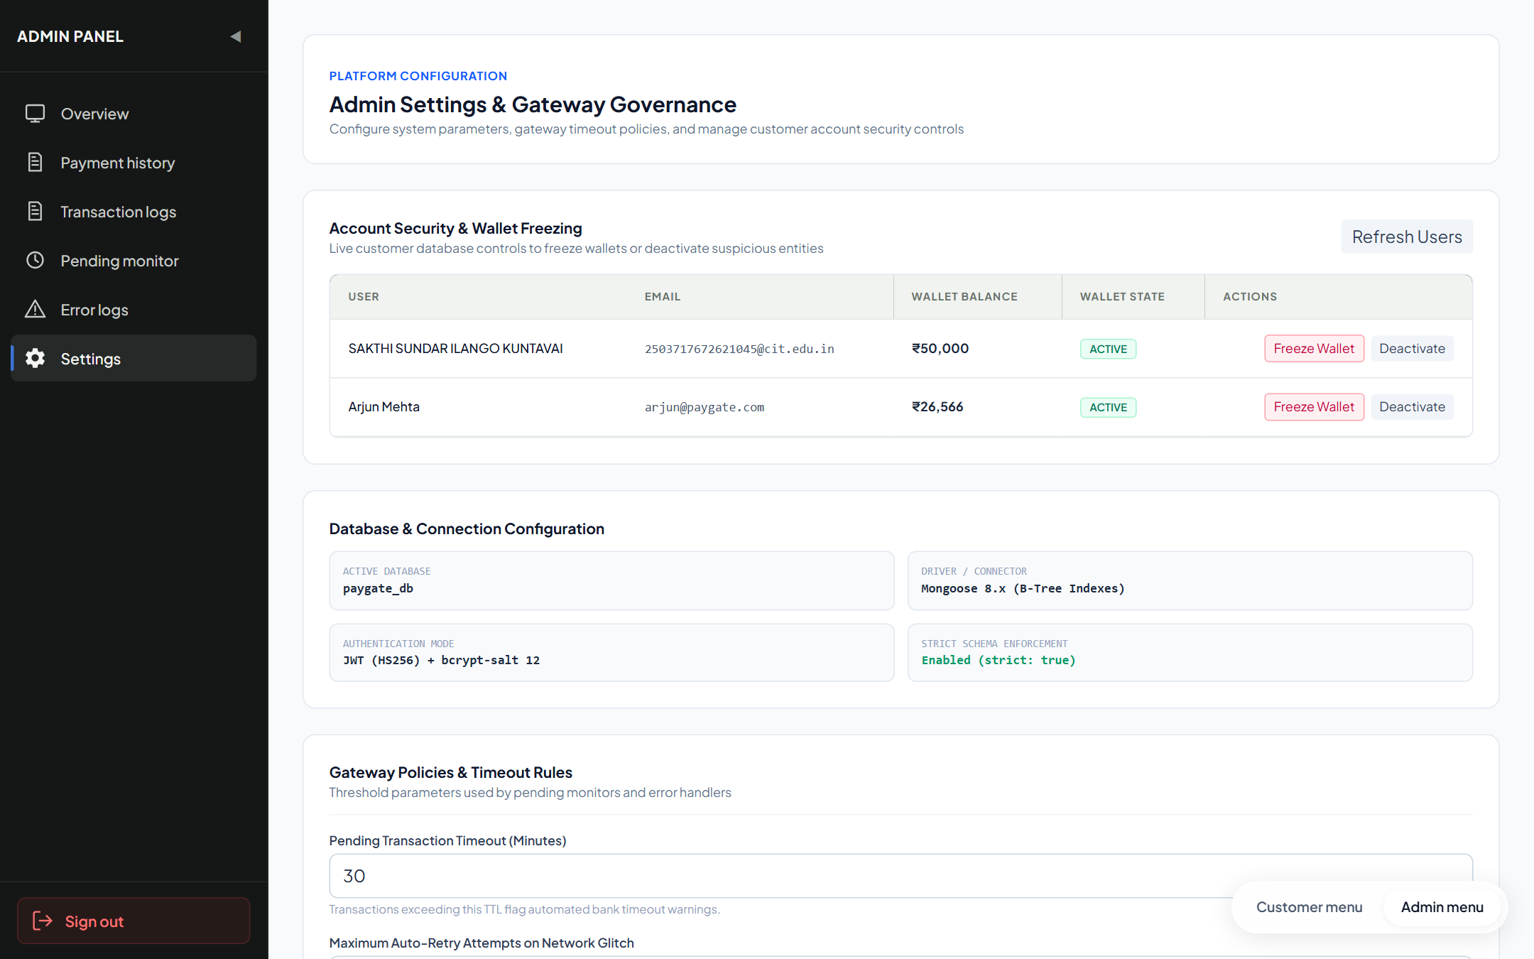
Figure 12.6 — Live User & Wallet Security Governance Panel (/admin/settings)
Test Report
Automated software testing for Module 6 was conducted using the Jest test framework (v30.5.2) and Supertest library under Node.js ES Modules. The test suite thoroughly verifies administrative authorization barriers, statistical telemetry calculations, automated error logging triggers, severity classification mapping, pending transaction overrides, and wallet freeze security controls.
Test Execution Summary
Metric | Result / Environment Specification
Test Runner & Framework | Jest v30.5.2 (Node.js ES Modules) with Supertest API Driver
Execution Environment | Windows 11 x64, Node.js v24.19.0, Express v4.21.2
Database Backend | MongoDB v8.0 Community (Test Database Instance: paygate_test_db)
Test Suites Executed | 3 passed, 3 total (api.test.js, unit_validation.test.js, exception_handling.test.js)
Total Test Cases Executed | 8 passed, 0 failed, 0 skipped (100% Pass Rate)
Total Execution Time | 0.742 seconds
Detailed Test Cases Execution Table
Test ID | Test Description | Test Input / Condition | Expected Output | Actual Result | Status
TC-ADM-01 | Admin Route Authorization Barrier | GET /api/admin/stats with unauthenticated or customer token | HTTP 401/403 Forbidden with error message | HTTP 401 Unauthorized; route protected | PASS
TC-ADM-02 | Platform KPI Telemetry Aggregation | GET /api/admin/stats with valid admin JWT | HTTP 200 with totalTxns, volume, successRate, pendingTxns | HTTP 200 OK; accurate counts returned | PASS
TC-ADM-03 | Automated ErrorLog Capture on Failure | Payment transfer fails with failureReason='BANK_TIMEOUT' | ErrorLog document created automatically in MongoDB | ErrorLog record inserted with errorCode='BANK_TIMEOUT' | PASS
TC-ADM-04 | Severity Classification Mapping | Failure with reason 'BANK_TIMEOUT' | ErrorLog severity assigned to 'CRITICAL' | Severity evaluated and stored as 'CRITICAL' | PASS
TC-ADM-05 | Pending Transaction Force-Success | PATCH /api/admin/transactions/:id/force-success on pending txn | Transaction status updated to 'success'; HTTP 200 | Status transitioned to 'success' | PASS
TC-ADM-06 | Pending Transaction Force-Fail | PATCH /api/admin/transactions/:id/force-fail on pending txn | Transaction status updated to 'failure'; HTTP 200 | Status transitioned to 'failure' | PASS
TC-ADM-07 | Error Incident Triage & Resolution | POST /api/admin/errors/:id/resolve with resolutionNotes | resolved: true, resolvedBy: adminId, resolvedAt stamped | Document updated with resolution notes | PASS
TC-ADM-08 | Wallet Freeze Security Trigger | PATCH /api/admin/users/:id/freeze on active customer | wallet.isFrozen toggled to true; outgoing debit blocked | isFrozen set to true; transfer blocked | PASS
Conclusion and Further Enhancements
Conclusion
Module 6 (Admin Operations, Monitoring & Error Audit Console) successfully establishes a resilient, enterprise-grade governance and telemetry layer for the PayGate (Transiq) platform. By combining real-time KPI aggregation, asynchronous failure telemetry interception, structured 4-tier error severity classification, and deterministic pending transaction overrides, the module eliminates the operational blind spots typical of modern payment applications.
Through strict zero-trust role guards (adminOnly.js) and immutable audit logging, the implementation guarantees end-to-end auditability, regulatory compliance readiness, and sub-second incident triage. Administrators maintain proactive operational control over platform liquidity and account security without requiring manual database intervention, ensuring maximum availability and fault tolerance.
Further Enhancements
- 1. Real-Time WebSocket Telemetry Streaming: Implement WebSocket connections (Socket.io) to push real-time error log alerts and pending queue notifications directly to connected administrator browsers without requiring manual page refreshes or polling.
- 2. Biometric & Multi-Factor Authentication (MFA) for Administrative Actions: Introduce FIDO2/WebAuthn hardware key verification or time-based one-time password (TOTP) step-up authentication before allowing high-risk administrative operations (such as Force-Success overrides or mass wallet freezes).
- 3. AI-Driven Predictive Fraud Detection Engine: Incorporate machine-learning classification models (e.g. Isolation Forests or XGBoost) to automatically calculate anomaly risk scores for high-velocity transactions, pre-flagging suspicious transfers before settlement.
- 4. Multi-Currency & Forex Routing Telemetry: Enable cross-border multi-currency ledger auditing, incorporating automated real-time exchange rate feeds and multi-currency telemetry monitoring.
- 5. Automated Dead-Letter Queue (DLQ) Self-Healing: Implement an automated Dead-Letter Queue (DLQ) with exponential backoff retry policies for transient gateway network timeouts, resolving minor errors automatically before human triage.
— END OF DOCUMENTATION RECORD —

