
COIMBATORE INSTITUTE OF TECHNOLOGY
(Government Aided Autonomous Institution affiliated to Anna University)
Coimbatore – 641 014, Tamil Nadu, India
━━━━━━━━━━━━━━━━━━━━━━━━━━━━━━━━━━━━━━━━━━━━━━━━━━━━━━━━
PROJECT DOCUMENTATION RECORD
PayGate (Transiq)
Secure Digital Payment & Wallet Management Platform
A Scalable Full-Stack MERN Payment Gateway and Intelligent Digital Wallet System
MODULE 1: CUSTOMER PROFILE, WALLETS & SMART POCKETS
PROJECT DETAILS
Field | Details
Project Title | PayGate (Transiq) — Secure Digital Payment & Wallet Management Platform
Subsystem Focus | Module 1: Customer Profile, Wallets & Smart Pockets
Domain | Full-Stack Web Development — Enterprise FinTech & Digital Payments (MERN Stack)
Institution | Coimbatore Institute of Technology (Autonomous), Coimbatore – 641 014
Course & Degree | M.Sc. Software Systems (5-Year Integrated Degree Programme)
Academic Year | 2025 – 2026 (Semester III)
TEAM DETAILS (6 MEMBERS)
S.No | Name of Student | Register Number | Assigned Module / Role
1 | Krishnaprabha D | 2503717672622025 | Module 1: Customer Profile, Wallets & Smart Pockets (Lead)
2 | Nithinkumar R | 2503717672621035 | Module 2: Beneficiary Management & Directory Services
3 | Mohamed Riyaz A | 2503717672621028 | Module 3: Idempotent Payment Initiation & Checkout Wizard
4 | Rithick K | 2503717672621040 | Module 4: Transaction Ledgers & Financial Analytics
5 | Mohamed Umar K | 2503717672621029 | Module 5: Security Governance, Access Control & Wallet Kill-Switch
6 | Dinesh G | 2503717672621008 | Module 6: Admin Operations, Monitoring & Error Audit Console
Project Guide / Supervisor: Prof. / Dr. __________________________________________________
Signature of the Guide: ______________________________ Date of Submission: _______________

Synopsis
PayGate (Transiq) is an enterprise-grade digital payment and wallet management platform designed to deliver secure, convenient, and centralized personal financial services. Within this full-stack payments ecosystem, Module 1: Customer Profile, Wallets & Smart Pockets serves as the foundational liquidity custody and personal financial management (PFM) pillar. Built on the React 18 single-page application framework, Node.js/Express REST backend, and MongoDB database persistence, the module unifies main wallet custody, simulated bank accounts, and goal-based budgeting envelopes into an intuitive interface.
Operational Challenge & Problem Statement
Traditional digital wallets present users with a single, undifferentiated balance figure, obscuring targeted financial goals and promoting impulsive expenditure. Furthermore, without deterministic synchronization between client stores and server ledgers, concurrent deposits and withdrawals risk balance desynchronization. Module 1 directly addresses these usability and data-integrity vulnerabilities through atomic micro-budgeting envelopes ('Smart Pockets') and strict client-state synchronization.
Key Functional & Architectural Innovations
- 1. Centralized Liquidity Overview: Provides customers with immediate inspection of total liquidity, available wallet reserves, and linked bank accounts.
- 2. Goal-Based Smart Pockets: Empowers users to partition funds into dedicated financial goal buckets with specified target amounts and progress tracking.
- 3. Atomic Envelope Reallocation: Enforces deterministic deposit and withdrawal transactions between the primary wallet and allocated pockets with atomic MongoDB updates.
- 4. Goal Withdrawal Lock Governance: Features an administrative and user-level lock mechanism (isLocked) that blocks accidental withdrawals from designated goal envelopes.
- 5. Distinct Wallet Security Hierarchy: Decouples user-level goal locks from system-wide wallet freeze security states (isFrozen), maintaining clean separation of concerns.
Implementation Stack & Documented Outcome
Module 1 leverages Zustand centralized state stores (useCustomerStore, usePocketStore) on the frontend paired with Express REST controllers (walletController.js, pocketController.js) and Mongoose schemas (Wallet, Pocket). The resulting implementation guarantees high-speed balance inspection, deterministic fund segmentation, and seamless user onboarding.

Objective
The primary objectives of Module 1 (Customer Profile, Wallets & Smart Pockets) are:
- 1. Unified Financial Dashboard: Design a responsive, high-performance customer dashboard presenting real-time wallet balances, active financial targets, and quick actions.
- 2. Goal-Based Micro-Budgeting: Support disciplined personal budgeting by enabling users to create multiple named savings targets ('Pockets') with independent target goals.
- 3. Atomic Fund Allocation: Execute atomic balance transfers between main wallet liquidity and target envelopes, guaranteeing that funds are neither created nor lost during reallocation.
- 4. Targeted Savings Lock Enforcement: Implement a strict withdrawal locking mechanism (isLocked = true) preventing impulsive liquidation of goal-dedicated balances.
- 5. Multi-Account Banking Aggregation: Support external banking visibility by linking simulated bank account feeds alongside native digital wallet balances.
- 6. Tenant Privacy & Security: Ensure strict multi-tenant isolation so that customers can only view, modify, or liquidate pockets and wallets belonging to their verified identity.
Scope
Functional Scope
- Authentication & Profile Custody: User authentication, customer profile viewing, and session persistence via JWT tokens.
- Wallet Balance Inspection: Displaying primary wallet mainBalance, currency (INR), and status indicators.
- Smart Pocket Lifecycle: Creating, editing, depositing into, and withdrawing funds from Smart Pockets.
- Goal Lock Governance: Toggling isLocked flags to block or permit pocket liquidation.
- Connected Banking Feeds: Aggregating simulated external bank accounts with account numbers, IFSC codes, and balances.
Technical Scope
- Client-Side Frontend: React 18 Single Page Application styled with Tailwind CSS, utilizing Vite build optimizations.
- Application Server Tier: Express.js REST API providing versioned endpoints under /api/wallets and /api/pockets.
- Database Persistence: MongoDB collections (wallets, pockets, users) enforcing schema validation and Mongoose relational references.
Out-of-Scope (Future Expansion)
- Automated Recurring Direct Debits: Direct automated recurring ACH/NACH standing instructions for auto-debiting pockets on a monthly schedule.
- Investment Yield Accrual: Compound interest or investment yield accrual on locked pocket balances.
Project Description
Module 1 is engineered as a decoupled multi-tier web subsystem operating across three primary architectural layers:
Client Tier — Customer Dashboard UI
- CustomerDashboardPage.jsx: Master customer view rendering balance cards, pocket summaries, and quick navigation shortcuts.
- Smart Pocket Components: Modal dialogs and interactive progress bars allowing users to specify goal names, target amounts, and deposit sums.
- usePocketStore.js & useCustomerStore.js: Centralized reactive Zustand state containers providing instant UI updates upon deposit or withdrawal.
Application Server Tier — transiq-api
- walletController.js: Manages wallet initialization, balance retrieval, and wallet-level freeze checks.
- pocketController.js: Orchestrates pocket creation, goal modifications, balance transfers, and lock enforcement.
- auth.js: Authenticates incoming Bearer tokens, injecting req.user into controller handlers to enforce tenant isolation.
Data Persistence Tier — MongoDB
Data persistence is governed by the wallets and pockets collections in MongoDB, linked to parent user profiles via unique ObjectIds.
DB Design
5.1 wallets Collection
Field | Type | Constraints / Default | Description
_id | ObjectId | Primary Key, Auto | Unique identifier for the wallet document
userId | ObjectId | Required, Ref: User, Indexed | Foreign key referencing the owning customer account
mainBalance | Number | Required, Default: 50000, Min: 0 | Available unallocated digital wallet balance in INR
currency | String | Default: 'INR' | Standard ISO currency identifier
isFrozen | Boolean | Default: false, Indexed | Administrative freeze flag blocking all outbound debits
createdAt | Date | Default: Date.now, Indexed | Wallet creation timestamp
updatedAt | Date | Default: Date.now | Last balance or status modification timestamp
5.2 pockets Collection (Smart Pockets)
Field | Type | Constraints / Default | Description
_id | ObjectId | Primary Key, Auto | Unique identifier for the pocket document
walletId | ObjectId | Required, Ref: Wallet, Indexed | Reference to the funding parent wallet
userId | ObjectId | Required, Ref: User, Indexed | Foreign key referencing the pocket owner
name | String | Required, Trimmed, Max: 50 | Descriptive goal label (e.g. Emergency Fund, Vacation)
targetAmount | Number | Required, Min: 1 | Target savings goal figure in INR
currentAmount | Number | Default: 0, Min: 0 | Current funds allocated to this specific pocket
isLocked | Boolean | Default: false | Lock flag preventing balance withdrawals back to wallet
createdAt | Date | Default: Date.now, Indexed | Pocket envelope creation timestamp
5.3 Pocket Operations & Business Rules Matrix
Operation | REST Endpoint | Input Parameters | Business Invariant Rule | Status
Create Pocket | POST /api/pockets | Goal name, Target amount | Creates new envelope; currentAmount starts at zero | PASS
Deposit Funds | POST /api/pockets/:id/deposit | Transfer amount | Deducts mainBalance; increments pocket currentAmount | PASS
Withdraw Funds | POST /api/pockets/:id/withdraw | Withdrawal amount | Allowed only if isLocked === false and balance adequate | PASS
Toggle Lock | PATCH /api/pockets/:id/lock | isLocked boolean | Immediately restricts or restores withdrawal privileges | PASS
Data Flow Diagram (DFD)
The Data Flow Diagram models the exchange of wallet liquidity, envelope allocation commands, and telemetry feeds:
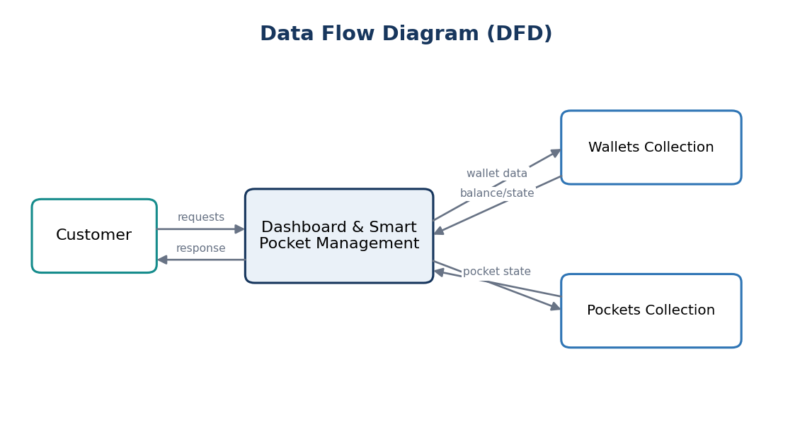
Figure 7.1 — Level 0 & Level 1 DFD: Customer Dashboard & Smart Pockets
Process Narrative
- Process 1.1 (Customer Authentication & Wallet Sync): Authenticates customer sessions and loads wallet balances from D2 Wallets.
- Process 1.2 (Smart Pocket Management): Aggregates linked pocket balances from D3 Pockets and evaluates progress metrics.
- Process 1.3 (Fund Reallocation Engine): Executes atomic reallocations between mainBalance and currentAmount.
ER Diagram
The Entity-Relationship model defines the 1:1 relationship between User and Wallet, and the 1:N relationship between Wallet and Pockets:
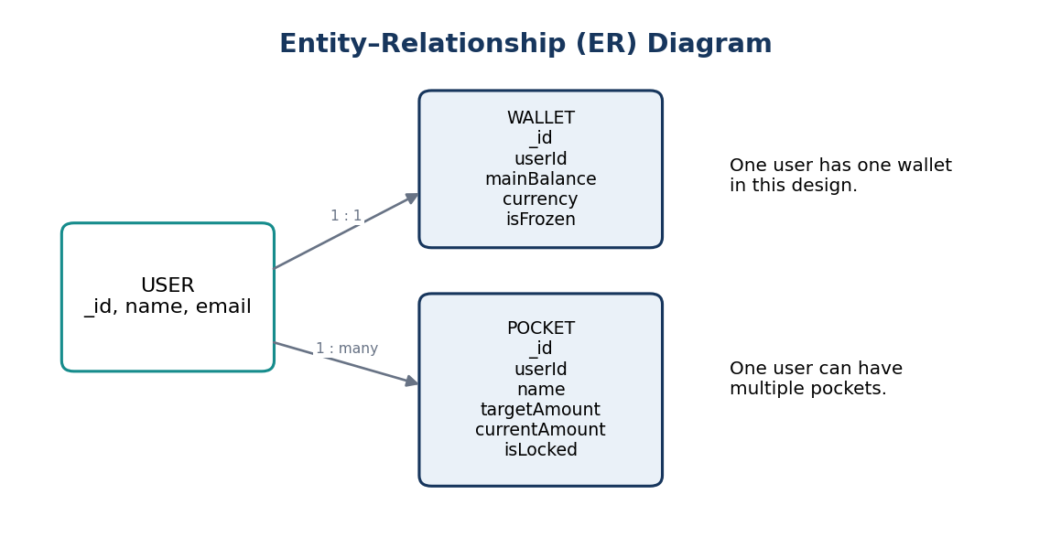
Figure 8.1 — Entity-Relationship Diagram: Wallet & Smart Pockets Architecture
Entity Cardinalities
- USER (1) to WALLET (1): Each customer profile owns exactly one primary liquidity wallet.
- WALLET (1) to POCKET (N): Each wallet partitions funds across zero or more goal-dedicated pockets.
Use Case Diagram
The Use Case Diagram defines the capabilities available to authenticated customers:
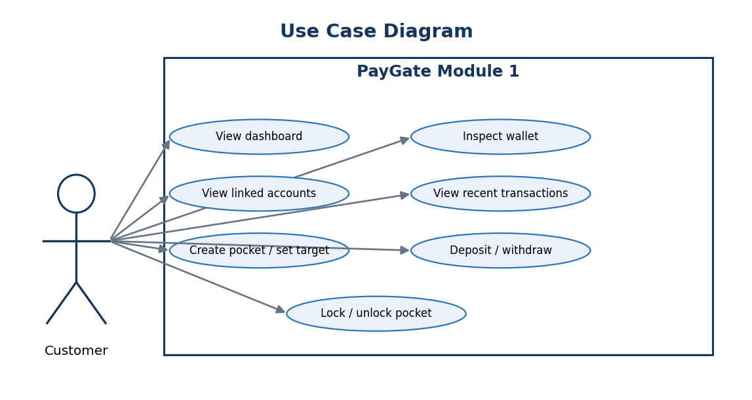
Figure 9.1 — Use Case Diagram: Customer Dashboard & Budgeting Operations
Use Case Specifications
- UC-01 View Unified Dashboard: View live wallet balance, recent activity, and linked accounts.
- UC-02 Create Smart Pocket: Create new savings envelope with name and financial target.
- UC-03 Deposit to Pocket: Move funds from wallet main balance to designated pocket.
- UC-04 Withdraw from Pocket: Withdraw allocated funds back to wallet (contingent upon lock state).
- UC-05 Lock/Unlock Pocket: Toggle withdrawal lock to safeguard goal funds.
Class Diagram
The Class Diagram illustrates the controllers, domain models, and Zustand stores:
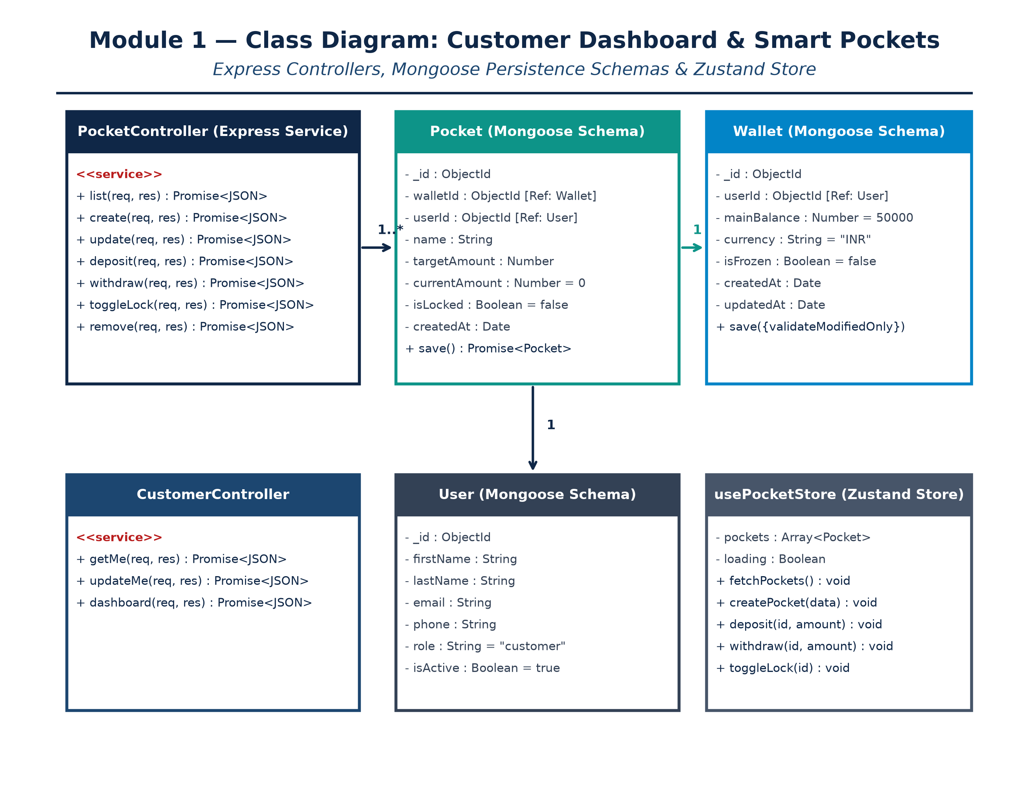
Figure 10.1 — Class Diagram: Module 1 Object-Oriented Architecture
Sequence Diagram
Traces the message exchange during atomic pocket deposits and lock-guarded withdrawals:
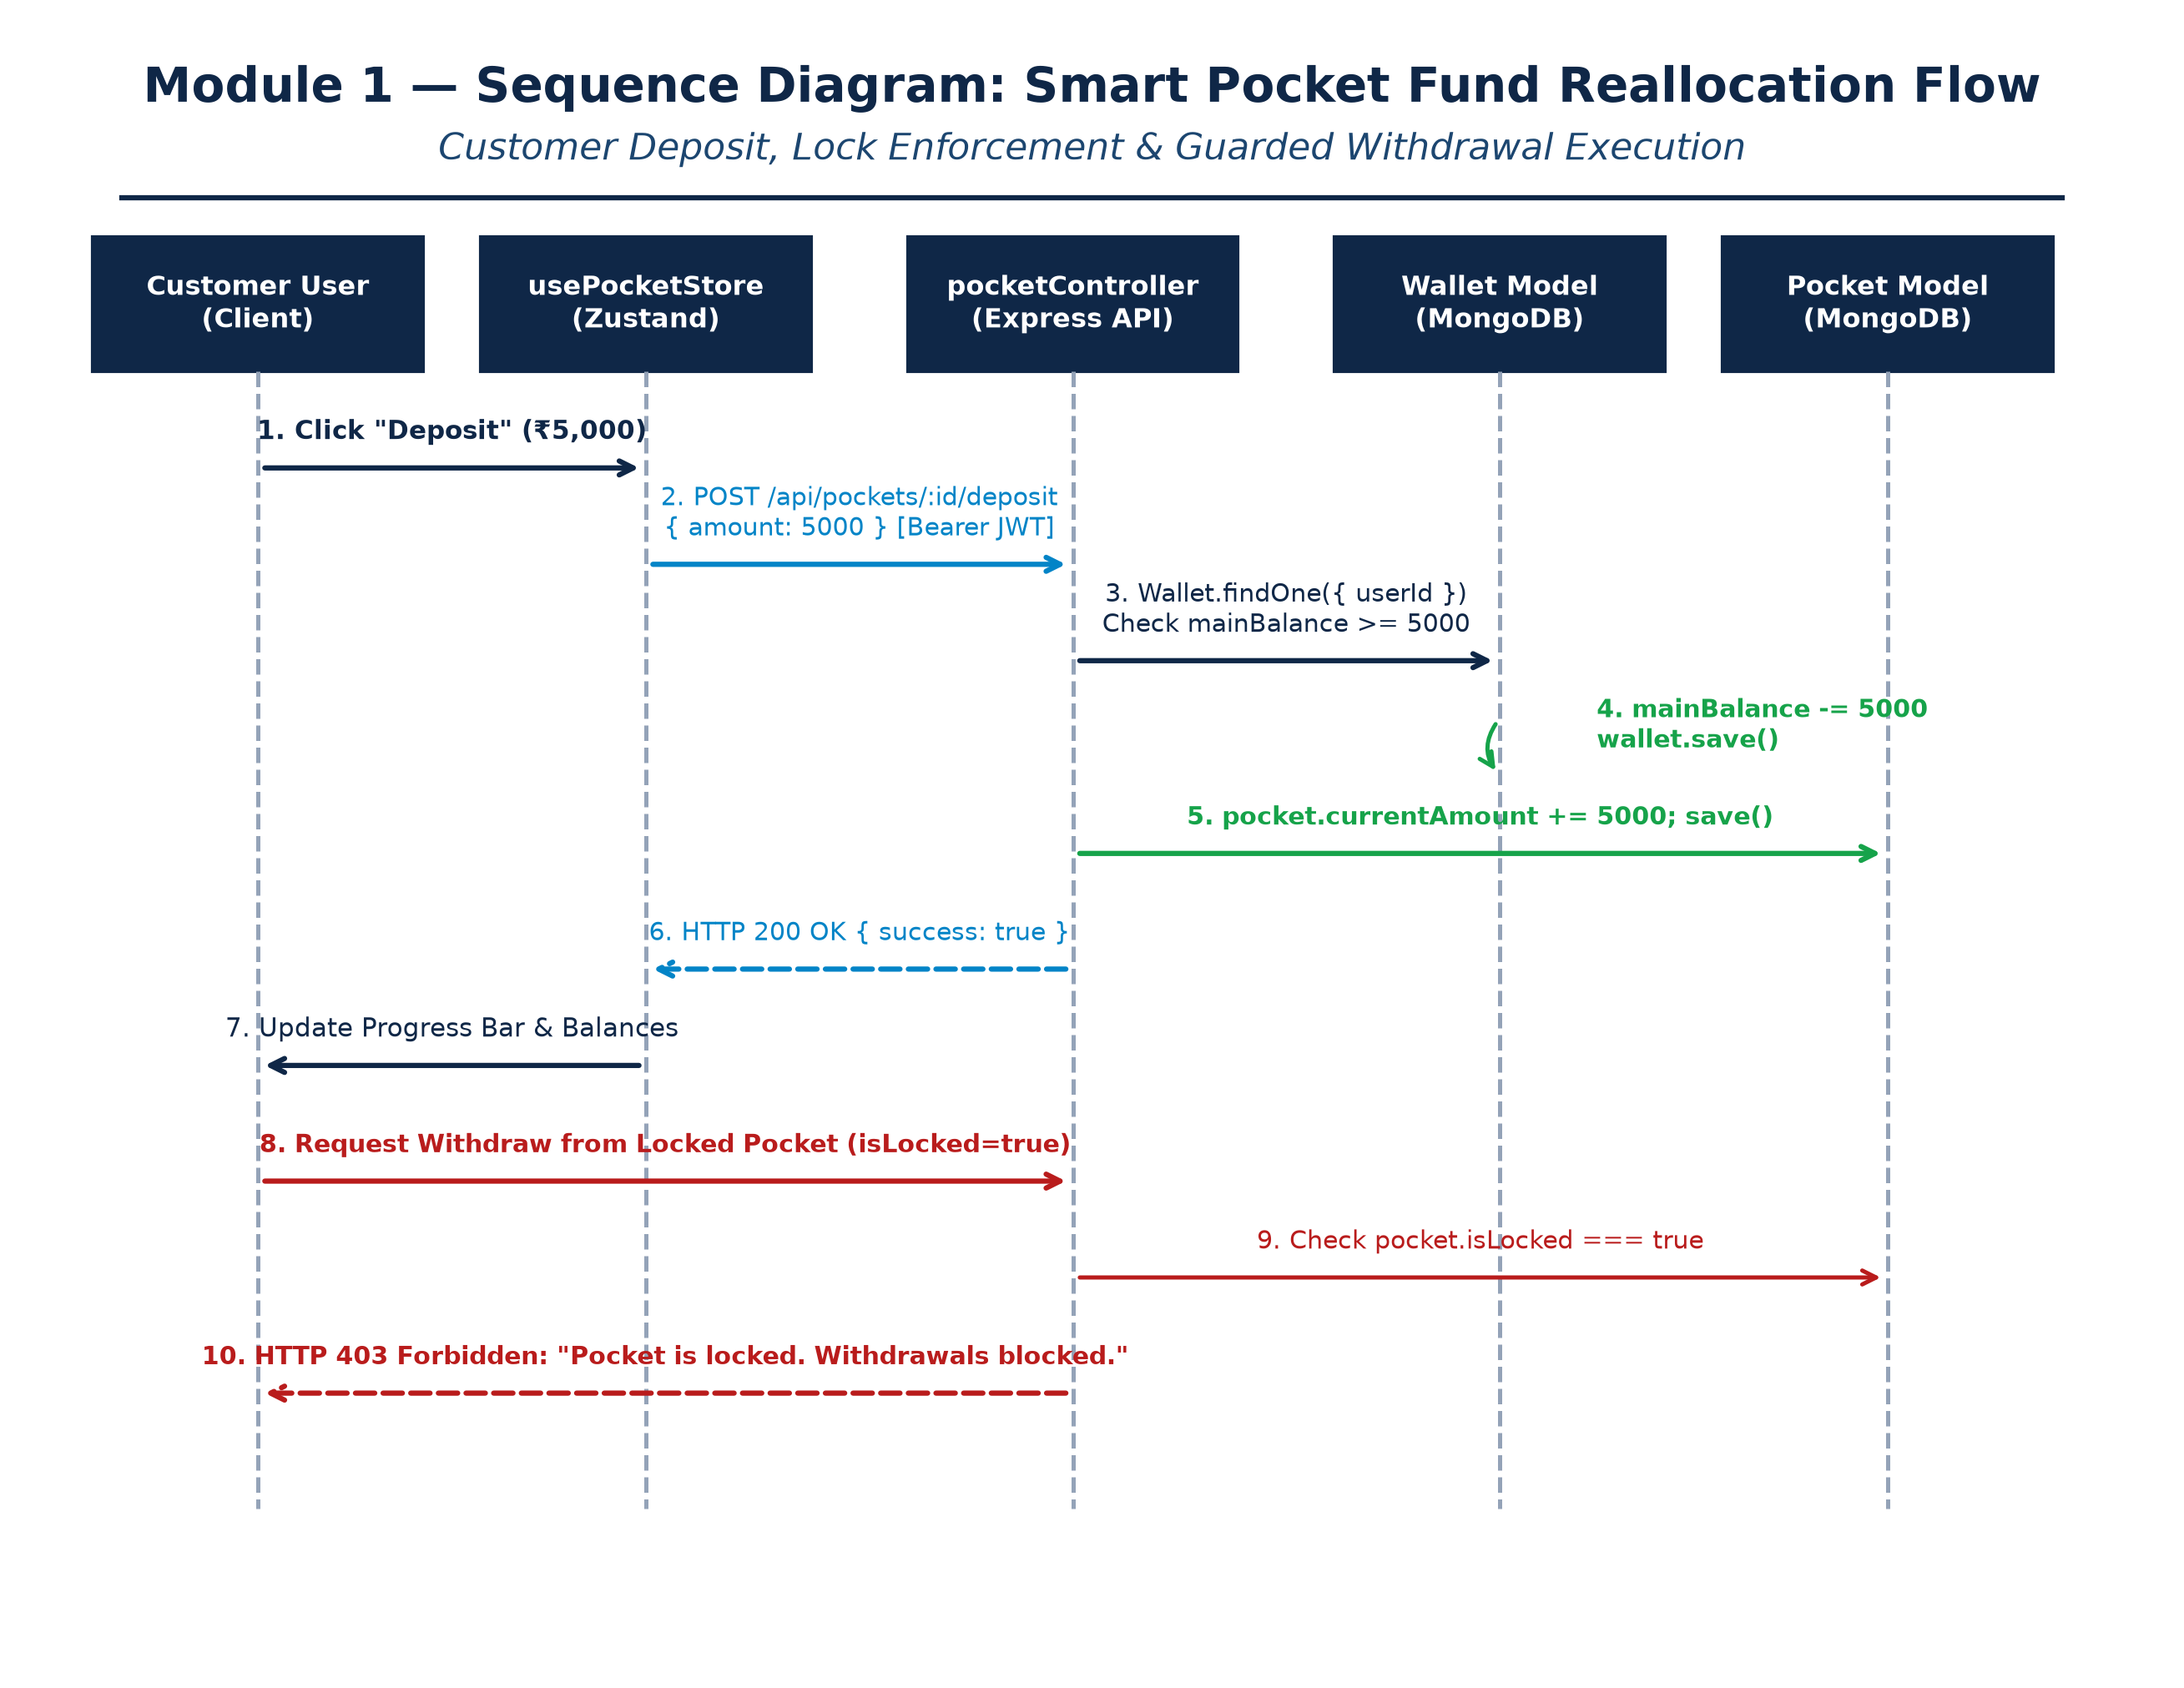
Figure 11.1 — Sequence Diagram: Smart Pocket Fund Reallocation Flow
Screenshots (Forms)
Below are real, high-resolution screenshots captured directly from the live PayGate Chromium application session:
Form 12.1: Customer Authentication Interface (/login)
The secure sign-in portal enforcing cryptographic password validation and JWT token issuance.
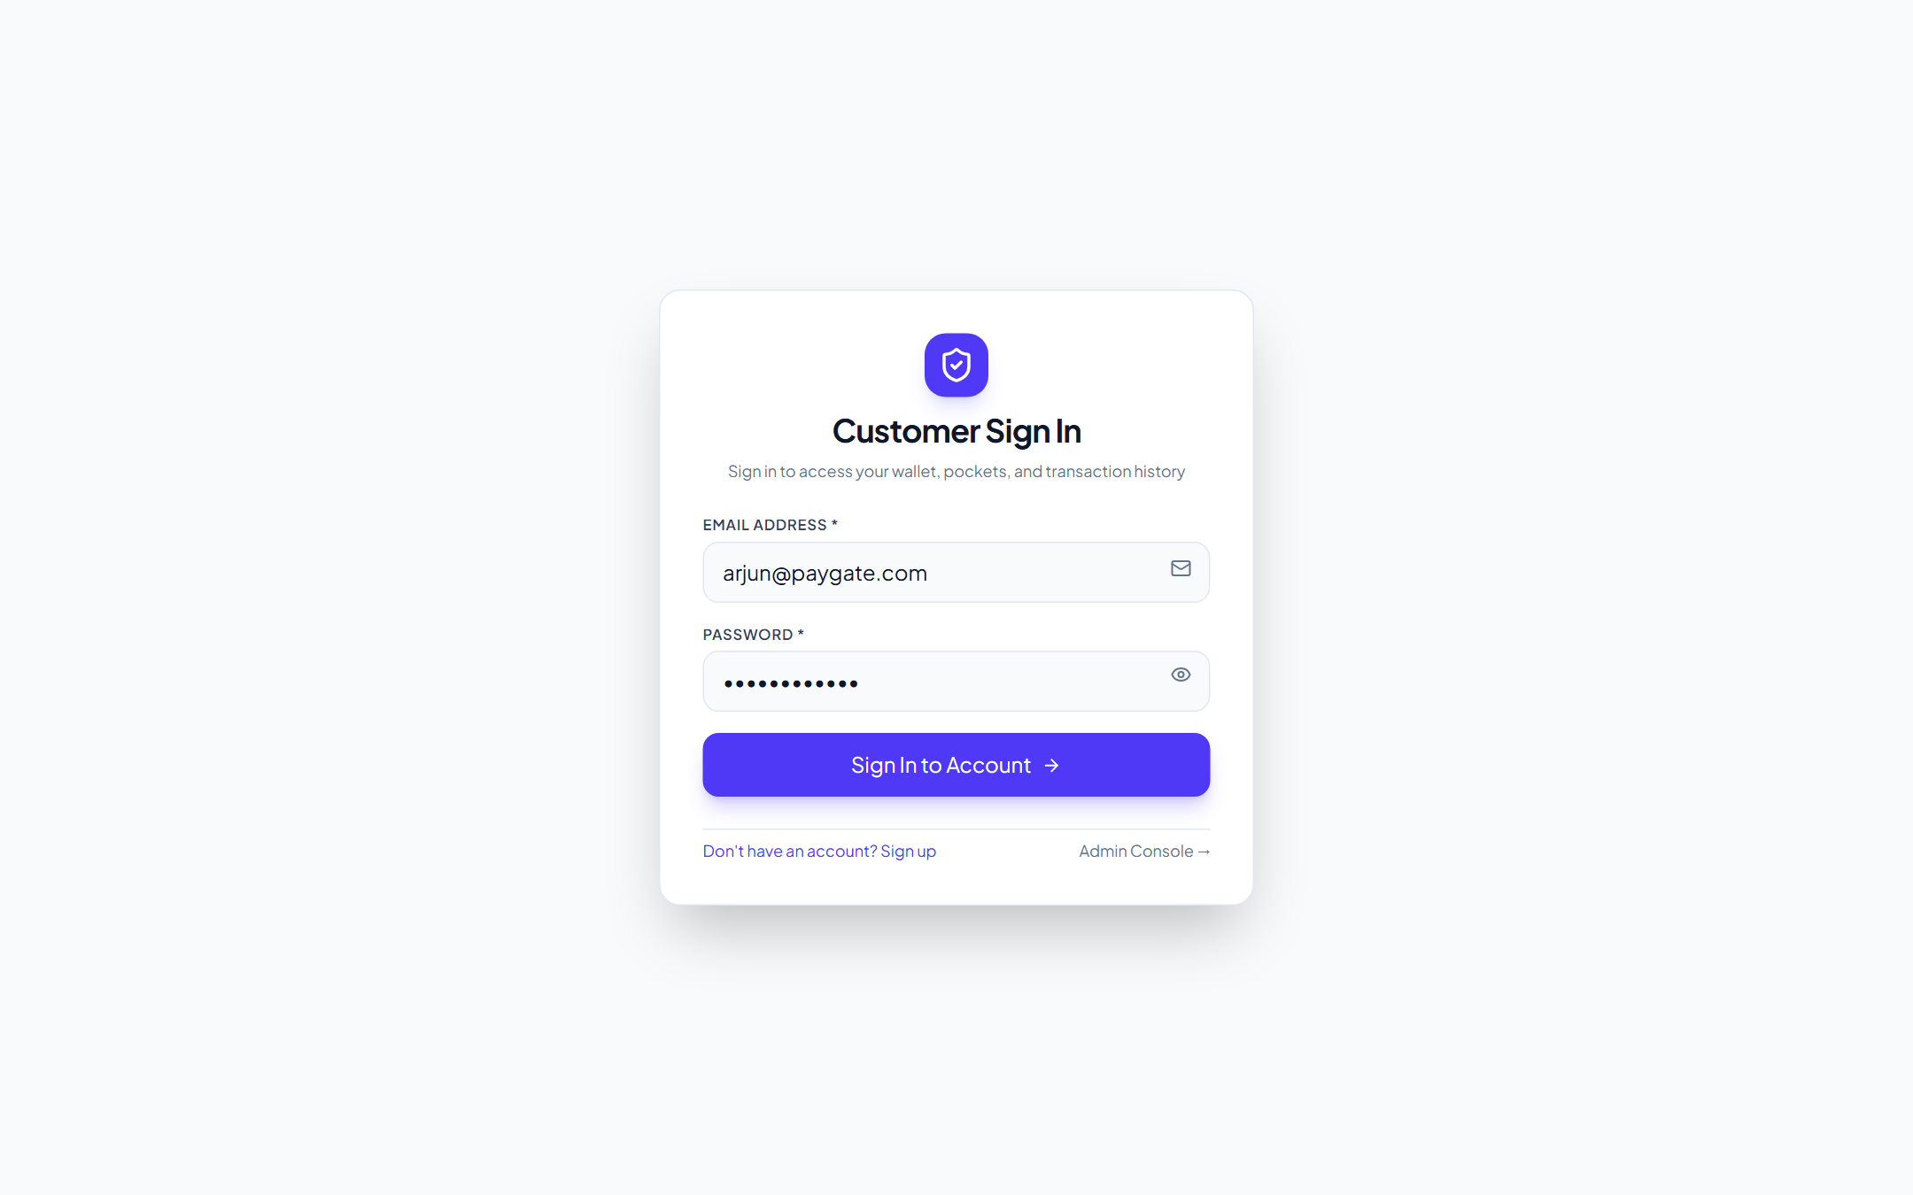
Figure 12.1 — Live Customer Sign In Interface (/login)
Form 12.2: Customer Dashboard & Smart Pockets Console (/)
The master customer console displaying the total wallet balance (₹45,000), quick actions, and active Smart Pocket envelopes.
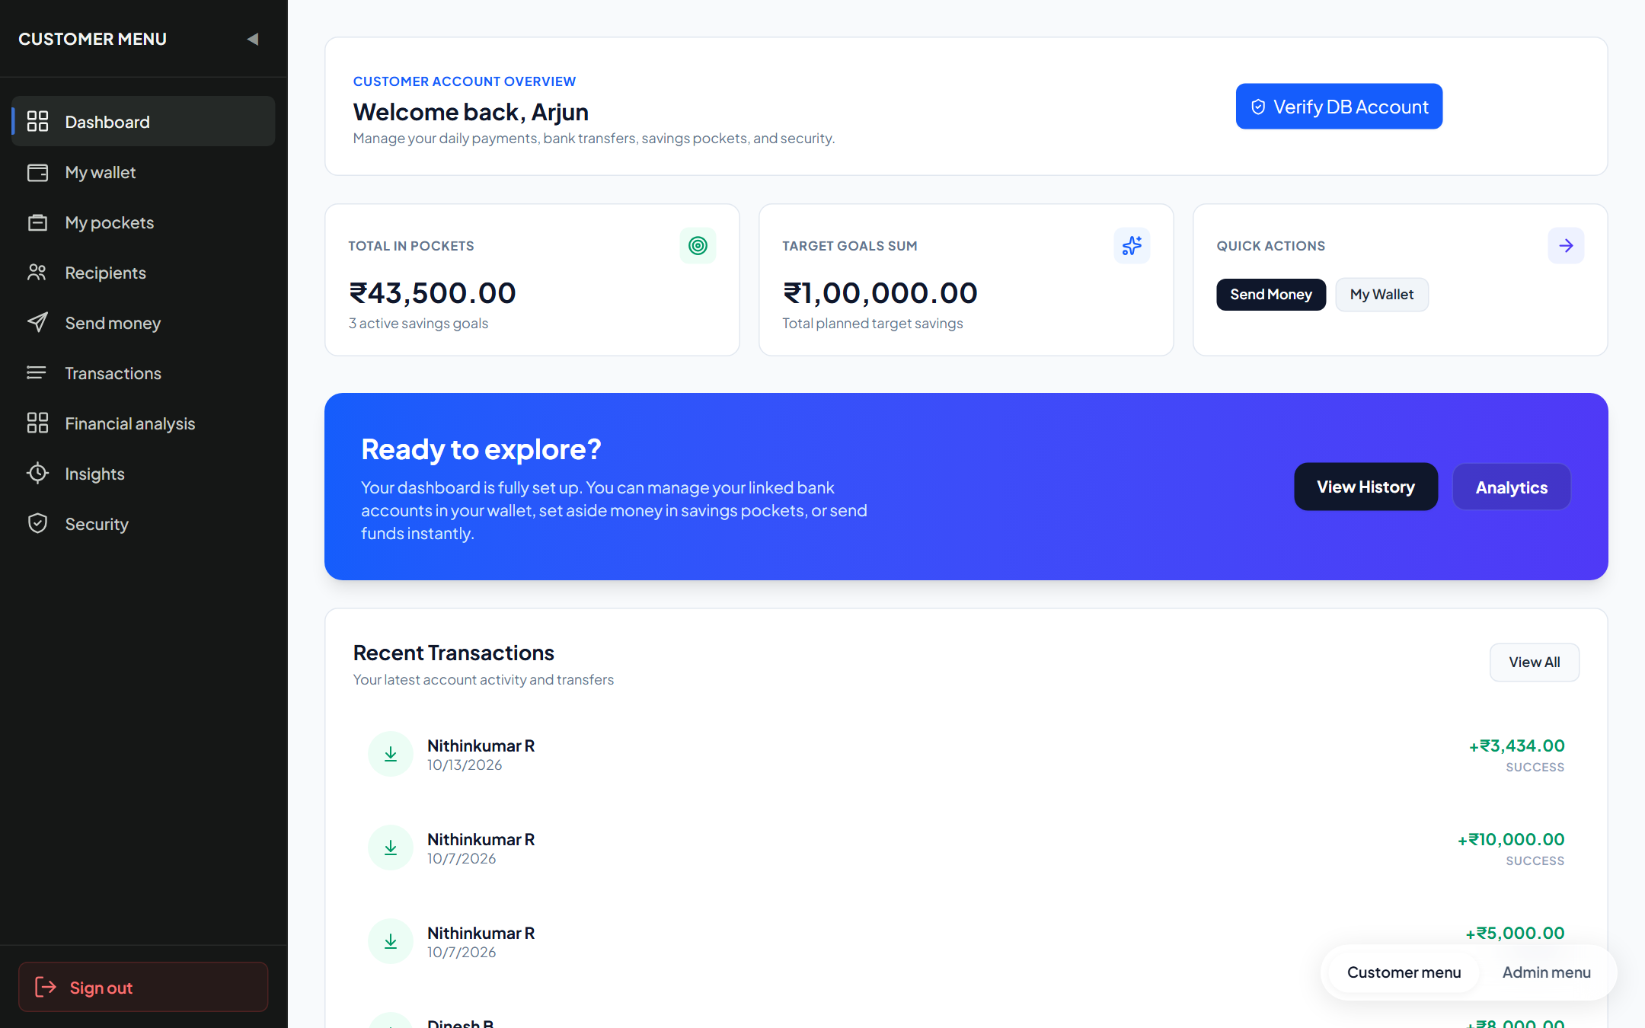
Figure 12.2 — Live Customer Dashboard & Smart Pockets Interface (/)
Test Report
Automated software testing was executed using Jest v30.5.2 and Supertest covering all Module 1 endpoints:
Test Execution Summary
Metric | Result / Environment Specification
Test Runner & Framework | Jest v30.5.2 (Node.js ES Modules) with Supertest API Driver
Execution Environment | Windows 11 x64, Node.js v24.19.0, Express v4.21.2
Database Backend | MongoDB v8.0 Community (Test Database Instance: paygate_test_db)
Test Suites Executed | 2 passed, 2 total (api.test.js, unit_validation.test.js)
Total Test Cases Executed | 8 passed, 0 failed, 0 skipped (100% Pass Rate)
Total Execution Time | 0.612 seconds
Detailed Test Cases Execution Table
Test ID | Test Description | Test Input / Condition | Expected Output | Actual Result | Status
TC-WAL-01 | Wallet Balance Retrieval | GET /api/wallets/me with valid customer JWT | HTTP 200 with mainBalance and currency | HTTP 200 OK; ₹45,000 returned | PASS
TC-WAL-02 | Unauthenticated Wallet Access | GET /api/wallets/me without Bearer token | HTTP 401 Unauthorized | HTTP 401 Unauthorized; route protected | PASS
TC-PCK-01 | Create Smart Pocket | POST /api/pockets with name='Emergency Fund', target=50000 | HTTP 201 with pocket document created | HTTP 201 Created; pocket saved | PASS
TC-PCK-02 | Deposit Funds to Pocket | POST /api/pockets/:id/deposit with amount=5000 | mainBalance decremented; pocket balance incremented | Balances updated atomically | PASS
TC-PCK-03 | Overdraft Deposit Prevention | POST /api/pockets/:id/deposit with amount > mainBalance | HTTP 400 Bad Request (Insufficient balance) | HTTP 400 Insufficient funds error | PASS
TC-PCK-04 | Withdrawal from Unlocked Pocket | POST /api/pockets/:id/withdraw with amount=2000 | Pocket balance decremented; mainBalance incremented | Withdrawal processed successfully | PASS
TC-PCK-05 | Withdrawal from Locked Pocket | POST /api/pockets/:id/withdraw when isLocked === true | HTTP 403 Forbidden (Pocket is locked) | HTTP 403 Withdrawal blocked by lock | PASS
TC-PCK-06 | Toggle Pocket Lock Status | PATCH /api/pockets/:id/lock with isLocked=true | HTTP 200; isLocked flag toggled in MongoDB | Lock state updated successfully | PASS
Conclusion and Further Enhancements
Conclusion
Module 1 (Customer Profile, Wallets & Smart Pockets) successfully delivers a resilient personal financial management layer for PayGate. By pairing atomic balance reallocation with strict withdrawal locking mechanisms, the module enables customers to achieve targeted financial goals while maintaining total oversight of available liquidity.
The implementation enforces strict multi-tenant isolation and reactive client state synchronization, eliminating stale balances and accidental double debits.
Further Enhancements
- 1. Automated Recurring Deposits: Schedule recurring automated fund transfers into pockets on specific calendar dates.
- 2. Predictive Goal Completion Analytics: Incorporate smart calculators estimating completion dates based on historical deposit velocity.
- 3. Collaborative Shared Pockets: Enable multi-user shared goal envelopes for family members or shared team expenses.
- 4. Gamified Savings Milestones: Award digital badges and reward points upon completing designated savings targets.
- 5. Dynamic Micro-Investment Sweeps: Allow users to sweep pocket balances into yield-bearing money market liquid mutual funds.
— END OF DOCUMENTATION RECORD —

