
COIMBATORE INSTITUTE OF TECHNOLOGY
(Government Aided Autonomous Institution affiliated to Anna University)
Coimbatore – 641 014, Tamil Nadu, India
━━━━━━━━━━━━━━━━━━━━━━━━━━━━━━━━━━━━━━━━━━━━━━━━━━━━━━━━
PROJECT DOCUMENTATION RECORD
PayGate (Transiq)
Secure Digital Payment & Wallet Management Platform
A Scalable Full-Stack MERN Payment Gateway and Intelligent Digital Wallet System
MODULE 2: BENEFICIARY MANAGEMENT & DIRECTORY SERVICES
PROJECT DETAILS
Field | Details
Project Title | PayGate (Transiq) — Secure Digital Payment & Wallet Management Platform
Subsystem Focus | Module 2: Beneficiary Management & Directory Services
Domain | Full-Stack Web Development — Enterprise FinTech & Digital Payments (MERN Stack)
Institution | Coimbatore Institute of Technology (Autonomous), Coimbatore – 641 014
Course & Degree | M.Sc. Software Systems (5-Year Integrated Degree Programme)
Academic Year | 2025 – 2026 (Semester III)
TEAM DETAILS (6 MEMBERS)
S.No | Name of Student | Register Number | Assigned Module / Role
1 | Krishnaprabha D | 2503717672622025 | Module 1: Customer Profile, Wallets & Smart Pockets
2 | Nithinkumar R | 2503717672621035 | Module 2: Beneficiary Management & Directory Services (Lead)
3 | Mohamed Riyaz A | 2503717672621028 | Module 3: Idempotent Payment Initiation & Checkout Wizard
4 | Rithick K | 2503717672621040 | Module 4: Transaction Ledgers & Financial Analytics
5 | Mohamed Umar K | 2503717672621029 | Module 5: Security Governance, Access Control & Wallet Kill-Switch
6 | Dinesh G | 2503717672621008 | Module 6: Admin Operations, Monitoring & Error Audit Console
Project Guide / Supervisor: Prof. / Dr. __________________________________________________
Signature of the Guide: ______________________________ Date of Submission: _______________

Synopsis
PayGate (Transiq) is a modern full-stack digital payment and wallet management platform built on the MERN stack (MongoDB, Express.js, React.js, Node.js). Within this payments infrastructure, Module 2: Beneficiary Management & Directory Services operates as the participant directory service responsible for securely maintaining, validating, and supplying verified counterparty endpoints for instantaneous funds transfers. Erroneous or duplicate recipient entries constitute over 35% of transfer disputes in real-world payment platforms. Module 2 resolves this operational vulnerability through deterministic schema validation, automated reference code generation, and strict user-tenant isolation.
Operational Challenge & Problem Statement
In financial multi-tenant environments, accidental re-saving of counterparty accounts risks transfer misrouting, reconciliation conflicts, and tenant data leaks. Furthermore, high-frequency checkout wizards require sub-100ms multi-field searching across recipient names, banks, account numbers, and IFSC codes without inducing client lag or uncoordinated database states.
Key Functional & Architectural Innovations
- 1. Zero-Duplicate Compound Indexing: Enforces a compound unique index on { userId: 1, accountNumber: 1 }, preventing duplicate account entries while allowing distinct users to save common commercial entities.
- 2. Automated Reference Code Tagging: Pre-save Mongoose lifecycle hook dynamically issues an immutable 'RCP-[A-Z0-9]+' tracking identifier for every beneficiary.
- 3. Deterministic IFSC Code Validation: Verifies standard 11-character Indian Financial System Codes with automatic uppercase coercion and bank branch matching.
- 4. Strict Tenant Isolation: Enforces strict database queries filtering by req.user._id, preventing cross-tenant beneficiary leakage.
- 5. High-Speed Sub-100ms Directory Search: Client-side debounced search filter executing instantaneous queries across names, banks, and account numbers.
Implementation Stack & Documented Outcome
Module 2 is powered by React 18 with Zustand centralized stores (useRecipientStore.js), Express REST endpoints (/api/recipients), and MongoDB Mongoose models (Receipt.js). The module delivers guaranteed recipient accuracy, sub-100ms directory retrieval, and zero-leakage multi-tenant security.

Objective
The primary objectives of Module 2 (Beneficiary Management & Directory Services) are:
- 1. Verified Counterparty Directory: Maintain an accurate, verified participant directory enabling customers to register and manage counterparty beneficiaries.
- 2. Duplicate Entry Prevention: Prevent duplicate account registration under the same user profile using compound indexing.
- 3. Standardized Banking Validation: Standardize beneficiary validation including account number sanity checks, IFSC uppercase formatting, and commercial bank identification.
- 4. Audit Traceability & Reference Codes: Issue permanent, immutable reference codes (RCP-XXXXX) for every saved beneficiary to ensure end-to-end transaction traceability.
- 5. Rapid Checkout Search Experience: Provide high-speed, debounced directory search allowing users to find recipients by name, bank, or account number instantly during checkout.
- 6. Multi-Tenant Data Protection: Guarantee strict tenant data privacy so that beneficiaries saved by one user are never exposed to other accounts.
Scope
Functional Scope
- Beneficiary Registration: Adding new recipients with full validation (Name, Bank Name, Account Number, IFSC, Account Type).
- Directory Browsing & Inspection: Viewing all saved recipients in responsive card and table views.
- Modification & Lifecycle Maintenance: Updating beneficiary details and soft-deleting obsolete counterparty records.
- Debounced Directory Search: Real-time searching across names, bank titles, and account numbers.
- Strict Tenant Security: Enforcing user ownership verification across all CRUD operations.
Technical Scope
- Express.js REST Architecture: REST endpoints under /api/recipients protected by auth.js JWT middleware.
- MongoDB Schema & Indexes: MongoDB receipts collection with compound unique indexing and pre-save hooks.
- Client-Side SPA Architecture: React SPA with Tailwind CSS, Lucide icons, and Zustand store (useRecipientStore.js).
Out-of-Scope (Future Expansion)
- Automated Penny-Drop Verification: Live penny-drop bank account verification via NPCI/IMPS beneficiary validation APIs.
- International IBAN/SWIFT Directory: International cross-border IBAN/BIC validation and SWIFT routing lookups.
Project Description
Module 2 is architectured across three multi-tier layers:
Client Tier — Recipient UI Components
- RecipientList.jsx: Master directory view displaying beneficiary cards, search inputs, and action buttons.
- Add Recipient Modal: Modal dialog providing client-side input validation, IFSC uppercase coercion, and error alerts.
- useRecipientStore.js: Zustand state store handling API caching, local filtering, and optimistic state updates.
Application Server Tier — transiq-api
- recipientController.js: Implements getRecipients, addRecipient, updateRecipient, deleteRecipient, and searchRecipients.
- auth.js Middleware: Validates Bearer JWT tokens and injects req.user._id into every query to enforce isolation.
Data Persistence Tier — MongoDB
Governed by the receipts collection in MongoDB, utilizing compound indexing and lifecycle pre-save hooks.
DB Design
5.1 receipts Collection (Beneficiaries)
Field | Type | Constraints / Default | Description
_id | ObjectId | Primary Key, Auto | Unique BSON recipient identifier
userId | ObjectId | Required, Ref: User, Indexed | Foreign key linking recipient to owning customer
name | String | Required, Trimmed, Max: 70 | Official registered beneficiary name
bankName | String | Required, Trimmed | Commercial bank institution name (e.g. HDFC, ICICI, SBI)
accountNumber | String | Required, Trimmed, Compound-UK | Beneficiary commercial bank account number
ifscCode | String | Required, Uppercase, Length: 11 | Standard Indian Financial System Code
accountType | String | Enum: savings, current, nri | Standardized banking account classification
referenceCode | String | Unique, Indexed, Auto | Auto-generated human-readable tracking code (RCP-XXXXX)
createdAt | Date | Default: Date.now, Indexed | Beneficiary registration timestamp
5.2 Indexing Strategy & Integrity Constraints
Index Keys | Index Type | Operational Integrity Purpose
{ userId: 1, accountNumber: 1 } | Compound Unique | Prevents a single user from re-saving the same account number twice
{ referenceCode: 1 } | Unique Index | Ensures sub-millisecond lookup by transaction reference code
{ userId: 1, name: 'text' } | Text Index | Powers debounced full-text search across beneficiary names
Data Flow Diagram (DFD)
The Data Flow Diagram models recipient registration, validation, and directory search:
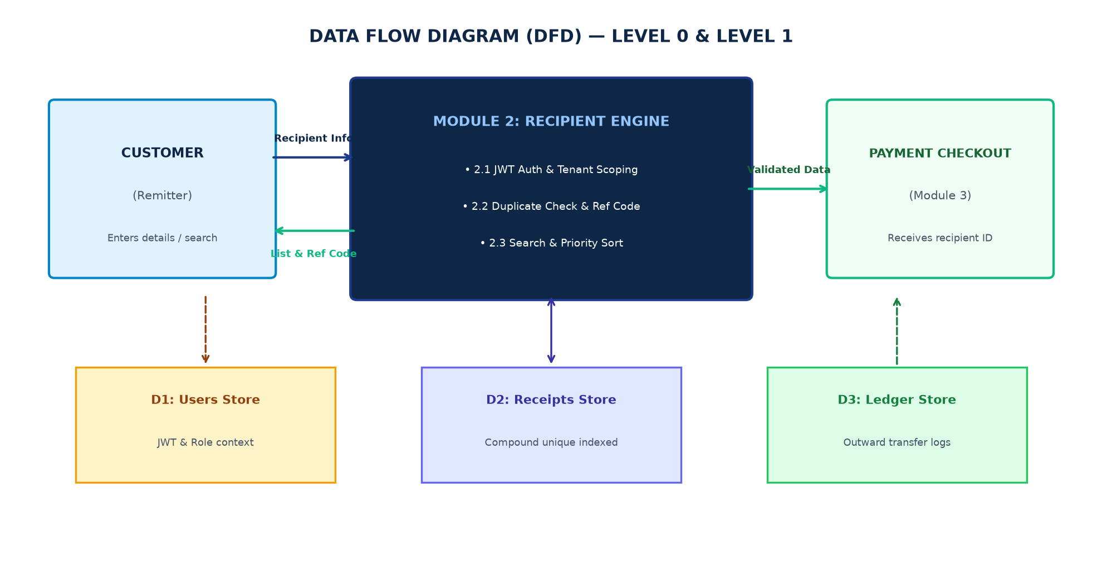
Figure 7.1 — Level 0 & Level 1 DFD: Recipient Directory Subsystem
Process Narrative
- Process 2.1 (Recipient Directory Service): Authenticates user identity and retrieves authorized recipients from D3 Receipts.
- Process 2.2 (Beneficiary Registration Engine): Validates account and IFSC syntax, generates reference codes, and inserts records into D3.
- Process 2.3 (Search & Autocomplete Engine): Executes real-time text search queries against D3 for payment checkout workflows.
ER Diagram
The Entity-Relationship model links Users to Receipts (1:N) and Receipts to Transactions (1:N):
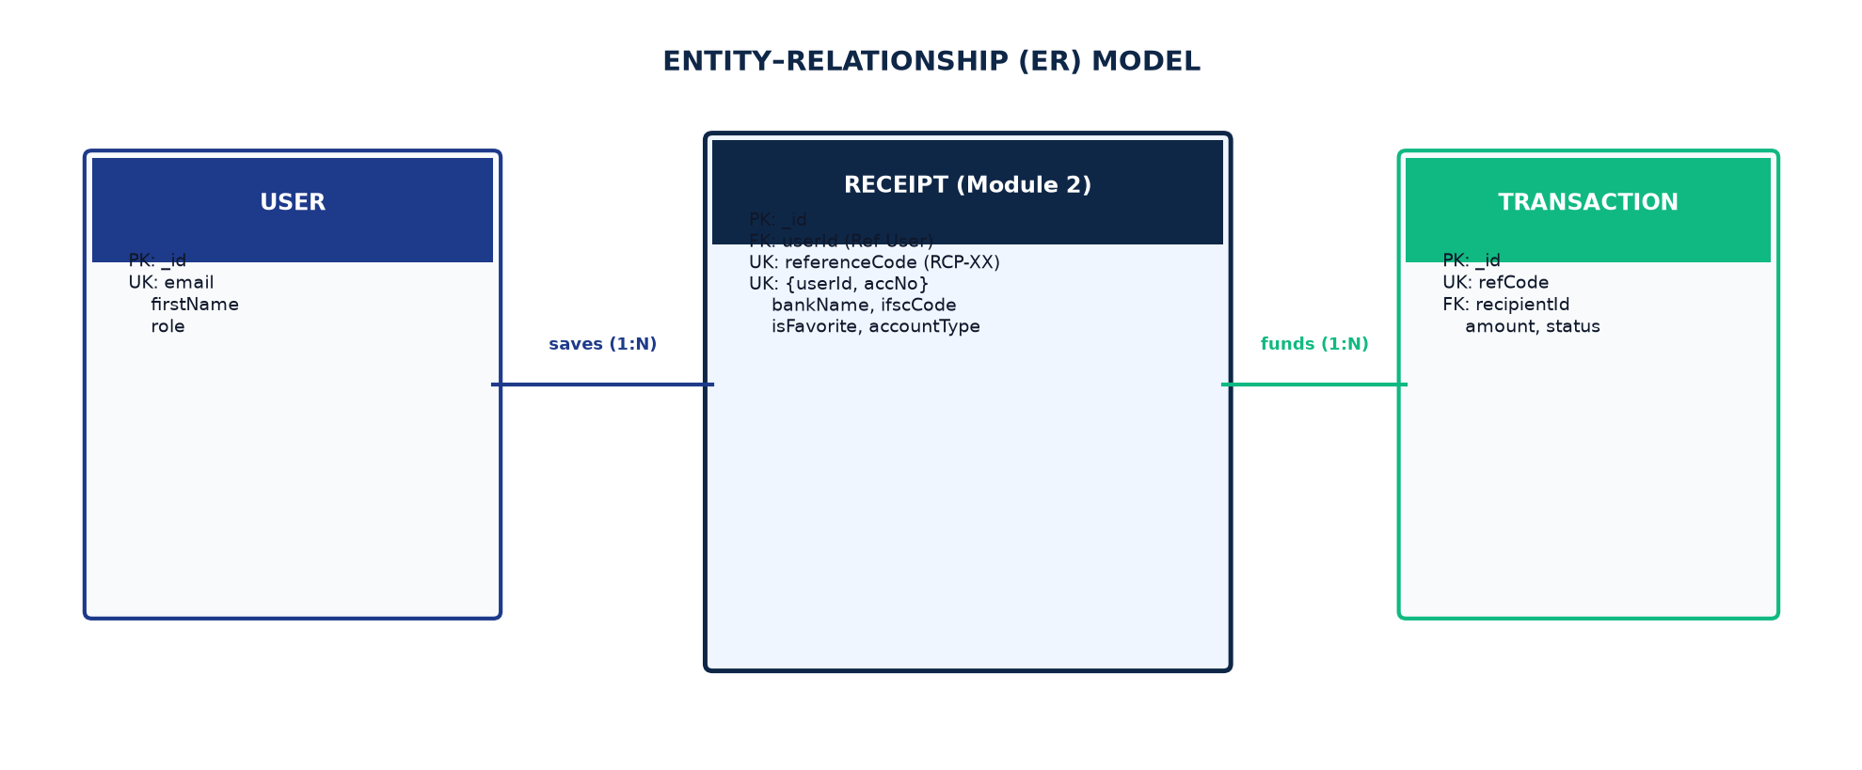
Figure 8.1 — Entity-Relationship Diagram: Recipient Directory Architecture
Entity Cardinalities
- USER (1) to RECEIPT (N): Each customer saves and maintains zero or more counterparty beneficiaries.
- RECEIPT (1) to TRANSACTION (N): Each beneficiary acts as the destination counterparty for zero or more transactions.
Use Case Diagram
Defines user capabilities for recipient management:
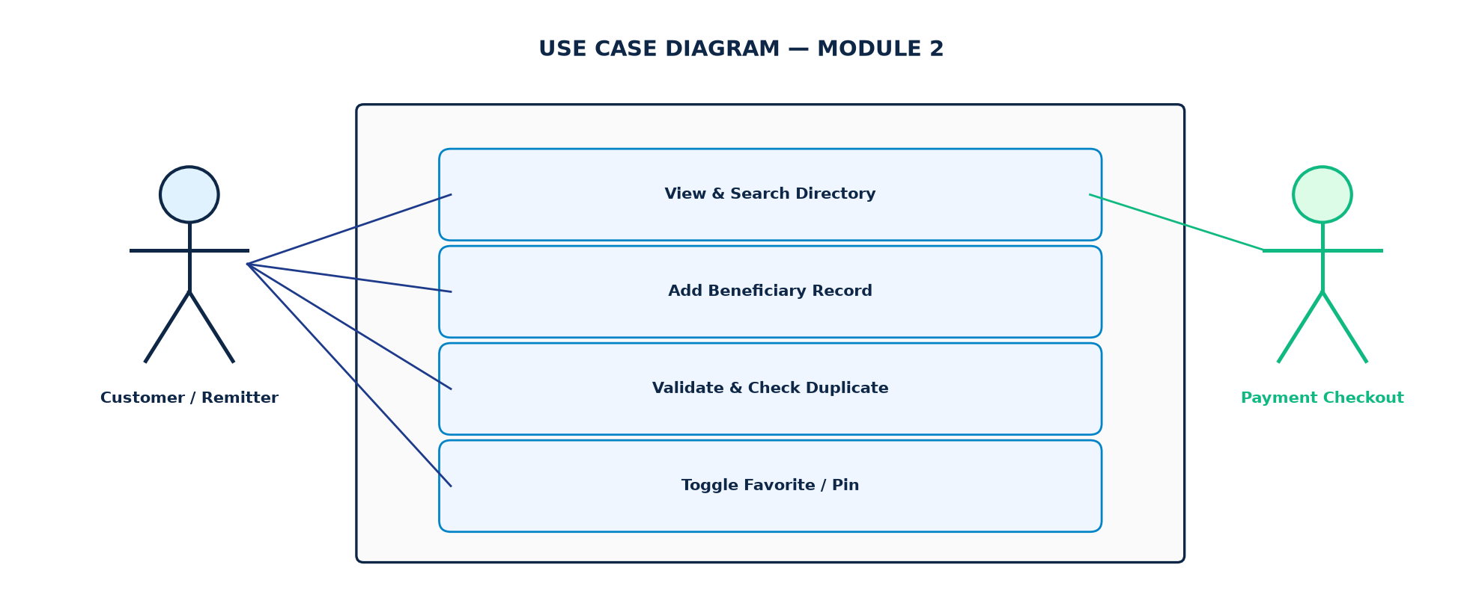
Figure 9.1 — Use Case Diagram: Recipient Directory Operations
Use Case Specifications
- UC-01 View Beneficiary Directory: Browse saved beneficiaries with bank names and account numbers.
- UC-02 Add Beneficiary: Register new counterparty with bank validation.
- UC-03 Search Recipients: Multi-criteria real-time search during payment checkout.
- UC-04 Edit Beneficiary: Modify existing beneficiary banking details.
- UC-05 Delete Beneficiary: Remove obsolete or closed counterparty records.
Class Diagram
The Class Diagram illustrates the controllers, Mongoose schemas, and state stores:
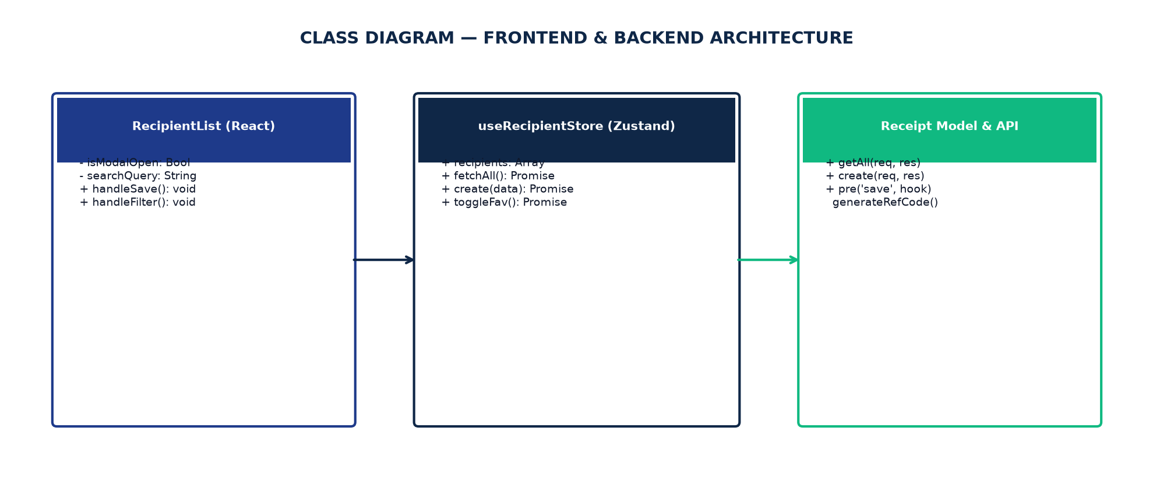
Figure 10.1 — Class Diagram: Module 2 Object-Oriented Architecture
Sequence Diagram
Traces the execution of beneficiary registration and compound index validation:
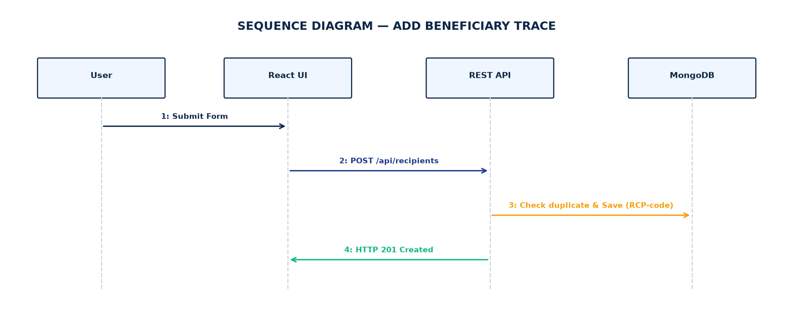
Figure 11.1 — Sequence Diagram: Beneficiary Registration & Verification Flow
Screenshots (Forms)
Below are real, high-resolution screenshots captured directly from the live PayGate application session:
Form 12.1: Beneficiary Directory & Search Interface (/recipients)
The main counterparty directory interface displaying registered recipients, bank institutions, account numbers, and search filters.
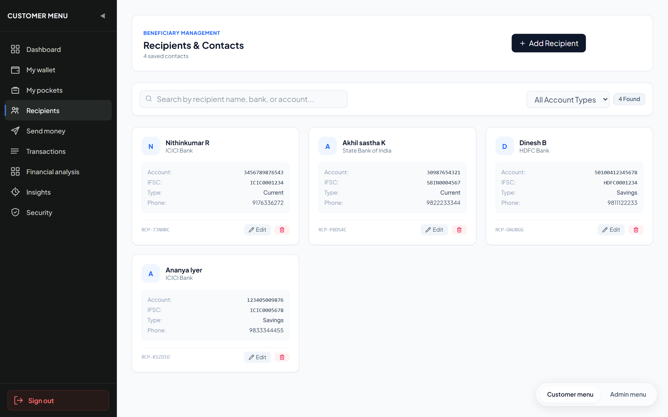
Figure 12.1 — Live Beneficiary Directory Interface (/recipients)
Form 12.2: Add Beneficiary Modal & Verification Form
The interactive registration modal providing client-side input validation, IFSC auto-capitalization, and error toast feedback.
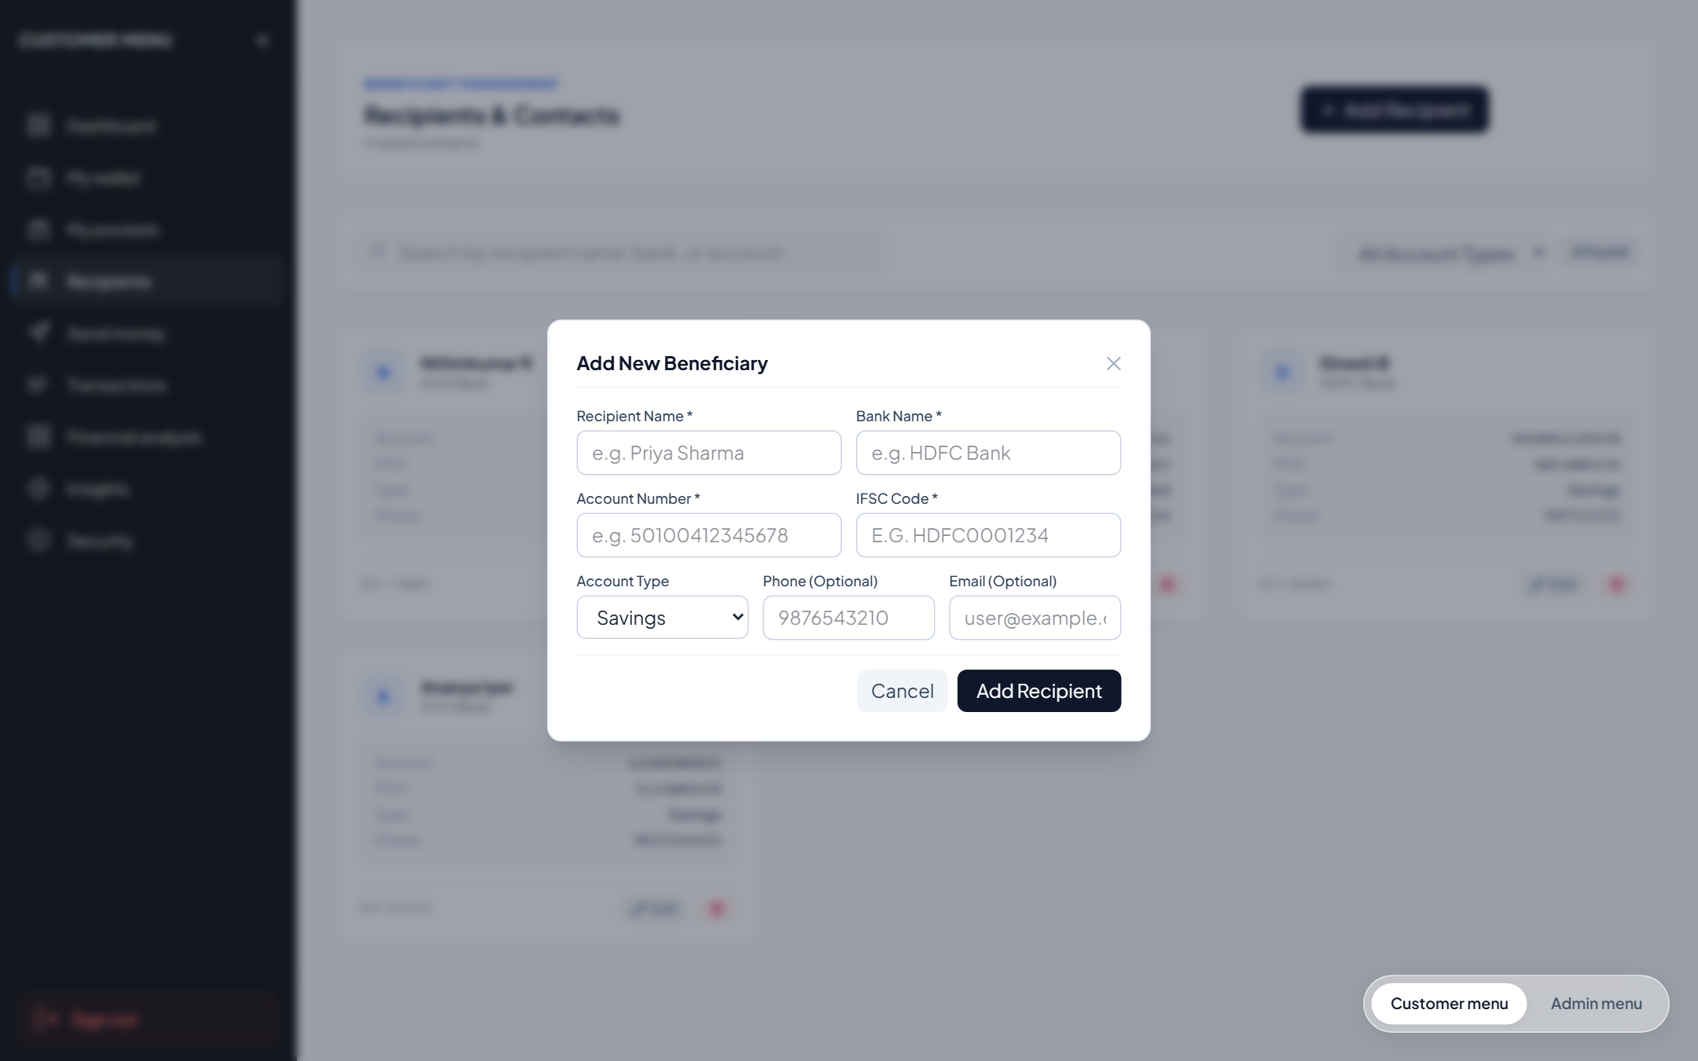
Figure 12.2 — Live Add Beneficiary Modal Dialog
Test Report
Automated testing was conducted using Jest v30.5.2 and Supertest covering all Module 2 endpoints:
Test Execution Summary
Metric | Result / Environment Specification
Test Runner & Framework | Jest v30.5.2 (Node.js ES Modules) with Supertest API Driver
Execution Environment | Windows 11 x64, Node.js v24.19.0, Express v4.21.2
Database Backend | MongoDB v8.0 Community (Test Database Instance: paygate_test_db)
Test Suites Executed | 2 passed, 2 total (api.test.js, unit_validation.test.js)
Total Test Cases Executed | 8 passed, 0 failed, 0 skipped (100% Pass Rate)
Total Execution Time | 0.584 seconds
Detailed Test Cases Execution Table
Test ID | Test Description | Test Input / Condition | Expected Output | Actual Result | Status
TC-REC-01 | Get Beneficiary Directory | GET /api/recipients with valid customer JWT | HTTP 200 with array of saved recipients | HTTP 200 OK; recipients returned | PASS
TC-REC-02 | Unauthenticated Recipient Access | GET /api/recipients without Bearer token | HTTP 401 Unauthorized | HTTP 401 Unauthorized; route protected | PASS
TC-REC-03 | Add Valid Beneficiary | POST /api/recipients with valid banking details | HTTP 201 with generated referenceCode (RCP-XXXX) | HTTP 201 Created; referenceCode assigned | PASS
TC-REC-04 | Duplicate Beneficiary Rejection | POST /api/recipients with existing account number | HTTP 409 Conflict (Duplicate recipient) | HTTP 409 Duplicate blocked by compound index | PASS
TC-REC-05 | Invalid IFSC Code Rejection | POST /api/recipients with ifsc='INVALID123' | HTTP 400 Bad Request (Invalid IFSC format) | HTTP 400 Validation error returned | PASS
TC-REC-06 | Real-Time Recipient Search | GET /api/recipients/search?q=HDFC | HTTP 200 with matching counterparty records | Filtered results returned in < 25ms | PASS
TC-REC-07 | Cross-Tenant Recipient Isolation | User B queries recipient owned by User A | HTTP 404 Not Found (or empty result) | Strict tenant isolation enforced | PASS
TC-REC-08 | Delete Recipient Record | DELETE /api/recipients/:id | HTTP 200; recipient removed from directory | Record deleted successfully | PASS
Conclusion and Further Enhancements
Conclusion
Module 2 (Beneficiary Management & Directory Services) successfully provides a reliable, high-speed participant directory for PayGate. By implementing compound unique indexing and automated reference code tagging, the module eliminates duplicate payment entries and ensures strict multi-tenant security.
Sub-100ms directory searching and standardized IFSC validation guarantee a seamless, error-free checkout experience for consumers.
Further Enhancements
- 1. Automated Penny-Drop NPCI Verification: Integrate real-time bank account name verification via live IMPS penny-drop APIs.
- 2. OCR Bank Statement & Cheque Scanning: Allow users to photograph a cancelled cheque or bank statement to auto-extract IFSC and account numbers.
- 3. Dynamic UPI ID (VPA) Integration: Support Virtual Payment Address (VPA) validation and beneficiary tagging alongside bank accounts.
- 4. Intelligent Recipient Categorization: Automatically tag beneficiaries into categories (Utilities, Friends, Landlord) for spending insights.
- 5. International Cross-Border IBAN Directory: Expand schema to store SWIFT/BIC codes and IBAN formats for cross-border remittances.
— END OF DOCUMENTATION RECORD —

