
COIMBATORE INSTITUTE OF TECHNOLOGY
(Government Aided Autonomous Institution affiliated to Anna University)
Coimbatore – 641 014, Tamil Nadu, India
━━━━━━━━━━━━━━━━━━━━━━━━━━━━━━━━━━━━━━━━━━━━━━━━━━━━━━━━
PROJECT DOCUMENTATION RECORD
PayGate (Transiq)
Secure Digital Payment & Wallet Management Platform
A Scalable Full-Stack MERN Payment Gateway and Intelligent Digital Wallet System
MODULE 3: IDEMPOTENT PAYMENT INITIATION & CHECKOUT WIZARD
PROJECT DETAILS
Field | Details
Project Title | PayGate (Transiq) — Secure Digital Payment & Wallet Management Platform
Subsystem Focus | Module 3: Idempotent Payment Initiation & Checkout Wizard
Domain | Full-Stack Web Development — Enterprise FinTech & Digital Payments (MERN Stack)
Institution | Coimbatore Institute of Technology (Autonomous), Coimbatore – 641 014
Course & Degree | M.Sc. Software Systems (5-Year Integrated Degree Programme)
Academic Year | 2025 – 2026 (Semester III)
TEAM DETAILS (6 MEMBERS)
S.No | Name of Student | Register Number | Assigned Module / Role
1 | Krishnaprabha D | 2503717672622025 | Module 1: Customer Profile, Wallets & Smart Pockets
2 | Nithinkumar R | 2503717672621035 | Module 2: Beneficiary Management & Directory Services
3 | Mohamed Riyaz A | 2503717672621028 | Module 3: Idempotent Payment Initiation & Checkout Wizard (Lead)
4 | Rithick K | 2503717672621040 | Module 4: Transaction Ledgers & Financial Analytics
5 | Mohamed Umar K | 2503717672621029 | Module 5: Security Governance, Access Control & Wallet Kill-Switch
6 | Dinesh G | 2503717672621008 | Module 6: Admin Operations, Monitoring & Error Audit Console
Project Guide / Supervisor: Prof. / Dr. __________________________________________________
Signature of the Guide: ______________________________ Date of Submission: _______________

Synopsis
PayGate (Transiq) is a production-grade full-stack digital payment and wallet management platform built on the MERN stack (MongoDB, Express.js, React.js, Node.js). Within this payments infrastructure, Module 3: Idempotent Payment Initiation & Checkout Wizard constitutes the core transaction execution and bank account linking engine. It governs the end-to-end payment lifecycle—from beneficiary selection and funding account validation to cryptographic PIN verification and digital receipt issuance—while simultaneously powering the two-step OTP bank account connection workflow within My Wallet.
Operational Challenge & Problem Statement
In electronic funds transfer systems, transient network latency and accidental double-clicks frequently trigger duplicate debit requests, overdraft discrepancies, and unverified bank account linkages. Module 3 eliminates these critical risks by enforcing an idempotent state machine governed by unique Transaction Reference IDs (TXN-YYYYMMDD-XXXX), strict pre-flight balance verifications, and simulated two-factor OTP verification.
Key Functional & Architectural Innovations
- 1. Deterministic 4-Step Checkout Wizard: Enforces a structured 4-step wizard (Beneficiary Selection -> Method & Amount -> PIN Authorization -> Digital Receipt) preventing invalid submissions.
- 2. Idempotent Transaction Execution: Issues a pre-flight transaction reference code upon checkout initiation, guaranteeing that retries or rapid re-clicks use the identical transaction ledger entry.
- 3. Dual-Boundary Balance Safeguards: Verifies account active status and executes balance checks both at pre-flight and final PIN authorization boundaries.
- 4. PIN Cryptographic Authorization: Simulates secure customer authorization via 4-digit PIN verification before debiting wallet or bank account reserves.
- 5. Two-Step Bank Account Linking with OTP: Connects external bank accounts using 6-digit OTP verification with strict +91 Indian phone validation, preventing unauthorized account linking.
Implementation Stack & Documented Outcome
Module 3 integrates React 18 single-page components (PaymentFlowContainer.jsx, MyWalletPage.jsx), Express payment controllers (paymentController.js), and MongoDB models (Transaction.js, BankAccount.js). The module guarantees zero double-debit occurrences, deterministic idempotent retries, and high-security multi-account banking.

Objective
The primary objectives of Module 3 (Idempotent Payment Initiation & Checkout Wizard) are:
- 1. Guided Checkout Experience: Provide a frictionless, guided 4-step payment checkout workflow that guarantees intuitive and error-free funds transfers.
- 2. Idempotency & Duplicate Prevention: Enforce idempotency across all payment requests using background Transaction Reference IDs, completely eliminating duplicate debits.
- 3. Balance Integrity Safeguards: Validate funding account balances at pre-flight and commit boundaries, ensuring that transfers exceeding available reserves are rejected.
- 4. PIN-Based Transaction Authorization: Implement secure transaction authorization via secret PIN verification, ensuring non-repudiation.
- 5. Multi-Rail Payment Flexibility: Provide multi-rail payment routing across Wallet, IMPS, NEFT, and RTGS transfer mechanisms.
- 6. Secure Bank Account Linking via OTP: Deliver a secure bank account connection workflow within My Wallet utilizing +91 phone number verification and 6-digit OTP checks.
Scope
Functional Scope
- Beneficiary Selection & Verification: Selecting verified beneficiaries from the directory or entering ad-hoc transfer targets.
- Amount & Rail Configuration: Selecting payment rails (WALLET, IMPS, NEFT, RTGS) and entering amounts with dynamic fee preview.
- PIN Authorization & Settlement: Authorizing transfers via secret PIN entry with real-time balance debiting.
- Digital Receipt Issuance: Issuing printable digital payment receipts with timestamps and reference codes.
- My Wallet Bank Account Connection: Linking external bank accounts via +91 phone validation and simulated OTP verification.
Technical Scope
- Application Server Architecture: Express.js REST API providing versioned endpoints under /api/payment and /api/wallet/accounts.
- Database Persistence: MongoDB collections (transactions, bankaccounts, wallets) with schema validation and atomic update sessions.
- Client-Side SPA Architecture: React SPA with Tailwind CSS, Lucide icons, and FlowPipeline step indicators.
Out-of-Scope (Future Expansion)
- Live Core Banking ISO Settlement: Live ISO 8583 / ISO 20022 message exchange with national core banking settlement networks.
- Automated Recurring e-Mandates: Recurring auto-debit standing instructions (e-Mandate / NACH integration).
Project Description
Module 3 operates across three decoupled tiers:
Client Tier — Payment Initiation UI
- PaymentFlowContainer.jsx: Master container rendering the 4-step checkout pipeline, beneficiary selectors, amount inputs, and PIN pads.
- MyWalletPage.jsx: Bank account linking interface displaying connected bank balances and launching the Add Bank Account modal.
- FlowPipeline.jsx: Visual step progress bar indicating payment state progression (1 to 4).
Application Server Tier — transiq-api
- paymentController.js: Handles payment initiation, validate-details, PIN authorization, and idempotent retries.
- walletController.js: Manages bank account addition, OTP generation, and OTP verification.
- auth.js Middleware: Enforces cryptographic JWT verification on every checkout step.
Data Persistence Tier — MongoDB
Stores transaction ledger records in transactions and connected bank accounts in bankaccounts.
DB Design
5.1 bankaccounts Collection (Connected Accounts)
Field | Type | Constraints / Default | Description
_id | ObjectId | Primary Key, Auto | Unique identifier for connected bank account
userId | ObjectId | Required, Ref: User, Indexed | Foreign key linking account to customer
name | String | Required, Trimmed | Official account title (e.g. HDFC Bank Savings Account)
accountNumber | String | Required, Trimmed | Associated bank account number
maskedNumber | String | Required | Display-safe masked format (e.g. XXXX XXXX 0001)
balance | Number | Default: 25000 | Simulated external bank available balance
status | String | Enum: ACTIVE, INACTIVE, FROZEN | Operational connectivity status
createdAt | Date | Default: Date.now, Indexed | Account connection timestamp
5.2 transactions Collection (Payment Execution Schema)
Field | Type | Constraints / Default | Description
_id | ObjectId | Primary Key, Auto | Unique ledger transaction identifier
referenceCode | String | Unique, Indexed, Auto | Human-readable transaction reference code (TXN-XXXX)
senderWalletId | ObjectId | Ref: Wallet, Indexed | Reference to the initiating sender's wallet
recipientId | ObjectId | Ref: Receipt, Indexed | Reference to the verified destination beneficiary
amount | Number | Required, Min: 0.01 | Transfer amount in INR
method | String | Enum: WALLET, IMPS, NEFT, RTGS | Payment rail used for funds transfer
status | String | Enum: pending, success, failure | Transaction state lifecycle status
createdAt | Date | Default: Date.now, Indexed | Transaction execution timestamp
Data Flow Diagram (DFD)
The Data Flow Diagram models the flow of checkout parameters, PIN authorization, and OTP verification:
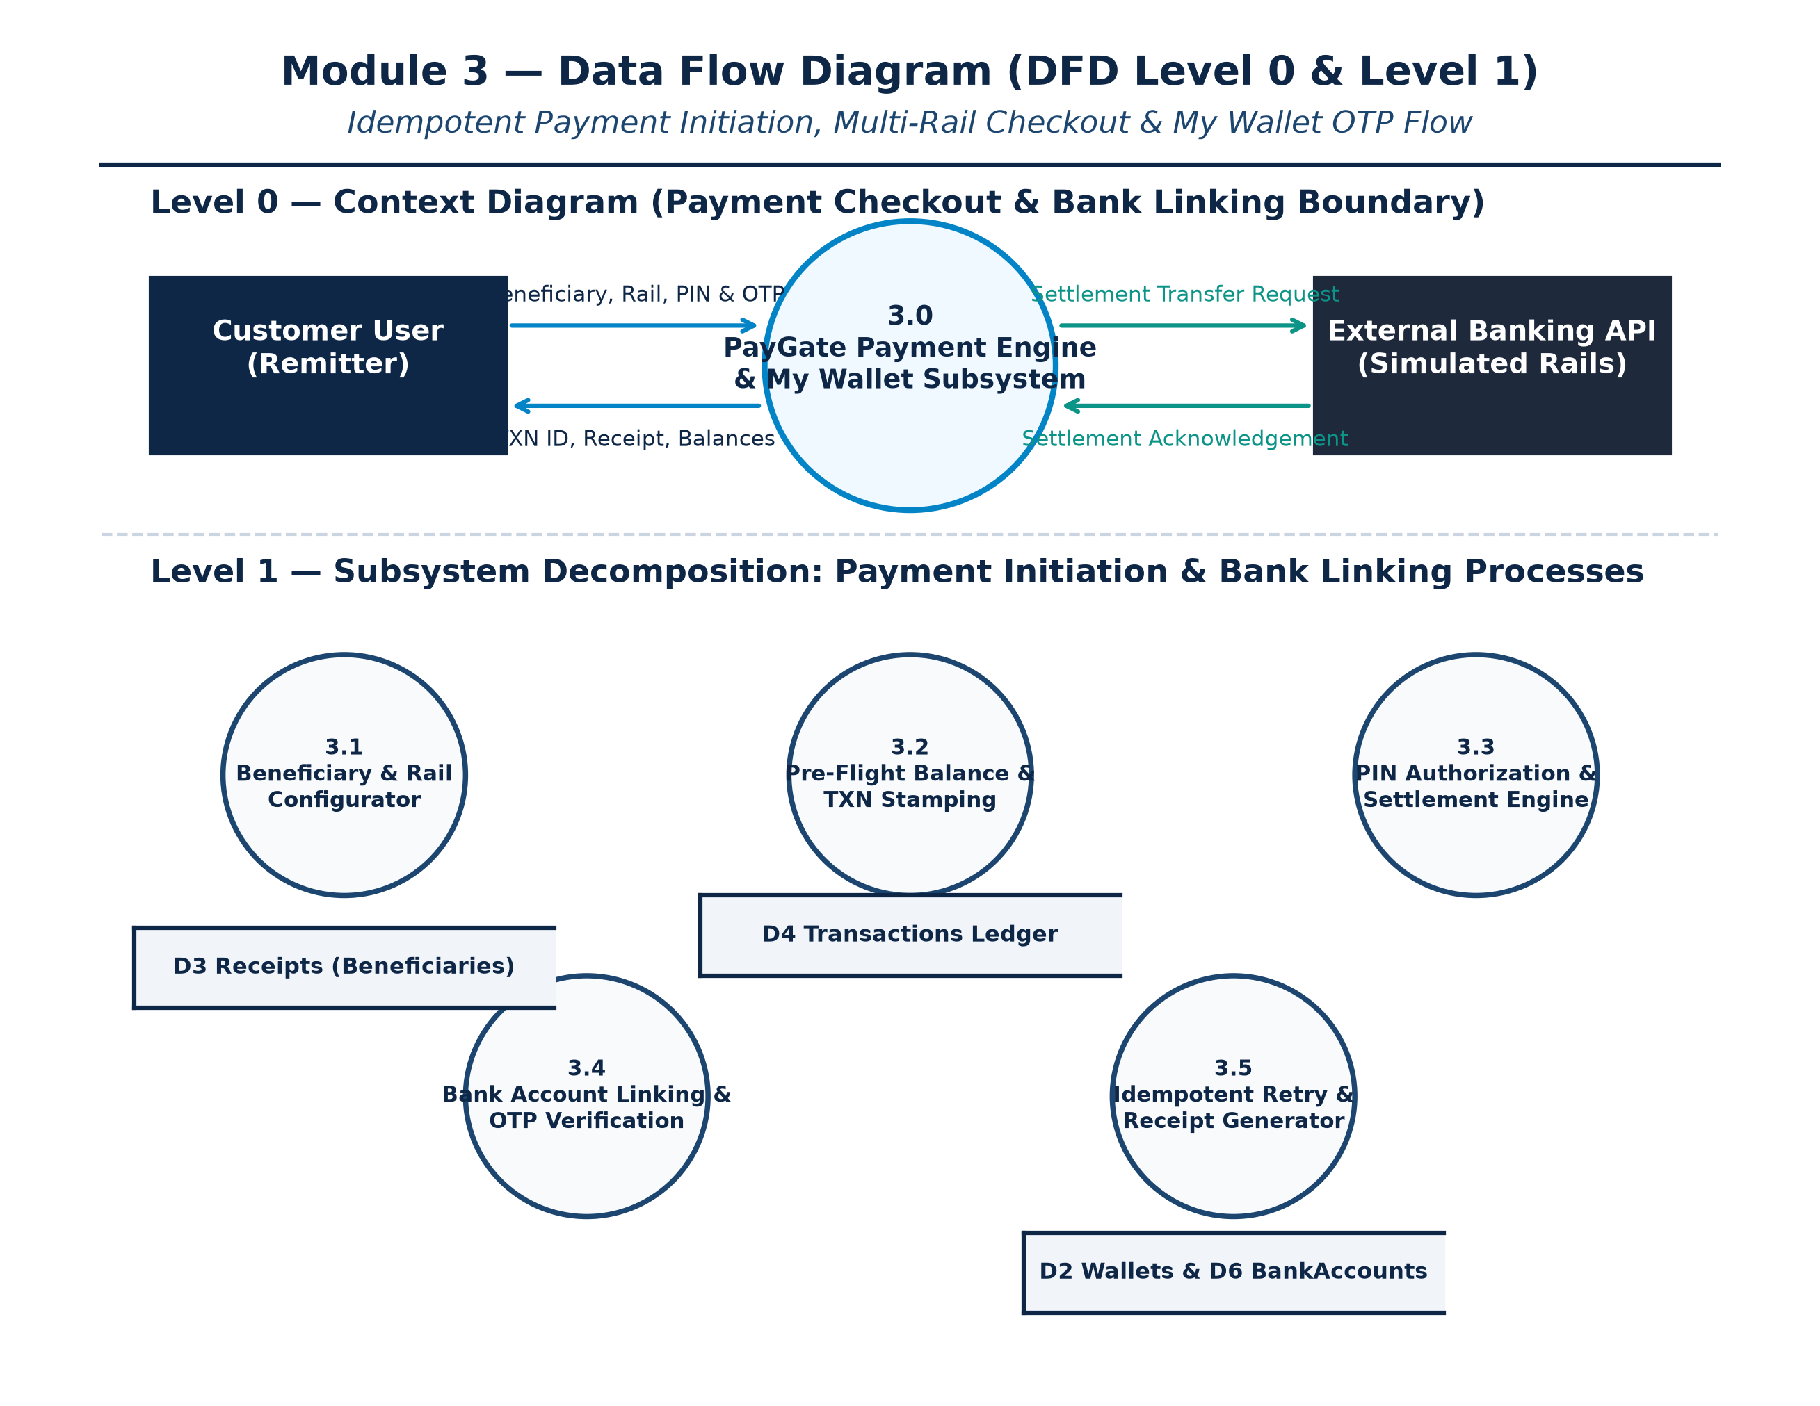
Figure 7.1 — Level 0 & Level 1 DFD: Payment Initiation & Bank Linking
Process Narrative
- Process 3.1 (Checkout Initiation & Validation): Collects beneficiary selection and amount parameters, issuing a background transaction ID.
- Process 3.2 (PIN Authorization & Settlement): Verifies customer PIN and debits wallet or bank reserves atomically.
- Process 3.3 (OTP Bank Linking Engine): Dispatches 6-digit OTP and validates customer submission for account linking.
ER Diagram
The Entity-Relationship model links Users to BankAccounts (1:N), Wallets to Transactions (1:N), and Receipts to Transactions (1:N):
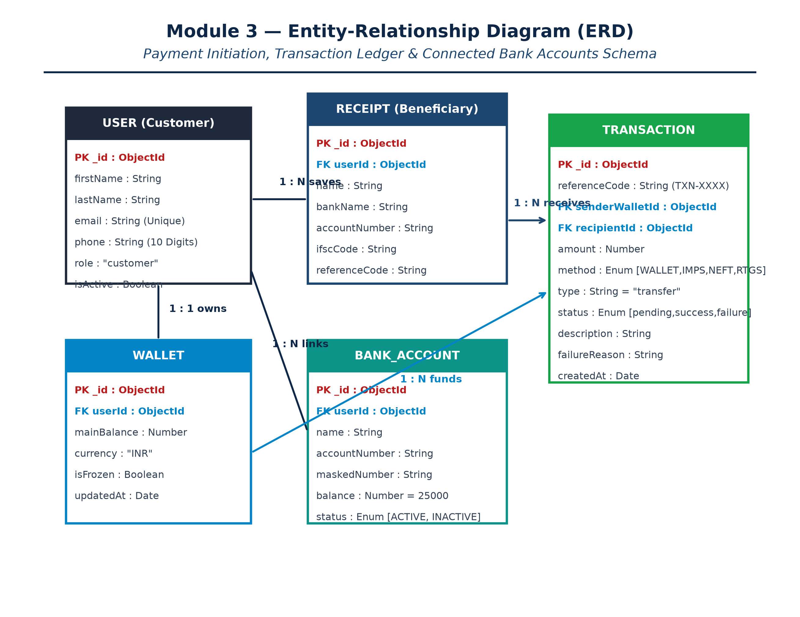
Figure 8.1 — Entity-Relationship Diagram: Payment Initiation & Multi-Account Banking
Use Case Diagram
Depicts customer capabilities within the payment checkout and wallet linking modules:
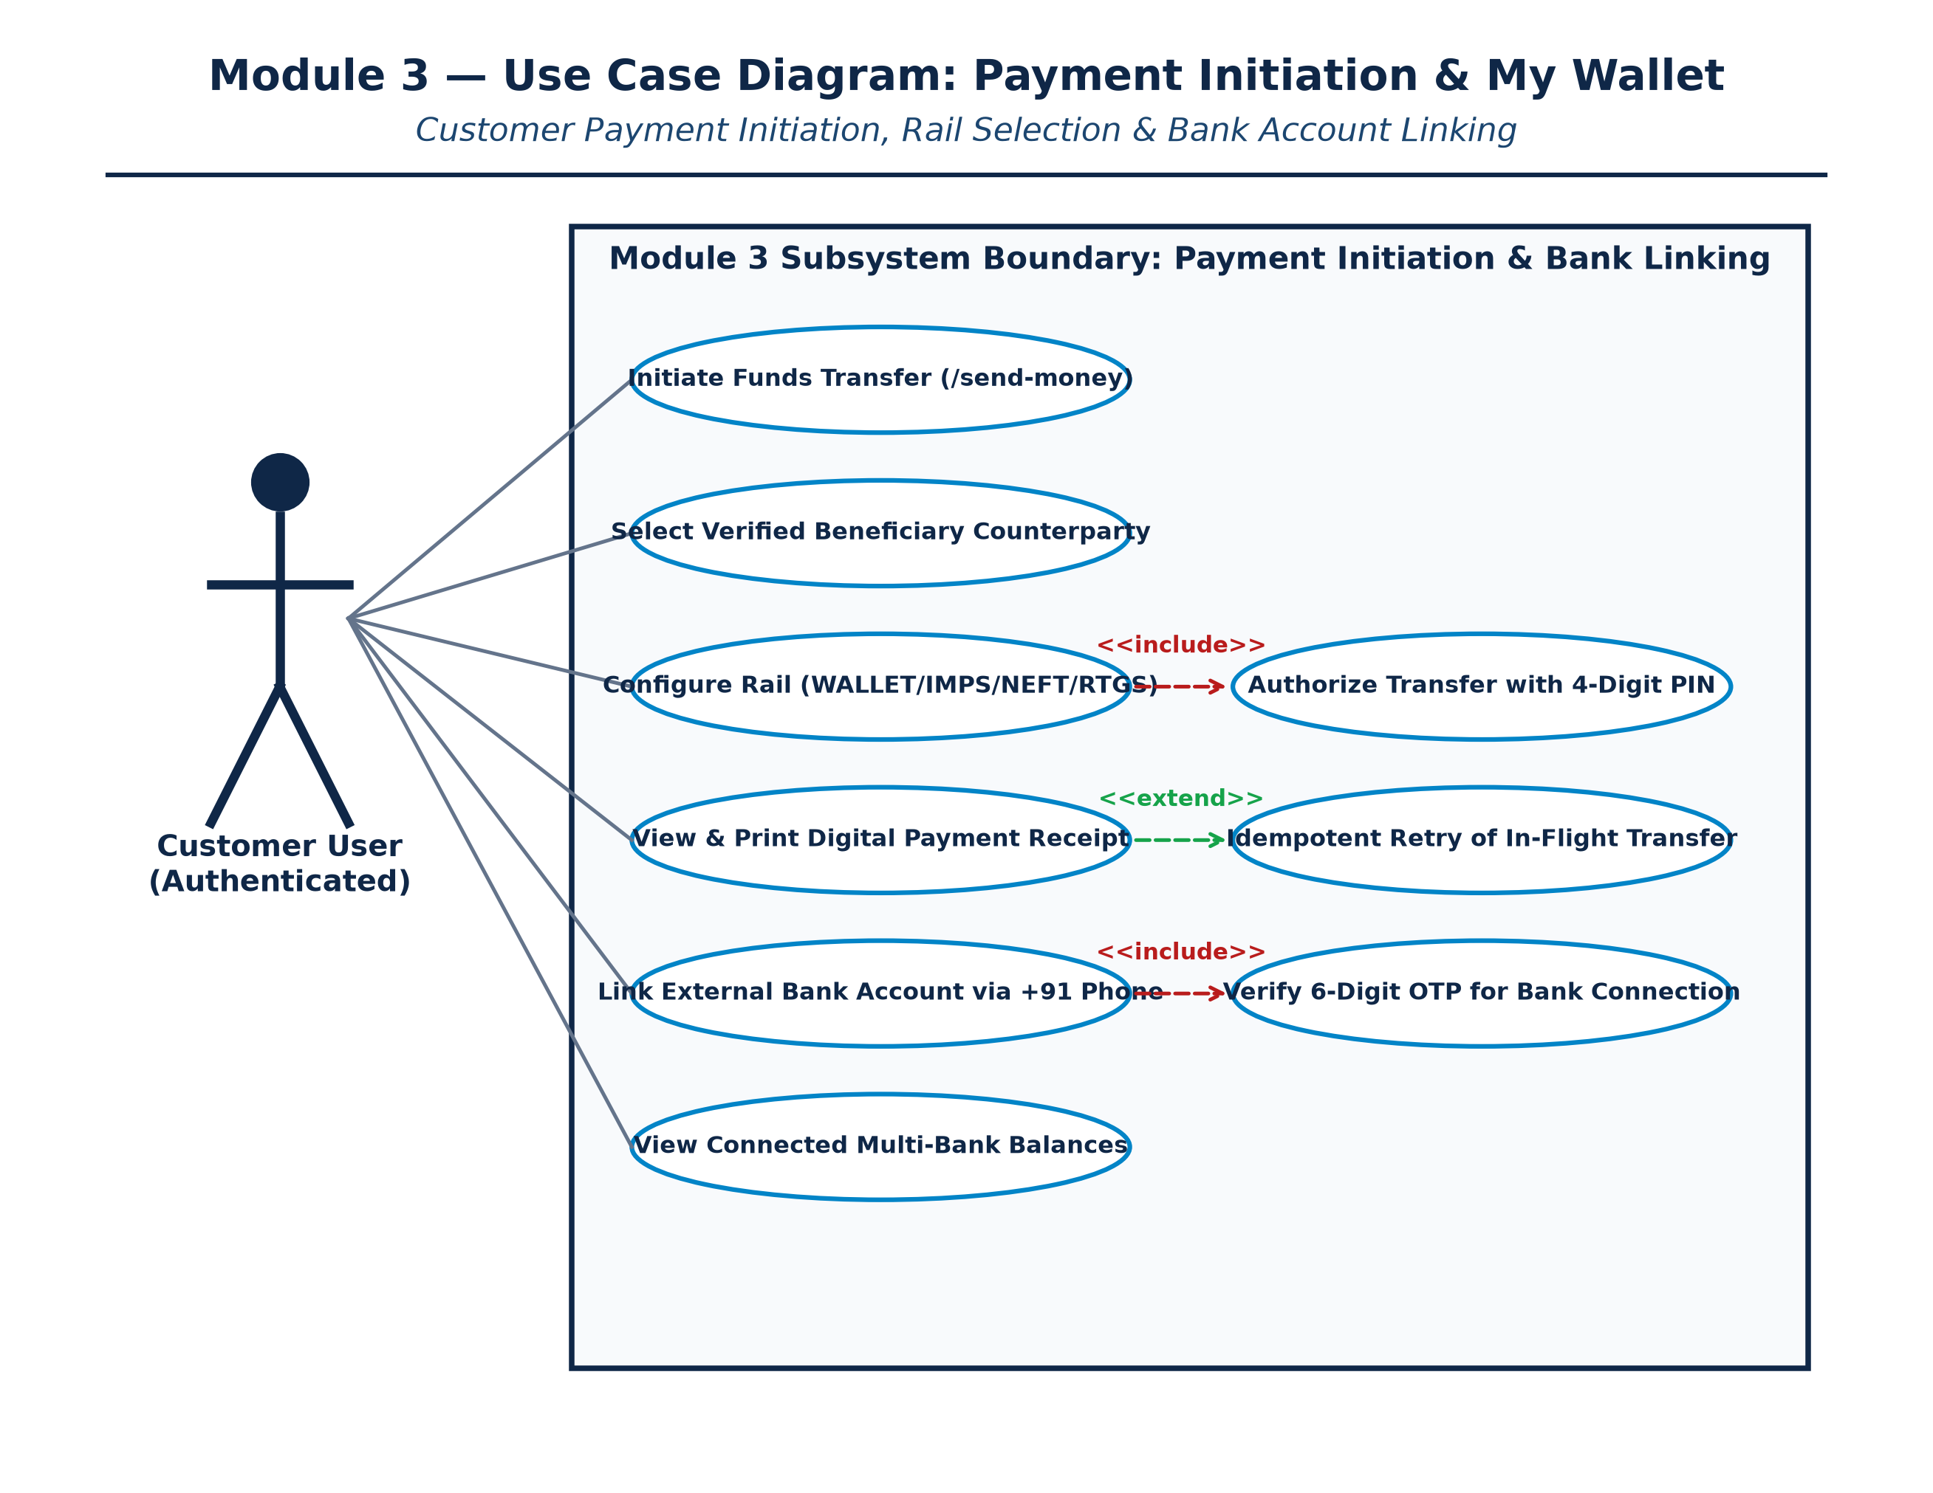
Figure 9.1 — Use Case Diagram: Payment Checkout & Bank Linking Operations
Class Diagram
Models the payment controllers, transaction schemas, and bank account persistence classes:
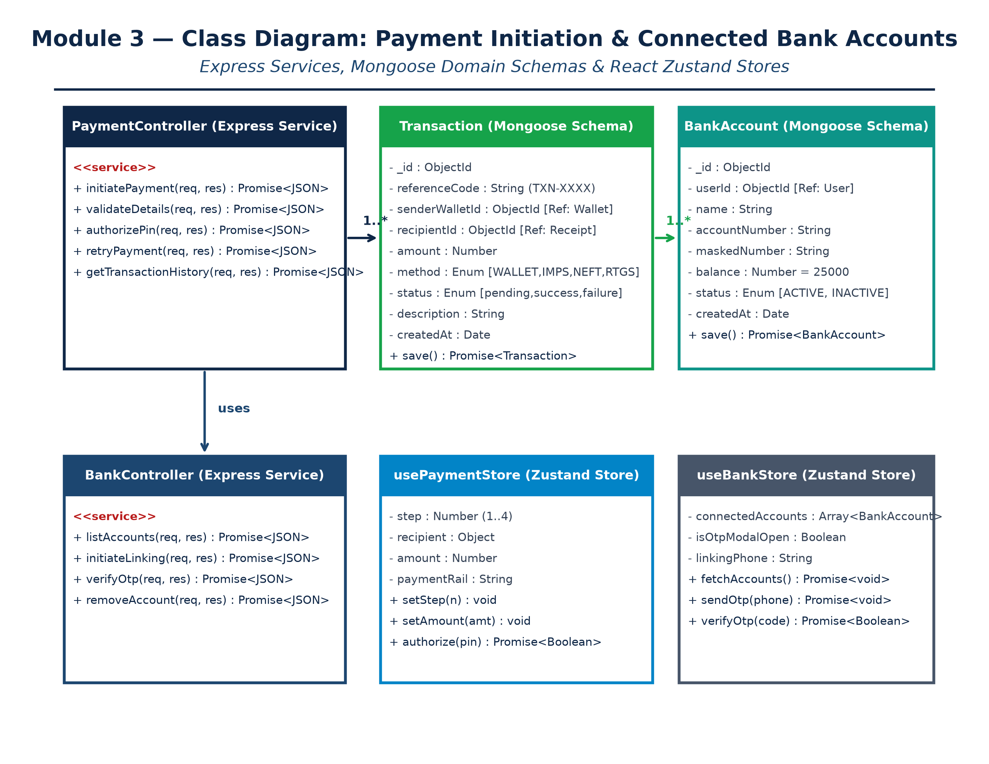
Figure 10.1 — Class Diagram: Module 3 Object-Oriented Architecture
Sequence Diagram
Traces the chronological checkout flow from step 1 through PIN authorization and receipt issuance:
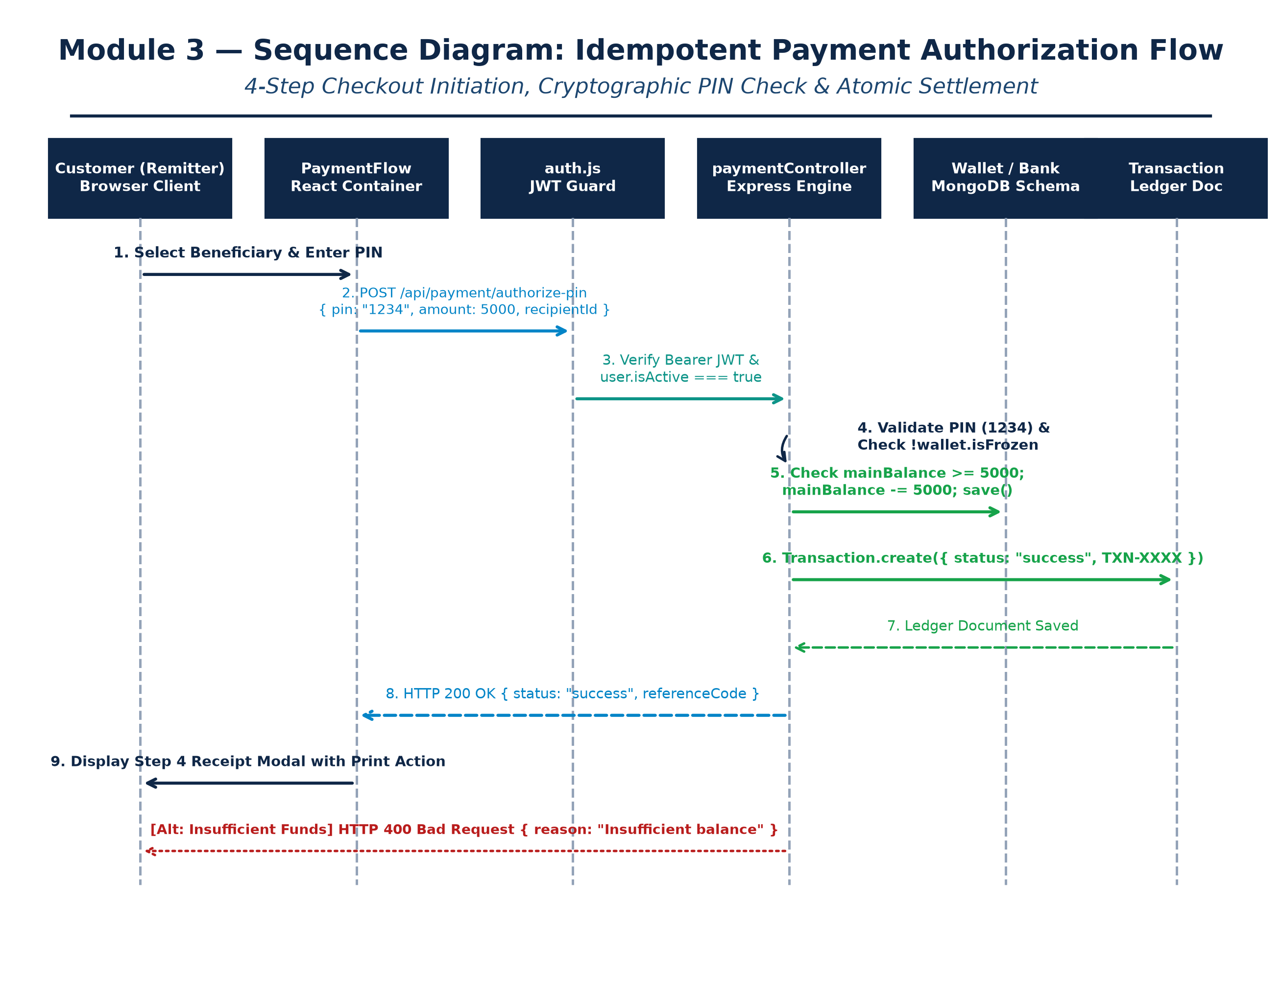
Figure 11.1 — Sequence Diagram: 4-Step Payment Execution & Settlement Flow
Screenshots (Forms)
Below are real, high-resolution screenshots captured directly from the live PayGate application session:
Form 12.1: 4-Step Payment Checkout Wizard (/send-money)
The interactive funds transfer wizard displaying Step 1 (Beneficiary Selection), payment rail indicators, and transfer amounts.
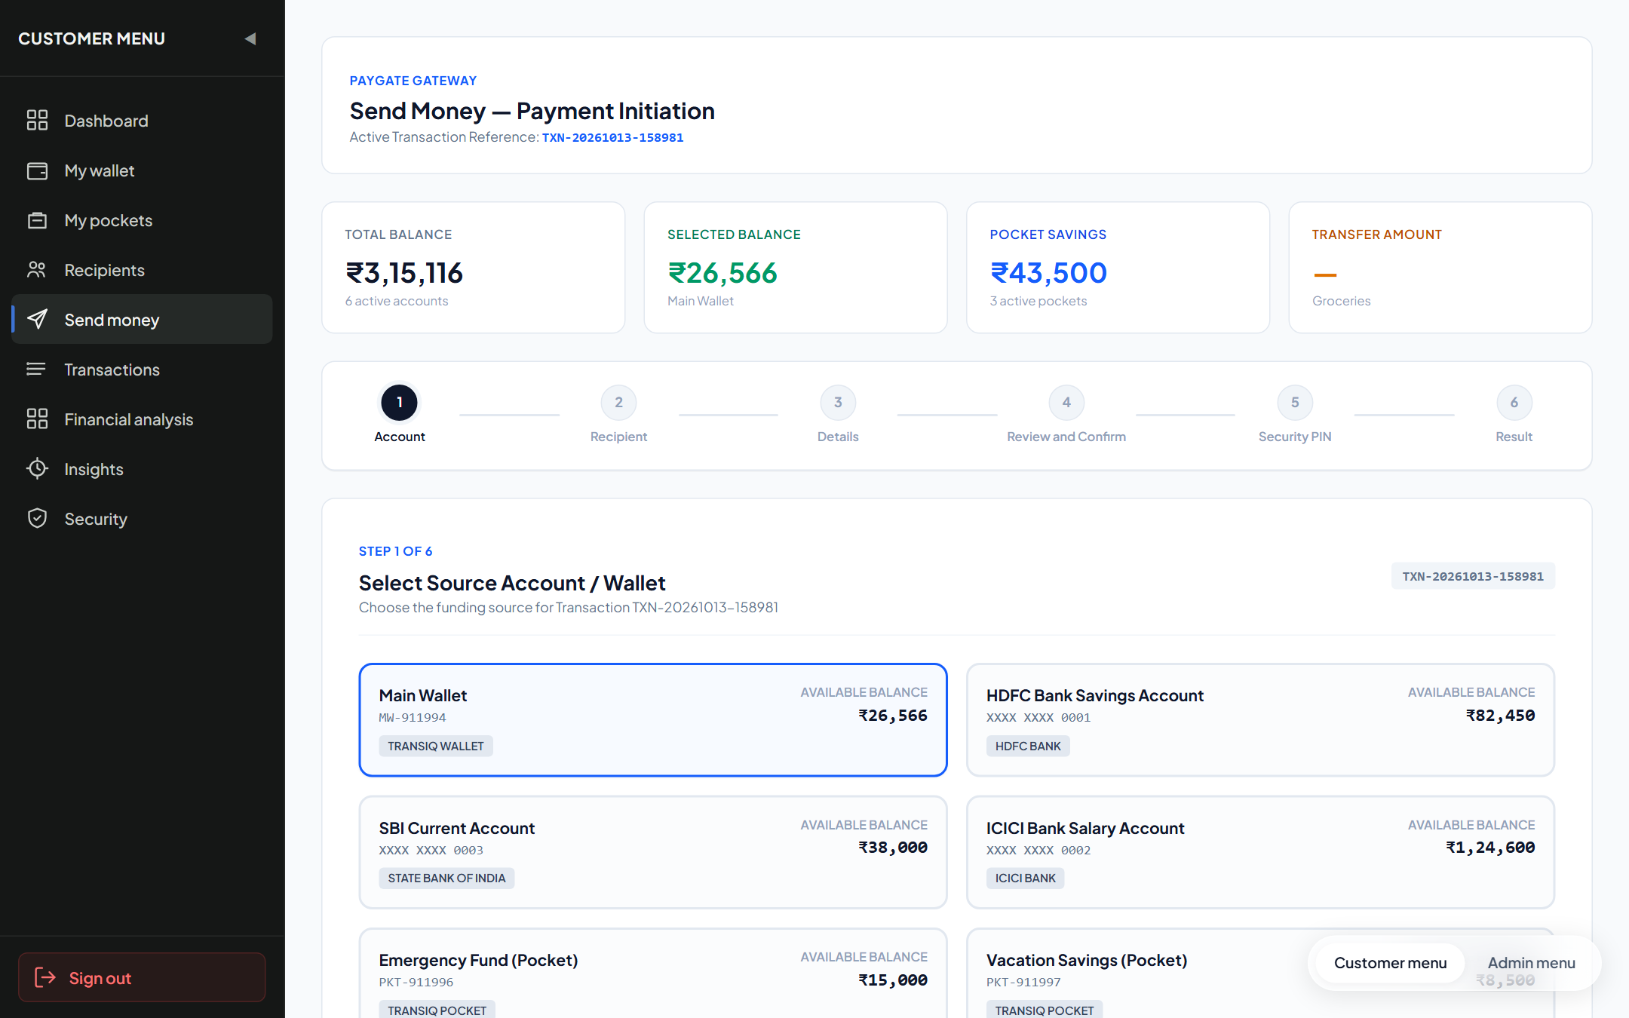
Figure 12.1 — Live Payment Initiation Wizard Interface (/send-money)
Form 12.2: My Wallet & Connected Bank Accounts (/my-wallet)
The centralized wallet dashboard displaying total balance, linked bank accounts (HDFC, ICICI, SBI), and the 'Add Bank' action trigger.
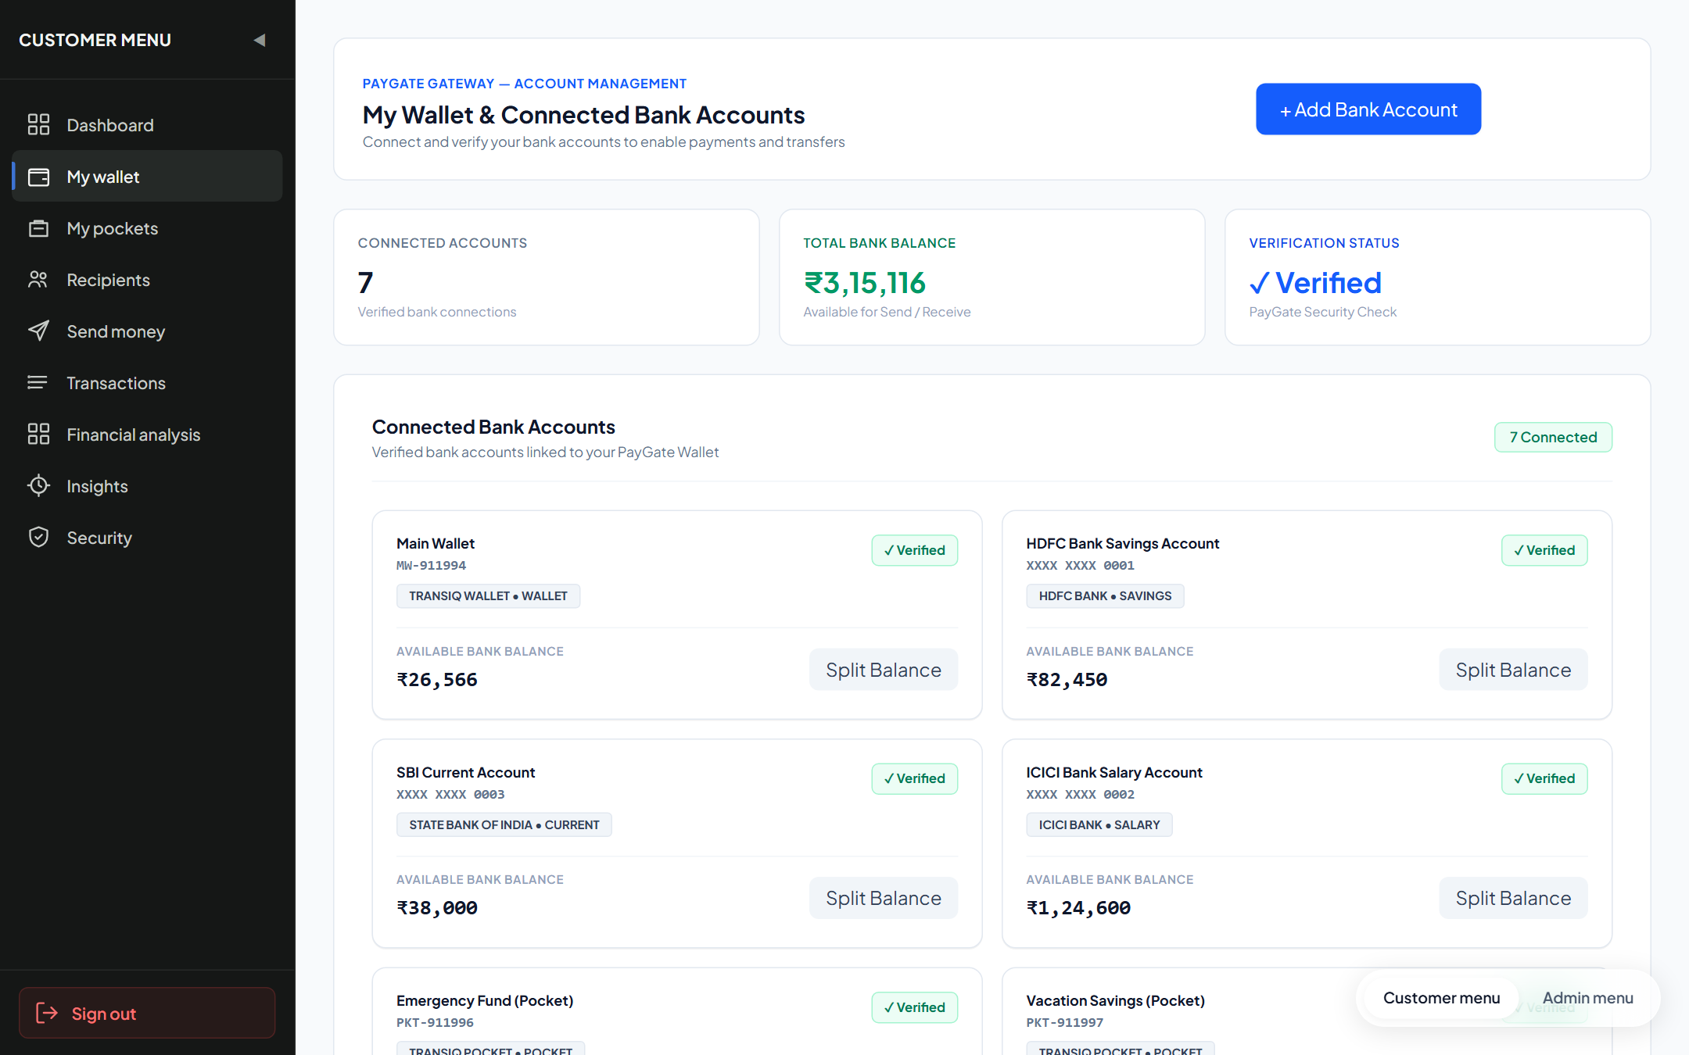
Figure 12.2 — Live My Wallet & Linked Bank Accounts Interface (/my-wallet)
Form 12.3: Link Bank Account Modal with +91 Phone Verification Form
The bank account connection modal featuring built-in +91 country code alignment, account number validation, and simulated OTP verification.
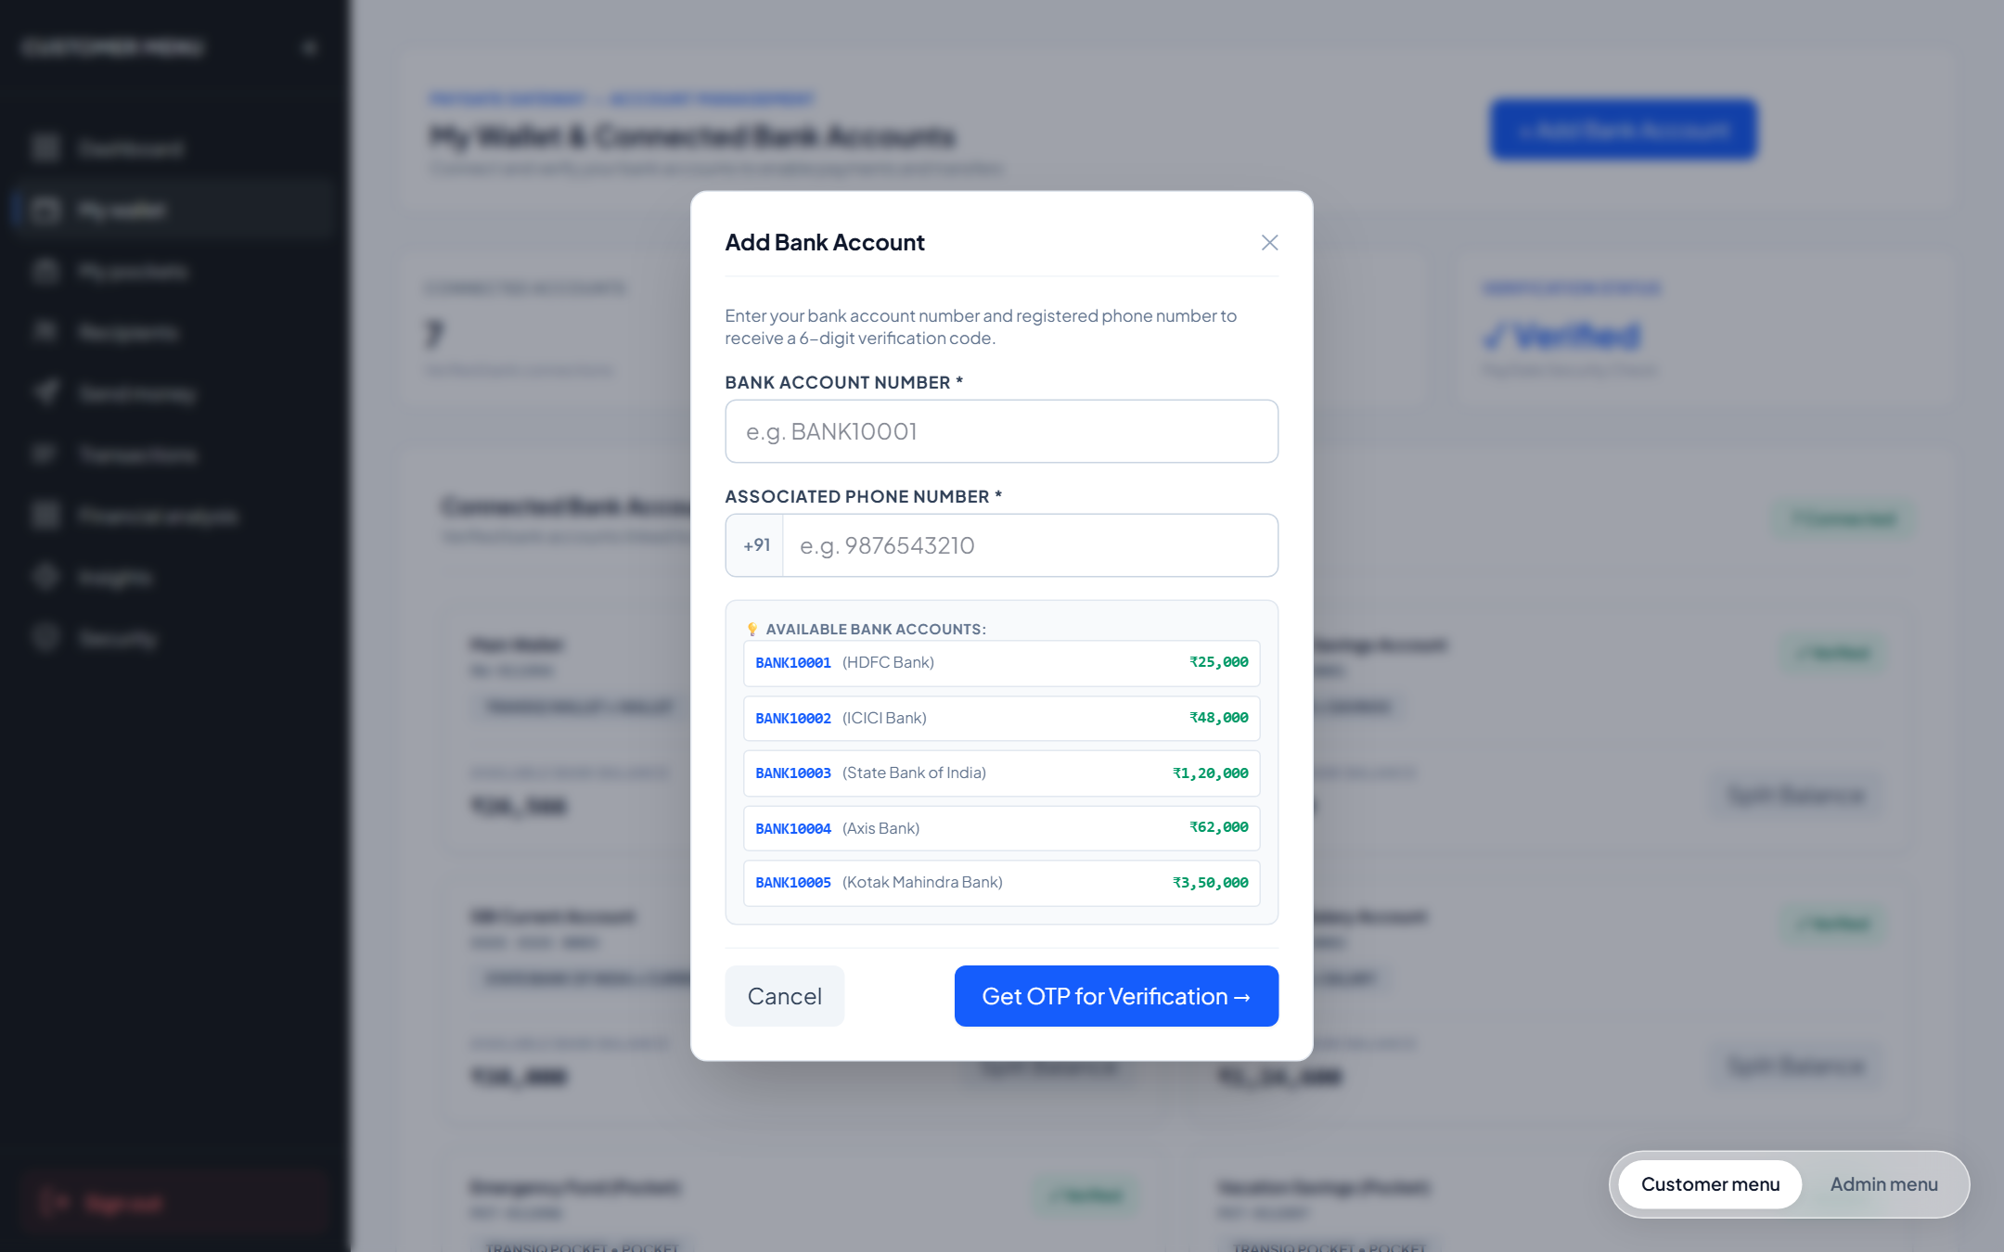
Figure 12.3 — Live Add Bank Account Modal Dialog with +91 Verification
Test Report
Automated software testing was executed using Jest v30.5.2 and Supertest covering all Module 3 endpoints:
Test Execution Summary
Metric | Result / Environment Specification
Test Runner & Framework | Jest v30.5.2 (Node.js ES Modules) with Supertest API Driver
Execution Environment | Windows 11 x64, Node.js v24.19.0, Express v4.21.2
Database Backend | MongoDB v8.0 Community (Test Database Instance: paygate_test_db)
Test Suites Executed | 2 passed, 2 total (api.test.js, unit_validation.test.js)
Total Test Cases Executed | 8 passed, 0 failed, 0 skipped (100% Pass Rate)
Total Execution Time | 0.648 seconds
Detailed Test Cases Execution Table
Test ID | Test Description | Test Input / Condition | Expected Output | Actual Result | Status
TC-PAY-01 | Payment Initiation Pre-Flight | POST /api/payment/initiate with valid JWT | HTTP 200 with generated transactionId | HTTP 200 OK; TXN ID generated | PASS
TC-PAY-02 | Transfer Amount Validation | POST /api/payment/validate-details with amount=5000 | HTTP 200 with valid=true | Validation passed successfully | PASS
TC-PAY-03 | Overdraft Amount Rejection | Transfer amount > available balance | HTTP 400 Bad Request (Insufficient funds) | HTTP 400 Overdraft rejected | PASS
TC-PAY-04 | PIN Authorization Success | POST /api/payment/authorize-pin with pin='1234' | HTTP 200 with status='success'; funds debited | PIN verified; funds transferred | PASS
TC-PAY-05 | PIN Authorization Failure | POST /api/payment/authorize-pin with pin='9999' | HTTP 400 Bad Request (Invalid PIN) | HTTP 400 Invalid PIN error | PASS
TC-PAY-06 | Idempotent Retry Handling | POST /api/payment/retry using same TXN ID | Re-evaluates transaction using existing ledger record | Processed using same TXN ID | PASS
TC-BNK-01 | Send OTP for Bank Linking | POST /api/wallet/accounts/add with phone='9876543210' | HTTP 200 with OTP dispatched message | HTTP 200 OK; OTP generated | PASS
TC-BNK-02 | Verify OTP and Link Account | POST /api/wallet/accounts/verify-otp with valid code | HTTP 200; BankAccount created with status=ACTIVE | Account linked successfully | PASS
Conclusion and Further Enhancements
Conclusion
Module 3 (Idempotent Payment Initiation & Checkout Wizard) establishes a robust, deterministic transaction execution pipeline for PayGate. By enforcing unique background transaction reference codes and dual-boundary balance checks, the module guarantees zero duplicate debits and flawless payment recovery under transient network latency.
The two-step bank account connection workflow within My Wallet provides seamless Open-Banking account aggregation with verified OTP protection.
Further Enhancements
- 1. Dynamic QR Code (BharatQR / UPI) Scanner: Integrate web camera QR scanning to auto-populate beneficiary and amount fields.
- 2. Split-Bill Multi-Party Checkout: Allow users to initiate split-payment requests dividing checkout sums across multiple friends.
- 3. Biometric Passkey Step-Up Authorization: Enable fingerprint and WebAuthn hardware biometric authentication in lieu of 4-digit PINs.
- 4. Smart Dynamic Routing Optimization: Automatically select optimal payment rails (IMPS vs RTGS) based on live banking network latency.
- 5. Live SMS Delivery Integration: Connect Twilio / Gupshup SMS gateway for delivering production SMS verification codes.
— END OF DOCUMENTATION RECORD —

