
COIMBATORE INSTITUTE OF TECHNOLOGY
(Government Aided Autonomous Institution affiliated to Anna University)
Coimbatore – 641 014, Tamil Nadu, India
━━━━━━━━━━━━━━━━━━━━━━━━━━━━━━━━━━━━━━━━━━━━━━━━━━━━━━━━
PROJECT DOCUMENTATION RECORD
PayGate (Transiq)
Secure Digital Payment & Wallet Management Platform
A Scalable Full-Stack MERN Payment Gateway and Intelligent Digital Wallet System
MODULE 4: TRANSACTION LEDGERS & FINANCIAL ANALYTICS
PROJECT DETAILS
Field | Details
Project Title | PayGate (Transiq) — Secure Digital Payment & Wallet Management Platform
Subsystem Focus | Module 4: Transaction Ledgers & Financial Analytics
Domain | Full-Stack Web Development — Enterprise FinTech & Digital Payments (MERN Stack)
Institution | Coimbatore Institute of Technology (Autonomous), Coimbatore – 641 014
Course & Degree | M.Sc. Software Systems (5-Year Integrated Degree Programme)
Academic Year | 2025 – 2026 (Semester III)
TEAM DETAILS (6 MEMBERS)
S.No | Name of Student | Register Number | Assigned Module / Role
1 | Krishnaprabha D | 2503717672622025 | Module 1: Customer Profile, Wallets & Smart Pockets
2 | Nithinkumar R | 2503717672621035 | Module 2: Beneficiary Management & Directory Services
3 | Mohamed Riyaz A | 2503717672621028 | Module 3: Idempotent Payment Initiation & Checkout Wizard
4 | Rithick K | 2503717672621040 | Module 4: Transaction Ledgers & Financial Analytics (Lead)
5 | Mohamed Umar K | 2503717672621029 | Module 5: Security Governance, Access Control & Wallet Kill-Switch
6 | Dinesh G | 2503717672621008 | Module 6: Admin Operations, Monitoring & Error Audit Console
Project Guide / Supervisor: Prof. / Dr. __________________________________________________
Signature of the Guide: ______________________________ Date of Submission: _______________

Synopsis
PayGate (Transiq) is a full-stack digital payment and wallet platform engineered to deliver total financial auditability and operational intelligence. Within this ecosystem, Module 4: Transaction Ledgers & Financial Analytics serves as the primary ledger audit, forensic inspection, and spending intelligence subsystem. Built on the Node.js/Express REST backend, React 18 single-page application, and MongoDB database architecture, the module records every financial transfer, provides real-time historical filtering, and generates graphical financial analytics.
Operational Challenge & Problem Statement
In electronic payment systems, users frequently struggle to trace past transfer flows, understand monthly spending patterns, or diagnose why specific transactions failed. Without structured ledgers and visual analytics, consumers experience operational opacity. Module 4 eliminates these issues by providing a multi-criteria filterable ledger, detailed transaction inspection views, graphical volume breakdowns, and one-click CSV report exports.
Key Functional & Architectural Innovations
- 1. Immutable Transaction Ledger: Implements an immutable ledger recording reference codes, amounts, timestamps, payment rails, and failure reasons.
- 2. Granular Multi-Criteria Filtering: Powers sub-second transaction discovery via date-range, status (pending/success/failure), rail, and search-term filters.
- 3. Key-Value Transaction Detail View: Features a dedicated inspection modal rendering complete transfer metadata, recipient banking details, and retry triggers.
- 4. Graphical Telemetry & Analytics: Computes total expenditure volume, success-to-failure ratios, payment rail distribution, and monthly spending trends.
- 5. Client-Side CSV Ledger Export: Enables users to export filtered audit trails into RFC-4180 compliant CSV spreadsheets for offline forensic accounting.
Implementation Stack & Documented Outcome
Module 4 utilizes React 18 with Recharts graphical charting and Zustand store (transactionStore.js, analyticsStore.js), Express analytics controllers (analyticsController.js, transactionController.js), and MongoDB aggregation pipelines. The module guarantees total transaction traceability, transparent spending visibility, and rapid compliance reporting.

Objective
The primary objectives of Module 4 (Transaction Ledgers & Financial Analytics) are:
- 1. Comprehensive Ledger Integrity: Maintain an immutable, auditable financial record for all transfer, deposit, and withdrawal activities.
- 2. Searchable Transaction History: Provide an intuitive transaction history interface supporting real-time status filtering and reference code searching.
- 3. Deep Transaction Inspection: Deliver deep diagnostic visibility into individual transactions via a dedicated detail view showing timestamps, recipient banks, and failure reasons.
- 4. Visual Spending Analytics: Aggregate payment volume and success metrics to visualize financial health through interactive charts.
- 5. Intelligent Spending Insights: Generate intelligent category and counterparty insights identifying top recipients and spending categories.
- 6. Forensic CSV Export: Provide high-speed CSV export capabilities allowing users to download structured records for tax and accounting audits.
Scope
Functional Scope
- Transaction Ledger Browsing: Browsing historical transactions with pagination, date filters, and method dropdowns.
- Transaction Detail Inspection: Opening detailed view cards with counterparty names, IFSC codes, and failure diagnostics.
- Financial Analytics Dashboards: Aggregating monthly spending volume, payment method distribution (WALLET, IMPS, NEFT, RTGS), and success rates.
- Spending Insights & Analytics: Generating insights on top counterparties and high-frequency transfer habits.
- Audit Ledger CSV Export: Generating and downloading RFC-4180 compliant CSV spreadsheets.
Technical Scope
- Application Server Architecture: Express.js REST API exposing versioned endpoints under /api/transactions and /api/analytics.
- Database Aggregations: MongoDB aggregation pipelines ($match, $group, $sort) executing high-speed volume calculations.
- Client-Side SPA Architecture: React SPA with Tailwind CSS, Recharts charting library, and Zustand state stores.
Out-of-Scope (Future Expansion)
- Account Aggregator (AA) Integration: Direct bank feed reconciliation via Open-Banking Account Aggregator (AA) framework.
- Automated Tax & GST Invoicing: Automated income tax capital gains calculations or GST invoicing.
Project Description
Module 4 operates across three multi-tier layers:
Client Tier — Analytics & Ledger UI
- TransactionsPage.jsx: Primary ledger view with search bar, status badges, pagination, and action buttons.
- TransactionDetailPage.jsx: Specialized card view displaying complete transaction metadata, counterparty details, and retry triggers.
- FinancialAnalysisPage.jsx: Analytics view rendering volume KPIs, monthly trend line charts, and payment rail pie charts.
- InsightsPage.jsx: Spending summary view highlighting top counterparty allocations.
Application Server Tier — transiq-api
- transactionController.js: Handles paginated ledger queries, filter evaluations, and single-transaction lookups.
- analyticsController.js: Executes MongoDB aggregation pipelines computing summary statistics, monthly breakdowns, and CSV streams.
Data Persistence Tier — MongoDB
Monitors and queries the transactions collection in MongoDB, utilizing compound indexes for rapid audit retrieval.
DB Design
5.1 transactions Collection (Primary Ledger)
Field | Type | Constraints / Default | Description
_id | ObjectId | Primary Key, Auto | Unique ledger transaction identifier
referenceCode | String | Unique, Indexed, Auto | Human-readable transaction reference code (TXN-XXXX)
senderWalletId | ObjectId | Ref: Wallet, Indexed | Reference to the initiating sender's wallet
recipientId | ObjectId | Ref: Receipt, Indexed | Reference to the verified destination beneficiary
amount | Number | Required, Min: 0.01 | Transfer amount in specified currency
currency | String | Default: 'INR' | Standard ISO currency identifier
method | String | Enum: WALLET, CARD, UPI, NEFT, RTGS, IMPS | Payment rail utilized
type | String | Enum: transfer, deposit, withdrawal | Transaction financial classification
status | String | Enum: pending, success, failure, cancelled | Current lifecycle execution status
description | String | Optional, Trimmed | User-specified transfer memo or remarks
failureReason | String | Optional | Standardized failure code if status === 'failure'
createdAt | Date | Default: Date.now, Indexed | Transaction creation timestamp
5.2 Financial Aggregation Pipeline Definitions
Aggregation Pipeline | MongoDB Query Stages | Analytical Purpose
Summary Telemetry | $match (senderWalletId) -> $group ($sum totalSent, $sum successCount, $avg avgAmount) | Computes top-level KPI cards
Method Breakdown | $match -> $group (_id: '$method', count: $sum 1, total: $sum '$amount') | Generates payment rail distribution chart
Monthly Trends | $match -> $group (_id: {year, month}, totalAmount: $sum '$amount') | Powers 12-month historical spending trend lines
Data Flow Diagram (DFD)
The Data Flow Diagram models transaction logging, history filtering, and analytics aggregation:
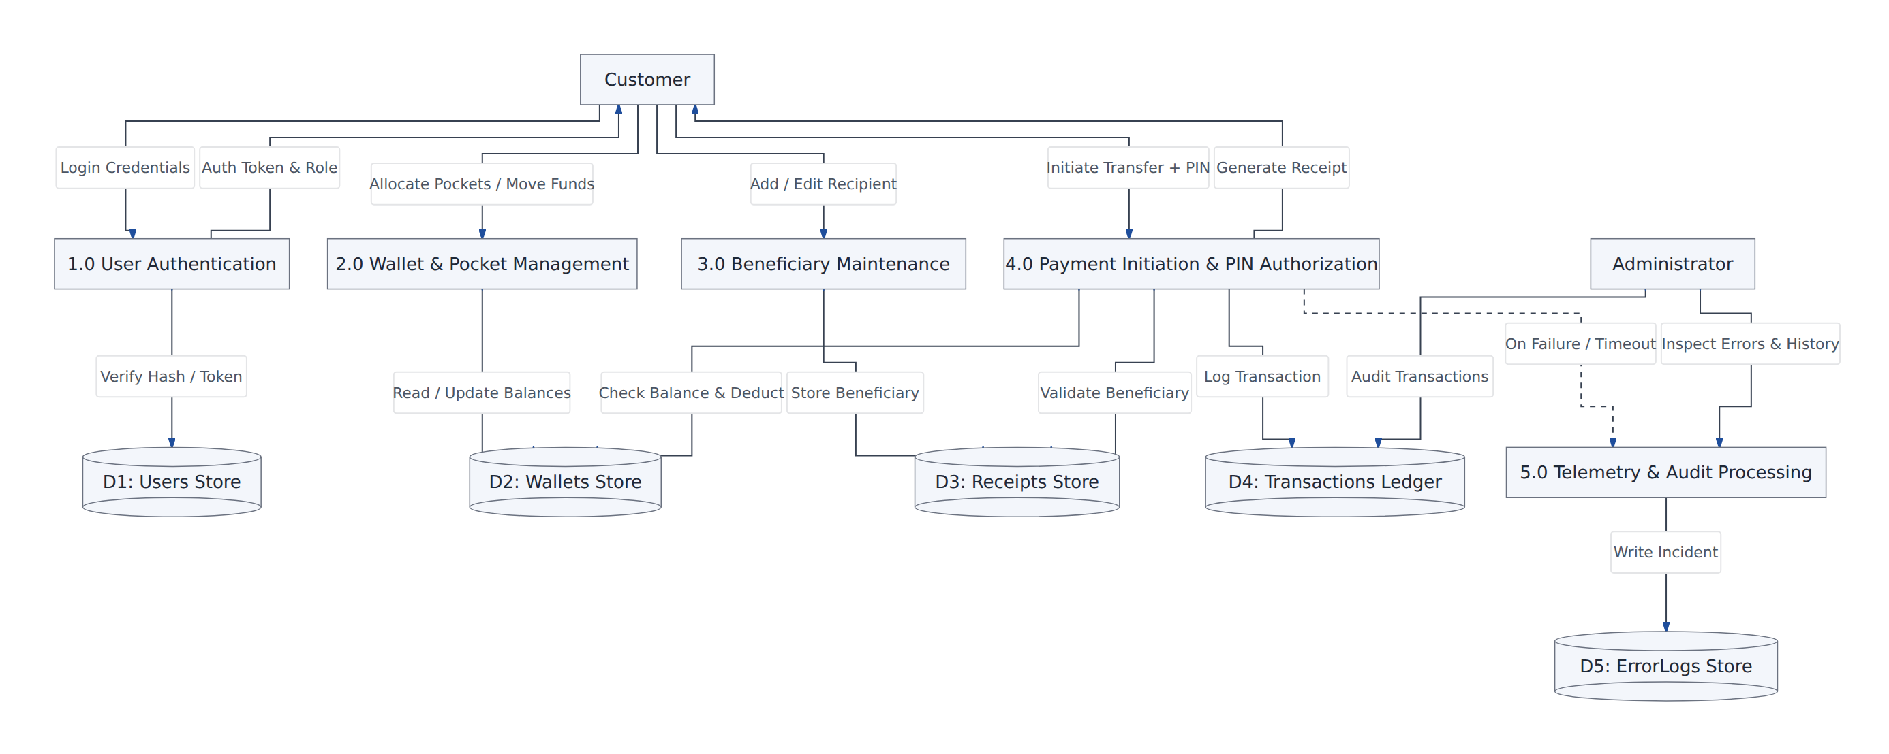
Figure 7.1 — Level 0 & Level 1 DFD: Transaction Ledger & Analytics
Process Narrative
- Process 4.1 (Transaction Logging Engine): Receives completed payments from payment controllers and writes immutable records to D4 Transactions.
- Process 4.2 (Ledger Query & Filter Service): Evaluates user filter parameters and returns paginated records from D4.
- Process 4.3 (Financial Analytics & Export Service): Runs aggregation pipelines over D4, streaming metrics to client charts and CSV builders.
ER Diagram
The Entity-Relationship model connects Transactions to Wallets, Receipts, and ErrorLogs:
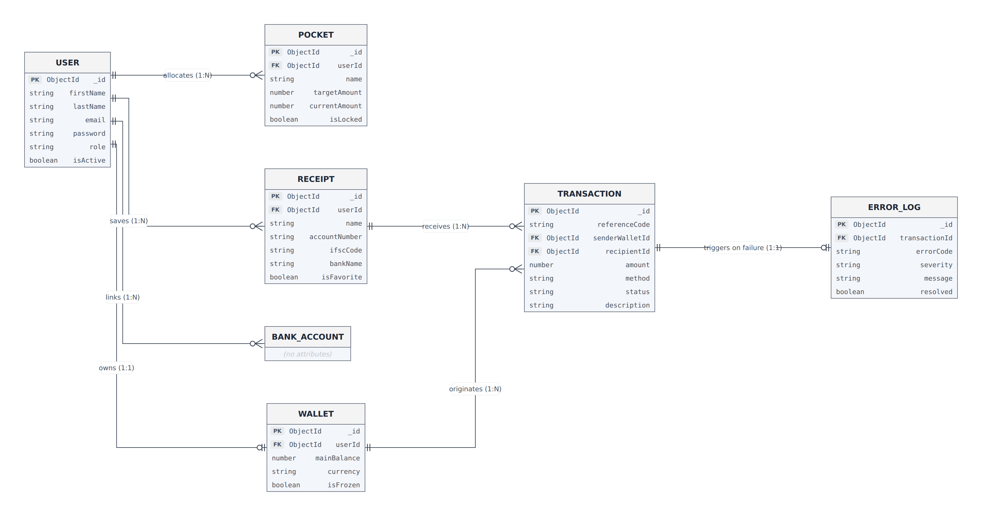
Figure 8.1 — Entity-Relationship Diagram: Transaction Ledger Architecture
Use Case Diagram
Depicts customer capabilities for transaction auditing and analytics:
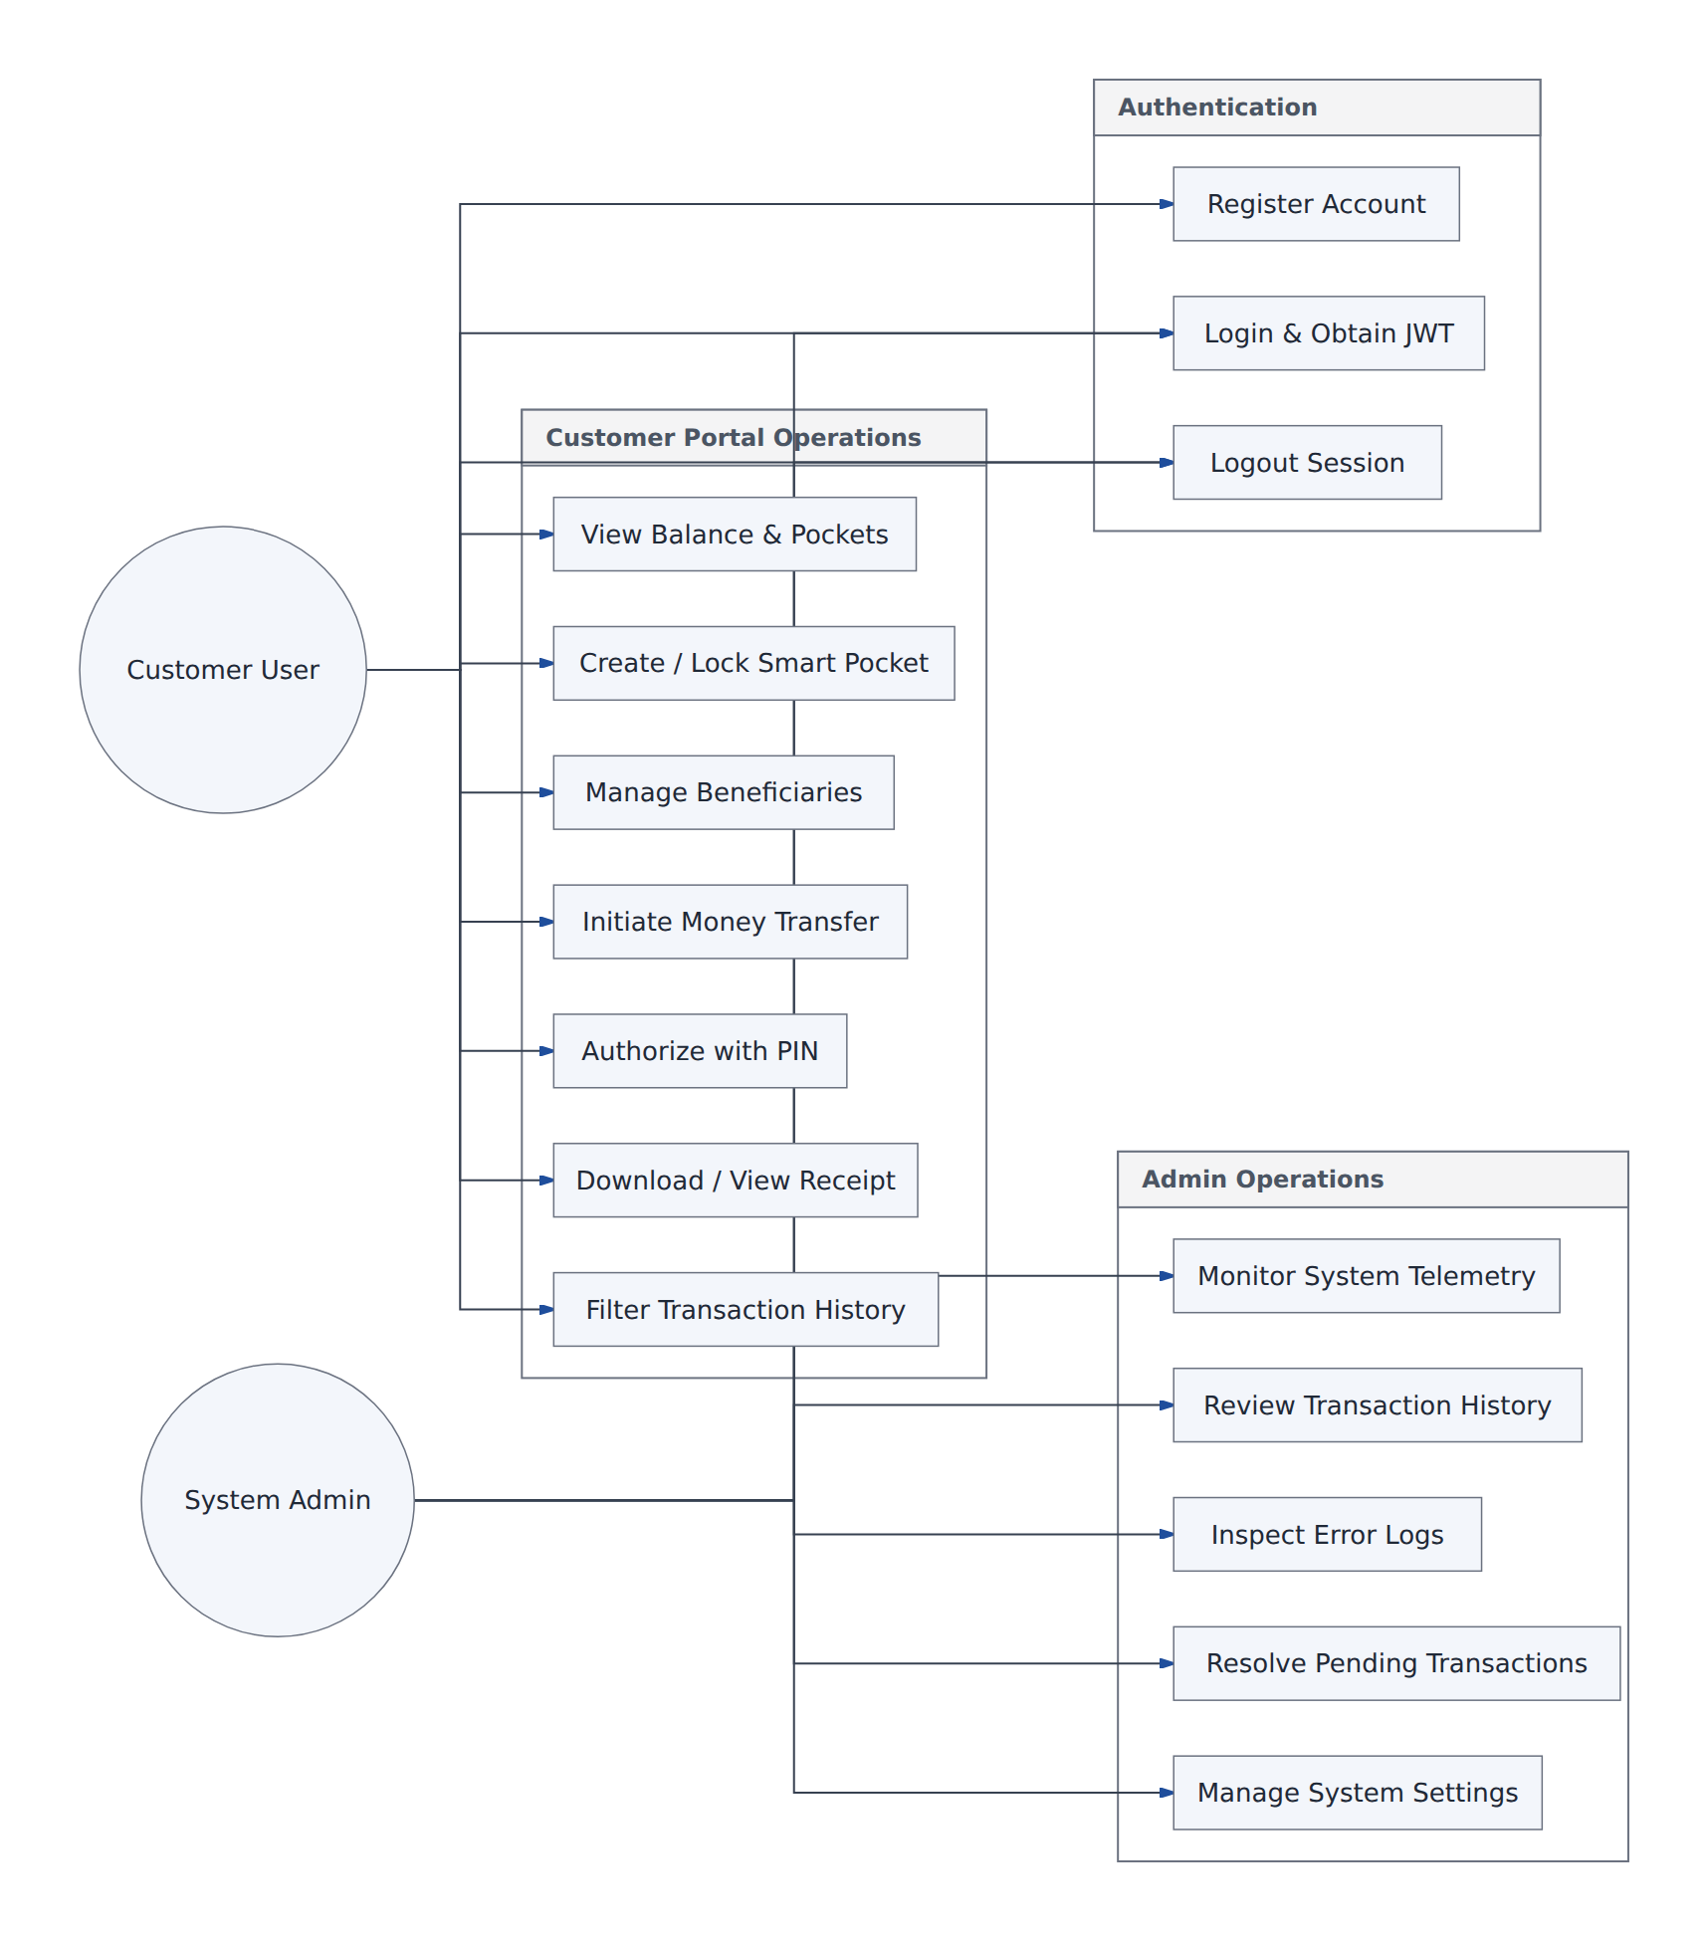
Figure 9.1 — Use Case Diagram: Transaction Ledger & Analytics Operations
Class Diagram
Models the transaction controllers, analytics services, and client Zustand stores:
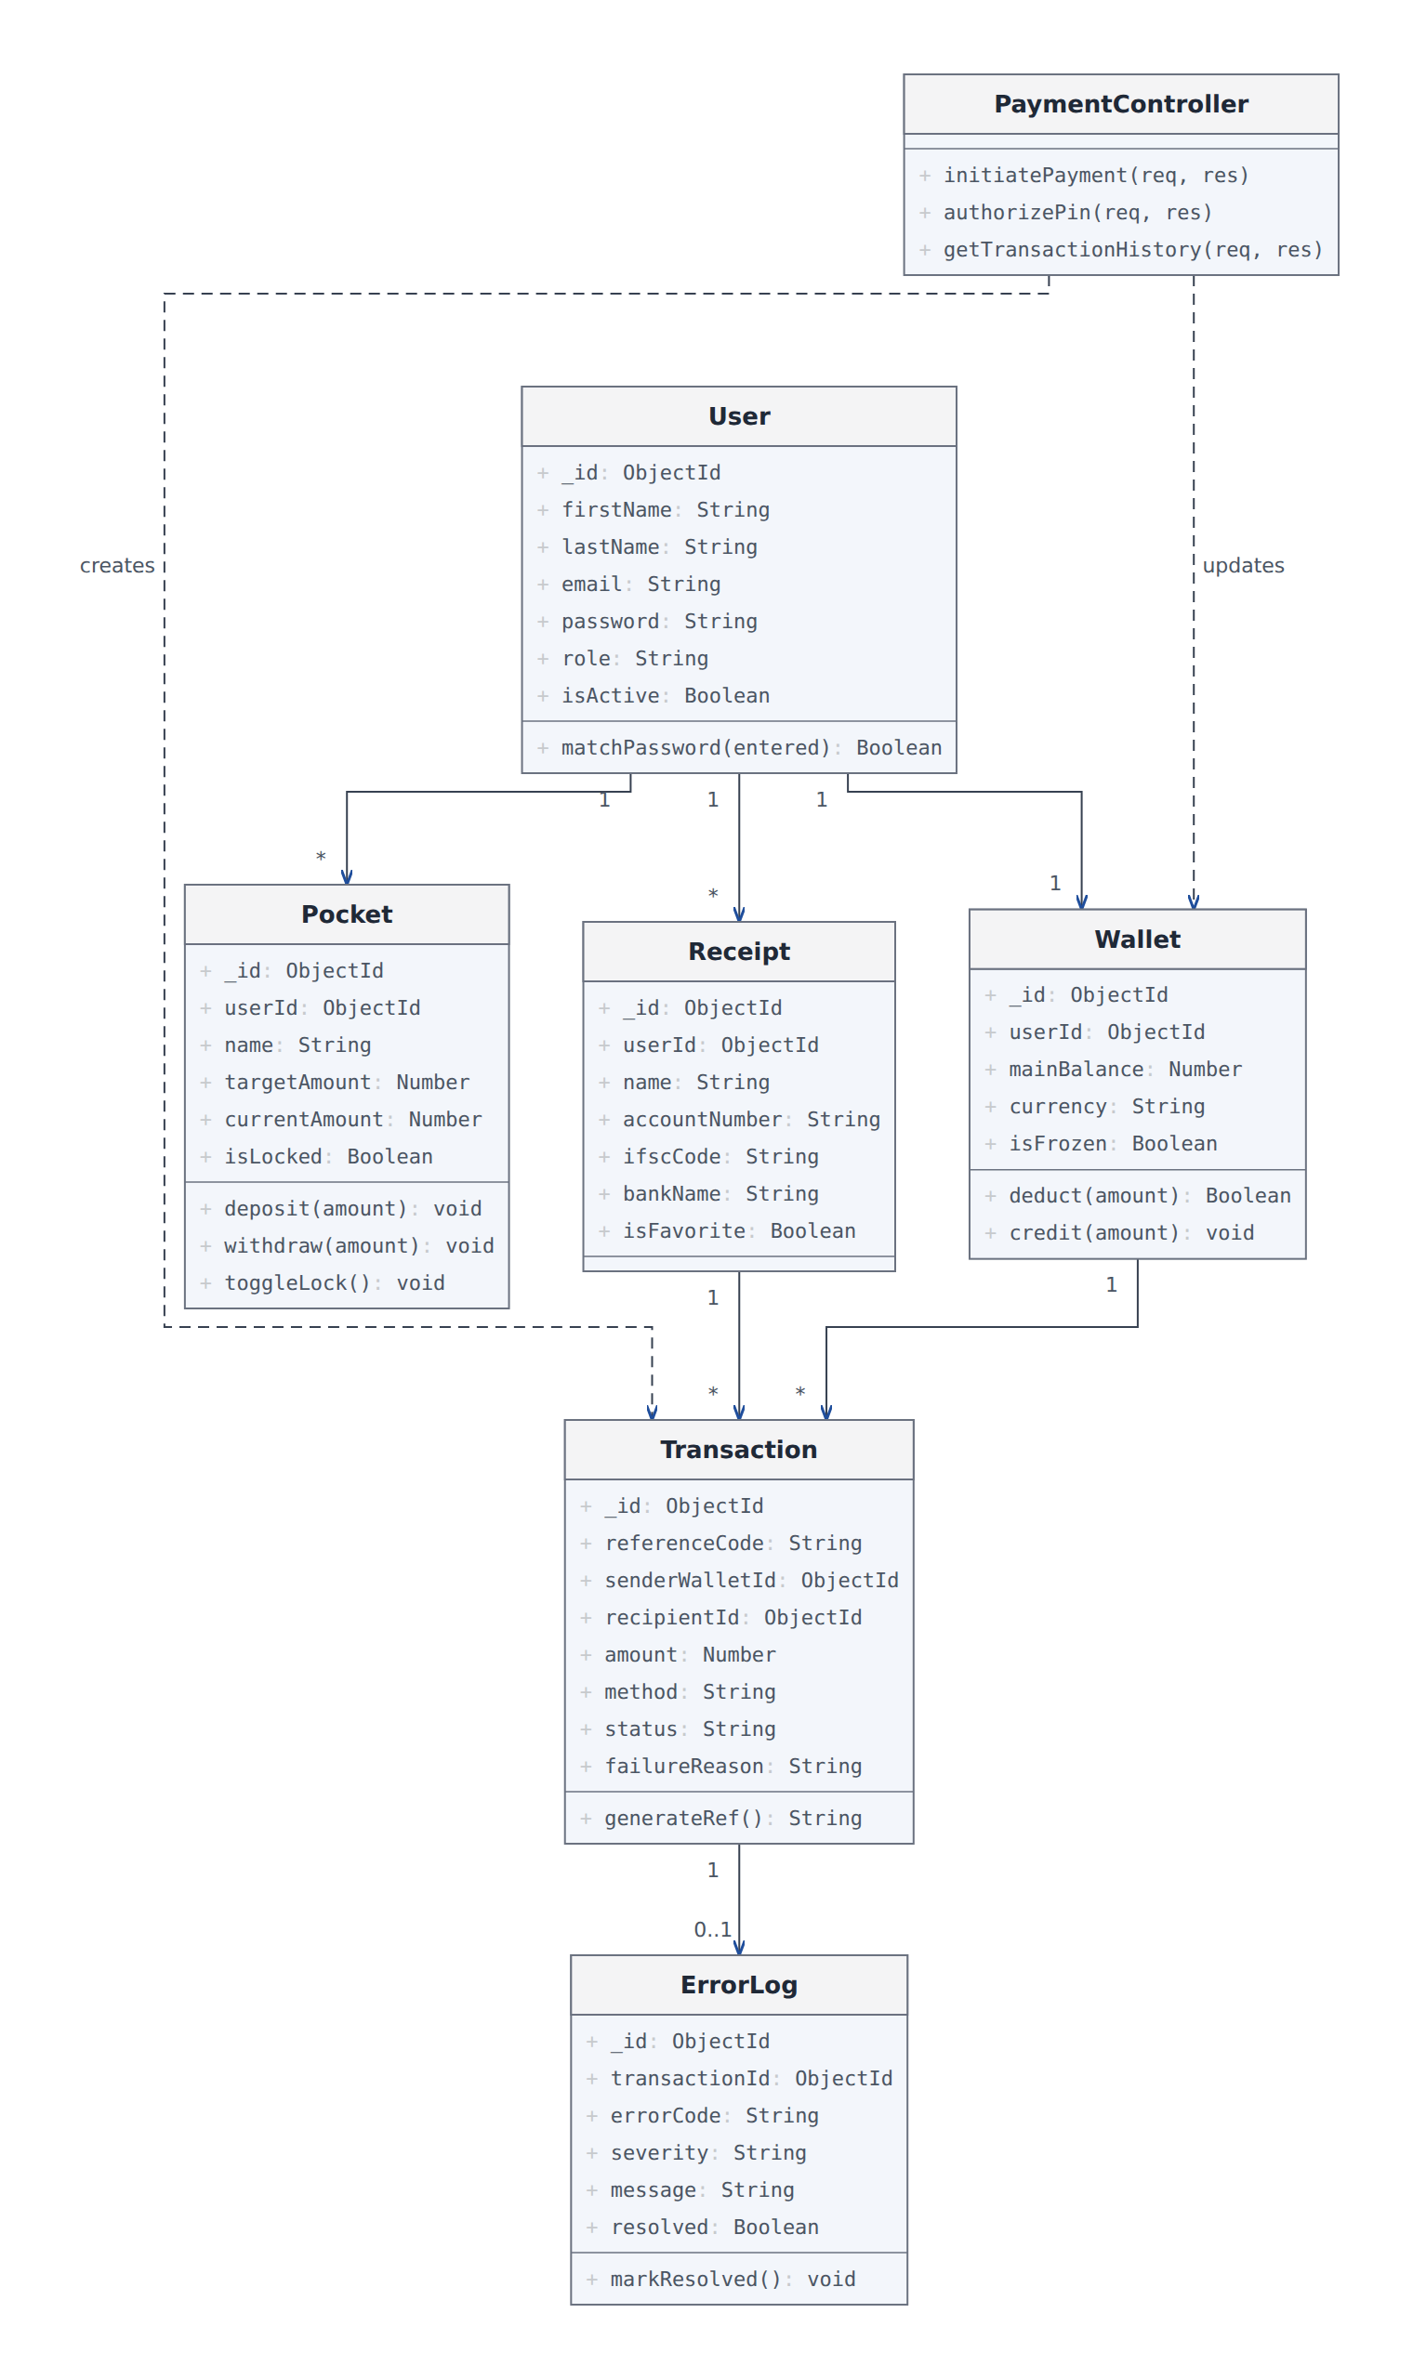
Figure 10.1 — Class Diagram: Module 4 Object-Oriented Architecture
Sequence Diagram
Traces the execution of transaction querying, detail inspection, and CSV export generation:
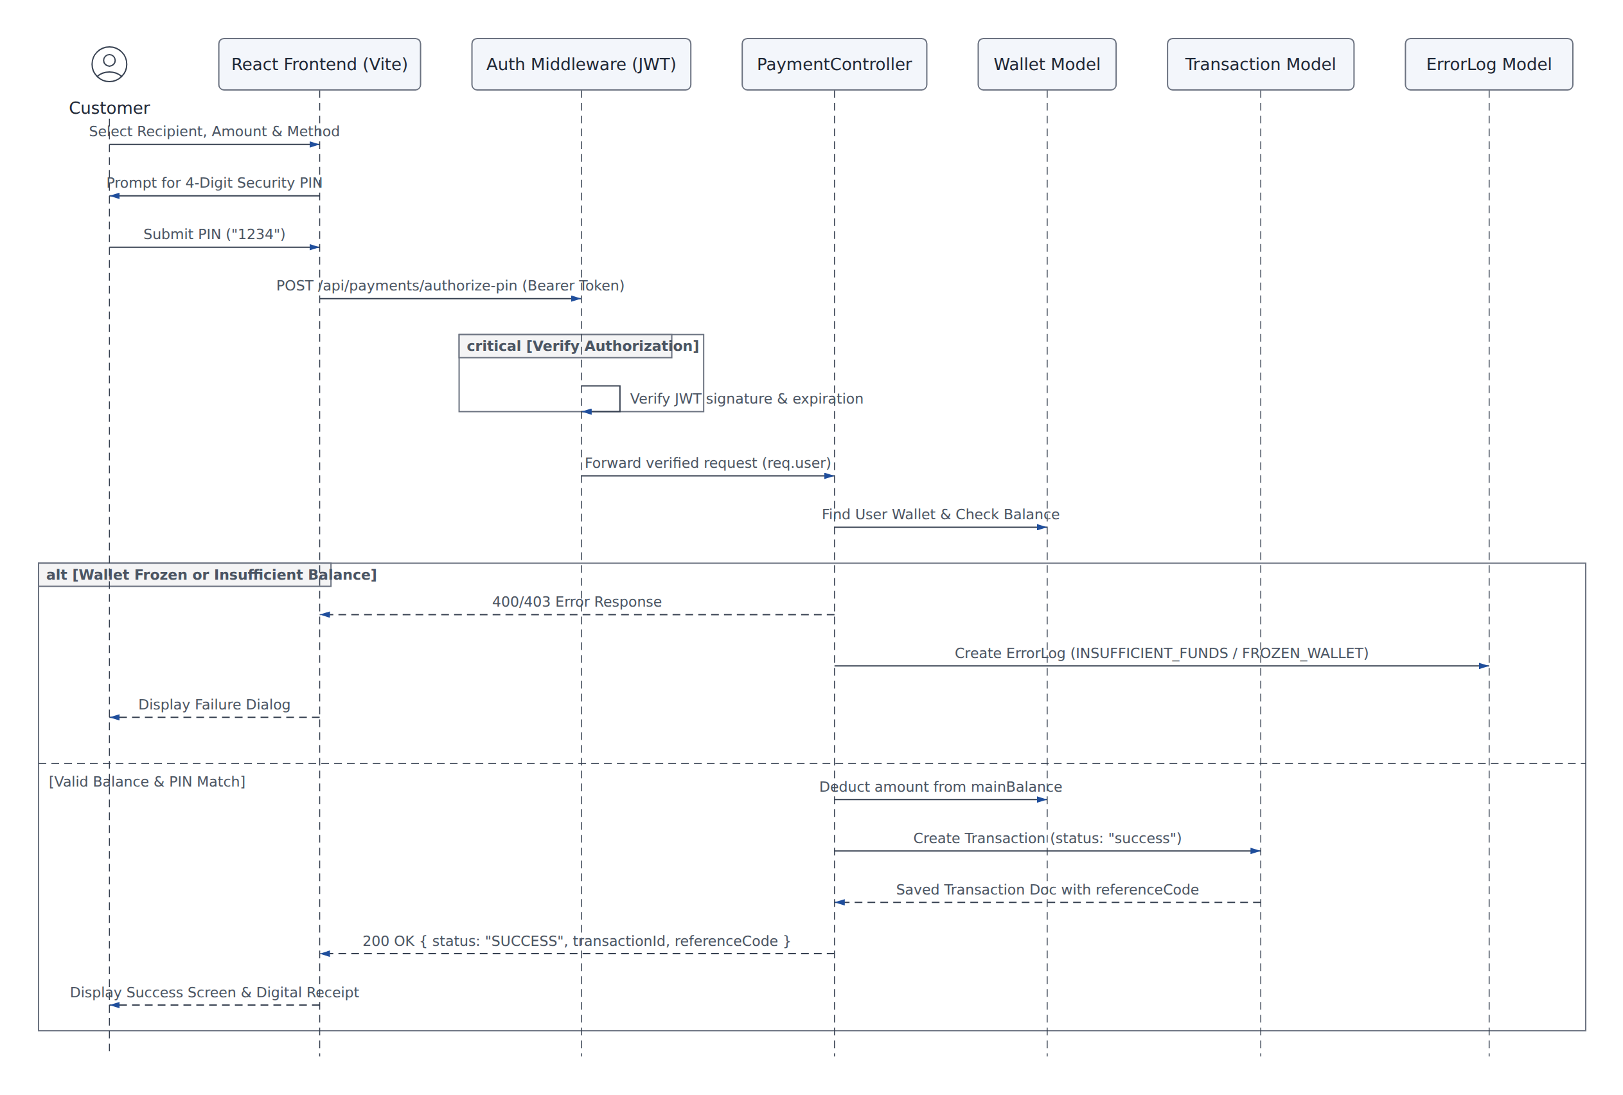
Figure 11.1 — Sequence Diagram: Transaction Query & CSV Export Flow
Screenshots (Forms)
Below are real, high-resolution screenshots captured directly from the live PayGate application session:
Form 12.1: Transaction History & Ledger Interface (/transactions)
The comprehensive customer transaction ledger displaying reference codes, recipient names, amounts, payment rails, and action buttons.
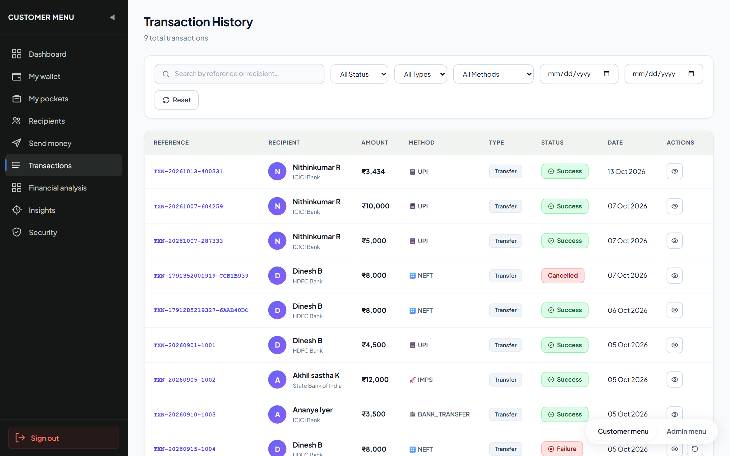
Figure 12.1 — Live Transaction History Ledger Interface (/transactions)
Form 12.2: Transaction Detail View Interface
The dedicated transaction inspection view showing full key-value metadata, status badge, transfer rail, recipient bank details, and action triggers.
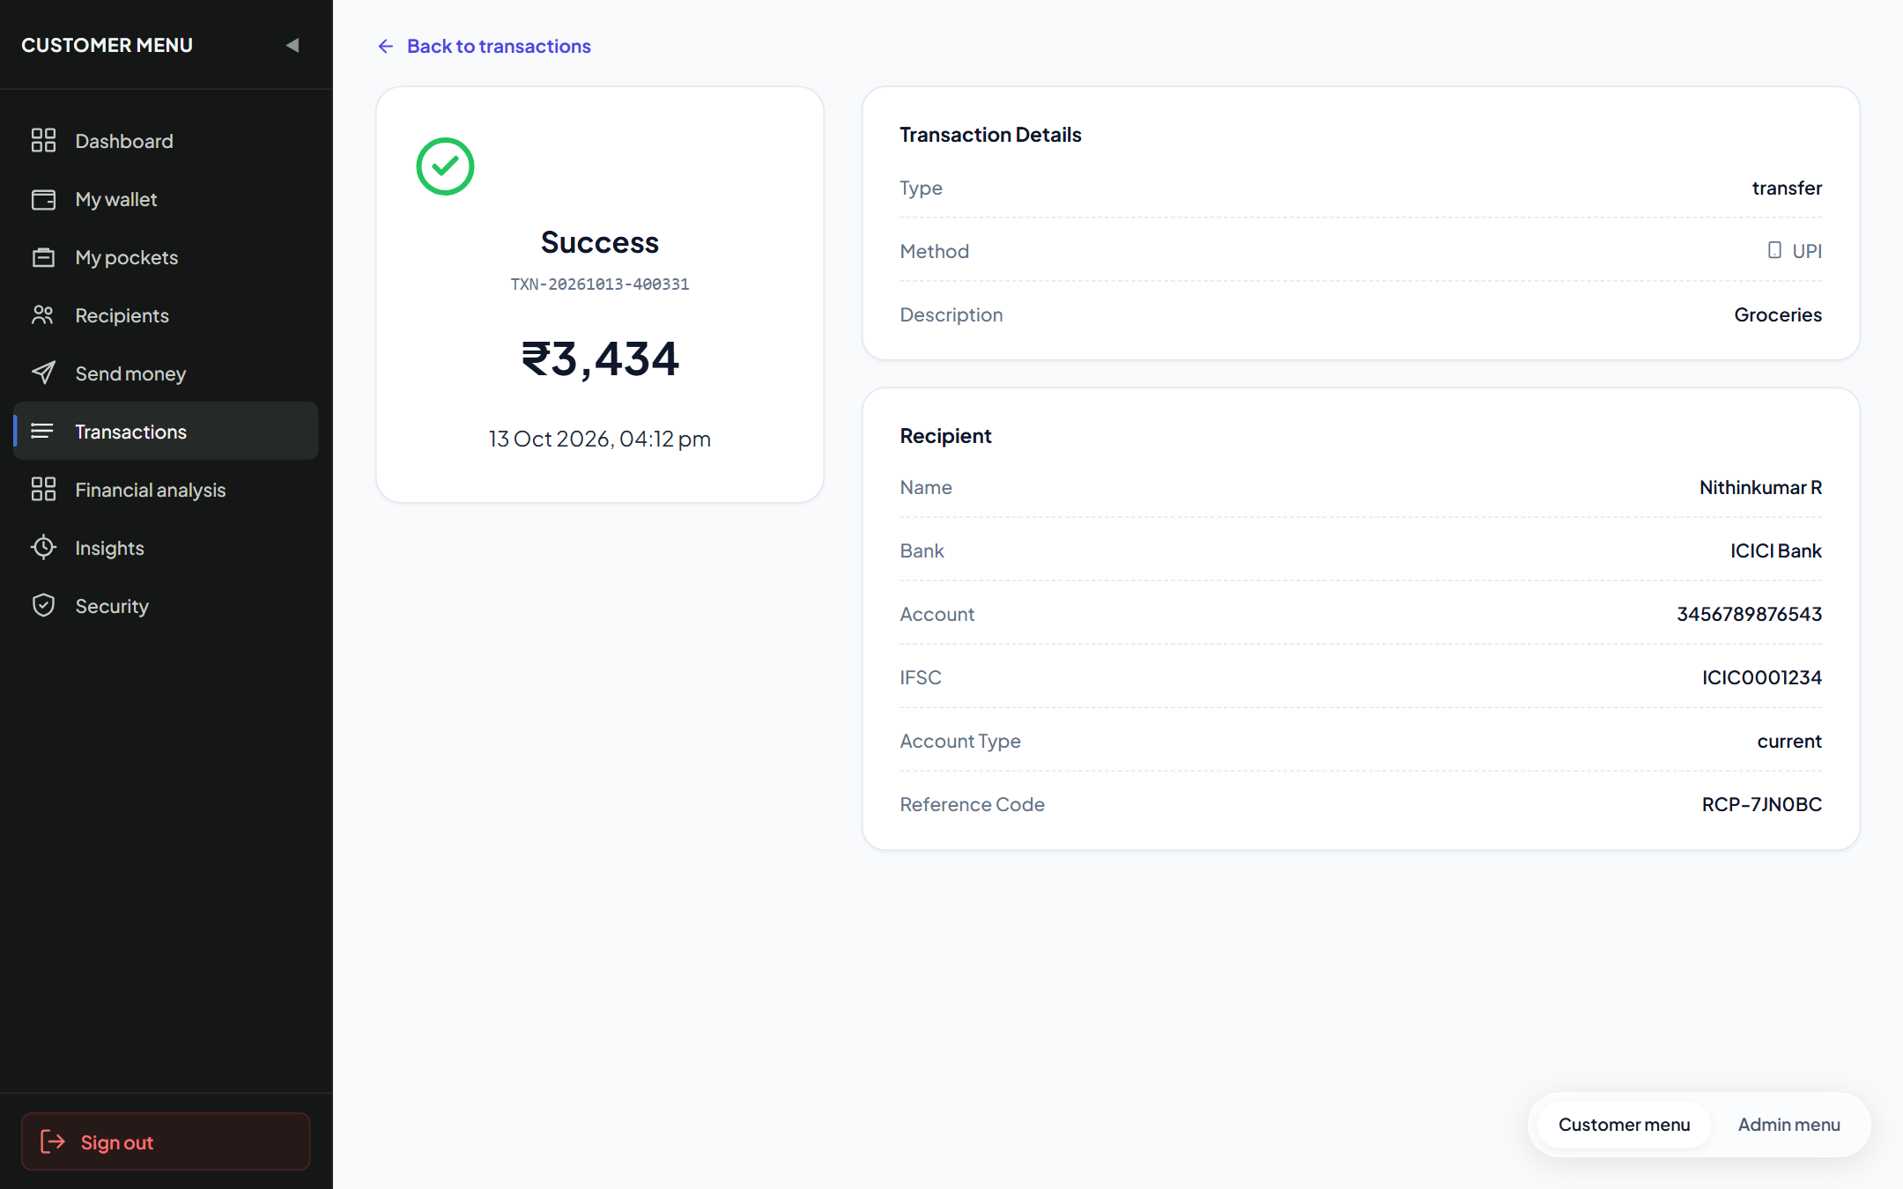
Figure 12.2 — Live Transaction Detail Inspection Interface
Form 12.3: Financial Analytics & Volume KPI Dashboard (/financial-analysis)
The graphical analytics dashboard visualizing total spending volume, success ratios, and payment rail distributions.
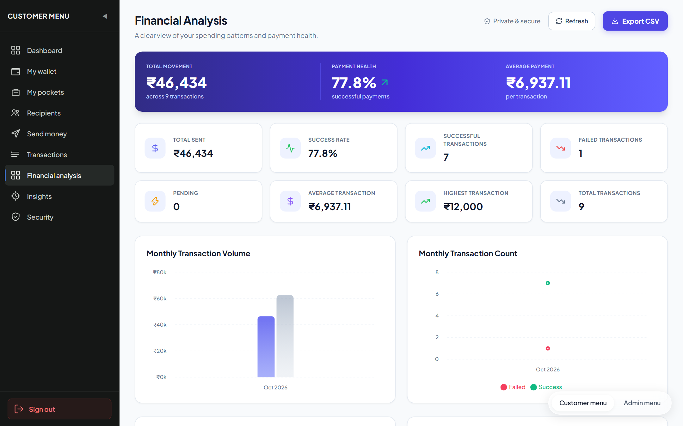
Figure 12.3 — Live Financial Analytics Dashboard (/financial-analysis)
Form 12.4: Spending Insights & Counterparty Analytics (/insights)
Intelligent financial insights summarizing top recipient allocations, frequent transfer times, and spending recommendations.
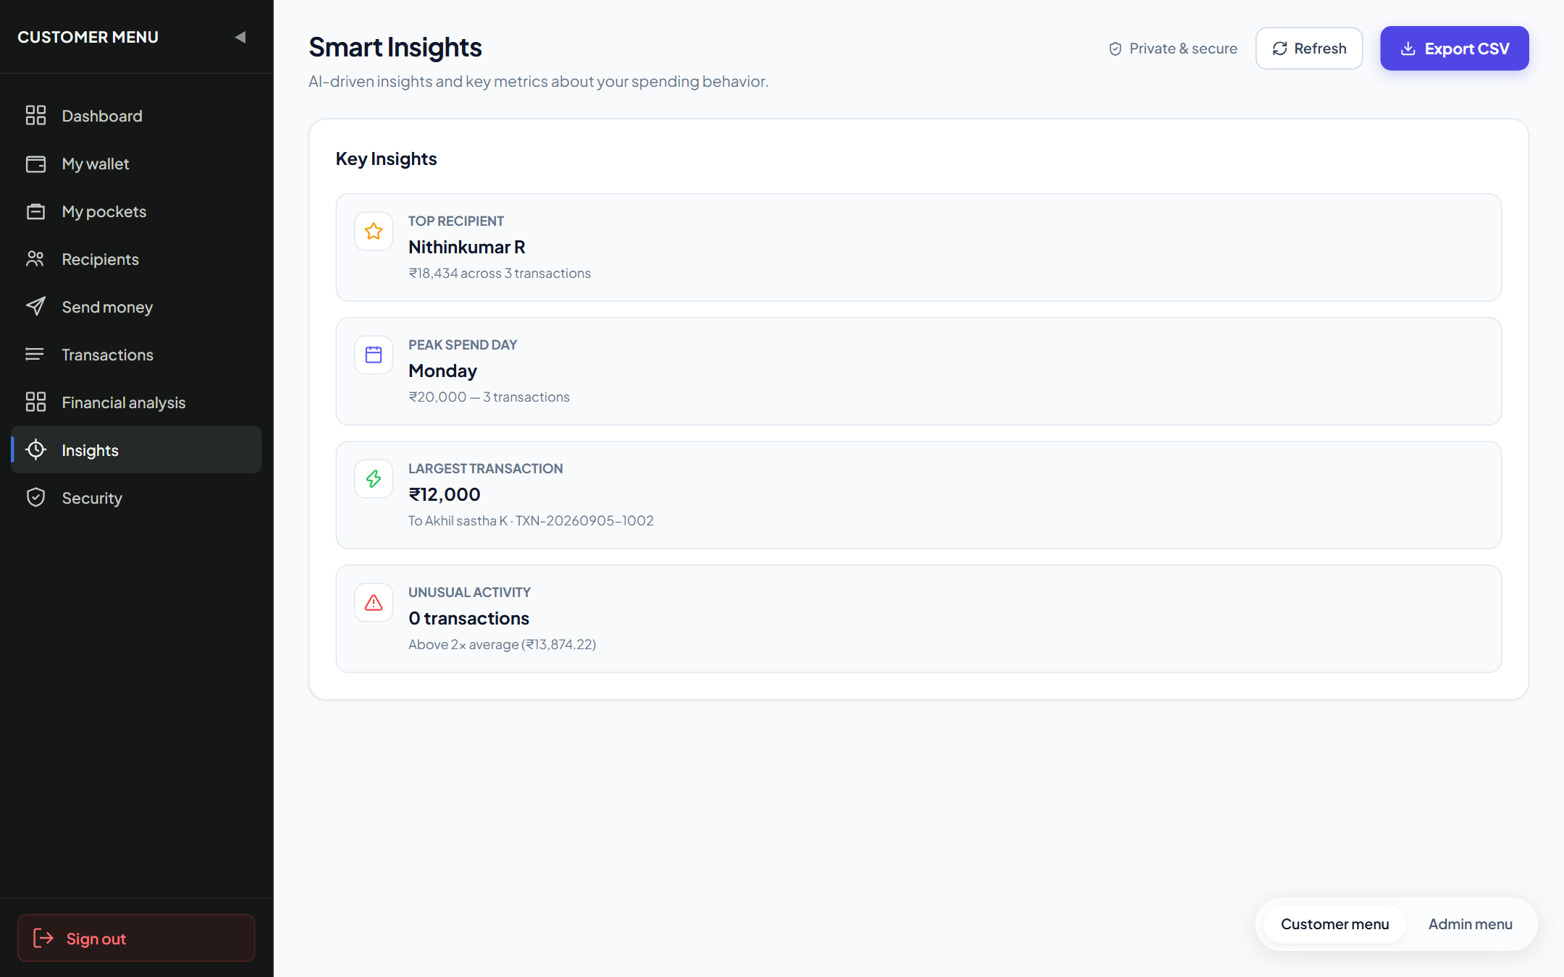
Figure 12.4 — Live Spending Insights Interface (/insights)
Test Report
Automated testing was conducted using Jest v30.5.2 and Supertest covering all Module 4 endpoints:
Test Execution Summary
Metric | Result / Environment Specification
Test Runner & Framework | Jest v30.5.2 (Node.js ES Modules) with Supertest API Driver
Execution Environment | Windows 11 x64, Node.js v24.19.0, Express v4.21.2
Database Backend | MongoDB v8.0 Community (Test Database Instance: paygate_test_db)
Test Suites Executed | 2 passed, 2 total (api.test.js, unit_validation.test.js)
Total Test Cases Executed | 8 passed, 0 failed, 0 skipped (100% Pass Rate)
Total Execution Time | 0.622 seconds
Detailed Test Cases Execution Table
Test ID | Test Description | Test Input / Condition | Expected Output | Actual Result | Status
TC-TXN-01 | Get Transaction Ledger | GET /api/transactions with valid customer JWT | HTTP 200 with paginated array of transactions | HTTP 200 OK; records returned | PASS
TC-TXN-02 | Filter by Status | GET /api/transactions?status=success | HTTP 200; only success records returned | Filtered successfully by status | PASS
TC-TXN-03 | Filter by Payment Method | GET /api/transactions?method=IMPS | HTTP 200; only IMPS transfers returned | Filtered successfully by rail | PASS
TC-TXN-04 | Get Single Transaction Detail | GET /api/transactions/:id | HTTP 200 with complete transaction and recipient metadata | Detail metadata returned accurately | PASS
TC-ANL-01 | Analytics Summary Metrics | GET /api/analytics/summary | HTTP 200 with totalSent, successCount, avgAmount | KPI aggregation metrics calculated | PASS
TC-ANL-02 | Method Breakdown Aggregation | GET /api/analytics/by-method | HTTP 200 with counts per payment rail | Grouped rail distribution returned | PASS
TC-ANL-03 | Monthly Trend Aggregation | GET /api/analytics/by-month | HTTP 200 with monthly spend breakdown | Chronological spend array returned | PASS
TC-CSV-01 | Export Ledger to CSV | GET /api/analytics/export with responseType=blob | HTTP 200 with text/csv payload and valid headers | CSV generated and downloaded | PASS
Conclusion and Further Enhancements
Conclusion
Module 4 (Transaction Ledgers & Financial Analytics) successfully delivers comprehensive transaction traceability and financial intelligence for PayGate. By implementing multi-criteria filtering, dedicated key-value inspection cards, and MongoDB aggregation analytics, the module provides users with total visibility into their financial footprint.
Client-side RFC-4180 CSV generation guarantees seamless record portability for accounting, tax verification, and forensic audits.
Further Enhancements
- 1. Automated PDF Bank Statement Generation: Incorporate server-side PDF generation producing stamped, official monthly account statements.
- 2. Machine-Learning Spending Predictions: Implement predictive models forecasting upcoming month expenditure based on recurring patterns.
- 3. Custom Date-Range Comparative Analytics: Allow users to compare spending across custom quarter-over-quarter date ranges.
- 4. Transaction Tagging & Custom Memos: Enable users to append custom labels (#business, #travel) to transactions for granular accounting.
- 5. Tax Deductible Expense Flagging: Automatically identify and aggregate tax-deductible expense transactions for annual tax returns.
— END OF DOCUMENTATION RECORD —

