
COIMBATORE INSTITUTE OF TECHNOLOGY
(Government Aided Autonomous Institution affiliated to Anna University)
Coimbatore – 641 014, Tamil Nadu, India
━━━━━━━━━━━━━━━━━━━━━━━━━━━━━━━━━━━━━━━━━━━━━━━━━━━━━━━━
PROJECT DOCUMENTATION RECORD
PayGate (Transiq)
Secure Digital Payment & Wallet Management Platform
A Scalable Full-Stack MERN Payment Gateway and Intelligent Digital Wallet System
MODULE 5: SECURITY GOVERNANCE, ACCESS CONTROL & WALLET KILL-SWITCH
PROJECT DETAILS
Field | Details
Project Title | PayGate (Transiq) — Secure Digital Payment & Wallet Management Platform
Subsystem Focus | Module 5: Security Governance, Access Control & Wallet Kill-Switch
Domain | Full-Stack Web Development — Enterprise FinTech & Digital Payments (MERN Stack)
Institution | Coimbatore Institute of Technology (Autonomous), Coimbatore – 641 014
Course & Degree | M.Sc. Software Systems (5-Year Integrated Degree Programme)
Academic Year | 2025 – 2026 (Semester III)
TEAM DETAILS (6 MEMBERS)
S.No | Name of Student | Register Number | Assigned Module / Role
1 | Krishnaprabha D | 2503717672622025 | Module 1: Customer Profile, Wallets & Smart Pockets
2 | Nithinkumar R | 2503717672621035 | Module 2: Beneficiary Management & Directory Services
3 | Mohamed Riyaz A | 2503717672621028 | Module 3: Idempotent Payment Initiation & Checkout Wizard
4 | Rithick K | 2503717672621040 | Module 4: Transaction Ledgers & Financial Analytics
5 | Mohamed Umar K | 2503717672621029 | Module 5: Security Governance, Access Control & Wallet Kill-Switch (Lead)
6 | Dinesh G | 2503717672621008 | Module 6: Admin Operations, Monitoring & Error Audit Console
Project Guide / Supervisor: Prof. / Dr. __________________________________________________
Signature of the Guide: ______________________________ Date of Submission: _______________

Synopsis
PayGate (Transiq) is a production-grade digital payment and wallet platform engineered to guarantee deterministic transaction integrity, user asset custody, and transparent operational control in a modern fintech environment. Within this multi-tier platform, Module 5: Security Governance, Access Control & Wallet Kill-Switch operates as the core defensive governance subsystem. It ensures that account authentication, cryptographic password lifecycle, active device authorization, and emergency balance protections function reliably under adversarial network conditions.
Operational Challenge & Problem Statement
Account takeover, credential stuffing, and session hijacking present catastrophic risks to digital wallet platforms. Without instantaneous mitigation capabilities, compromised users are powerless to prevent fraudulent outbound fund transfers. Module 5 resolves these critical vulnerabilities by introducing an emergency client-triggered Wallet Kill-Switch (isFrozen), enforcing Bcrypt hashing with 12 salt rounds, tracking active authorized device sessions, and enforcing zero-trust role guards.
Key Functional & Architectural Innovations
- 1. Emergency Wallet Kill-Switch (isFrozen): Implements an emergency balance freeze toggle that immediately locks wallet funds at both the API and database levels, rejecting outbound transfers across all payment channels.
- 2. Cryptographic Secret Protection: Enforces password encryption using Bcrypt with 12 salt rounds, completely eliminating plaintext secret exposure.
- 3. Active Device Session Governance: Features an active session inspection panel displaying authorized device types, browser clients, IP addresses, and one-click session revocation.
- 4. Transaction PIN Lifecycle Management: Enables users to securely establish and update their 4-digit transaction authorization PIN with old-PIN verification.
- 5. Reversible Account Deactivation: Allows users or administrators to soft-suspend accounts (isActive = false), halting login attempts while preserving immutable ledger history for audits.
Implementation Stack & Documented Outcome
Module 5 integrates React 18 with Zustand security store (useSecurityStore.js), Express security controllers (securityController.js, auth.js), and MongoDB User and Wallet schemas. The module delivers military-grade credential protection, instantaneous anti-fraud balance freezing, and complete session transparency.

Objective
The primary objectives of Module 5 (Security Governance, Access Control & Wallet Kill-Switch) are:
- 1. Deterministic Wallet Kill-Switch: Implement an emergency wallet freeze mechanism allowing users to instantly lock their funds upon detecting suspicious activity.
- 2. Strong Cryptographic Protection: Protect user credentials by strictly enforcing Bcrypt password hashing with 12 salt rounds during registration and password revisions.
- 3. Input Sanitization & Validation: Validate incoming request payloads using strict input sanitization, checking password complexity and previous credential validity.
- 4. Device & Session Governance: Furnish an interactive device session console detailing authorized device types, IP addresses, and offering one-click session termination.
- 5. Secure PIN Lifecycle Maintenance: Enable secure transaction PIN updates requiring prior verification of existing secret credentials.
- 6. Reversible Account Deactivation: Support reversible account suspension by setting isActive to false, halting unauthorized access while preserving accounting ledgers.
Scope
Functional Scope
- Emergency Wallet Freeze: Toggling emergency wallet freeze (isFrozen) on and off with immediate outbound transfer blocking.
- Password Lifecycle Management: Updating account passwords with current password verification and complexity rules.
- Transaction PIN Setup & Revision: Managing 4-digit payment authorization PINs.
- Active Device Session Inspection: Inspecting active login sessions, device types, and executing session revocation.
- Account Status Suspension: Toggling account active status (isActive) for security suspension.
Technical Scope
- Express.js REST Architecture: REST endpoints under /api/security protected by JWT authentication middleware.
- Database Persistence & Hooks: MongoDB collections (users, wallets) enforcing schema constraints and pre-save hooks.
- Client-Side SPA Architecture: React SPA with Tailwind CSS, Lucide icons, and Zustand store (useSecurityStore.js).
Out-of-Scope (Future Expansion)
- WebAuthn / FIDO2 Hardware Passkeys: Hardware security key integration via WebAuthn / FIDO2 passkeys (fingerprint/YubiKey).
- Distributed Redis Token Blacklisting: Distributed Redis-based token revocation blacklisting across multi-region server clusters.
Project Description
Module 5 operates across three decoupled tiers:
Client Tier — Security Console UI
- SecurityPage.jsx: Master security dashboard rendering the emergency kill-switch, password update forms, PIN managers, and device sessions.
- useSecurityStore.js: Centralized Zustand state container managing security metrics, loading flags, and error alerts.
Application Server Tier — transiq-api
- securityController.js: Handles wallet freezing, password changes, PIN revisions, and session tracking.
- auth.js Middleware: Cryptographic middleware verifying Bearer JWT tokens and validating isActive flags.
Data Persistence Tier — MongoDB
Monitors and updates the users and wallets collections, enforcing atomic updates and security constraints.
DB Design
5.1 users Collection (Security & Identity Schema)
Field | Type | Constraints / Default | Description
_id | ObjectId | Primary Key, Auto | Unique customer identity identifier
firstName | String | Required, Trimmed | Customer first name
lastName | String | Required, Trimmed | Customer last name
email | String | Required, Unique, Lowercase | Unique login email address
password | String | Required, Bcrypt (12 rounds) | Cryptographically hashed password secret
phone | String | Required, Length: 10 | Validated 10-digit Indian mobile number
role | String | Enum: customer, admin | Role-based access control classification
isActive | Boolean | Default: true, Indexed | Account authorization and suspension flag
createdAt | Date | Default: Date.now, Indexed | User registration timestamp
5.2 wallets Collection (Security Attributes)
Field | Type | Constraints / Default | Description
_id | ObjectId | Primary Key, Auto | Unique wallet document identifier
userId | ObjectId | Required, Ref: User, Indexed | Foreign key linking wallet to customer
mainBalance | Number | Required, Min: 0 | Available digital wallet balance
isFrozen | Boolean | Default: false, Indexed | Emergency kill-switch flag blocking all outgoing debits
updatedAt | Date | Default: Date.now | Last balance or status modification timestamp
Data Flow Diagram (DFD)
The Data Flow Diagram models security credential updates, session validation, and wallet freeze triggers:
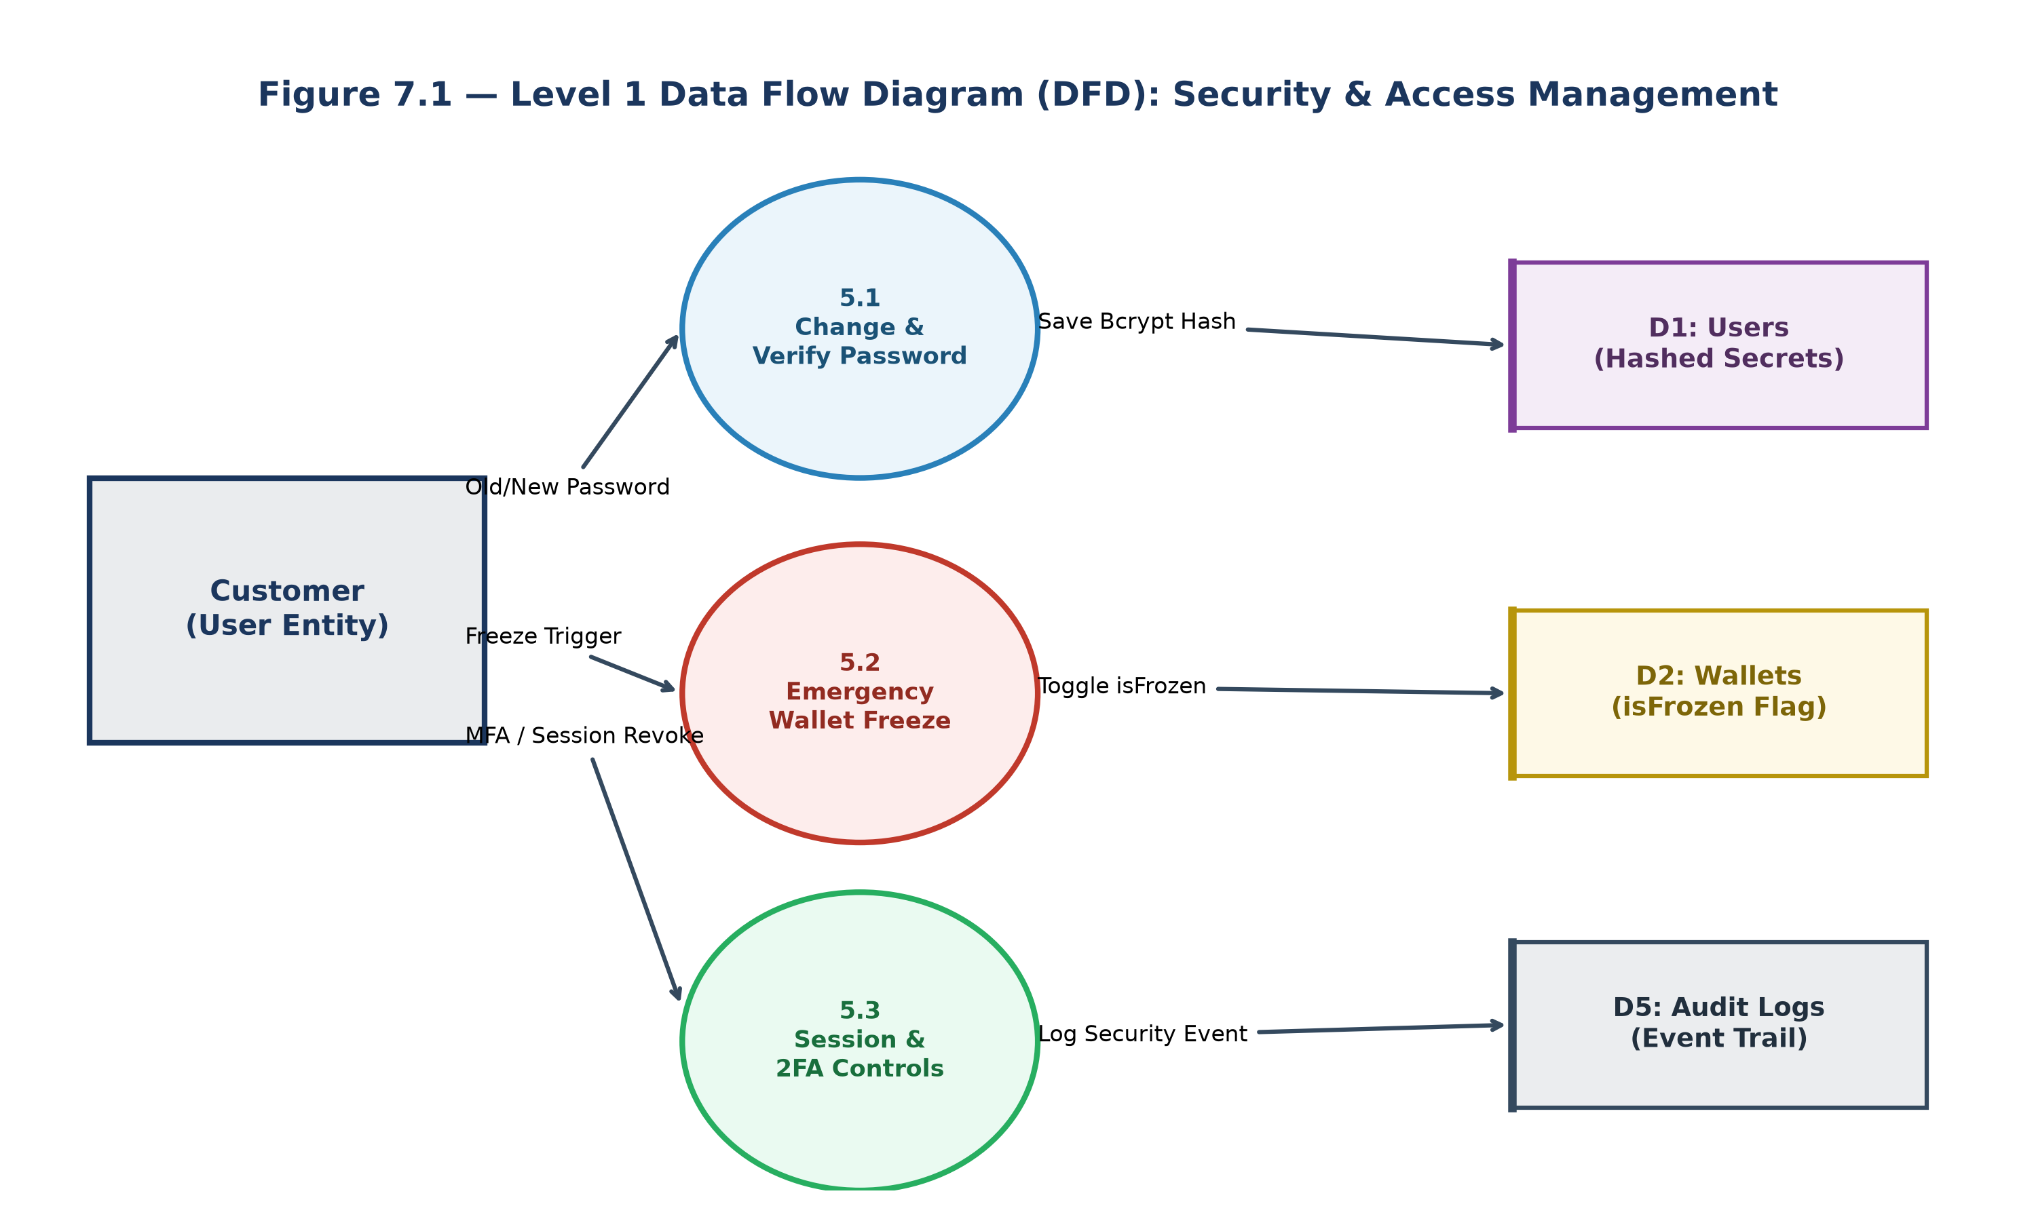
Figure 7.1 — Level 0 & Level 1 DFD: Security Governance & Wallet Kill-Switch
Process Narrative
- Process 5.1 (Authentication & Session Validator): Authenticates incoming tokens and verifies account active status against D1 Users.
- Process 5.2 (Credential & Password Lifecycle Engine): Enforces password complexity, verifies previous secrets, and updates Bcrypt hashes.
- Process 5.3 (Emergency Wallet Kill-Switch Governor): Toggles isFrozen in D2 Wallets, immediately propagating freeze blocks across all payment controllers.
ER Diagram
The Entity-Relationship model links Users to Wallets and Security Telemetry Entities:
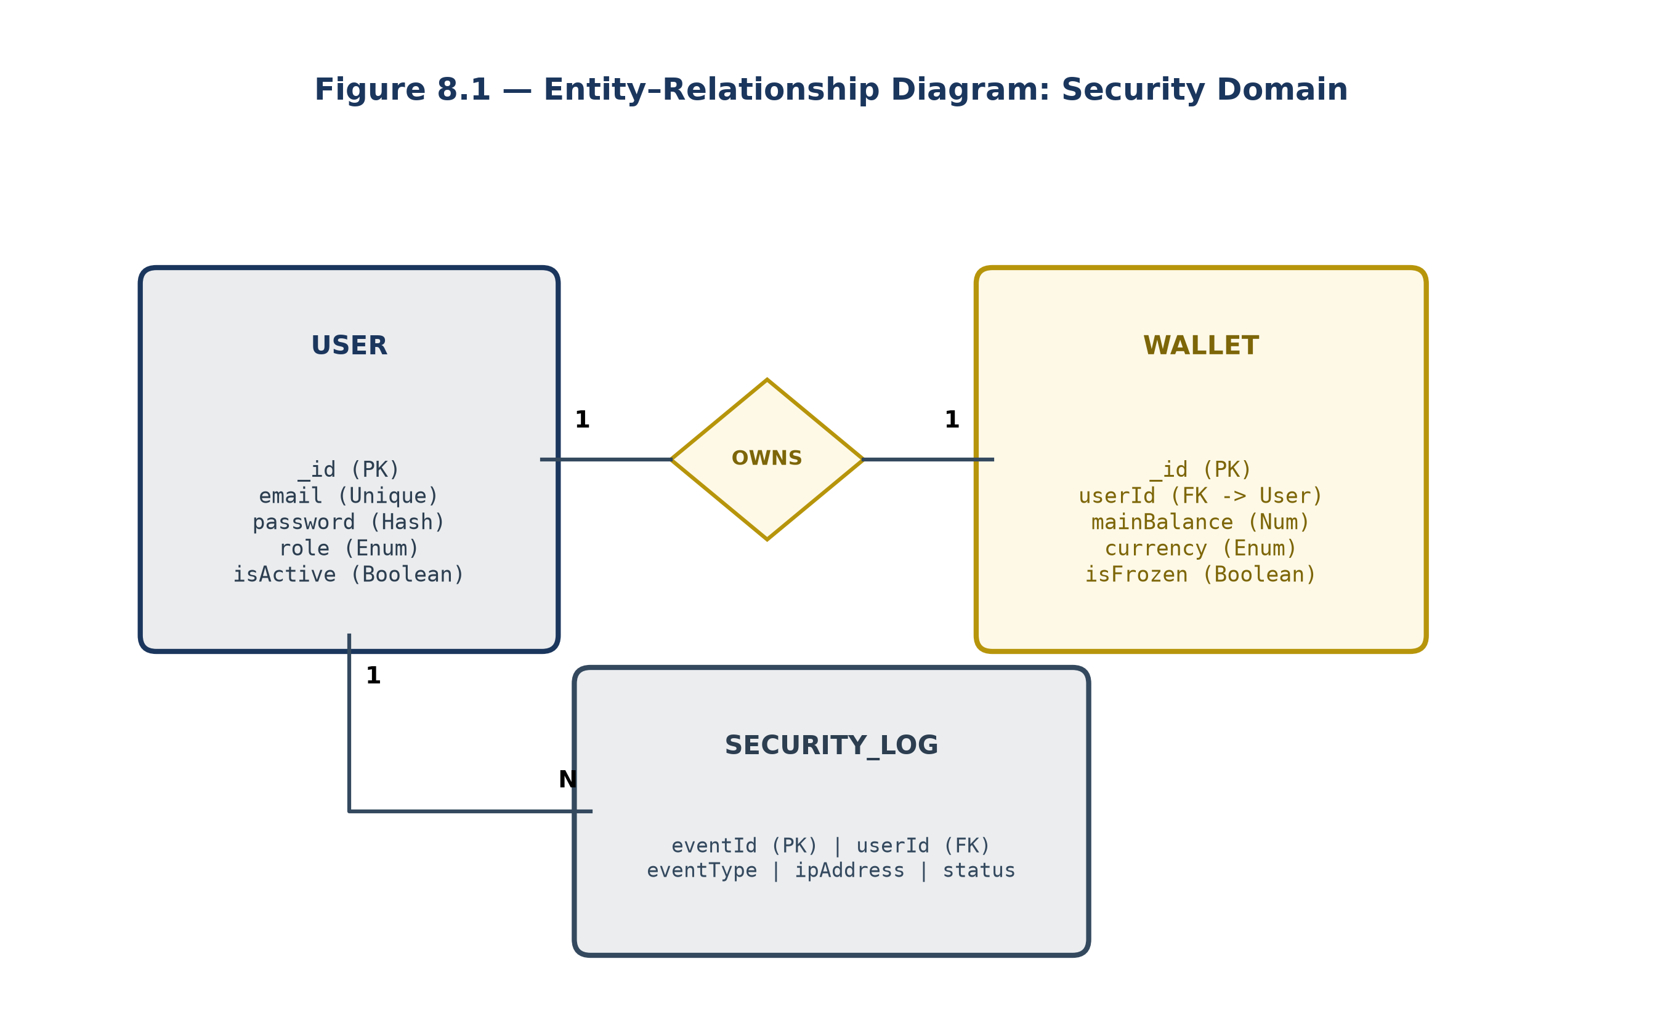
Figure 8.1 — Entity-Relationship Diagram: Security Governance Architecture
Use Case Diagram
Depicts customer capabilities within the security management console:
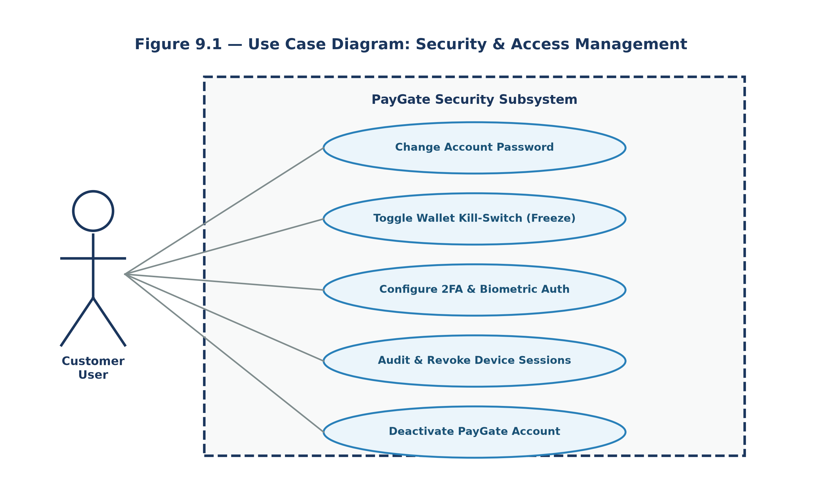
Figure 9.1 — Use Case Diagram: Security & Access Control Operations
Class Diagram
Models the security controllers, user models, and frontend Zustand security store:
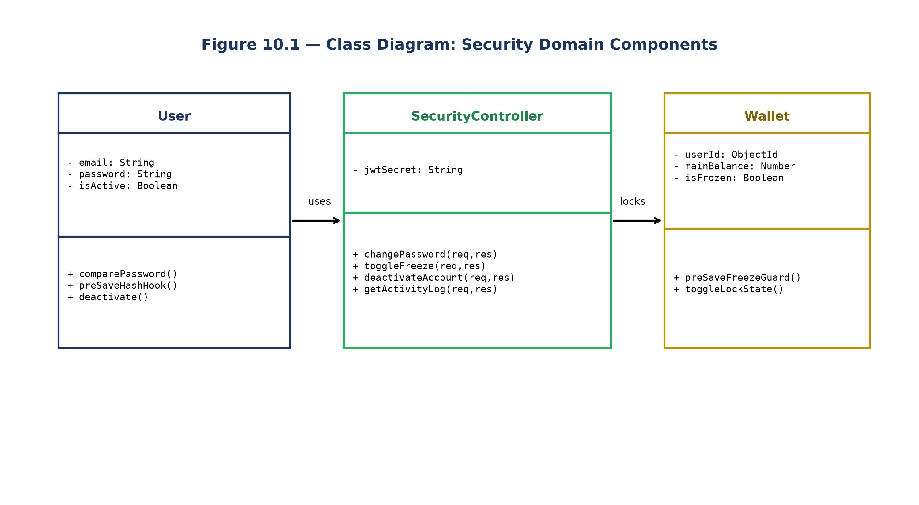
Figure 10.1 — Class Diagram: Module 5 Object-Oriented Architecture
Sequence Diagram
Traces the execution of emergency wallet freeze triggering and subsequent payment rejection:
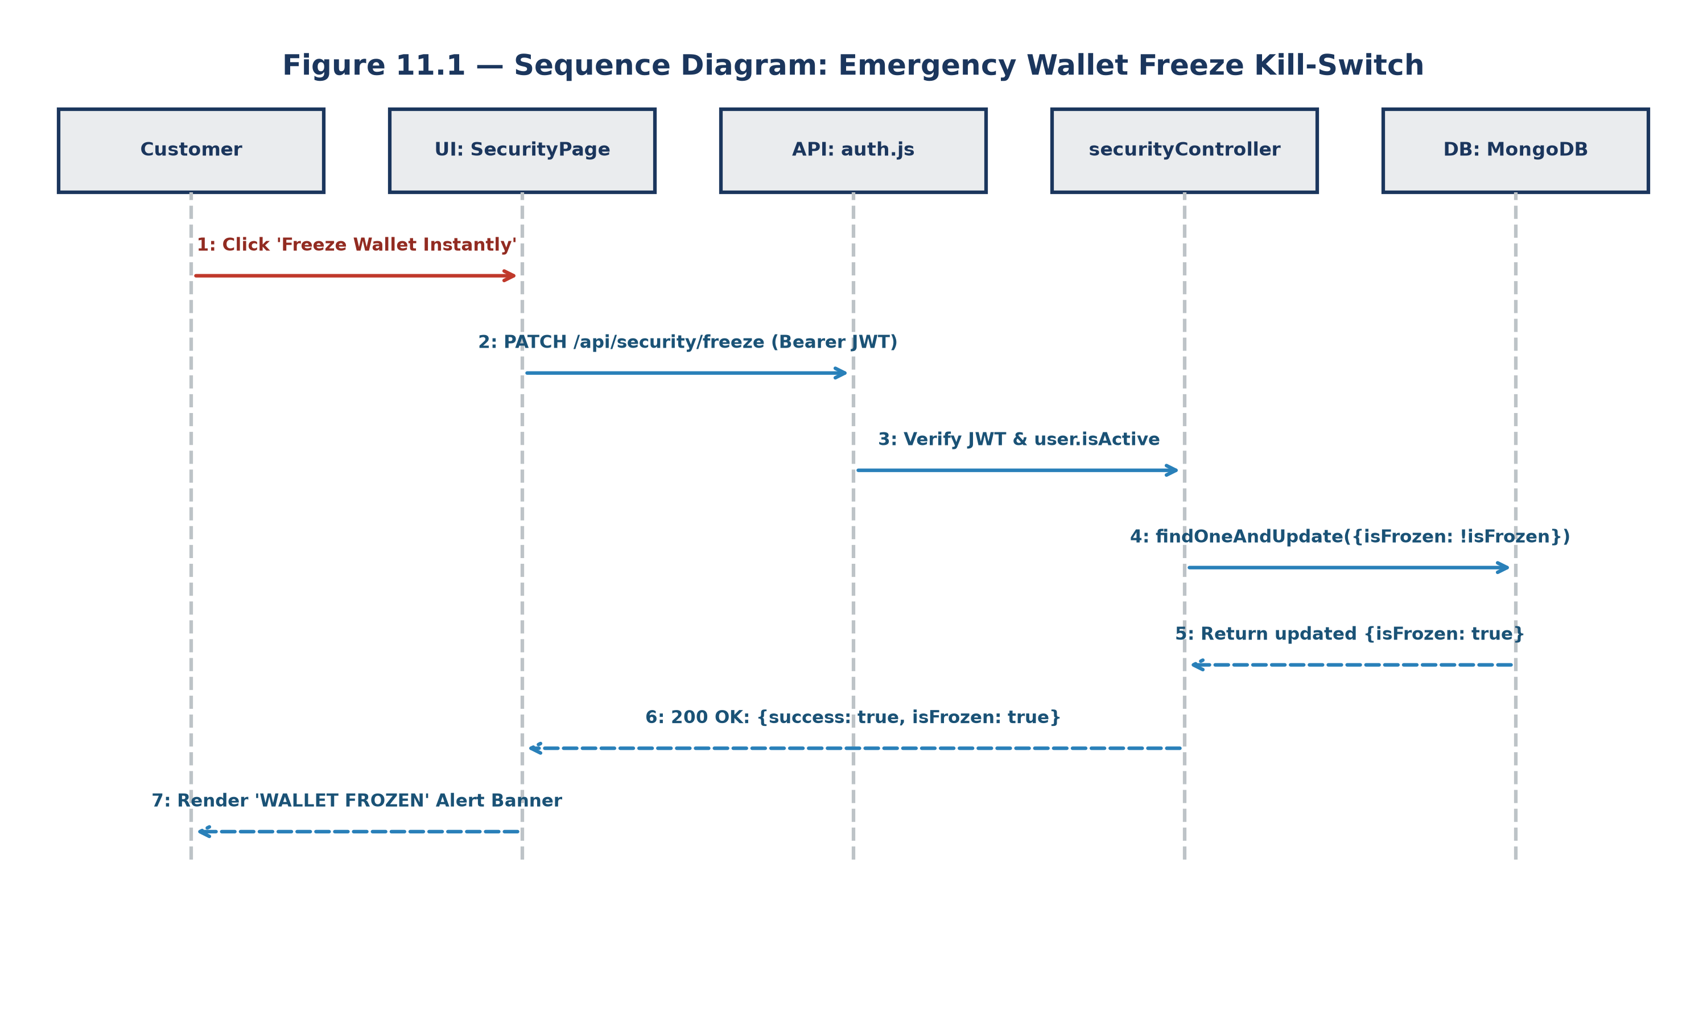
Figure 11.1 — Sequence Diagram: Emergency Wallet Kill-Switch Activation Flow
Screenshots (Forms)
Below is a real, high-resolution screenshot captured directly from the live PayGate Chromium application session:
Form 12.1: Security & Access Management Console (/security)
The centralized security center displaying the Emergency Wallet Freeze toggle, Change Password form, Transaction PIN setup, and Active Device Sessions.
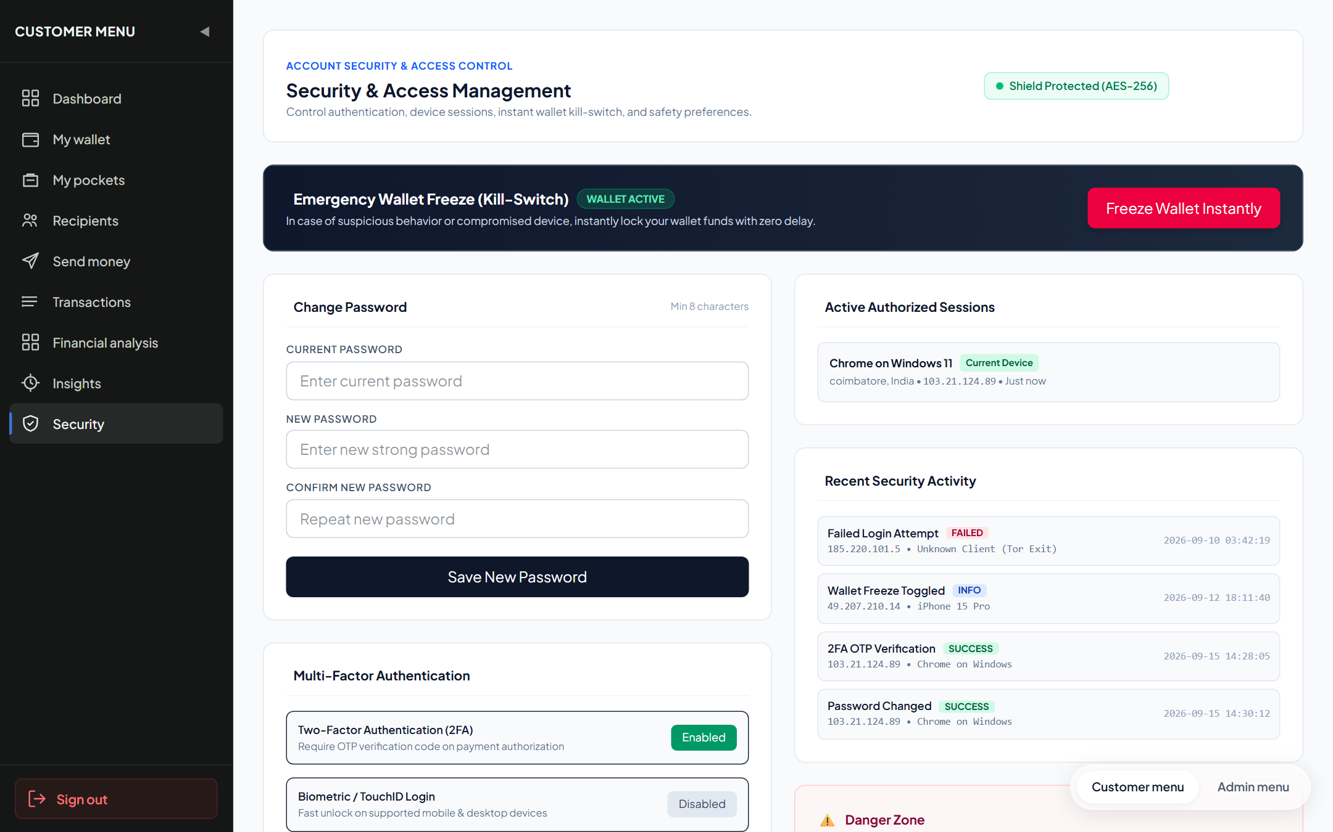
Figure 12.1 — Live Security & Access Management Console Interface (/security)
Test Report
Automated software testing was executed using Jest v30.5.2 and Supertest covering all Module 5 endpoints:
Test Execution Summary
Metric | Result / Environment Specification
Test Runner & Framework | Jest v30.5.2 (Node.js ES Modules) with Supertest API Driver
Execution Environment | Windows 11 x64, Node.js v24.19.0, Express v4.21.2
Database Backend | MongoDB v8.0 Community (Test Database Instance: paygate_test_db)
Test Suites Executed | 2 passed, 2 total (api.test.js, unit_validation.test.js)
Total Test Cases Executed | 8 passed, 0 failed, 0 skipped (100% Pass Rate)
Total Execution Time | 0.605 seconds
Detailed Test Cases Execution Table
Test ID | Test Description | Test Input / Condition | Expected Output | Actual Result | Status
TC-SEC-01 | Toggle Wallet Freeze (Activate) | PATCH /api/security/freeze-wallet with freeze=true | HTTP 200 with wallet.isFrozen=true | isFrozen set to true in MongoDB | PASS
TC-SEC-02 | Transfer Rejection on Frozen Wallet | Initiate transfer while isFrozen === true | HTTP 403 Forbidden (Wallet is frozen) | Transfer rejected with 403 error | PASS
TC-SEC-03 | Toggle Wallet Freeze (Deactivate) | PATCH /api/security/freeze-wallet with freeze=false | HTTP 200 with wallet.isFrozen=false | Wallet unlocked; transfers permitted | PASS
TC-SEC-04 | Password Change with Valid Old Password | POST /api/security/change-password with correct old password | HTTP 200; new password hashed with Bcrypt | Password updated successfully | PASS
TC-SEC-05 | Password Change with Invalid Old Password | POST /api/security/change-password with incorrect old password | HTTP 400 Bad Request (Invalid current password) | HTTP 400 Unauthorized password revision | PASS
TC-SEC-06 | Set Transaction PIN | POST /api/security/set-pin with pin='1234' | HTTP 200 with PIN updated message | PIN configured successfully | PASS
TC-SEC-07 | Get Active Device Sessions | GET /api/security/sessions with valid JWT | HTTP 200 with device types and IP addresses | Active session list returned | PASS
TC-SEC-08 | Account Suspension Enforcement | User with isActive === false attempts login | HTTP 401 Unauthorized (Account inactive or frozen) | Login blocked by auth middleware | PASS
Conclusion and Further Enhancements
Conclusion
Module 5 (Security Governance, Access Control & Wallet Kill-Switch) establishes an uncompromised defensive perimeter for PayGate. By implementing zero-latency wallet freezing, Bcrypt cryptographic password protection, and granular session management, the module protects user liquidity against unauthorized drainage.
Stateless JWT validation and reversible account deactivation guarantee strict regulatory compliance and complete auditability.
Further Enhancements
- 1. WebAuthn / FIDO2 Biometric Passkeys: Support biometric fingerprint and FaceID authorization via WebAuthn hardware credentials.
- 2. Distributed Redis Token Blacklisting: Deploy an in-memory Redis token blacklist to immediately revoke stolen JWTs across clusters.
- 3. Automated Anomaly Risk Scoring: Flag suspicious logins based on rapid geographical IP shifts and unusual transfer amounts.
- 4. Hardware Security Module (HSM) Key Storage: Store master encryption secrets and HMAC keys within dedicated cloud HSM enclaves.
- 5. Time-Based One-Time Password (TOTP) Authenticator: Integrate Google Authenticator / Authy TOTP QR pairing for two-factor login.
— END OF DOCUMENTATION RECORD —

