ANALYSIS AND DESIGN OF ALGORITHMS LAB
Assignment-1: Algorithm Foundations

Name: Akhil
Roll No.: 2401010148
Section: C
Specialisation: B.Tech CSE

Task 1: Algorithm Growth Observation
Implement O(1), O(n), O(n^2), O(log n) and measure execution time.
- Constant Time : O(1)
- Linear Time : O(n)
- Quadratic Time : O(n²)
- Logarithmic Time : O(log n)
import time import random import matplotlib.pyplot as plt import math def constant_time(n):
return n * 5 def linear_time(n):
total = 0 for i in range(n):
total += i
return total
def quadratic_time(n):
total = 0 for i in range(n): for j in range(n):
total += 1 return total def logarithmic_time(n):
count = 0 while n > 1: n //= 2 count += 1
return count sizes = [10, 100, 500, 1000] results = {"O(1)": [], "O(n)": [], "O(n^2)": [], "O(log n)": []}
for n in sizes: # O(1) start = time.time() constant_time(n) results["O(1)"].append(time.time() - start)
# O(n) start = time.time() linear_time(n) results["O(n)"].append(time.time() - start)
# O(n^2) start = time.time() quadratic_time(n) results["O(n^2)"].append(time.time() - start)
# O(log n) start = time.time() logarithmic_time(n) results["O(log n)"].append(time.time() - start)
for key in results:
plt.plot(sizes, results[key], label=key)
plt.xlabel("Input Size (n)") plt.ylabel("Execution Time (seconds)") plt.title("Growth of Time Complexities") plt.legend() plt.show()
Output:
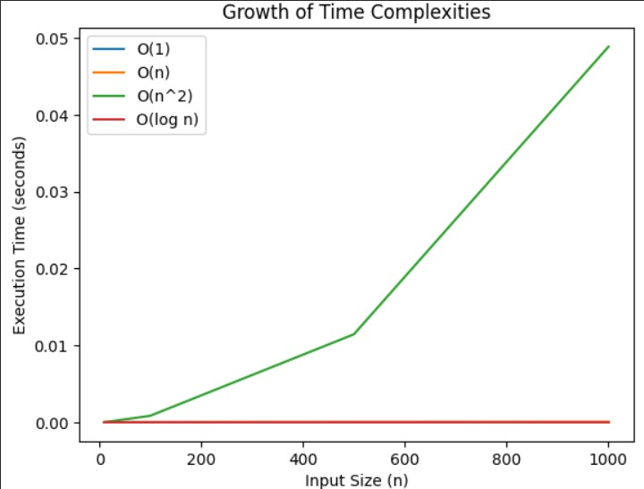

Task 2: Best, Average, and Worst Case Analysis
Implement Linear Search and Binary Search and compare execution times.
def linear_search(arr, key): for i in range(len(arr)): if arr[i] == key: return i return -1 def binary_search(arr, key): low, high = 0, len(arr) - 1 while low <= high:
mid = (low + high) // 2 if arr[mid] == key: return mid elif arr[mid] < key: low = mid + 1 else: high = mid - 1 return -1 sizes = [100, 500, 1000, 5000] linear_times = [] binary_times = []
for n in sizes:
arr = sorted(random.sample(range(n*10), n)) start = time.time() linear_search(arr, -1) linear_times.append(time.time() - start)
start = time.time() binary_search(arr, -1) binary_times.append(time.time() - start)
plt.plot(sizes, linear_times, label="Linear Search") plt.plot(sizes, binary_times, label="Binary Search") plt.xlabel("Input Size")
plt.ylabel("Execution Time") plt.legend() plt.title("Linear vs Binary Search") plt.show()

Output:
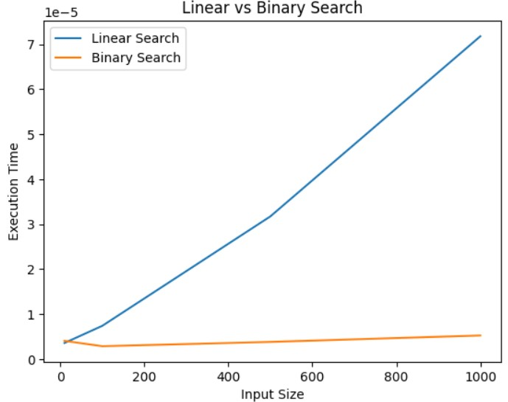

Task 3: Recursion and Recurrence Validation
Implement Factorial, Fibonacci (Recursive), Fibonacci (DP).
call_count = 0
def factorial(n): global call_count call_count += 1 if n == 0: return 1 return n * factorial(n-1)
def fibonacci_recursive(n):
global call_count
call_count += 1
if n <= 1:
return n return fibonacci_recursive(n-1) + fibonacci_recursive(n-2)
def fibonacci_dp(n): fib = [0, 1] for i in range(2, n+1):
fib.append(fib[i-1] + fib[i-2]) return fib[n]

Output:

n | Recursive Calls (Fib) | Time (Recursive) | Time (DP)
10 | High | High | Very Low
20 | Very High | Very High | Low

Task 4: Solving Recurrences through Code
Implement recursive functions for given recurrences.
- T(n) = T(n/2) + n
- T(n) = 2T(n/2) + n

call_count = 0
def recurrence1(n): global call_count call_count += 1 if n <= 1: return 1 return recurrence1(n//2) + n
def recurrence2(n): global call_count call_count += 1 if n <= 1: return 1
return recurrence2(n//2) + recurrence2(n//2) + n

Github: https://github.com/Akhil-gltich/ada-lab-assignment/tree/main

