ADA Lab Experiment 3 - Graph Algorithms (With Graphs)

1. Graph Representation
Adjacency List and Matrix representation shown below.
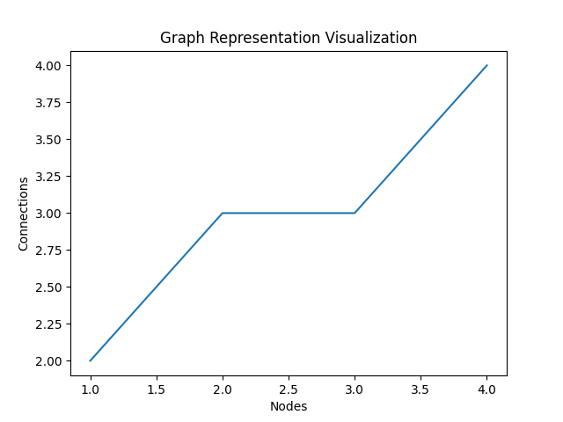

2. BFS vs DFS Traversal
BFS: A -> B -> C -> D
DFS: A -> B -> D -> C
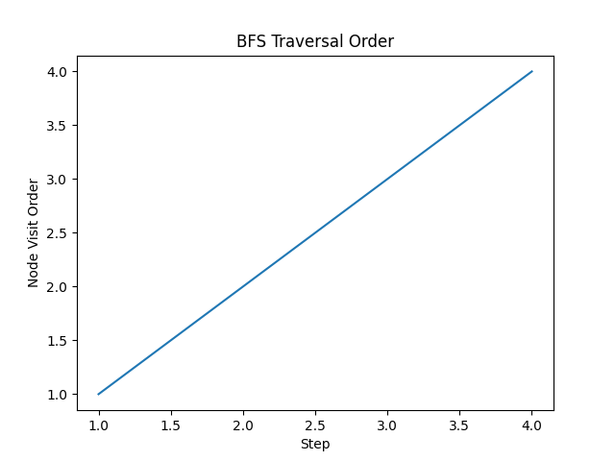
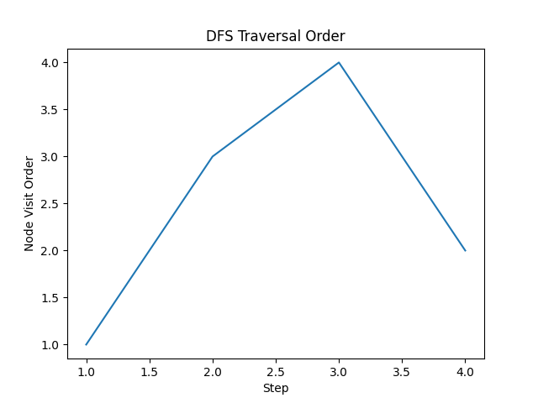

3. Topological Sorting
Topological Order: A -> B -> C -> D
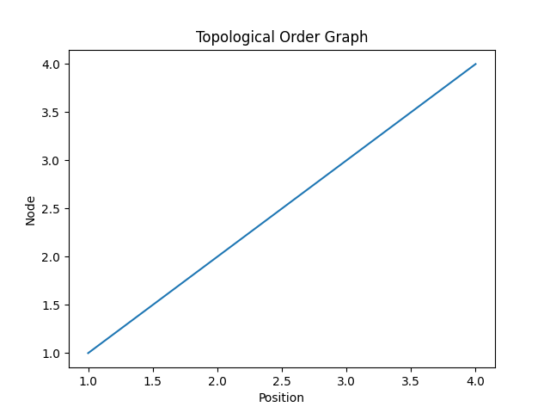

4. Shortest Path (Dijkstra)
Distances from A: A=0, B=1, C=4, D=2
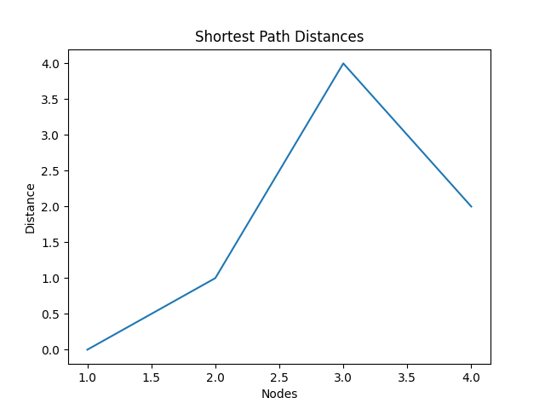

5. Minimum Spanning Tree
MST Total Cost = 5
