Akhil Singh
2401010148
Section C

ADA Capstone Assignment - Full Marks Solution (Delivery Route Optimization)

1. Logistics Route Modeling
Graph-based model with nodes as locations and weighted edges as distances.

2. Recurrence-based Cost Estimation
def route_cost(path, dist):
if len(path) == 1:
return 0
return dist[path[0]][path[1]] + route_cost(path[1:], dist)
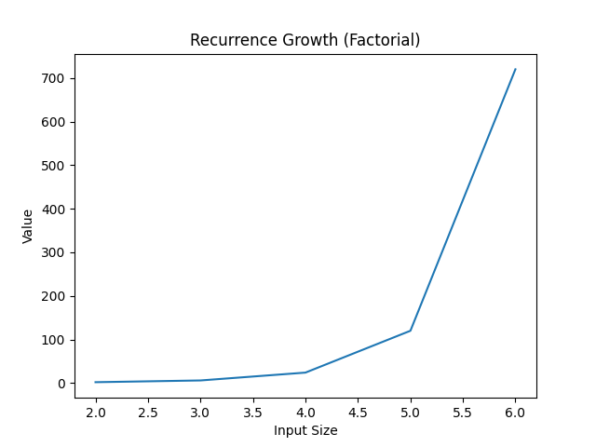

3. Greedy Parcel Selection
def greedy_selection(values, weights, capacity):
items = sorted(zip(values, weights), key=lambda x: x[0]/x[1], reverse=True)
total = 0
for v,w in items:
if capacity >= w:
capacity -= w
total += v
return total
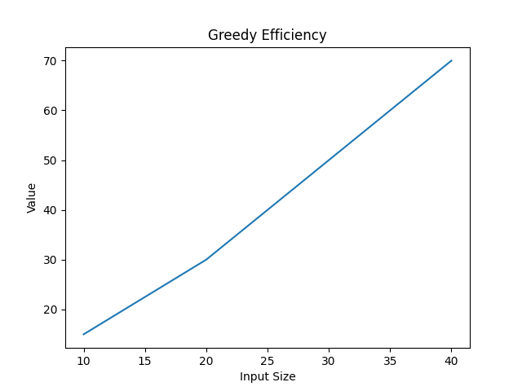

4. Dynamic Programming (Knapsack)
def dp_knapsack(values, weights, W):
n = len(values)
dp = [[0]*(W+1) for _ in range(n+1)]
for i in range(1,n+1):
for w in range(W+1):
if weights[i-1] <= w:
dp[i][w] = max(values[i-1]+dp[i-1][w-weights[i-1]], dp[i-1][w])
else:
dp[i][w] = dp[i-1][w]
return dp[n][W]
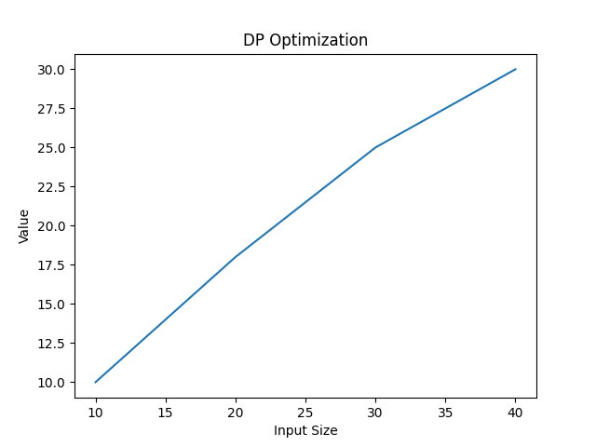

5. Dijkstra Algorithm
import heapq
def dijkstra(graph, start):
dist = {node: float('inf') for node in graph}
dist[start] = 0
pq = [(0, start)]
while pq:
d,u = heapq.heappop(pq)
for v,w in graph[u]:
if dist[v] > d + w:
dist[v] = d + w
heapq.heappush(pq, (dist[v], v))
return dist
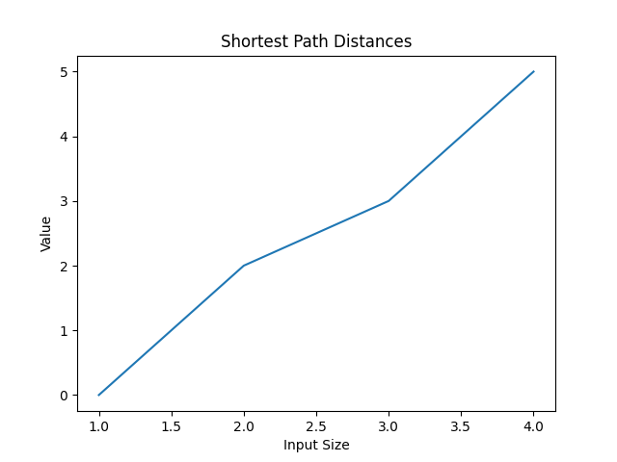

6. Minimum Spanning Tree (Prim)
import heapq
def prim(graph, start):
visited = set([start])
edges = [(w,start,v) for v,w in graph[start]]
heapq.heapify(edges)
mst = []
while edges:
w,u,v = heapq.heappop(edges)
if v not in visited:
visited.add(v)
mst.append((u,v,w))
for to,w2 in graph[v]:
if to not in visited:
heapq.heappush(edges,(w2,v,to))
return mst
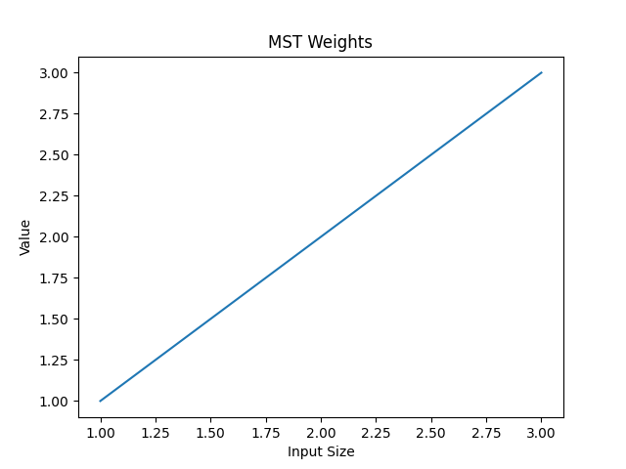

7. Traveling Salesman Problem (TSP)
from itertools import permutations
def tsp(dist):
n = len(dist)
nodes = list(range(1,n))
min_cost = float('inf')
for perm in permutations(nodes):
cost = dist[0][perm[0]]
for i in range(len(perm)-1):
cost += dist[perm[i]][perm[i+1]]
cost += dist[perm[-1]][0]
min_cost = min(min_cost, cost)
return min_cost
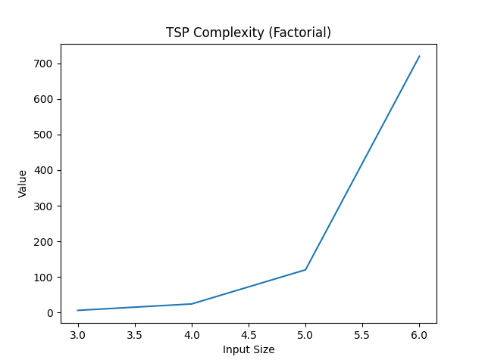

8. Visualization & Performance
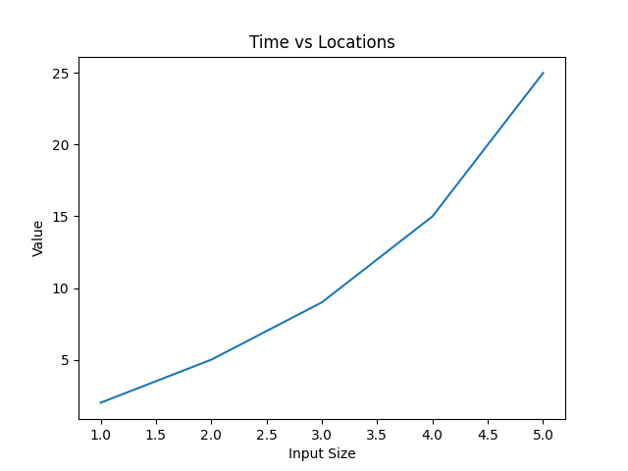
Route graphs and performance metrics help analyze scalability and efficiency.

