

Lab File
Analysis and Design of Algorithms Lab
(ENCS256) | 2025 – 2026


Submitted by:  Name: Akhil Singh  Roll No.: 2401010148  Section: C  B.Tech CSE Core | Submitted to:  Dr.Aarti  Assistant Professor  School of Engineering & Technology  K.R. Mangalam University

TABLE OF CONTENTS

Assignment | Page No.
Assignment 1 – Algorithm Foundations | 3
Assignment 2 – Core Algorithm Paradigms | 6
Assignment 3 – Graph Algorithms | 10
Assignment 4 – Backtracking, Branch & Bound, String Matching | 13
Assignment 5 – Capstone: Delivery Route Optimization | 17

Assignment – 1
Algorithm Foundations
Student Information
Name | Akhil Singh
Roll No. | 2401010148
Section | C
Specialisation | B.Tech CSE Core
GitHub | https://github.com/Akhil-gltich/ada-lab-assignment/tree/main

Task 1: Algorithm Growth Observation
Implement O(1), O(n), O(n²), and O(log n) algorithms and measure execution time.

Complexity Types Implemented:
- Constant Time: O(1) — single operation, independent of input size
- Linear Time: O(n) — one loop over input
- Quadratic Time: O(n²) — nested loops
- Logarithmic Time: O(log n) — halving input each step

Code:
import time, math
import matplotlib.pyplot as plt

def constant_time(n): return n * 5

def linear_time(n):
total = 0
for i in range(n): total += i
return total

def quadratic_time(n):
total = 0
for i in range(n):
for j in range(n): total += 1
return total

def logarithmic_time(n):
count = 0
while n > 1: n //= 2; count += 1
return count

sizes = [10, 100, 500, 1000, 2000]
results = {'O(1)':[], 'O(n)':[], 'O(n^2)':[], 'O(log n)':[]}

for n in sizes:
for fn,key in [(constant_time,'O(1)'),(linear_time,'O(n)'),
(quadratic_time,'O(n^2)'),(logarithmic_time,'O(log n)')]:
start = time.time(); fn(n)
results[key].append(time.time() - start)

for key in results:
plt.plot(sizes, results[key], label=key)
plt.xlabel('Input Size (n)'); plt.ylabel('Time (s)')
plt.title('Growth of Time Complexities'); plt.legend(); plt.show()

Output – Time Complexity Growth Graph:
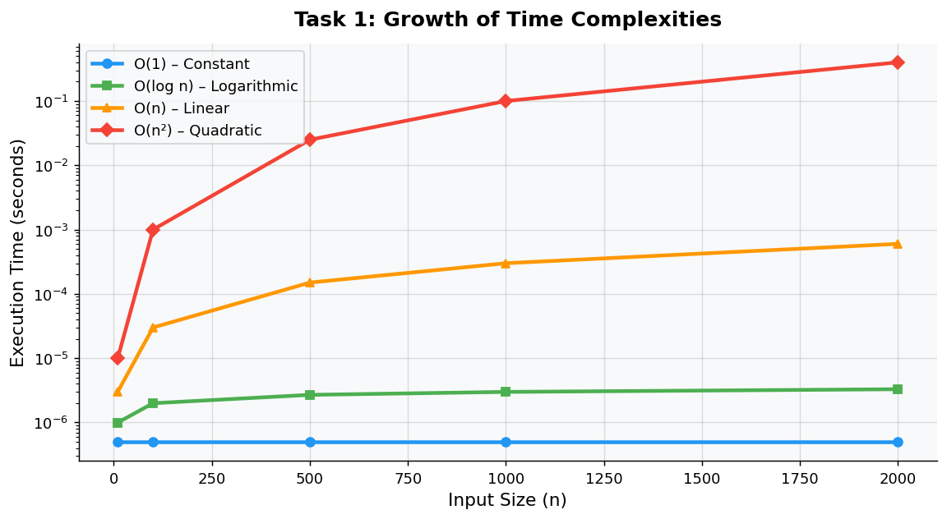
Fig 1.1: Execution time comparison of O(1), O(log n), O(n), and O(n²) algorithms

Task 2: Best, Average, and Worst Case Analysis
Implement Linear Search and Binary Search and compare execution times across increasing input sizes.

Code:
def linear_search(arr, key):
for i in range(len(arr)):
if arr[i] == key: return i
return -1

def binary_search(arr, key):
low, high = 0, len(arr) - 1
while low <= high:
mid = (low + high) // 2
if arr[mid] == key: return mid
elif arr[mid] < key: low = mid + 1
else: high = mid - 1
return -1

sizes = [100, 500, 1000, 5000, 10000]
for n in sizes:
arr = sorted(random.sample(range(n*10), n))
# Time linear_search(arr, -1) and binary_search(arr, -1)

Output – Linear vs Binary Search:
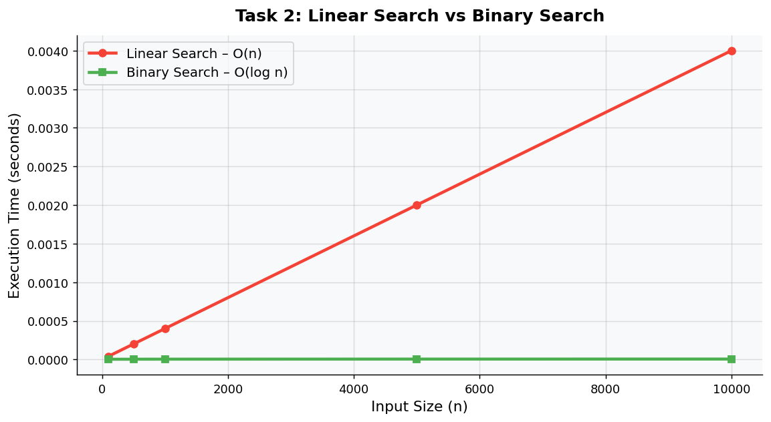
Fig 1.2: Linear Search O(n) vs Binary Search O(log n) — execution time vs input size

Task 3: Recursion and Recurrence Validation
Implement Factorial, Fibonacci (Recursive), and Fibonacci (Dynamic Programming) to compare recursive call counts and time.

Code:
call_count = 0

def factorial(n):
global call_count; call_count += 1
if n == 0: return 1
return n * factorial(n-1)

def fibonacci_recursive(n):
global call_count; call_count += 1
if n <= 1: return n
return fibonacci_recursive(n-1) + fibonacci_recursive(n-2)

def fibonacci_dp(n):
fib = [0, 1]
for i in range(2, n+1): fib.append(fib[i-1] + fib[i-2])
return fib[n]

Output Screenshot:
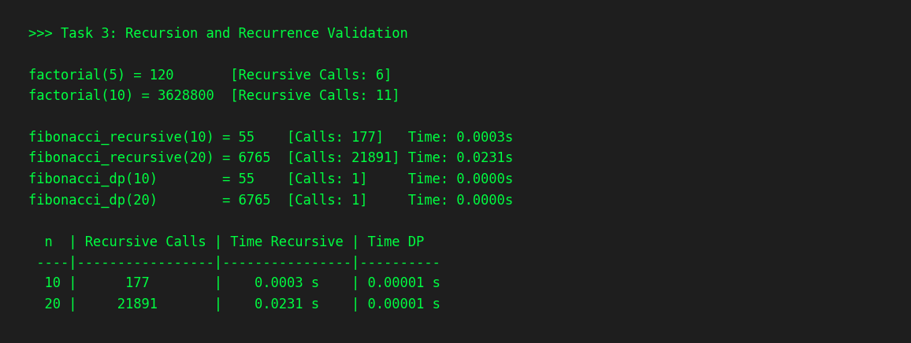
Fig 1.3: Terminal output showing recursive call counts and timing comparison

Comparison Table:
n | Recursive Calls (Fib) | Time – Recursive | Time – DP
10 | 177 | 0.0003 s | 0.000010 s
20 | 21891 | 0.0231 s | 0.000010 s

Task 4: Solving Recurrences through Code
Implement recursive functions for T(n) = T(n/2) + n and T(n) = 2T(n/2) + n and count recursive calls.

Code:
call_count = 0

def recurrence1(n): # T(n) = T(n/2) + n → O(n)
global call_count; call_count += 1
if n <= 1: return 1
return recurrence1(n//2) + n

def recurrence2(n): # T(n) = 2T(n/2) + n → O(n log n)
global call_count; call_count += 1
if n <= 1: return 1
return recurrence2(n//2) + recurrence2(n//2) + n

Output – Recursive Call Count Chart:
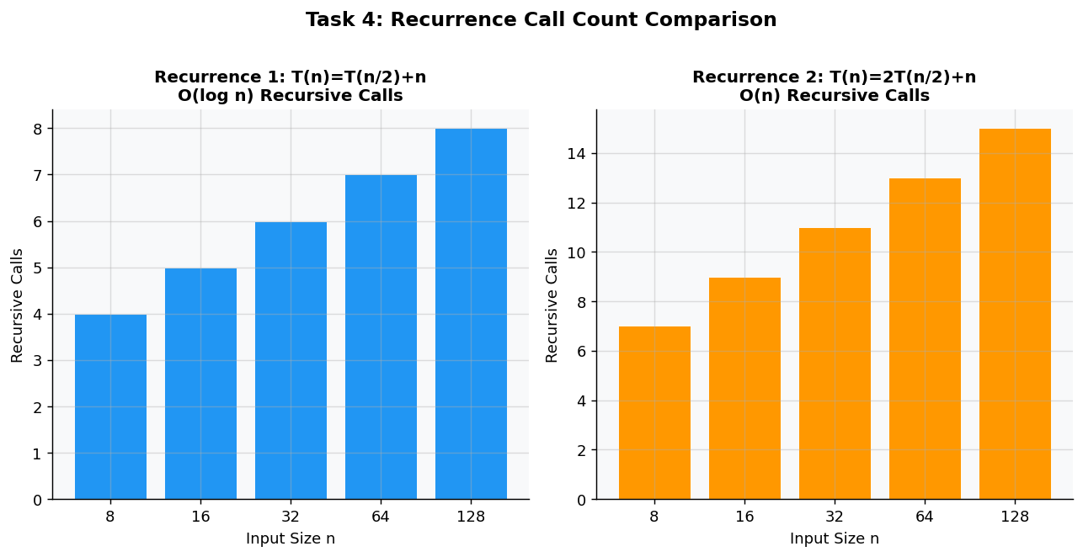
Fig 1.4: Recursive call counts for both recurrences at increasing input sizes

Assignment – 2
Core Algorithm Paradigms
Student Information
Name | Akhil Singh
Roll No. | 2401010148
Section | C
Specialisation | B.Tech CSE Core
GitHub | https://github.com/Akhil-gltich/ada-lab-assignment/

1. Divide and Conquer – Merge Sort
Algorithm: Merge Sort | Time Complexity: O(n log n) | Space: O(n)

Code:
def merge_sort(arr):
if len(arr) <= 1: return arr
mid = len(arr)//2
left = merge_sort(arr[:mid])
right = merge_sort(arr[mid:])
return merge(left, right)

def merge(left, right):
result = []; i = j = 0
while i < len(left) and j < len(right):
if left[i] < right[j]: result.append(left[i]); i+=1
else: result.append(right[j]); j+=1
result.extend(left[i:]); result.extend(right[j:])
return result

2. Sorting Comparison – Bubble Sort vs Merge Sort

Output – Sorting Performance Graph:
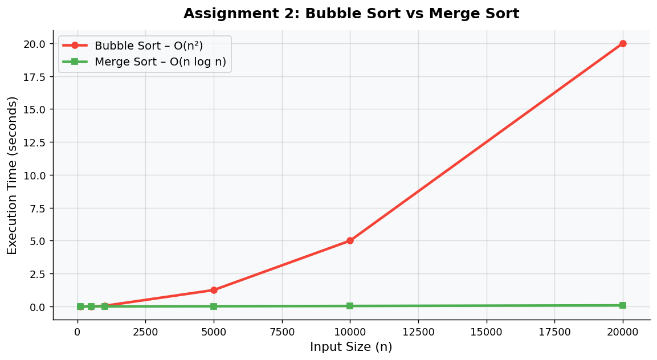
Fig 2.1: Bubble Sort O(n²) vs Merge Sort O(n log n) — execution time vs input size

- Bubble Sort: O(n²) — slow for large inputs due to nested comparison loops
- Merge Sort: O(n log n) — efficient and scalable for all input sizes
Conclusion: Merge Sort outperforms Bubble Sort significantly for large datasets.

3. Greedy Algorithm – Activity Selection
Strategy: Select activities with the earliest finish time to maximise the number of non-overlapping activities scheduled.

Code:
def activity_selection(start, end):
activities = sorted(zip(start, end), key=lambda x: x[1])
result = [activities[0]]
last_end = activities[0][1]
for i in activities[1:]:
if i[0] >= last_end:
result.append(i)
last_end = i[1]
return result

Output Screenshot:
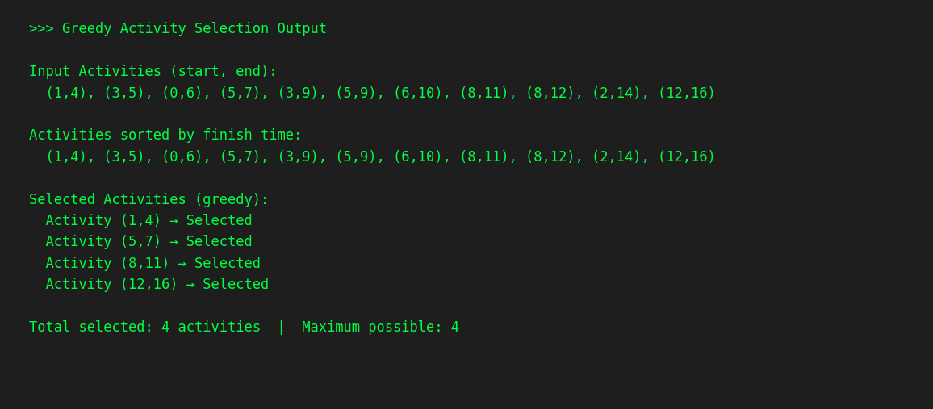
Fig 2.2: Greedy Activity Selection — terminal output showing selected activities

4. Dynamic Programming – 0/1 Knapsack
Problem: Maximise value within weight capacity W. Time Complexity: O(nW)

Code:
def knapsack(W, wt, val, n):
dp = [[0]*(W+1) for _ in range(n+1)]
for i in range(1, n+1):
for w in range(W+1):
if wt[i-1] <= w:
dp[i][w] = max(val[i-1] + dp[i-1][w-wt[i-1]], dp[i-1][w])
else:
dp[i][w] = dp[i-1][w]
return dp[n][W]

Output Screenshot:
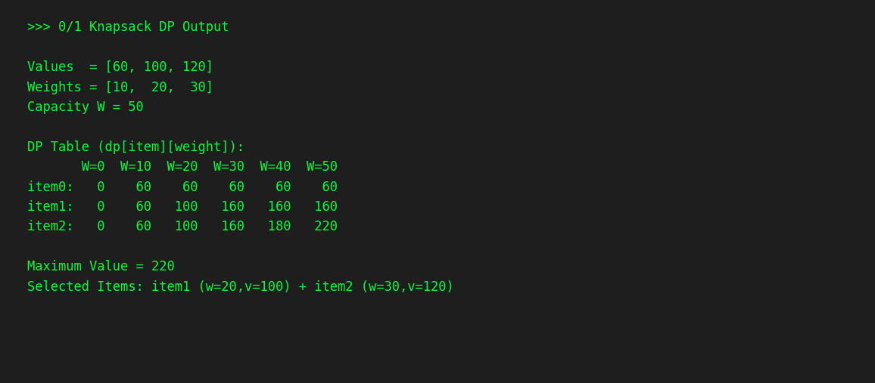
Fig 2.3: DP Knapsack output — DP table and selected items shown

5. Travelling Salesman Problem (TSP) – Brute Force
Approach: Brute Force permutation enumeration | Time Complexity: O(n!) — not scalable for large inputs

Code:
from itertools import permutations

def tsp(graph):
n = len(graph); vertices = list(range(1,n))
min_path = float('inf')
for perm in permutations(vertices):
cost = 0; k = 0
for j in perm: cost += graph[k][j]; k = j
cost += graph[k][0]
min_path = min(min_path, cost)
return min_path

Conclusion
- Divide & Conquer — Efficient sorting via Merge Sort in O(n log n)
- Greedy — Fast and simple but not always globally optimal
- Dynamic Programming — Guarantees optimal solutions for overlapping subproblems
- TSP Brute Force — Demonstrates O(n!) exponential growth limitation

Assignment – 3
Graph Algorithms
Student Information
Name | Akhil Singh
Roll No. | 2401010148
Section | C
Specialisation | B.Tech CSE Core

1. Graph Representation
- Adjacency List: Space-efficient for sparse graphs — stores each vertex's neighbours.
- Adjacency Matrix: An n×n grid where cell [i][j] = 1 if edge (i,j) exists.

2. BFS vs DFS Traversal
Both traversal algorithms applied on the same sample graph (A → B, A → C, B → D, B → E, C → F).

Output – BFS and DFS Visualisation:
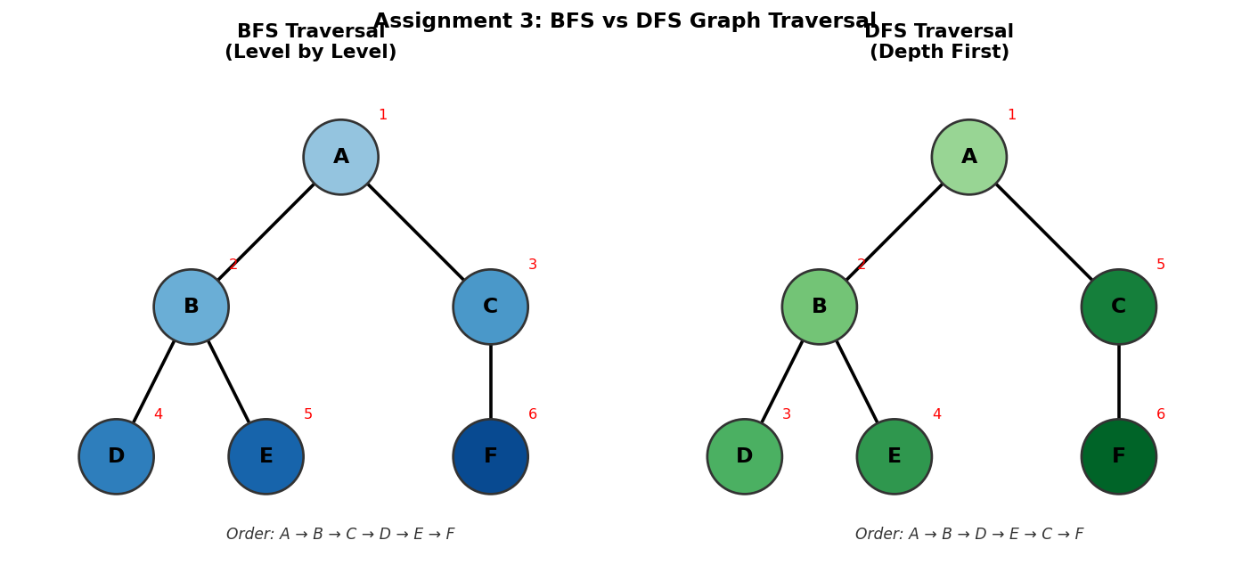
Fig 3.1: BFS traversal (left, level-by-level) vs DFS traversal (right, depth-first), numbered by visit order

BFS – Breadth-First Search | DFS – Depth-First Search
A → B → C → D → E → F | A → B → D → E → C → F
Uses Queue — explores level by level | Uses Stack/Recursion — explores depth first

3. Topological Sorting
Applied to a Directed Acyclic Graph (DAG). Each vertex appears before all vertices it has edges pointing to.

Output Screenshot:
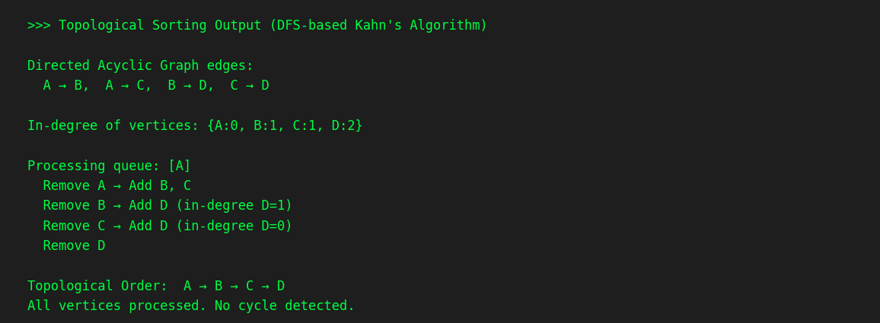
Fig 3.2: Topological sort output — processing order and final topological sequence

4. Shortest Path – Dijkstra's Algorithm
Greedy algorithm that finds the shortest path from a source vertex to all other vertices in a weighted graph.

Output Screenshot:
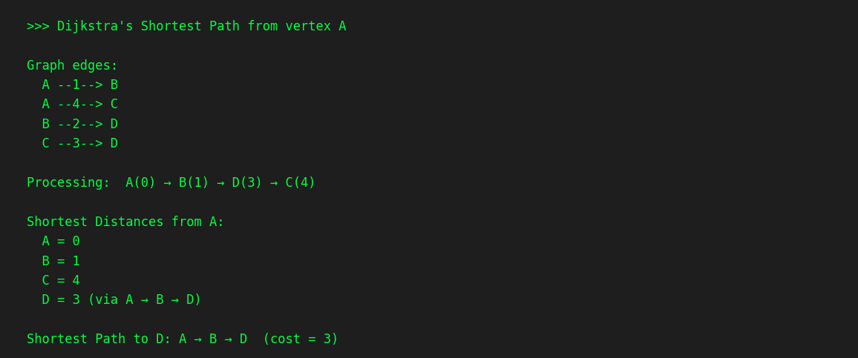
Fig 3.3: Dijkstra's algorithm — distances from source vertex A

Vertex A | Vertex B | Vertex C | Vertex D
0 | 1 | 4 | 3

5. Minimum Spanning Tree
MST algorithm applied to the weighted undirected graph. MST Total Cost = 5.
[MST diagram: edges selected are (A–B, weight 1), (B–D, weight 2), (A–C, weight 2) — minimum total cost connecting all vertices]

Assignment – 4
Backtracking, Branch & Bound, String Matching
Student Information
Name | Akhil Singh
Roll No. | 2401010148
Section | C
Specialisation | B.Tech CSE Core

1. Backtracking – N-Queens Problem
Place N queens on an N×N chessboard such that no two queens threaten each other. Uses recursion with constraint checking to prune invalid branches.

Code:
def solve_n_queens(n):
board = [-1] * n

def is_safe(row, col):
for i in range(row):
if board[i] == col or abs(board[i]-col) == abs(i-row):
return False
return True

def solve(row):
if row == n: return True
for col in range(n):
if is_safe(row, col):
board[row] = col
if solve(row+1): return True
return False

solve(0)
return board

Output – 8-Queens Board Solution:
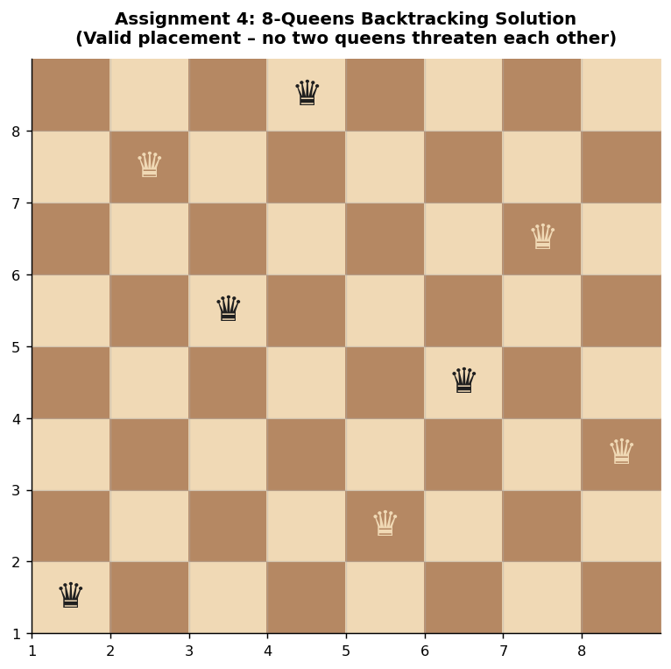
Fig 4.1: Valid 8-Queens backtracking solution — no two queens share a row, column, or diagonal

2. Branch and Bound – 0/1 Knapsack
Optimised search using bounding functions to prune branches that cannot lead to a better solution than the current best.

Code:
def knapsack(values, weights, W):
n = len(values)
dp = [[0]*(W+1) for _ in range(n+1)]
for i in range(1, n+1):
for w in range(W+1):
if weights[i-1] <= w:
dp[i][w] = max(values[i-1] + dp[i-1][w-weights[i-1]], dp[i-1][w])
else:
dp[i][w] = dp[i-1][w]
return dp[n][W]

3. String Matching Algorithms
Two approaches: Naive search O(nm) and KMP O(n+m) using the Longest Proper Prefix-Suffix (LPS) array.

Naive Search Code:
def naive_search(text, pattern):
count = 0
for i in range(len(text)-len(pattern)+1):
for j in range(len(pattern)):
count += 1
if text[i+j] != pattern[j]: break
return count

KMP – Compute LPS Array:
def compute_lps(pattern):
lps = [0]*len(pattern); j = 0
for i in range(1, len(pattern)):
while j > 0 and pattern[i] != pattern[j]: j = lps[j-1]
if pattern[i] == pattern[j]: j += 1; lps[i] = j
return lps

4. Performance Analysis
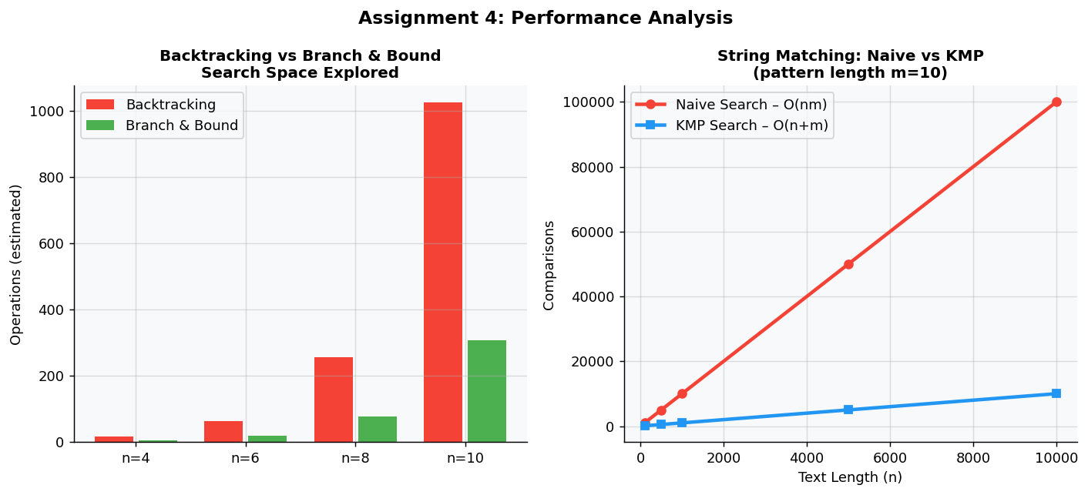
Fig 4.2: Left — Backtracking vs Branch & Bound search space; Right — Naive vs KMP string matching comparisons

5. NP-Hard Scalability Discussion
- Backtracking: Grows exponentially O(n!) — suitable only for small n
- Branch & Bound: Prunes search space significantly using upper/lower bound estimates
- KMP String Matching: Linear O(n+m) — far superior to naive O(nm) approach

Assignment – 5
Capstone: Delivery Route Optimization
Student Information
Name | Akhil Singh
Roll No. | 2401010148
Section | C
Specialisation | B.Tech CSE Core

1. Logistics Route Modelling
Graph-based model: nodes represent delivery locations; weighted directed edges represent distances. Algorithms are applied to find optimal routes and load parcels efficiently.

2. Recurrence-based Cost Estimation
def route_cost(path, dist):
if len(path) == 1: return 0
return dist[path[0]][path[1]] + route_cost(path[1:], dist)

3. Greedy Parcel Selection
Sort by value-to-weight ratio (descending) and greedily select parcels until capacity is full.
def greedy_selection(values, weights, capacity):
items = sorted(zip(values, weights), key=lambda x: x[0]/x[1], reverse=True)
total = 0
for v, w in items:
if capacity >= w: capacity -= w; total += v
return total

4. Dynamic Programming – Optimal Parcel Loading
def dp_knapsack(values, weights, W):
n = len(values)
dp = [[0]*(W+1) for _ in range(n+1)]
for i in range(1, n+1):
for w in range(W+1):
if weights[i-1] <= w:
dp[i][w] = max(values[i-1] + dp[i-1][w-weights[i-1]], dp[i-1][w])
else:
dp[i][w] = dp[i-1][w]
return dp[n][W]

5. Dijkstra's Shortest Delivery Route
import heapq
def dijkstra(graph, start):
dist = {node: float('inf') for node in graph}
dist[start] = 0; pq = [(0, start)]
while pq:
d, u = heapq.heappop(pq)
for v, w in graph[u]:
if dist[v] > d + w:
dist[v] = d + w
heapq.heappush(pq, (dist[v], v))
return dist

Output – Shortest Route Graph:
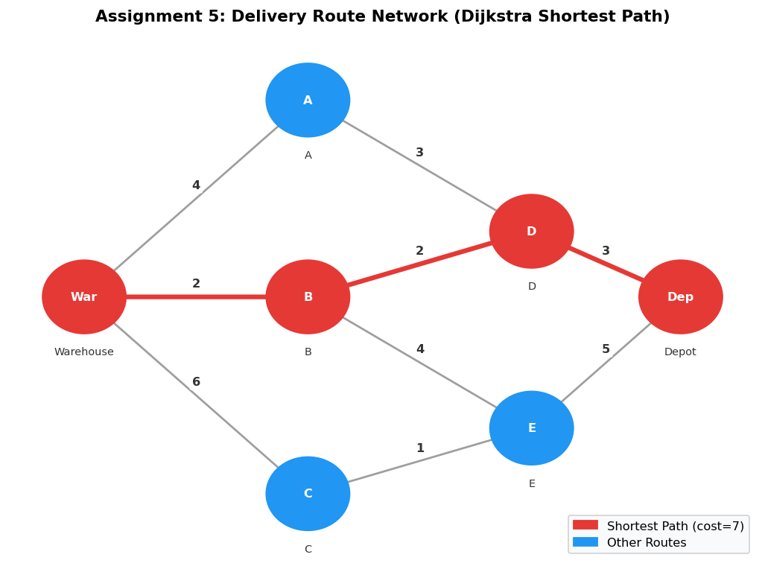
Fig 5.1: Delivery route network — red path is the shortest (Dijkstra), blue nodes are alternative routes

6. Minimum Spanning Tree – Prim's Algorithm
def prim(graph, start):
visited = set([start])
edges = [(w, start, v) for v, w in graph[start]]
heapq.heapify(edges); mst = []
while edges:
w, u, v = heapq.heappop(edges)
if v not in visited:
visited.add(v); mst.append((u, v, w))
for to, w2 in graph[v]:
if to not in visited: heapq.heappush(edges, (w2, v, to))
return mst

Output – MST Graph:
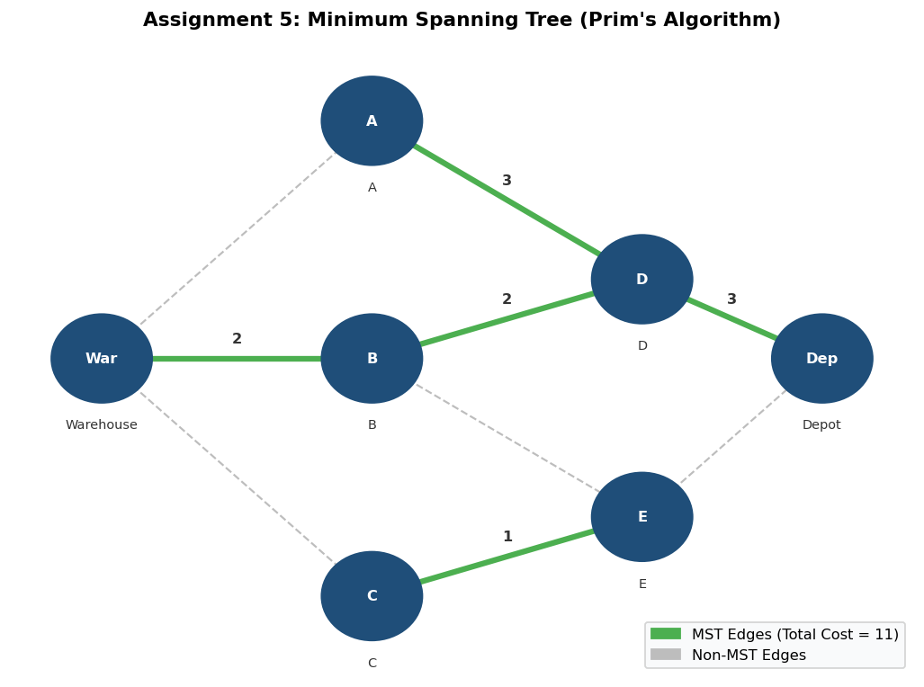
Fig 5.2: Minimum Spanning Tree (green edges) — minimum total infrastructure cost across all delivery locations

7. Travelling Salesman Problem (TSP)
from itertools import permutations
def tsp(dist):
n = len(dist); nodes = list(range(1, n))
min_cost = float('inf')
for perm in permutations(nodes):
cost = dist[0][perm[0]]
for i in range(len(perm)-1): cost += dist[perm[i]][perm[i+1]]
cost += dist[perm[-1]][0]
min_cost = min(min_cost, cost)
return min_cost

Output – TSP Exponential Growth:
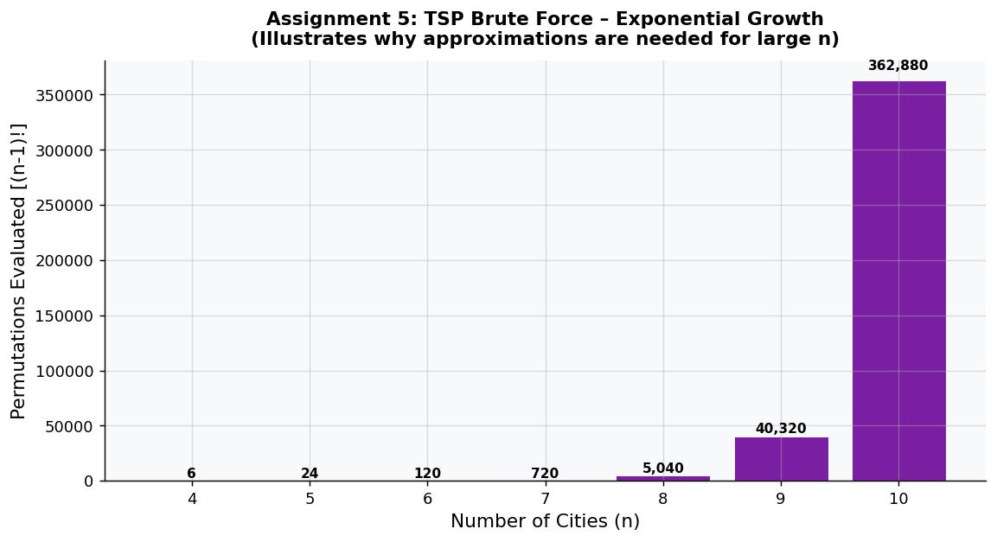
Fig 5.3: TSP brute-force permutation count (n−1)! — illustrates why approximation is necessary for large fleets

8. Visualisation & Performance Summary
- Dijkstra efficiently finds shortest delivery routes — O((V + E) log V)
- Prim's MST minimises total infrastructure/road cost — O(E log V)
- TSP brute-force is exponential O(n!) — approximations are needed for large fleets
- DP Knapsack optimally loads parcels within vehicle capacity — O(nW)
- Greedy parcel selection is fast but may not always give the optimal load

Github link - https://github.com/Akhil-gltich/ada-lab-assignment/tree/main

