Assignment 5: Quicksort Algorithm : Implementation, Analysis, and Randomization

Akhil Reddy Tekula
Student ID : 005043361
MSCS-532 Algorithms and Data Structures
Michael Solomon
University of the Cumberlands
July 25, 2026

Implementation
The algorithm implemented is Quicksort, which is a divide-and-conquer algorithm, and it is done in Python. The pivot is picked as the last value in the array in the deterministic case. Reorder the array elements such that all of those that are less than or equal to the pivot are on the left, and those that are greater than the pivot is on the right. The algorithm then recursively sorts the left and right subarrays, until the entire array is sorted.
A second implementation, Randomised Quicksort, was also created. It now picks a pivot at random from the sub-array before partitioning as opposed to always selecting the last element in the sub-array. Since this small adjustment mitigates the risk of having a bad pivot at every step, it causes an overall increase in reliability of the algorithm.

Performance Analysis
The efficiency of Quicksort relies on the distribution of the elements on each recursive call to the function. If the partition created by the pivot is close to equal, then it would be very efficient, time O(n log n). Every partition takes O(n) time, and the recursion time would be on the order of log n, thus making the average running time O(n log n).
In the very worst case, most of the pivots are the minimum or maximum elements, generating extremely irregular partitions. This makes the total run time O(n²). This often happens when the calls to sort an array that is already sorted or reverse-sorted, in this implementation of the deterministic case.
Case | Time Complexity
Best Case | O(n log n)
Average Case | O(n log n)
Worst Case | O(n²)
Quicksort is an in-place sorting algorithm which uses little extra memory. The space complexity of this function is the average case of O(log n) as it is recursive, but in the worst case, when the recursion is high, space complexity is O(n). There is only a small overhead of random pivot positions with the randomised implementation.

Randomized Quicksort
Randomised Quicksort is the same as the standard Quicksort but chooses the pivot from a random location rather than taking the last element of the array, as in the standard algorithm. Random pivot selection leads to an increased stability of the algorithm with respect to input variations because it eliminates the worst-case partitions. The randomised version is a bit more time-consuming, in that it requires an additional operation to generate a random pivot; however, it is still O(n log n) in expected running time and has a consistent performance with sorted and reverse-sorted arrays.

Empirical Analysis
Two code implementations of the recursive method were tested – deterministic and randomised – both tested with randomly generated arrays of varying sizes. If you try it, you will get the following values for the execution times.
Table 1 : Benchmark Results
Input Size | Deterministic (ms) | Randomized (ms)
1000 | 0.60 | 0.77
2000 | 1.24 | 1.67
5000 | 3.51 | 4.37
From the results, it is seen that for the random values given as inputs, both implementations are working efficiently. The deterministic version is a little bit quicker, as it doesn't require the random selection of a pivot, resulting in additional overhead. The performance is more consistent with the randomised implementation, and there is less chance of a worst-case scenario under it than with the other; therefore, it is better to use in practice when the input order is unknown.
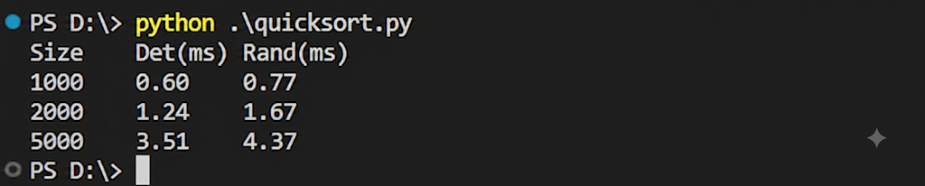
Figure 1 : Program Output
The above figure represents successful implementation of the benchmark programme. As the input size grows, the measured time to execute grows increasingly, as expected from the O(n log n) worst-case time complexity of Quicksort. The randomised implementation has slightly longer execution time for random data output due to an additional random pivot selection but is more well-preserving to cover various kinds of input distribution.

