MSE 01 – DEVOPS
NAME :- AKHIL KUMAR
BRANCH – CSE
SECTION – A
SUBJECT - DEVOPS
DATE – 21/09/2026

Github repo :- https://github.com/Akhil05441/github-skills-challenge

Pull request URL used to validate the workflows :-
https://github.com/DebbieAUG/github-skills-challenge/pull/114

Screenshot showing the GitHub Actions workflows

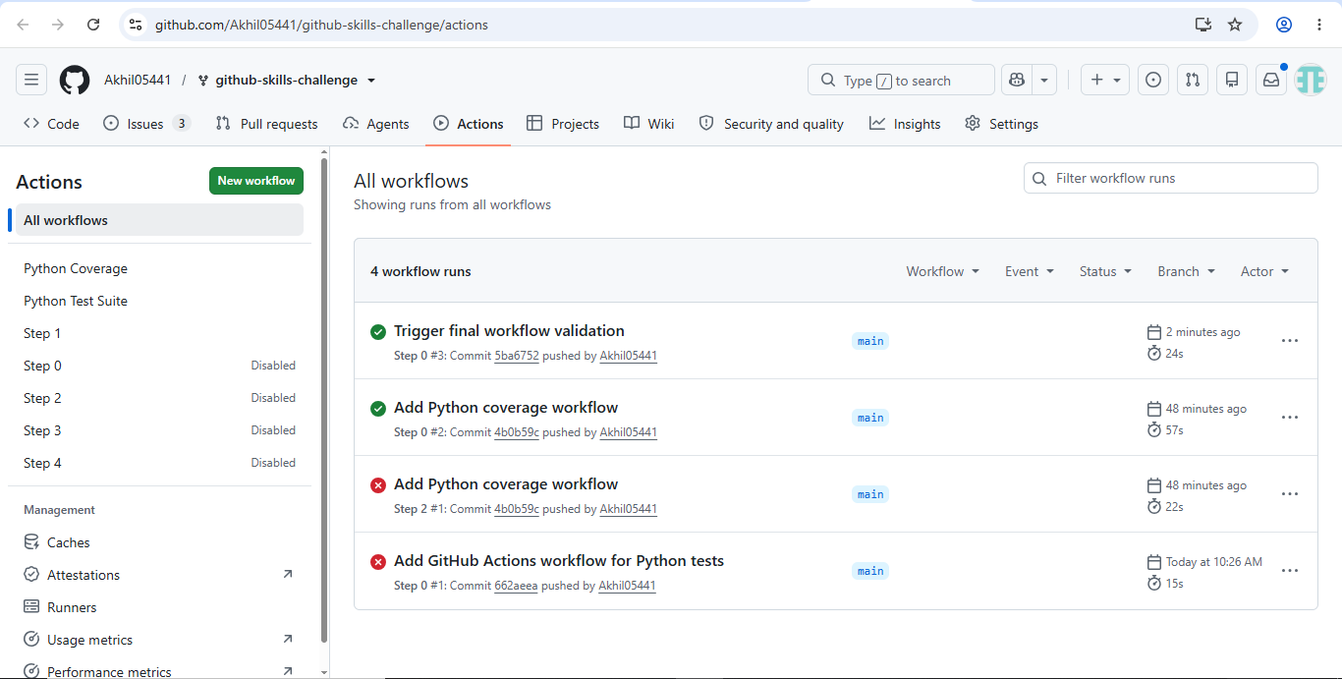

Screenshot showing a successful test workflow execution

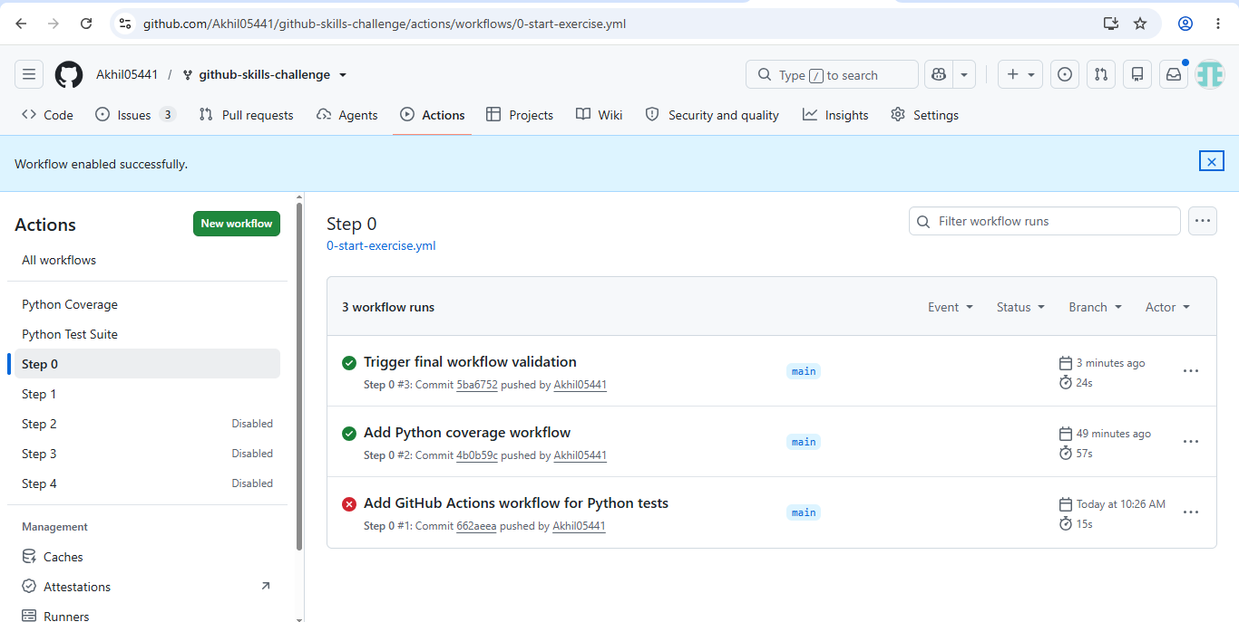

Screenshot showing the coverage result/comment on the pull request

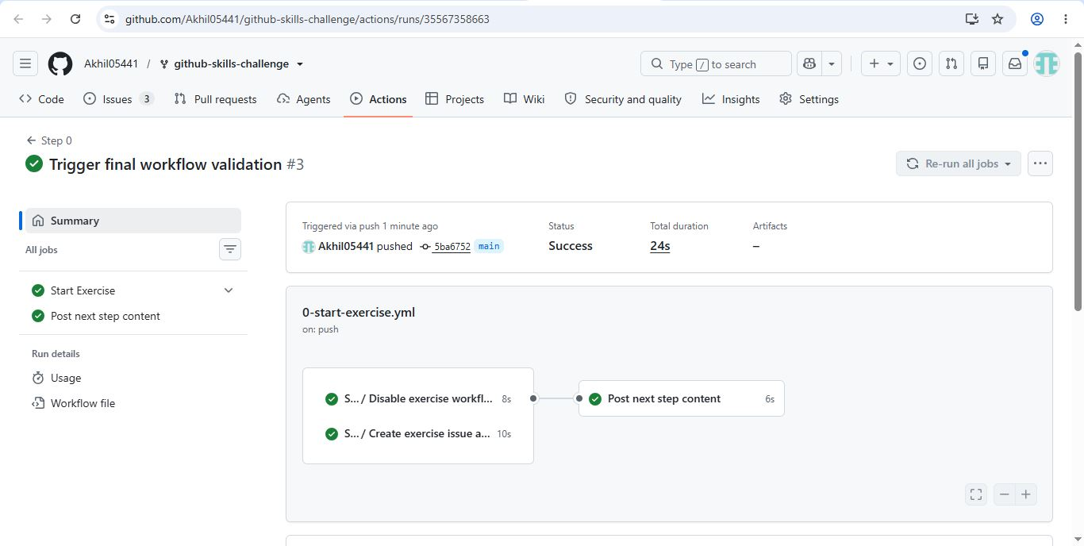
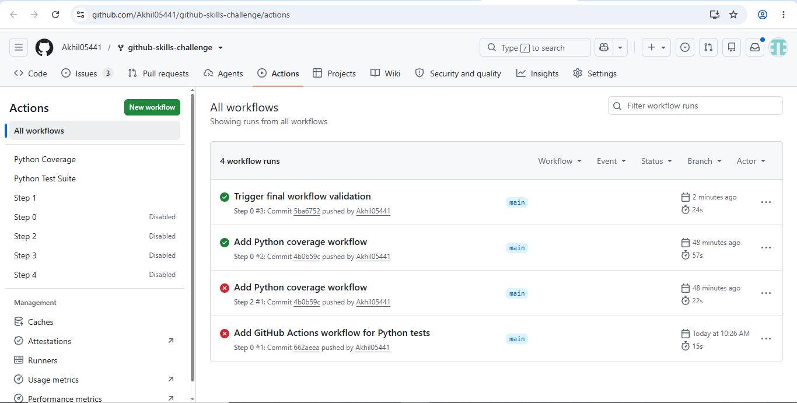

Screenshot showing the final repository/workflow files

