CNN HARDWARE ACCELERATOR
Design and RTL-to-GDS Implementation of a Parameterized 2-D Convolution Engine Using Implicit Im2Col Addressing and an Output-Stationary Systolic PE Chain
Project Report
[Your Name]
M.Tech, [Specialization], Semester I
[Institute Name]
Guide: [Guide Name]
Tools: SystemVerilog, Cadence Genus, Cadence Innovus

Abstract
Convolution accounts for most of the computation in a convolutional neural network (CNN), which makes it the main target for hardware acceleration. This report describes the design of a parameterized hardware accelerator, written in SystemVerilog, that performs 2-D convolution of a single-channel (grayscale) image with a 3×3 kernel. The design combines two well-established techniques: implicit Im2Col addressing, in which pixel addresses are generated on the fly instead of building an Im2Col matrix in memory, and a one-dimensional output-stationary systolic array, in which each processing element (PE) accumulates one output while kernel weights flow through the chain with a one-cycle skew.
The baseline configuration processes a 5×5 image with nine PEs, one per output window. All dimensions are parameters resolved at elaboration time, and the PE chain is generated with SystemVerilog generate blocks. The design is verified against a Python reference model and implemented from RTL to GDSII using Cadence Genus for logic synthesis and Cadence Innovus for place and route, within a one-month schedule.
The report also analyses the pixel access pattern of the design and shows that, in the baseline configuration, the nine PEs never need more than two distinct pixels in the same cycle, and every image pixel is needed in exactly one cycle. This observation motivates a pixel-reuse optimization, which is planned as the first item of future work together with a scaled architecture that adds window-level and filter-level parallelism.
Keywords: CNN accelerator, systolic array, output-stationary dataflow, Im2Col, SystemVerilog, RTL-to-GDS, Cadence Genus, Cadence Innovus.

1. Introduction

1.1 Motivation
CNNs are the standard approach for image classification, object detection, and many other vision tasks. Their convolutional layers perform enormous numbers of multiply-accumulate (MAC) operations: a single 3×3 convolution over one 224×224 feature map already requires about 443,000 MACs, and a full network performs billions. General-purpose processors execute these operations largely sequentially, which costs time and energy. Dedicated hardware can perform many MACs in parallel and, more importantly, can reuse data that has already been fetched instead of reading it from memory again. In accelerators, moving data typically costs more energy than computing with it, so the way data flows through the hardware is as important as the number of multipliers.

1.2 Objectives
- Design a parameterized 2-D convolution accelerator in synthesizable SystemVerilog.
- Separate address generation, image storage, kernel streaming, computation, and output storage into independent blocks with clean interfaces.
- Verify the design against a software reference model with a self-checking testbench.
- Take the design through a complete physical implementation flow, from RTL to a DRC- and LVS-clean GDSII layout, using Cadence Genus and Innovus.
- Report measured area, timing, and power, and identify the main optimization opportunity for future work.

1.3 Scope
The baseline design handles a single-channel 5×5 image, a 3×3 kernel, stride 1, no padding, and 8-bit data, which produces a 3×3 output. Multi-channel inputs, multiple kernels, larger images, and design-for-test are outside the one-month scope and are described as future work in Section 13. The design is parameterized so these extensions do not require rewriting the existing RTL.

1.4 Report Organization
Section 2 explains the background concepts: convolution, Im2Col, and systolic dataflows. Section 3 presents the architecture block by block. Section 4 walks through the cycle-by-cycle operation with a numeric example. Sections 5 to 8 cover the PE microarchitecture, control, parameterization, and the top-level interface. Sections 9 and 10 describe verification and the physical implementation flow. Sections 11 to 13 discuss limitations, prior work, and future work, and Section 14 holds the implementation results.

2. Background

2.1 2-D Convolution
In a convolutional layer, a small matrix of weights called a kernel (or filter) slides across the input image. At each position, the kernel is multiplied element by element with the pixels underneath it, and the products are summed to produce one output value. For an input image I and a K×K kernel W, the output at position (r, c) with stride S is:
O[r][c] = Σ (i = 0..K−1) Σ (j = 0..K−1) I[r·S + i][c·S + j] × W[i][j]

The region of the image covered by the kernel at one position is called a window. The number of window positions in each dimension, which is also the output size, is:
OUT_H = (IMG_H − K) / S + 1 OUT_W = (IMG_W − K) / S + 1

For the baseline 5×5 image with a 3×3 kernel and stride 1, this gives a 3×3 output: nine windows, each requiring nine MACs, for a total of 81 MACs. Neighbouring windows overlap: with stride 1, two horizontally adjacent windows share six of their nine pixels. This overlap is a major opportunity for data reuse in hardware.
In this project the image is single-channel (grayscale), so each kernel has 3×3 = 9 weights. In a colour image or in deeper CNN layers, each kernel also extends across input channels (for example 3×3×3 for RGB), and the products from all channels are summed into one output value. This extension is discussed in Section 13.

2.2 Im2Col
Im2Col ("image to column") is a technique that converts convolution into matrix multiplication. Each window is unrolled into a column of K² pixels, and all columns are placed side by side to form a matrix. Multiplying the flattened kernel by this matrix produces all outputs at once. The advantage is that matrix multiplication is a regular, well-understood operation that maps efficiently onto hardware.
The drawback of explicit Im2Col is memory: because windows overlap, every pixel is copied into several columns. For a 3×3 kernel with stride 1, the Im2Col matrix is roughly nine times larger than the image. Implicit Im2Col avoids this by never building the matrix. Instead, an address generator computes, at each cycle, which original image pixel each column entry corresponds to, and reads it directly from the image memory. This project uses implicit Im2Col.

2.3 Systolic Arrays
A systolic array is a grid or chain of identical processing elements that pass data to their neighbours in a regular rhythm, one step per clock cycle. The name comes from the rhythmic pumping of the heart. Each data value fetched from memory is used by many PEs as it moves through the array, which reduces memory traffic. Because each PE only talks to its neighbours, wiring is short and regular, which suits VLSI implementation. Systolic arrays were introduced by H.T. Kung in the late 1970s and today form the core of accelerators such as Google's Tensor Processing Unit.

Dataflows
A convolution involves three kinds of data: inputs (pixels), weights, and partial sums. A systolic dataflow is defined by which of these stays fixed inside each PE and which ones move:
Dataflow | Stays in the PE | Moves between PEs | Typical benefit
Weight-stationary | Weights | Pixels and partial sums | Each weight is fetched once and reused for many windows
Output-stationary | Partial sums | Weights and/or pixels | Partial sums never leave the PE until the result is final
Input-stationary | Pixels | Weights and partial sums | Each pixel is fetched once and reused for many weights
Table 2.1. Common systolic dataflows.
This design is output-stationary: each PE owns one output window and keeps its accumulator internal for the whole computation, while weights move from PE to PE. Output-stationary designs avoid moving wide partial sums between PEs, and they extend naturally to multi-channel convolution because a PE can simply keep accumulating across channels.

3. System Architecture
Figure 3.1 shows the top-level architecture. The design is divided into five blocks. The Im2Col block decides which pixel each PE needs; the image buffer stores the image and performs the reads; the kernel block stores and streams the weights; the systolic array performs the MACs; and the output memory stores the results. Separating "which data" (Im2Col) from "where data is stored" (image buffer) means either block can be changed without affecting the other, which is important for the pixel-reuse optimization planned in future work.
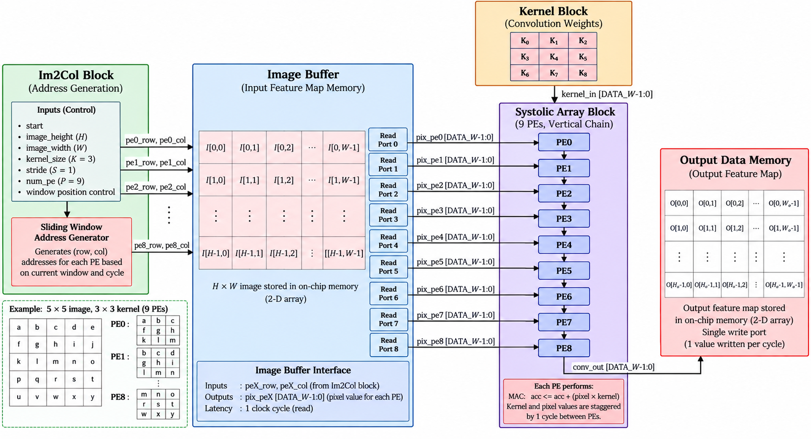
Figure 3.1. Top-level architecture of the accelerator.

3.1 Im2Col Block (Address Generation)
The Im2Col block is the address-generation controller. For each of the P PEs, it produces a (row, column) address into the image buffer every cycle. The address depends on the window assigned to that PE and on which kernel coefficient the PE is currently using. If PE p is assigned the window starting at (r₀, c₀) and is processing kernel coefficient number k, the pixel it needs is:
row = r₀ + (k / K) col = c₀ + (k mod K)

In the baseline, PE p is assigned window p in row-major order, so PE0 starts at (0,0), PE1 at (0,1), PE2 at (0,2), PE3 at (1,0), and so on to PE8 at (2,2). Because of the weight skew described in Section 3.3, PE p processes coefficient k = t − p at cycle t.
Implementation note. The division and modulo in the formula above are not built as hardware dividers. Division circuits are large and slow. Instead, the block uses small counters: a kernel-column counter that wraps from K−1 to 0 and, when it wraps, increments a kernel-row counter. The same counter approach is used for window positions. Values that never change at runtime, such as the window origins, are computed at elaboration time (Section 7).
Port | Dir | Width | Description
clk, rst_n | in | 1 | Clock and active-low reset
start | in | 1 | Begins address generation
pe_row[p], pe_col[p] | out | $clog2(IMG_H), $clog2(IMG_W) | Pixel address for PE p, one pair per PE
addr_valid[p] | out | 1 | PE p has a valid address this cycle
Table 3.1. Im2Col block ports.

3.2 Image Buffer
The image buffer stores the input feature map as a 2-D array, image_mem[row][col], of DATA_W-bit values. It is written through a single write port during the load phase and read through P independent read ports during computation. Each read port takes a (row, column) address from the Im2Col block and returns the pixel one clock cycle later.
At the baseline size of 25 pixels × 8 bits = 200 bits, the buffer is built from flip-flops. Each read port is effectively a 25-to-1 multiplexer, so nine ports mean nine such multiplexers. This is acceptable at this size but grows quickly with image size and port count, which is the main motivation for pixel reuse (Section 13.1). An SRAM macro is not used because typical single- or dual-port SRAMs cannot provide nine simultaneous reads.
Port | Dir | Width | Description
img_we, img_waddr, img_wdata | in | 1, 5, 8 | Load interface, one pixel per cycle
rd_row[p], rd_col[p] | in | 3, 3 | Read address for port p (from Im2Col)
pix_pe[p] | out | DATA_W | Pixel for PE p, valid one cycle after the address
Table 3.2. Image buffer ports (baseline widths).

3.3 Kernel Block
The kernel block stores the nine weights K0 to K8 in row-major order (K0 K1 K2 in the first kernel row, K3 K4 K5 in the second, K6 K7 K8 in the third). During computation it sends one weight per cycle into PE0, starting with K0. Each PE holds the weight in a register for one cycle and passes it to the next PE. The result is a one-cycle skew between neighbouring PEs, shown in Table 3.3: at cycle t, PE p receives weight K(t − p).
Cycle | PE0 | PE1 | PE2 | PE3 | … | PE8
0 | K0 | – | – | – |  | –
1 | K1 | K0 | – | – |  | –
2 | K2 | K1 | K0 | – |  | –
3 | K3 | K2 | K1 | K0 |  | –
8 | K8 | K7 | K6 | K5 |  | K0
9 | done | K8 | K7 | K6 |  | K1
16 | done | done | done | done |  | K8
Table 3.3. Weight skew through the PE chain.
Because each weight is fetched from the kernel block once and then reused by all nine PEs as it travels down the chain, the kernel block needs only one output port, regardless of the number of PEs.

3.4 Systolic Array
The systolic array is a 1-D chain of P PEs, generated with a SystemVerilog generate loop. Each PE receives its own pixel stream from the image buffer and the weight stream from the previous PE, multiplies them, and adds the product to its accumulator. The internal structure of a PE is described in Section 5.
Since each PE starts one cycle after its predecessor, each PE also finishes one cycle after its predecessor. PE0 completes its nine MACs at the end of cycle 8, PE1 at cycle 9, and PE8 at cycle 16. Results therefore become available one per cycle, in order, which matches a single-write-port output memory.

3.5 Output Data Memory
The output memory is a 2-D array, out_mem[row][col], of ACC_W-bit values with a single write port. Finished results are moved out of the PEs through a shift-out path and written one per cycle. After computation, results are read through the top-level read interface (Section 8).

4. Dataflow and Worked Example

4.1 Example Data
To make the operation concrete, this section follows the baseline design through one complete computation with real numbers. The image is labelled with letters a to y in row-major order to make pixel positions easy to follow, and assigned the numeric values in Table 4.1. The kernel is a vertical-edge (Sobel-type) filter, chosen because it includes positive, negative, and zero weights.
 | col 0 | col 1 | col 2 | col 3 | col 4
row 0 | a = 3 | b = 1 | c = 4 | d = 1 | e = 5
row 1 | f = 9 | g = 2 | h = 6 | i = 5 | j = 3
row 2 | k = 5 | l = 8 | m = 9 | n = 7 | o = 9
row 3 | p = 3 | q = 2 | r = 3 | s = 8 | t = 4
row 4 | u = 6 | v = 2 | w = 6 | x = 4 | y = 3
Table 4.1. Example 5×5 input image (letter = value).
 | col 0 | col 1 | col 2
row 0 | K0 = 1 | K1 = 0 | K2 = -1
row 1 | K3 = 2 | K4 = 0 | K5 = -2
row 2 | K6 = 1 | K7 = 0 | K8 = -1
Table 4.2. Example 3×3 kernel.

4.2 One PE in Detail
PE0 computes the window with top-left corner at pixel a, which covers pixels a, b, c, f, g, h, k, l, m. Table 4.3 shows its nine MAC steps. At step k, PE0 receives weight Kk and the matching pixel, and adds their product to its accumulator.
Step k | Weight | Pixel | Product | Accumulator
0 | K0 = 1 | a = 3 | 3 | 3
1 | K1 = 0 | b = 1 | 0 | 3
2 | K2 = -1 | c = 4 | -4 | -1
3 | K3 = 2 | f = 9 | 18 | 17
4 | K4 = 0 | g = 2 | 0 | 17
5 | K5 = -2 | h = 6 | -12 | 5
6 | K6 = 1 | k = 5 | 5 | 10
7 | K7 = 0 | l = 8 | 0 | 10
8 | K8 = -1 | m = 9 | -9 | 1
Table 4.3. MAC sequence of PE0. The final value, 1, is output O[0][0].
All nine PEs perform the same procedure on their own windows. Table 4.4 shows the resulting 3×3 output, which matches the result computed by the Python reference model.
 | col 0 | col 1 | col 2
row 0 | 1 | -5 | 5
row 1 | -5 | -7 | 2
row 2 | -4 | -13 | 1
Table 4.4. Expected output feature map O.

4.3 Complete Pixel Schedule
Table 4.5 shows, for every cycle of the computation, which pixel and which weight each PE uses. An entry such as "g·K4" means the PE multiplies pixel g by weight K4 in that cycle. The last column counts how many distinct pixels the whole array needs in that cycle.
t | PE0 | PE1 | PE2 | PE3 | PE4 | PE5 | PE6 | PE7 | PE8 | Distinct
0 | a·K0 | – | – | – | – | – | – | – | – | 1
1 | b·K1 | b·K0 | – | – | – | – | – | – | – | 1
2 | c·K2 | c·K1 | c·K0 | – | – | – | – | – | – | 1
3 | f·K3 | d·K2 | d·K1 | f·K0 | – | – | – | – | – | 2
4 | g·K4 | g·K3 | e·K2 | g·K1 | g·K0 | – | – | – | – | 2
5 | h·K5 | h·K4 | h·K3 | h·K2 | h·K1 | h·K0 | – | – | – | 1
6 | k·K6 | i·K5 | i·K4 | k·K3 | i·K2 | i·K1 | k·K0 | – | – | 2
7 | l·K7 | l·K6 | j·K5 | l·K4 | l·K3 | j·K2 | l·K1 | l·K0 | – | 2
8 | m·K8 | m·K7 | m·K6 | m·K5 | m·K4 | m·K3 | m·K2 | m·K1 | m·K0 | 1
9 | – | n·K8 | n·K7 | p·K6 | n·K5 | n·K4 | p·K3 | n·K2 | n·K1 | 2
10 | – | – | o·K8 | q·K7 | q·K6 | o·K5 | q·K4 | q·K3 | o·K2 | 2
11 | – | – | – | r·K8 | r·K7 | r·K6 | r·K5 | r·K4 | r·K3 | 1
12 | – | – | – | – | s·K8 | s·K7 | u·K6 | s·K5 | s·K4 | 2
13 | – | – | – | – | – | t·K8 | v·K7 | v·K6 | t·K5 | 2
14 | – | – | – | – | – | – | w·K8 | w·K7 | w·K6 | 1
15 | – | – | – | – | – | – | – | x·K8 | x·K7 | 1
16 | – | – | – | – | – | – | – | – | y·K8 | 1
Table 4.5. Pixel and weight used by each PE in each compute cycle.
The table shows three properties of the design:
- Pipeline fill and drain. The array is fully busy only at cycle 8, when all nine PEs are active. One computation takes K² + P − 1 = 17 cycles and performs 81 MACs out of 9 × 17 = 153 available MAC slots, a utilization of about 53%. When the chain is reused for further windows (Section 13.2), PE0 starts its next window at cycle 9, so the fill and drain overlap and utilization approaches 100%.
- Results finish in order. A PE finishes when it processes K8. Reading down the K8 diagonal, PE0 finishes at cycle 8 and PE8 at cycle 16, one result per cycle.
- Pixels are heavily shared. Although nine read ports are active in the middle of the computation, at most two distinct pixels are needed in any cycle. At cycle 5, for example, all six active PEs need pixel h. Section 13.1 analyses this property.

4.4 Timing Alignment
The image buffer returns a pixel one cycle after it receives an address. If the Im2Col block issues the address for compute cycle t at clock cycle t, the pixel arrives at cycle t + 1. The weight stream into PE0 is therefore delayed by one register stage, so that the weight and the matching pixel reach each PE in the same cycle. The cycle numbers in Table 4.5 refer to compute cycles after this alignment.

4.5 Latency and Throughput
Phase | Cycles (baseline) | Notes
Load image | 25 | One pixel per cycle through img_we / img_wdata
Load kernel | 9 | One weight per cycle; can overlap with image load if separate ports are used
Compute | 17 + 1 | K² + P − 1 compute cycles plus one cycle of read latency
Write results | overlapped | Results written one per cycle as PEs finish
Read results | 9 | One result per cycle through out_addr / out_rdata
Table 4.6. Approximate cycle count for one complete operation.
The load and read phases dominate for a tiny 5×5 image because there are only 81 MACs to perform. For larger images, the compute phase dominates and the chain approaches its peak throughput of P MACs per cycle, which is one finished output per cycle in steady state.

5. Processing Element Microarchitecture
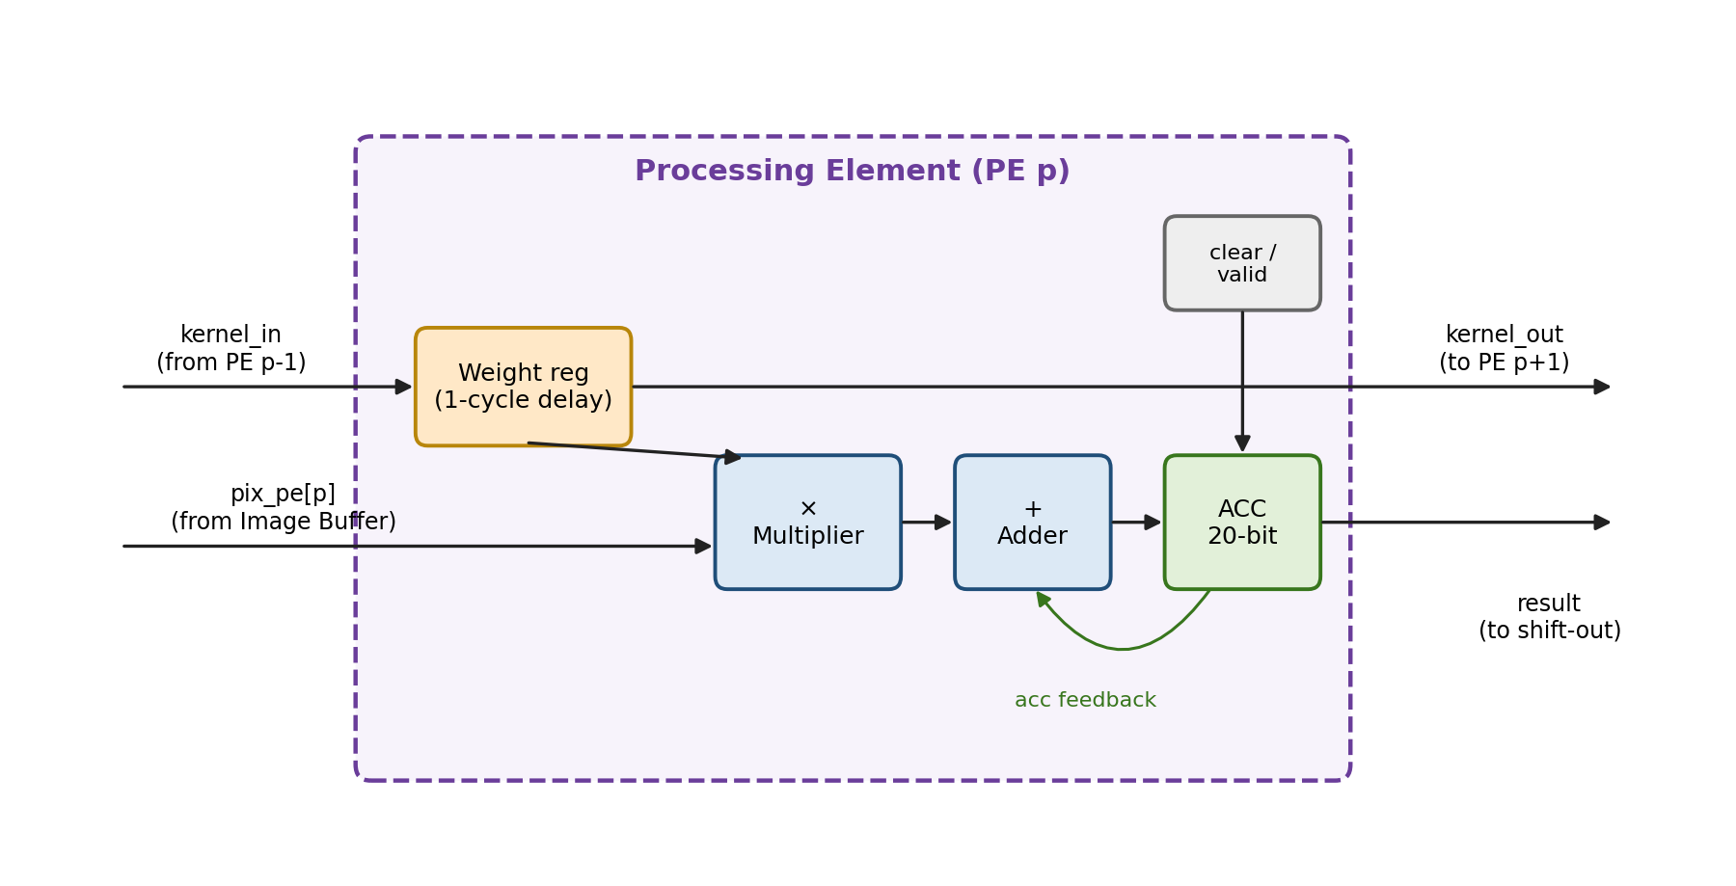
Figure 5.1. Internal structure of one PE.
Each PE contains four main parts:
- Weight register. Captures the incoming weight and forwards it to the next PE one cycle later. This single register is what creates the systolic skew.
- Multiplier. Multiplies the pixel by the weight. With 8-bit operands the product is 16 bits.
- Adder and accumulator. Adds the product to the running sum and stores it in the accumulator register.
- Control. A clear signal resets the accumulator at the start of a window, and a valid (enable) signal prevents accumulation during idle cycles, so that PEs which have not started or have finished do not add garbage values.

5.1 Accumulator Width
The accumulator must be wide enough to hold the largest possible sum without overflow. Multiplying two DATA_W-bit numbers gives a 2·DATA_W-bit product, and adding K² such products can grow the sum by up to ⌈log₂(K²)⌉ bits:
ACC_W = 2 · DATA_W + ⌈log₂(K²)⌉ = 2 · 8 + ⌈log₂ 9⌉ = 16 + 4 = 20 bits

This formula assumes both operands use the same signedness. In this design weights are signed, because filters such as the edge detector in Section 4 contain negative values. If pixels are also treated as signed 8-bit values, 20 bits is sufficient. If pixels are unsigned (0 to 255) while weights are signed, the pixel must be extended to 9 bits for signed multiplication, and the accumulator needs one more bit (21 bits). The choice is fixed in the RTL as a parameter and documented in the testbench.

5.2 Result Shift-Out
In the original block diagram only PE8 drives conv_out, so results from PE0 to PE7 would have no path to the output memory. The design therefore adds a result shift-out path: when a PE finishes, its result is loaded into a result register that forms a chain toward the output. Because PEs finish exactly one cycle apart, results move out in order with no conflicts, and one result per cycle is written to memory. An alternative is a P-to-1 multiplexer selected by a counter; the shift-out chain is preferred because it keeps wiring local, in keeping with the systolic style.

6. Control Unit
A finite state machine (FSM) sequences the accelerator through loading, computing, and completion. Figure 6.1 shows the states and Table 6.1 describes each one.
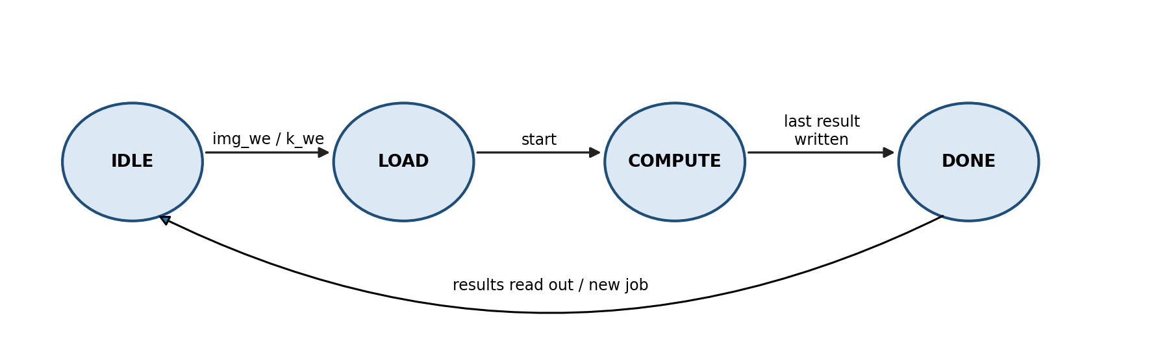
Figure 6.1. Control FSM.
State | Activity | Exit condition
IDLE | Waits after reset; all PE accumulators cleared | A load write enable is asserted
LOAD | Image and kernel values are written through the load interface | start is asserted
COMPUTE | Kernel streaming, address generation, MACs, and result write-back run | The last PE result is written
DONE | done is asserted; results can be read through the read interface | A new job begins
Table 6.1. FSM states.
During COMPUTE, a cycle counter drives the kernel block and the Im2Col block, and generates the clear and valid signals for each PE from its index: PE p is valid from cycle p to cycle p + K² − 1. Because these signals are skewed in the same way as the weights, they can also be passed down the chain alongside the weights instead of being decoded separately for each PE.

7. Parameterization
All sizes in the design are parameters. Derived values are written as localparam expressions and constant functions, which the simulator and Genus evaluate during elaboration, the first step of reading the design. These values become fixed constants before any logic is generated, so the formulas cost no hardware. Only values that change at runtime, such as counters, become circuits.
Parameter | Baseline | Type | Meaning
DATA_W | 8 | Top-level | Pixel and weight width in bits
IMG_H, IMG_W | 5, 5 | Top-level | Image height and width
K | 3 | Top-level | Kernel size (K × K)
S | 1 | Top-level | Stride
NUM_PE | 9 | Top-level | Number of PEs in the chain
OUT_H, OUT_W | 3, 3 | Derived | (IMG − K) / S + 1
NUM_WIN | 9 | Derived | OUT_H × OUT_W
ACC_W | 20 | Derived | 2·DATA_W + $clog2(K·K)
IMG_AW | 5 | Derived | $clog2(IMG_H · IMG_W), image address width
K_AW | 4 | Derived | $clog2(K · K), kernel address width
OUT_AW | 4 | Derived | $clog2(NUM_WIN), output address width
Table 7.1. Design parameters.
Baseline limitation
In the baseline, NUM_PE equals NUM_WIN, so every window has its own PE. This only holds for small images. A 224×224 image with a 3×3 kernel has 222 × 222 ≈ 49,000 windows, and no design builds that many PEs. The scaled design in Section 13.2 decouples the two: a fixed number of PEs processes windows in batches.

The derived parameters are declared as follows:
localparam int OUT_H = (IMG_H - K) / S + 1;
localparam int OUT_W = (IMG_W - K) / S + 1;
localparam int NUM_WIN = OUT_H * OUT_W;
localparam int ACC_W = 2*DATA_W + $clog2(K*K);

The PE chain is built with a generate loop. Each PE takes the weight from the previous stage and passes it to the next, so the chain of weight wires is simply an array indexed by PE number:
genvar p;
generate
for (p = 0; p < NUM_PE; p++) begin : g_pe
pe #(.DATA_W(DATA_W), .ACC_W(ACC_W)) u_pe (
.clk (clk), .rst_n (rst_n),
.pix_in (pix[p]),
.k_in (k_chain[p]), .k_out (k_chain[p+1]),
.clr (clr[p]), .en (en[p]),
.acc_out(acc[p])
);
end
endgenerate

8. Top-Level Interface
The top-level ports are what the outside world sees, first the testbench and later the chip boundary. The internal pixel buses, nine 8-bit buses in the baseline, are not exposed, because that would require far too many pins and would not scale. Instead, the design uses narrow interfaces to load data and read results, with all address widths derived from parameters.
Group | Signal | Dir | Width | Purpose
Control | clk | in | 1 | System clock
Control | rst_n | in | 1 | Active-low reset
Control | start | in | 1 | Begin computation
Control | done | out | 1 | Computation finished
Image load | img_we | in | 1 | Image write enable
Image load | img_addr | in | 5 | Pixel index 0–24
Image load | img_wdata | in | 8 | Pixel value
Kernel load | k_we | in | 1 | Kernel write enable
Kernel load | k_addr | in | 4 | Weight index 0–8
Kernel load | k_wdata | in | 8 | Weight value
Result read | out_addr | in | 4 | Output index 0–8
Result read | out_rdata | out | 20 | Output value
 | Total |  | 55
Table 8.1. Top-level ports for the baseline configuration.

8.1 Operation Sequence
- Assert rst_n low, then release it. The FSM enters IDLE.
- Write the 25 pixels using img_we, img_addr, and img_wdata, one per cycle.
- Write the 9 weights using k_we, k_addr, and k_wdata, one per cycle.
- Pulse start for one cycle.
- Wait until done is asserted.
- Read the 9 results by applying each out_addr and sampling out_rdata.
The testbench drives exactly these pins and follows exactly this sequence, so the simulated behaviour matches how the block would be used in a real system. If design-for-test is added later, three more pins (scan_en, scan_in, scan_out) are needed.

9. Verification Methodology
Verification checks that the RTL computes the correct outputs for all intended inputs. A bug found after synthesis or layout forces the whole flow to be re-run, so RTL verification is completed before synthesis begins.

9.1 Reference Model
A Python script using NumPy computes the expected output for any image and kernel, using the convolution formula from Section 2.1 directly. The script writes the image, kernel, and expected outputs into text files that the SystemVerilog testbench reads with $readmemh. Because the reference model is independent of the hardware structure, it catches errors in addressing, skew, and accumulation alike.

9.2 Self-Checking Testbench
The testbench loads each test case through the top-level pins, runs the computation, reads all outputs, and compares each one with the expected value. It prints a pass or fail message per output and a summary at the end, so no manual waveform inspection is needed to know whether a test passed. Waveforms are used only to debug failures.

9.3 Test Cases
Test | Purpose
Worked example (Section 4) | Known values that can be checked by hand
Random images and kernels | General correctness across many inputs (for example, 1,000 random cases)
All-zero image or kernel | Accumulator clearing and no leftover values
Maximum-magnitude values | Accumulator width and overflow behaviour
Negative weights | Signed arithmetic
Back-to-back jobs | Correct reset of state between computations
Identity kernel (only centre weight = 1) | Address generation: output must equal the window centres
Table 9.1. Planned test cases.

9.4 Gate-Level Simulation
The same testbench is re-run on the synthesized netlist from Genus, and finally on the post-route netlist from Innovus with SDF back-annotation, which adds real gate and wire delays. Passing all three levels (RTL, synthesized netlist, and post-route netlist) shows that synthesis and layout preserved the intended function and that the design meets timing in simulation.

10. Physical Implementation Flow
Physical implementation turns the verified RTL into a layout that could be manufactured. The flow has three main stages: logic synthesis, which converts RTL into a netlist of standard cells; place and route, which positions those cells on the chip and connects them with metal wires; and signoff, which checks that the layout is correct and manufacturable. All steps are scripted in TCL, so a change to the RTL only requires re-running scripts.

10.1 Logic Synthesis with Cadence Genus
Inputs | Outputs
SystemVerilog RTL | Gate-level netlist (Verilog)
Standard-cell timing libraries (.lib) | Timing, area, and power reports
Timing constraints (SDC) | Constraints for Innovus (SDC)
Table 10.1. Genus inputs and outputs.
Genus reads and elaborates the RTL, maps it to the standard cells of the target technology, and optimizes the result to meet the timing constraints with the smallest area and power. The constraints are written in SDC (Synopsys Design Constraints) format. A typical starting point looks like this, with the values tuned during the clock sweep:
create_clock -name clk -period 5.0 [get_ports clk]
set_clock_uncertainty 0.3 [get_clocks clk]
set_input_delay 1.0 -clock clk [remove_from_collection [all_inputs] [get_ports clk]]
set_output_delay 1.0 -clock clk [all_outputs]

After synthesis, the reports are checked for negative slack, unintended latches, unmapped cells, and unexpected area. The longest combinational path in this design is expected to run through the multiplier and adder inside each PE.

Choosing the clock frequency
A clock sweep in Genus, trying progressively shorter clock periods while watching the slack, gives a first estimate of the achievable frequency. However, slack at synthesis is optimistic, because the design has no real wires and no clock tree yet. After place and route, wire delays and clock skew reduce the slack, sometimes substantially. The target clock is therefore set 10 to 20 percent below the synthesis limit, with clock uncertainty included in the SDC. The final operating frequency is the one that passes setup and hold checks after routing.

10.2 Place and Route with Cadence Innovus
Step | What happens
Design import | Load the netlist, SDC, timing libraries, and LEF files that describe cell and routing-layer geometry
Floorplan | Define the core area and its aspect ratio; place I/O pins; a starting utilization of 60–70% leaves room for routing
Power planning | Add power rings around the core and power stripes across it so every cell receives VDD and VSS
Placement | Position all standard cells, trading off wire length, timing, and congestion
Clock tree synthesis (CTS) | Build a buffered tree that delivers the clock to every flip-flop with minimal skew; hold timing becomes meaningful after this step
Routing | Connect all cells with metal wires across the available routing layers
Post-route optimization | Fix remaining setup and hold violations by resizing or inserting cells
Table 10.2. Innovus implementation steps.
The nine image-buffer read multiplexers all draw from the same 200 flip-flops, so they are the area most likely to show routing congestion. Congestion maps from placement are checked for this region.

10.3 Signoff
- Static timing analysis (STA). Confirms setup and hold timing on the routed design with extracted wire parasitics.
- Design rule check (DRC). Confirms the layout obeys the foundry's manufacturing rules, such as minimum wire widths and spacings.
- Layout versus schematic (LVS). Confirms the layout implements exactly the circuit in the netlist.
- Gate-level simulation with SDF. Confirms function with real delays (Section 9.4).
- GDSII stream-out. Exports the final layout, the deliverable of the physical design flow.

10.4 Schedule
Week | Stage | Main tasks | Exit criterion
1 | RTL and verification | Complete RTL including FSM and result shift-out; reference model; self-checking testbench; lint | All tests pass
2 | Synthesis | SDC, clock sweep, timing/area/power reports, gate-level simulation | Clean netlist with timing margin
3 | Place and route | Floorplan, power plan, placement, CTS, routing, post-route optimization | No setup or hold violations
4 | Signoff | STA, DRC, LVS, SDF simulation, GDSII export, buffer time | DRC/LVS-clean GDSII
Table 10.3. One-month implementation schedule.

11. Design Trade-offs and Limitations
The baseline design deliberately favours simplicity and correctness so the full RTL-to-GDS flow can be completed in one month. Its main limitations, and how they are addressed later, are:
- Nine read ports. Each PE has an independent read port, so read logic grows with the number of PEs. Section 13.1 shows that at most two distinct pixels are needed per cycle, so most of this logic is redundant.
- PEs tied to windows. NUM_PE equals the number of windows, which only works for small images. Window batching removes this limit (Section 13.2).
- Single channel and single kernel. Real CNN layers have many input channels and many kernels. Both extensions fit the output-stationary design (Sections 13.2 and 13.3).
- Flip-flop storage. Appropriate for 200 bits, but not for realistic feature maps, which need SRAM macros.
- Load-dominated latency. For a 5×5 image, loading and reading data take longer than computing. This is inherent to small problem sizes and disappears as the image grows.
- No design-for-test. The baseline has no scan chains, so manufactured chips could not be tested for defects. DFT is planned as future work.

12. Relation to Prior Work
The techniques used in this design are well established. This project is an implementation of known ideas rather than a new architecture, and its contribution is a complete, parameterized, verified implementation taken through the full physical design flow with measured results. Table 12.1 relates the design to key prior work.
Work | Main idea | Relation to this project
H.T. Kung, "Why Systolic Architectures?" (1982) [1] | Systolic arrays and a catalogue of 1-D convolution designs, including weight-moving, result-staying variants | The PE chain is an output-stationary, weight-moving design of this family
Kung and Picard (1984) [2] | 1-D systolic arrays for 2-D convolution with I/O bandwidth independent of kernel size | Shows how pixel streaming can avoid many read ports; motivates pixel reuse
BP-Im2col (2022) [3] | Implicit Im2Col with hardware address generation on a TPU-like systolic accelerator | Same implicit Im2Col principle as the Im2Col block
Zhang et al. (FPGA 2015) [4] | Loop tiling and roofline analysis to choose parallelism and memory bandwidth | Basis for window batching and filter parallelism in future work
Ma et al. (FPGA 2017) [5] | Systematic optimization of loop unrolling, tiling, and dataflow for data reuse | Framework for evaluating the scaled design
Google TPU, Eyeriss | Large 2-D systolic arrays (TPU v1: 256×256 MACs) and dataflow-optimized PE arrays (Eyeriss: 168 PEs) | Show that real accelerators use fixed arrays and process large layers in multiple passes
Table 12.1. Related work.

13. Future Work

13.1 Pixel Reuse
Table 4.5 shows that the nine PEs often need the same pixel in the same cycle. This can be explained directly. PE p = 3a + b handles the window starting at row a, column b, and at cycle t it uses weight number k = t − p, which corresponds to kernel offset (i, j) with k = 3i + j. The pixel it needs is at row R = a + i and column C = b + j. Adding up the indices gives:
t = p + k = (3a + b) + (3i + j) = 3(a + i) + (b + j) = 3R + C

So at cycle t, every active PE needs a pixel (R, C) satisfying 3R + C = t. Since the image is 5 columns wide, C ranges from 0 to 4, and for any t there are at most two such pixels: one with C = t mod 3 and, if it fits, one with C = (t mod 3) + 3. This matches the last column of Table 4.5, which never exceeds 2.
Two consequences follow for the baseline configuration:
- Two ports suffice. The nine independent read ports can be replaced by two pixel buses, with each PE selecting one of the two. This replaces nine 25-to-1 multiplexers with two, plus a small 2-to-1 selector per PE.
- Each pixel is fetched exactly once. Summing the distinct-pixel column gives 9 × 1 + 8 × 2 = 25, exactly the number of pixels in the image. The baseline performs 81 pixel reads per computation; with pixel reuse, 25 reads suffice, a reduction of about 3.2×.
This derivation relies on the baseline mapping, in which the number of windows per row equals the kernel width. For other image and kernel sizes the general pattern must be re-derived, and a line buffer is the standard general solution. Both the baseline and the pixel-reuse version will be synthesized so that the savings in area, power, and routing congestion can be measured directly.

13.2 Scaled Architecture
The scaled design adds two independent forms of parallelism, shown in Figure 13.1.
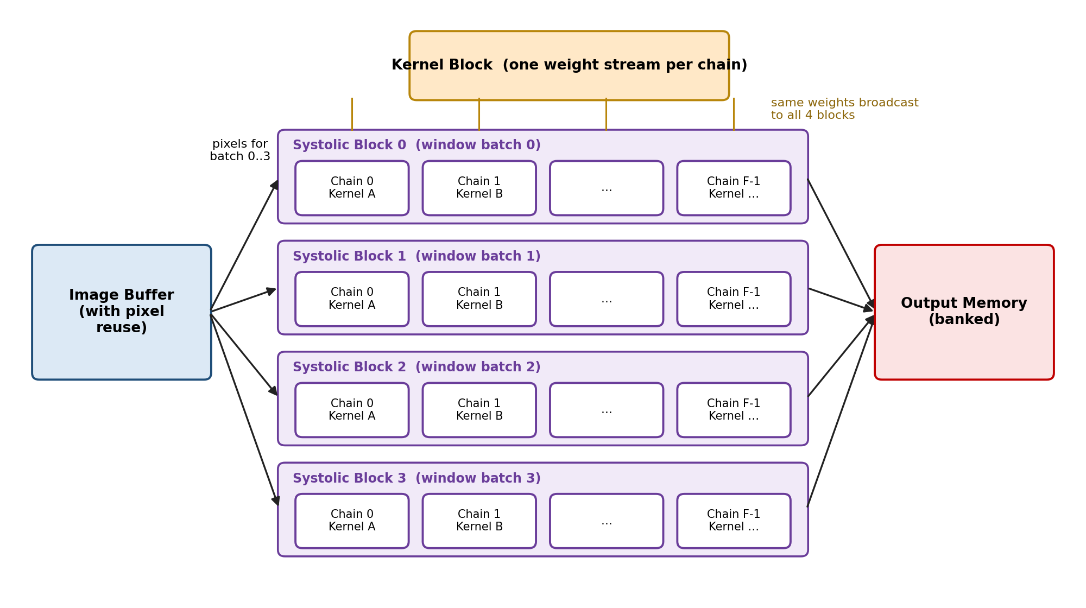
Figure 13.1. Scaled architecture: four systolic blocks, each with F kernel chains.
- Window parallelism. Four identical systolic blocks process four different batches of windows at the same time. Every block uses the same kernel at the same time, so weights are broadcast to all four blocks from one kernel stream.
- Filter parallelism. Inside each block, F PE chains apply F different kernels to the same windows. All chains in a block see the same pixels, so they share one set of pixel ports. Adding chains therefore does not add read ports; only adding blocks does.
The number of chains per block, F, is a fixed synthesis parameter, for example 8 or 16. When a layer has more kernels than chains, the hardware runs multiple passes: with 16 chains and 64 kernels, four passes are needed. Large images are handled the same way, by splitting windows into batches that are processed one after another. When the chain is reused for the next batch, PE0 starts its new window as soon as it finishes the previous one, so the pipeline stays full and MAC utilization approaches 100%.
This structure creates two new requirements. First, four blocks need four batches of pixels at once, which makes pixel reuse essential to keep read logic manageable. Second, four blocks with F chains each can finish up to 4F results per cycle, so the output memory must be split into banks that can be written in parallel. Measuring how throughput and area change as the number of blocks and chains grows is a planned study.

13.3 Multi-Channel Inputs
For an RGB image or a deeper CNN layer, each kernel has size K × K × C_in, and the products from all input channels are summed into one output. In the output-stationary design, a PE simply keeps accumulating while the channels are fed in one after another, before writing its result. The main changes are a channel counter in the control unit and a wider accumulator (adding ⌈log₂ C_in⌉ bits).

13.4 Design-for-Test
Scan insertion in Genus converts flip-flops into scan flip-flops connected in chains, and Cadence Modus generates test patterns (ATPG) and reports stuck-at fault coverage. Scan insertion adds three pins and slightly changes timing, so it is done at the synthesis stage.

13.5 SRAM-Based Storage
Once pixel reuse reduces the required number of read ports, the image buffer can be built from SRAM macros, which are far denser than flip-flops for realistic feature-map sizes. This requires the memory compiler views for each macro: .lib for timing, LEF for layout abstraction, a Verilog model for simulation, GDS for the final layout, and a netlist for LVS.

14. Implementation Results
This section will be completed after implementation.
Metric | Synthesis (Genus) | Post-route (Innovus)
Technology node
Target clock period (ns)
Achieved frequency (MHz)
Worst setup slack (ns)
Worst hold slack (ns) | —
Standard-cell area (µm²)
Number of cells
Core utilization (%) | —
Total power (mW)
DRC violations | —
LVS result | —
Table 14.1. Implementation results (baseline design).
Screenshots of the final layout, the clock tree, and the timing and DRC/LVS reports should be included here, as they are the evidence that the flow was completed.

15. Conclusion
This project designs a parameterized 2-D convolution accelerator that combines implicit Im2Col addressing with an output-stationary systolic PE chain, and takes it through verification and a complete RTL-to-GDS flow with Cadence Genus and Innovus. The cycle-level analysis in this report shows how the weight skew lets nine PEs compute nine windows with one weight stream, and reveals that the nine pixel read ports are largely redundant: in the baseline, no more than two distinct pixels are needed per cycle and every pixel is needed only once. This finding defines the first optimization step, and the parameterized structure provides a clear path toward a scaled design with window and filter parallelism, multi-channel support, and design-for-test.

References
[1] H.T. Kung, "Why Systolic Architectures?", IEEE Computer, vol. 15, no. 1, 1982.
[2] H.T. Kung and R.L. Picard, "One-Dimensional Systolic Arrays for Multidimensional Convolution and Resampling," in VLSI for Pattern Recognition and Image Processing, Springer, 1984.
[3] "BP-Im2col: Implicit Im2col Supporting AI Backpropagation on Systolic Arrays," arXiv:2209.09434, 2022.
[4] C. Zhang, P. Li, G. Sun, Y. Guan, B. Xiao, and J. Cong, "Optimizing FPGA-based Accelerator Design for Deep Convolutional Neural Networks," Proc. ACM/SIGDA FPGA, 2015.
[5] Y. Ma, Y. Cao, S. Vrudhula, and J. Seo, "Optimizing Loop Operation and Dataflow in FPGA Acceleration of Deep Convolutional Neural Networks," Proc. ACM/SIGDA FPGA, 2017.

Appendix A. Glossary
Term | Meaning
ATPG | Automatic test pattern generation, used to test manufactured chips for defects
CTS | Clock tree synthesis: building the network that distributes the clock
DRC | Design rule check: verifies the layout follows manufacturing rules
Elaboration | The step where tools resolve parameters and build the design hierarchy
GDSII | The standard file format for a finished chip layout
Im2Col | Rearranging convolution windows into matrix columns
LEF | Library Exchange Format: physical abstract of cells and macros
LVS | Layout versus schematic: verifies the layout matches the netlist
MAC | Multiply-accumulate: acc = acc + a × b
Output-stationary | Dataflow in which partial sums stay inside each PE
PE | Processing element: one MAC unit with its registers
SDC | Synopsys Design Constraints: clock and I/O timing constraints
SDF | Standard Delay Format: delays back-annotated into simulation
Slack | Margin by which a timing path meets (positive) or misses (negative) its requirement
Stride | The step size by which the kernel moves between windows
Systolic array | Array of PEs that pass data rhythmically to their neighbours
Window | The image region covered by the kernel at one position

