Low-Level Design (LLD)
Version: 1.0
Date: 16-02-2026
Prepared by: Trenser Technology Private Ltd

1. Purpose

The purpose of this LLD is to provide a detailed technical specification for the Humidity Monitor & Alarm. It translates the architecture from the HLD into specific C functions, pin assignments, and logic flow, enabling the developer to implement the code on the STM32 platform.

2. Functional Decomposition
The system is broken down into the following logical units:
- Initialization: Sets up GPIOs and system clocks.
- Input Stub: Sensor_Stub() - Generates simulated humidity data (55%–65%).
- Control Logic: Monitor_Logic() - Compares data against the 60% threshold.
- Output Driver: Hardware_Alarm() - Controls the physical STM32 GPIO pins (PA5/PB5).

3. Detailed Function Descriptions
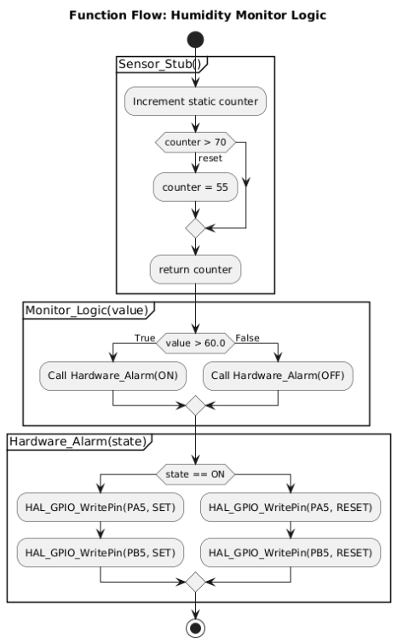

1. Sensor_Stub() (Data Source)
- Purpose: Simulates a physical humidity sensor using software.
- Mechanism: Uses a static variable to increment humidity values (e.g., 55, 56, 57...).
- Looping: Once the value exceeds 70, it resets to 55. This ensures the logic passes through the 60% threshold repeatedly for testing.
2. Monitor_Logic() (Processor)
- Purpose: Acts as the "brain" or Application Layer.
- Mechanism: Receives the current humidity value and performs a mathematical comparison.
- Output: It does not control pins directly; it sends an ON/OFF command to the next module.
3. Hardware_Alarm() (Actuator)
- Purpose: Interfaces directly with the STM32 hardware.
- Mechanism: Translates the logic commands into electrical signals.
- Pins: Uses PA5 (LED) and PB5 (Buzzer).
- States: SET (3.3V) activates the components; RESET (0V) deactivates them.

4. Data Structures
- Constants: #define THRESHOLD 60.0f
- Pins: LED_PIN = PA5, BUZZER_PIN = PB5
- Variables: static float current_humidity

5. Error Handling
- Bounds Check: Ensure input is between 0 and 100.
- Fail-Safe: If the stub fails, turn the alarm OFF by default to save power/prevent noise.

6. Timing and Performance
- Rate: 1000ms loop (1 Hz).
- RAM/Flash: Minimal usage (under 2KB).

7. Test Points
- TP1: Force stub to return 61.0 $\rightarrow$ verify LED turns on.
- TP2: Force stub to return 59.0 $\rightarrow$ verify LED turns off.

8. Traceability
- Req-01 (Measure) -> Sensor_Stub()
- Req-02 (Logic) -> Monitor_Logic()
- Req-03 (Alert -> Hardware_Alarm()

