Humidity Alarm System

High-Level Design (HLD)

Version: 1.1
Date: 17-02-2026
Prepared by: Akhil A A

1. Purpose
The purpose of this document is to describe the High-Level Design (HLD) of the Humidity Alarm System It includes the overview of the system, key components, high-level architecture diagram, software architecture with module wise data control flow and their interactions. It also describes APIs, inter-process communication methods (Message Queues and Semaphores), and data exchange formats with error handling and fault management mechanisms required to monitor relative humidity (%RH) and trigger real-time alerts when predefined thresholds are exceeded.

2. System Overview

2.1 Introduction
The Humidity Sensor Alarm system provides continuous monitoring of humidity readings. It operates regularly (every HUMIDITY_READ_FREQUENCY millisecond) reading the humidity level and evaluating it against predefined threshold limits (HUMIDITY_THRESHOLD_MIN to HUMIDITY_THRESHOLD_MAX). If a reading falls outside this acceptable range, the system triggers an alert by printing the message “Humidity Alarm Triggered.” If the humidity remains within the limits, no message is printed. This continuous cycle of reading and evaluation runs indefinitely, ensuring constant vigilance for alarm conditions.
Parameters | Description | Value
HUMIDITY_THRESHOLD_MIN | Minimum threshold humidity limit | 20% RH
HUMIDITY_THRESHOLD_MAX | Maximum threshold humidity limit | 60% RH
HUMIDITY_READ_FREQUENCY | Sensor polling frequency | 100 ms
MAX_BREACH_LIMIT | Threshold breach limit | 3
ALARM_DURATION | Duration of Alarm notification | 50 ms
READ_RETRY_COUNT | Retry sensor read once failed | 3

2.2 Key Components

2.2.1 Humidity Read Module
This module is responsible for continuous humidity monitoring. It interfaces with the sensor to read humidity levels every HUMIDITY_READ_FREQUENCY millisecond. After performing initial validation (ensuring the value is within a logical 0-100% range), the processed data is sent to the Humidity Threshold Check module via a message queue.

2.2.2 Humidity Threshold Check Module
This module performs moisture level validation by comparing the incoming data from the Humidity Read module against the established safety range (HUMIDITY_THRESHOLD_MIN to HUMIDITY_THRESHOLD_MAX). If the humidity readings remain outside these bounds for a consecutive period defined by MAX_BREACH_LIMIT, the module signals the Alarm Module using a binary semaphore.

2.2.3 Alarm Module
When this module is activated by a semaphore signal, it executes the alert protocol. It prints the notification: "Humidity Alarm Triggered" to the console or system log. The alert state remains active for ALARM_DURATION milliseconds before the module returns to its idle state, waiting for the next trigger.

2.3 High Level Architecture Diagrams

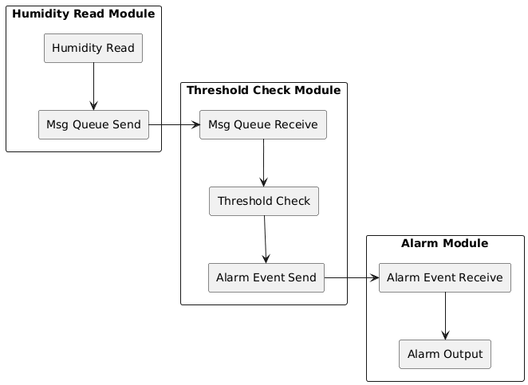

3. Software Architecture

The Humidity Alarm System comprises three main threads responsible for core functionalities:

1. Humidity Reading Thread:
- This thread's sole purpose is to read the humidity value at regular intervals defined by HUMIDITY_READ_FREQUENCY.
- The acquired humidity data is then placed into a message queue for consumption by the threshold checking thread.

2. Humidity Threshold Checking Thread:
- Operating in a blocking mode, this thread continuously waits for and receives humidity data from the message queue.
- Upon receipt, the humidity is immediately compared against the acceptable operating range defined by HUMIDITY_THRESHOLD_MIN and HUMIDITY_THRESHOLD_MAX.
- If the humidity falls outside these limits, the alarm thread is activated using a binary semaphore.

3. Alarm Thread:
- It waits for an alarm binary semaphore flag to get incremented.
- Once triggered by the threshold checking thread (when a humidity violation is detected), it prints the corresponding notification: "Humidity Alarm Triggered".
- The alarm remains active for ALARM_DURATION milliseconds before the thread returns to its waiting state for the next event.

4. Module Descriptions

4.1 Humidity Read Module
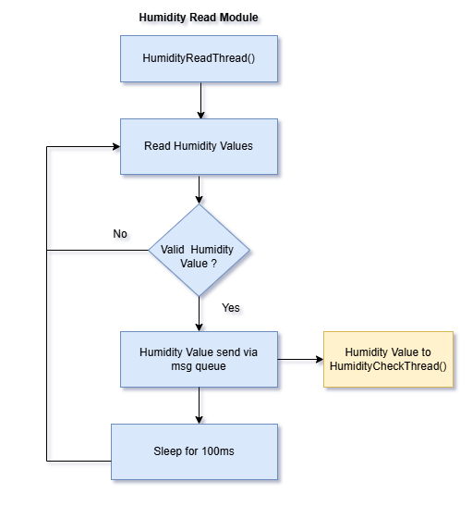

4.2 Humidity Threshold Check Module
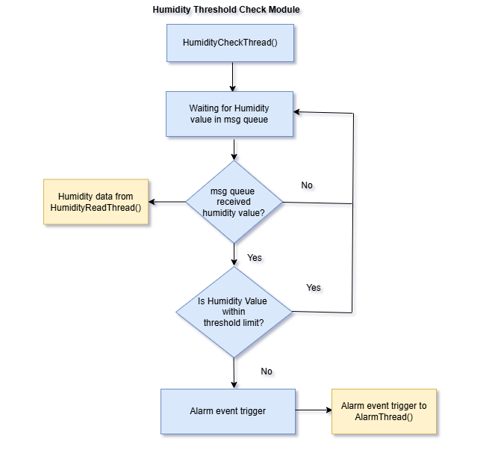

4.3 Alarm Module
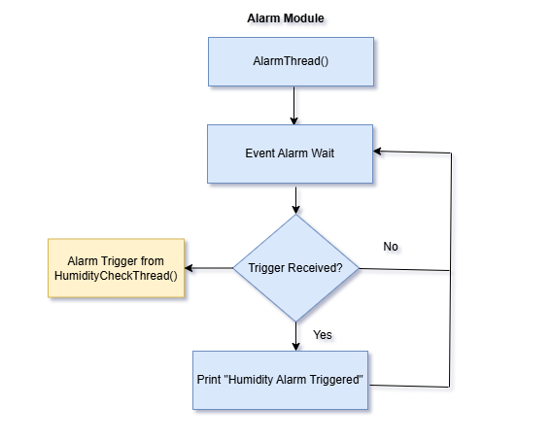

5. Interface Design

5.1 Application Programming Interface(API)

API | Description
void HumidityReadThread(void *arg) | Read and Validate Humidity: Obtain the humidity reading from the sensor and perform necessary validation (0-100% RH range).  Queue Humidity Value: Enqueue the validated humidity value into the sensor message queue.  Send to Threshold Checking Thread: The humidity value is sent to the HumidityCheckThread() via the sensor message queue.
void HumidityCheckThread (void *arg) | Wait for Humidity Value: This thread operates in blocking mode, waiting for data from HumidityReadThread() via the sensor message queue.  Check Threshold Limits: The received humidity value is compared against predefined limits HUMIDITY_THRESHOLD_MIN and HUMIDITY_THRESHOLD_MAX.  Activate Alarm: If the humidity value falls outside the acceptable range, AlarmThread() is activated using a binary semaphore signal.
void AlarmThread(void *arg) | Wait for Alarm Flag: This thread is responsible for waiting for the alarm activation semaphore signled by HumidityCheckThread().  Alarm Trigger Action: Upon receiving the sem_post() signal, it prints the message "Humidity Alarm Triggered" and remains active for the duration defined by ALARM_DURATION.

6. Data Flow

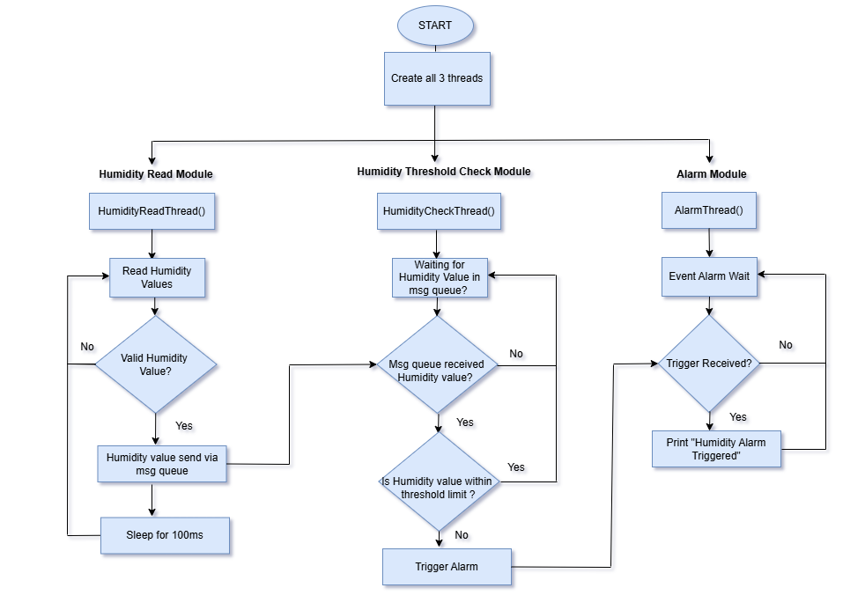

7. Error Handling & Fault Management

7.1 Message queue failures
Detects queue transmission failures using return codes and timeouts.

7.2 Humidity value validation
Detect invalid humidity read using proper logic and error codes

7.3 APIs failure check
Use error codes to detect failure for all APIs

8. Traceability

Major Design Component | Software Requirement / Feature ID | Requirement Description
Humidity Read Module | REQ_HUMIDITY_01 | The system shall read relative humidity (%RH) every 100 ms.
Humidity Threshold Check Module | REQ_HUMIDITY_02 | The system shall compare current readings against defined limits (20% to 60%).
Alarm Module | REQ_HUMIDITY_03 | The system shall trigger a notification "Humidity Alarm Triggered" upon limit breach.
Message Queue (IPC) | REQ_HUMIDITY_04 | Data shall be transferred from the read thread to the check thread via a message queue.
Binary Semaphore (IPC) | REQ_HUMIDITY_05 | The threshold check module shall signal the alarm module using a binary semaphore.
Error Handler | REQ_HUMIDITY_06 | The system shall detect sensor read failures and IPC communication errors.

