Mini Project Report

On

**Web application for easing government procurements**

Thesis submitted in partial fulfillment of the requirements for the award of degree of

**Bachelor of Engineering**

In

**Computer Science and Engineering**

By

PUNNA AKHIL 1608-20-733-086

MOHAMMED ABUBAKER SIDDIQ 1608-20-733-102

GOKARLA NAVEEN 1608-20-733-085

Under the guidance of

**Mr. Bikshapathy Peruka**

Assistant Professor



**Department of Computer Science and Engineering**

**Matrusri Engineering College**

**Accredited by NBA & NAAC**

(Affiliated to Osmania University, Approved by AICTE)

Saidabad, Hyderabad-500059

(2022-2023)

**Department of Computer Science and Engineering**

**Matrusri Engineering College**

**Accredited by NBA & NAAC**

(Affiliated to Osmania University, Approved by AICTE)

Saidabad, Hyderabad-500059

(2022-2023)



**CERTIFICATE**

This is to Certify that a mini project report entitled **“Web application for easing government procurements**” is being submitted by Punna Akhil **(** 1608-20-733-086**),** Mohammed Abubaker Siddiq **(** 1608-20-733-102**)** and Gokarla Naveen (1608-20-733-085)in partial fulfillment of the requirement of the award of the degree of Bachelor of Engineering in “Computer Science and Engineering”,Osmania University., Hyderabad during the year 2022-2023 is a record of the bonafide work carried out by them under my guidance. The results presented in this thesis have been verified and are found to be satisfactory.

**Project Guide H.O.D.**

**Mr. Bikshapathy Peruka Dr. P. Vijayapal Reddy**

**Assistant Professor, Professor & Head,**

**Dept of C.S.E. Dept. of CSE**

**External Examiner(s)**

**Department of Computer Science and Engineering**

**Matrusri Engineering College**

**Accredited by NBA & NAAC**

(Affiliated to Osmania University, Approved by AICTE) Saidabad, Hyderabad-500059 (2022-2023)



**DECLARATION**

We, Punna Akhil (1608-20-733-086), Mohammed Abubaker Siddiq (1608-20-733-102), Gokarla Naveen (1608-20-733-085), hereby certify that the project report entitled “**Web application for easing government procurements**” is submitted in the partial fulfillment of the requirement for the award of the degree of Bachelor of Engineering in Computer Science and Engineering.

This is a record of the bonafide work carried out by us under the guidance of Mr. Bikshapathy Peruka, Assistant Professor, Matrusri Engineering College, Saidabad, Hyderabad. The Results embodied in this report have not been reproduced/copied from any source. The results embodied in this report have not been submitted to any other University or Institute for the award of any other degree or diploma.

**Punna Akhil (1608-20-733-086)**

**Mohammmed Abubaker Siddiq (1608-20-733-102)**

**Gokarla Naveen (1608-20-733-085)**

**Dept. of CSE, MECS**

**ACKNOWLEDGEMENT**

This project consumed huge amount of work, research and dedication. Still implementation would not have been possible if we did not have support of my Project Guide, Project Coordinator, Head of the Department and Principal. Therefore, we like to extend our sincere gratitude to all of them.

We are grateful to our project guide **Mr. Bikshapathy Peruka**, Assistant Professor, for provision of expertise, technical support and guidance in the implementation.

We wish to express our gratitude to project coordinators for their indefatigable inspiration, constructive criticisms and encouragement throughout this dissertation work.

We would like to express our sincere thanks to the Professor and Head of the Department, **Dr. P. Vijaya Pal Reddy**, for permitting us to do this project.

We would like to express our gratitude to **Dr. D. Hanumantha Rao**, principal of Matrusri Engineering College who permitted to carry out this project as per the academics.

We would like to thank CSE Department for providing us this opportunity to share and contribute our part of work to accomplish the project in time and all the teaching and support staff for their steadfast support and encouragement.

Nevertheless, we express our gratitude towards our families and colleagues for their kind cooperation and encouragement which helped us in completion of this project.

**Punna Akhil (1608-20-733-086)**

**Mohammmed Abubaker Siddiq (1608-20-733-102)**

**Gokarla Naveen (1608-20-733-085)**

**Dept. of CSE, MECS**

**ABSTRACT**

Procurement is the vital process of acquiring goods and services from external sources to fulfill an organization or government's needs. It involves various stages such as identifying requirements, selecting suppliers, negotiating contracts, and awarding agreements to optimize costs, enhance quality, and boost efficiency. This project focuses on developing a dynamic web application for procurements, which enables organizations and governments to streamline the procurement process effectively.

The web application facilitates real-time updates and modifications to procurement details. Government entities or organizations can easily add new procurements, set deadlines, and provide estimated costs for required goods or services. Clients can access all active procurements, apply for them, and submit quotations, timeframes, and relevant experience. The government then validates and evaluates the applications, selecting the most suitable contractor through the application itself.

By implementing this web application, contractors can efficiently participate in various tenders at the country or state level. The application significantly reduces tender processing time by simplifying the validation process for participants. Furthermore, the government/organization can leverage the application to assess and compare contractors based on their quotation prices and previous contracts completed for the respective entity. Overall, this project aims to optimize the procurement process, making it more transparent, time-efficient, and beneficial for all stakeholders involved.

Acknowledgement…………………………………………………………………………….iv

Abstract……………………………………………………………………..............................v

List of Figures……………………………………………………………………………… viii

Table of Contents

1 INTRODUCTION ix

1.1 EXISTING SYSTEMS: x

1.1.1 Enterprise Resource Planning (ERP) Systems: x

1.1.2 eProcurement Systems: x

1.1.3 Procure-to-Pay (P2P) Systems: x

1.1.4 Supplier Relationship Management (SRM) Systems: x

1.1.5 Contract Management Systems: x

1.1.6 Disadvantages of Existing Systems xi

1.2 OBJECTIVES: xi

1.2.1 User-Friendly Web Application: xi

1.2.2 Automated L1 Selection: xii

1.2.3 Reduced Evaluation Time: xii

1.2.4 Improved Transparency and Rate Parity: xii

1.2.5 Enhanced Tender Reach: xii

1.3 PROPOSED METHODS xiii

1.3.1 Releasing Tender Notice: xiii

1.3.2 Applying for Tenders: xiii

1.3.3 Deletion of Tenders: xiii

1.3.4 Selection of L1 (Lowest Bidder): xiii

1.3.5 Registration of Contractors: xiii

1.3.6 Adding New Admin: xiv

2 LITERATURE SURVEY xiv

2.1 E-procurement: business and technical issues xiv

2.2 E-PROCUREMENT AT WORK: A CASE STUDY xv

3 METHODOLOGY xvi

4 DESIGN OF THE PROJECT xviii

4.1 CLASS DIAGRAM xix

4.2 USE CASE DIAGRAM xix

4.3 ACTIVITY DIAGRAM xx

4.4 SEQUENCE DIAGRAM xx

4.5 COMPONENT DIAGRAM xxi

4.6 DEPLOYMENT DIAGRAM xxi

5 IMPLEMENTATION xxii

6 TESTING AND RESULTS xxv

6.1 User Login xxv

6.2 User Register xxvi

6.3 User Interface xxvi

6.4 Admin Interface xxvii

7 CONCLUSION xxviii

8 LIMITATIONS OF THE PROJECT xxx

9 SCOPE OF THE PROJECT xxxi

10 FUTURE ENHANCEMENTS xxxi

11 REFERENCES xxxiv

**LIST OF FIGURES**

|  |  |  |  |
| --- | --- | --- | --- |
| **S.No** | **Fig No.** | **Name of the Figure** | **Page No** |
| 1 | 1 | Class Diagram | 20 |
| 2 | 2 | Use Case Diagram | 20 |
| 3 | 3 | Activity Diagram | 21 |
| 4 | 4 | Sequence Diagram | 21 |
| 5 | 5 | Component Diagram | 22 |
| 6 | 6 | Deployment Diagram | 22 |
| 7 | 7 | Login page | 23 |
| 8 | 8 | Admin page | 24 |
| 9 | 9 | Login configuration | 25 |
| 10 | 10 | Apply configuration | 26 |
| 11 | 11 | Login Interface | 27 |
| 12 | 12 | Register Interface | 27 |
| 13 | 13 | User Interface | 28 |
| 14 | 14 | Apply for contractor | 29 |
| 15 | 15 | Admin Interface | 29 |

# INTRODUCTION

Procurement plays a pivotal role in organizations across diverse industries, facilitating the acquisition of essential goods and services from external sources through purchasing or contracting. This multifaceted process involves various key steps that collectively ensure the smooth flow of resources necessary for an organization's optimal functioning and success.

The procurement process commences with a meticulous identification of the organization's needs for goods or services. Subsequently, a thorough evaluation of potential suppliers takes place, during which factors such as product quality, pricing, and supplier reputation are carefully assessed. Through effective negotiations, organizations endeavour to secure favourable terms and conditions before finalizing a contract with the chosen supplier.

Efficient procurement practices can yield a multitude of benefits for organizations. One significant advantage lies in the potential to reduce operational costs significantly. By strategically managing the procurement process, organizations can obtain goods and services at optimal prices, maximizing their budget allocation for other critical endeavours. Moreover, the pursuit of higher-quality products and services during the procurement process enhances the overall standard of the organization's output.

To cater to diverse procurement needs, various procurement methods exist, each tailored to specific circumstances. The competitive bidding process enables multiple suppliers to submit proposals, fostering healthy competition and offering organizations the freedom to choose the most suitable option. Conversely, direct negotiation allows for more personalized interactions with suppliers, suitable for unique or high-value purchases. The request for proposal (RFP) process facilitates comprehensive supplier submissions and is ideal for complex projects with specific requirements.

In this digital age, technological advancements have spurred the emergence of e-procurement, revolutionizing traditional procurement practices. E-procurement, or electronic procurement, leverages digital platforms to automate, streamline, and enhance the efficiency of the procurement process. This transformational approach has gained immense popularity, driving organizations to embrace the digital landscape for their procurement needs.

The adoption of e-procurement brings forth a myriad of advantages over conventional methods. Foremost, it dramatically reduces the time and effort required to carry out procurement tasks. Digital platforms expedite data processing, communication, and document management, empowering organizations to make quicker decisions and execute procurement activities with unparalleled swiftness.

Another significant advantage of e-procurement lies in the increased transparency it fosters. Leveraging digital platforms enables a larger pool of suppliers to participate in the bidding process, leading to a more competitive environment. This heightened competition not only drives down prices but also ensures fairer selection procedures, granting equal opportunities to all eligible suppliers.

Government procurement, known for its complex and time-consuming tendering processes, has witnessed a transformative shift with the adoption of e-procurement. The traditional tender allocation that could often take several months is now expedited through digital platforms, allowing government entities to focus on more pressing matters while expediting essential projects.

E-procurement's streamlined processes lead to more timely and efficient execution of government projects, resulting in cost savings, improved project management, and heightened citizen satisfaction. As governments and organizations continue to embrace the digital revolution, e-procurement remains a critical element in ensuring transparent, efficient, and cost-effective procurement practices.

## EXISTING SYSTEMS:

### Enterprise Resource Planning (ERP) Systems:

Enterprise Resource Planning systems are comprehensive business management platforms that integrate various processes across an organization. These systems often include dedicated procurement modules that handle purchasing, inventory management, and vendor management. ERP systems streamline procurement by centralizing data, automating workflows, and providing real-time visibility into procurement activities. With ERP, organizations can optimize procurement decisions, track supplier performance, and ensure compliance with purchasing policies.

### eProcurement Systems:

eProcurement systems are specialized software designed to handle electronic procurement processes. They facilitate the entire procurement lifecycle, from creating requisitions to receiving and paying for goods or services. eProcurement systems usually include features like online catalogue, electronic purchase orders, approval workflows, and automated invoicing. By digitizing procurement operations, eProcurement systems reduce paperwork, increase process efficiency, and enhance spend control.

### Procure-to-Pay (P2P) Systems:

Procure-to-Pay systems offer end-to-end automation of the procurement process. Starting from requisition creation, these systems guide users through approval workflows, supplier selection, purchase order generation, receipt of goods or services, and invoice processing. P2P systems enable organizations to enforce purchasing policies, consolidate spending data, and improve cash flow management. They also help prevent maverick spending and provide better insights for strategic procurement decisions.

### Supplier Relationship Management (SRM) Systems:

Supplier Relationship Management systems focus on managing interactions with suppliers effectively. These systems enable organizations to evaluate supplier performance, assess risks, and collaborate with suppliers to improve overall performance. SRM systems facilitate communication between buyers and suppliers, fostering mutually beneficial relationships and driving innovation within the supply chain.

### Contract Management Systems:

Contract Management systems provide a centralized repository for managing contracts throughout their lifecycle. They help streamline contract creation, negotiation, approval, and execution. These systems also track key contract milestones, monitor compliance, and facilitate contract renewals or terminations. Contract management systems improve contract visibility, reduce risks associated with contract non-compliance, and optimize contract-related processes.

### Disadvantages of Existing Systems

1. Cost: Implementing and maintaining procurement management systems can be expensive, especially for larger organizations or complex implementations. Costs may include software licensing fees, hardware infrastructure, training, customization, and ongoing support.
2. Complexity: Some systems can be complex and require significant training for users to operate effectively. The learning curve can lead to resistance and lower user adoption, impacting the overall efficiency of the procurement process.
3. Integration Challenges: Integrating procurement systems with other existing software and enterprise systems can be challenging. Incompatibility issues may arise, leading to data inconsistencies and additional integration costs.
4. Customization Limitations: Off-the-shelf systems might not meet all the unique needs of an organization. Customization can be costly and time-consuming, and over-customization may result in compatibility and support challenges.
5. Dependence on Internet Connectivity: Cloud-based procurement solutions require a stable internet connection. If the internet goes down or experiences disruptions, users may face difficulties accessing critical procurement data and functionalities.
6. Data Security and Privacy Concerns: Storing sensitive procurement data on external servers or cloud platforms raises concerns about data security and privacy. Organizations must ensure that their data is protected from unauthorized access and breaches.
7. Vendor Reliability: The effectiveness of a procurement management system relies heavily on the reliability and support provided by the vendor. If the vendor faces financial or operational issues, it could impact system performance and customer support.
8. Inflexibility: Some systems may be rigid in terms of accommodating changes in procurement processes or regulatory requirements. This lack of flexibility can hinder an organization's ability to adapt to evolving business needs.
9. User Resistance: Employees may resist using the new system, especially if it drastically changes established procurement processes or requires significant changes in their daily routines.
10. Maintenance and Upgrades: Regular system maintenance and updates are necessary to keep the software secure and running efficiently. Failing to perform timely updates can lead to security vulnerabilities and performance issues.
11. Supplier Onboarding Challenges: Integrating suppliers into the system can be time-consuming and challenging, especially if suppliers have varying levels of technological capabilities.

## OBJECTIVES:

### User-Friendly Web Application:

The primary objective of this project is to design and develop a highly efficient and user-friendly web application that caters to the complex needs of procurement management. The web application will serve as a comprehensive platform, accommodating both government/organization users and contractors seamlessly. Through an extensive user research and design process, we will ensure that the application's interface is not only aesthetically pleasing but also intuitive, ensuring a smooth and enjoyable user experience for all stakeholders involved.

### Automated L1 Selection:

The project's core focus lies in simplifying and streamlining the process of selecting the Lowest Bidder (L1) among the contractors. To achieve this, we will leverage cutting-edge technologies such as artificial intelligence and machine learning algorithms. The web application will automatically evaluate contractors' quotation prices, comparing them against predefined criteria and project requirements. This intelligent system will not only expedite the L1 selection process but also enhance its accuracy, eliminating manual errors and biases that can be inherent in traditional evaluation methods.

### Reduced Evaluation Time:

By implementing the feature-rich web application, we aim to dramatically reduce the time and effort required for evaluating contractors. Traditionally, this evaluation process can be time-consuming and resource-intensive, often taking over two months for each contractor. Our solution will optimize the entire evaluation workflow, automating repetitive tasks, and providing real-time data visualization and analytics. This will empower procurement teams to make informed decisions promptly, saving valuable time and resources while ensuring a more efficient procurement process.

### Improved Transparency and Rate Parity:

Transparency is a fundamental aspect of a fair and competitive procurement process. The web application will revolutionize transparency levels by providing an open and inclusive platform for contractors to submit their bids. With increased transparency, contractors can better understand the competition and make more informed pricing decisions. Furthermore, the application will enhance rate parity among contractors by presenting real-time aggregated pricing data, allowing them to align their bids competitively and thus promoting a level playing field for all participants.

### Enhanced Tender Reach:

The web application's widespread accessibility will significantly expand the reach of tenders, benefiting both government/organizations and contractors alike. Contractors from various geographical locations can effortlessly access available opportunities, and with our platform's user-friendly features, they can quickly identify relevant tenders aligned with their expertise. The enhanced tender reach will encourage a diverse pool of contractors to participate, stimulating healthy competition and driving innovation, ultimately resulting in improved project outcomes.

In summary, this project represents a transformative effort to modernize and optimize the procurement management process. By developing a user-friendly web application, implementing automated L1 selection, reducing evaluation time, improving transparency, and enhancing tender reach, we aim to revolutionize procurement practices. Our goal is to empower government/organization users and contractors with an innovative platform that fosters efficiency, fairness, and collaboration, ultimately driving positive impacts on procurement processes and project outcomes

## PROPOSED METHODS

### Releasing Tender Notice:

The web application will incorporate a robust and user-friendly Admin interface that allows the government or organization to seamlessly post new tenders. This process involves capturing comprehensive information about the tender, ensuring all crucial details are included. The Admin will be prompted to provide the tender's name, detailed description, specific department or category the tender belongs to, estimated cost, and the geographical location where the project will take place. Once the necessary information is filled in, the Admin can review and verify the details before posting the tender. Upon posting, the tender's information will be securely stored in the active tenders database, readily accessible for all relevant stakeholders.

### Applying for Tenders:

The web application's user interface dedicated to contractors will offer an intuitive and user-friendly platform for applying to tenders. Contractors seeking to participate in the tendering process will first need to complete a registration process to create a unique user account. During registration, contractors will be prompted to provide personal information, contact details, company information, and other relevant details that validate their eligibility to participate in tenders. Additionally, contractors will be required to submit their quotation price, proposed time period for project completion, and details of their relevant experience in similar projects. The application will ensure that all required fields are completed to ensure a comprehensive evaluation during the selection process for the Lowest Bidder (L1).

### Deletion of Tenders:

In order to provide flexible and efficient tender management, the web application will grant the Admin the authority to manage tenders effectively. The Admin will be able to delete a tender at any point, which could be necessary due to various factors such as changes in project requirements or unforeseen circumstances. Additionally, the Admin will have the ability to update the estimated cost of the tender, ensuring that potential contractors are aware of any changes in the project's scope and budget. Furthermore, the Admin will have the capability to modify requirements or instructions for the tender if necessary, enabling seamless communication with prospective contractors and adapting to evolving project needs.

### Selection of L1 (Lowest Bidder):

As the tender process nears its conclusion, the web application will provide a streamlined and efficient method for determining the L1 and the Second Lowest Bidder (L2) from the pool of applied contractors. The application will utilize sophisticated algorithms to evaluate the submitted quotations and other relevant data provided by contractors during the application process. These evaluations will take into account various factors such as pricing, proposed timeframes, and contractors' relevant experience. The comprehensive analysis will enable the web application to determine the most suitable and cost-effective contractor, ensuring a fair and transparent selection process for the project.

### Registration of Contractors:

To ensure the integrity and legitimacy of the tendering process, contractors will be required to complete a comprehensive registration process on the web application. During registration, contractors will provide personal information, contact details, company credentials, and any relevant licenses or certifications. Additionally, contractors will need to furnish details of their experience in handling similar tenders, showcasing their expertise in relevant projects. The submission of previous tender details undertaken by contractors will serve as a valuable reference for the evaluation process during the selection of L1. Furthermore, contractors will be required to submit their PAN (Permanent Account Number) details and asset information, contributing to a robust evaluation process to identify the most suitable contractors.

### Adding New Admin:

In the event of a new employee joining the organization, the web application will facilitate the seamless addition of a new Admin to the database. This capability will be exclusively available to existing Admins or government officials, ensuring secure and controlled access to the administrative functions of the platform. The process of adding a new Admin will be straightforward, involving essential information such as the new Admin's name, contact details, and designated role within the organization. This feature will enhance the scalability and adaptability of the web application, allowing the organization to efficiently manage its procurement management team and ensure smooth operation in the case of personnel changes.

# LITERATURE SURVEY

The literature survey aims to explore the current research, technologies, and approaches in the domain of citizen safety applications against cybercrime. The primary objective is to gain a comprehensive understanding of the state-of-the-art in this field, with a particular focus on identifying and analyzing various features and functionalities included in such applications.

## E-procurement: business and technical issues

*Rajkumar, T.M., 2003. E-procurement: business and technical issues. In IS Management Handbook (pp. 657-670). Auerbach Publications.*

**ABSTRACT**

This study delves into the utilization of the Internet, specifically in electronic commerce, to enhance purchasing efficiencies and gain a competitive edge. Many companies are actively devising strategies to integrate Internet-based electronic commerce into their supply-chain management practices, seeking to establish and sustain a competitive advantage. The advantages of using the Internet for procurement processes include cost reduction, improved operational efficiencies, heightened accuracy, and faster processing and delivery of products and services. The Internet's transformative impact on the corporate world has been revolutionary, reshaping traditional business practices, and playing various roles as a market maker, disruptor, and catalyst for industry changes. The study focuses on business-to-business (B2B) E-commerce, highlighting the use of web technologies in inter-firm relationships and transactions.

**CONCLUSION**

In conclusion, the study on "E-procurement: Business and Technical Issues" highlights the substantial impact of Internet utilization, particularly in electronic commerce, on enhancing purchasing efficiencies and gaining a competitive edge. The research underscores the proactive approach of companies in devising strategies to integrate Internet-based electronic commerce into their supply-chain management practices to establish and sustain a competitive advantage.

The study emphasizes the advantages of leveraging the Internet in procurement processes, including cost reduction, improved operational efficiencies, heightened accuracy, and faster processing and delivery of products and services. This transformative impact has revolutionized traditional business practices, making the Internet a pivotal player in reshaping the corporate world. The Internet serves various roles, acting as a market maker, disruptor, and catalyst for industry changes.

Moreover, the study emphasizes the significance of business-to-business (B2B) E-commerce, underscoring the critical role of web technologies in facilitating inter-firm relationships and transactions. The integration of web technologies has opened new avenues for efficient and seamless business interactions, leading to enhanced collaboration among organizations.

In light of the study's findings, it becomes evident that embracing the potential of the Internet and web technologies in procurement processes can lead to significant benefits for organizations. By leveraging the transformative capabilities of the Internet, companies can streamline procurement operations, optimize supply-chain management, and gain a competitive edge in the dynamic marketplace.

Overall, the study serves as a valuable resource for businesses and researchers alike, providing insights into the strategic importance of adopting E-procurement practices and highlighting the potential for continued growth and innovation in the realm of electronic commerce and supply-chain management. By harnessing the power of the Internet, organizations can proactively position themselves for success in an increasingly digital and competitive business landscape.

## E-PROCUREMENT AT WORK: A CASE STUDY

*Ageshin, E.A., 2001. E-procurement at work: A case study. Production and Inventory Management Journal, 42(1), pp.48-53.*

The Internet has brought about a revolution in corporate purchasing practices, leading to significant productivity improvements across various industries. Companies offering e-procurement solutions position themselves as facilitators of substantial cost savings, especially for manufacturers who consume a significant portion of the economy's tangible inputs. The overall productivity of manufacturers now heavily relies on their efficiency in procuring these essential inputs.

E-procurement sites, also known as B2B marketplaces, electronic supply chains, trading hubs, or trading communities, are web-based procurement networks where companies aim to source suppliers at the lowest possible costs. In essence, e-procurement serves the same purpose as traditional tendering, but it leverages the power of the Internet to revolutionize the process beyond mere computerization and automation. By adopting e-procurement solutions, companies can efficiently source input products and services while ensuring they meet all technical and tender specifications.

# METHODOLOGY

1. **Requirements Gathering:**

In this phase, the project team will conduct thorough discussions and consultations with stakeholders to understand and document the specific requirements of the web application. Detailed user stories and use cases will be gathered to identify the functionalities needed for both the government/organization and the contractors' interfaces. The team will outline the essential features, such as tender posting, tender application submission, tender manipulation, and the L1 selection process. A comprehensive requirements document will be created to serve as a blueprint for the development process.

**2. Database Design**:

Based on the gathered requirements, the team will design the database schema to store the relevant information related to tenders, users, contractors, and other necessary data. The database design will include creating tables to store tender details, user information, contractor details, and other attributes essential for the application's smooth functioning. The database design will ensure data integrity and efficient data retrieval for improved performance.

**3. Front-end Development**:

The front-end development phase will focus on implementing the user interfaces for both the government/organization and contractors/users. Using HTML, CSS, and JavaScript, the team will design visually appealing and user-friendly interfaces. The government/organization interface will provide access to functionalities such as tender manipulation, posting new tenders, and the L1 selection process. The contractors' interface will display active tenders and enable contractors to submit applications.

**4. Back-end Development**:

The back-end development will involve creating the server-side functionalities using PHP. These scripts will handle form submissions, process user inputs, and execute SQL queries for data retrieval and storage. The back-end will act as the bridge between the front-end interfaces and the database, ensuring seamless communication and data processing. Security measures will be implemented to prevent unauthorized access and protect sensitive data.

**5. User Registration and Authentication**:

To enable contractors to participate in the tendering process, a user registration system will be implemented using PHP. Contractors will register with the application, providing necessary information and credentials. Authentication mechanisms will be put in place to ensure secure access to the contractor interface, safeguarding the confidentiality of user data.

**6. Database Interaction**:

The web application will interact with the database using SQL queries. PHP scripts will be developed to insert, update, and retrieve data from the database. Information about newly posted tenders by the government/organization will be stored in the database, and contractors will be able to view active tenders from the database.

**7. Tender Application Submission**:

PHP scripts will be created to handle the tender application submission process by contractors. Contractors will provide personal information, quotation price, time period, and relevant experience through the interface. This data will be captured and stored in the database, ready for evaluation during the L1 selection process.

**8. Tender Manipulation**:

To facilitate efficient tender management, PHP scripts will be developed to allow the government/organization to manipulate tenders. These scripts will enable the deletion of tenders, updating of estimated costs, and adding new requirements or instructions to existing tenders. The government/organization will have full control over the tender details.

**9. L1 Selection**:

The L1 selection process will involve developing PHP scripts to evaluate contractors based on specific attributes. Contractor attributes, such as experience in tenders, previous tender history, PAN details, and assets details, will be considered during the evaluation process. The application will determine the L1 and L2 contractors before closing the tender, based on predefined criteria.

**10. Testing and Debugging**:

The web application will undergo comprehensive testing to identify and resolve any bugs or issues. The project team will conduct unit testing, integration testing, and system testing to ensure the application meets all requirements. User acceptance testing will involve real users testing the application to validate its functionality and usability.

**11. Deployment:**

After successful testing, the web application will be deployed on a suitable web server with a robust database backend. The deployment process will ensure that the application is accessible to authorized users securely and reliably. Appropriate security measures will be implemented to protect sensitive data and prevent unauthorized access.

**12. Maintenance and Updates:**

Following deployment, the project team will continuously monitor and maintain the web application, addressing any issues that may arise. Regular updates and improvements will be planned based on user feedback and changing requirements to ensure the application remains current and responsive to users' needs. Ongoing maintenance and support will ensure the long-term sustainability and success of the citizen safety web application.

# DESIGN OF THE PROJECT

UML (Unified Modelling Language) diagrams are graphical representations used to visualize, specify, construct, and document the different aspects of a software system. They are a valuable tool for designing and documenting software projects.

UML enables us to create various diagrams, providing insights into both the static and dynamic aspects of our application. Structural diagrams visualize the system's static structure, while behavioural diagrams depict dynamic behaviours and interactions. Utilizing UML helps us capture requirements, make informed decisions, and promote efficient collaboration among team members.

Here are some common UML diagrams you can use to write the design of your web application project in the documentation:

1. **Use Case Diagrams**: Use case diagrams depict the interactions between users (actors) and the system. They illustrate the various use cases and functionalities of the application from the perspective of different users, such as admins and contractors.

2. **Class Diagrams**: Class diagrams show the static structure of the system, representing the classes, their attributes, methods, and the relationships between classes. They provide an overview of the application's data model.

3. **Sequence Diagrams**: Sequence diagrams depict the interactions between objects and the sequence of messages exchanged among them. They help visualize the flow of actions and communication during specific scenarios in the application.

4. **Activity Diagrams**: Activity diagrams represent the workflow or business processes within the system. They illustrate the steps and decision points in a specific process, such as the tender application process.

5. **State Diagrams**: State diagrams show the various states that an object or a system can be in and the transitions between those states. They are useful for modelling the lifecycle of entities in the application.

6. **Component Diagrams**: Component diagrams illustrate the physical and logical components of the system and how they interact with each other. They help in understanding the architecture and dependencies of the application.

7. **Deployment Diagrams**: Deployment diagrams show the physical deployment of the application components on hardware nodes (e.g., servers) and the connections between them.

8. **Communication Diagrams**: Communication diagrams are similar to sequence diagrams but focus on showing the interactions between objects and their associations in a more simplified manner.

## CLASS DIAGRAM

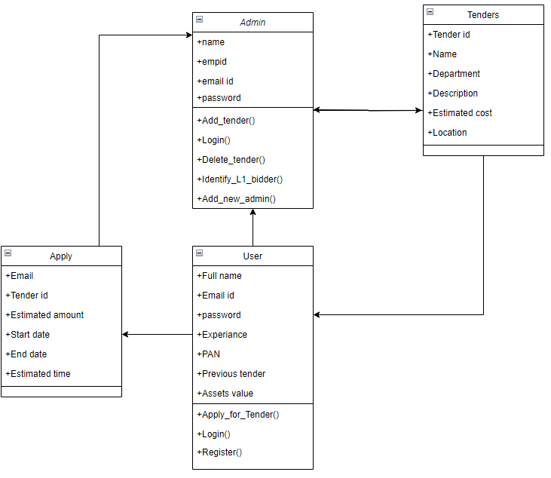

Figure 1: class diagram

## USE CASE DIAGRAM

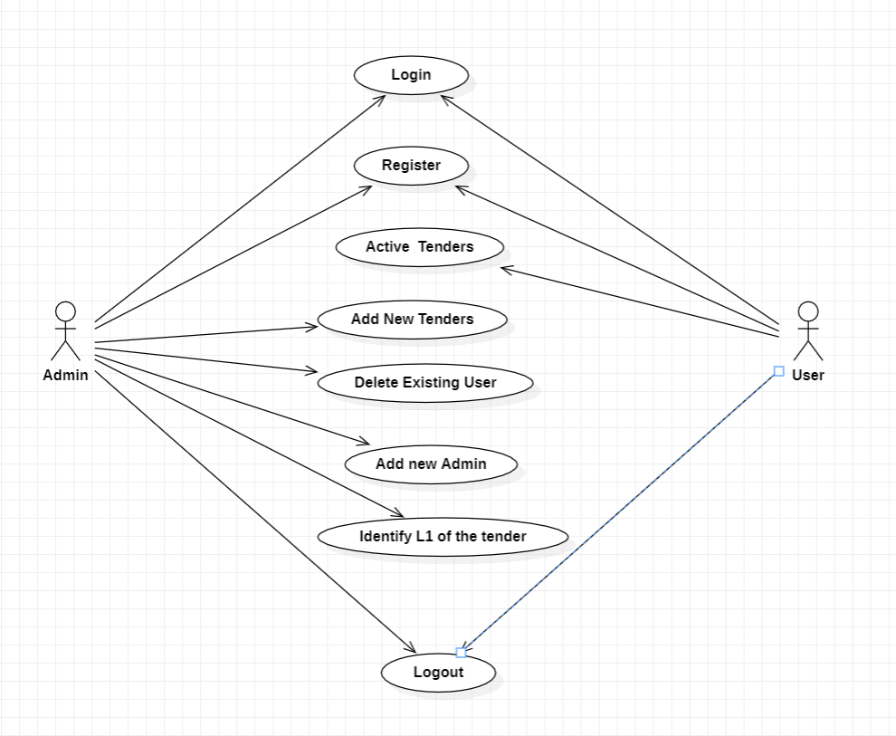

Figure 2: Use Case Diagram

## ACTIVITY DIAGRAM

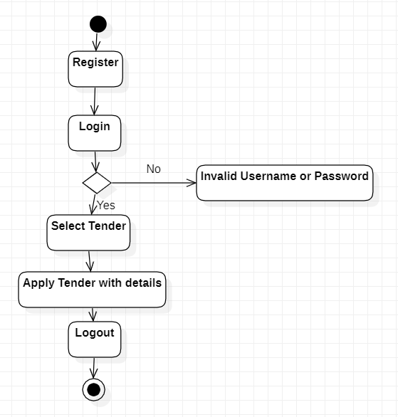

Figure 3: Activity Diagram

## SEQUENCE DIAGRAM

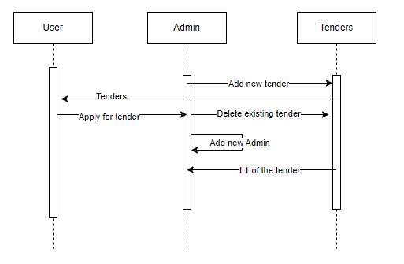

Figure 4: Sequence Diagram

## COMPONENT DIAGRAM

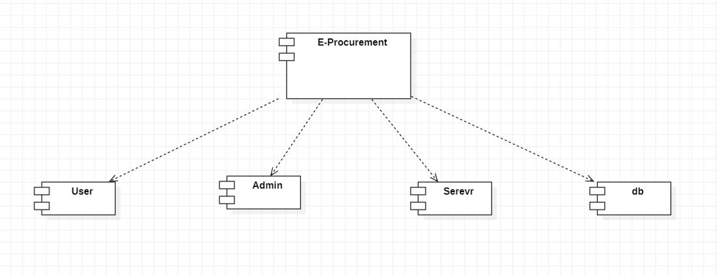

Figure 5: Component Diagram

## DEPLOYMENT DIAGRAM

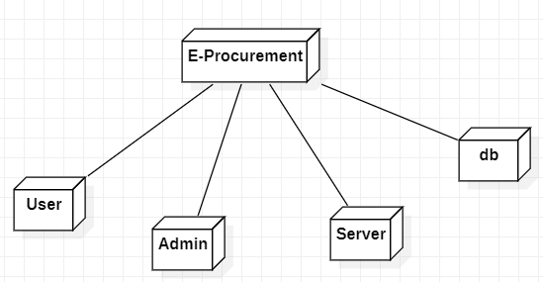

Figure 6: Deployment Diagram

# IMPLEMENTATION

The project implementation involves the utilization of multiple technologies and dependencies, organized in the form of modules. These modules are combined and integrated to create a successful application. However, in this discussion, we will focus solely on the core features and their corresponding modules, code, or methods responsible for their functionality.

**Login page sample code:**  
The code is an HTML login form that collects the user's email and password. Users must enter both fields to log in. The data is sent to the server via the "POST" method for authentication. The form also offers links for user registration and administrator login.

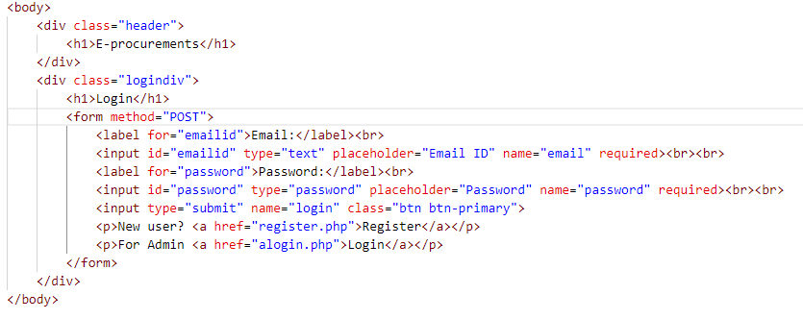

Figure 7: Login page

**Admin page sample code**

Admin page with two sections: a side navigation bar and a main content area. The side navigation bar contains links for various admin tasks, such as viewing active tenders, posting new tenders, deleting tenders, adding new admins, and viewing applied contractors.

The main content area displays a table with information about active tenders. The data is fetched from the database using PHP and MySQL. The table includes columns for S.No (serial number), tender ID, tender name, department, estimated cost, location, and description. The PHP code retrieves the tender data from the database and populates the table dynamically.

Overall, the code creates an admin page with navigation links and a table displaying details of active tenders in a user-friendly and organized manner

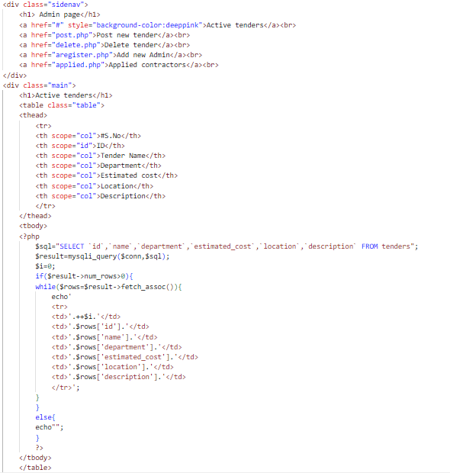

Figure 8: Admin page

**Configuring using PHP: sample code**

The provided PHP code handles user and admin login functionalities. It checks if the login or alogin button was pressed in the form and retrieves the email and password entered by the user or admin, respectively. The code then queries the database to match the email and password. Upon successful login, users are redirected to "apply.php," and admins are redirected to "index.php." If login attempts fail, error messages are displayed indicating incorrect credentials. Session variables are used to store email information for later use in the application.

Top of Form

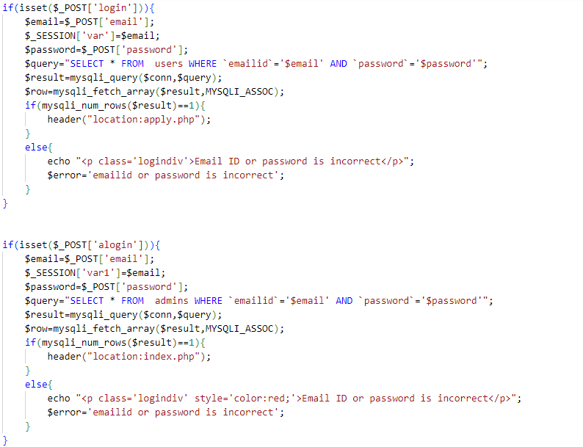

Figure 9: Login configuration

**Sample code for applying tender**

1. The first part of the code checks if a user has submitted a request to delete a tender. If so, it retrieves the tender ID from the POST request and uses it to construct a SQL query that deletes the corresponding tender record from the database.
2. The second part of the code checks if a user has submitted a request to apply for a tender. If so, it retrieves the tender ID, estimated amount, start date, end date, and estimated time from the POST request. It then uses this data to construct a SQL query that inserts a new record into the "apply" table in the database.
3. The script also includes some basic error handling to display an alert message if there are any issues with the SQL queries.

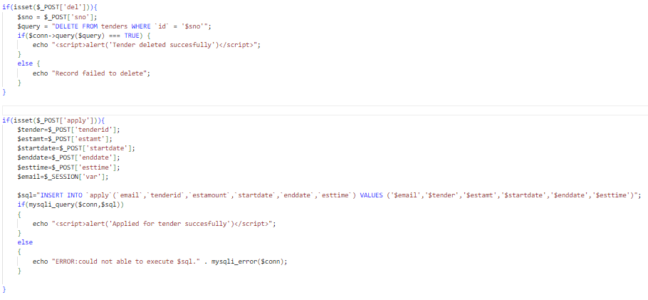

Figure 10: Apply configuration

# TESTING AND RESULTS

## User Login

The login section consists of two input fields for the user to enter their email and password. The email field has the label "Email," and the password field has the label "Password." Both fields are required to be filled for successful login. Below the input fields, there is a submit button labeled "Login" to initiate the login process. Additionally, there are two hyperlinks: "New user? Register" and "For Admin Login." The first link redirects new users to the registration page, while the second link leads to the admin login page.

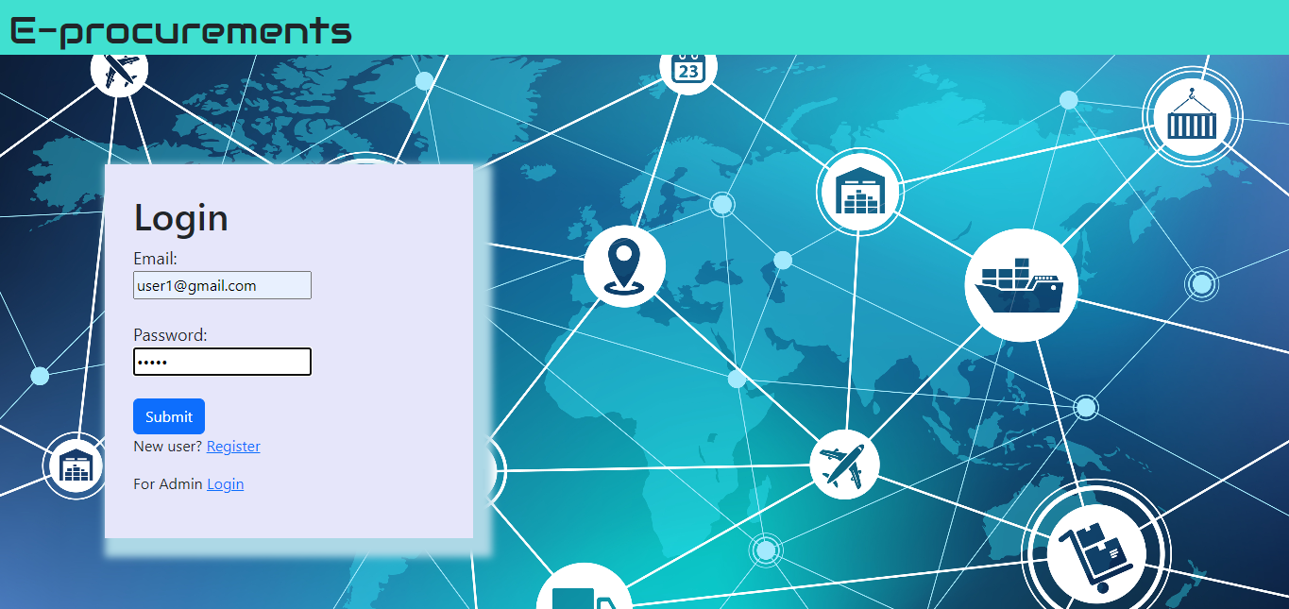

Figure 11: Login Interface

## User Register

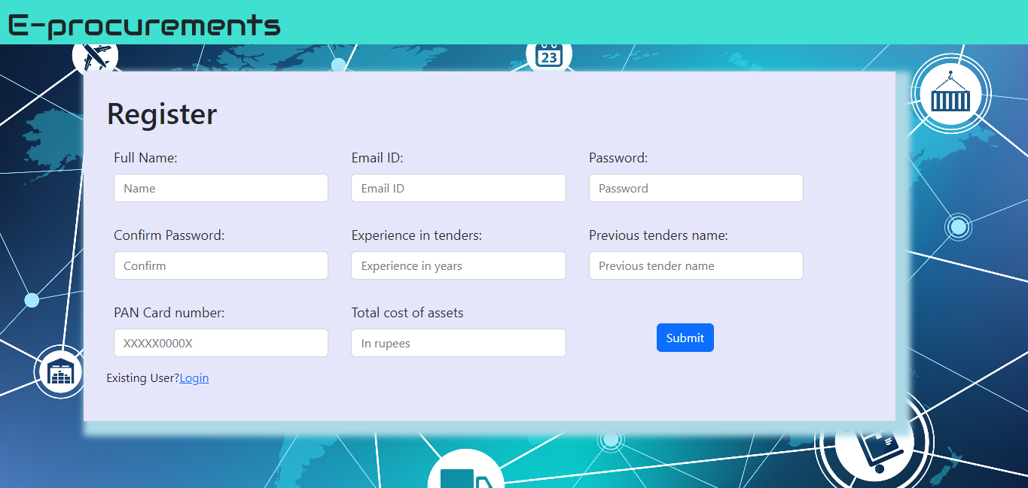

Figure 12: Register Interface

The registration process allows new users to create an account on the web application for procurement management. To register, users need to provide their full name, email address, and a password for account security. The password needs to be confirmed to ensure accuracy. Additionally, users are required to input their experience in tenders (in years), previous tender names they have participated in, their PAN card number, and the total cost of their assets.

Upon entering all the necessary information, users can submit the registration form by clicking the "Submit" button. The application will then store their details in the database, creating a new user profile. Once registered, users can access the system's features, such as viewing active tenders and applying for them through the login page.

The registration process helps ensure that only authenticated and eligible users can participate in the procurement activities facilitated by the web application. By capturing essential information about the user's tender experience and assets, the application can evaluate and validate contractors during the tendering process. This enhances transparency and trust within the procurement ecosystem, benefiting both the government/organization and the participating contractors.Top of Form

## User Interface

It has a table displaying active tenders with various columns such as tender ID, department, estimated cost, location, description, and apply button. When the apply button is clicked, it leads to a form that asks for details like tender ID, estimated amount, start date, end date, and estimated time. After filling out these details, the user can submit the form by clicking on the "apply" button.

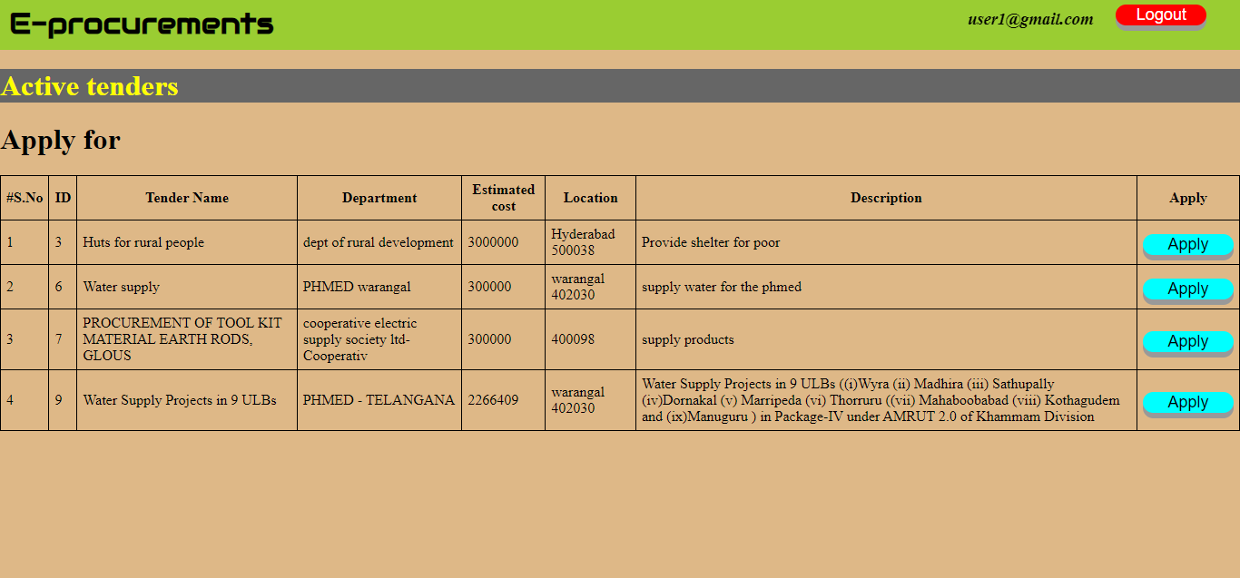

Figure 13: User Interface

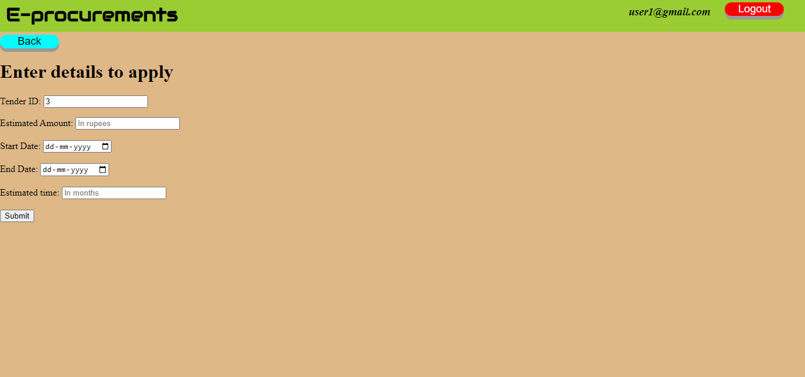

Figure 14: Apply for contract

## Admin Interface

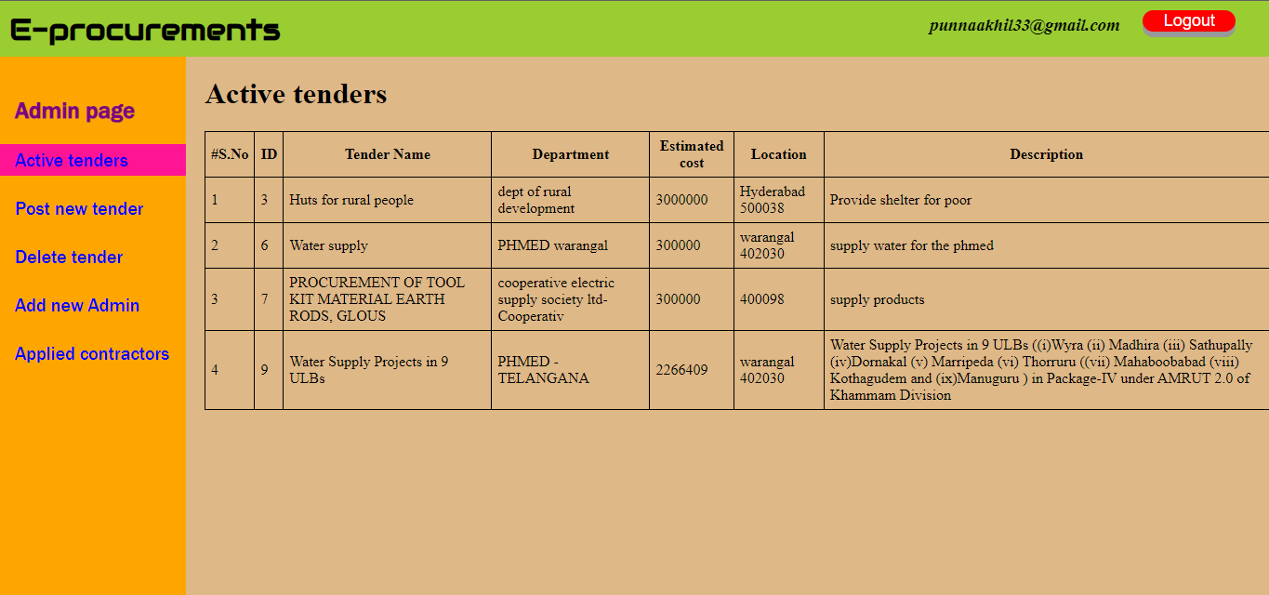

Figure 15: Admin Interface

**Side Navigation Bar:**

* The side navigation bar displays the heading "Admin page."
* It contains five hyperlinks:
  1. "Active tenders" (with a pink background): It appears to be the current page or section the admin is viewing.
  2. "Post new tender": Redirects the admin to a page where they can create and post a new tender.
  3. "Delete tender": Redirects the admin to a page where they can delete existing tenders.
  4. "Add new Admin": Takes the admin to a page to add new administrators to the system.
  5. "Applied contractors": Leads to a page displaying a list of contractors who have applied for specific tenders.

**Main Content Area:**

* The main content area displays the heading "Active tenders."
* It includes a table with several columns:
  1. "#S.No": Represents the serial number of the tender.
  2. "ID": Shows the unique identifier of the tender.
  3. "Tender Name": Indicates the name of the tender.
  4. "Department": Specifies the department associated with the tender.
  5. "Estimated cost": Displays the estimated cost of the tender.
  6. "Location": Shows the location where the tender is to be carried out.

# CONCLUSION

The development of a dynamic web application for procurements marks a significant milestone in the quest to enhance the efficiency and transparency of the procurement process. This project has undertaken the endeavor to create a user-friendly and comprehensive platform that streamlines procurement activities for government entities, organizations, departments, and contractors alike. Through the integration of cutting-edge technologies and a commitment to fostering fairness and collaboration, the web application presents a transformative solution to optimize procurement practices.

The primary objective of this project was to design and develop a highly efficient and user-friendly web application that caters to the complex needs of procurement management. By leveraging extensive user research and design methodologies, the application boasts an intuitive interface, ensuring a smooth and enjoyable user experience for all stakeholders involved.

Automation has been a key focus in this project, and the implementation of automated L1 selection algorithms demonstrates the commitment to enhancing efficiency and accuracy in contractor evaluation. This intelligent system expedites the L1 selection process, reducing manual intervention and minimizing errors and biases. Contractors can now participate more efficiently in tenders at various levels, benefiting from reduced processing time and a simplified validation process.

Transparency has been ingrained in the core of the web application, promoting openness and inclusivity. Contractors and businesses gain access to a wealth of tender information, allowing them to make informed decisions and align their bids competitively. The application's real-time aggregated pricing data ensures rate parity among contractors, fostering a level playing field for all participants.

Moreover, the dynamic web application has significantly reduced evaluation time, allowing procurement teams to make informed decisions promptly. By optimizing the evaluation workflow and providing real-time data visualization and analytics, the application empowers organizations to achieve greater efficiency in their procurement activities.

The enhanced accessibility of tenders through the web application has stimulated diverse contractor participation, inviting talent and expertise from various geographical locations. Contractors can effortlessly explore and apply for tenders aligned with their capabilities, thereby fostering a competitive environment and driving innovation within the procurement ecosystem.

The successful implementation of this project has had a positive impact on procurement practices. The web application has streamlined and centralized procurement activities, making it easier for government entities and organizations to manage their procurement needs effectively. The reduction in manual processes and automation of key tasks have led to significant time and resource savings, translating into cost optimization and enhanced operational efficiency.

As we look to the future, this dynamic web application is poised to play a pivotal role in driving cost optimization, quality enhancement, and overall operational efficiency in procurement activities. By continuously improving the platform, incorporating user feedback, and embracing technological advancements, the application is well-equipped to remain relevant and effective in the ever-evolving procurement landscape.

In conclusion, the successful development and implementation of this dynamic web application represent a significant step towards creating a more transparent, time-efficient, and beneficial procurement process. The project's achievements have been anchored in its commitment to fostering fairness, efficiency, and collaboration among all stakeholders involved. With the vision to drive positive impacts on procurement practices and project outcomes, this web application stands as a powerful tool to empower organizations, governments, and contractors on their journey towards procurement excellence.

# LIMITATIONS OF THE PROJECT

1. **Can’t vouch for the contractors:** One potential concern is the trustworthiness of contractors participating in the tendering process. Since the L1 selection is entirely done through the application, there might be uncertainties about the legitimacy and reliability of some contractors. To address this issue, the application should implement a robust verification process to ensure that registered contractors are legitimate entities with a proven track record.
2. **Only registered users can apply:** To maintain a secure and controlled environment, the application requires contractors to register before they can apply for tenders. This registration process allows the application to verify the identity and credentials of contractors, reducing the likelihood of fraudulent or unqualified users participating in the tendering process.
3. **Performance issues:** Depending on the server's capacity and load, there might be performance issues, especially if there are numerous concurrent users. In peak times or crowded scenarios, the server may become slow, leading to delays in tender submission and response times. To mitigate this, the application should be hosted on a scalable and high-performance server infrastructure to handle increased traffic efficiently.
4. **No offline functionality:** The application's reliance on internet connectivity and web browsers means that it lacks offline functionality. Users must have an active internet connection to access and interact with the application. To provide some level of flexibility, the application could consider implementing a caching mechanism to store certain data temporarily for limited offline access or explore progressive web app (PWA) technologies.
5. **Evaluation of contractors:** The process of selecting contractors for a tender is crucial. The application should use a comprehensive evaluation method that considers various factors, such as the contractor's experience in similar projects, past performance in previous tenders, financial stability, and overall reputation. Implementing an efficient scoring system can aid in objectively ranking contractors and ensuring fair selection based on merit.

# SCOPE OF THE PROJECT

The stakeholders involved in the procurement management system can be categorized into three main groups: Government/Organization, Departments of Public and Private Sectors, and the Public.

1. **Government/Organization:** This category includes organizations with a budget and recognition, such as government bodies, public institutions, and private organizations. They are responsible for posting and managing tenders for various products and services required by different departments within their organization. Government entities at the state or national level, as well as private organizations, fall under this group. They play a crucial role in defining the procurement needs, setting budgets, and evaluating bids from contractors.
2. **Departments of Public and Private Sectors:** Within the Government/Organization category, various departments of public and private sectors participate in the procurement process. These departments can range from healthcare, education, transportation, and natural resources to finance and marketing. Each department may have specific requirements for goods or services to fulfill their respective missions and objectives. For instance, the Department of Health may require medical equipment and supplies, while the Department of Transportation may seek construction services for infrastructure projects. Each department is responsible for identifying their procurement needs and collaborating with the central procurement unit of the organization.
3. **Public:** The public, including interested individuals and businesses, can view the tenders posted by the Government/Organization. While they may not actively participate in the tendering process through the application, they have access to tender information, which fosters transparency in the procurement system. This transparency enables interested parties to stay informed about upcoming opportunities and potential business prospects within the government or organization.

# FUTURE ENHANCEMENTS

The future scope of your project on procurement management through a web application is vast and promising. As technology and business needs continue to evolve, there are several potential areas of growth and improvement for your project:

1. **Automated Notifications:**

Implementing automated email or in-app notifications will significantly enhance the user experience and engagement within your procurement web application. Contractors registered on the platform will receive timely alerts about newly released tender notices relevant to their areas of expertise and interest. By integrating this feature, contractors won't miss any opportunities, increasing the participation and competitiveness of the tendering process. Moreover, administrators can customize notification settings, allowing users to receive updates on preferred tender categories, locations, or specific keywords. This will streamline communication and keep all stakeholders informed throughout the tendering lifecycle, leading to improved transparency and efficiency.

1. **Bid Evaluation System:**

Developing a systematic and transparent method for bid evaluation and automatic selection of the Lowest Bidder (L1) will revolutionize the tendering process. By integrating predefined evaluation criteria, such as price, experience, and qualifications, into the application, it will automatically analyze and rank the submitted bids. The automated system will significantly reduce human bias, errors, and the time spent on manual evaluations. Additionally, it will foster a fair and competitive environment for all contractors, promoting trust and confidence in the tendering process. The application can also provide detailed feedback to bidders, helping them understand their performance and improve their submissions in the future.

1. **Contractor Profile Management:**

Enabling registered contractors to manage their profiles efficiently will empower them to present their capabilities effectively. Contractors can update their contact information, certifications, past project details, and performance records. A well-maintained profile will boost their credibility and increase their chances of being selected for tenders. The profile management feature can also allow contractors to track the status of their submitted tenders, view historical data of past tenders, and receive performance analytics to identify areas for improvement. Such transparency and self-management capabilities will enhance contractor satisfaction and foster long-term relationships with the procurement platform.

1. **Real-time Collaboration:**

Introducing real-time collaboration and communication features within the procurement web application will revolutionize the way contractors and procurement officials interact. By incorporating instant messaging, file sharing, and commenting capabilities, contractors can seek clarifications, request additional information, or receive updates directly from the procurement team. This real-time engagement will expedite query resolutions, minimizing delays and ensuring a smooth tendering process. Additionally, it will help build trust and rapport between contractors and officials, leading to better collaboration and fostering a positive ecosystem for all stakeholders involved.

1. **Mobile Application:**

Developing a dedicated mobile app version of the procurement web application will extend accessibility and convenience to users on-the-go. Contractors and procurement officials can access the platform from their smartphones or tablets, enabling them to stay connected and participate in the tendering process from anywhere. The mobile app should offer a user-friendly interface, optimized for smaller screens, with all essential features and functionalities available at their fingertips. Push notifications can be utilized to ensure users receive time-sensitive updates and reminders, further enhancing user engagement and participation.

1. **Accessibility and Localization:**

Ensuring the procurement web application is accessible to all users, regardless of their abilities, is essential for inclusive participation. Implementing accessibility standards, such as WCAG (Web Content Accessibility Guidelines), will make the platform usable for individuals with disabilities. This includes providing alternative text for images, proper semantic markup, keyboard navigation support, and color contrast considerations. Furthermore, incorporating localization support for multiple languages will enable contractors from diverse regions and linguistic backgrounds to participate comfortably. Localization can extend beyond text translation and include culturally appropriate content and date formats, enhancing the platform's appeal to a global audience.

1. **Integration with E-Procurement Systems:**

Integrating your procurement web application with existing e-procurement systems can unlock a host of benefits for all stakeholders involved. By leveraging existing databases and procurement protocols, your platform can seamlessly access a wider range of tenders and streamline the procurement process. This integration can also enable two-way data exchange, allowing contractors to submit bids directly through your application, which will then be automatically synchronized with the main e-procurement system. This level of integration will not only save time and effort but also increase the visibility and accessibility of your platform, attracting more contractors and boosting its reputation within the procurement community.

# REFERENCES

1. *Rajkumar, T.M., 2003. E-procurement: business and technical issues. In IS Management Handbook (pp. 657-670). Auerbach Publications.*
2. *Ageshin, E.A., 2001. E-procurement at work: A case study. Production and Inventory Management Journal, 42(1), pp.48-53.*
3. *Ronchi, S., Brun, A., Golini, R. and Fan, X., 2010. What is the value of an IT e-procurement system?. Journal of Purchasing and Supply management, 16(2), pp.131-140.*
4. *Walker, H. and Brammer, S., 2012. The relationship between sustainable procurement and e-procurement in the public sector. International Journal of Production Economics, 140(1), pp.256-268.*
5. *Gunasekaran, A. and Ngai, E.W., 2008. Adoption of e-procurement in Hong Kong: An empirical research. International Journal of Production Economics, 113(1), pp.159-175.*
6. *Panayiotou, N.A., Gayialis, S.P. and Tatsiopoulos, I.P., 2004. An e-procurement system for governmental purchasing. International journal of production economics, 90(1), pp.79-102.*
7. *Davila, A., Gupta, M. and Palmer, R., 2003. Moving procurement systems to the internet:: The adoption and use of e-procurement technology models. European management journal, 21(1), pp.11-23.*
8. *Croom, S. and Brandon-Jones, A., 2007. Impact of e-procurement: experiences from implementation in the UK public sector. Journal of Purchasing and Supply management, 13(4), pp.294-303.*
9. *Knudsen, D., 2003. Aligning corporate strategy, procurement strategy and e‐procurement tools. International journal of physical distribution & logistics management, 33(8), pp.720-734.*
10. *Walker, H. and Harland, C., 2008. E‐procurement in the United Nations: influences, issues and impact. International Journal of Operations & Production Management, 28(9), pp.831-857.*
11. *Puschmann, T. and Alt, R., 2005. Successful use of e‐procurement in supply chains. Supply Chain Management: an international journal, 10(2), pp.122-133.*
12. *Moon, M.J., 2005. E-procurement management in state governments: diffusion of e-procurement practices and its determinants. Journal of public procurement, 5(1), pp.54-72.*
13. *McCue, C. and Roman, A.V., 2012. E-procurement: Myth or reality. Journal of Public procurement, 12(2), pp.221-248.*
14. *Vaidya, K. and Campbell, J., 2016. Multidisciplinary approach to defining public e-procurement and evaluating its impact on procurement efficiency. Information Systems Frontiers, 18, pp.333-348.*