**PROJECT BASED LAB REPORT**

On

**BUS RESERVATION SYSTEM**

Submitted in partial fulfillment of the

Requirements for the award of the Degree of

**Bachelor of Technology**

In

**Electrical Engineering**

By

|  |  |
| --- | --- |
| K.TEJASRI  (13006067) | K.AKHILANAND  (14004298) |
| CH.HEMANTH  (13006001) | D.BABA FAKRUDDIN  (13006017) |



**DEPARTMENT OF ELECTRICAL ENGINEERING**

**K L University**

Green Fields, Vaddeswaram, Guntur district-522 502

**APRIL 2015**



CERTIFICATE

This is to certify that the course based project titled **“Bus Reservation System”**, being submitted byK.Tejasri(13006067),Ch.Hemanth(13006001),P.NagaBhuvan(13006131)D.BabaFakruddinn(13006017) in partial fulfillment for the award of degree of **Bachelor of Technology** in Electrical Engineering is a record of bonofide work carried out by them under my guidance during the academic year **2014-2015**  and it has been found worthy of acceptance according to the requirements of the university.

**Project Guide**

**Dr.G.Krishna Mohan Signature of H.O.D**

**Assist Professor,**

**Dept. Computer Science and Engineering**

**INDEX**

Page No

**1.Abstract** 4

**2. Introduction 5**

**2.1 Description 6-7**

**2.2Module wise description 8-9**

**3.Algorithm 10**

**4.Source Codes**

**4.1 Module 1 11-15**

**4.2 Module2 16-21**

**4.3 Module3 22-25**

**4.4 Module 4 26-42**

**5.Conclusion 45**

**6.Reference 46**

ABSTRACT

Journey became part and parcel of a human being’s life. Without moving around, people cannot communicate and share the moments with others. In this busy world, especially when more and more population is seen in the developing nations, it is highly essential to have a comfortable and safe journey. When a passenger wants to go on a journey, he wants to first reserve some seat in a bus and for the intended date. This becomes easy with software which helps in obtaining reservations of seats in a bus well before and take the tickets also online by staying at home. The passenger should select a bus and then the available seats information is displayed. The passenger can select the seats whatever he likes. In the next screen, he can provide his details along with the credit card number. The amount is calculated and deducted from his account. Customers can book a ticket which is a five step process that includes Search Bus, Select Bus, Select Seats, Provide Customer Information and Make Payment.  This application also provides facility to cancel a booked ticket online.

**INTRODUCTION**

ONLINE  BUS  TICKET  RESERVATION Which can be  used  for  the  all  of  the internet users. The Ticket Reservation System is  an  Internet based application  that can  be accesses  throughout  the  Net  and  can be  accessed  by  anyone  who  has  a  net  connection. This  application  will  automate the  reservation  of  tickets and  Enquiries  about  availability of the tickets . This application includes email information for the tickets.

The  system  also  provides  a  comprehensive  mechanism  of  ticket  booking  for  any  travel agency this project is  designed  to  help  wide  range  of  travel  agencies  come together  and  provide  service  to  the  customer.  This Project comprehensive functionality  helps  the  agencies  expand  their  horizons  in  the  field  of  providing  service  to  the customers. The  system  also  provides  a  comprehensive  mechanism  of  ticket  booking  for  any  travel agency this project is  designed  to  help  wide  range  of  travel  agencies  come together  and  provide  service  to  the  customer.

**Description**

The Bus reservation system is meant for supporting the user for effecting well planned smooth travel. The system should maintain the details of various Buses scheduled to commute between the locations. The users should be able to reserve or cancel their travel. The status of the reservations made should also be provided when enquiries are made by the users. The users are to be provided with details of the Bus being run from one location to the other. Comprehensive functionality  helps  the  agencies  expand  their  horizons  in  the  field  of  providing  service  to  the customers. Present system is manual. The Project Metrics has to enter all the details of project, documents, and tasks. It also maintenance the team information and also efforts estimation. For this purpose the organization maintain the size of the document, source code and update     the information  about team member’s details   manually. Which is much of time consuming process and  more  importantly it is error prone. Limitations Of the Manual system

* It is time consuming
* It leads to error prone results
* It consumes lot of manpower to better results
* It lacks of data security
* Retrieval of data takes lot of time
* Percentage of accuracy is less
* Reports take time to produce

Hence Computerization of the existing system is proposed. The new system completely removes all manual burdens and provide efficient on the entry system.

After understanding the existing system and understanding the need for developing a new system different people involved in the related activities have been consulted. The data needed for the study has been collected from company records.

The computerization of this system would avoid the wrong interpretation and bad calculation of data .The system help the user to see any documents, source code, tasks, activities, team information with details at the click of a button. The record data is maintained and backed up such a way that data is not loss. The speed of the system could also increase. Traveling is a large growing business across all countries. Bus reservation system deals with maintenance of records of details of each passenger. It also includes maintenance of information like schedule and details of each bus. In counter Bus reservation system there are many operations, which they have to do manually takes a lot of time and causing many errors while data entry. Due to this, sometimes a lot of problems occur and they were facing many disputes with customers. To solve the above problem, and further maintaining records of passenger details, seat availability, price per seat, bill generation and other things, this proposal of computerized reservation system is better.

This application allows to reserve/cancel tickets, enquire for bus, seat selection and time saving as it is accessed via internet. This project provides and checks all sorts of constraints so that user does give only useful data and thus validation is done in an effective way.Online system provides real time quotations, real time bus booking services for round trips, multiple payment channels, cost comparison,last minute booking, an in-house call center and even home delivery of tickets.

Online system provides real time quotations, real time bus booking services for round trips, multiple payment channels, cost comparison,last minute booking, an in-house call center and even home delivery of ticket

To generate the quick reports

To make accuracy and efficient calculations

To provide proper information briefly

To provide data security

To provide huge maintenance of records

Flexibility of transactions can be completed in time

**Modules of Description**

**1) Management of Bus Information:**

This system allows the passengers to create, update and to search the information of buses between two travelling cities such as “Arrival city and Departure city” with respective dates and timings. system should be created with information such as Date of journey, Bus no:, Name of bus, charges and Duration to their destinations. After creating a system we perform the search, and the system displays the availability of busses and helps the passengers to choose the buses as per their need. An accredited bus operator must have a method to produce, maintain and control documents and bus safety records relevant to the safe management of bus operations to ensure ongoing accuracy of data and currency of information.

**2)Reservation and Cancellation:**

This “Bus Reservation System” helps the passengers to manage the information, to Reserve and Cancel their tickets as per their requirement and also which is meant for supporting the user for effecting well planned smooth travel.

The  system  also  provides  a  comprehensive  mechanism  of  ticket  booking  for  any  travel agency this project is  designed  to  help  wide  range  of  travel  agencies  come together  and  provide  service  to  the  customer. This project also helps to generate the waiting list for the passengers. If any person booked the ticket and cancelled after few days the first waiting list person’s ticket get conformed. like this we are maintain waiting lists upto ten persons.

**3) Enquiry:**

This application allows to reserve/cancel tickets, enquire for bus, seat selection and time saving as it is accessed via internet. This project provides and checks all sorts of constraints so that user does give only useful data and thus validation is done in an effective way.Online system provides real time quotations, real time bus booking services for round trips, multiple payment channels, cost comparison,last minute booking, an in-house call center and even home delivery of tickets.

**4)Integration**

This module combines the whole data and also provides the menu for users. it also provides the system banner. And also provides security for the system. Integration is nothing but integrates the all modules and providing extra information about the system. This application allows to reserve/cancel tickets, enquire for bus, seat selection and time saving as it is accessed via internet. This project provides and checks all sorts of constraints so that user does give only useful data and thus validation is done in an effective way.

***ALGORITHM:***

**Step 1:** start the program

**Step:2** Taking a class named as a.

**Step 3:** Declaring the variables and arrays as busn[5], driver[10], arrival[5], depart[5], from[10], to[10], seat[8][4][10].

**Step:4** And in public of the class we are giving member functions as

install(), allotment(), empty(), show(), avail(), position(int i);

**Step:5** And giving that maximum buses available are 10.

**Step:6** And now with respect to installing function we gave few options to enter in the run time which will gives to enter the bus details from back end of the system like bus no, Driver's name, Arrival time, Departure time, from and to .

**Step:7** And now with respect to allotment function we can allot seats for customer according to their preferable seat numbers.

**Step:8** And the empty function shows that the seats are empty in the bus.

**Step:9** And the show function shows that the how many seats available in the given bus. And which seats are all ready reserved in the bus**.**

**step:10** terminate the process

**Source code:**

**-1:**

package reservation;

import java.util.*;

import java.io.*;

class BusRec

{

int busno;

float arrtime,depatime;

String busname;

String type;

String from,to;

void displayRecord()

{

System.out.print("bus no.: " + busno);

System.out.print(" bus name: " +busname);

System.out.println("type: " + type);

System.out.println("From: " +from);

System.out.println("To: " +to);

System.out.println("Arrival time: " +arrtime);

System.out.println("Departure time: " +depatime);

}

}

class CreateReadFile {

public static void main(String args[])

throws IOException {

int i,num;

int choice=0;

int searchbusno=0;

String str="";

boolean flag=true;

BufferedReader br = new BufferedReader(new InputStreamReader(System.in));

BusRec record = new BusRec();

while(flag)

{

System.out.println("\n Menu");

System.out.println("1. Write File");

System.out.println("2. Search");

System.out.println("3. Display File");

System.out.println("4. Quit");

System.out.print("Enter your choice: ");

choice= Integer.parseInt(br.readLine());

switch(choice){

case 1:

FileWriter fout = new FileWriter("test.txt");

System.out.print("How many bus records? ");

num= Integer.parseInt(br.readLine());

for(i=0;i<num;i++)

{

System.out.print("enter bus no: ");

record.busno= Integer.parseInt(br.readLine());

System.out.print("Enter bus name:");

record.busname=br.readLine();

System.out.print("enter type:");

record.type =br.readLine();

System.out.print("Enter starting place:");

record.from=br.readLine();

System.out.print("Enter destination place:");

record.to=br.readLine();

System.out.print("enter arrival time: ");

record.arrtime= (int) Float.parseFloat(br.readLine());

System.out.print("enter departure time: ");

record.depatime= (int) Float.parseFloat(br.readLine());

fout.write(record.busno+" \n");

fout.write(record.busname+" \n");

fout.write(record.type+" \n");

fout.write(record.from+" \n");

fout.write(record.to+" \n");

fout.write(record.arrtime+" \n");

fout.write(record.depatime+" \n");

}

fout.write("EOF");

fout.close();

System.out.println("File is created");

break;

case 2:

System.out.print("enter search bus no: ");

searchbusno = Integer.parseInt(br.readLine());

case 3:

FileReader fin = new FileReader("test.txt");

Scanner sc = new Scanner(fin);

while(sc.hasNextInt())

{

record.busno = sc.nextInt();

record.busname = sc.next();

record.type= sc.next();

record.from=sc.next();

record.to=sc.next();

record.arrtime=sc.nextFloat();

record.depatime=sc.nextFloat();

if(choice==3)

record.displayRecord();

if(choice==2)if(record.busno==searchbusno)

record.displayRecord();

}

str= sc.next();

if(str.equals("EOF"))

System.out.println("End of file");

else System.out.println("File format error.");

fin.close();

break;

case 4: flag=false;

break;

default:System.out.println("Wrong Choice!!");

}

}

System.out.println("Program is over");

}

}

**Module:2**

package reservation1;

import java.util.*;

import java.io.*;

class Businfo

{

int pNo,age,phno;

String name;

int nooftickets;

int temp= 0;

void displayRecord()

{

System.out.print("pNo.: " + pNo);

System.out.print(" Name: " + name);

System.out.println(" phoneno: "+phno);

System.out.println("age"+age);

}

}

public class Reservation1 {

public static void main(String[] args) throws IOException {

int i,t=0;

int choice=0;

int searchpassNo=0,tickets=1;

String str="";

String searchpassname = null;

String temp=null;

boolean flag=true;

BufferedReader br = new BufferedReader(new InputStreamReader(System.in));

Businfo record = new Businfo();

while(flag)

{

System.out.println("\n Menu");

System.out.println("1.booking");

System.out.println("2. Search");

System.out.println("3. Display File");

System.out.println("4.cancilation");

System.out.println("5. quit");

System.out.print("Enter your choice: ");

choice= Integer.parseInt(br.readLine());

switch(choice){

case 1:

FileWriter fout = new FileWriter("test.txt");

System.out.println("enter the num of tickets");

t= Integer.parseInt(br.readLine());

for(i=0;i<t;i++)

{

System.out.print("enter passanger number: ");

record.pNo= Integer.parseInt(br.readLine());

System.out.print("Enter name:");

record.name=br.readLine();

System.out.print("enter phone no:");

record.phno =Integer.parseInt(br.readLine());

System.out.println("enter the age");

record.age=Integer.parseInt(br.readLine());

if(i<tickets){

System.out.println("\n");

}

if(i>tickets){

System.out.println("your ticket is in waiting list");

}

fout.write(record.pNo+"\n");

fout.write(record.name+"\n");

fout.write(record.phno+"\n");

fout.write(record.age+"\n");

}

fout.write("EOF");

fout.close();

System.out.println("File is created");

break;

case 2:

System.out.print("enter search passenger: ");

searchpassNo = Integer.parseInt(br.readLine());

case 3:

FileReader fin = new FileReader("test.txt");

Scanner sc = new Scanner(fin);

while(sc.hasNextInt())

{

record.pNo = sc.nextInt();

record.name = sc.next();

record.phno= sc.nextInt();

record.age=sc.nextInt();

if(choice==3)

record.displayRecord();

if(choice==2) if(record.pNo==searchpassNo)

record.displayRecord();

}

str= sc.next();

if(str.equals("EOF")){

System.out.println("End of file");

}

else{

System.out.println("File format error.");

}

fin.close();

break;

case 4:

System.out.println("enter the passenger name");

searchpassname = br.readLine();

FileReader fin1 = new FileReader("test.txt");

Scanner sc1 = new Scanner(fin1);

while(sc1.hasNextInt())

{

record.pNo = sc1.nextInt();

record.name = sc1.next();

record.phno= sc1.nextInt();

record.age=sc1.nextInt();

temp=record.name;

if((temp).equals(searchpassname))

{

record.pNo=0;

record.name=null;

record.phno=0;

record.age=0;

}record.displayRecord();

System.out.println(" your booking is cancelled");

}

str= sc1.next();

if(str.equals("EOF"))

System.out.println("End of file");

else System.out.println("File format error.");

fin1.close();

break;

case 5: flag=false;

break;

default:System.out.println("Wrong Choice!!");

}

}

System.out.println("Program is over");

}

}

**Module:3**

package createreadfile;

import java.util.*;

import java.io.*;

class Businfo

{

int rootno,busno,seats;

String name,sp,ep;

double time;

void displayRecord()

{

System.out.print("rootno of the bus: " + rootno);

System.out.println("busnumber is :"+busno);

System.out.println("number of seats avaliable are"+seats);

System.out.println("starting piont is"+sp);

System.out.println("ending piont is"+ep);

System.out.print(" Name: " + name);

String timest = null;

System.out.println(" the bus is start at : "+timest);

String timeend = null;

System.out.println("the bus reached destination in :"+timeend);

}

}

class CreateReadFile {

public static void main(String args[])

throws IOException {

int i,num;

int choice=0;

int searchrootno=0;

String str="";

boolean flag=true;

BufferedReader br = new BufferedReader(new InputStreamReader(System.in));

Businfo record = new Businfo();

while(flag)

{

System.out.println("1. information about bus");

System.out.println("4. Quit");

System.out.print("Enter your choice: ");

choice= Integer.parseInt(br.readLine());

switch(choice){

case 1:

FileWriter fout = new FileWriter("test.txt");

System.out.print("enter rootno? ");

num= Integer.parseInt(br.readLine());

if(num==143)

{

System.out.println("// the bus is traveeling from vijayawada to hyderabad //");

System.out.println("// starts in vijayawada from 6 A.m and reaches hyderabad in 12 A.M //");

System.out.println("// Superclass Bus //");

System.out.println("// charges are RS 350 //\n\n");

{

fout.write(record.rootno+"\n");

}

fout.write("EOF");

fout.close();

break;

}

if(num==123)

{

System.out.println("// the bus is traveeling from Vijayawda to Rajamundry //");

System.out.println("// starts in vijayawada from 6:00 A.m and reaches hyderabad in 9:30 A.M //");

System.out.println("// deulux Bus //");

System.out.println("// charges are RS 150 //\n\n");

{

fout.write(record.rootno+"\n");

}

fout.write("EOF");

fout.close();

break;

}

if(num==222)

{

System.out.println("// the bus is traveeling from Rajamundry to visakapatanam //");

System.out.println("// starts in vijayawada from 6 A.m and reaches visakapatanam in 12 A.M //");

System.out.println("// Superluxzery AC Bus //");

System.out.println("// charges are RS 400 //\n\n");

{

fout.write(record.rootno+"\n");

}

fout.write("EOF");

fout.close();

break;

}

}

}

}

}

**Module:4**

package project3;

import java.util.*;

import java.io.*;

class Businfo

{

String user;

String password;

String confirm="*****";

int RouteNo;

Double durationofthejourney;

int pNo,age,phno;

int nooftickets;

int temp= 0;

int busno,sno,seatno;

float arrtime,depatime;

String busname,passname;

String type;

String from,to;

String startingplace,destinationplace;

int charge;

public void displayRecord()

{

System.out.print("BusNo.:" + busno);

System.out.print(" BusName: " + busname);

System.out.println(" Routeno: "+RouteNo);

System.out.println("Ariival"+startingplace);

System.out.println("depature"+destinationplace);

System.out.println("arrivaltime"+arrtime);

System.out.println("depaturetime"+depatime);

System.out.println("durationof the journey in hrs"+durationofthejourney);

}

void displayRecord1()

{

System.out.print("pNo.: " + pNo);

System.out.print(" Name: " + passname);

System.out.println(" phoneno: "+phno);

System.out.println("age"+age);

}

public void displayRecord2()

{

System.out.println("bus no.: " + busno);

System.out.println("bus name: " +busname);

System.out.println("type: " + type);

System.out.println("From: " +from);

System.out.println("To: " +to);

System.out.println("Arrival time: " +arrtime);

System.out.println("Departure time: " +depatime);

System.out.println("\n");

}

public void displayRecord3()

{

System.out.println(" sno.: " + sno);

System.out.println("starting place: " +startingplace);

System.out.println("destination place: " +destinationplace );

System.out.println("type: " +type);

System.out.println("charge: " +charge);

}

}

public class Project3 {

public static void main(String[] args) throws IOException {

int i,num=1,t=0,ch,opt;

int choice=0;

String str="";

boolean flag=true;

int searchpassNo=0,tickets=1;

String searchpassname = null;

String temp=null;

int searchbusno=0;

String searchbusname = null;

String searchdestination = null;

String searchstartingplace = null;

String searchdestinationplace = null;

BufferedReader br=new BufferedReader(new InputStreamReader(System.in));

Businfo record = new Businfo();

System.out.println("enter userID");

record.user = br.readLine();

System.out.println("Enter password");

record.password = br.readLine();

System.out.println("Confirm your password");

record.confirm = br.readLine();

if (record.password.equals(record.confirm)) {

while(flag)

{

System.out.println("WLCOME TO BUS RESERVATION SYATEM");

System.out.println("BUS INFO MENU");

System.out.println("1.bus information File");

System.out.println("2. Search");

System.out.println("3. Display File");

System.out.println("reservation menu");

System.out.println("4.booking");

System.out.println("5. Search");

System.out.println("6. Display File");

System.out.println("7.cancilation");

System.out.println("enquiry menu");

System.out.println("8.search by bus no");

System.out.println("9.search by destination");

System.out.println("10.search by bus name");

System.out.println("11.charges");

System.out.println("12.conformation of berth/seat");

System.out.println("13.quota availability");

System.out.println("14. quit");

System.out.print("Enter your choice: ");

choice= Integer.parseInt(br.readLine());

switch(choice){

case 1:

FileWriter fout = new FileWriter("bus.txt");

for(i=0;i<num;i++)

{

System.out.print("enter Bus number: ");

record.busno= Integer.parseInt(br.readLine());

System.out.print("Enter Bus name:");

record.busname=br.readLine();

System.out.print("enter Route no:");

record.RouteNo =Integer.parseInt(br.readLine());

System.out.println("enter arrival place");

record.startingplace=br.readLine();

System.out.println("enter depature place");

record.destinationplace=br.readLine();

System.out.println("enter arrival timings of the bus");

record.arrtime=Float.parseFloat(br.readLine());

System.out.println("enter depature timings of the bus");

record.depatime=Float.parseFloat(br.readLine());

System.out.println("enter duration of the journey");

record.durationofthejourney=Double.parseDouble(br.readLine());

fout.write(record.busno+"\n");

fout.write(record.busname+"\n");

fout.write(record.RouteNo+"\n");

fout.write(record.startingplace+"\n");

fout.write(record.destinationplace+"\n");

fout.write(record.arrtime+"\n");

fout.write(record.depatime+"\n");

fout.write(record.durationofthejourney+"\n");

}

fout.write("EOF");

fout.close();

System.out.println("File is created");

break;

case 2:

System.out.print("enter search Bus No: ");

searchbusno = Integer.parseInt(br.readLine());

case 3:

FileReader fin = new FileReader("bus.txt");

Scanner sc = new Scanner(fin);

while(sc.hasNextInt())

{

record.busno = sc.nextInt();

record.busname = sc.next();

record.RouteNo= sc.nextInt();

record.startingplace=sc.next();

record.destinationplace=sc.next();

record.arrtime=sc.nextFloat();

record.depatime=sc.nextFloat();

record.durationofthejourney=sc.nextDouble();

if(choice==3)

record.displayRecord();

if(choice==2) if(record.busno==searchbusno)

record.displayRecord();

}

str= sc.next();

if(str.equals("EOF"))

System.out.println("End of file");

else System.out.println("File format error.");

fin.close();

break;

case 4:

FileWriter fout1 = new FileWriter("test.txt");

System.out.println("enter the num of tickets");

t= Integer.parseInt(br.readLine());

for(i=0;i<t;i++)

{

System.out.print("enter passanger number: ");

record.pNo= Integer.parseInt(br.readLine());

System.out.print("Enter name:");

record.passname=br.readLine();

System.out.print("enter phone no:");

record.phno =Integer.parseInt(br.readLine());

System.out.println("enter the age");

record.age=Integer.parseInt(br.readLine());

if(i<tickets){

System.out.println("\n");

}

if(i>tickets){

System.out.println("your ticket is in waiting list");

}

fout1.write(record.pNo+"\n");

fout1.write(record.passname+"\n");

fout1.write(record.phno+"\n");

fout1.write(record.age+"\n");

}

fout1.write("EOF");

fout1.close();

System.out.println("File is created");

break;

case 5:

System.out.print("enter search passenger: ");

searchpassNo = Integer.parseInt(br.readLine());

case 6:

FileReader fin1 = new FileReader("bus1.txt");

Scanner sc1 = new Scanner(fin1);

while(sc1.hasNextInt())

{

record.pNo = sc1.nextInt();

record.passname = sc1.next();

record.phno= sc1.nextInt();

record.age=sc1.nextInt();

if(choice==3)

record.displayRecord();

if(choice==2) if(record.pNo==searchpassNo)

record.displayRecord1();

}

str= sc1.next();

if(str.equals("EOF")){

System.out.println("End of file");

}

else{

System.out.println("File format error.");

}

fin1.close();

break;

case 7:

System.out.println("enter the passenger name");

searchpassname = br.readLine();

FileReader fin2 = new FileReader("bus1.txt");

Scanner sc2 = new Scanner(fin2);

while(sc2.hasNextInt())

{

record.pNo = sc2.nextInt();

record.passname = sc2.next();

record.phno= sc2.nextInt();

record.age=sc2.nextInt();

temp=record.passname;

if((temp).equals(searchpassname))

{

record.pNo=0;

record.passname=null;

record.phno=0;

record.age=0;

}record.displayRecord1();

System.out.println(" your booking is cancelled");

}

str= sc2.next();

if(str.equals("EOF"))

System.out.println("End of file");

else System.out.println("File format error.");

fin2.close();

break;

case 8:

System.out.print("enter search bus no: ");

searchbusno = Integer.parseInt(br.readLine());

FileReader fin3 = new FileReader("test.txt");

Scanner sc3 = new Scanner(fin3);

while(sc3.hasNextInt())

{

//Read data from file

record.busno = sc3.nextInt();

record.busname = sc3.next();

record.type= sc3.next();

record.from=sc3.next();

record.to=sc3.next();

record.arrtime=sc3.nextFloat();

record.depatime=sc3.nextFloat();

if(record.busno==searchbusno)

record.displayRecord2();

// else

// System.out.println("no trains are available with train no: "+searchtrainno);

}

str= sc3.next();

if(str.equals("EOF"))

System.out.println("End of file");

else System.out.println("File format error.");

fin3.close();

break;

case 9:

System.out.print("enter destination:");

searchdestination=br.readLine();

FileReader fin4 = new FileReader("test.txt");

Scanner sc4 = new Scanner(fin4);

while(sc4.hasNextInt())

{

//Read data from file

record.busno = sc4.nextInt();

record.busname = sc4.next();

record.type= sc4.next();

record.from=sc4.next();

record.to=sc4.next();

record.arrtime=sc4.nextFloat();

record.depatime=sc4.nextFloat();

if((searchdestination).equals(record.to))

record.displayRecord2();

// else

// System.out.println("no buses are available to: "+searchdestination)

}

str= sc4.next();

if(str.equals("EOF"))

System.out.println("End of file");

else System.out.println("File format error.");

fin4.close();

break;

case 10:

System.out.print("enter bus name:");

searchbusname=br.readLine();

FileReader fin5 = new FileReader("test.txt");

Scanner sc5 = new Scanner(fin5);

while(sc5.hasNextInt())

{

//Read data from file

record.busno = sc5.nextInt();

record.busname = sc5.next();

record.type= sc5.next();

record.from=sc5.next();

record.to=sc5.next();

record.arrtime=sc5.nextFloat();

record.depatime=sc5.nextFloat();

if((searchbusname).equals(record.busname))

record.displayRecord2();

// else

// System.out.println("no buses are available with bus name: "+searchbusname);

str= sc5.next();

if(str.equals("EOF"))

System.out.println("End of file");

else System.out.println("File format error.");

fin5.close();

break;

case 11:

System.out.print("enter starting place:");

searchstartingplace=br.readLine();

System.out.print("enter destination place:");

searchdestinationplace=br.readLine();

FileReader fin6 = new FileReader("charges.txt");

Scanner sc6 = new Scanner(fin6);

while(sc6.hasNextInt())

{

record.sno=sc6.nextInt();

record.startingplace=sc6.next();

record.destinationplace=sc6.next();

record.type=sc6.next();

record.charge=sc6.nextInt();

if((searchstartingplace).equals(record.startingplace))

{

if((searchdestinationplace).equals(record.destinationplace))

{

record.displayRecord3();

}

}

}

str= sc6.next();

if(str.equals("EOF"))

System.out.println("End of file");

else System.out.println("File format error.");

fin6.close();

break;

case 12:

System.out.print("enter passenger name:");

searchpassname=br.readLine();

FileReader fin7 = new FileReader("r8-4-15.txt");

Scanner sc7 = new Scanner(fin7);

while(sc7.hasNextInt())

{

//Read data from file

record.seatno = sc7.nextInt();

record.passname = sc7.next();

temp=record.passname;

if((temp).equals(searchpassname))

System.out.println(" your seat is conformed");

}

str= sc7.next();

if(str.equals("EOF"))

System.out.println("End of file");

else System.out.println("File format error.");

fin7.close();

break;

case 13:

FileReader fin8 = new FileReader("r8-4-15.txt");

Scanner sc8 = new Scanner(fin8);

while(sc8.hasNextInt())

{

//Read data from file

record.seatno = sc8.nextInt();

record.passname = sc8.next();

temp=record.passname;

if((temp).equals("---")) System.out.println("seat no :"+record.seatno);

}

str= sc8.next();

if(str.equals("EOF"))

System.out.println("End of file");

else System.out.println("File format error.");

fin8.close();

break;

case 14:

flag=false;

break;

default:System.out.println("Wrong Choice!!");

}

}

System.out.println("Program is over");

}

else

{

System.out.println("Password is incorrect unable to acess the record");

System.exit(0);

}

}

}

**Bus information**

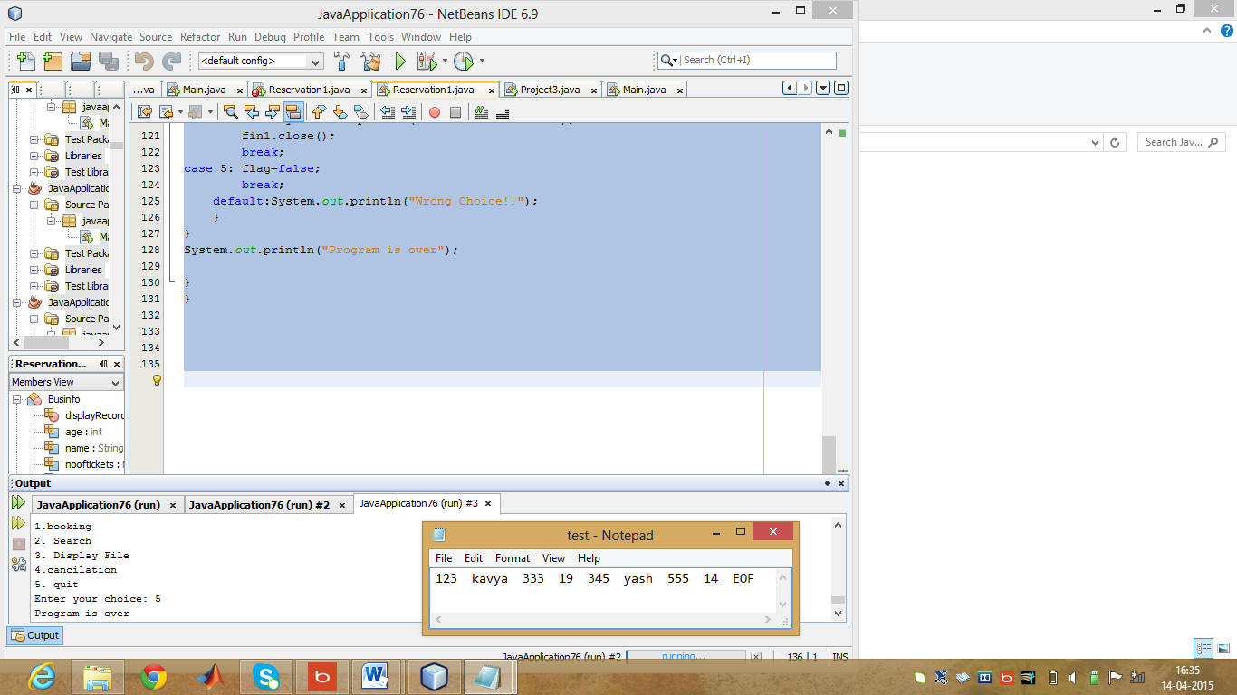

**Booking and cancelling of tickets**

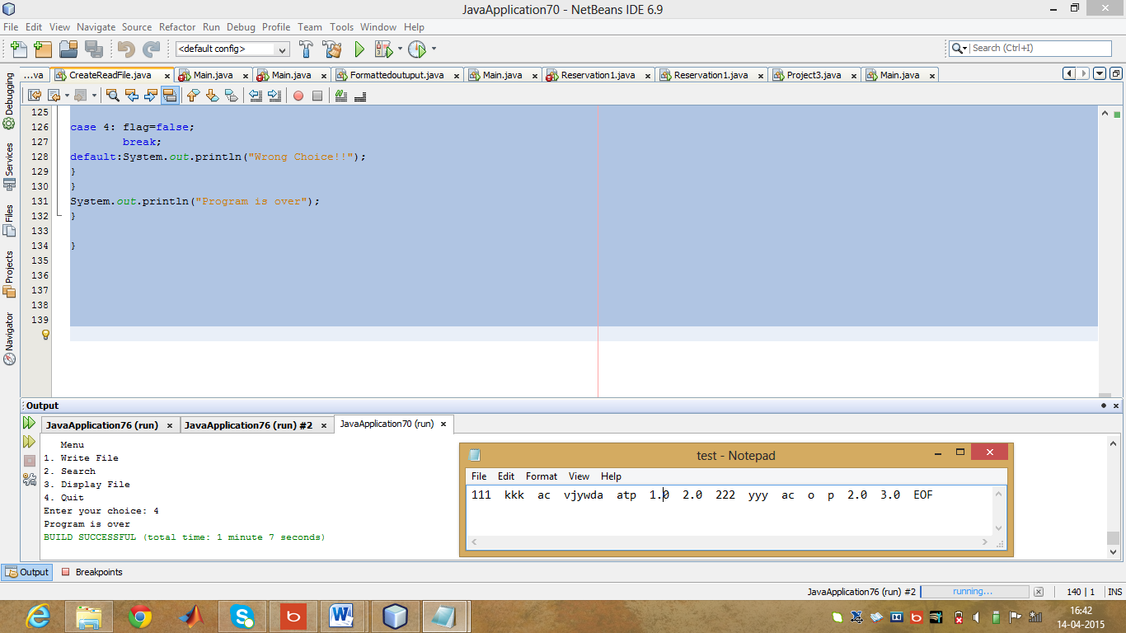

**Enquiry**

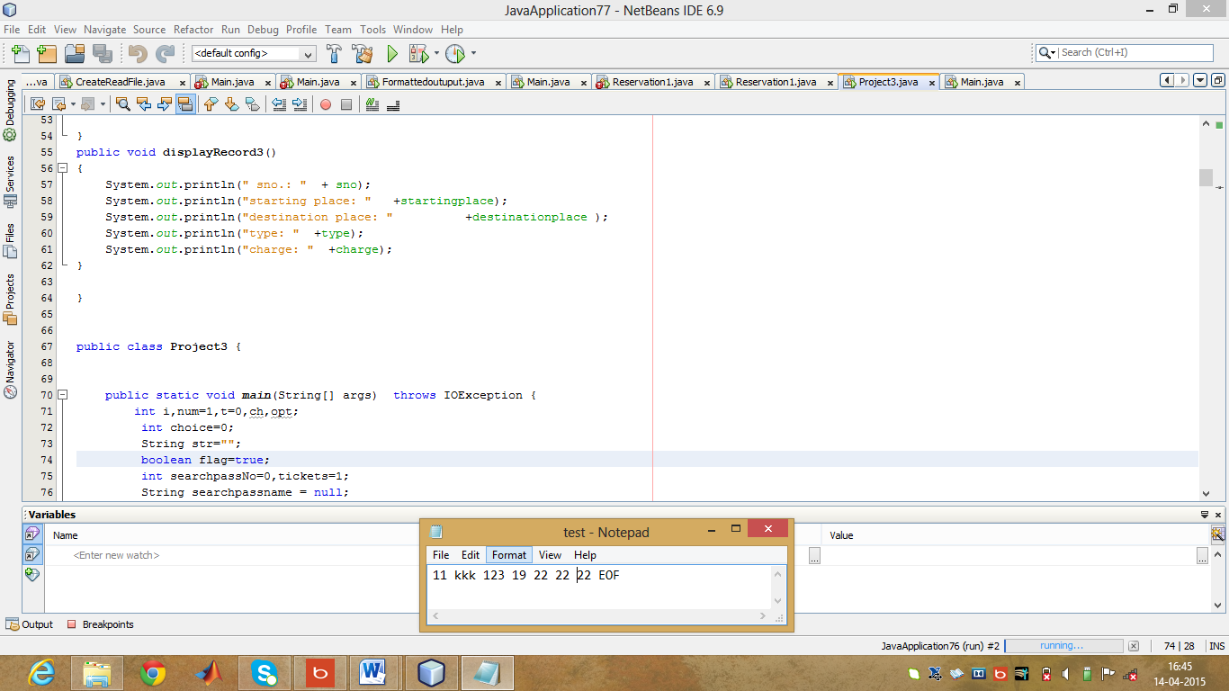

**CONCLUSION:**

This system is user friendly and accurate. this system available twenty four hours and efficient in reservation. It has no hidden cost in fares. It simplifies the task and reduces paperwork. this system is more accurate, user friendly, Availability, Efficiency, Reliable and Durable. Bus reservation system there are many operations, which they have to do manually takes a lot of time and causing many errors while data entry. Due to this, sometimes a lot of problems occur and they were facing many disputes with customers. To solve the above problem, and further maintaining records of passenger details, seat availability, price per seat, bill generation and other things, this proposal of computerized reservation system is better.

**Reference:**

**Text book: The complete Reference java by Herbert Schildt**

<http://www.slideshare.net/smitpatel10192/online-bus-ticket-reservation?related=1>

<http://www.slideshare.net/saifullahmalik/online-reservation-of-bus>

<http://www.slideshare.net/Tuvshuud/online-bus-ticket-reservation-system>