**Scientific Calculator**

End-Term Report

BACHELOR OF TECHNOLOGY

In

COMPUTER SCIENCE AND ENGINEERING

By:

|  |  |  |  |
| --- | --- | --- | --- |
| S.no | Name | Roll No. | Registration no. |
| 1. | Jaspreet Singh | 08 | 11902345 |
| 2. | Akhil Kr Choubey | 32 | 11905101 |
| 3. | Kaushal Kumar | 49 | 11913809 |

Course Code: INT213



Table of Contents

1. Objective of project
2. Introduction
3. Structure Of application
4. GUI of application
5. Database connectivity Of application
6. Conclusion and Learning Outcomes
7. References

Objective

Objective of this project is in order to implement different learning of course of Python Programming Language and to develop a scientific calculator with all required functionalities . Objective is to also provide user with an interactive and fully functional Scientific calculator . This project also aims at establishing a database connectivity between the developed app using MySQL so that user can be provided with the benefit of viewing previous results he got by using the particular app. Through this project other objective is in order to implement one the indispensible part of todays modern technology world which is calculator using our knowledge of python programming language as this put’s our knowledge of python programming language to test and also helps to practically showcase skills.

Scientific Calculator is one the most important tool for any kind of person who wants to make his/her calculation work easier and since it’s an important part so this projects objective is to make us able to develop day to important applications with knowledge we have gained. This project also aims at improving knowledge of already known parts and modules of python and also develop the understanding of additional modules and put our knowledge into use. This project aims at providing us with the confidence of skills on python programming language and with a sense of satisfaction that we are able to implement things practically we have learnt.

Intoduction

As world is improving day by day in the technology field there are no limits on what we can achieve through this technological advancement going on . But as we heading forward some of the devices and the logics remain in a constant touch with us no matter how far we have progressed there are many instances in our day to day life that we use the devices that were developed and invented long back but are still in use although their functionality may be improved . One such gadget is calculator . Everybody in their lives do not want to waste their valuable time in doing calculations on pen and paper in order to be able to perform some mathematical calculations . Calculator comes at rescue for this part and saves valuable amount of time in everybody’s life.

This project is divided into two parts:

* Default Part : This part is visible to user as soon as user opens the window . This part contains entry part where input provided and result of calculation is visible . This part contains basic mathematical calculations like division , multiplication, addition , subtraction . This part also contains the numbers from 0-9 . This part of program also contains features like clear ,delete ,previous(database connectivity) . From this part user is able to either switch to scientific part or to Exit the application.
* Scientific Part:

This part opens up increased functionality to user . This part contains a whole lot of scientific calculation features which may be required by the user.

Structure Of the application

Size of the root window is “290x370”.Size of the main window is altered further depending on functions user is choosing. Main Window is made non-resizable by initializing height and width as “False”. This means that window is restricted to remain of the size as coded and no alterations are allowed either by using the full screen mode or cursor. Background color of main window is set using color code value .

Main Window is divided basically into 3 different frames. These different frames serve 3 different purpose. One frame serves as a housing for the menu bar. Second frame enclose the entry box along with some buttons. Third and the largest of them contains all the main functionality buttons which are provided to user. Hence , these three frames house all widgets used in calculator

GUI of application

-1)Menu bar

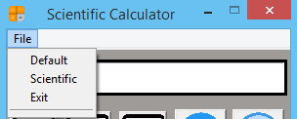

First a menu bar is created and placed within first frame. Then Sub-menus are placed within main menu by calling “Menu()” again and specifying name of main menu created within parenthesis . Then commands are added to the submenus and tear off is specified as “0”.

-2) Entry box

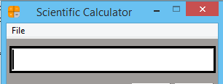

* Entry box is placed within the second frame using grid geometry manager.
* It’s thickness is highlighted.
* It’s relief is specified by the frame in which it is placed.
* Width of Entry box is adjusted according to the size of window.

-3)Buttons

There are total 48 buttons Each button instead of utilizing the conventional text format is assigned with a separate .png image for each. Using “PhotoImage” part of tkinter module image is imported from directory. Image is resized in order to fit button using “subsample”.Pixel size is used to specify x , y length

Buttons consist of command to insert value associated in them. Each button is placed in the frame using the grid geometry manger.

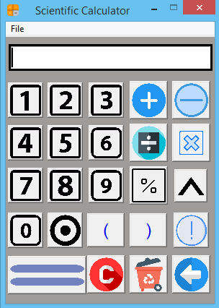

-4) Scientific Part

Whenever User wishes to use scientific functions of calculator user just needs to switch mode from “default” to “Scientific” in the menu bar. As soon as user clicks on it main window’s size is redefined and increased to house greater functionality. Any time user wants only “default” part to be displayed hiding the scientific part user is allowed to do so by selecting “default” command in menu bar. Hence, the user is not stuck to one respective mode.

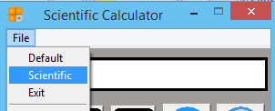

Fig: How to switch to scientific part.

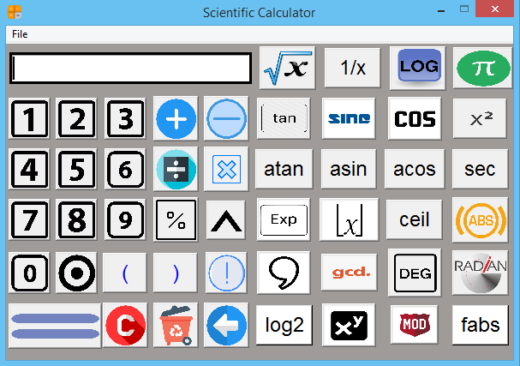

-5)Exit part

If User chooses “Exit” command from menu bar a “yes no” message box appears on screen. If user chooses “yes” then main window terminates. However , if the user chooses no then another message box “show info” displays information that you will be returned to original window .

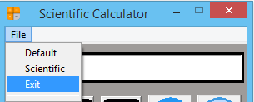

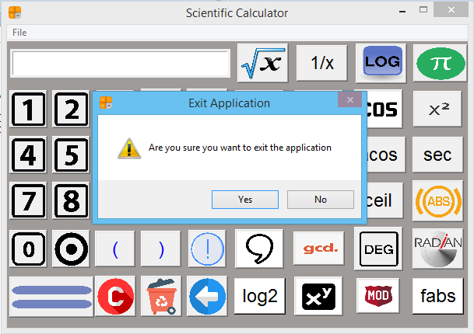

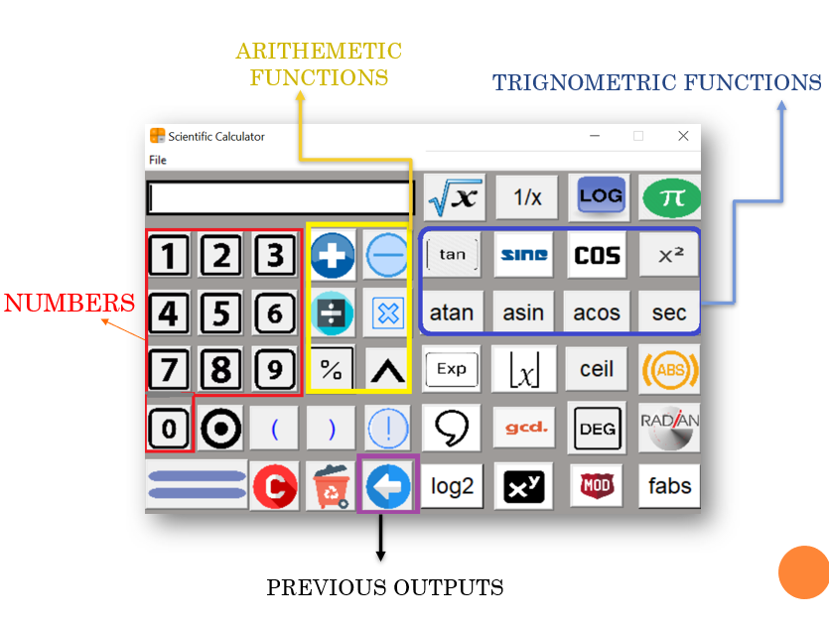

DATABASE CONNECTIVITY OF APPLICATION-

For database connectivity we have **mysql.connector** module. Firstly , we have connect our project with Mysql server of our System using **connect()** function of mysql.connector module. In , connect function we have passed the server name (In our case it is localhost) and the password of our mysql server.

After the successful connection we have created an database named as **calculator123** using execute() function then after that we have created a table in the calculator123 database named as **storevalues** . Table storevalues have one attribute named as **value** .

We have used database connectivity in our project to store all the previously saved outputs calculated by user.

By the use of previous button available in our gui interface user would be able to get the previously saved values in a sequence .

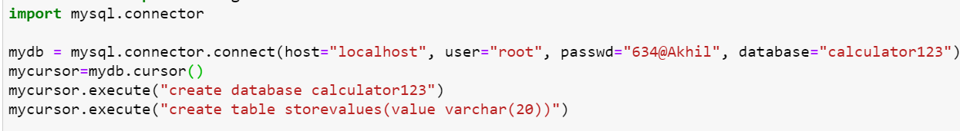

To store values in database we have written our sql query in calculate function so that when the user click the calculate function , at the same time the latest calculated value get saved into the storevalues table of our calculate123 databse.

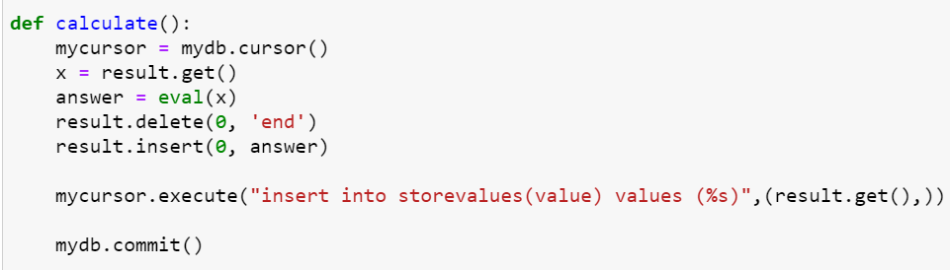

To extract the saved values from the database we have created an previous button and for achieving the actual functionality we have created an function named **previous()** .

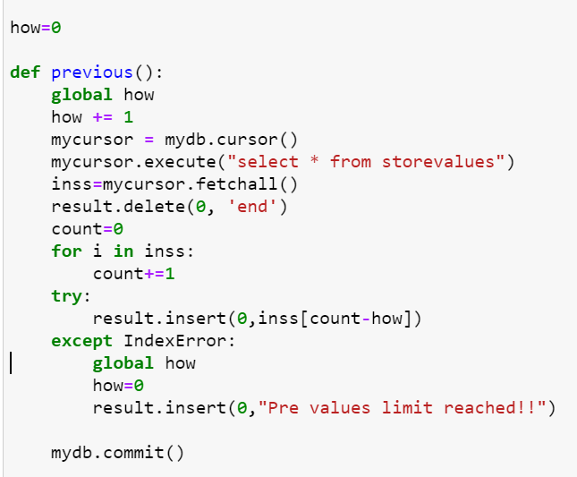

Also , when all the previous values gets extracted an warning message gets printed **“Pre values limit reached!!”**

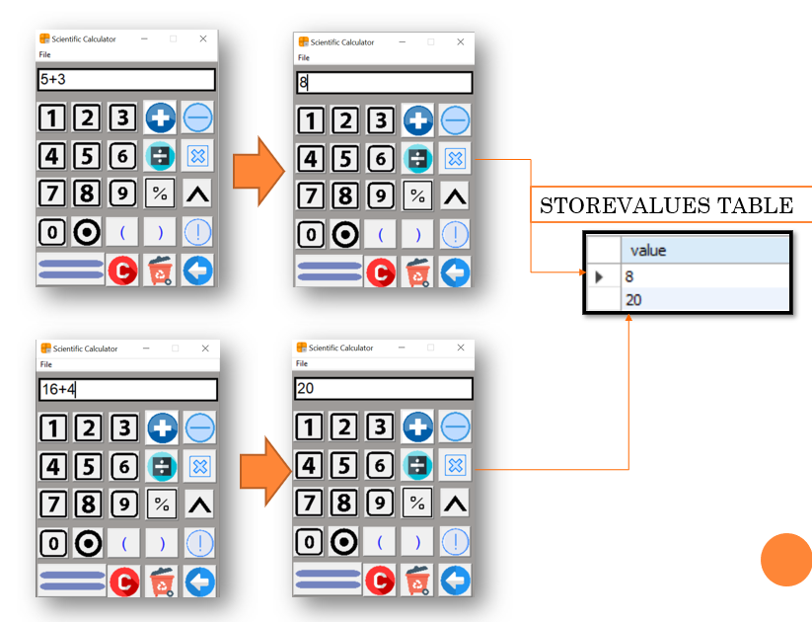

After we write the expression to be calculated we click the calculate button (For first case the value is 8 and for the second case the value is 20).

As soon as we click the calculate button for both the case the values will be automatically saved in the storevalues table of calculate123 database.

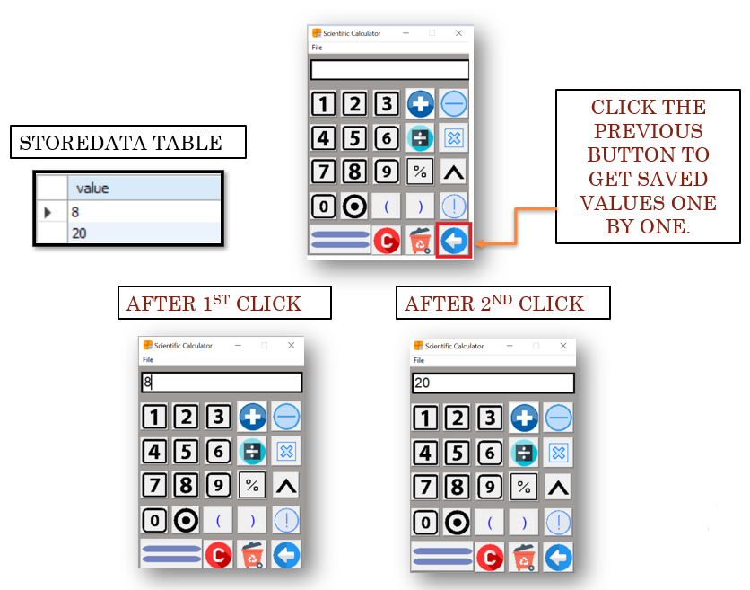

To extract the data we have created previous button for that purpose . When we will click the previous button the stored values will get inserted on the entry box one by one in the sequence the values got saved.

For the above example , after first click 8 will be printed and after second click 20 will be inserted in the entry box.

CONCLUSION AND LEARNING OUTCOME-

In this project we have created an complete scientific calculator . To implement it we have used tkinter module for GUI interface and for database connectivity we have used mysql.connector module . From tkinter module we have used different widgets like – Buttons , Message box , Entry box and menu bar . we have 48 buttons in total having different functionalities . For providing functionalities we have used math module .

To make our project more attractive we have used different attractive images for different buttons using PhotoImage() function. Our first interface is for default calculator which is a kind of simple calculator . To switch from default to scientific one we have used menu bar and when we are done with our calculation we can use exit option in our menu bar . Once , we will click the exit option an message box will appear for the conformation .

For database connectivity we have first created the required database and table . Then we have used then whenever required for the storage purpose of data . we have used an previous button to extract the data saved in our database.

* We have gone through deep learning about python tkinter module and how to get started with it.
* Learned about different widgets of tkinter module .
* Learned about database connectivity for an python GUI.
* We have used different photos for different buttons.
* We have learned how to use different styles to make our project more attractive.

REFERENCES-

* [**https://www.w3schools.com/python/**](https://www.w3schools.com/python/)
* [**https://www.geeksforgeeks.org/sql-using-python/**](https://www.geeksforgeeks.org/sql-using-python/)
* [**https://stackoverflow.com**](https://stackoverflow.com)
* [**www.tutorialspoint.com**](http://www.tutorialspoint.com)
* [**www.google.com**](http://www.google.com)
* [**www.quora.com**](http://www.quora.com)

------------THE END-------------