**ShopBridge(Manual Guide)**

**How to run the Project :**

Step 1: Open Visual Studio 2019 with all updated references and click Files -> Clone repository and then mention the Repostory location and the path where you need to clone the project.

**Repository Location** : <https://github.com/AkhilDhingra1993/InventoryShopBridge>

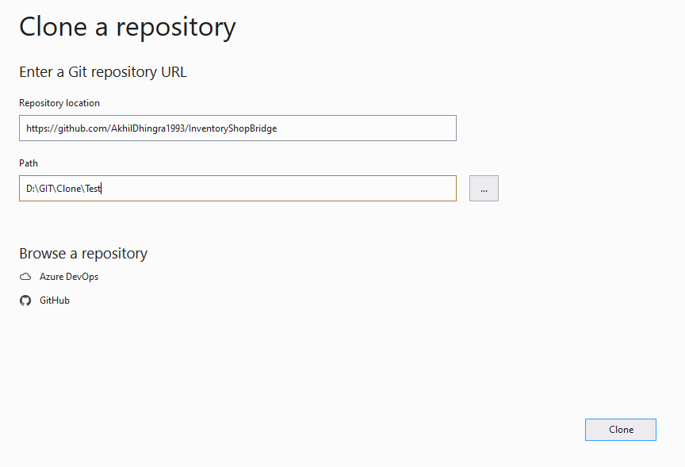

**Step 2 : Go to path “~\ShopBridge\DababaseScript” and restore the script of Database backup “InventoryDB“ in SQL server :**

**Path is as below :**

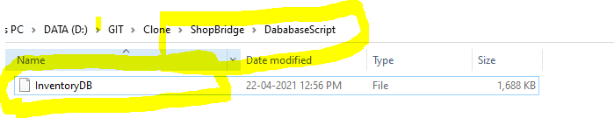

**Step 3 :** Your project should look line below screenshot:

**Project 1 :** ShopBridge - API Project

**Project 2 :** ShopBridgeDataAccess – ClassLiberary with edmx database connectivity.

**Step 4 :** below is the screenshot of Database and Projects included.

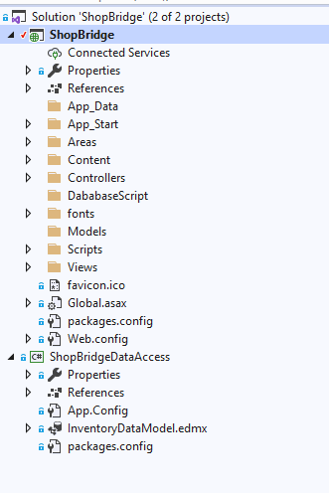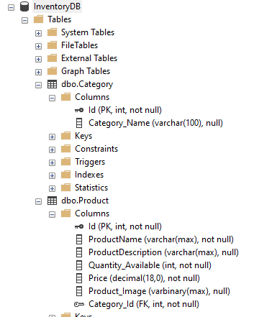

Step 5 : Go to **Web .config** and **App.config** and update the database connection string according to your local database in the below location:

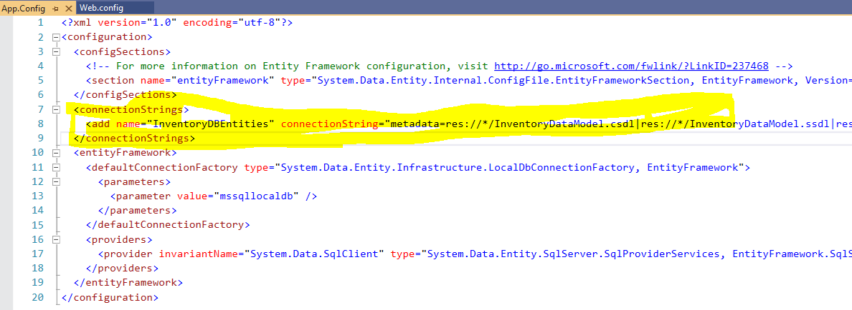

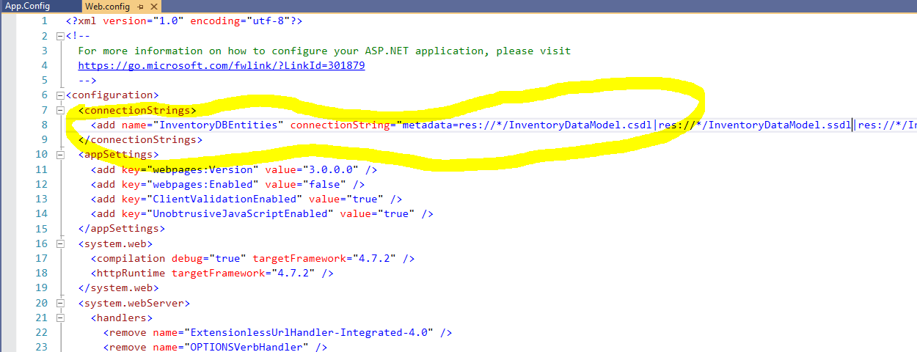

Step 6 : Select the **Project 1 : ShopBridge - API Project -** SET AS StartUp Project.

Step 7 : Run the project and lets wait till it runs and shows like below :

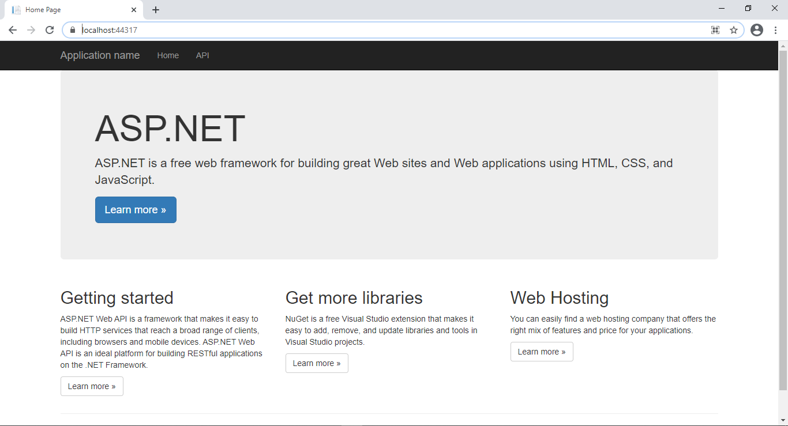

**Step 8 : Now open PostMan:**

Below API's to be run on Postman or any other tool.

For GET/Fetching the products

<https://localhost:44371/api/Products/>

<https://localhost:44371/api/Products/1>

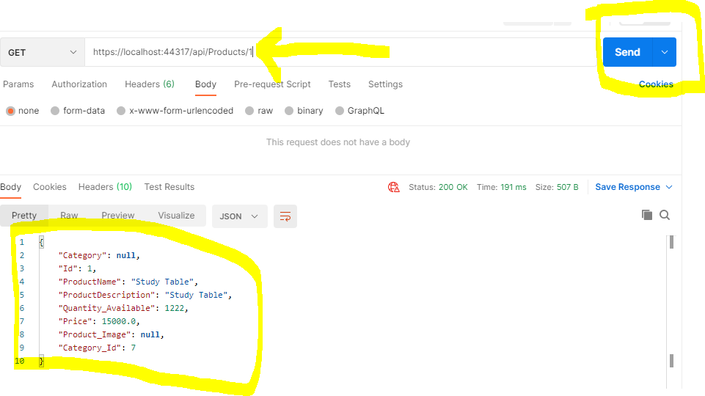

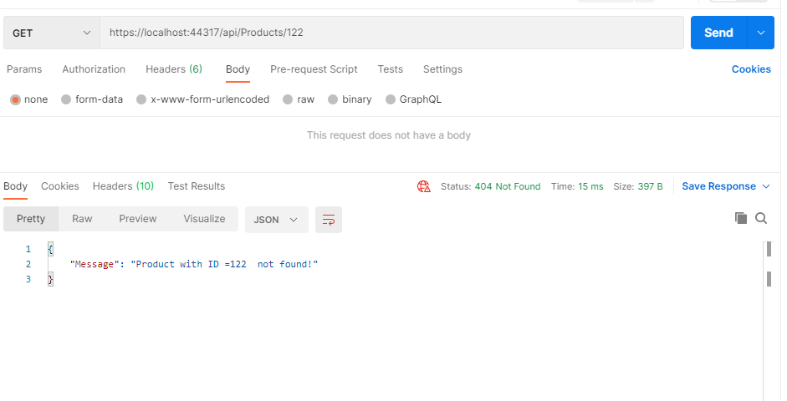

For GET/Fetching the Category

<https://localhost:44371/api/Category/>

<https://localhost:44371/api/Category/1>

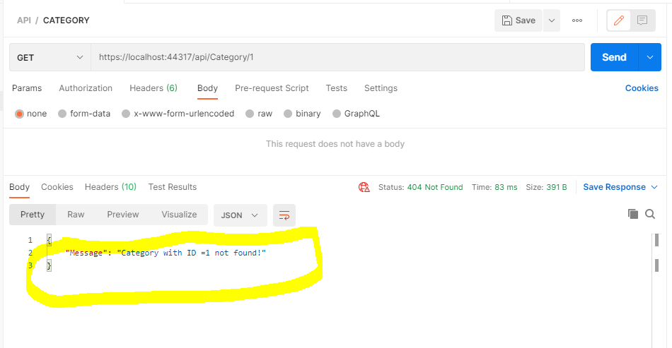

For Posting the data to Products

<https://localhost:44371/api/Products/>

{"ProductName": "Study Chair","ProductDescription": "Study Chair","Quantity_Available": 1222,"Price": 12367.12,"Product_Image": null,"Category_Id": 2}

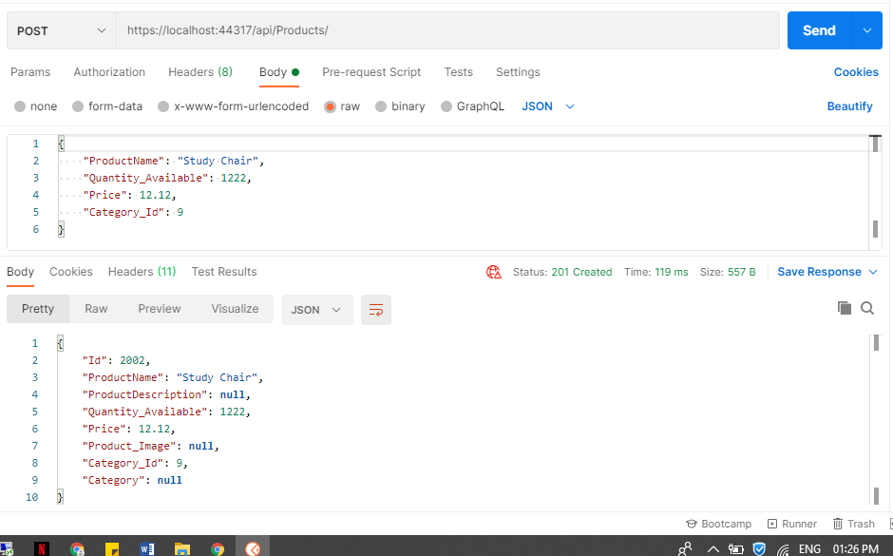

For Posting the data to Category

<https://localhost:44371/api/Category/>

 {"Category_Name": "Mobile" }

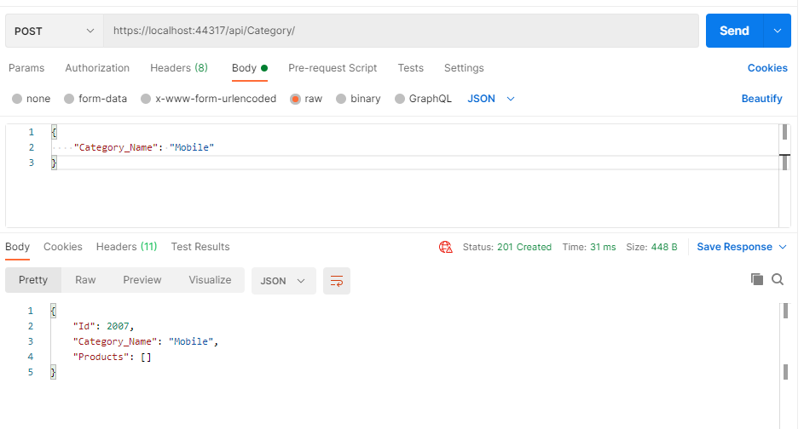

**DELETE the product**

<https://localhost:44371/api/Products/1>

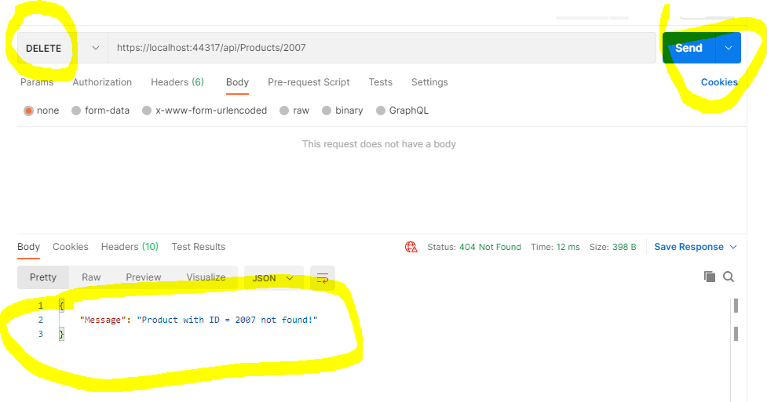

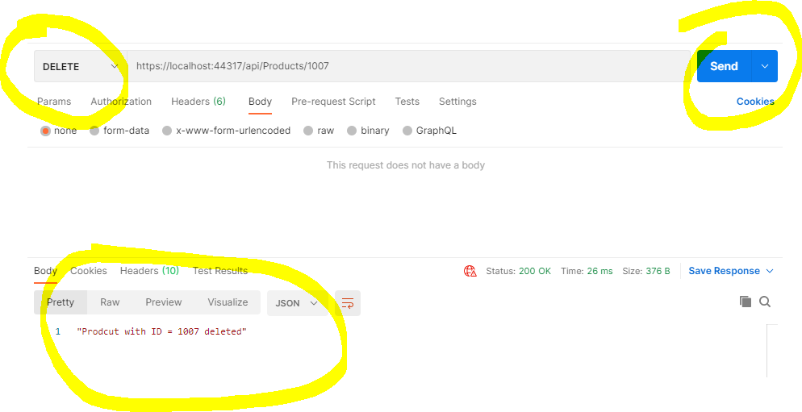

**DELETE the category**

https://localhost:44371/api/Category/4

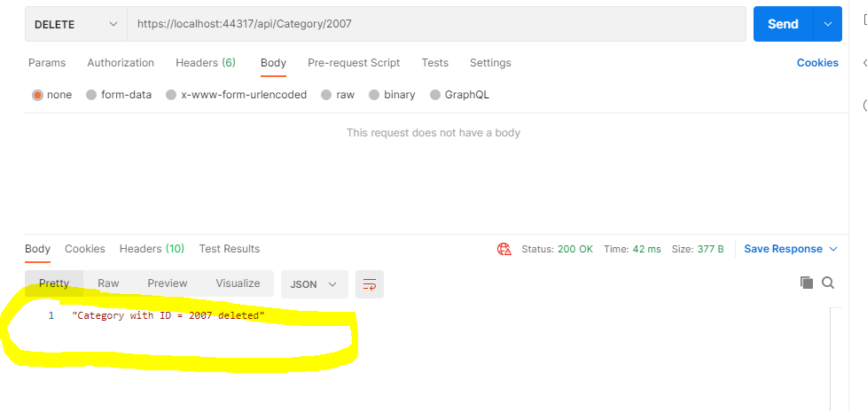

**Put/modify the Category and products**

<https://localhost:44371/api/Products/2>

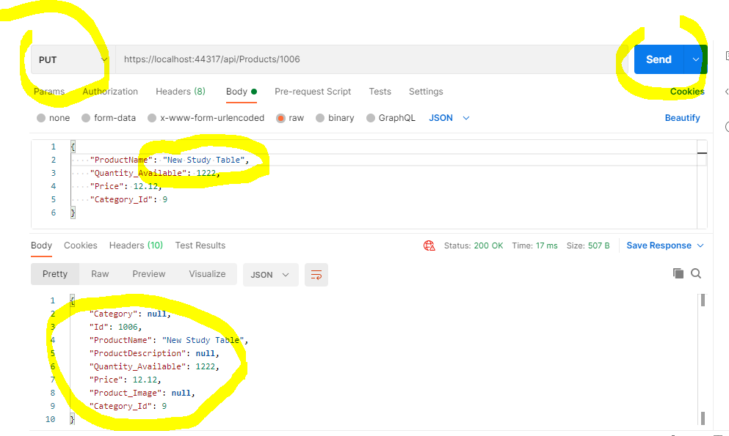

https://localhost:44371/api/Category/9

