**Doctor Appointment Booking System**

The output Images of the webpage will be:

1. **Home page**

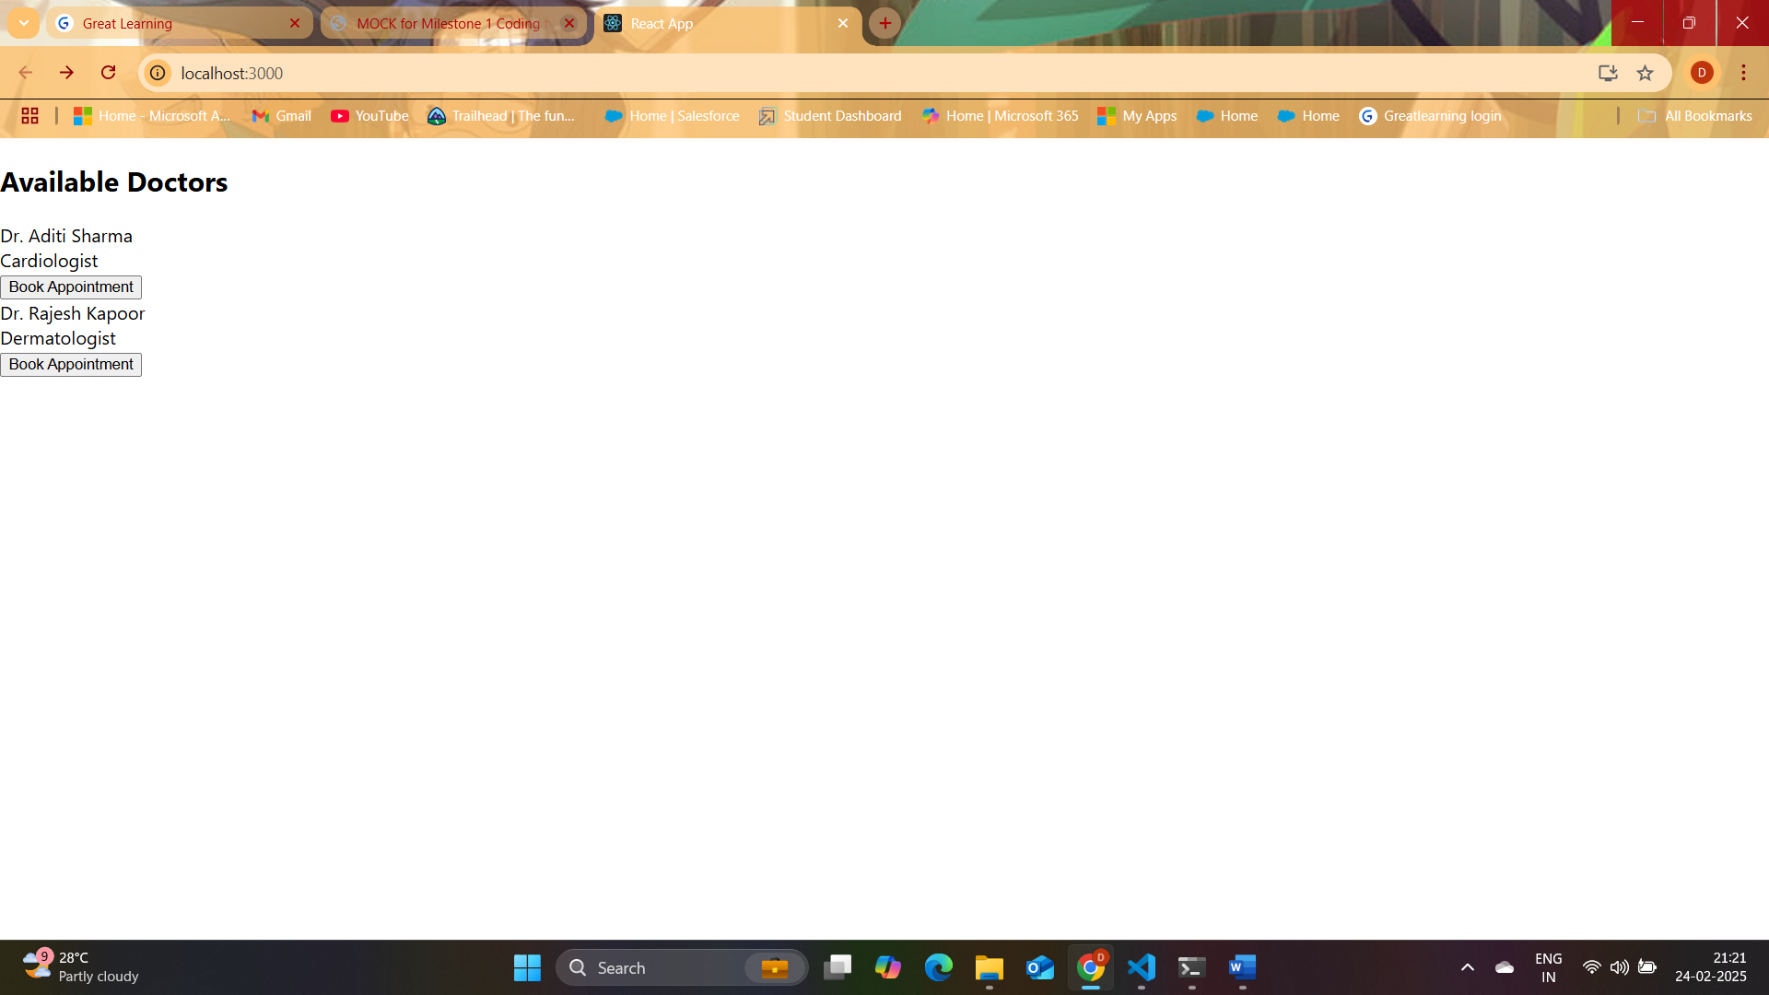

1. **Booking Page**

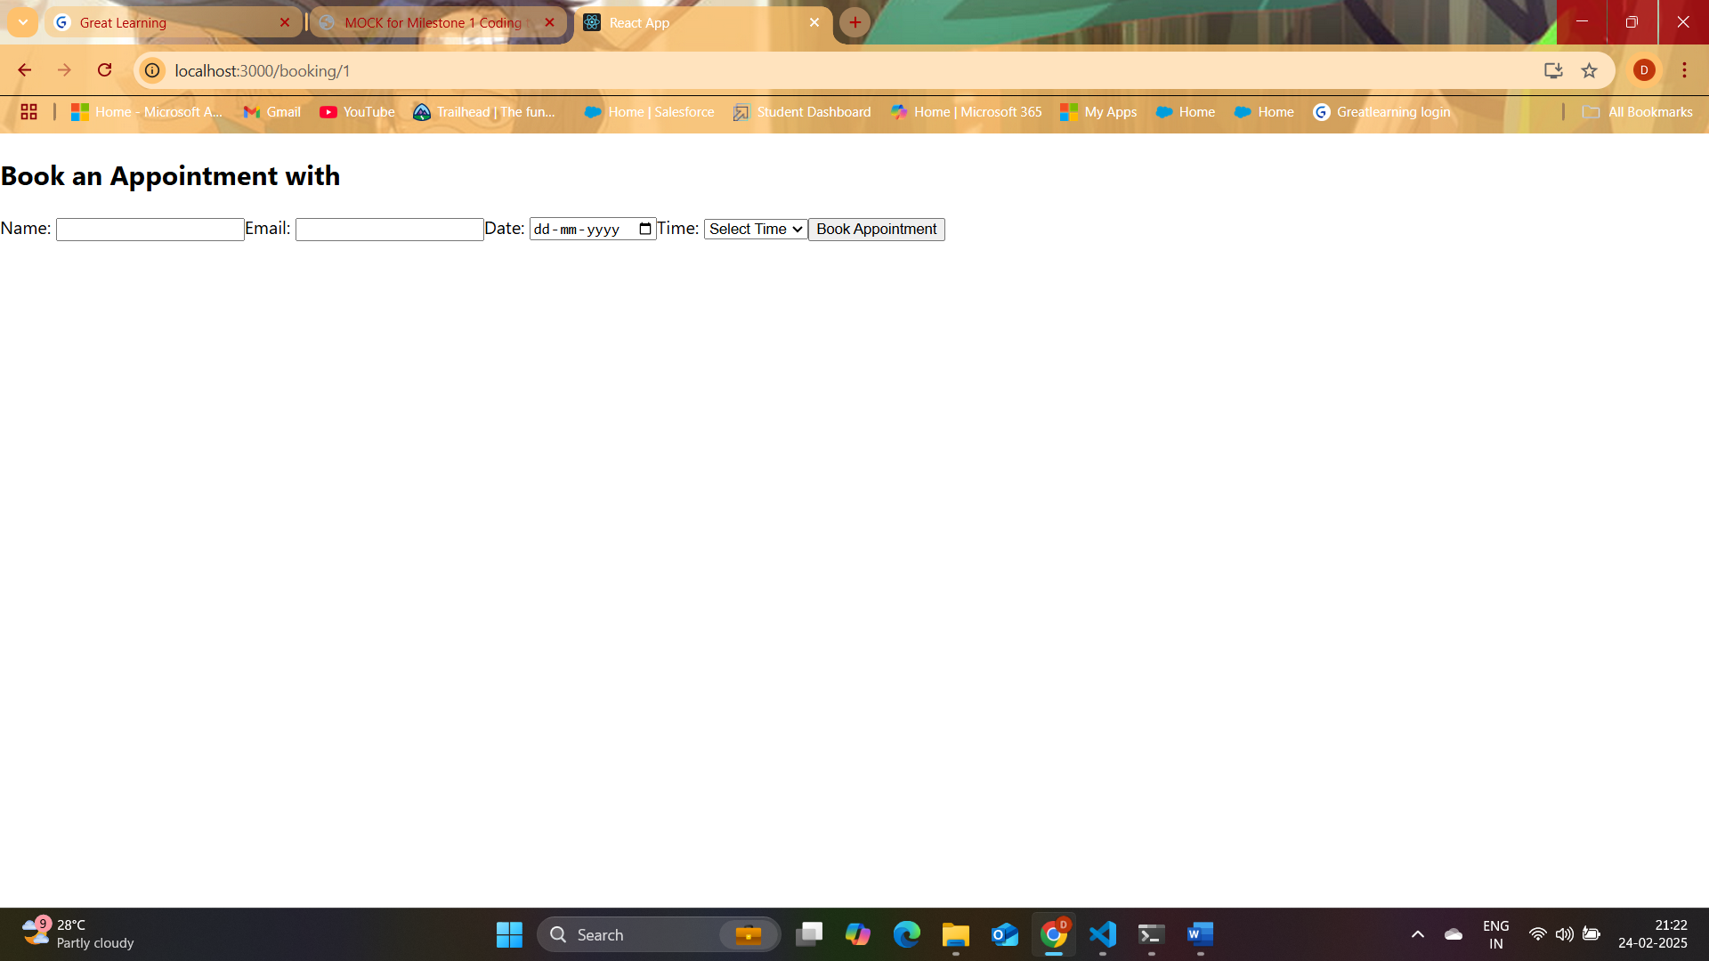

1. **Booking Successful Popup**

