Retail Sales & Customer Analytics
SQL + Excel Project — Project Case Study Document

1. Problem Statement
A mid-size online retailer selling all-occasion gift-ware needs to understand which customers, countries, and products actually drive profitable revenue, and where operational issues (cancellations, discount-heavy sales) are eroding it. Leadership wants a data-backed view to inform Q1 marketing and retention budget allocation, and to flag markets or customer segments that need operational attention.

2. Dataset Used
Online Retail II — UCI Machine Learning Repository. Real transaction-level data from a UK-based, non-store online retailer, covering all transactions between 1 December 2009 and 9 December 2011.
Metric | Value
Raw rows (2 sheets combined) | 1,067,371
Rows after cleaning | 1,027,017
Countries represented | 43
Unique customers | 5,878
Unique products (StockCodes) | 5,305
Date range | 01 Dec 2009 – 09 Dec 2011

3. Tools & Technologies
- SQLite (SQL) — data modeling, cleaning validation, and all analytical queries
- Microsoft Excel (openpyxl) — executive KPI dashboard, pivot-style summaries, and a discount what-if simulator

4. Methodology

4.1 Data Cleaning (documented decisions)
Issue Found | Rows Affected | Decision & Rationale
Missing Description | 4,382 | Dropped — can't analyze an unnamed product line
Cancelled orders (Invoice starts with 'C') | 19,494 | Kept, flagged with IsCancelled — needed to calculate cancellation rate as a business KPI, not just removed
Zero or negative price | 6,207 | Dropped — these are internal adjustments/samples, not real sales, and would distort revenue
Exact duplicate rows | 34,335 | Dropped — same invoice/product/qty/date/price/customer repeated, almost certainly double-scan errors
Missing Customer ID | 229,202 (kept) | Retained and flagged as guest/unlinked purchases rather than dropped, since they still represent real revenue

Net result: 40,354 rows removed (3.8% of raw data) — a realistic cleaning rate for genuine transactional data, not an over-aggressive cleanup that would distort the analysis.

4.2 SQL Analysis
Queries were written in progressive difficulty, from basic aggregation through advanced window functions and CTE-based customer segmentation (see accompanying analysis_queries.sql file):
- Basic: total revenue/orders/customers, revenue by country
- Intermediate: monthly revenue trend, CASE WHEN price-band segmentation, top products
- Advanced: month-over-month growth using LAG(), RFM customer segmentation using CTEs + NTILE(), RANK() to find each country's best-selling product, running total revenue with window functions, and cancellation-rate-by-country using conditional aggregation

4.3 Excel Deliverable
Built as a 6-tab workbook (Retail_Sales_Analytics.xlsx): Executive Summary (KPI cards + key findings, all formula-driven), Monthly Trend (with line chart), Country Analysis (with bar chart and formula-calculated revenue share/AOV), RFM Segments (with formula-calculated averages and % of revenue), a What-If Discount Simulator (adjustable input cell recalculates projected impact), and a Raw Data Sample tab (1,000-row sample, since the full 1M+ row dataset exceeds what's practical to browse in a single sheet).

5. Key Findings
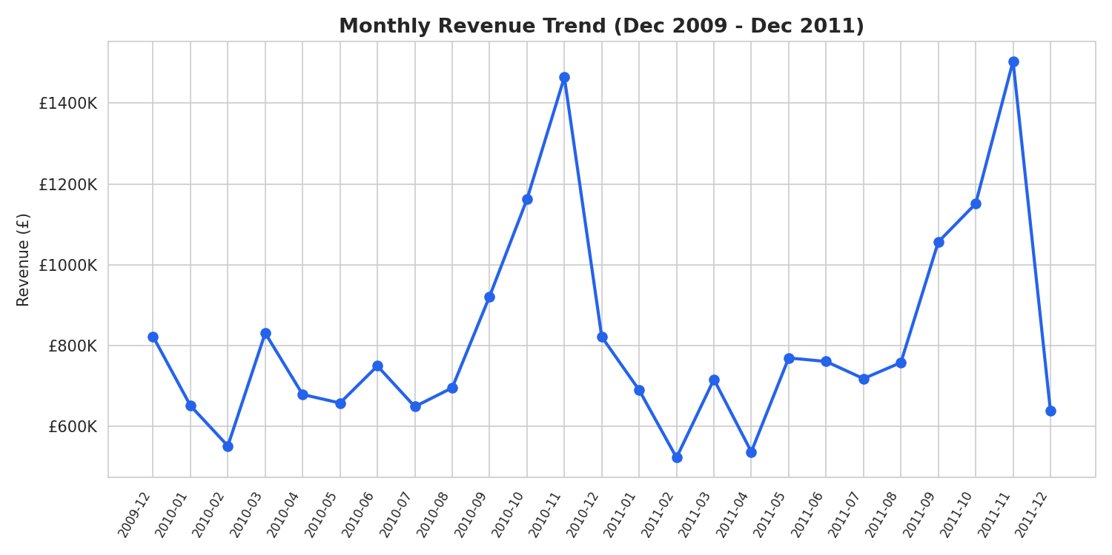
Revenue is strongly seasonal — a clear pre-Christmas peak in November each year (gift-retail seasonality) followed by a January-February dip. This should directly inform inventory and staffing planning.
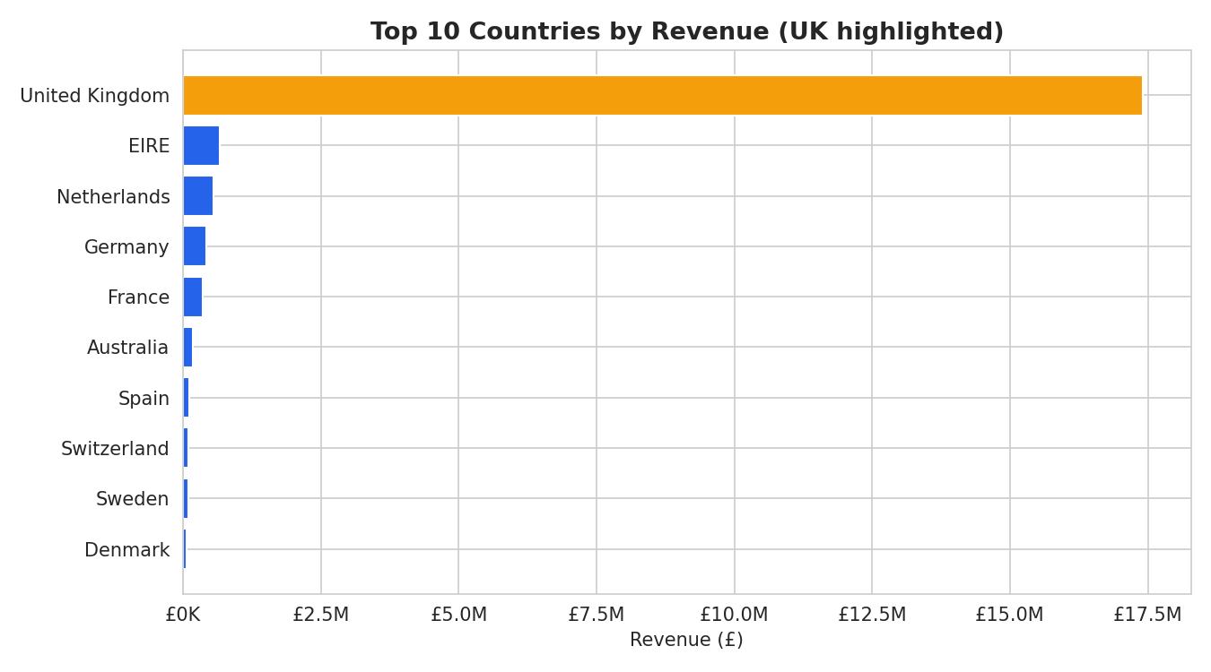
The UK generates roughly 85% of all revenue (£17.4M of £20.5M). While that reflects the retailer's core market, it's also a concentration risk — a shift in the UK market disproportionately affects the whole business. EIRE, the Netherlands, and Germany are the strongest secondary markets.
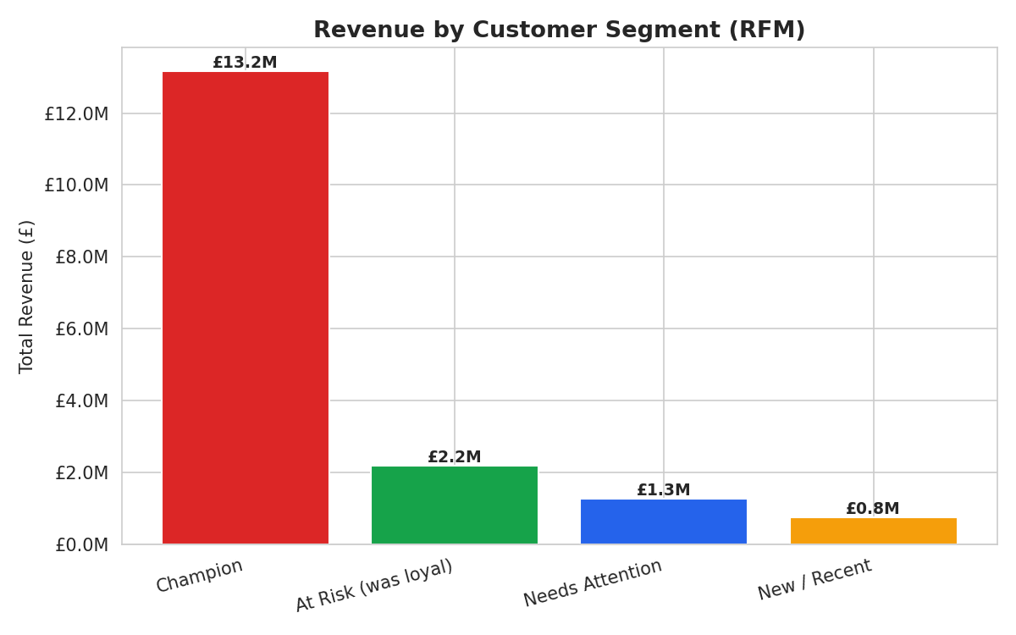
RFM segmentation is the standout finding: the 1,814 'Champion' customers (about 31% of the customer base) generate roughly 64% of total revenue (£13.2M). This is a classic Pareto pattern — the business's health depends disproportionately on a small, high-value group, which is exactly the kind of insight a discovery-only dashboard would miss.
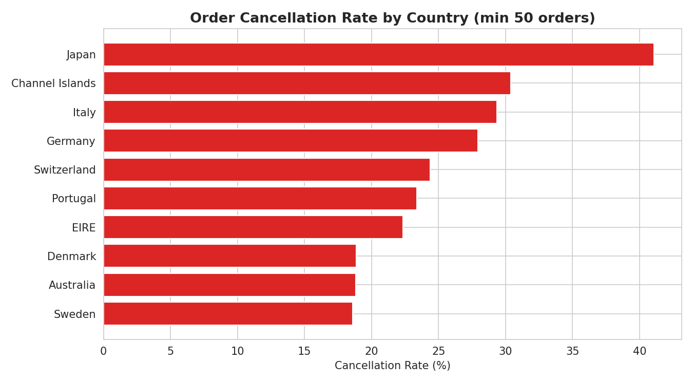
Japan, Channel Islands, and Italy show cancellation rates of 29-41%, more than double the overall average. At this scale it's unlikely to be random — it points to a market-specific issue (sizing/fit expectations, delivery cost surprises, or communication gaps) worth investigating operationally.
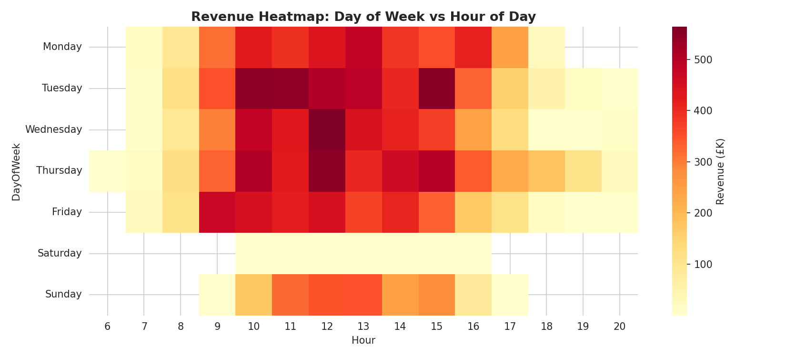
Wednesday and Thursday between 10am and 3pm are consistently the highest-revenue windows. This is a directly actionable input for email/ad campaign scheduling.

6. Business Impact & Recommendations
- Champion-segment retention program: protecting the £13.2M revenue base concentrated in 1,814 customers is a higher-ROI priority than broad top-of-funnel acquisition spend.
- Investigate fulfilment in Japan, Channel Islands & Italy: even halving the cancellation rate in these three markets could recover an estimated £15,000-£20,000 in orders that currently fall through.
- Shift campaign timing to Wed/Thu 10am-3pm based on observed engagement patterns, rather than a flat weekly send schedule.
- Consider a deliberate second-market push into Netherlands or Germany, which already show organic demand, to reduce reliance on the UK market.

7. Files in This Deliverable
File | Contents
analysis_queries.sql | 12 SQL queries, basic to advanced (window functions, CTEs, RFM)
retail.db | SQLite database with the cleaned 1,027,017-row transactions table
Retail_Sales_Analytics.xlsx | 6-tab Excel workbook: KPIs, trends, country/segment analysis, what-if simulator
retail_cleaning_eda.py | Python cleaning + chart-generation script
charts/ | 6 PNG chart exports used in this document and the presentation

