ZOMATO BANGALORE RESTAURANTS
Exploratory Data Analysis Report
A Python-Based Data Analysis Project
Dataset: 51,660 restaurant listings across Bangalore
Tools: Python (pandas, matplotlib, seaborn)
Prepared by: Data Analytics Team
Date: September 2026

1. Executive Summary
This report presents a comprehensive exploratory data analysis (EDA) of 51,660 restaurant listings scraped from Zomato for the city of Bangalore, India. The objective is to understand the competitive landscape of Bangalore's restaurant industry — pricing patterns, cuisine popularity, service features, and the factors that are associated with higher customer ratings — in order to generate actionable business insight for restaurant owners, aggregator platforms, and prospective investors.
The analysis covers data cleaning, univariate and bivariate exploration, correlation analysis, and locality-level benchmarking. All figures in this report were generated programmatically using Python (pandas for data wrangling, matplotlib/seaborn for visualization) and are fully reproducible using the accompanying analysis scripts.
51,660  Restaurants Analyzed | 3.7 / 5  Average Rating | 93  Localities Covered | 58.8%  Accept Online Orders

Key Takeaways
- Table booking is the strongest quality signal: Restaurants that accept table booking average a 4.14 rating versus 3.62 for those that don't — the single largest rating gap found in the dataset.
- North Indian cuisine and BTM dominate supply: North Indian is the most common primary cuisine (12,287 restaurants), and BTM is the most saturated locality (5,114 listings).
- Premium micro-markets exist: Lavelle Road has the highest average rating (4.14/5) among localities with 30+ restaurants, suggesting a cluster of premium dining establishments.
- Price and popularity both track with quality: Cost for two and rating show a moderate positive correlation (r = 0.399), and votes correlate even more strongly with rating (r = 0.434), indicating popular restaurants tend to be better reviewed.
- Quick Bites lead the format mix: Quick Bites is the dominant restaurant format (19,498 listings), reflecting Bangalore's fast-casual dining culture.

2. Introduction & Objectives
Bangalore is one of India's largest and most dynamic food markets, home to tens of thousands of restaurants ranging from street-side quick bites to fine dining establishments. Understanding what drives customer satisfaction and where competitive gaps exist is valuable for restaurant owners planning new outlets, food-delivery platforms optimizing recommendations, and investors evaluating the sector.

2.1 Objectives
- Profile the overall structure of Bangalore's restaurant market (locations, cuisines, formats, price points).
- Quantify the relationship between service features (online ordering, table booking) and customer ratings.
- Identify high-performing localities and cuisine segments.
- Examine how cost, popularity (votes), and menu breadth (cuisine count) relate to rating.
- Translate findings into concrete recommendations for restaurant operators and platform strategy.

2.2 Dataset Overview
The source dataset (zomato.csv) contains 51,660 rows, each representing a restaurant listing (a single physical restaurant can appear multiple times if it is listed under several service categories such as Delivery, Dine-out, or Buffet). The raw data includes 17 fields covering restaurant identity, location, service features, pricing, cuisines, customer reviews, and ratings.

3. Data Cleaning & Methodology
Real-world scraped data required substantial cleaning before analysis. The following steps were applied using a dedicated Python script (01_clean_data.py):
- Removed non-analytical columns: url, phone, and menu_item (unstructured/low analytical value).
- Parsed the rate field (e.g. "4.1/5") into a numeric rating column; entries marked "NEW" or "-" were treated as missing (19.4% of rows had no rating yet).
- Converted approx_cost(for two people) from a comma-formatted string to a numeric field, and capped extreme outliers at the 99th percentile for cleaner visualizations while preserving the raw values.
- Standardized online_order and book_table into binary flags (1 = Yes, 0 = No).
- Parsed the reviews_list field (a Python-literal list of tuples) to derive a review_count feature capturing how many individual reviews were captured for each listing.
- Extracted primary_cuisine and cuisine_count from the multi-value cuisines field, and primary_rest_type from rest_type, to enable clean categorical grouping.
- Removed 57 exact duplicate rows and validated that all ratings fall within the valid 1–5 range.
After cleaning, the analysis-ready dataset contains 51,660 rows and 18 well-typed columns, saved to zomato_clean.csv.

4. Analysis & Findings

4.1 Rating Distribution
Ratings are approximately bell-shaped and left-skewed, centered around 3.7 (median 3.7). Very few restaurants score below 2.5 or above 4.7, indicating that Zomato's rating scale on this dataset is compressed — most restaurants cluster in the "decent to good" range (3.3–4.2), making relative comparisons more meaningful than absolute scores.
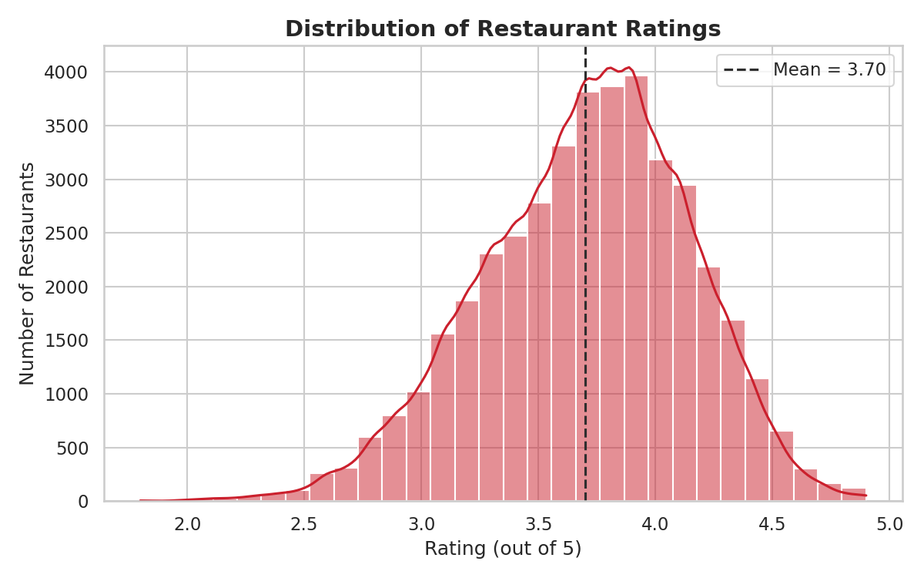
Figure 1: Distribution of restaurant ratings across all listings.

4.2 Impact of Online Ordering
58.8% of listings accept online orders. Restaurants offering online ordering have a marginally higher average rating (3.72) than those that don't (3.66). The effect is real but modest — online ordering appears to be table stakes rather than a strong differentiator on its own.
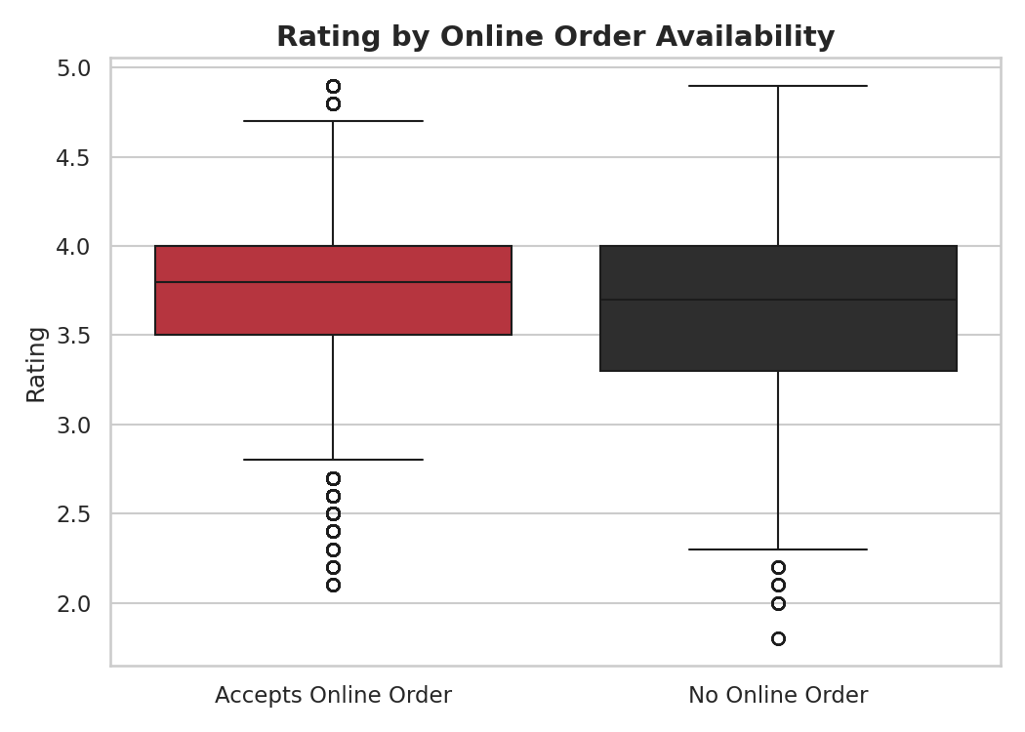
Figure 2: Rating distribution split by online order availability.

4.3 Impact of Table Booking
Table booking shows the strongest relationship with rating in the entire dataset. Only 12.5% of restaurants offer table booking, but those that do average 4.14 versus 3.62 for those that don't — a gap of 0.52 points. Table booking is typically offered by more established, higher-service-standard restaurants (fine dining, casual dining with reservations), which explains the strong association.
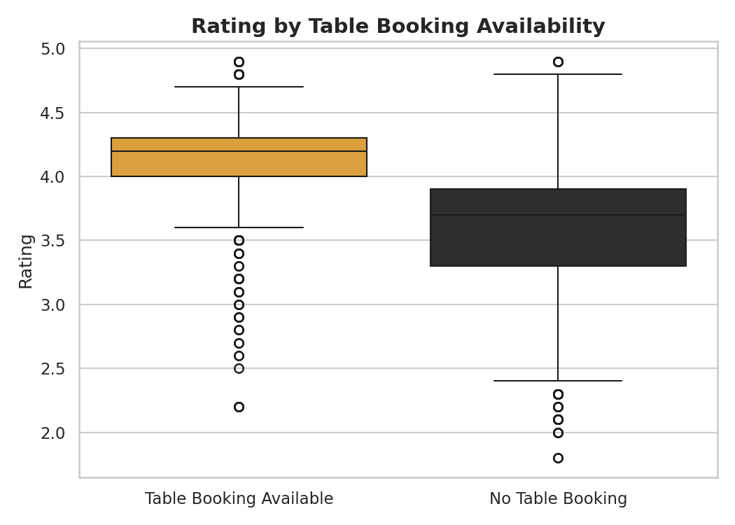
Figure 3: Rating distribution split by table booking availability.

4.4 Geographic Concentration
Restaurant supply is highly concentrated: BTM alone hosts 5,114 listings, and the top 15 localities account for a large share of the market across 93 total localities tracked.
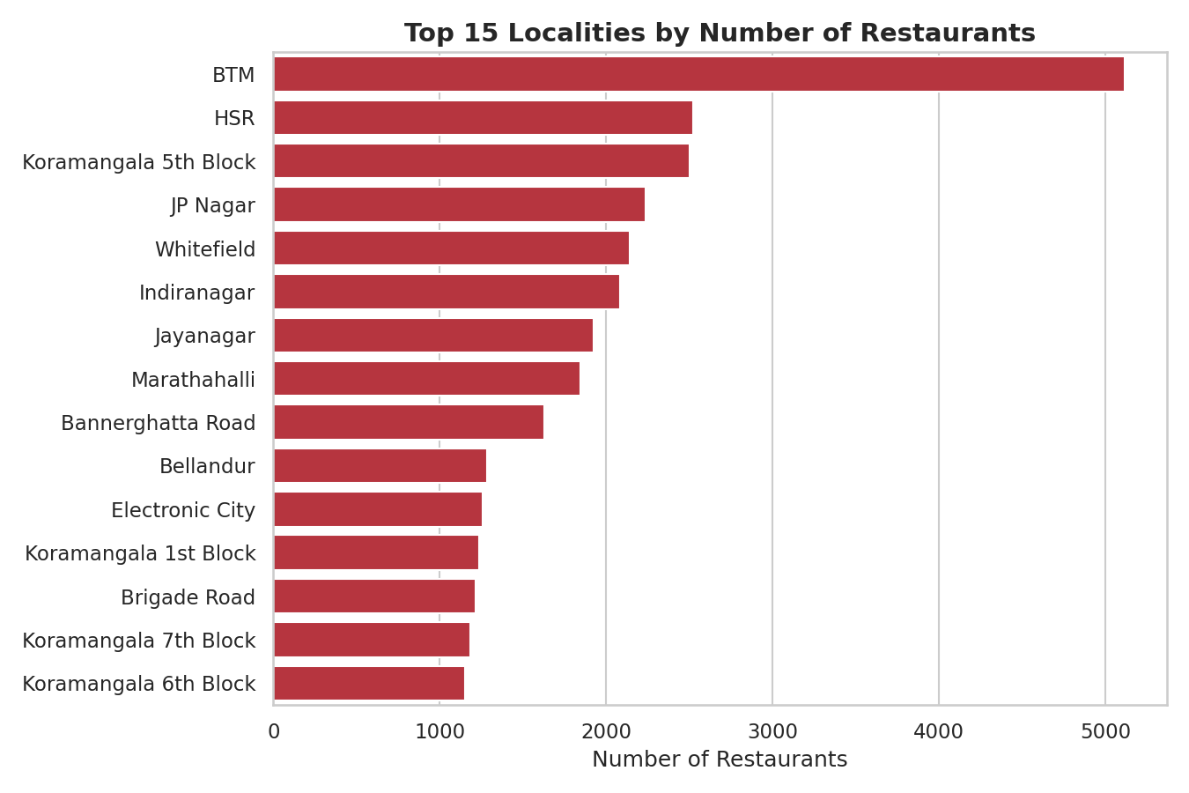
Figure 4: Top 15 localities ranked by number of restaurant listings.
However, raw restaurant count does not equal quality. Ranking localities by average rating (restricted to localities with at least 30 restaurants to avoid small-sample noise) surfaces a different set of leaders:
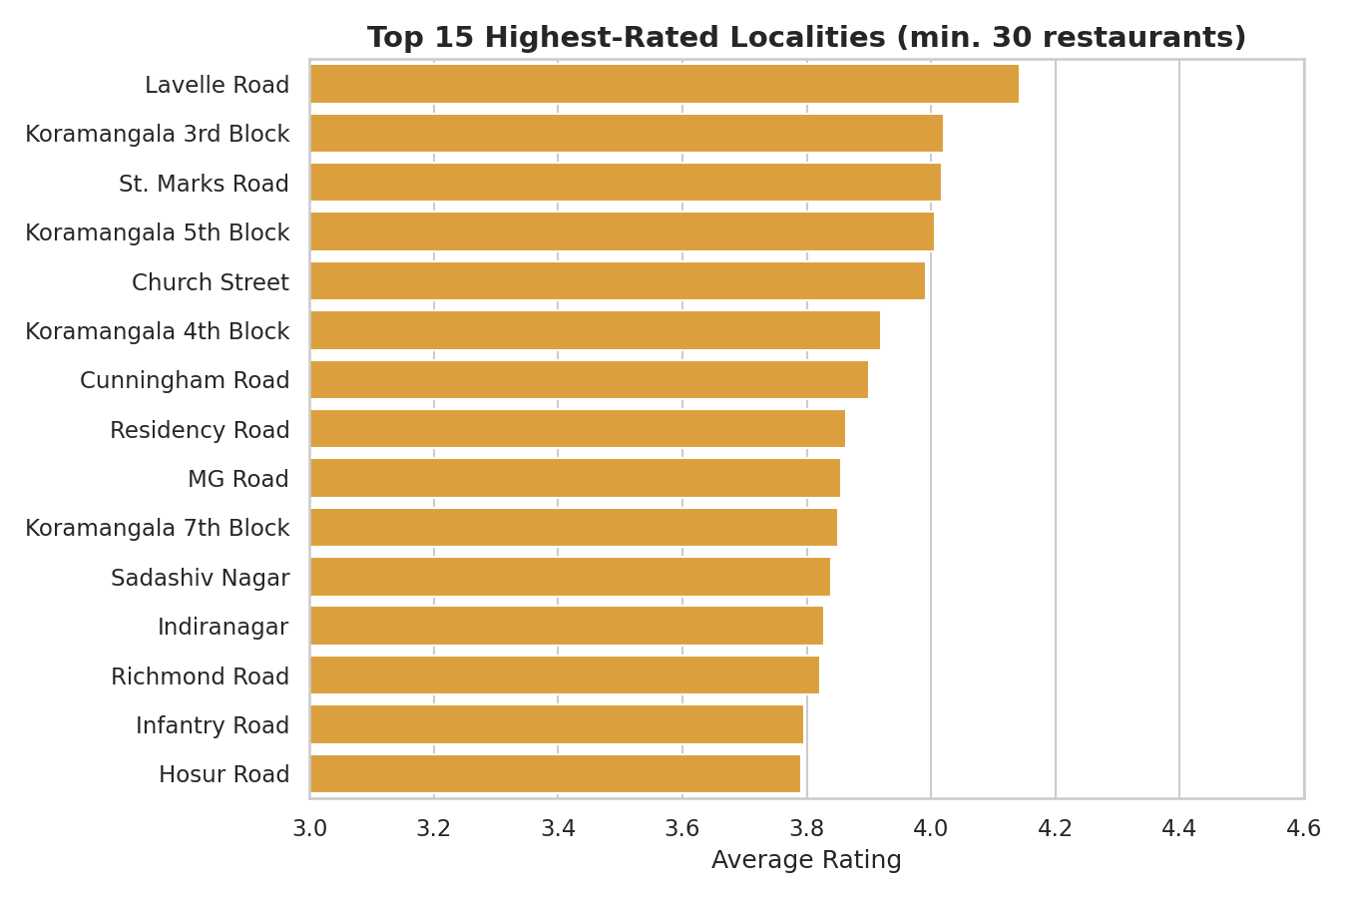
Figure 5: Top 15 highest-rated localities. Lavelle Road leads with an average rating of 4.14.

4.5 Cuisine Landscape
North Indian is the single most common primary cuisine, appearing in 12,287 listings, reflecting broad, mainstream demand. When all cuisine combinations are considered (e.g. "North Indian, Chinese"), the dataset contains 2,723 distinct combinations, showing that most restaurants differentiate by blending 2–3 cuisines rather than specializing narrowly.
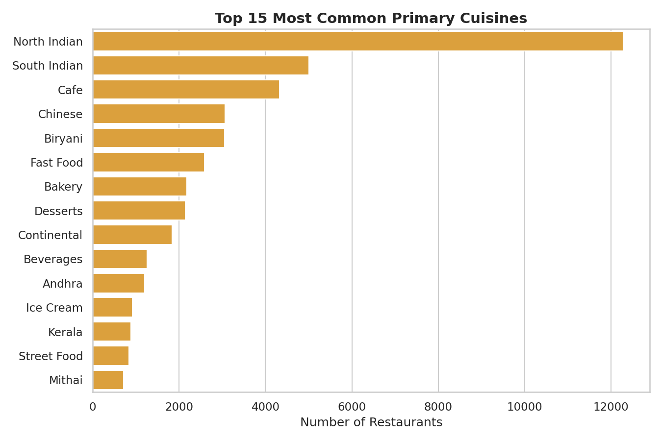
Figure 6: Top 15 most common primary cuisines.
Restaurants offering a moderate number of cuisines (2–4) tend to rate slightly better than ultra-specialized single-cuisine spots or those spreading themselves across many cuisines:
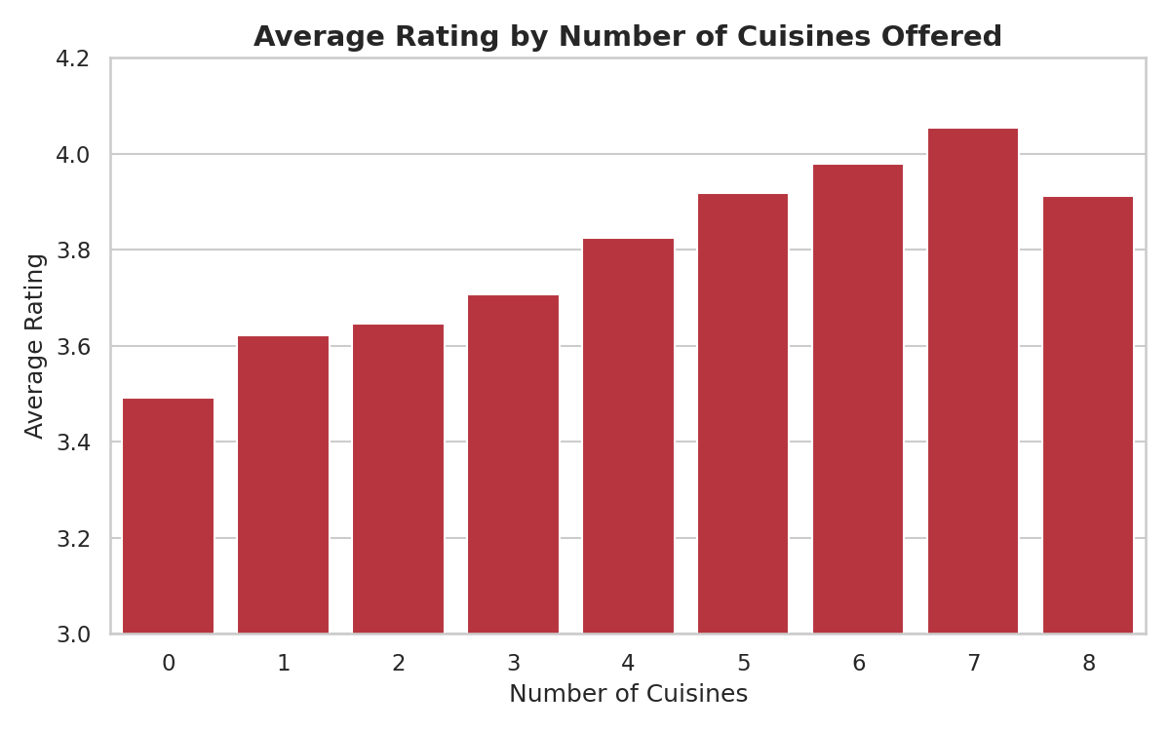
Figure 7: Average rating by number of cuisines offered.

4.6 Restaurant Format Mix
Quick Bites is the dominant restaurant format in Bangalore, with 19,498 listings — consistent with a market driven by convenience, delivery, and casual on-the-go dining rather than formal sit-down experiences.
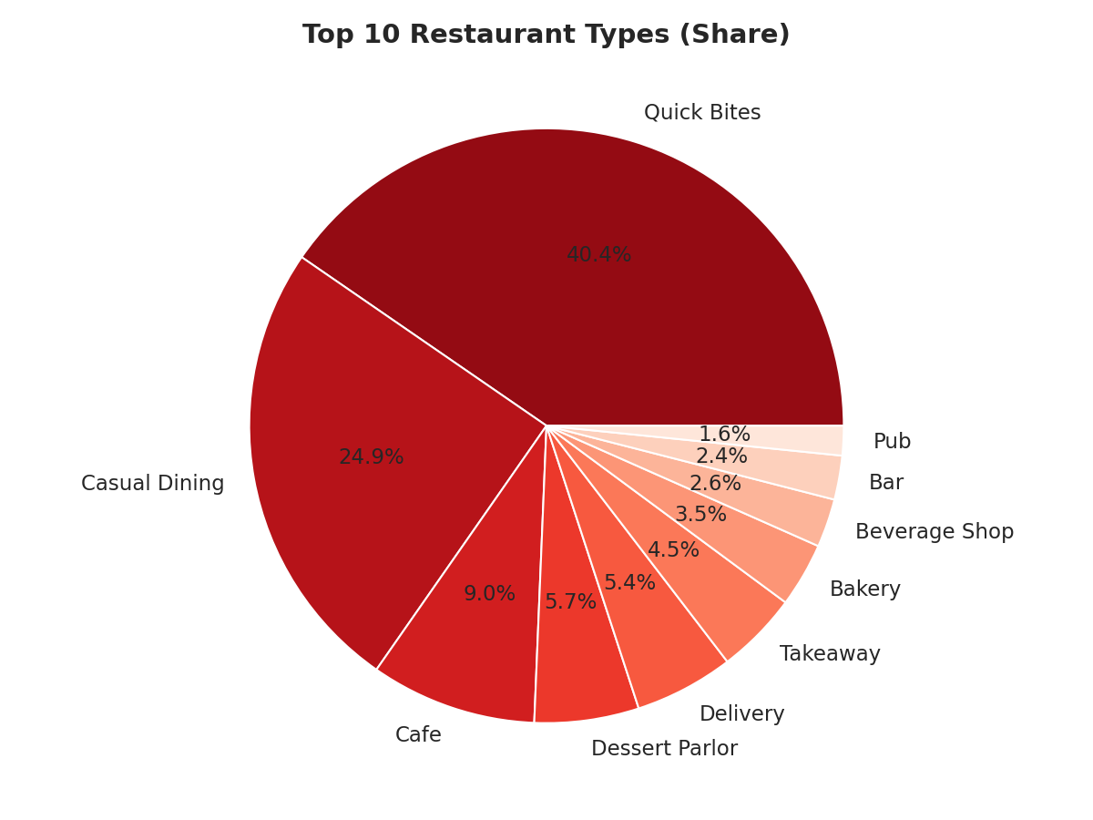
Figure 8: Share of the top 10 restaurant types.
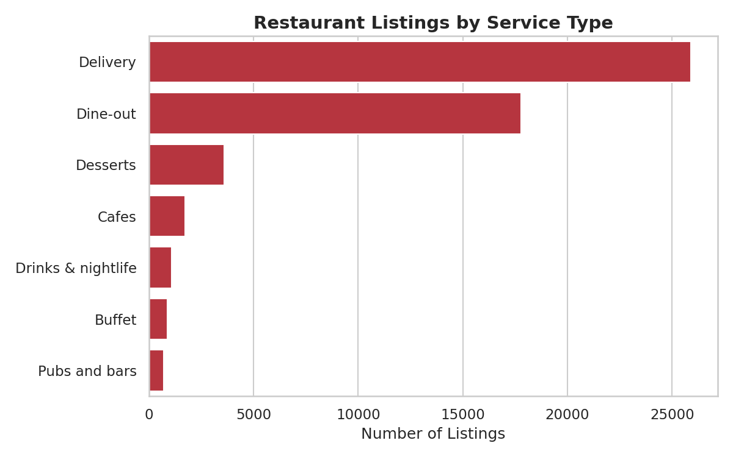
Figure 9: Restaurant listings broken down by Zomato service category (Delivery, Dine-out, Buffet, etc.).

4.7 Pricing Analysis
The average cost for two is ₹555 (median ₹400), reflecting a market skewed toward affordable dining with a long tail of premium establishments. Cost shows a moderate positive correlation with rating (r = 0.399) — pricier restaurants tend to invest more in food quality, ambience, and service, which shows up in ratings, though the relationship is far from deterministic.
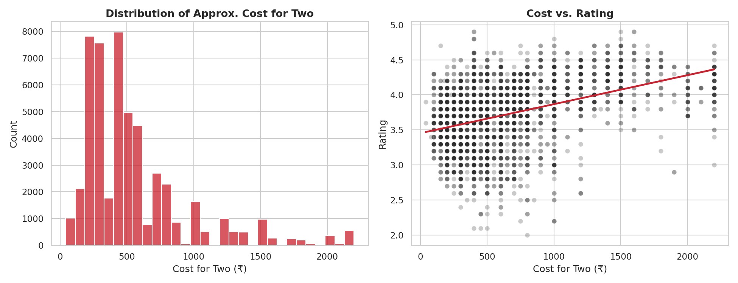
Figure 10: Distribution of cost for two (left) and cost vs. rating relationship (right).

4.8 Popularity vs. Quality
Number of votes correlates with rating at r = 0.434, a stronger relationship than cost. This makes intuitive sense: restaurants that are genuinely good accumulate more repeat visits and reviews, creating a reinforcing cycle. Restaurants with very few votes show much higher rating volatility, since a handful of reviews can swing an average sharply in either direction.
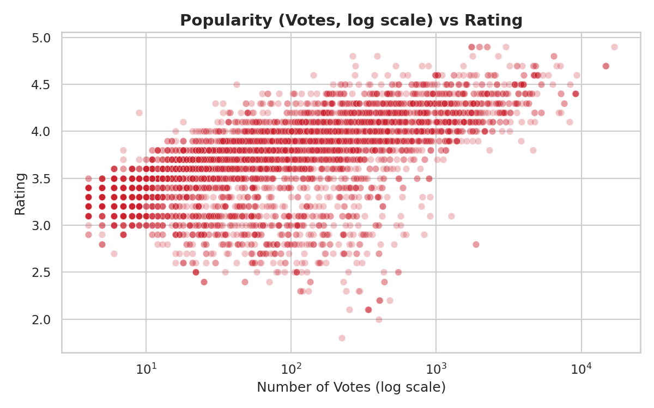
Figure 11: Relationship between number of votes (log scale) and rating.

4.9 Correlation Summary
The heatmap below consolidates the relationships between all key numeric features. Votes and rating show the strongest positive correlation, followed by cost. Online ordering and table booking show weaker but positive associations with rating, consistent with the boxplot findings above.
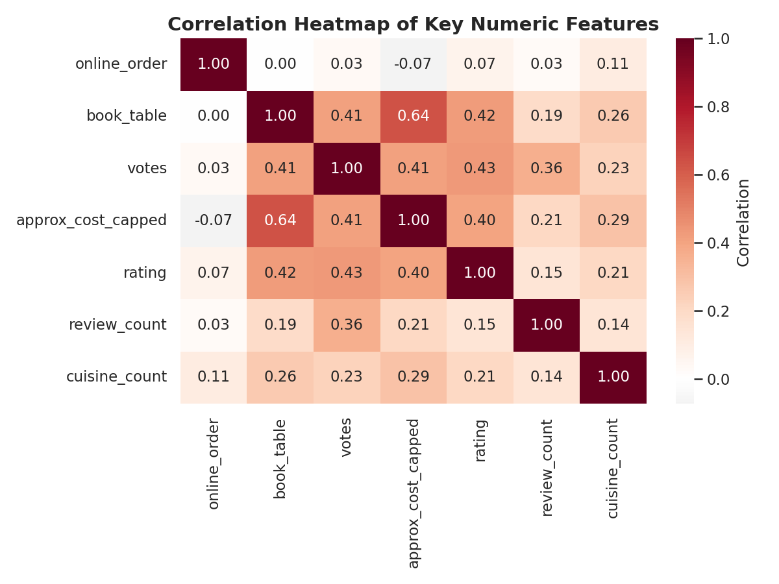
Figure 12: Correlation heatmap of key numeric features.

5. Business Recommendations

For Restaurant Owners
- 1. Enable table reservations where feasible — it shows the strongest association with higher ratings, likely reflecting operational maturity and service quality that customers reward.
- 2. Treat online ordering as a baseline requirement rather than a differentiator; competitive advantage will need to come from food quality and service.
- 3. Consider offering 2–4 complementary cuisines rather than an overly narrow or overly broad menu, matching the sweet spot observed in the rating data.
- 4. Evaluate expansion into under-served but promising localities identified in Figure 5 (e.g. Lavelle Road), which combine high average ratings with room for additional supply relative to saturated hubs like BTM.

For Zomato / Aggregator Platforms
- 1. Use vote count as a leading indicator of restaurant quality for ranking algorithms, since it correlates more strongly with rating than price does.
- 2. Introduce a 'new / low-review' confidence flag for restaurants with very few votes, where rating volatility is high, to avoid misleading users.
- 3. Support restaurants in saturated localities with differentiation tools (e.g. cuisine tagging, promotions) since raw restaurant density does not guarantee customer satisfaction.

For Investors
- 1. Favor locations and formats with structurally higher ratings (e.g. table-booking-enabled casual/fine dining in high-rated micro-markets) over the most saturated quick-bite segments, which face intense price competition.

6. Conclusion
This analysis of 51,660 Zomato Bangalore restaurant listings shows that customer ratings are shaped less by price alone and more by service maturity signals — particularly table booking availability — combined with sustained popularity (votes). Bangalore's restaurant market remains heavily concentrated in a handful of localities and dominated by quick-bite formats and North Indian-led multi-cuisine offerings, but pockets of higher-rated, lower-density localities represent attractive opportunities for new entrants. The complete, reproducible analysis pipeline (data cleaning + EDA scripts) accompanies this report for further exploration.

7. Appendix: Files Delivered
- 01_clean_data.py — data cleaning and feature engineering script
- 02_eda_analysis.py — full exploratory analysis, generates all 12 charts and summary_stats.json
- zomato_clean.csv — cleaned, analysis-ready dataset
- charts/ — all 12 chart images (PNG, 150 DPI) used in this report and the accompanying presentation
- Zomato_Analysis_Presentation.pptx — executive summary slide deck

