CDK creation of RDS,S3,DDB :

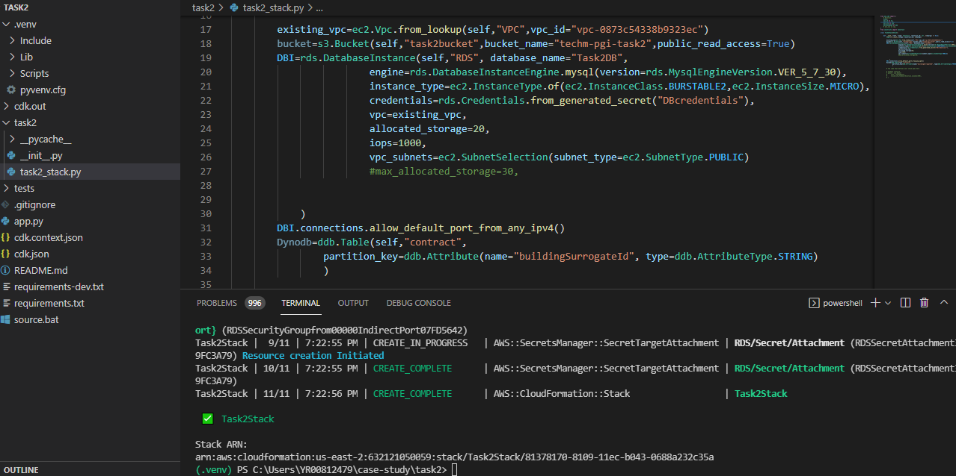

S3 bucket created :

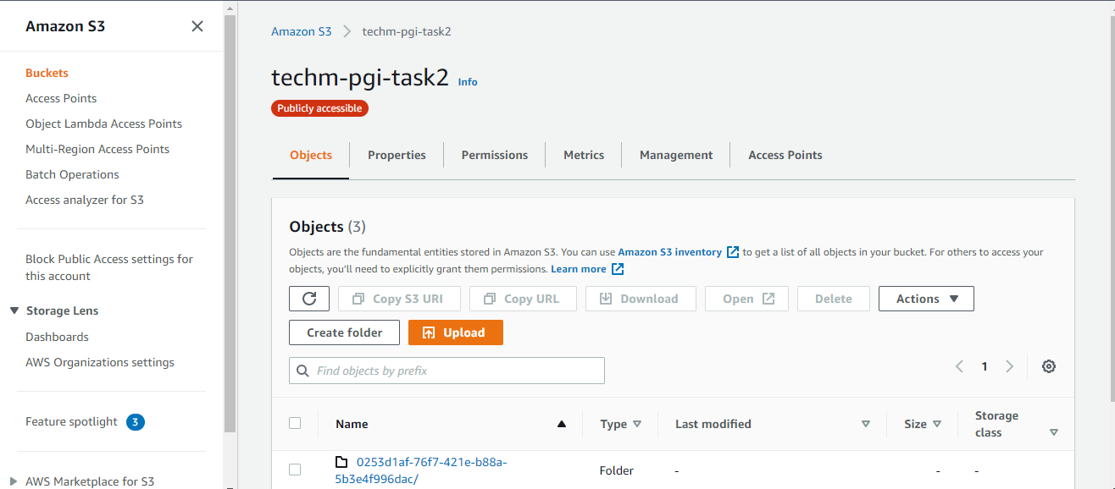

RDS created :

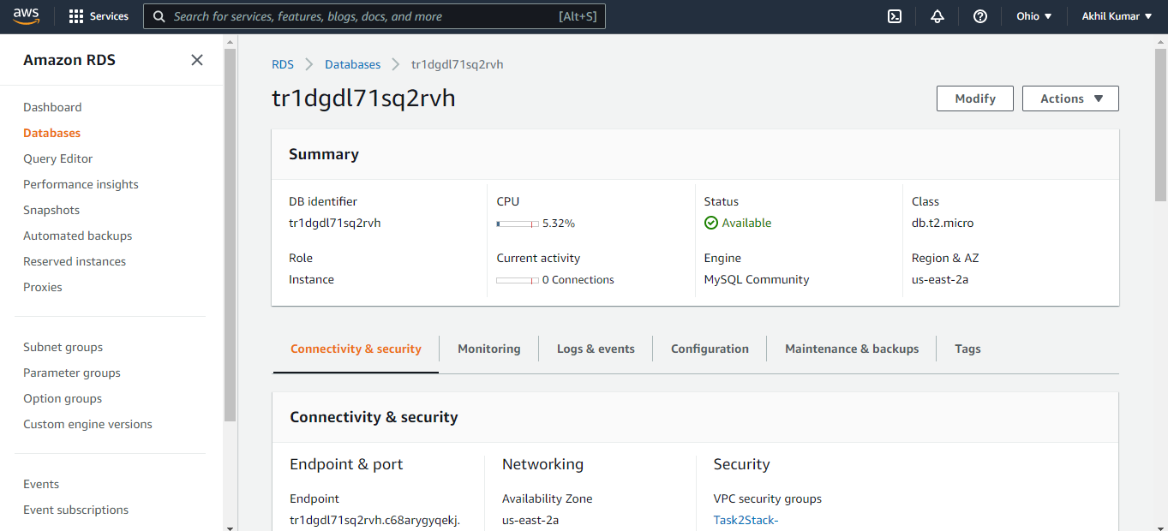

DDB created :

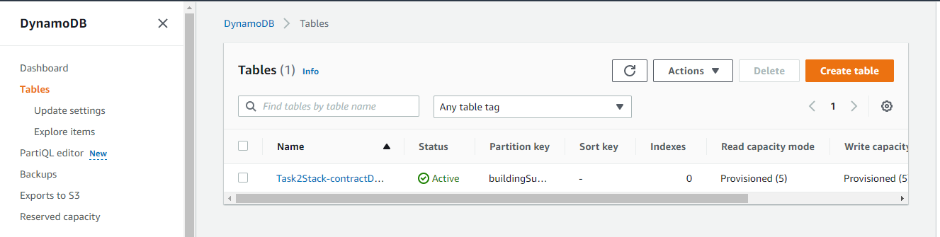

Uploaded 2 files(nested and building) to s3:

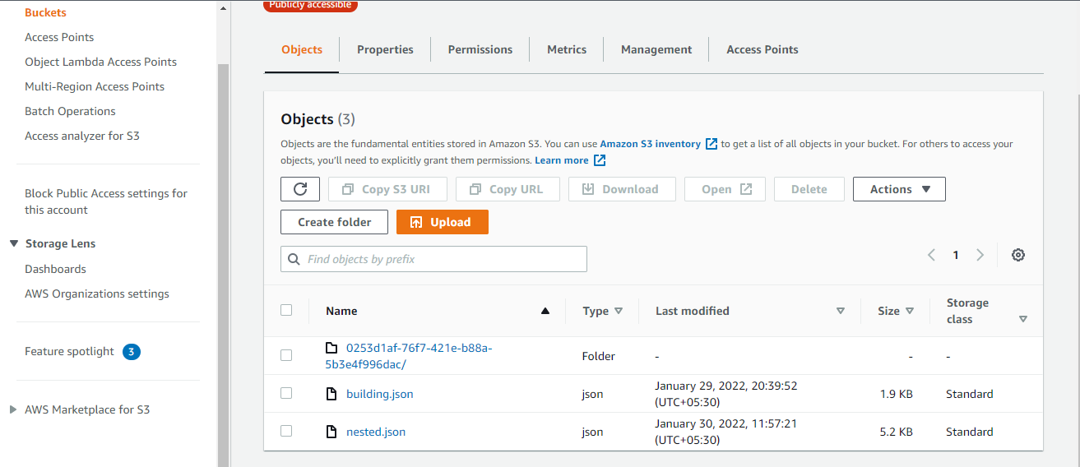

Created classifiers :

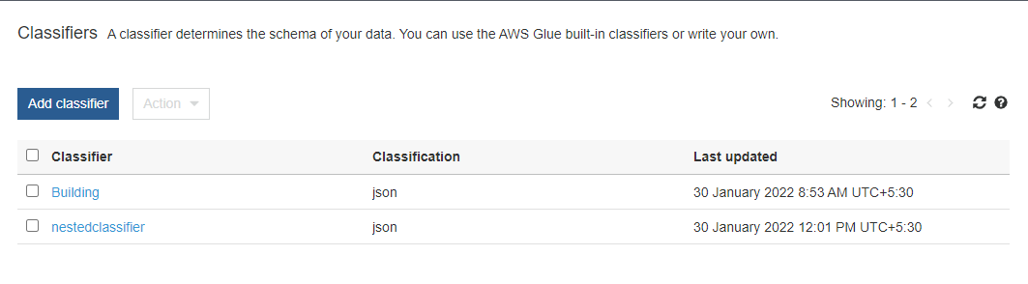

Created crawler :

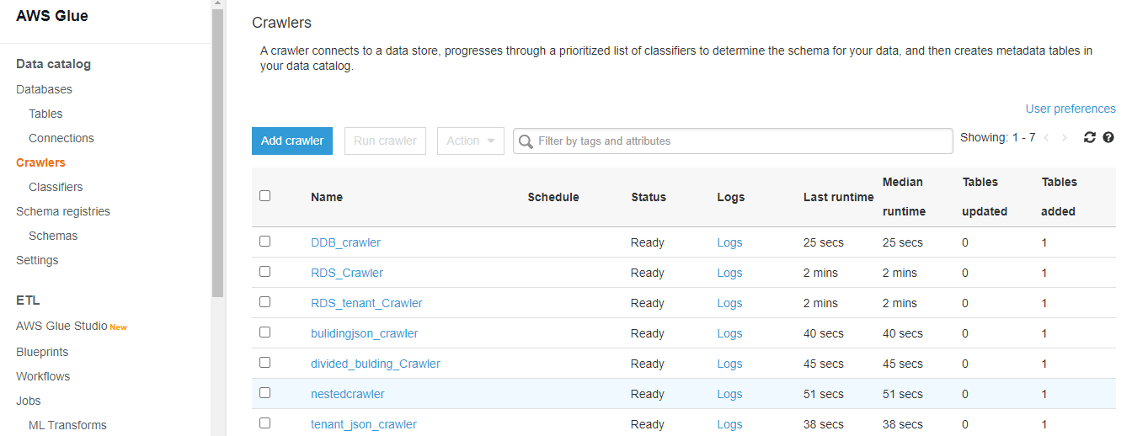

Once crawler runs , it will have created tables :

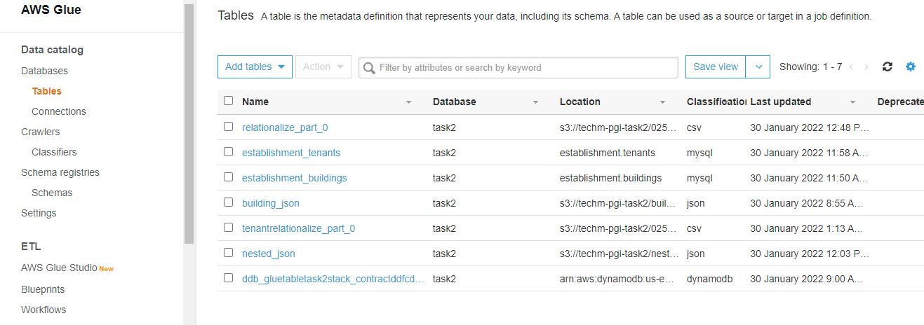

And added a connection to rds mysql:

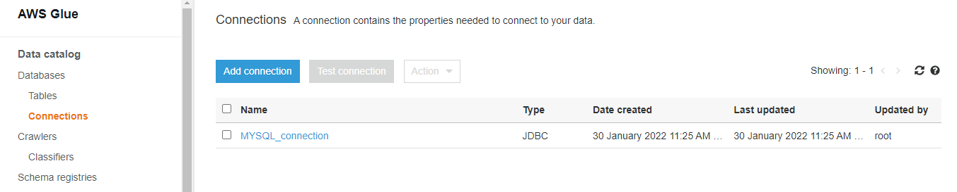

Job for tenants table load :

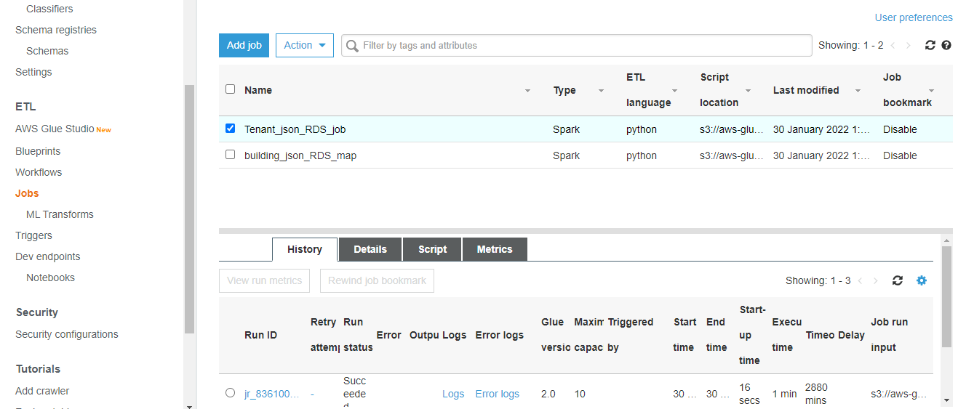

Job for buildings table load :

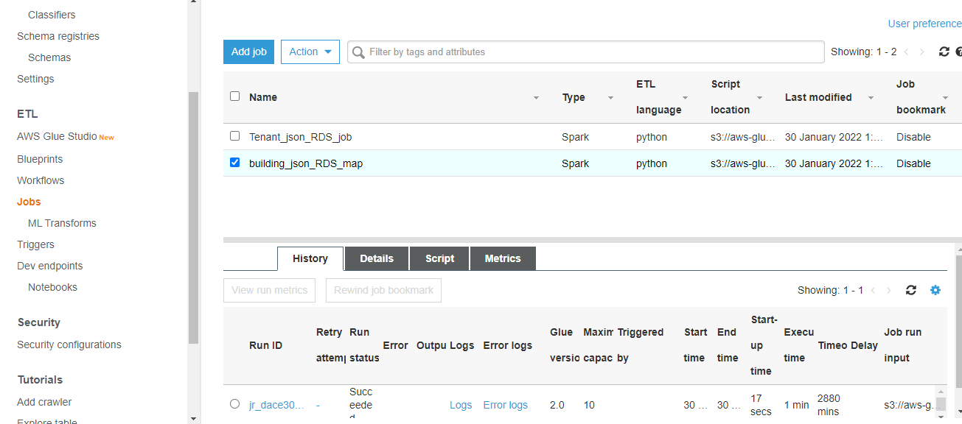

Tenants table :

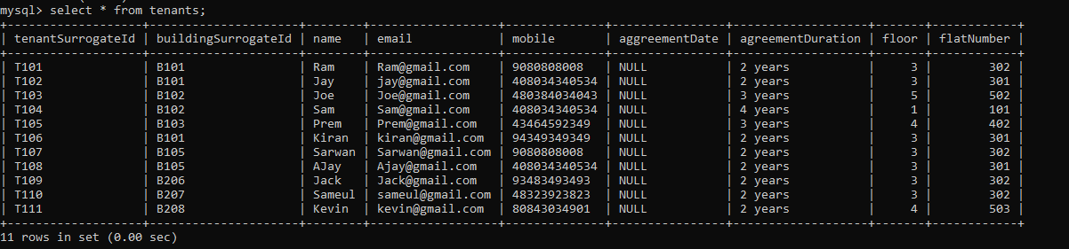

Buldings table :

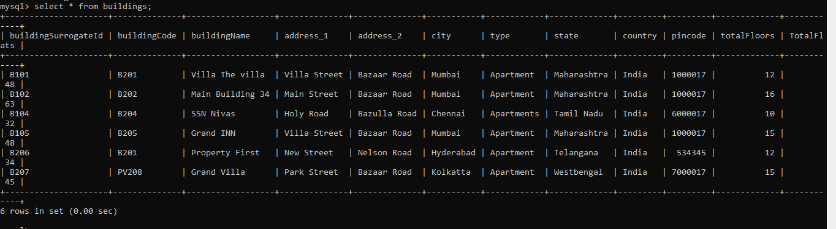

Sagemaker Notebook Script execution :

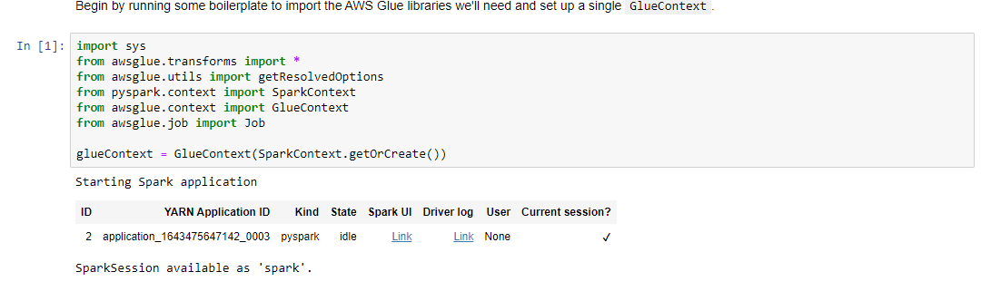

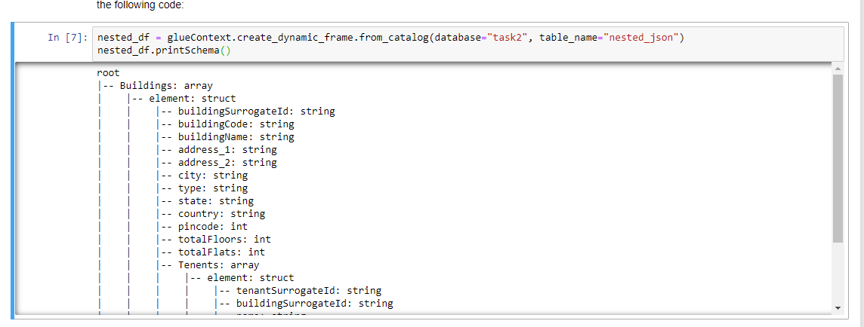

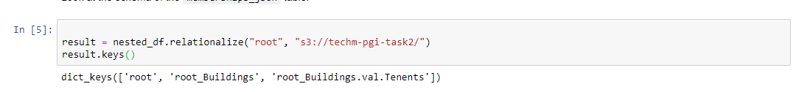

Quick sight :

Made a connection to buildings table in mysql database

