## 

## FACIAL EMOTION DETECTION

A PROJECT REPORT

Submitted by

P.AKHIL(22331A1284)

In the fulfilment for the Mini Project

Of

### BACHELOR OF TECHNOLOGY

Under the Esteemed Guidance of

Dr.V. Nagesh M.Tech (Ph.D)

D. Nagendra M.Tech (IT)

P.Ramya M.Tech (Ph.D)



**DEPARTMENT OF INFORMATION TECHNOLOGY MVGR COLLEGE OF ENGINEERING (Autonomous)**

**VIZIANAGARAM-535005, AP (INDIA) (Accredited by NBA, NAAC, and**

**Permanently Affiliated to Jawaharlal Nehru Technological University GV)**

## DECLARATION

I hereby declare that the project entitled " FACIAL EMOTION DETECTION " submitted for the fulfilment of Mini Project in B.Tech Degree is my original work and the project has not formed on the basis for the submission in any degree or any other similar titles.

**P.AKHIL 22331A1284**

**PLACE :**

**DATE :**

## CERTIFICATE



This is to certify that the project entitled "FACIAL EMOTION DETECTION" is the bonafide work carried out by P.AKHIL (22331A1284) of B.Tech VI Sem Information Technology, MVGR College of Engineering (Autonomous), Vizianagaram, during the year 2024-2025, in fulfilment of the Mini project in Bachelor of Technology and that project has not formed the basis for the submission previously of any degree or any other similar titles.

Signature of the Guide Signature of Head Of the Department

Mrs.A.Bhanusri M.Tech,(Ph.D) Dr P.Srinivasa M.Tech,(Ph.D)

Assistant Professor Professor

Dept of Information Technology Dept of Information Technology

MVGR College of the Engineering MVGR College of the Engineering

## TABLE OF CONTENTS

|  |  |  |
| --- | --- | --- |
| **Chapter** | **Title** | **Page Number** |
| 1 | ABSTRACT | 1 |
| 2 | INTRODUCTION | 2 |
| 3 | PROBLEM STATEMENT | 3 |
| 4 | SYSTEM REQUIREMENTS | 4-5 |
| 4.1 | HARDWARE REQUIREMENTS | 4 |
| 4.2 | SOFTWARE REQUIREMENTS | 5 |
| 5 | TECHNOLOGIES USED | 6 |
| 6 | EXISTING SYSTEM | 7 |
| 7 | PROPOSED SYSTEM | 8 |
| 8 | USE - CASES | 9-10 |
| 9 | PROCESS FLOW | 11 |
| 10 | SAMPLE CODE | 12-15 |
| 11 | OUTPUT SCREENSHOTS | 16-19 |
| 12 | ADVANTAGES | 20 |
| 13 | LIMITATIONS | 21 |
| 14 | CONCLUSIONS | 22 |
| 15 | FUTURE SCOPE | 23 |
| 16 | REFERENCE | 24 |

**1.ABSTRACT**

Facial emotion detection plays a significant role in human-computer interaction, sentiment analysis, and behavioral studies. This project aims to develop an advanced facial emotion recognition system using Convolutional Neural Network (CNN). The model is pretrained on a high-quality facial emotion dataset to improve classification accuracy. The system detects five key emotions: happiness, sadness, anger, surprise, and neutrality.

To enhance usability, a professional and visually appealing interface is developed for seamless user interaction. Real-time emotion detection via webcam is integrated to analyze facial expressions dynamically. The deep learning model extracts facial features effectively, ensuring precise emotion classification. The solution is optimized for speed and accuracy, making it suitable for various applications.

Potential use cases include customer behavior analysis, mental health monitoring, and AI-driven interactive systems. The model is evaluated using standard performance metrics to ensure reliability. The project leverages deep learning advancements to enhance real-time emotion detection. Future improvements may include expanding the dataset and adding more emotional categories.

# 2.INTRODUCTION

Facial emotion detection is an essential aspect of human-computer interaction (HCI), enabling machines to interpret and respond to human emotions effectively. It has diverse applications in sentiment analysis, customer behavior assessment, mental health monitoring, and interactive AI systems. Recognizing emotions from facial expressions is a challenging task due to variations in facial structures, lighting conditions, and individual differences.

The proposed model classifies facial expressions into five key emotions: happiness, sadness, anger, surprise, and neutrality. To enhance performance, we train the model from scratch using a high-quality dataset, ensuring better generalization across diverse facial expressions. Additionally, we implement real-time emotion detection via a webcam, allowing dynamic analysis of facial expressions in live interactions.

Beyond model improvements, the project also focuses on refining the user interface to create a visually appealing and professional web-based application. The integration of real-time emotion analysis with an intuitive interface enhances the user experience, making the system practical for real-world applications.

This project aims to bridge the gap between emotion recognition and practical deployment, offering an accurate, efficient, and user-friendly facial emotion detection system suitable for various industries, including entertainment, healthcare, and marketing.

## 3.PROBLEM STATEMENT

Facial emotion detection is a crucial technology in various domains, including human-computer interaction, sentiment analysis, mental health monitoring, and customer behavior assessment. However, existing emotion detection systems often suffer from limitations such as low accuracy, poor generalization across diverse facial expressions, and ineffective real-time performance. Traditional machine learning models rely on handcrafted features, which are not robust enough to capture complex facial patterns, leading to inaccurate emotion classification.

Deep learning approaches, particularly Convolutional Neural Networks (CNNs), have improved emotion recognition, but many existing models still face challenges related to dataset quality, model architecture limitations, and computational efficiency. Moreover, real-time emotion detection requires optimized models that balance accuracy and processing speed.

Another critical issue is the user interface of many facial emotion detection systems, which often lack a professional and visually appealing design. An intuitive and engaging interface is essential for real-world applications, ensuring usability across various industries.

## 4.SYSTEM REQUIREMENTS

### 4.1 HARDWARE REQUIREMENTS

The system must be deployed on a robust hardware setup to efficiently handle emotion detection, and user interactions.

#### **1. Development and Training Requirements:**

* **Processor (CPU):** Intel Core i7/i9 (10th Gen or later) or AMD Ryzen 7/9 (Zen 3 or later)
* **Graphics Processing Unit (GPU):** NVIDIA RTX 3090/4090 or A100 (for faster deep learning training)
* **RAM:** Minimum 16GB (Recommended: 32GB or more for handling large datasets)
* **Storage:** 256GB SSD (Recommended: 1TB SSD for faster data access and storage)
* **Cooling System:** Efficient cooling to prevent overheating during long training sessions

#### **2. Real-time Emotion Detection Deployment:**

* **Processor (CPU):** Intel Core i5/i7 (8th Gen or later) or AMD Ryzen 5/7
* **RAM:** 8GB (Recommended: 16GB for optimal performance)
* **Graphics Card (GPU):** NVIDIA GTX 1660 / RTX 3060 or equivalent for real-time inference
* **Camera:** HD Webcam (Minimum 720p, Recommended 1080p or higher for better image quality)

### 4.2 SOFTWARE REQUIREMENTS

The system relies on a combination of software tools and technologies for development, deployment, and operation.

#### **Backend:**

* **Programming Language:** Python (Flask) for server-side scripting.
* **Machine Learning Libraries (if used):** TensorFlow,

#### **Frontend Technologies:**

* **Markup & Styling:** HTML, CSS (for structuring and designing the UI).
* **Client-Side Scripting:** JavaScript (React.js / Vue.js for dynamic user interfaces).

#### **Development Tools:**

* **Code Editor:** Visual Studio Code.

## 5.TECHNOLOGIES USED

**HTML:**

* Defines the webpage structure with a header, description, button, and footer.
* Uses the <button> element with onclick="runScript()" to trigger emotion detection.
* Includes a loading message (<p class="loading">), which is initially hidden and displayed when the script runs.
* Uses semantic HTML tags to improve readability and accessibility.
* Loads the CSS for styling and JavaScript for interactivity within the page.

**CSS:**

* Enhances the UI with gradient backgrounds, smooth fonts, and modern styling.
* Implements a hover effect and transitions for the button (.btn) to improve user interaction.
* Ensures a responsive design with proper flexbox alignment and positioning.
* Styles the loading message to be visually distinct and engaging when displayed.
* Applies box shadows and rounded corners to elements for a polished, professional appearance.

**JavaScript:**

* Handles the button click event to start the emotion detection process.
* Uses the fetch('/run-script') function to communicate with the Flask backend.
* Displays a loading message while detection is in progress.
* Handles the response from Flask, showing an alert box with the detection result.
* Implements error handling, displaying a fallback message if the detection process fails.

## 6.EXISTING SYSTEM

Traditional methods of emotion detection relied on manual observation, psychological assessments, and behavioral analysis across various fields. In healthcare, therapists used face-to-face evaluations, self-reporting methods, and physiological measurements to assess emotions. Human-Computer Interaction (HCI) depended on user feedback, focus groups, and manual observation to enhance user experience. Businesses analyzed customer emotions through retail staff intuition, interviews, and surveys, while education relied on teacher observation and classroom interactions to gauge student engagement. Security and surveillance used police interrogation techniques, eyewitness interviews, and security personnel monitoring to detect deception and suspicious behavior. In entertainment, media houses and filmmakers observed test audiences, critic reviews, and body language analysis to measure emotional impact. However, these methods were time-consuming, subjective, and inconsistent, leading to the rise of AI-driven Facial Emotion Detection (FED) for faster, more accurate, and scalable emotion analysis

**Limitations of Traditional Emotion Detection Methods**

1. **Subjectivity & Bias** – Human interpretation of emotions varies, leading to inconsistent results.
2. **Time-Consuming** – Manual observation and analysis take longer, making real-time detection impractical.
3. **Lack of Scalability** – Traditional methods cannot efficiently analyze emotions on a large scale.
4. **Inaccuracy in Self-Reporting** – People may misreport or hide their true emotions, reducing reliability.
5. **Cultural Differences** – Facial expressions and body language vary across cultures, leading to misinterpretation.
6. **Limited Real-Time Processing** – Observational techniques cannot provide instant emotion analysis like AI-based systems.
7. **Dependency on Expertise** – Requires trained professionals, making it costly and not widely accessible.

## 7.PROPOSED SYSTEM

The proposed system utilizes deep learning and computer vision to automatically detect and classify human emotions in real time. Unlike traditional methods, which rely on manual observation and subjective interpretation, this system processes facial expressions using a trained deep neural network for accurate and scalable emotion recognition.

**Key Features:**

* **Deep Learning Model:** Uses a **CNN** for high-accuracy emotion classification.
* **Real-Time Detection:** Processes live video streams to classify emotions instantly.
* **Improved Accuracy:** Reduces human bias by relying on **pre-trained deep learning models**.
* **Scalability:** Can analyze large datasets and multiple users simultaneously.
* **Automation:** Eliminates the need for manual observation, making it faster and more efficient.

**Advantages Over Traditional Methods:**

* **More Accurate & Objective** – Eliminates human errors in emotion interpretation.
* **Faster Processing** – Detects emotions within seconds, enabling real-time applications.
* **Works in Digital Environments** – Can be integrated into web applications, chatbots, and smart devices.
* **Reduces Human Effort** – Automates emotion detection without requiring trained professionals.

## 8.USE-CASES

**Use Cases of Facial Emotion Detection (FED)**

1. **Healthcare & Mental Health Monitoring**
   * Detects emotional distress in patients during therapy sessions.
   * Assists in diagnosing **depression, anxiety, and stress levels.**
   * **Helps in tracking emotional well-being over time.**
2. **Human-Computer Interaction (HCI)**
   * Enhances user experience in apps and software by adapting to users’ emotions.
   * Improves AI-driven virtual assistants and chatbots by making them emotionally responsive.
3. **Education & E-Learning**
   * Analyzes student engagement and attention levels in online learning.
   * Alerts educators about students struggling with stress or frustration.
4. **Customer Experience & Business Analytics**
   * Assesses customer emotions in retail stores for product feedback and marketing analysis.
   * Improves personalized advertisements based on user reactions.
5. **Security & Surveillance**
   * Identifies suspicious or aggressive behavior in public places.
   * Assists law enforcement in lie detection and criminal profiling.
6. **Entertainment & Media**
   * Tracks audience reactions to movies, advertisements, and video games.
   * Helps filmmakers and advertisers create content that resonates emotionally.
7. **Workplace & Employee Well-being**
   * Monitors employee emotions to improve workplace satisfaction.
   * Prevents burnout and str**ess** by detecting early emotional distress.
8. **Autonomous Vehicles & Safety Systems**
   * Detects driver fatigue and emotional states to prevent accidents.
   * Alerts drowsy or distracted drivers in real-time.
9. **Smart Homes & IoT Devices**
   * Adjusts lighting, music, and temperature based on user emotions.
   * Enhances home automation by responding to emotional cues.

**9.PROCESS FLOW**

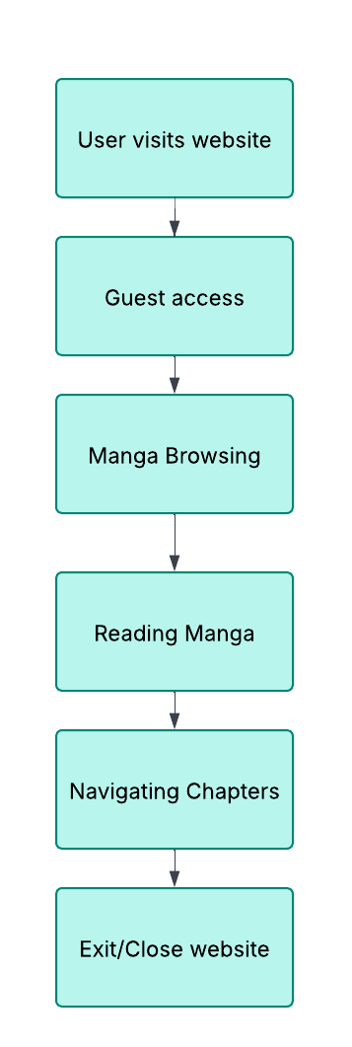

## 10.SAMPLE CODE

**INDEX.HTML**

<!DOCTYPE html>

<html lang="en">

<head>

    <meta charset="UTF-8">

    <meta name="viewport" content="width=device-width, initial-scale=1.0">

    <title>Facial Emotion Detection</title>

    <style>

        body {

*font-family*: 'Poppins', sans-serif;

            margin: 0;

            padding: 0;

            background: linear-gradient(to bottom, #ff9900, #ffffff);

            color: #333;

            display: flex;

            flex-direction: column;

            min-height: 100vh;

        }

        .container {

            display: flex;

            flex-direction: column;

            justify-content: center;

            align-items: center;

            height: 80vh;

        }

        .content {

            max-width: 600px;

            margin-bottom: 30px;

        }

        .content p {

            font-size: 18px;

            color: #0e0d0df0;

            line-height: 1.6;

        }

        .btn {

            padding: 14px 28px;

            font-size: 18px;

            font-weight: 600;

            color: white;

            background: linear-gradient(to right, #ff7b00, #b35700);

            border: none;

            border-radius: 8px;

            cursor: pointer;

            transition: 0.3s;

            outline: none;

            box-shadow: 0px 4px 10px rgba(255, 170, 0, 0.3);

            margin-top: 20px;

        }

        .footer {

            text-align: center;

            padding: 15px;

            background: linear-gradient(to right, #ffffff, #cce5ff);

            position: fixed;

            bottom: 0;

            width: 100%;

            margin: 0;

        }

    </style>

</head>

<body>

    <div class="header">Facial Emotion Detection</div>

    <div class="container">

        <div class="content">

            <h2>Analyze Facial Expressions</h2>

            <p>Effortlessly detect and analyze emotions such as happiness, sadness, anger, surprise, and more with our advanced facial recognition technology. Simply click to start and let our tool instantly identify facial expressions and classify them into emotional categories. Ideal for businesses, entertainment, and mental health applications, our tool provides accurate, real-time insights to enhance user experience and decision-making.</p>

        </div>

        <button class="btn" onclick="runScript()">Start Detection</button>

        <p class="loading" id="loading">Detecting emotions...This may take few seconds, please wait...</p>

    </div>

    <div class="footer">

        © 2025 Facial Emotion Detection | Emotion analysis for real-time insights.

    </div>

    <script>

        function runScript() {

            document.getElementById("loading").style.display = "block";

            fetch('/run-script')

                .then(response => response.text())

                .then(data => {

                    document.getElementById("loading").style.display = "none";

                    alert(data);  // You can display a success message here

                })

                .catch(*error* *=>* {

                    document.getElementById("loading").style.display = "none";

                    alert("Error running script!");

                });

        }

    </script>

</body>

</html>

**BACKEND(FLASK):**

from flask import Flask

import subprocess

app = Flask(__name__)

@app.route('/')

*def* home():

    return open("index.html").read()

@app.route('/run-script')

*def* run_script():

    try:

        # Run the Python script without expecting any output

        subprocess.run(["python", "fed.py"], *check*=True)

        return "Detection process completed"

    except Exception as e:

        return *f*"Error running script: {str(e)}"

if __name__ == '__main__':

    app.run(*debug*=True)

**FED.py**

import cv2

import numpy as np

import time

from tensorflow.keras.models import load_model

# Load trained model

model = load_model("emotion_model.h5")

# Emotion labels

emotion_labels = ["Angry", "Disgust", "Fear", "Happy", "Neutral", "Sad", "Surprise"]

# Start webcam

cap = cv2.VideoCapture(0)

face_cascade = cv2.CascadeClassifier(cv2.data.haarcascades + "haarcascade_frontalface_default.xml")

# Progress bar countdown

start_time = time.time()

while True:

    ret, frame = cap.read()

    if not ret:

        break

    elapsed_time = int(time.time() - start_time)

    remaining_time = max(10 - elapsed_time, 0)

    # Display countdown timer on screen

    cv2.putText(frame, *f*"Capturing in {remaining_time} sec", (50, 50), cv2.FONT_HERSHEY_SIMPLEX, 1, (0, 0, 255), 2)

    cv2.imshow("Real-Time Emotion Detection", frame)

    if remaining_time == 0:

        break

    if cv2.waitKey(1) & *0x*FF == ord("q"):

        cap.release()

        cv2.destroyAllWindows()

        exit()

# Capture final image

ret, frame = cap.read()

if ret:

    gray = cv2.cvtColor(frame, cv2.COLOR_BGR2GRAY)

    faces = face_cascade.detectMultiScale(gray, *scaleFactor*=1.3, *minNeighbors*=5)

    for (x, y, w, h) in faces:

        roi = gray[y:y+h, x:x+w]

        roi = cv2.resize(roi, (48, 48)) / 255.0

        roi = np.expand_dims(roi, *axis*=0)

        roi = np.expand_dims(roi, *axis*=-1)

        # Predict emotion

        preds = model.predict(roi)

        emotion = emotion_labels[np.argmax(preds)]

        # Draw bounding box & label

        cv2.rectangle(frame, (x, y), (x + w, y + h), (0, 255, 0), 2)

        cv2.putText(frame, emotion, (x, y - 10), cv2.FONT_HERSHEY_SIMPLEX, 0.8, (0, 255, 0), 2)

    # Show captured image with detected emotion

    cv2.imshow("Captured Emotion Detection", frame)

    cv2.waitKey(0)  # Display result for 3 seconds

cap.release()

cv2.destroyAllWindows()

## 11.OUTPUT SCREENS

### USER INTERFACE

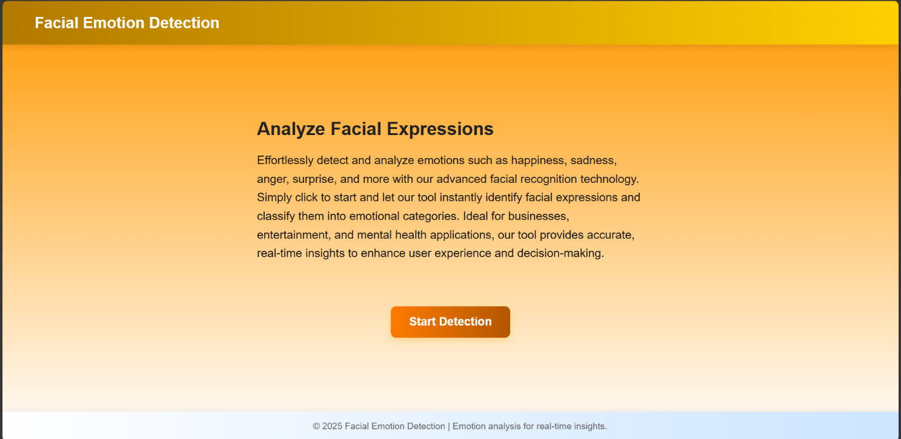

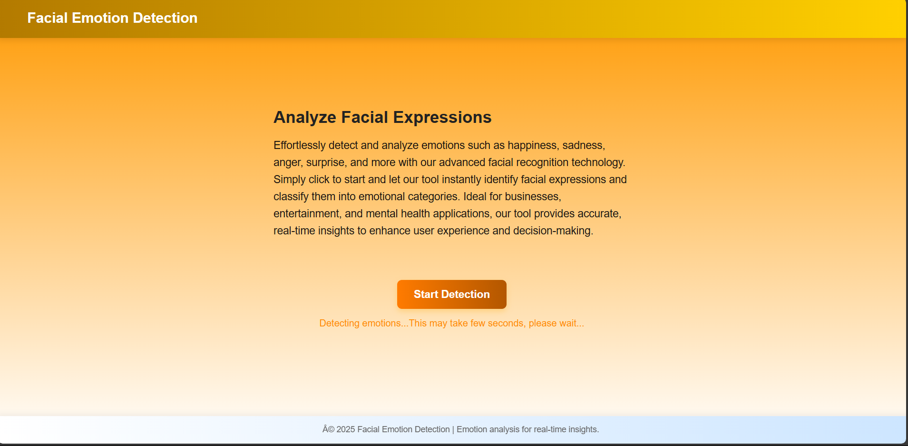

**OUTPUT:-**

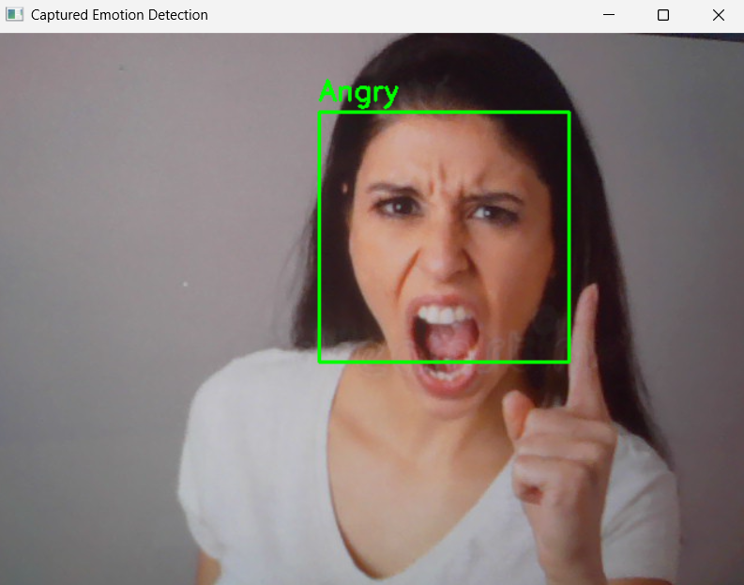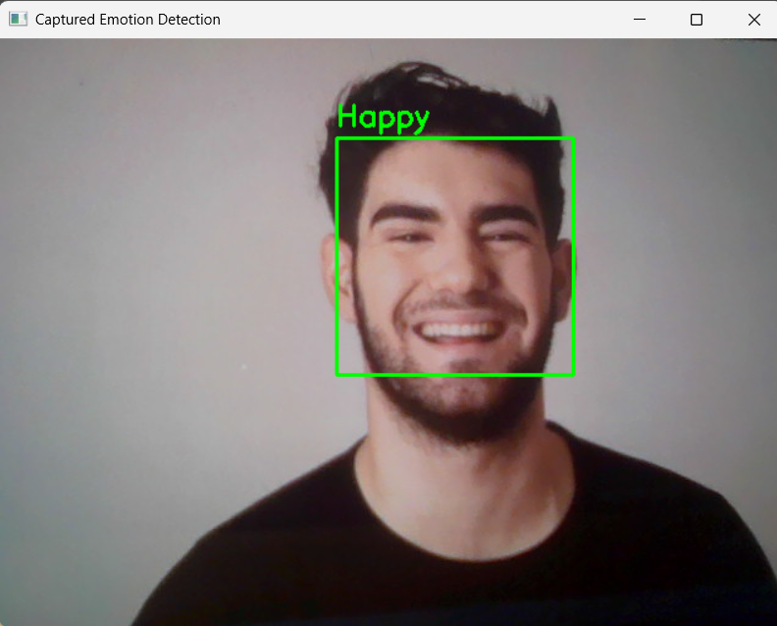

## 

## 

## 

## 

## 12.ADVANTAGES

#### 1 **Real-Time Emotion Analysis**

#### Instantly detects and classifies emotions from live video streams or images.

#### **High Accuracy & Objectivity**

#### Uses deep learning models to reduce human bias and improve detection accuracy.

#### **Automation & Efficiency**

#### Eliminates manual observation, making emotion analysis faster and more scalable.

#### **Enhanced Human-Computer Interaction (HCI)**

#### Enables emotion-aware AI assistants, chatbots, and smart applications.

#### **Improved Mental Health Assessment**

#### Helps psychologists and therapists detect stress, anxiety, and depression.

#### **Better Customer Experience & Business Insights**

#### Assists businesses in understanding customer emotions to improve marketing and user engagement.

#### **Security & Crime Prevention**

#### Identifies suspicious or aggressive behavior for law enforcement and surveillance systems.

#### **Education & Student Engagement**

#### Monitors student emotions to enhance learning experiences and adapt teaching methods.

#### **Safer Driving & Transportation**

#### Detects driver fatigue, stress, and distraction to prevent accidents in autonomous vehicles.

#### **Adaptive Entertainment & Gaming**

#### Enhances movies, video games, and virtual reality experiences based on user emotions.

#### Facial Emotion Detection bridges the gap between human emotions and technology, making interactions more intuitive, responsive, and intelligent

## 13.LIMITATIONS

## Accuracy Challenges

## Misclassification can occur due to low lighting, occlusions (glasses, masks), or poor camera quality.

## Cultural and Individual Differences

## Facial expressions vary across cultures and individuals, leading to potential misinterpretations.

## Emotion Complexity

## Some emotions are subtle or mixed, making it difficult to classify overlapping emotional states.

## Privacy and Ethical Concerns

## Continuous emotion tracking raises concerns about data privacy, consent, and misuse of personal emotions.

## Vulnerability to External Factors

## Brightness, camera angles, and background noise can affect detection accuracy.

## Emotional Ambiguity

## Some emotions (e.g., sarcasm, nervousness) are hard to distinguish based on facial features alone.

## 14.CONCLUSION

Facial Emotion Detection (FED) is a cutting-edge AI-driven technology that bridges the gap between human emotions and digital interactions. By utilizing deep learning and computer vision, the system accurately classifies facial expressions in real time, enabling applications in healthcare, customer experience, security, education, and entertainment.

Compared to traditional methods, which rely on manual observation and subjective interpretation, this system provides faster, more objective, and scalable emotion recognition. Despite its advantages, challenges such as accuracy issues, privacy concerns, and emotional complexity need to be addressed for widespread adoption.

Future improvements could involve multi-modal emotion analysis, integrating voice tone, body language, and contextual awareness to enhance accuracy. As AI continues to evolve, Facial Emotion Detection has the potential to revolutionize human-computer interaction, making technology more intelligent, empathetic, and responsive.

## 15.FUTURE SCOPE

1. **Multi-Modal Emotion Analysis**
   * Integrating voice tone, speech analysis, and body language to enhance emotion recognition accuracy.
2. **Improved Deep Learning Models**
   * Using advanced AI architectures like Transformer-based models for better emotion classification.
3. **Personalized Emotion Detection**
   * Adapting models to recognize individual differences in facial expressions for more personalized results.
4. **Ethical & Privacy Enhancements**
   * Developing secure, privacy-focused emotion detection with user consent and encrypted data handling.
5. **Low-Power & Edge Computing Integration**
   * Deploying emotion detection on IoT devices, smartphones, and embedded systems for real-time processing.
6. **Cross-Cultural Emotion Recognition**
   * Training models on diverse datasets to reduce bias and improve accuracy across different ethnicities and cultures.
7. **Emotion-Aware Virtual Assistants**
   * Enhancing AI assistants (e.g., Alexa, Siri, chatbots) to respond based on user emotions.
8. **Mental Health Monitoring**
   * Real-time emotion tracking to detect early signs of stress, anxiety, or depression for better mental healthcare.

With continuous advancements, Facial Emotion Detection will become an essential tool in AI-driven human interaction, making technology more adaptive

.

# 16.REFERENCES

**[1].** [**W3Schools Online Web Tutorials**](https://www.w3schools.com/)

**[2].** [**Learn Flask | Codecademy**](https://www.codecademy.com/learn/learn-flask)

**[3].** [**Learn Python - Free Interactive Python Tutorial**](https://www.learnpython.org/)

**[4].** [**Facial Emotion Recognition Using Transfer Learning in the Deep CNN**](https://www.mdpi.com/2079-9292/10/9/1036)

**[5].** [**Facial Emotion Recognition (FER) using Convolutional Neural Network (CNN) - ScienceDirect**](https://www.sciencedirect.com/science/article/pii/S1877050924008731)