8_1.R

dell

Thu Sep 08 22:08:46 2016

rm(list=ls(all=T))  
  
set.seed(999)  
  
setwd("C:/Users/dell/Dropbox/compitition/nasscom/BFSI")  
library(data.table)

## Warning: package 'data.table' was built under R version 3.2.5

library(mice)

## Warning: package 'mice' was built under R version 3.2.5

## Loading required package: Rcpp

## Warning: package 'Rcpp' was built under R version 3.2.5

## mice 2.25 2015-11-09

library(dummies)

## Warning: package 'dummies' was built under R version 3.2.3

## dummies-1.5.6 provided by Decision Patterns

library(xgboost)

## Warning: package 'xgboost' was built under R version 3.2.5

library(Matrix)  
library(corrplot)

## Warning: package 'corrplot' was built under R version 3.2.5

library(car)

## Warning: package 'car' was built under R version 3.2.5

library(caret)

## Warning: package 'caret' was built under R version 3.2.5

## Loading required package: lattice

## Loading required package: ggplot2

## Warning: package 'ggplot2' was built under R version 3.2.5

library(leaps)

## Warning: package 'leaps' was built under R version 3.2.5

library(xlsx)

## Warning: package 'xlsx' was built under R version 3.2.3

## Loading required package: rJava

## Warning: package 'rJava' was built under R version 3.2.3

## Loading required package: xlsxjars

## Warning: package 'xlsxjars' was built under R version 3.2.3

library(randomForest)

## Warning: package 'randomForest' was built under R version 3.2.3

## randomForest 4.6-12

## Type rfNews() to see new features/changes/bug fixes.

##   
## Attaching package: 'randomForest'

## The following object is masked from 'package:ggplot2':  
##   
## margin

require('vcd')

## Loading required package: vcd

## Warning: package 'vcd' was built under R version 3.2.5

## Loading required package: grid

source("funplot.R")  
#1.Data Preparation   
  
tr<-fread("BFSI Stage 1 Train data.csv",stringsAsFactors=F)  
te<-fread("BFSI Stage 1 Test data.csv",stringsAsFactors=F)  
  
sol<-fread("BFSI - Solution submission template.csv",stringsAsFactors=T)  
te<-te[,c("Behavioural_Score","Application_Score"):= NA]  
  
c<-list(tr, te)  
a<- rbindlist(c)  
  
a$Total_Bank_Products<-ordered(a$Total_Bank_Products,levels=c(">=6","5","2","1","3","0","4"),labels=c(6,5,2,1,3,0,4))  
a$Active_Bank_Products<-ordered(a$Active_Bank_Products,levels=c(">=5","2","1","3","0","4"),labels=c(5,2,1,3,0,4))  
a$Tenure_with_Bank_Group<-ordered(a$Tenure_with_Bank_Group,levels=c("<=5 YRS","<=10 YRS",">10 YRS","<=2 YRS", "<=1 YRS"),labels=c(2,4,5,1,0))  
a$Education<-ordered(a$Education,levels=c("University","Graduate and Higher","Intermediate","High School","Unknown","No Education","Primary School" ),labels=c(5,4,3,2,NA,0,1))  
  
colSums(is.na(a))

## Identifier Age   
## 0 0   
## Education Indutry_Groups   
## 0 0   
## Industry_Domain Marital_Status   
## 0 0   
## Occupation Customer_Segment   
## 0 0   
## Gender Metropolitan_City   
## 0 0   
## Residence Insurance_Product_type   
## 0 0   
## Insurance_Acquisition_Channel Active_Bank_Products   
## 0 0   
## Total_Bank_Products Commercial_Loan   
## 0 0   
## Consumer_Auto_Loan Mortgage_Loan   
## 0 0   
## Personal_Loan Credit_Card   
## 0 0   
## Deposit Pre-Approved Auto Limit   
## 0 0   
## Pre-Approved Mortgage Limit Pre-Approved Personal Limit   
## 0 0   
## Tenure_with_Bank_Group Tenure_of_Insurance   
## 0 0   
## Salary_Amount Credit_Limit   
## 976 1681   
## Total_Asset_Under_Mngmnt Avg_Monthly_Balance   
## 0 0   
## Application_Score Behavioural_Score   
## 2307 2307

a[,.(.N),.(`Pre-Approved Auto Limit`)]

## Pre-Approved Auto Limit N  
## 1: MISSING 6084  
## 2: >480,000 1944  
## 3: <360,000 328  
## 4: <480,000 354  
## 5: <240,000 344  
## 6: <120,000 151  
## 7: ZERO 26

a[,.(.N),.(`Pre-Approved Mortgage Limit`)]

## Pre-Approved Mortgage Limit N  
## 1: MISSING 6084  
## 2: >=5,000,000 1434  
## 3: <2,500,000 612  
## 4: <5,000,000 505  
## 5: <1,000,000 335  
## 6: ZERO 261

a[,.(.N),.(`Pre-Approved Personal Limit`)]

## Pre-Approved Personal Limit N  
## 1: MISSING 6084  
## 2: ZERO 2068  
## 3: <1,500,000 782  
## 4: <1,000,000 250  
## 5: <500,000 47

a_train<-a[,":="(`Pre-Approved Mortgage Limit`=NULL,  
 `Pre-Approved Auto Limit`=NULL,  
 `Pre-Approved Personal Limit`=NULL)]  
  
a0<-rbindlist(c)  
cp<-cor(a0[,c(2,16,17,18,19,20,21,26:32),with=F],use="complete.obs")  
col1 <- colorRampPalette(c("#7F0000","red","#FF7F00","yellow","white",   
 "cyan", "#007FFF", "blue","#00007F"))  
corrplot.mixed(cp,order="AOE",col=col1(100))

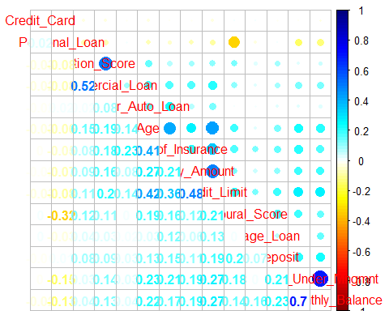

a_train <- a[,":="(Identifier =as.numeric(Identifier),  
 Age=as.numeric(Age),  
 Education=(Education),  
 Indutry_Groups=as.numeric(as.factor(Indutry_Groups)),  
 Industry_Domain=as.numeric(as.factor(Industry_Domain)),  
 Marital_Status=as.numeric(as.factor(Marital_Status)),  
 Occupation=as.numeric(as.factor(Occupation)),  
 Customer_Segment=as.numeric(as.factor(Customer_Segment)),  
 Gender=ifelse(Gender=="Male",1,0),  
 Metropolitan_City=as.numeric(as.factor(Metropolitan_City)),  
 Residence=as.numeric(as.factor(Residence)),  
 Insurance_Product_type=as.numeric(as.factor(Insurance_Product_type)),  
 Insurance_Acquisition_Channel=as.numeric(as.factor(Insurance_Acquisition_Channel)),  
 Active_Bank_Products=(Active_Bank_Products),  
 Total_Bank_Products=as.numeric(Total_Bank_Products),  
 Commercial_Loan=as.numeric(as.factor(Commercial_Loan)),  
 Consumer_Auto_Loan=as.numeric(as.factor(Consumer_Auto_Loan)),  
 Mortgage_Loan=as.numeric(as.factor(Mortgage_Loan)),  
 Personal_Loan=as.numeric(as.factor(Personal_Loan)),  
 Credit_Card=as.numeric(as.factor(Credit_Card)),  
 Deposit=as.numeric(as.factor(Deposit)),  
 Tenure_with_Bank_Group=(Tenure_with_Bank_Group),  
 Tenure_of_Insurance=as.numeric(Tenure_of_Insurance),  
 Salary_Amount=as.numeric(Salary_Amount),  
 Credit_Limit=as.numeric(Credit_Limit),  
 Total_Asset_Under_Mngmnt=as.numeric(as.factor(Total_Asset_Under_Mngmnt)),  
 Avg_Monthly_Balance=as.numeric(Avg_Monthly_Balance),  
 Application_Score=as.numeric(Application_Score),  
 Behavioural_Score=as.numeric(Behavioural_Score)  
)]  
  
  
Dat1 <- subset(a_train, select=c(Salary_Amount,Credit_Limit,Avg_Monthly_Balance,Tenure_of_Insurance,  
 Active_Bank_Products,Total_Bank_Products,Age,Total_Asset_Under_Mngmnt))   
imp <- mice(Dat1, m=5, maxit=10,method="pmm", seed=999)

##   
## iter imp variable  
## 1 1 Salary_Amount Credit_Limit  
## 1 2 Salary_Amount Credit_Limit  
## 1 3 Salary_Amount Credit_Limit  
## 1 4 Salary_Amount Credit_Limit  
## 1 5 Salary_Amount Credit_Limit  
## 2 1 Salary_Amount Credit_Limit  
## 2 2 Salary_Amount Credit_Limit  
## 2 3 Salary_Amount Credit_Limit  
## 2 4 Salary_Amount Credit_Limit  
## 2 5 Salary_Amount Credit_Limit  
## 3 1 Salary_Amount Credit_Limit  
## 3 2 Salary_Amount Credit_Limit  
## 3 3 Salary_Amount Credit_Limit  
## 3 4 Salary_Amount Credit_Limit  
## 3 5 Salary_Amount Credit_Limit  
## 4 1 Salary_Amount Credit_Limit  
## 4 2 Salary_Amount Credit_Limit  
## 4 3 Salary_Amount Credit_Limit  
## 4 4 Salary_Amount Credit_Limit  
## 4 5 Salary_Amount Credit_Limit  
## 5 1 Salary_Amount Credit_Limit  
## 5 2 Salary_Amount Credit_Limit  
## 5 3 Salary_Amount Credit_Limit  
## 5 4 Salary_Amount Credit_Limit  
## 5 5 Salary_Amount Credit_Limit  
## 6 1 Salary_Amount Credit_Limit  
## 6 2 Salary_Amount Credit_Limit  
## 6 3 Salary_Amount Credit_Limit  
## 6 4 Salary_Amount Credit_Limit  
## 6 5 Salary_Amount Credit_Limit  
## 7 1 Salary_Amount Credit_Limit  
## 7 2 Salary_Amount Credit_Limit  
## 7 3 Salary_Amount Credit_Limit  
## 7 4 Salary_Amount Credit_Limit  
## 7 5 Salary_Amount Credit_Limit  
## 8 1 Salary_Amount Credit_Limit  
## 8 2 Salary_Amount Credit_Limit  
## 8 3 Salary_Amount Credit_Limit  
## 8 4 Salary_Amount Credit_Limit  
## 8 5 Salary_Amount Credit_Limit  
## 9 1 Salary_Amount Credit_Limit  
## 9 2 Salary_Amount Credit_Limit  
## 9 3 Salary_Amount Credit_Limit  
## 9 4 Salary_Amount Credit_Limit  
## 9 5 Salary_Amount Credit_Limit  
## 10 1 Salary_Amount Credit_Limit  
## 10 2 Salary_Amount Credit_Limit  
## 10 3 Salary_Amount Credit_Limit  
## 10 4 Salary_Amount Credit_Limit  
## 10 5 Salary_Amount Credit_Limit

Data.imp<- complete(imp,4)  
  
X_train <- a_train[,":="(Salary_Amount=Data.imp$Salary_Amount,  
 Credit_Limit=Data.imp$Credit_Limit)][1:6924,]  
X_train<-X_train[-c(5255,which(X_train$Application_Score==0)),]  
  
X_test <- a_train[,":="(Salary_Amount=Data.imp$Salary_Amount,  
 Credit_Limit=Data.imp$Credit_Limit)][6925:9231,]  
X_targeta <- as.numeric(X_train$Application_Score)  
X_targetb <- as.numeric(X_train$Behavioural_Score)  
  
ma<-lm(X_targeta~.-(Application_Score+Behavioural_Score+Identifier),data = X_train)  
summary(ma)

##   
## Call:  
## lm(formula = X_targeta ~ . - (Application_Score + Behavioural_Score +   
## Identifier), data = X_train)  
##   
## Residuals:  
## Min 1Q Median 3Q Max   
## -369.44 -18.65 -0.56 19.75 716.08   
##   
## Coefficients:  
## Estimate Std. Error t value Pr(>|t|)   
## (Intercept) 1.823e+02 1.231e+01 14.806 < 2e-16 ***  
## Age 4.739e-02 1.210e-01 0.392 0.695197   
## Education.L -7.552e+00 6.867e+00 -1.100 0.271461   
## Education.Q 3.772e+00 7.772e+00 0.485 0.627442   
## Education.C -6.612e+00 9.656e+00 -0.685 0.493524   
## Education^4 -1.659e+01 6.065e+00 -2.735 0.006260 **   
## Education^5 6.599e+00 1.169e+01 0.564 0.572489   
## Education^6 5.448e+00 1.010e+01 0.540 0.589555   
## Indutry_Groups 6.717e-01 7.283e-01 0.922 0.356396   
## Industry_Domain -2.033e-01 6.477e-02 -3.139 0.001700 **   
## Marital_Status -2.600e+00 1.351e+00 -1.925 0.054331 .   
## Occupation 1.257e+01 8.730e-01 14.402 < 2e-16 ***  
## Customer_Segment -3.351e-01 1.156e+00 -0.290 0.771980   
## Gender -3.078e+00 1.715e+00 -1.795 0.072722 .   
## Metropolitan_City 1.490e+00 2.346e-01 6.350 2.29e-10 ***  
## Residence -2.442e-02 7.281e-01 -0.034 0.973245   
## Insurance_Product_type 5.081e-02 4.269e-01 0.119 0.905264   
## Insurance_Acquisition_Channel -1.490e+01 1.284e+00 -11.605 < 2e-16 ***  
## Active_Bank_Products.L -3.353e-01 2.172e+00 -0.154 0.877285   
## Active_Bank_Products.Q 9.004e+00 2.341e+00 3.846 0.000121 ***  
## Active_Bank_Products.C -4.615e+00 2.560e+00 -1.803 0.071479 .   
## Active_Bank_Products^4 1.246e-01 2.776e+00 0.045 0.964208   
## Active_Bank_Products^5 2.467e+00 2.720e+00 0.907 0.364491   
## Total_Bank_Products -3.845e-01 4.852e-01 -0.793 0.428068   
## Commercial_Loan 2.013e+02 5.189e+00 38.795 < 2e-16 ***  
## Consumer_Auto_Loan -5.914e+00 2.486e+00 -2.379 0.017389 *   
## Mortgage_Loan 1.436e+00 1.942e+00 0.739 0.459764   
## Personal_Loan -5.698e+00 1.788e+00 -3.187 0.001444 **   
## Credit_Card -1.209e+00 1.575e+00 -0.768 0.442583   
## Deposit 2.311e+00 1.765e+00 1.310 0.190387   
## Tenure_with_Bank_Group.L -1.601e+01 3.433e+00 -4.663 3.18e-06 ***  
## Tenure_with_Bank_Group.Q -1.550e+01 3.092e+00 -5.014 5.45e-07 ***  
## Tenure_with_Bank_Group.C 7.346e+00 2.288e+00 3.211 0.001330 **   
## Tenure_with_Bank_Group^4 8.664e+00 1.864e+00 4.649 3.40e-06 ***  
## Tenure_of_Insurance -8.970e-01 3.090e-01 -2.903 0.003707 **   
## Salary_Amount -4.740e-06 1.440e-05 -0.329 0.742010   
## Credit_Limit -2.088e-05 1.189e-05 -1.756 0.079116 .   
## Total_Asset_Under_Mngmnt 1.321e-03 4.080e-04 3.238 0.001211 **   
## Avg_Monthly_Balance -4.638e-05 9.548e-06 -4.858 1.21e-06 ***  
## ---  
## Signif. codes: 0 '***' 0.001 '**' 0.01 '*' 0.05 '.' 0.1 ' ' 1  
##   
## Residual standard error: 62 on 6864 degrees of freedom  
## Multiple R-squared: 0.3373, Adjusted R-squared: 0.3336   
## F-statistic: 91.94 on 38 and 6864 DF, p-value: < 2.2e-16

plot(ma)

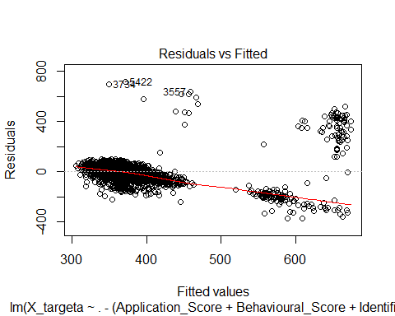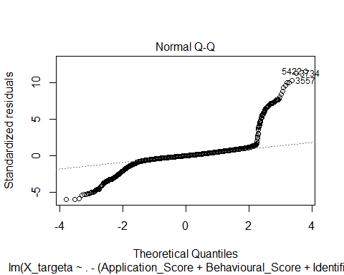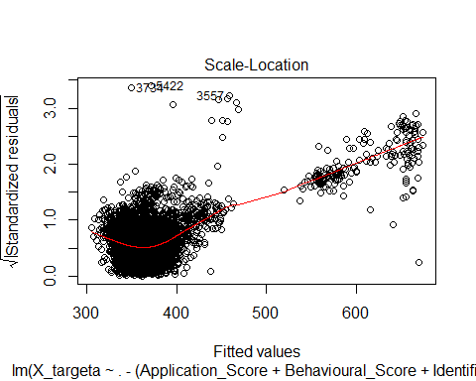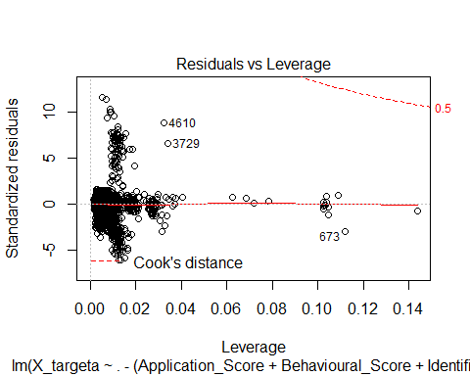

dia(ma)

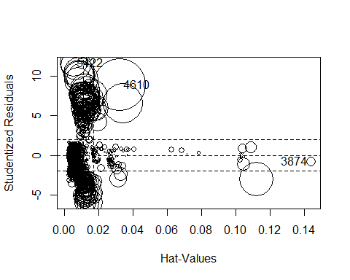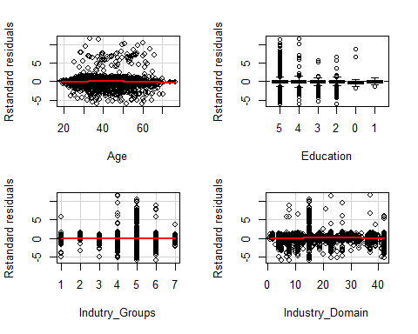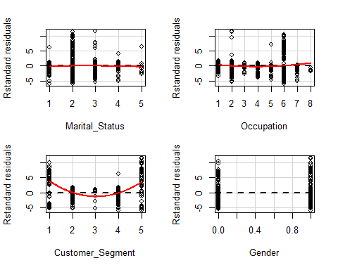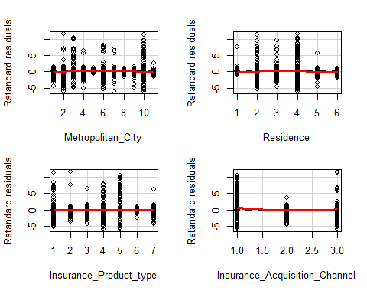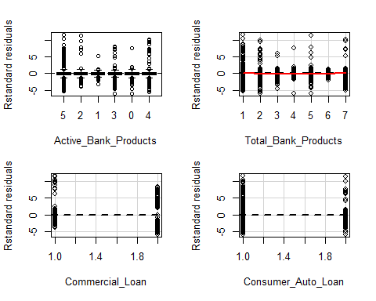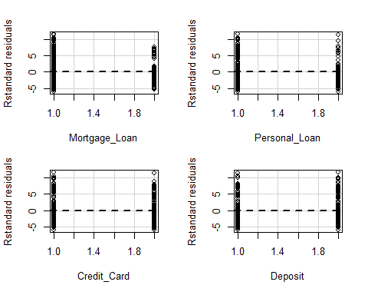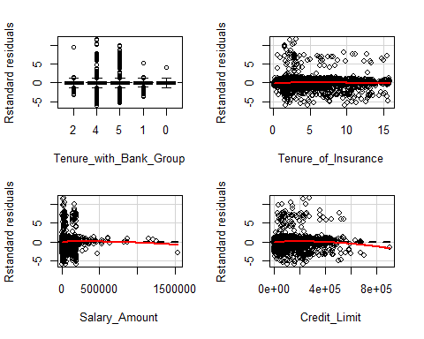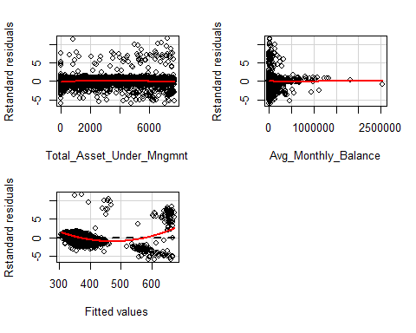

## Test stat Pr(>|t|)  
## Age -3.050 0.002  
## Education NA NA  
## Indutry_Groups -0.493 0.622  
## Industry_Domain -3.836 0.000  
## Marital_Status -2.398 0.016  
## Occupation 7.570 0.000  
## Customer_Segment 71.560 0.000  
## Gender -0.159 0.874  
## Metropolitan_City -0.624 0.533  
## Residence -2.344 0.019  
## Insurance_Product_type -0.256 0.798  
## Insurance_Acquisition_Channel 11.180 0.000  
## Active_Bank_Products NA NA  
## Total_Bank_Products 2.417 0.016  
## Commercial_Loan -0.230 0.818  
## Consumer_Auto_Loan -0.237 0.813  
## Mortgage_Loan -0.254 0.800  
## Personal_Loan -0.245 0.806  
## Credit_Card -0.234 0.815  
## Deposit -0.255 0.799  
## Tenure_with_Bank_Group NA NA  
## Tenure_of_Insurance -1.682 0.093  
## Salary_Amount -1.470 0.142  
## Credit_Limit -5.061 0.000  
## Total_Asset_Under_Mngmnt -2.852 0.004  
## Avg_Monthly_Balance 0.068 0.946  
## Tukey test 56.941 0.000

mb<-lm(X_targetb~.-(Application_Score+Behavioural_Score+Identifier),data = X_train)  
summary(mb)

##   
## Call:  
## lm(formula = X_targetb ~ . - (Application_Score + Behavioural_Score +   
## Identifier), data = X_train)  
##   
## Residuals:  
## Min 1Q Median 3Q Max   
## -160.608 -24.262 3.931 25.216 119.501   
##   
## Coefficients:  
## Estimate Std. Error t value Pr(>|t|)   
## (Intercept) 6.542e+02 7.469e+00 87.582 < 2e-16 ***  
## Age 1.156e-01 7.336e-02 1.576 0.115068   
## Education.L -3.905e+00 4.165e+00 -0.938 0.348433   
## Education.Q -9.449e+00 4.714e+00 -2.004 0.045062 *   
## Education.C -6.941e+00 5.857e+00 -1.185 0.235983   
## Education^4 6.258e-01 3.679e+00 0.170 0.864919   
## Education^5 1.296e+01 7.091e+00 1.828 0.067557 .   
## Education^6 6.892e+00 6.125e+00 1.125 0.260540   
## Indutry_Groups -2.312e-01 4.417e-01 -0.523 0.600658   
## Industry_Domain -1.652e-01 3.928e-02 -4.204 2.65e-05 ***  
## Marital_Status -1.593e+00 8.193e-01 -1.944 0.051936 .   
## Occupation -3.348e-01 5.295e-01 -0.632 0.527209   
## Customer_Segment 6.007e-01 7.012e-01 0.857 0.391698   
## Gender 1.006e+00 1.040e+00 0.967 0.333400   
## Metropolitan_City 2.332e-01 1.423e-01 1.639 0.101244   
## Residence 2.065e+00 4.416e-01 4.677 2.97e-06 ***  
## Insurance_Product_type 3.596e-02 2.589e-01 0.139 0.889560   
## Insurance_Acquisition_Channel -2.970e+00 7.787e-01 -3.814 0.000138 ***  
## Active_Bank_Products.L 1.191e+01 1.317e+00 9.041 < 2e-16 ***  
## Active_Bank_Products.Q -4.150e+01 1.420e+00 -29.230 < 2e-16 ***  
## Active_Bank_Products.C 2.731e+00 1.553e+00 1.758 0.078731 .   
## Active_Bank_Products^4 -2.486e+01 1.684e+00 -14.766 < 2e-16 ***  
## Active_Bank_Products^5 -3.462e+01 1.650e+00 -20.984 < 2e-16 ***  
## Total_Bank_Products -1.155e+00 2.943e-01 -3.926 8.73e-05 ***  
## Commercial_Loan 6.108e+00 3.147e+00 1.940 0.052367 .   
## Consumer_Auto_Loan -3.772e+00 1.508e+00 -2.502 0.012390 *   
## Mortgage_Loan -1.597e+00 1.178e+00 -1.355 0.175344   
## Personal_Loan -1.445e+01 1.084e+00 -13.322 < 2e-16 ***  
## Credit_Card 3.322e+00 9.553e-01 3.478 0.000509 ***  
## Deposit 5.923e+00 1.070e+00 5.534 3.25e-08 ***  
## Tenure_with_Bank_Group.L -1.385e+01 2.082e+00 -6.652 3.11e-11 ***  
## Tenure_with_Bank_Group.Q -1.324e+01 1.875e+00 -7.059 1.85e-12 ***  
## Tenure_with_Bank_Group.C 2.303e+00 1.388e+00 1.660 0.096991 .   
## Tenure_with_Bank_Group^4 4.322e+00 1.130e+00 3.824 0.000133 ***  
## Tenure_of_Insurance 2.704e-01 1.874e-01 1.443 0.149143   
## Salary_Amount -1.364e-05 8.732e-06 -1.562 0.118313   
## Credit_Limit 1.258e-05 7.210e-06 1.745 0.081069 .   
## Total_Asset_Under_Mngmnt 1.025e-02 2.475e-04 41.414 < 2e-16 ***  
## Avg_Monthly_Balance -1.186e-05 5.791e-06 -2.048 0.040563 *   
## ---  
## Signif. codes: 0 '***' 0.001 '**' 0.01 '*' 0.05 '.' 0.1 ' ' 1  
##   
## Residual standard error: 37.6 on 6864 degrees of freedom  
## Multiple R-squared: 0.3922, Adjusted R-squared: 0.3889   
## F-statistic: 116.6 on 38 and 6864 DF, p-value: < 2.2e-16

plot(mb)

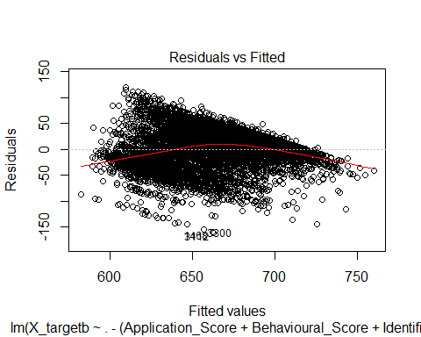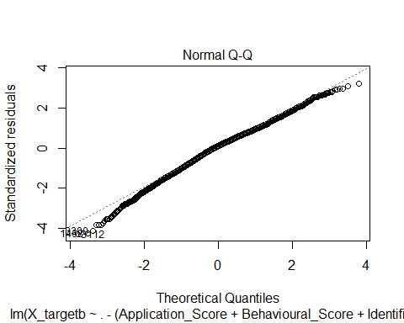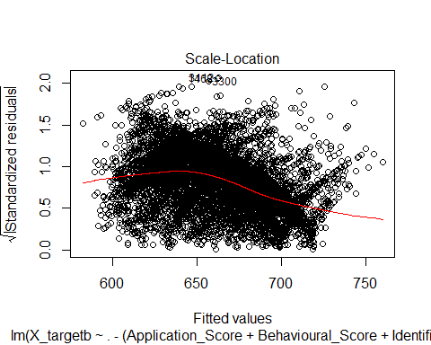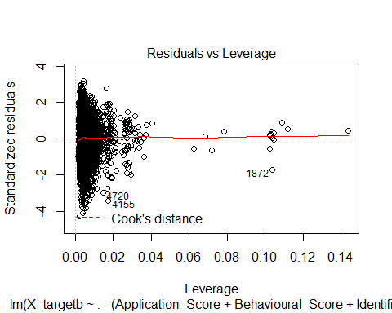

dia(mb)

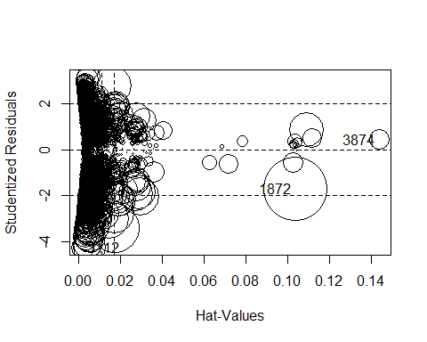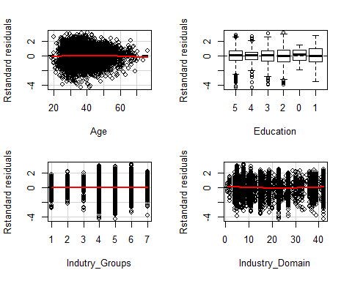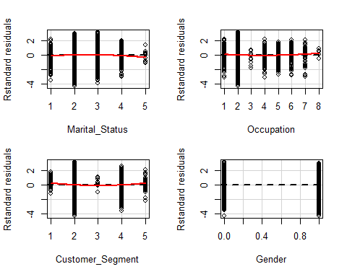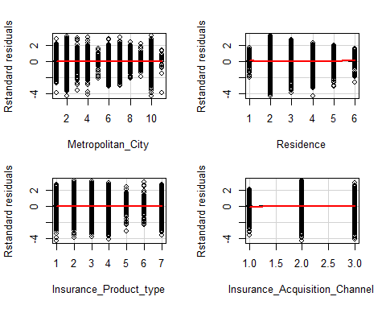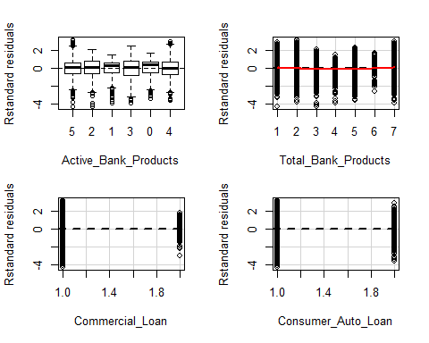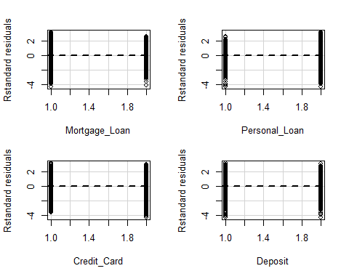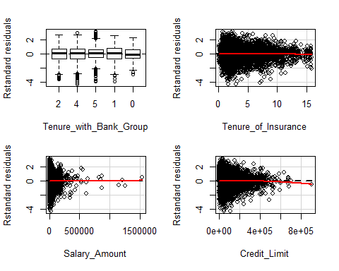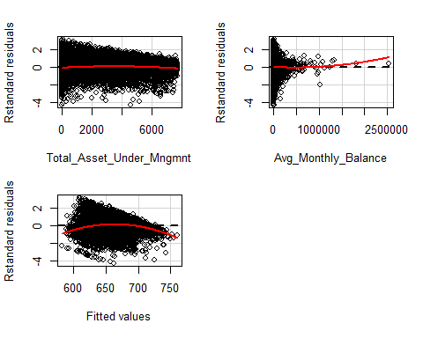

## Test stat Pr(>|t|)  
## Age -1.764 0.078  
## Education NA NA  
## Indutry_Groups -0.602 0.547  
## Industry_Domain 4.689 0.000  
## Marital_Status -2.835 0.005  
## Occupation 1.898 0.058  
## Customer_Segment 3.544 0.000  
## Gender 1.440 0.150  
## Metropolitan_City 0.019 0.985  
## Residence 1.861 0.063  
## Insurance_Product_type 0.331 0.741  
## Insurance_Acquisition_Channel -2.889 0.004  
## Active_Bank_Products NA NA  
## Total_Bank_Products 8.208 0.000  
## Commercial_Loan -1.119 0.263  
## Consumer_Auto_Loan -1.115 0.265  
## Mortgage_Loan -1.105 0.269  
## Personal_Loan -1.102 0.270  
## Credit_Card -1.118 0.263  
## Deposit -1.111 0.267  
## Tenure_with_Bank_Group NA NA  
## Tenure_of_Insurance -1.228 0.219  
## Salary_Amount 0.116 0.907  
## Credit_Limit -1.310 0.190  
## Total_Asset_Under_Mngmnt -6.353 0.000  
## Avg_Monthly_Balance 1.560 0.119  
## Tukey test -14.749 0.000

X_train1<-X_train[X_train$Customer_Segment %in% c(1,5)]  
X_train2<-X_train[X_train$Customer_Segment %in% c(2,3,4)]  
X_targeta1 <- as.numeric(X_train1$Application_Score)  
X_targetb1 <- as.numeric(X_train1$Behavioural_Score)  
X_targeta2 <- as.numeric(X_train2$Application_Score)  
X_targetb2 <- as.numeric(X_train2$Behavioural_Score)  
  
I<-X_train$Identifier  
I1<-X_train1$Identifier  
I2<-X_train2$Identifier  
  
X_train<-X_train[,":="(Application_Score=NULL,Behavioural_Score=NULL,Identifier=NULL)]  
X_train1<-X_train1[,":="(Application_Score=NULL,Behavioural_Score=NULL,Identifier=NULL)]  
X_train2<-X_train2[,":="(Application_Score=NULL,Behavioural_Score=NULL,Identifier=NULL)]  
  
X_test1<-X_test[X_test$Customer_Segment %in% c(1,5)]  
X_test2<-X_test[X_test$Customer_Segment %in% c(2,3,4)]  
  
X_test1 <- X_test1[, .SDcols=names(X_train)]  
X_test2 <- X_test2[, .SDcols=names(X_train)]  
  
ma1<-lm((X_targeta1)~.,data = X_train1)  
summary(ma1)

##   
## Call:  
## lm(formula = (X_targeta1) ~ ., data = X_train1)  
##   
## Residuals:  
## Min 1Q Median 3Q Max   
## -593.4 -134.2 14.2 168.9 422.3   
##   
## Coefficients:  
## Estimate Std. Error t value Pr(>|t|)   
## (Intercept) 1.971e+03 6.812e+02 2.894 0.00502 **  
## Age 3.175e+00 3.198e+00 0.993 0.32399   
## Education.L 1.670e+02 1.543e+02 1.082 0.28263   
## Education.Q -1.149e+02 1.850e+02 -0.621 0.53669   
## Education.C -3.750e+01 1.509e+02 -0.248 0.80445   
## Education^4 1.704e+02 2.039e+02 0.836 0.40588   
## Indutry_Groups -8.022e+01 6.307e+01 -1.272 0.20744   
## Industry_Domain 4.166e+00 4.521e+00 0.922 0.35979   
## Marital_Status 6.195e+01 6.409e+01 0.967 0.33696   
## Occupation -1.862e+01 3.544e+01 -0.526 0.60078   
## Customer_Segment -1.493e+01 2.006e+01 -0.745 0.45889   
## Gender -4.672e+01 6.658e+01 -0.702 0.48508   
## Metropolitan_City -8.169e+00 9.503e+00 -0.860 0.39281   
## Residence -3.030e+01 4.021e+01 -0.754 0.45356   
## Insurance_Product_type -2.495e+01 2.030e+01 -1.229 0.22300   
## Insurance_Acquisition_Channel -2.348e+02 7.279e+01 -3.226 0.00188 **  
## Active_Bank_Products.L -7.005e+01 9.287e+01 -0.754 0.45308   
## Active_Bank_Products.Q 2.852e+02 1.275e+02 2.237 0.02833 *   
## Active_Bank_Products.C 2.213e+00 1.297e+02 0.017 0.98644   
## Active_Bank_Products^4 -1.019e+02 1.446e+02 -0.705 0.48314   
## Active_Bank_Products^5 4.494e+02 1.816e+02 2.475 0.01563 *   
## Total_Bank_Products -7.092e-01 2.398e+01 -0.030 0.97649   
## Commercial_Loan -9.372e+01 1.075e+02 -0.872 0.38611   
## Consumer_Auto_Loan -6.401e+01 8.867e+01 -0.722 0.47266   
## Mortgage_Loan -8.738e+01 8.820e+01 -0.991 0.32512   
## Personal_Loan -2.308e+01 9.328e+01 -0.247 0.80524   
## Credit_Card -6.187e+01 6.148e+01 -1.006 0.31755   
## Deposit 7.998e+01 7.600e+01 1.052 0.29605   
## Tenure_with_Bank_Group.L 2.778e+02 2.962e+02 0.938 0.35151   
## Tenure_with_Bank_Group.Q -2.726e+02 2.299e+02 -1.186 0.23953   
## Tenure_with_Bank_Group.C -5.682e+01 1.935e+02 -0.294 0.76989   
## Tenure_with_Bank_Group^4 -8.911e+01 1.349e+02 -0.660 0.51108   
## Tenure_of_Insurance 7.797e-01 9.737e+00 0.080 0.93640   
## Salary_Amount -7.006e-04 6.279e-04 -1.116 0.26816   
## Credit_Limit 4.039e-04 3.837e-04 1.053 0.29598   
## Total_Asset_Under_Mngmnt 2.204e-03 1.609e-02 0.137 0.89143   
## Avg_Monthly_Balance -9.323e-04 4.571e-04 -2.040 0.04501 *   
## ---  
## Signif. codes: 0 '***' 0.001 '**' 0.01 '*' 0.05 '.' 0.1 ' ' 1  
##   
## Residual standard error: 267.8 on 73 degrees of freedom  
## Multiple R-squared: 0.4258, Adjusted R-squared: 0.1426   
## F-statistic: 1.503 on 36 and 73 DF, p-value: 0.07074

plot(ma1)

## Warning: not plotting observations with leverage one:  
## 59

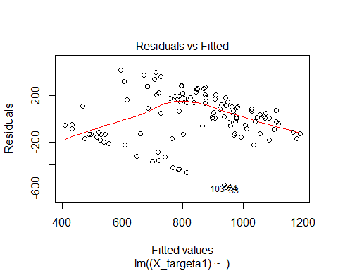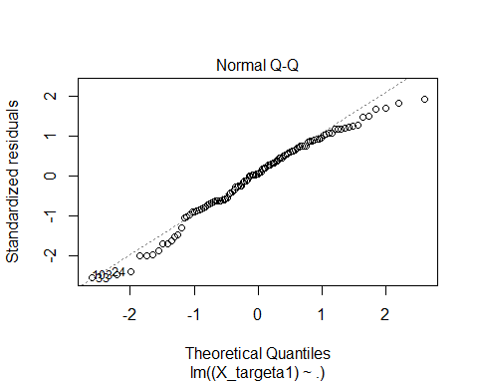

## Warning: not plotting observations with leverage one:  
## 59

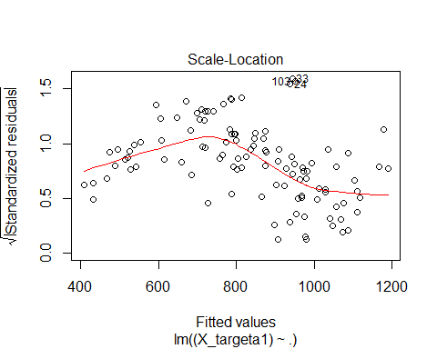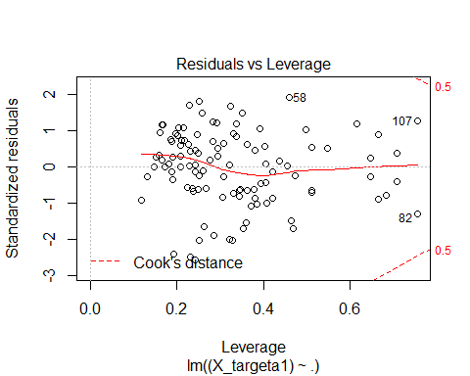

dia(ma1)

## Warning: not plotting observations with leverage one:  
## 59



## Warning: not plotting observations with leverage one:  
## 59

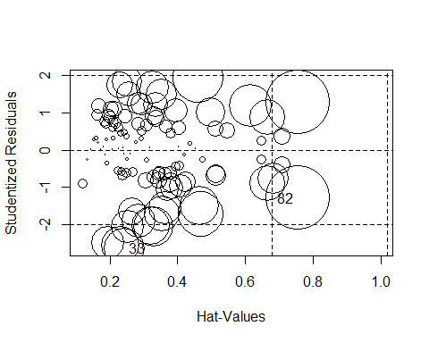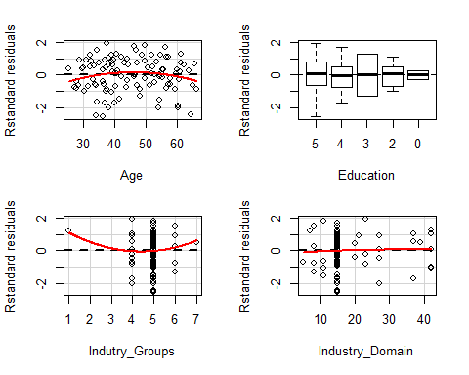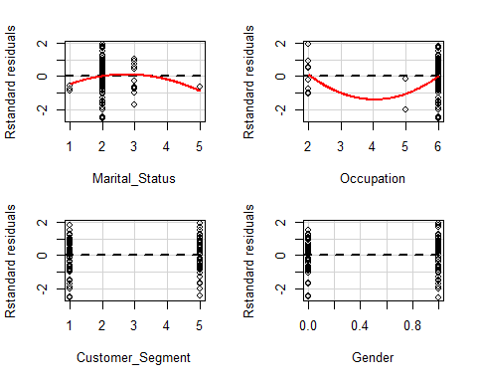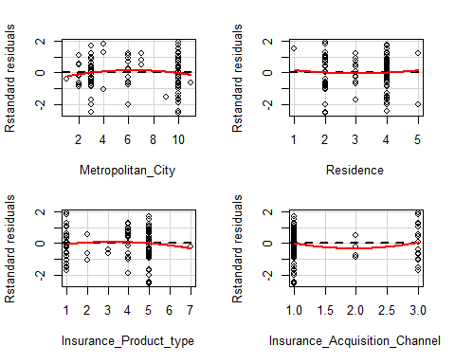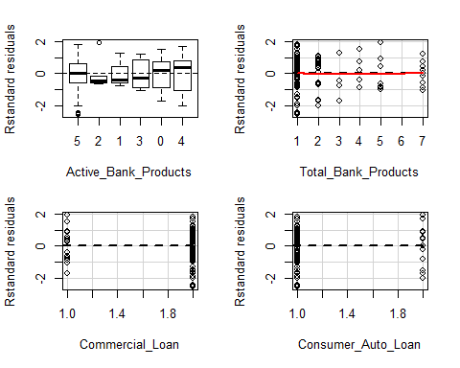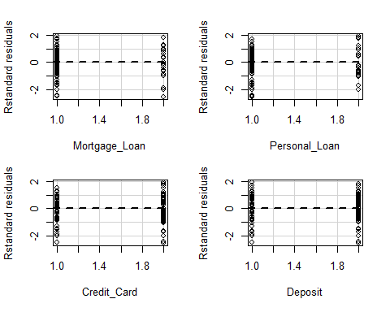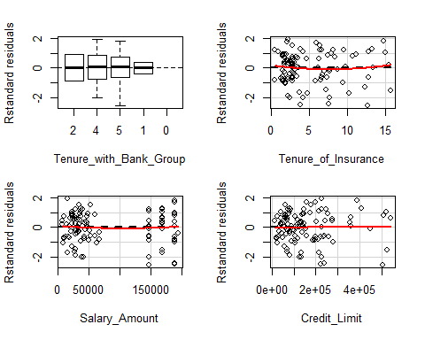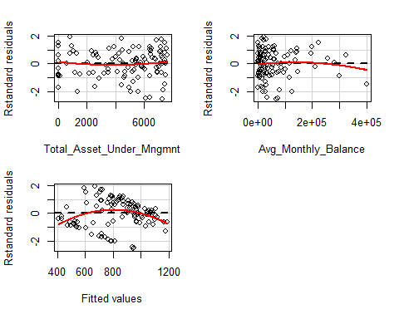

## Test stat Pr(>|t|)  
## Age -1.825 0.072  
## Education NA NA  
## Indutry_Groups 1.146 0.256  
## Industry_Domain -0.179 0.858  
## Marital_Status -1.028 0.308  
## Occupation 1.555 0.124  
## Customer_Segment -0.036 0.971  
## Gender 1.588 0.117  
## Metropolitan_City -0.813 0.419  
## Residence 0.137 0.891  
## Insurance_Product_type -0.390 0.698  
## Insurance_Acquisition_Channel 0.760 0.450  
## Active_Bank_Products NA NA  
## Total_Bank_Products 0.482 0.631  
## Commercial_Loan 1.544 0.127  
## Consumer_Auto_Loan 0.121 0.904  
## Mortgage_Loan -0.009 0.993  
## Personal_Loan -0.091 0.928  
## Credit_Card -0.240 0.811  
## Deposit 0.175 0.861  
## Tenure_with_Bank_Group NA NA  
## Tenure_of_Insurance 0.746 0.458  
## Salary_Amount 0.438 0.663  
## Credit_Limit -0.054 0.957  
## Total_Asset_Under_Mngmnt 0.815 0.418  
## Avg_Monthly_Balance -0.664 0.509  
## Tukey test -2.740 0.006

mb1<-lm((X_targetb1)~.,data = X_train1)  
summary(mb1)

##   
## Call:  
## lm(formula = (X_targetb1) ~ ., data = X_train1)  
##   
## Residuals:  
## Min 1Q Median 3Q Max   
## -68.539 -6.915 0.102 7.433 31.278   
##   
## Coefficients:  
## Estimate Std. Error t value Pr(>|t|)   
## (Intercept) 6.893e+02 4.470e+01 15.421 < 2e-16 ***  
## Age 4.185e-03 2.098e-01 0.020 0.984141   
## Education.L 2.944e+00 1.012e+01 0.291 0.771992   
## Education.Q -1.309e+01 1.214e+01 -1.079 0.284348   
## Education.C -2.829e+00 9.902e+00 -0.286 0.775926   
## Education^4 -8.426e+00 1.338e+01 -0.630 0.530772   
## Indutry_Groups -1.111e+00 4.138e+00 -0.268 0.789084   
## Industry_Domain 4.420e-02 2.966e-01 0.149 0.881955   
## Marital_Status 4.484e+00 4.205e+00 1.066 0.289865   
## Occupation -1.775e-01 2.325e+00 -0.076 0.939372   
## Customer_Segment -3.755e-01 1.316e+00 -0.285 0.776187   
## Gender -8.026e+00 4.369e+00 -1.837 0.070273 .   
## Metropolitan_City 2.815e-01 6.236e-01 0.452 0.652960   
## Residence 1.887e+00 2.639e+00 0.715 0.476744   
## Insurance_Product_type 7.919e-01 1.332e+00 0.594 0.554061   
## Insurance_Acquisition_Channel -8.399e+00 4.776e+00 -1.759 0.082817 .   
## Active_Bank_Products.L 1.310e+01 6.093e+00 2.149 0.034923 *   
## Active_Bank_Products.Q -3.250e+00 8.364e+00 -0.389 0.698694   
## Active_Bank_Products.C -1.195e+01 8.510e+00 -1.404 0.164595   
## Active_Bank_Products^4 -1.165e+01 9.490e+00 -1.228 0.223489   
## Active_Bank_Products^5 -2.609e+00 1.191e+01 -0.219 0.827235   
## Total_Bank_Products -1.697e+00 1.574e+00 -1.079 0.284357   
## Commercial_Loan 7.968e-01 7.053e+00 0.113 0.910364   
## Consumer_Auto_Loan -3.476e+00 5.818e+00 -0.597 0.552057   
## Mortgage_Loan 2.820e+00 5.787e+00 0.487 0.627574   
## Personal_Loan -1.641e+01 6.121e+00 -2.680 0.009084 **   
## Credit_Card 2.307e+00 4.034e+00 0.572 0.569236   
## Deposit -4.300e-01 4.986e+00 -0.086 0.931513   
## Tenure_with_Bank_Group.L -9.838e+01 1.944e+01 -5.062 3.01e-06 ***  
## Tenure_with_Bank_Group.Q -5.760e+01 1.508e+01 -3.819 0.000279 ***  
## Tenure_with_Bank_Group.C -3.322e+01 1.270e+01 -2.616 0.010793 *   
## Tenure_with_Bank_Group^4 2.037e+00 8.854e+00 0.230 0.818643   
## Tenure_of_Insurance 6.013e-01 6.389e-01 0.941 0.349744   
## Salary_Amount -1.174e-05 4.120e-05 -0.285 0.776551   
## Credit_Limit -4.042e-06 2.518e-05 -0.161 0.872896   
## Total_Asset_Under_Mngmnt 2.450e-03 1.056e-03 2.320 0.023136 *   
## Avg_Monthly_Balance 2.892e-05 2.999e-05 0.964 0.338073   
## ---  
## Signif. codes: 0 '***' 0.001 '**' 0.01 '*' 0.05 '.' 0.1 ' ' 1  
##   
## Residual standard error: 17.57 on 73 degrees of freedom  
## Multiple R-squared: 0.6674, Adjusted R-squared: 0.5034   
## F-statistic: 4.069 on 36 and 73 DF, p-value: 1.838e-07

plot(mb1)

## Warning: not plotting observations with leverage one:  
## 59

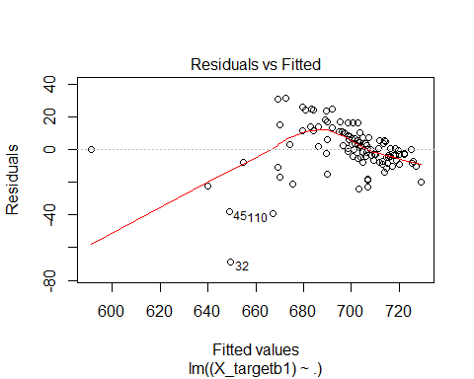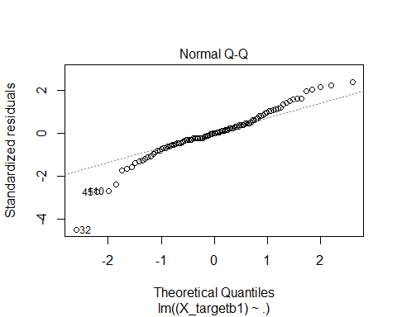

## Warning: not plotting observations with leverage one:  
## 59

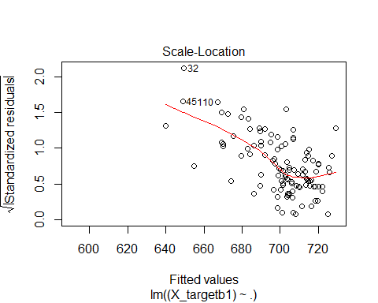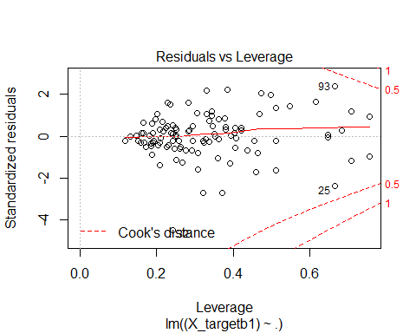

dia(mb1)

## Warning: not plotting observations with leverage one:  
## 59



## Warning: not plotting observations with leverage one:  
## 59

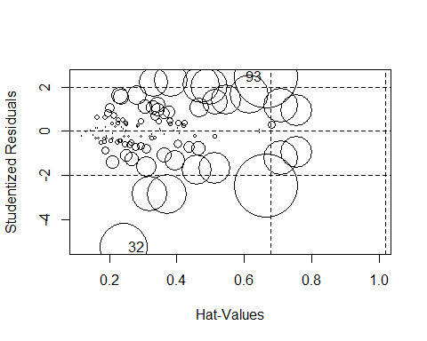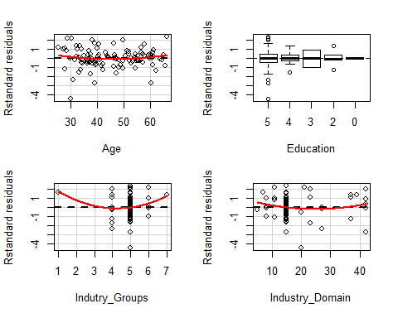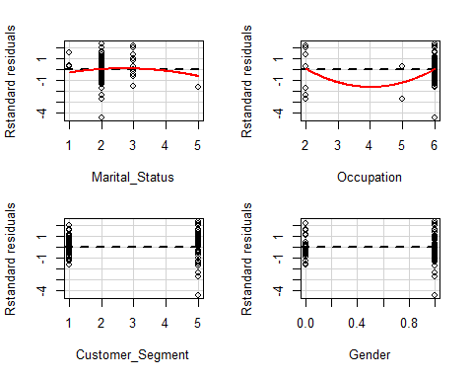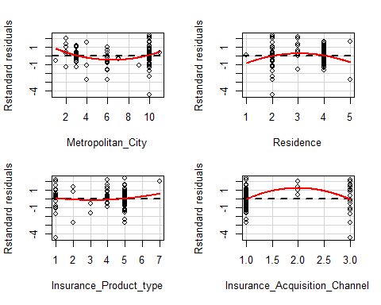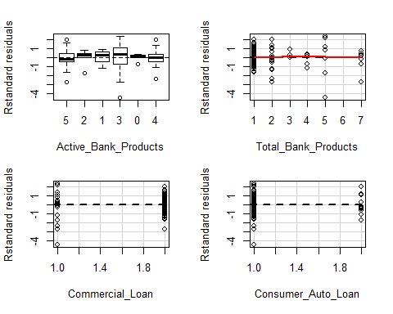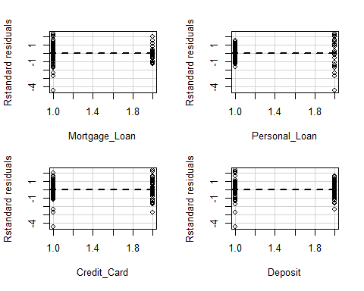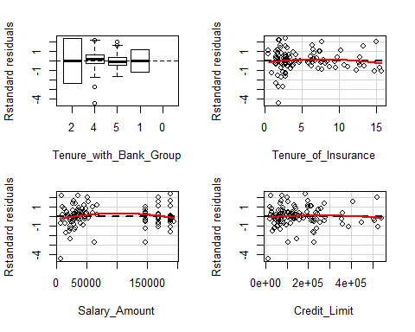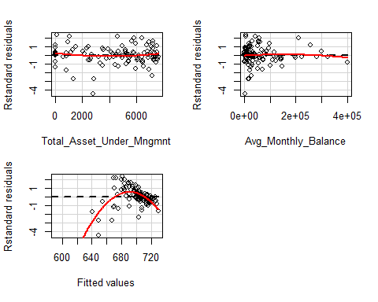

## Test stat Pr(>|t|)  
## Age 0.877 0.383  
## Education NA NA  
## Indutry_Groups 2.048 0.044  
## Industry_Domain 1.639 0.106  
## Marital_Status -0.581 0.563  
## Occupation 1.824 0.072  
## Customer_Segment 0.513 0.609  
## Gender 0.896 0.373  
## Metropolitan_City 2.325 0.023  
## Residence -1.774 0.080  
## Insurance_Product_type 0.949 0.346  
## Insurance_Acquisition_Channel -2.629 0.010  
## Active_Bank_Products NA NA  
## Total_Bank_Products -0.187 0.852  
## Commercial_Loan -0.523 0.602  
## Consumer_Auto_Loan -0.579 0.564  
## Mortgage_Loan -0.392 0.696  
## Personal_Loan -0.878 0.383  
## Credit_Card -0.652 0.516  
## Deposit -0.377 0.708  
## Tenure_with_Bank_Group NA NA  
## Tenure_of_Insurance -0.955 0.343  
## Salary_Amount -1.495 0.139  
## Credit_Limit -0.810 0.421  
## Total_Asset_Under_Mngmnt 1.313 0.193  
## Avg_Monthly_Balance -0.579 0.564  
## Tukey test -8.318 0.000

ma2<-lm((X_targeta2)~.,data = X_train2)  
summary(ma2)

##   
## Call:  
## lm(formula = (X_targeta2) ~ ., data = X_train2)  
##   
## Residuals:  
## Min 1Q Median 3Q Max   
## -205.81 -13.97 -1.18 16.40 471.72   
##   
## Coefficients:  
## Estimate Std. Error t value Pr(>|t|)   
## (Intercept) 3.396e+02 6.150e+00 55.224 < 2e-16 ***  
## Age 2.986e-01 5.891e-02 5.068 4.12e-07 ***  
## Education.L -8.387e+00 3.293e+00 -2.547 0.010891 *   
## Education.Q 4.432e+00 3.700e+00 1.198 0.231068   
## Education.C 4.140e+00 4.617e+00 0.897 0.369904   
## Education^4 -6.350e+00 2.940e+00 -2.160 0.030835 *   
## Education^5 5.757e+00 5.581e+00 1.032 0.302315   
## Education^6 3.444e+00 4.811e+00 0.716 0.474127   
## Indutry_Groups -1.019e+00 3.480e-01 -2.929 0.003409 **   
## Industry_Domain -1.149e-02 3.100e-02 -0.371 0.710897   
## Marital_Status -1.245e+00 6.470e-01 -1.925 0.054272 .   
## Occupation -3.846e+00 4.431e-01 -8.680 < 2e-16 ***  
## Customer_Segment -8.382e-02 6.179e-01 -0.136 0.892095   
## Gender 4.446e-03 8.237e-01 0.005 0.995693   
## Metropolitan_City 2.467e-01 1.132e-01 2.178 0.029420 *   
## Residence -1.289e-01 3.487e-01 -0.370 0.711710   
## Insurance_Product_type -6.559e-02 2.046e-01 -0.321 0.748504   
## Insurance_Acquisition_Channel 8.194e-02 6.263e-01 0.131 0.895920   
## Active_Bank_Products.L 2.418e+00 1.043e+00 2.319 0.020442 *   
## Active_Bank_Products.Q -1.096e+00 1.124e+00 -0.976 0.329223   
## Active_Bank_Products.C -4.751e+00 1.227e+00 -3.873 0.000108 ***  
## Active_Bank_Products^4 -4.915e+00 1.330e+00 -3.696 0.000221 ***  
## Active_Bank_Products^5 -4.497e+00 1.303e+00 -3.451 0.000563 ***  
## Total_Bank_Products 2.534e-01 2.327e-01 1.089 0.276174   
## Commercial_Loan -3.304e+00 3.210e+00 -1.029 0.303445   
## Consumer_Auto_Loan 2.745e+00 1.197e+00 2.294 0.021849 *   
## Mortgage_Loan 6.438e+00 9.339e-01 6.894 5.92e-12 ***  
## Personal_Loan 4.931e+00 8.607e-01 5.730 1.05e-08 ***  
## Credit_Card 1.381e+00 7.568e-01 1.825 0.068069 .   
## Deposit 2.438e+00 8.471e-01 2.878 0.004012 **   
## Tenure_with_Bank_Group.L -1.313e+01 1.639e+00 -8.013 1.31e-15 ***  
## Tenure_with_Bank_Group.Q -1.072e+01 1.478e+00 -7.254 4.50e-13 ***  
## Tenure_with_Bank_Group.C 2.753e+00 1.092e+00 2.521 0.011740 *   
## Tenure_with_Bank_Group^4 3.674e+00 8.943e-01 4.109 4.03e-05 ***  
## Tenure_of_Insurance -1.148e-01 1.492e-01 -0.769 0.441645   
## Salary_Amount -6.533e-06 6.930e-06 -0.943 0.345799   
## Credit_Limit 1.183e-06 5.885e-06 0.201 0.840654   
## Total_Asset_Under_Mngmnt 5.987e-04 1.960e-04 3.054 0.002264 **   
## Avg_Monthly_Balance 9.407e-07 4.613e-06 0.204 0.838404   
## ---  
## Signif. codes: 0 '***' 0.001 '**' 0.01 '*' 0.05 '.' 0.1 ' ' 1  
##   
## Residual standard error: 29.51 on 6754 degrees of freedom  
## Multiple R-squared: 0.1102, Adjusted R-squared: 0.1052   
## F-statistic: 22 on 38 and 6754 DF, p-value: < 2.2e-16

plot(ma2)

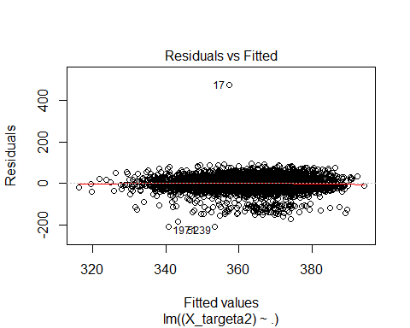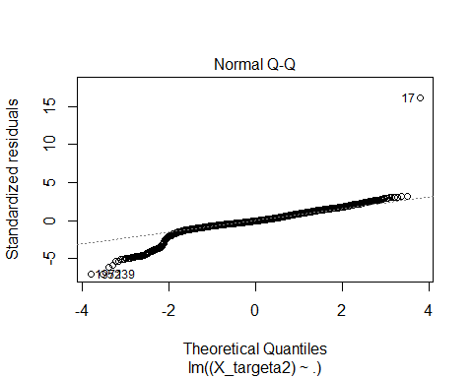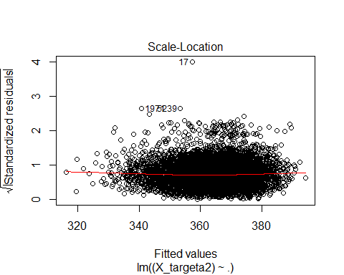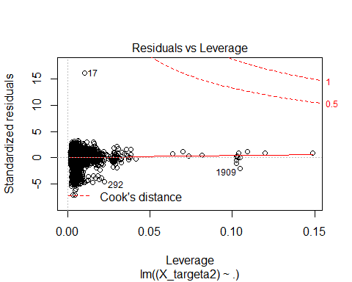

dia(ma2)

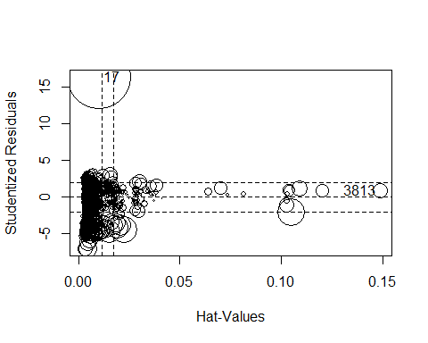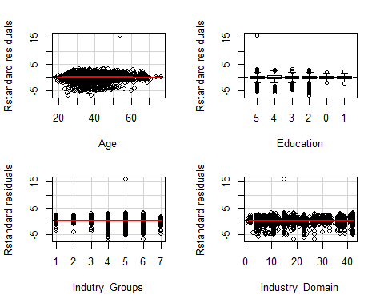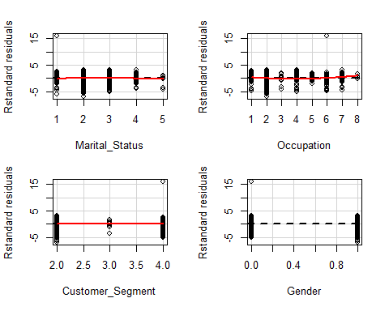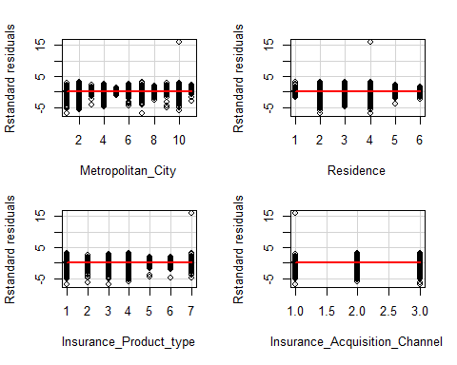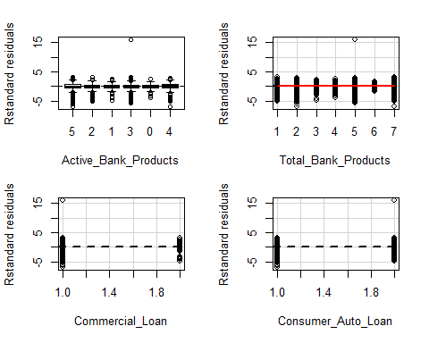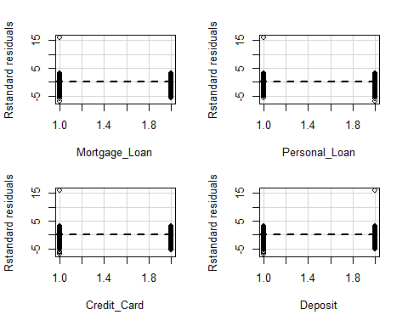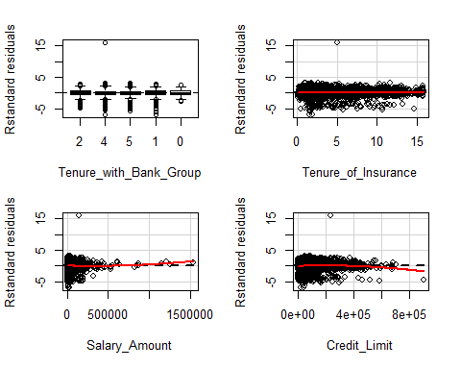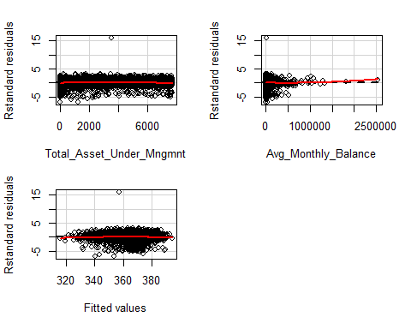

## Test stat Pr(>|t|)  
## Age -1.193 0.233  
## Education NA NA  
## Indutry_Groups 0.631 0.528  
## Industry_Domain 0.010 0.992  
## Marital_Status -1.523 0.128  
## Occupation 7.368 0.000  
## Customer_Segment -0.217 0.828  
## Gender -0.302 0.763  
## Metropolitan_City -0.716 0.474  
## Residence -0.350 0.727  
## Insurance_Product_type 1.481 0.139  
## Insurance_Acquisition_Channel 1.217 0.224  
## Active_Bank_Products NA NA  
## Total_Bank_Products -0.097 0.923  
## Commercial_Loan 0.124 0.901  
## Consumer_Auto_Loan 0.157 0.875  
## Mortgage_Loan 0.134 0.894  
## Personal_Loan 0.117 0.907  
## Credit_Card 0.131 0.895  
## Deposit 0.132 0.895  
## Tenure_with_Bank_Group NA NA  
## Tenure_of_Insurance 0.486 0.627  
## Salary_Amount 2.631 0.009  
## Credit_Limit -5.068 0.000  
## Total_Asset_Under_Mngmnt -4.837 0.000  
## Avg_Monthly_Balance 1.759 0.079  
## Tukey test -2.970 0.003

mb2<-lm((X_targetb2)~.,data = X_train2)  
summary(mb2)

##   
## Call:  
## lm(formula = (X_targetb2) ~ ., data = X_train2)  
##   
## Residuals:  
## Min 1Q Median 3Q Max   
## -160.014 -24.599 3.888 25.525 121.057   
##   
## Coefficients:  
## Estimate Std. Error t value Pr(>|t|)   
## (Intercept) 6.615e+02 7.862e+00 84.146 < 2e-16 ***  
## Age 1.308e-01 7.531e-02 1.737 0.082375 .   
## Education.L -3.535e+00 4.209e+00 -0.840 0.401117   
## Education.Q -9.477e+00 4.730e+00 -2.004 0.045156 *   
## Education.C -6.806e+00 5.902e+00 -1.153 0.248832   
## Education^4 5.517e-01 3.759e+00 0.147 0.883314   
## Education^5 1.253e+01 7.134e+00 1.756 0.079159 .   
## Education^6 6.656e+00 6.150e+00 1.082 0.279195   
## Indutry_Groups -3.120e-01 4.448e-01 -0.701 0.483119   
## Industry_Domain -1.557e-01 3.962e-02 -3.930 8.57e-05 ***  
## Marital_Status -1.492e+00 8.271e-01 -1.803 0.071369 .   
## Occupation -1.083e+00 5.664e-01 -1.912 0.055959 .   
## Customer_Segment 9.939e-01 7.899e-01 1.258 0.208330   
## Gender 1.282e+00 1.053e+00 1.217 0.223470   
## Metropolitan_City 1.835e-01 1.447e-01 1.267 0.205051   
## Residence 2.090e+00 4.458e-01 4.688 2.82e-06 ***  
## Insurance_Product_type 1.429e-02 2.615e-01 0.055 0.956419   
## Insurance_Acquisition_Channel -2.425e+00 8.007e-01 -3.029 0.002460 **   
## Active_Bank_Products.L 1.188e+01 1.333e+00 8.912 < 2e-16 ***  
## Active_Bank_Products.Q -4.211e+01 1.436e+00 -29.312 < 2e-16 ***  
## Active_Bank_Products.C 2.939e+00 1.568e+00 1.874 0.060914 .   
## Active_Bank_Products^4 -2.527e+01 1.700e+00 -14.864 < 2e-16 ***  
## Active_Bank_Products^5 -3.518e+01 1.666e+00 -21.114 < 2e-16 ***  
## Total_Bank_Products -1.075e+00 2.975e-01 -3.613 0.000305 ***  
## Commercial_Loan -4.664e+00 4.104e+00 -1.136 0.255814   
## Consumer_Auto_Loan -3.321e+00 1.530e+00 -2.170 0.030021 *   
## Mortgage_Loan -1.489e+00 1.194e+00 -1.247 0.212473   
## Personal_Loan -1.386e+01 1.100e+00 -12.597 < 2e-16 ***  
## Credit_Card 3.428e+00 9.674e-01 3.544 0.000397 ***  
## Deposit 6.097e+00 1.083e+00 5.630 1.87e-08 ***  
## Tenure_with_Bank_Group.L -1.331e+01 2.095e+00 -6.352 2.27e-10 ***  
## Tenure_with_Bank_Group.Q -1.270e+01 1.890e+00 -6.722 1.93e-11 ***  
## Tenure_with_Bank_Group.C 2.241e+00 1.396e+00 1.605 0.108563   
## Tenure_with_Bank_Group^4 4.032e+00 1.143e+00 3.526 0.000424 ***  
## Tenure_of_Insurance 2.972e-01 1.908e-01 1.558 0.119330   
## Salary_Amount -1.483e-05 8.858e-06 -1.675 0.094070 .   
## Credit_Limit 1.290e-05 7.523e-06 1.714 0.086523 .   
## Total_Asset_Under_Mngmnt 1.034e-02 2.506e-04 41.254 < 2e-16 ***  
## Avg_Monthly_Balance -1.123e-05 5.897e-06 -1.905 0.056799 .   
## ---  
## Signif. codes: 0 '***' 0.001 '**' 0.01 '*' 0.05 '.' 0.1 ' ' 1  
##   
## Residual standard error: 37.73 on 6754 degrees of freedom  
## Multiple R-squared: 0.3897, Adjusted R-squared: 0.3862   
## F-statistic: 113.5 on 38 and 6754 DF, p-value: < 2.2e-16

plot(mb2)

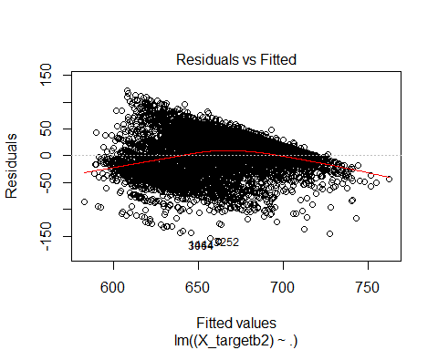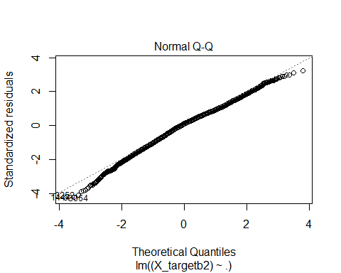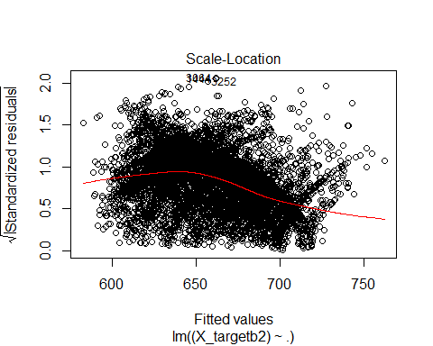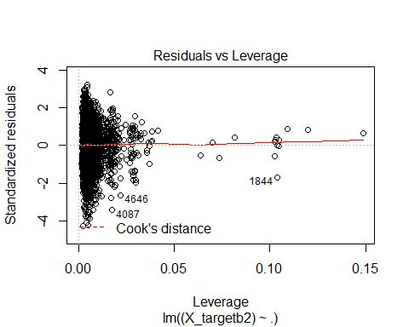

dia(mb2)

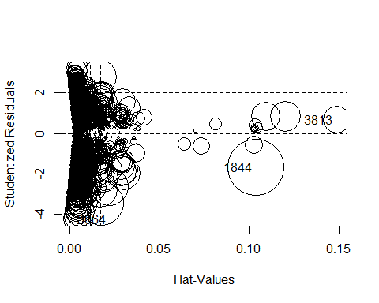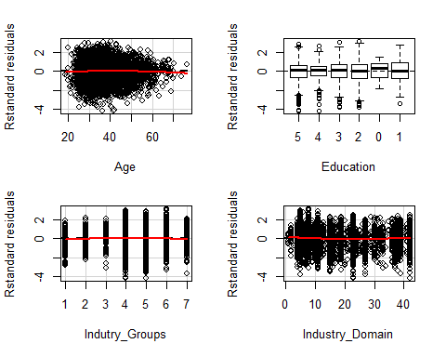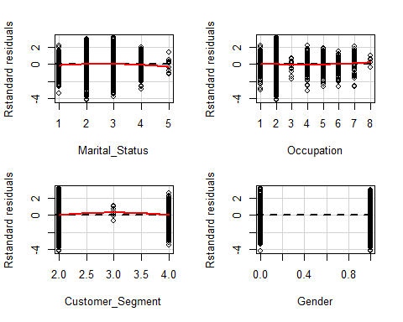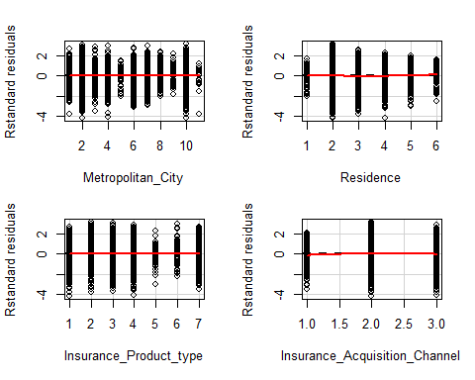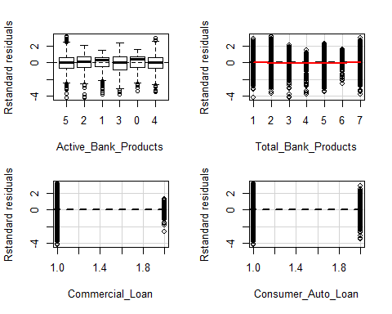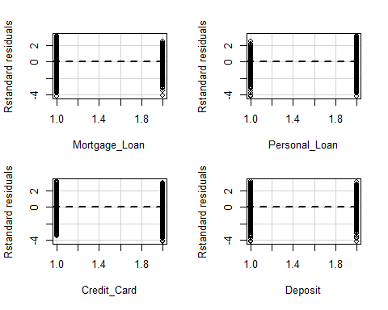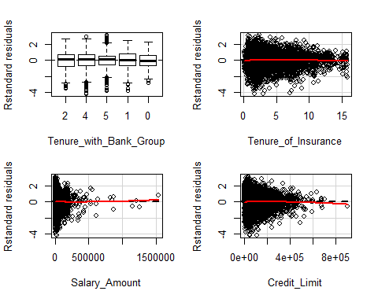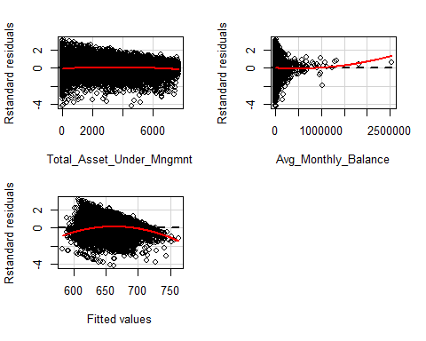

## Test stat Pr(>|t|)  
## Age -1.622 0.105  
## Education NA NA  
## Indutry_Groups -0.591 0.555  
## Industry_Domain 4.898 0.000  
## Marital_Status -2.618 0.009  
## Occupation 1.638 0.101  
## Customer_Segment -0.984 0.325  
## Gender -0.073 0.942  
## Metropolitan_City -0.071 0.943  
## Residence 1.978 0.048  
## Insurance_Product_type 0.338 0.735  
## Insurance_Acquisition_Channel -3.500 0.000  
## Active_Bank_Products NA NA  
## Total_Bank_Products 8.047 0.000  
## Commercial_Loan -1.091 0.275  
## Consumer_Auto_Loan -1.110 0.267  
## Mortgage_Loan -1.075 0.282  
## Personal_Loan -1.086 0.278  
## Credit_Card -1.105 0.269  
## Deposit -1.113 0.266  
## Tenure_with_Bank_Group NA NA  
## Tenure_of_Insurance -0.945 0.345  
## Salary_Amount 0.435 0.664  
## Credit_Limit -0.872 0.383  
## Total_Asset_Under_Mngmnt -6.265 0.000  
## Avg_Monthly_Balance 1.901 0.057  
## Tukey test -14.575 0.000

xgb_cva1 <- xgb.cv(data=data.matrix(X_train1), nfold=10,  
 label=as.matrix(X_targeta1), booster = "gblinear",   
 objective = "reg:linear",   
 max.depth = 20,  
 nrounds = 35,  
 lambda = 0,   
 lambda_bias = 0,   
 alpha = 0)

## [0] train-rmse:269.012817+5.829876 test-rmse:284.856631+47.772691  
## [1] train-rmse:259.933458+6.390437 test-rmse:285.401190+52.435462  
## [2] train-rmse:253.802367+6.518422 test-rmse:287.565715+54.625097  
## [3] train-rmse:250.105009+6.095926 test-rmse:288.422936+57.147010  
## [4] train-rmse:247.188727+6.249818 test-rmse:290.332507+58.972993  
## [5] train-rmse:244.982846+6.132134 test-rmse:290.011348+60.725771  
## [6] train-rmse:243.216715+6.200594 test-rmse:291.793999+63.756406  
## [7] train-rmse:241.829886+6.139884 test-rmse:293.881634+64.816326  
## [8] train-rmse:240.376675+6.351469 test-rmse:293.642612+66.056887  
## [9] train-rmse:239.258965+6.619909 test-rmse:294.873627+65.069658  
## [10] train-rmse:238.408266+6.740111 test-rmse:296.549817+65.680970  
## [11] train-rmse:237.613794+6.825877 test-rmse:297.404948+66.633653  
## [12] train-rmse:236.873854+6.871151 test-rmse:298.009752+66.362027  
## [13] train-rmse:236.287113+6.962913 test-rmse:298.519051+66.672329  
## [14] train-rmse:235.725584+7.032396 test-rmse:299.461019+66.187411  
## [15] train-rmse:235.225169+7.092383 test-rmse:300.220275+67.606892  
## [16] train-rmse:234.773212+7.194698 test-rmse:300.549016+68.287645  
## [17] train-rmse:234.330213+7.310027 test-rmse:300.927744+68.528592  
## [18] train-rmse:233.975008+7.382109 test-rmse:301.464398+68.549288  
## [19] train-rmse:233.574794+7.519729 test-rmse:301.867444+69.677616  
## [20] train-rmse:233.235351+7.596689 test-rmse:302.812763+69.857229  
## [21] train-rmse:232.939888+7.654463 test-rmse:303.521985+70.053385  
## [22] train-rmse:232.691789+7.686492 test-rmse:304.166046+70.166910  
## [23] train-rmse:232.430148+7.727810 test-rmse:304.636432+70.134991  
## [24] train-rmse:232.234982+7.766603 test-rmse:305.193209+70.179855  
## [25] train-rmse:232.065607+7.813216 test-rmse:306.008623+70.428403  
## [26] train-rmse:231.852812+7.890146 test-rmse:306.931586+70.913888  
## [27] train-rmse:231.689204+7.904962 test-rmse:307.134143+71.812616  
## [28] train-rmse:231.530925+7.951607 test-rmse:307.323975+71.919742  
## [29] train-rmse:231.387357+7.979478 test-rmse:307.792189+72.334916  
## [30] train-rmse:231.268286+8.023900 test-rmse:308.217378+72.511766  
## [31] train-rmse:231.168138+8.050758 test-rmse:308.523486+72.138816  
## [32] train-rmse:231.056709+8.073984 test-rmse:308.908070+71.950764  
## [33] train-rmse:230.960306+8.093547 test-rmse:309.001431+72.137148  
## [34] train-rmse:230.840282+8.152382 test-rmse:308.805009+72.046574

#one-hot-encoding categorical features  
ohe_feats = c('Insurance_Acquisition_Channel','Insurance_Product_type','Residence',  
 'Metropolitan_City','Customer_Segment')  
  
dummies <- dummyVars(~ (Insurance_Acquisition_Channel+Insurance_Product_type  
 +Residence+Metropolitan_City+Customer_Segment+Identifier),sep=':',  
 fullRank=T,sparse=T,data = a0)  
a_ohe <- as.data.table(predict(dummies, newdata =a0))  
#a_cbd <- merge(a[,-c(which(colnames(a) %in% ohe_feats))],a_ohe,  
# by='Identifier',all=TRUE)  
a_cbd <- cbind(a[,-c(which(colnames(a0) %in% ohe_feats)),with=F],a_ohe)  
a_cbd <-(a_cbd[,":="(Application_Score=NULL,  
 Behavioural_Score=NULL)])  
X_train0 = a_cbd[a_cbd$Identifier %in% I,2:49,with=FALSE]  
X_train01 = a_cbd[a_cbd$Identifier %in% I1,2:49,with=FALSE]  
X_train02 = a_cbd[a_cbd$Identifier %in% I2,2:49,with=FALSE]  
ma01<-lm((X_targeta1)~.,data = X_train01)  
summary(ma01)

##   
## Call:  
## lm(formula = (X_targeta1) ~ ., data = X_train01)  
##   
## Residuals:  
## Min 1Q Median 3Q Max   
## -570.25 -94.71 3.18 125.95 428.21   
##   
## Coefficients: (7 not defined because of singularities)  
## Estimate  
## (Intercept) 2.754e+03  
## Age 3.781e+00  
## Education.L 2.838e+02  
## Education.Q -1.077e+01  
## Education.C -3.018e+01  
## Education^4 1.564e+02  
## Indutry_Groups -1.636e+02  
## Industry_Domain 1.844e+00  
## Marital_Status 1.713e+02  
## Occupation -3.739e+01  
## Gender 1.347e+01  
## Active_Bank_Products.L -1.384e+02  
## Active_Bank_Products.Q 3.159e+02  
## Active_Bank_Products.C 6.710e+01  
## Active_Bank_Products^4 -7.482e+01  
## Active_Bank_Products^5 4.932e+02  
## Total_Bank_Products 1.053e+01  
## Commercial_Loan -3.346e+01  
## Consumer_Auto_Loan -6.511e+01  
## Mortgage_Loan -1.735e+02  
## Personal_Loan 3.474e+01  
## Credit_Card -1.373e+02  
## Deposit 8.823e+01  
## Tenure_with_Bank_Group.L 2.182e+02  
## Tenure_with_Bank_Group.Q -3.934e+02  
## Tenure_with_Bank_Group.C -1.467e+02  
## Tenure_with_Bank_Group^4 -1.774e+02  
## Tenure_of_Insurance -9.881e-01  
## Salary_Amount -5.886e-04  
## Credit_Limit 5.281e-04  
## Total_Asset_Under_Mngmnt -2.010e-03  
## Avg_Monthly_Balance -9.080e-04  
## Insurance_Acquisition_ChannelBank -4.176e+02  
## Insurance_Acquisition_ChannelDirect -5.064e+02  
## `Insurance_Product_typeCredit Card Insurance` -3.309e+02  
## `Insurance_Product_typeHealth Insurance` -4.892e+02  
## `Insurance_Product_typeHome Insurance` 1.137e+02  
## `Insurance_Product_typeSmall and Medium Enterprises Insurance` -9.675e+01  
## `Insurance_Product_typeTheft Insurance` NA  
## `Insurance_Product_typeTheft Insurance for Credit Card` -2.326e+02  
## `ResidenceLiving in a house owned by a family member` -6.216e+02  
## `ResidenceLiving with Family` -6.340e+02  
## `ResidenceOwn House` -6.197e+02  
## `ResidenceRented House` -1.164e+03  
## ResidenceUnknown NA  
## Metropolitan_CityBengaluru -2.466e+02  
## Metropolitan_CityChandigarh -3.043e+02  
## Metropolitan_CityChennai 2.732e+01  
## Metropolitan_CityDelhi NA  
## Metropolitan_CityHyderabad -2.961e+02  
## Metropolitan_CityIndore -1.511e+02  
## Metropolitan_CityLucknow NA  
## Metropolitan_CityMumbai -7.465e+02  
## Metropolitan_CityOthers -4.120e+02  
## Metropolitan_CityPune -8.017e+02  
## Customer_SegmentIndividual NA  
## `Customer_SegmentPrivate Banking` NA  
## `Customer_SegmentPrivilege Banking` NA  
## Customer_SegmentSME -5.059e+01  
## Std. Error  
## (Intercept) 1.035e+03  
## Age 3.616e+00  
## Education.L 1.671e+02  
## Education.Q 2.003e+02  
## Education.C 1.646e+02  
## Education^4 2.311e+02  
## Indutry_Groups 9.007e+01  
## Industry_Domain 5.268e+00  
## Marital_Status 1.028e+02  
## Occupation 4.270e+01  
## Gender 7.415e+01  
## Active_Bank_Products.L 1.070e+02  
## Active_Bank_Products.Q 1.466e+02  
## Active_Bank_Products.C 1.489e+02  
## Active_Bank_Products^4 1.656e+02  
## Active_Bank_Products^5 2.162e+02  
## Total_Bank_Products 2.657e+01  
## Commercial_Loan 1.311e+02  
## Consumer_Auto_Loan 1.024e+02  
## Mortgage_Loan 1.030e+02  
## Personal_Loan 1.119e+02  
## Credit_Card 6.731e+01  
## Deposit 9.271e+01  
## Tenure_with_Bank_Group.L 3.240e+02  
## Tenure_with_Bank_Group.Q 2.936e+02  
## Tenure_with_Bank_Group.C 2.110e+02  
## Tenure_with_Bank_Group^4 1.626e+02  
## Tenure_of_Insurance 1.085e+01  
## Salary_Amount 6.975e-04  
## Credit_Limit 4.315e-04  
## Total_Asset_Under_Mngmnt 1.817e-02  
## Avg_Monthly_Balance 5.036e-04  
## Insurance_Acquisition_ChannelBank 2.325e+02  
## Insurance_Acquisition_ChannelDirect 2.042e+02  
## `Insurance_Product_typeCredit Card Insurance` 2.578e+02  
## `Insurance_Product_typeHealth Insurance` 4.120e+02  
## `Insurance_Product_typeHome Insurance` 1.166e+02  
## `Insurance_Product_typeSmall and Medium Enterprises Insurance` 8.938e+01  
## `Insurance_Product_typeTheft Insurance` NA  
## `Insurance_Product_typeTheft Insurance for Credit Card` 4.762e+02  
## `ResidenceLiving in a house owned by a family member` 3.393e+02  
## `ResidenceLiving with Family` 3.431e+02  
## `ResidenceOwn House` 3.428e+02  
## `ResidenceRented House` 4.796e+02  
## ResidenceUnknown NA  
## Metropolitan_CityBengaluru 5.665e+02  
## Metropolitan_CityChandigarh 5.640e+02  
## Metropolitan_CityChennai 5.448e+02  
## Metropolitan_CityDelhi NA  
## Metropolitan_CityHyderabad 5.625e+02  
## Metropolitan_CityIndore 5.877e+02  
## Metropolitan_CityLucknow NA  
## Metropolitan_CityMumbai 6.155e+02  
## Metropolitan_CityOthers 5.578e+02  
## Metropolitan_CityPune 6.619e+02  
## Customer_SegmentIndividual NA  
## `Customer_SegmentPrivate Banking` NA  
## `Customer_SegmentPrivilege Banking` NA  
## Customer_SegmentSME 8.270e+01  
## t value  
## (Intercept) 2.661  
## Age 1.046  
## Education.L 1.698  
## Education.Q -0.054  
## Education.C -0.183  
## Education^4 0.677  
## Indutry_Groups -1.816  
## Industry_Domain 0.350  
## Marital_Status 1.667  
## Occupation -0.876  
## Gender 0.182  
## Active_Bank_Products.L -1.293  
## Active_Bank_Products.Q 2.154  
## Active_Bank_Products.C 0.451  
## Active_Bank_Products^4 -0.452  
## Active_Bank_Products^5 2.282  
## Total_Bank_Products 0.396  
## Commercial_Loan -0.255  
## Consumer_Auto_Loan -0.636  
## Mortgage_Loan -1.685  
## Personal_Loan 0.310  
## Credit_Card -2.040  
## Deposit 0.952  
## Tenure_with_Bank_Group.L 0.673  
## Tenure_with_Bank_Group.Q -1.340  
## Tenure_with_Bank_Group.C -0.695  
## Tenure_with_Bank_Group^4 -1.091  
## Tenure_of_Insurance -0.091  
## Salary_Amount -0.844  
## Credit_Limit 1.224  
## Total_Asset_Under_Mngmnt -0.111  
## Avg_Monthly_Balance -1.803  
## Insurance_Acquisition_ChannelBank -1.796  
## Insurance_Acquisition_ChannelDirect -2.480  
## `Insurance_Product_typeCredit Card Insurance` -1.283  
## `Insurance_Product_typeHealth Insurance` -1.188  
## `Insurance_Product_typeHome Insurance` 0.975  
## `Insurance_Product_typeSmall and Medium Enterprises Insurance` -1.083  
## `Insurance_Product_typeTheft Insurance` NA  
## `Insurance_Product_typeTheft Insurance for Credit Card` -0.488  
## `ResidenceLiving in a house owned by a family member` -1.832  
## `ResidenceLiving with Family` -1.848  
## `ResidenceOwn House` -1.808  
## `ResidenceRented House` -2.428  
## ResidenceUnknown NA  
## Metropolitan_CityBengaluru -0.435  
## Metropolitan_CityChandigarh -0.540  
## Metropolitan_CityChennai 0.050  
## Metropolitan_CityDelhi NA  
## Metropolitan_CityHyderabad -0.526  
## Metropolitan_CityIndore -0.257  
## Metropolitan_CityLucknow NA  
## Metropolitan_CityMumbai -1.213  
## Metropolitan_CityOthers -0.739  
## Metropolitan_CityPune -1.211  
## Customer_SegmentIndividual NA  
## `Customer_SegmentPrivate Banking` NA  
## `Customer_SegmentPrivilege Banking` NA  
## Customer_SegmentSME -0.612  
## Pr(>|t|)   
## (Intercept) 0.0101 *  
## Age 0.3000   
## Education.L 0.0948 .  
## Education.Q 0.9573   
## Education.C 0.8552   
## Education^4 0.5013   
## Indutry_Groups 0.0745 .  
## Industry_Domain 0.7275   
## Marital_Status 0.1009   
## Occupation 0.3848   
## Gender 0.8565   
## Active_Bank_Products.L 0.2011   
## Active_Bank_Products.Q 0.0354 *  
## Active_Bank_Products.C 0.6538   
## Active_Bank_Products^4 0.6530   
## Active_Bank_Products^5 0.0262 *  
## Total_Bank_Products 0.6932   
## Commercial_Loan 0.7994   
## Consumer_Auto_Loan 0.5272   
## Mortgage_Loan 0.0973 .  
## Personal_Loan 0.7574   
## Credit_Card 0.0459 *  
## Deposit 0.3452   
## Tenure_with_Bank_Group.L 0.5033   
## Tenure_with_Bank_Group.Q 0.1855   
## Tenure_with_Bank_Group.C 0.4897   
## Tenure_with_Bank_Group^4 0.2798   
## Tenure_of_Insurance 0.9277   
## Salary_Amount 0.4022   
## Credit_Limit 0.2260   
## Total_Asset_Under_Mngmnt 0.9123   
## Avg_Monthly_Balance 0.0766 .  
## Insurance_Acquisition_ChannelBank 0.0777 .  
## Insurance_Acquisition_ChannelDirect 0.0161 *  
## `Insurance_Product_typeCredit Card Insurance` 0.2045   
## `Insurance_Product_typeHealth Insurance` 0.2399   
## `Insurance_Product_typeHome Insurance` 0.3334   
## `Insurance_Product_typeSmall and Medium Enterprises Insurance` 0.2835   
## `Insurance_Product_typeTheft Insurance` NA   
## `Insurance_Product_typeTheft Insurance for Credit Card` 0.6271   
## `ResidenceLiving in a house owned by a family member` 0.0721 .  
## `ResidenceLiving with Family` 0.0697 .  
## `ResidenceOwn House` 0.0758 .  
## `ResidenceRented House` 0.0183 *  
## ResidenceUnknown NA   
## Metropolitan_CityBengaluru 0.6650   
## Metropolitan_CityChandigarh 0.5915   
## Metropolitan_CityChennai 0.9602   
## Metropolitan_CityDelhi NA   
## Metropolitan_CityHyderabad 0.6006   
## Metropolitan_CityIndore 0.7979   
## Metropolitan_CityLucknow NA   
## Metropolitan_CityMumbai 0.2301   
## Metropolitan_CityOthers 0.4632   
## Metropolitan_CityPune 0.2308   
## Customer_SegmentIndividual NA   
## `Customer_SegmentPrivate Banking` NA   
## `Customer_SegmentPrivilege Banking` NA   
## Customer_SegmentSME 0.5431   
## ---  
## Signif. codes: 0 '***' 0.001 '**' 0.01 '*' 0.05 '.' 0.1 ' ' 1  
##   
## Residual standard error: 265.9 on 58 degrees of freedom  
## Multiple R-squared: 0.5504, Adjusted R-squared: 0.155   
## F-statistic: 1.392 on 51 and 58 DF, p-value: 0.1112

rfa1<-randomForest((X_targeta1)~.,data = X_train1)  
p_rf1<-predict(rfa1,X_train1)  
RMS(p_rf1,X_targeta1,36)[1]

## [[1]]  
## [1] 155.688

varImpPlot(rfa1)

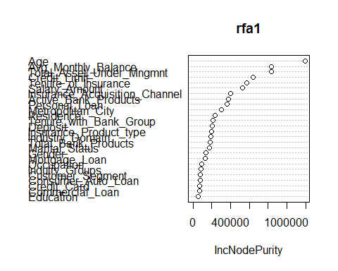

res_plot2(X_targeta1,p_rf1)

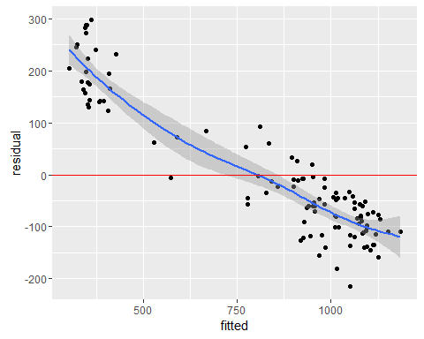

plot(rfa1)

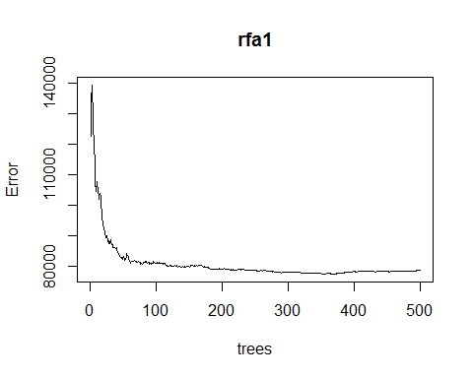

rfa1<-randomForest((X_targeta1)~.-(Gender+Occupation+Indutry_Groups+  
 Consumer_Auto_Loan+Commercial_Loan+Credit_Card+  
 Customer_Segment+Education+Mortgage_Loan),  
 importance=F,ntree =100,data = X_train1)  
p_rf1<-predict(rfa1,X_train1)  
RMS(p_rf1,X_targeta1,36)[1]

## [[1]]  
## [1] 160.6635

res_plot2(X_targeta1,p_rf1)

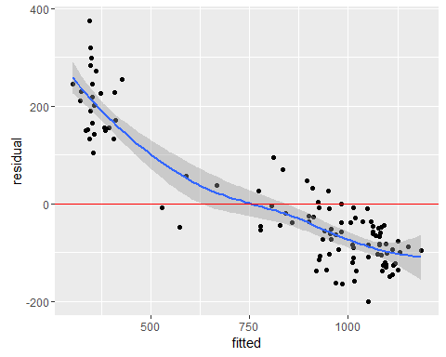

pa1<-predict(rfa1,X_test1)  
pa2<-predict(ma2,X_test2)  
pb1<-predict(mb1,X_test1)  
pb2<-predict(mb2,X_test2)  
  
da1<-as.data.table(cbind(X_test1$Identifier,pa1),check.names=T)[,.(P_Application_Score=pa1,Identifier=V1)]  
sol<-merge(x = sol, y = da1, by = "Identifier", all.x = TRUE)  
da2<-as.data.table(cbind(X_test2$Identifier,pa2),check.names=T)[,.(P_Application_Score=pa2,Identifier=V1)]  
sol<-merge(x = sol, y = da2, by = "Identifier", all.x = TRUE)  
sol$P_Application_Score<- rowSums(sol[,c("P_Application_Score.y","P_Application_Score"),with=F], na.rm=T)  
  
da1<-as.data.table(cbind(X_test1$Identifier,pb1),check.names=T)[,.(P_Behavioural_Score=pb1,Identifier=V1)]  
sol<-merge(x = sol, y = da1, by = "Identifier", all.x = TRUE)  
da2<-as.data.table(cbind(X_test2$Identifier,pb2),check.names=T)[,.(P_Behavioural_Score=pb2,Identifier=V1)]  
sol<-merge(x = sol, y = da2, by = "Identifier", all.x = TRUE)  
sol$P_Behavioural_Score<- rowSums(sol[,c("P_Behavioural_Score.y","P_Behavioural_Score"),with=F], na.rm=T)  
  
p1<-sol$P_Application_Score  
p2<-sol$P_Behavioural_Score  
sol<-fread("BFSI - Solution submission template.csv",stringsAsFactors=T)  
sol[,c("P_Application_Score","P_Behavioural_Score"):=list(p1,p2)]  
write.xlsx(sol,"BFSI - Solution submission template.xlsx",row.names=FALSE)