INT-404 AI

K18UW GROUP 1

REPORT FOR SYSTEM FOR FAMILY TREE

DETAILS OF PROJECT MEMBERS:

1.Akhil Reddy,11805219,04

2.Ganesh,11805287,22

3.Praneeth Chandar,11804928,32

ABOUT THE PROJECT:

System For Family Tree -

System is expected to store all your close blood relations. And, system have to tell, what is the name of the relationship between any two given person.

GIVEN INFORMATION ABOUT THE FAMILY:

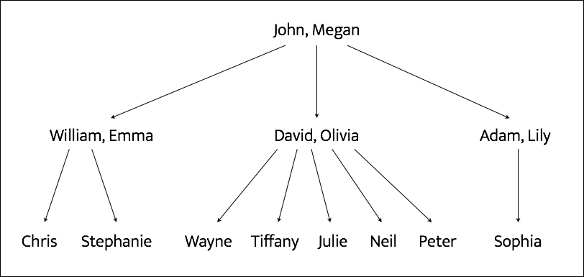

GITHUB LINK:

<https://github.com/AkhilReddy0409/Akhil-leo>

CODE SNIPPET :

1.json FILE

2.Python Code FILE

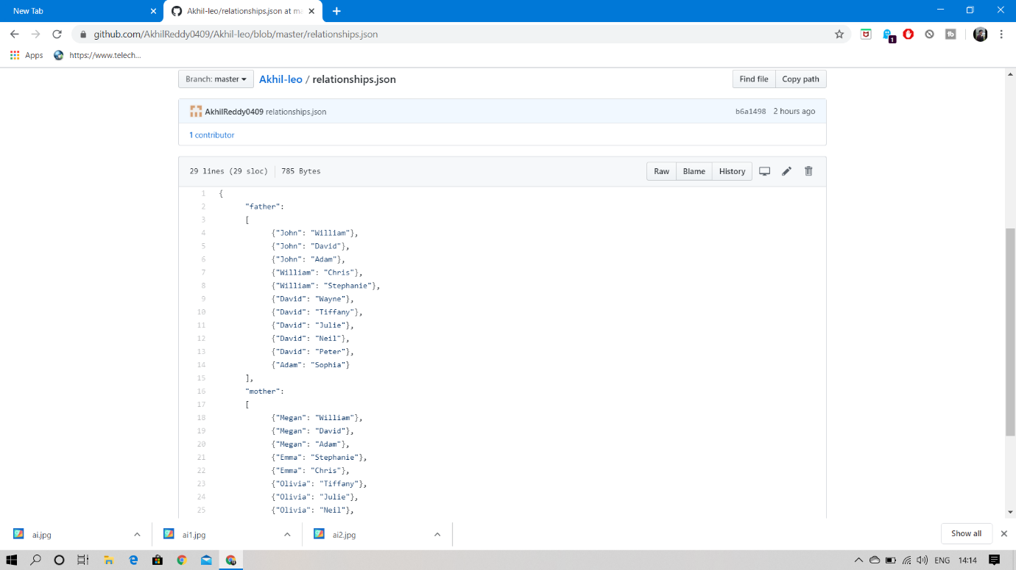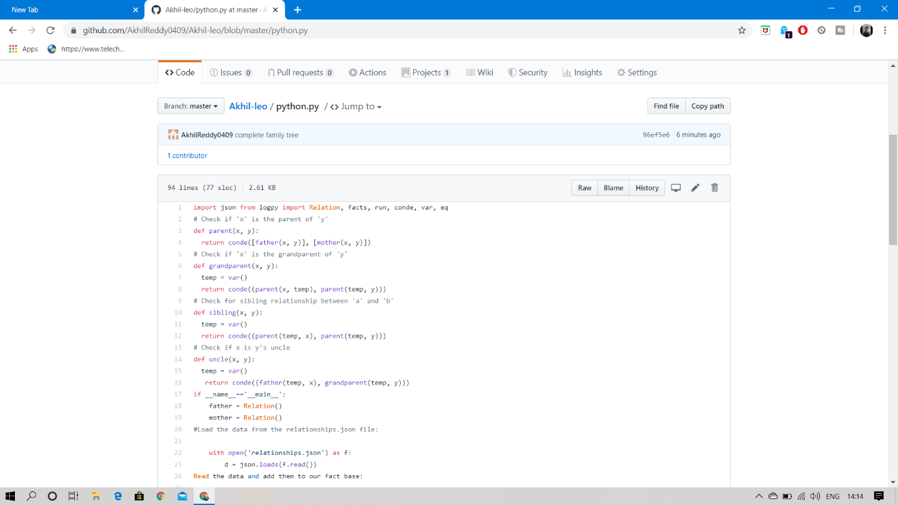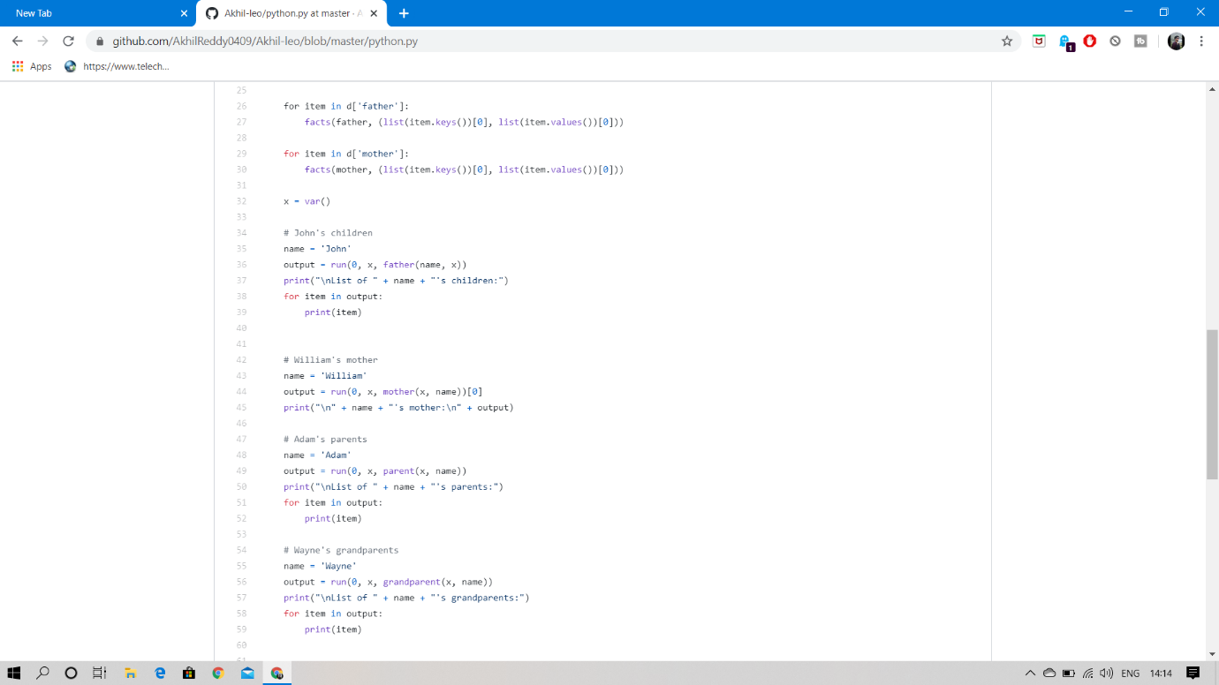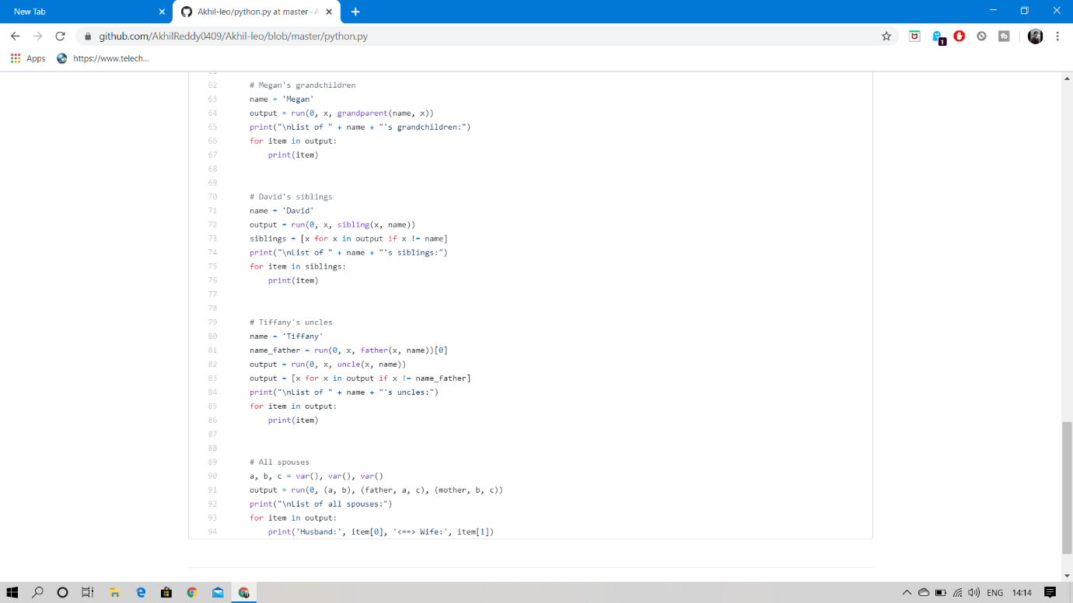

OUTPUT:

