1.Question : Write a program to demonstrate the usage of HashSet to store unique student IDs and perform operations like adding, removing, and checking membership of IDs.

Aim: To write a java programm that demonstrate the hashset demo that store student ids and perform operations

like add , remove, on HashSet.

SourceCode:

package study1;

import java.util.HashSet;

import java.util.Scanner;

public class HashSetDemo {

public static void main(String[] args) {

HashSet<Object> sIDs = new HashSet<Object>();

int ch;

Scanner s= new Scanner(System.in);

do{

System.out.println("ADD StudentIDs");

System.out.println("Remove StudentIDs");

System.out.println("Checking StudentIDs");

System.out.println("All StudentIDs");

System.out.println("Exit");

System.out.println("Enter your choice : ");

ch = s.nextInt();

switch(ch) {

case 1:

System.out.println("Enter student id : ");

int addid=s.nextInt();

sIDs.add(addid);

System.out.println(sIDs);

break;

case 2:

System.out.println("Enter remove student id : ");

int rID=s.nextInt();

sIDs.remove(rID);

System.out.println(sIDs);

break;

case 3:

int cIDS=s.nextInt();

if(sIDs.contains(cIDS))

System.out.println(cIDS+ " Present in StudentIDs");

else

System.out.println("Not present");

break;

case 4:

System.out.println( "All StudentIDs : " +sIDs);

break;

}

}while(ch!=5);

}}

OutPut:

|  |  |
| --- | --- |
|  |  |

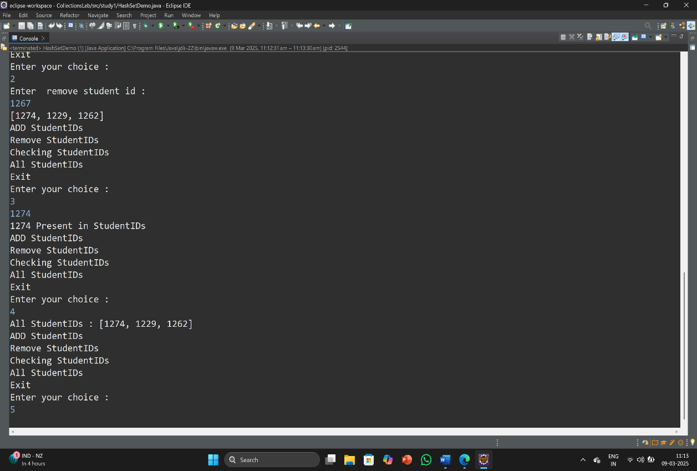

2.Question: Implement a program using LinkedList to simulate a queue of customers waiting in line, with operations to add customers and serve them in a FIFO manner.

Aim: To write a Java Programm that implements a linkedlist stores of customers and serve

Them in FIFO manner.

SourceCode:

package study1;

import java.util.LinkedList;

import java.util.Scanner;

public class LinkedListDemo {

public static void main(String[] args) {

LinkedList<Object> Cnames = new LinkedList<Object>();

int ch;

Scanner s= new Scanner(System.in);

do{

System.out.println("1.Adding Customers");

System.out.println("2. Serve and Remove Customers");

System.out.println("3.All Customers");

System.out.println("Press 4 to Exit");

System.out.println("Enter your choice : ");

ch = s.nextInt();

switch(ch) {

case 1:

System.out.println("Enter customer name: ");

String cname =s.next();

Cnames.addFirst(cname);

System.out.println(Cnames);

break;

case 2:

System.out.println("Remove Customers");

Cnames.removeLast();

System.out.println("After removal of customers : " +Cnames);

break;

case 3:

System.out.println( "All Customers : " +Cnames);

break;

}

}while(ch!=4);

}

}

OutPut:

|  |  |
| --- | --- |
|  |  |

3.Question : Develop a program using TreeSet to maintain a sorted list of student names and demonstrate operations like adding names, removing names, and displaying them in alphabetical order.

Aim: To write a Java Programm that demonstrate a treeset and add and remove student names and display in alphabetical order.

SourceCode:

package study1;

import java.util.Scanner;

import java.util.TreeSet;

public class TreeSetDemo {

public static void main(String[] args) {

TreeSet<Object> snames = new TreeSet<Object>();

int ch;

Scanner s= new Scanner(System.in);

do{

System.out.println("1.Adding Studentnames");

System.out.println("2.Remove Studentnames");

System.out.println("3.Display Studentnames in alphabeticalorder");

System.out.println("Press 4 to Exit");

System.out.println("Enter your choice : ");

ch = s.nextInt();

switch(ch) {

case 1:

System.out.println("Enter Student name: ");

String sname =s.next();

snames.add(sname);

System.out.println(snames);

break;

case 2:

System.out.println(" Enter Remove Studentname: ");

String rname=s.next();

snames.remove(rname);

System.out.println("After removal of students : " +snames);

break;

case 3:

System.out.println( "All student names in alpbabetical order : " +snames);

break;

}

}while(ch!=4);

}

}

OutPut:

|  |  |
| --- | --- |
|  |  |

4.Question : Create a program using PriorityQueue to manage a to-do list with tasks having different priorities, allowing operations to add tasks and retrieve them based on priority.

Aim : To write a Java Programm that implement a PriorityQueue and add some tasks and retrive them

based on Prority.

SourceCode:

package study1;

import java.util.Comparator;

import java.util.PriorityQueue;

import java.util.Queue;

public class PriorityQueueDemo {

public static void main(String[] args) {

Queue<Task> todolist=new PriorityQueue<Task>();

//Adding taks to priority queue

todolist.add(new Task("Task-1",4));

todolist.add(new Task("Task-2",2));

todolist.add(new Task("Task-3",1));

todolist.add(new Task("Task-4",5));

todolist.add(new Task("Task-5",3));

//Task removal from header

System.out.println("Task Processing order...");

while(!todolist.isEmpty()) {

Task task=todolist.poll();

System.out.println(task.getName()+","+task.getPriority());

}

}

}

class Task implements Comparable<Task>{

private int priority;

private String name;

Task(String name,int priority) {

//super();

this.priority = priority;

this.name = name;

}

public int getPriority() {

return priority;

}

public String getName() {

return name;

}

@Override

public int compareTo(Task o) {

return Integer.compare(this.priority, o.priority);

}

}

OutPut:

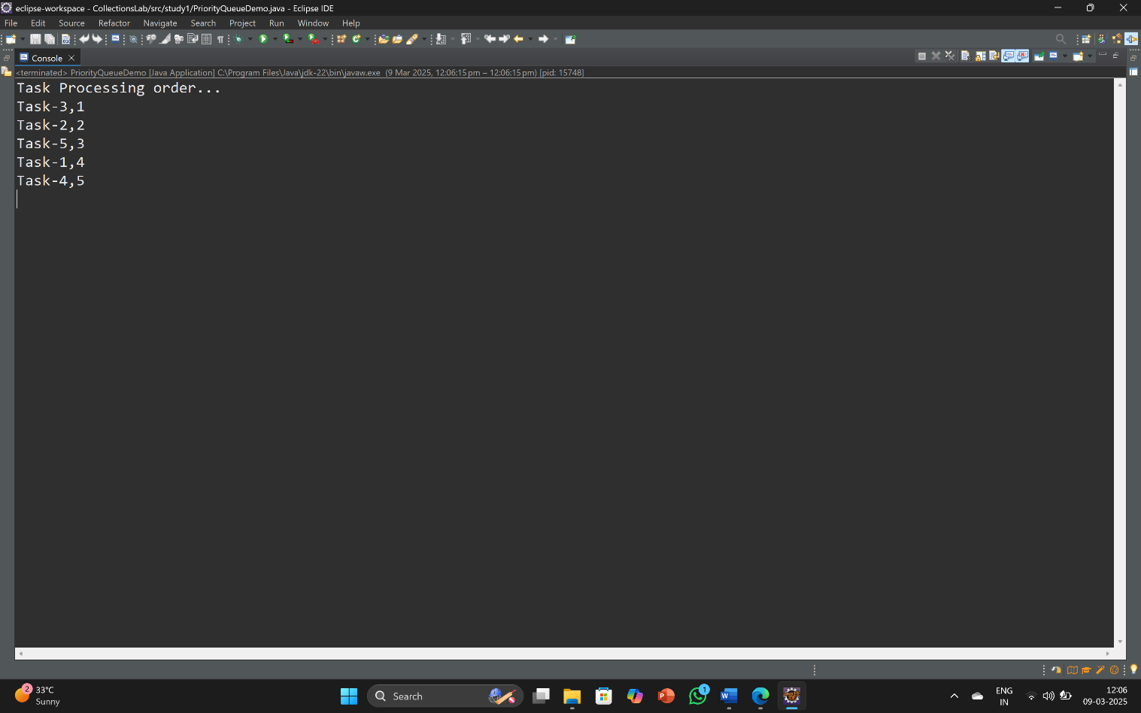

5.Question : 5.Write a program to manage a library catalog using an ArrayList. Implement functionalities to add books, remove books, and display the entire catalog.

Aim: To Write a Java Programm that implements a arraylist and perform operations add the

books and remove and display them.

SourceCode:

package study1;

import java.util.ArrayList;

import java.util.Scanner;

class Book{

String name;

int id;

String author;

Book(String name,int id,String author){

this.name=name;

this.id=id;

this.author=author;

}

String getName() {

return this.name;

}

int getId() {

return this.id;

}

String getAuthor() {

return this.author;

}

}

public class ArrayListDemo {

public static void main(String[] args) {

ArrayList<Book> u=new ArrayList<>();

Scanner om =new Scanner(System.in);

int count=0;

int ch;

do{

System.out.println("LibraryCatalog.....");

System.out.println("1.Adding Books 2.Removing Books 3.Displaying 4.exit");

System.out.print("Enter your choice: ");

ch=om.nextInt();

om.nextLine();

switch(ch) {

case 1:

System.out.print("Enter Book name :");

String name=om.nextLine();

System.out.print("Enter Book-Id : ");

int id=om.nextInt();

om.nextLine();

System.out.print("Enter Author name");

String author=om.nextLine();

u.add( new Book(name,id,author));

break;

case 2:

if(u.isEmpty())

System.out.println("List is Empty");

else {

System.out.print("Enter the book id : ");

int del=om.nextInt();

for(int i=0;i<u.size();i++) {

if((u.get(i).id)==del) {

u.remove(i);

}

}

System.out.println("Book " +del+" is deleted.");

}

break;

case 3:

if(u.isEmpty())

System.out.println("List is Empty");

else {

for(Book b:u)

System.out.println(b.getName()+" "+b.getId()+" "+b.getAuthor());

}

break;

}

}while(ch!=4);

}

}

OutPut:

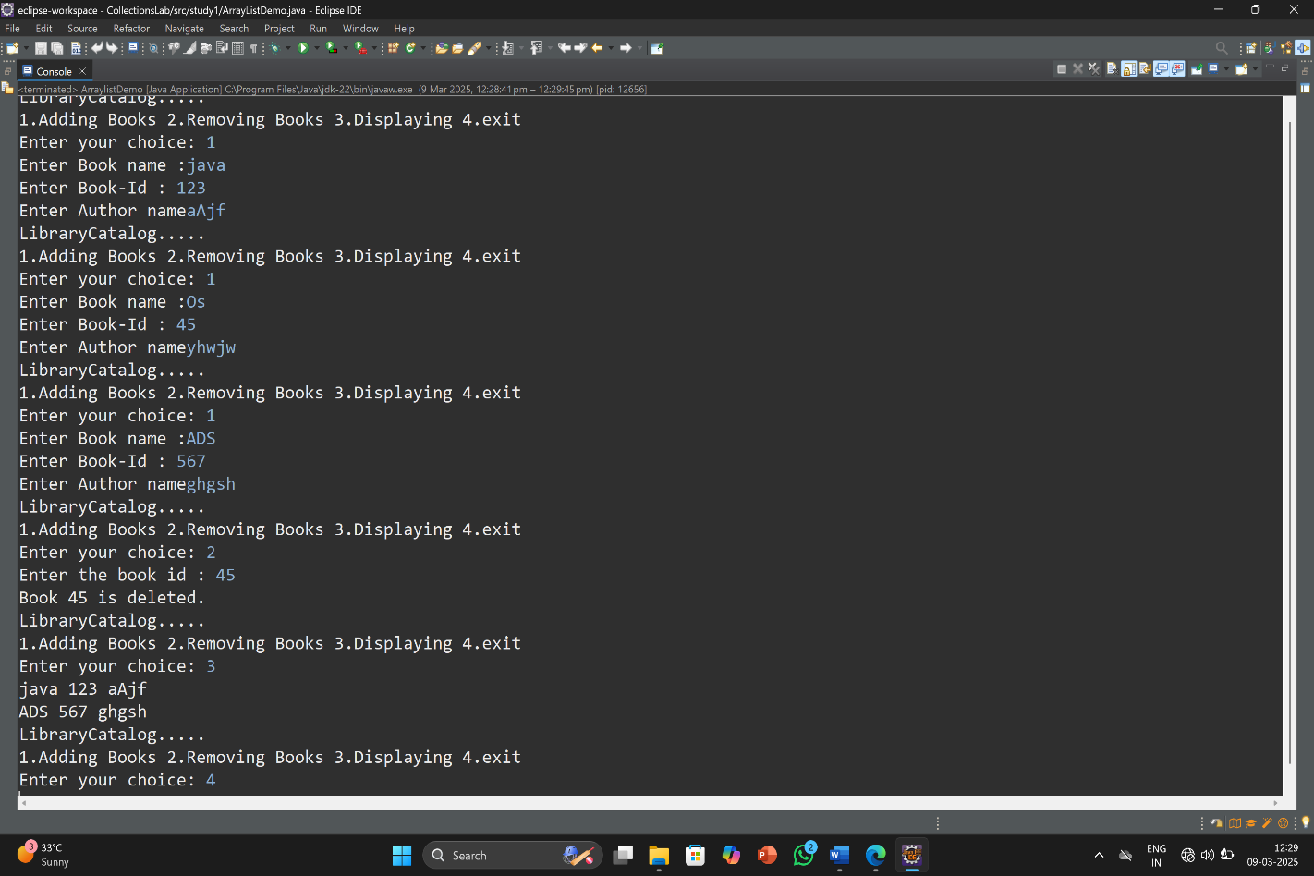

6.Question : Write a JDBC program to connect to a MySQL database and retrieve student records based on specific criteria.

Aim : To write a Java Programm that connects to your database and display table with student details in your

Database based on specific criteria.

SourceCode:

package jdbclab;

import java.sql.Connection;

import java.sql.DriverManager;

import java.sql.ResultSet;

import java.sql.Statement;

public class JDBCDemo {

public static void main(String[] args) {

// TODO Auto-generated method stub

try {

Class.forName("oracle.jdbc.driver.OracleDriver");

Connection con = DriverManager.getConnection("jdbc:oracle:thin:@//localhost:1521/XE","system","123456");

if(con!=null)

System.out.println("Connection established successfully");

Statement st=con.createStatement();

st.executeUpdate("create table IT(name varchar(15),id number(5),age number(4))");

System.out.println("Table created successfully!!");

int i= st.executeUpdate("insert into IT values('Akhila',74,19)");

System.out.println(i+ "record inserted");

int i1= st.executeUpdate("insert into IT values('Prani',67,19)");

System.out.println(i+ "record inserted");

int i2= st.executeUpdate("insert into IT values('Aira',56,18)");

System.out.println(i+ "record inserted");

int i3= st.executeUpdate("insert into IT values('Vibha',78,20)");

System.out.println(i+ "record inserted");

int i4= st.executeUpdate("insert into IT values('Rohini',29,16)");

System.out.println(i+ "record inserted");

int i5= st.executeUpdate("insert into IT values('Neelu',62,17)");

System.out.println(i+ "record inserted");

ResultSet result=st.executeQuery("select *from IT where age>18");

while(result.next())

{

System.out.println(result.getString(1)+" "+result.getInt(2)+" "+result.getInt(3));

}

con.close();

}

catch(Exception e) {

System.out.println(e);

} }

}

OutPut :

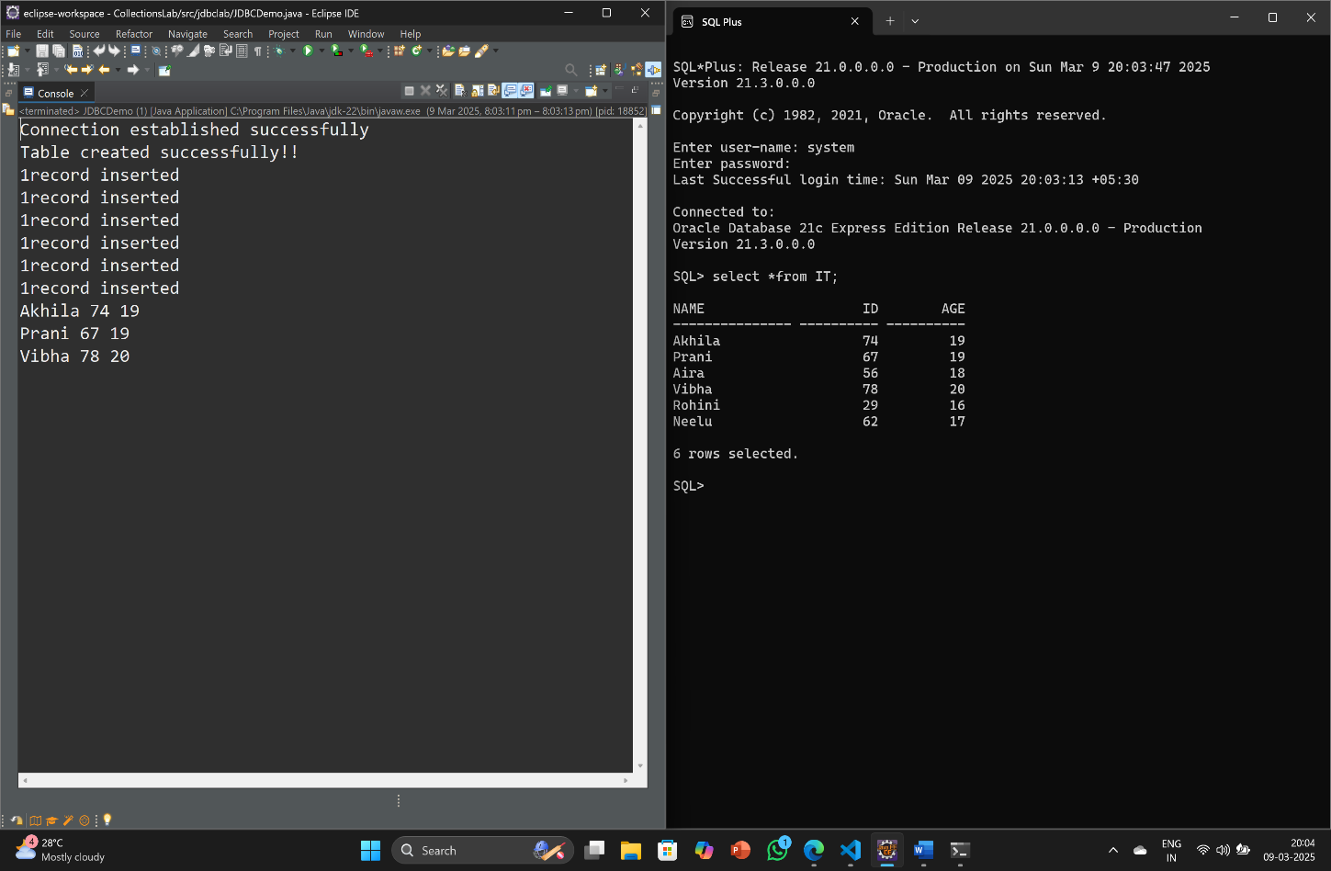

7.Question : Implement a JDBC program to perform CRUD operations (Create, Read, Update, Delete) on a table of employee records.

Aim : To Write a java Programm that connects with your database and perform CRUD

Operations on them and display them on console.

SourceCode :

package jdbclab;

import java.sql.Connection;

import java.sql.DriverManager;

import java.sql.PreparedStatement;

import java.sql.ResultSet;

import java.sql.Statement;

import java.util.Scanner;

public class JDBcCRUDDemo {

public static void main(String[] args) {

try {

Scanner sc= new Scanner(System.in);

Class.forName("oracle.jdbc.driver.OracleDriver");

Connection con = DriverManager.getConnection("jdbc:oracle:thin:@localhost:1521:xe","system","123456");

if(con!=null)

System.out.println("Connection established successfully");

Statement st=con.createStatement();

st.executeUpdate("create table std_IT(sname VARCHAR2(10),sid NUMBER(4),dept VARCHAR2(5))");

System.out.println("CRUD Operations on table");

System.out.println("Table created successfully");

String str="insert into std_IT values(?,?,?)";

PreparedStatement ps=con.prepareStatement(str);

System.out.println("Enter no.of Std details : ");

int n1=sc.nextInt();

for(int i=1;i<=n1;i++){

System.out.println("Enter student name:");

String s=sc.next();

System.out.println("Enter student id:");

int n=sc.nextInt();

System.out.println("Enter student dept:");

String dep=sc.next();

ps.setString(1, s);

ps.setInt(2, n);

ps.setString(3, dep);

ps.executeUpdate();

}

System.out.println("Executed successfully");

ps.executeUpdate("update std_IT set dept='IT' where dept='CSE'or dept='cse'");

System.out.println("Updated Succcesfully");

ps.executeUpdate("delete from std_IT where dept='AIML'or dept='aiml'");

System.out.println("Deleted Succcesfully");

ResultSet result=ps.executeQuery("select *from std_IT");

System.out.println("Retrived Data from Std_IT table");

while(result.next())

{

System.out.println(result.getString(1)+" "+result.getInt(2)+" "+result.getString(3));

}

}catch(Exception e) {

System.out.println(e);

}

}

}

OutPut :

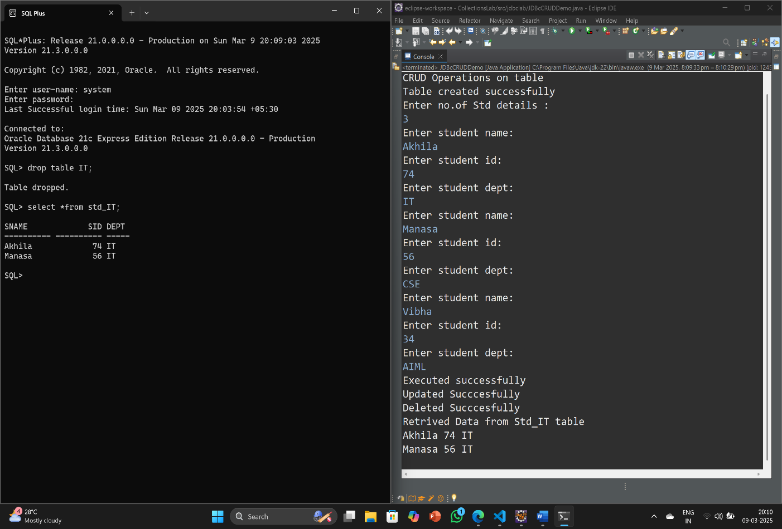

8.Question : Develop a servlet program to handle user login and session management, demonstrating the use of cookies to store user preferences.

Aim : To write a Servlet Programm that displays a login Page on WebPage and demonstrates the use of cookies.

SourceCode :

Html File :

<!DOCTYPE html>

<html>

<head>

<meta charset="UTF-8">

<title>Login Page:</title>

</head>

<body>

<h1>Login to courses:</h1>

<form method="get" action="Servlet1">

Enter username:<input type="text" name="uname"><br>

<br>

Enter password:<input type="password" name="pword"><br>

<br>

Enter College name : <input type="text" name="cname"><br>

<br>

Enter Email id: <input type="text" name="email"><br>

<br>

Select Branch:<select><br>

<br>

<option value="it">IT</option>

<option value="cse">CSE</option>

<option value="aiml">AIML</option>

<option value="csm">CSM</option>

</select>

<br><br>

Select Course:<select><br>

<br>

<option value="c">C</option>

<option value="java">Java</option>

<option value="Ds">DataStructures</option>

<option value="python">Python</option>

</select>

<br><br>

<input type ="submit" value="Login">

</form>

</body>

</html>

Servlet1 :

import java.io.IOException;

import java.io.PrintWriter;

import javax.servlet.RequestDispatcher;

import javax.servlet.ServletException;

import javax.servlet.annotation.WebServlet;

import javax.servlet.http.Cookie;

import javax.servlet.http.HttpServlet;

import javax.servlet.http.HttpServletRequest;

import javax.servlet.http.HttpServletResponse;

@WebServlet("/Cookie1")

public class CookieServlet1 extends HttpServlet {

protected void doGet(HttpServletRequest request, HttpServletResponse response) throws ServletException, IOException {

response.setContentType("text/html");

PrintWriter out = response.getWriter();

String cookieval=request.getParameter("uname");

String cookieval1=request.getParameter("pword");

String cookieval2=request.getParameter("email");

Cookie ck = new Cookie("cookie1",cookieval);

//adding cookie to response

Cookie ck1 = new Cookie("cookie2",cookieval1);

Cookie ck2=new Cookie ("cookie3",cookieval2);

response.addCookie(ck);

response.addCookie(ck1);

response.addCookie(ck2);

RequestDispatcher rd;

if(cookieval.equals("Akhila") && cookieval1.equals("akhila@2006")) {

out.print("Cookies Created");

out.print("<br><h2>To know how many Cookies Created<h2>");

out.print("<br>");

out.print("<h3> To know the Course is successfully login or not!</h3>");

out.print("<form action = 'CookieServlet2'>");

out.print("<br>Enter Username : <input type='text' name='uname'<br>");

out.print("<br><input type = 'submit'>");

out.print("</form>");

}

else

{

rd=request.getRequestDispatcher("/Login.html");

out.print("<h2 style = 'color : red'>Invalid username/password</h2>");

rd.include(request, response);

String name1=request.getParameter("uname");

}

}

}

Servlet2 :

import java.io.IOException;

import java.io.PrintWriter;

import javax.servlet.ServletException;

import javax.servlet.annotation.WebServlet;

import javax.servlet.http.Cookie;

import javax.servlet.http.HttpServlet;

import javax.servlet.http.HttpServletRequest;

import javax.servlet.http.HttpServletResponse;

@WebServlet("/Cookie2")

public class CookieServlet2 extends HttpServlet {

protected void doGet(HttpServletRequest request, HttpServletResponse response) throws ServletException, IOException {

response.setContentType("text/html");

PrintWriter out = response.getWriter();

//Accessing cookies

String name=request.getParameter("uname");

Cookie ck[] = request.getCookies();

out.print("No.of Cookies created : " +ck.length);

out.print("<br>Cookie Name : " +ck[0].getName());

out.print("<br> Cookie Value : Username : " +ck[0].getValue());

out.print("<br>Cookie Name : " +ck[1].getName());

out.print("<br> Cookie Value : Password: " +ck[1].getValue());

out.print("<br>Cookie Name : " +ck[2].getName());

out.print("<br> Cookie Value : Password: " +ck[2].getValue());

out.print("<br><h2>Welcome "+name+"! You are Successfully login to"+ " your Course with Email id<br>" +ck[2].getValue()+"</h2>");

}

}

OutPut :

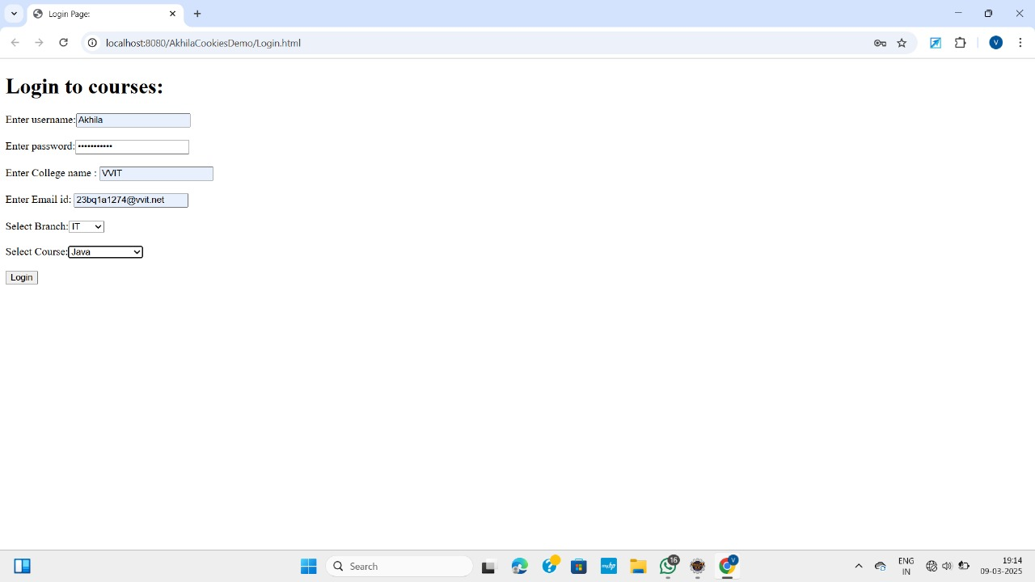

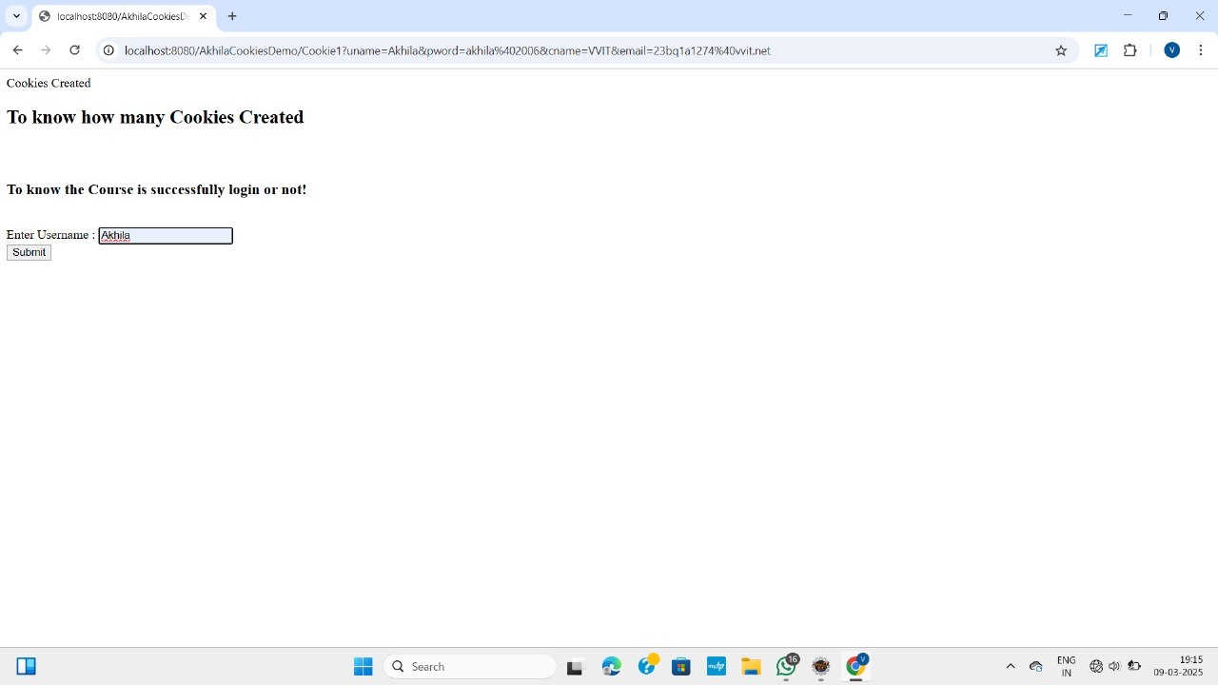

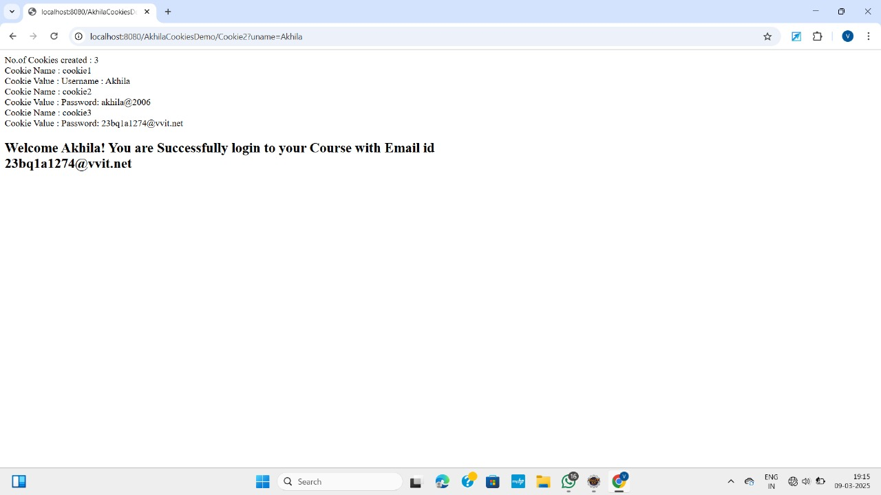

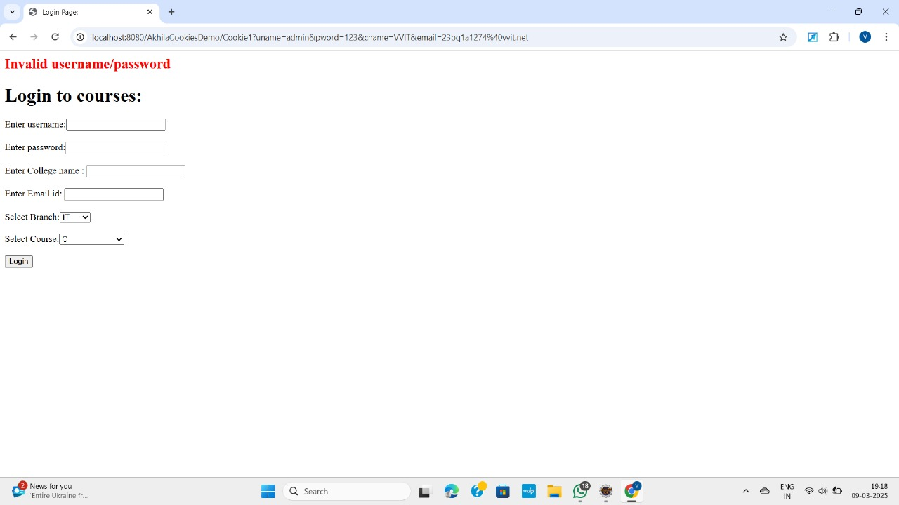

9.Question : Write a JDBC program to perform batch processing of SQL statements to insert multiple records into a database table efficiently.

Aim : To write Java Programm that connects with our database and create table and insert multiple records

into table using batch processing and display them on our database.

SourceCode :

package jdbclab;

import java.sql.Connection;

import java.sql.DriverManager;

import java.sql.PreparedStatement;

import java.sql.ResultSet;

import java.sql.Statement;

import java.util.Scanner;

public class JDBCBatchDemo {

public static void main(String[] args) {

Scanner s= new Scanner(System.in);

System.out.println("Number of Students:");

int n=s.nextInt();

String e_details[][]= new String[n][2];

for(int i = 0; i < n; i++) {

System.out.println("Enter student name:");

e_details[i][0] = s.next();

System.out.println("Enter student dept:");

e_details[i][1] = s.next();

}

try {

Scanner sc= new Scanner(System.in);

Class.forName("oracle.jdbc.driver.OracleDriver");

Connection con = DriverManager.getConnection("jdbc:oracle:thin:@localhost:1521:xe","system","123456");

if(con!=null)

System.out.println("Connection established successfully");

Statement st=con.createStatement();

st.executeUpdate("create table std_IT(sname Varchar2(10),dept VARCHAR2(5))");

System.out.println("Table created successfully");

String str="insert into std_IT values(?,?)";

PreparedStatement ps=con.prepareStatement(str);

for (String[] emp : e_details) {

ps.setString(1, emp[0]);

ps.setString(2, emp[1]);

ps.addBatch();

}

ps.executeBatch();

System.out.println("Batch insert completed successfully!");

ResultSet result=ps.executeQuery("select *from std_IT");

System.out.println("Retrived Data from Std_IT table");

while(result.next()){

System.out.println(result.getString(1)+" "+result.getString(2));

}

}catch(Exception e) {

System.out.println(e);

}

}

OutPut :

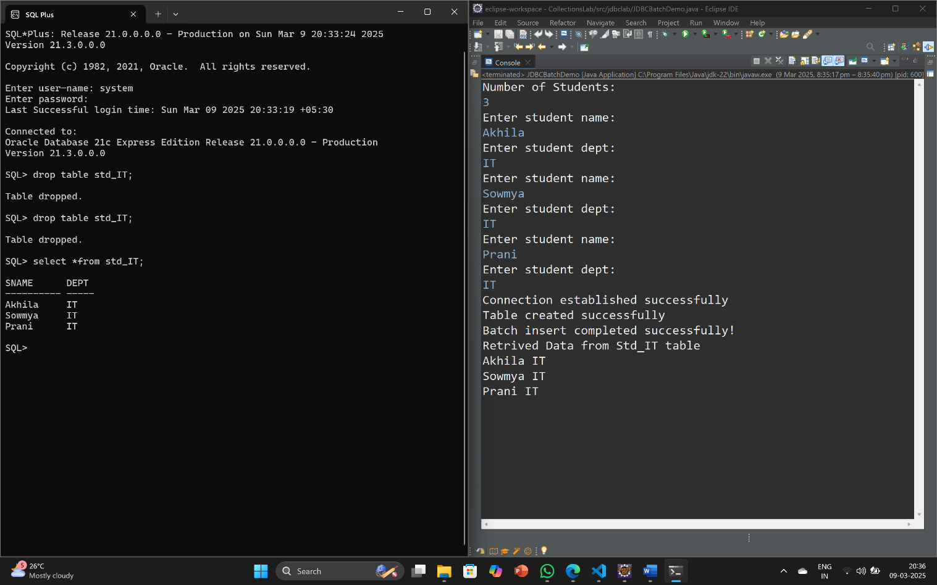

10.Question : .Develop a web application using Servlets to manage a student database. Implement functionalities like adding new students, updating student details, and displaying all student records.

Aim : To write a servlet programm that displays a table on webpage which is already created

in our database with JDBC programm.

SourceCode :

JDBC Programm:

package jdbclab;

import java.sql.Connection;

import java.sql.DriverManager;

import java.sql.PreparedStatement;

import java.sql.ResultSet;

import java.sql.Statement;

import java.util.Scanner;

public class JDBcCRUDDemo {

public static void main(String[] args) {

try {

Scanner sc= new Scanner(System.in);

Class.forName("oracle.jdbc.driver.OracleDriver");

Connection con = DriverManager.getConnection("jdbc:oracle:thin:@localhost:1521:xe","system","123456");

if(con!=null)

System.out.println("Connection established successfully");

Statement st=con.createStatement();

st.executeUpdate("create table std_IT(sname VARCHAR2(10),sid NUMBER(4),dept VARCHAR2(5))"); System.out.println("CRUD Operations on table");

System.out.println("Table created successfully");

String str="insert into std_IT values(?,?,?)";

PreparedStatement ps=con.prepareStatement(str);

System.out.println("Enter no.of Std details : ");

int n1=sc.nextInt();

for(int i=1;i<=n1;i++){

System.out.println("Enter student name:")

String s=sc.next();

System.out.println("Enter student id:");

int n=sc.nextInt();

System.out.println("Enter student dept:");

String dep=sc.next();

ps.setString(1, s);

ps.setInt(2, n);

ps.setString(3, dep);

ps.executeUpdate();

}

System.out.println("Executed successfully");

ps.executeUpdate("update std_IT set dept='IT' where dept='CSE'or dept='cse'");

System.out.println("Updated Succcesfully");

ps.executeUpdate("delete from std_IT where dept='AIML'or dept='aiml'");

System.out.println("Deleted Succcesfully");

ResultSet result=ps.executeQuery("select *from std_IT");

System.out.println("Retrived Data from Std_IT table");

while(result.next()) {

System.out.println(result.getString(1)+" "+result.getInt(2)+" "+result.getString(3)); }

}catch(Exception e) {

System.out.println(e);

}

}

}

ServletProgramm :

import java.io.IOException;

import java.io.PrintWriter;

import java.sql.Connection;

import java.sql.DriverManager;

import java.sql.ResultSet;

import java.sql.Statement;

import javax.servlet.ServletException;

import javax.servlet.annotation.WebServlet;

import javax.servlet.http.HttpServlet;

import javax.servlet.http.HttpServletRequest;

import javax.servlet.http.HttpServletResponse;

@WebServlet("/JdbcServlet")

public class JdbcServletDemo extends HttpServlet {

protected void doGet(HttpServletRequest request, HttpServletResponse response) throws ServletException, IOException {

response.setContentType("text/html");

PrintWriter out=response.getWriter();

try {

Class.forName("oracle.jdbc.driver.OracleDriver");

Connection con=DriverManager.getConnection("jdbc:oracle:thin:@localhost:1521:xe","system","123456”);

if(con!=null)

System.out.println("Connection established successfully");

Statement st=con.createStatement();

ResultSet rs=st.executeQuery("select *from std_IT");

out.print("<table border=2>"); out.print("<tr><td>Name</td><td>Rollno</td><td>Dept</td></tr>");

while(rs.next()) {

out.print("<tr><td>"+rs.getString(1)+ "</td><td>" +rs.getInt(2)+ "</td><td>" +rs.getString(3)+"</td></tr>"); }

con.close();

out.close();

}catch(Exception e) {

System.out.println(e);

}

}

}

OutPut :

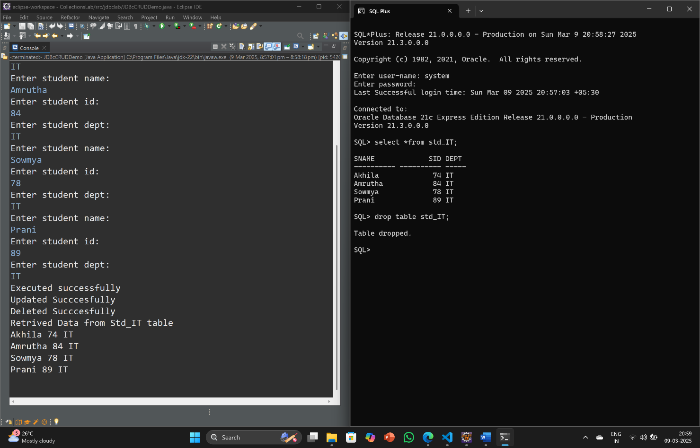

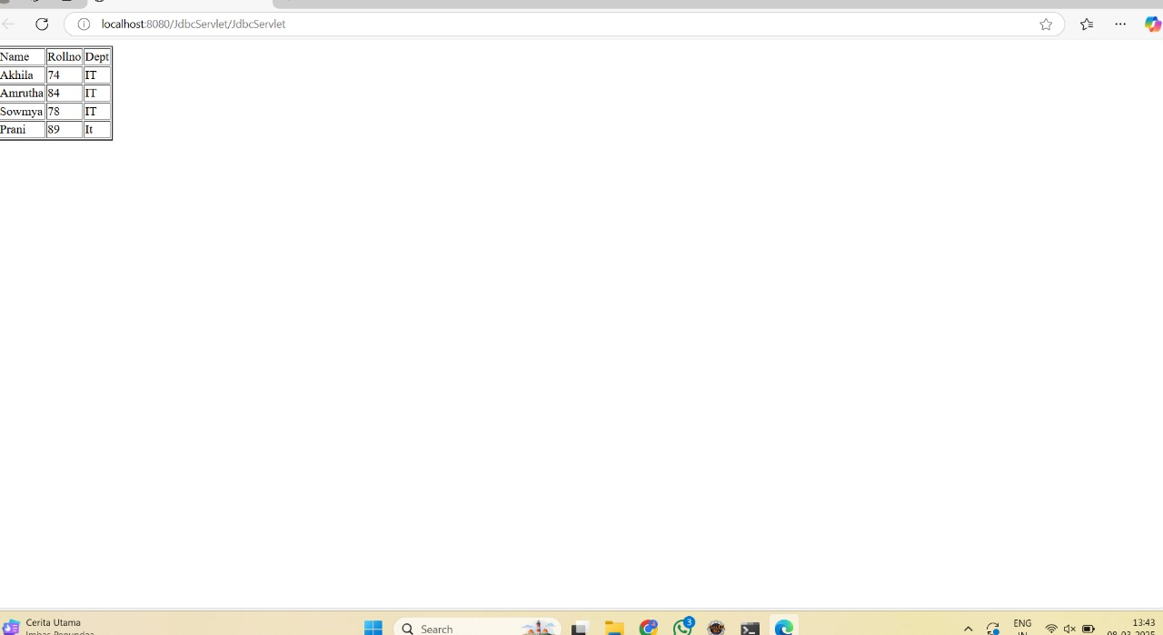

8.Question : Develop a servlet program to handle user login and session management, demonstrating the use of cookies to store user preferences.

Aim: To write a java Servlet programm that demonstrate use of Cookies.

SourceCode :

HtmlFile:

<!DOCTYPE html>

<html>

<head>

<meta charset="UTF-8">

<title>Register Page:</title>

</head>

<body>

<h1>Registration Form!</h1>

<form method="get" action="Servlet1">

Enter username:<input type="text" name="uname"><br>

<br>

Enter password:<input type="password" name="pword"><br>

<br>

Enter College name : <input type="text" name="cname"><br>

<br>

Enter Email id: <input type="text" name="email"><br>

<br>

Select Branch:<select><br>

<br>

<option value="it">IT</option>

<option value="cse">CSE</option>

<option value="aiml">AIML</option>

<option value="csm">CSM</option>

</select>

<br><br>

Select Course:<select><br>

<br>

<option value="c">C</option>

<option value="java">Java</option>

<option value="Ds">DataStructures</option>

<option value="python">Python</option>

</select>

<br><br>

<input type ="submit" value="Register">

</form>

</body>

</html>

Servlet1:

import java.io.IOException;

import java.io.PrintWriter;

import javax.servlet.ServletException;

import javax.servlet.annotation.WebServlet;

import javax.servlet.http.Cookie;

import javax.servlet.http.HttpServlet;

import javax.servlet.http.HttpServletRequest;

import javax.servlet.http.HttpServletResponse;

@WebServlet("/Cookie1")

public class CookieServlet1 extends HttpServlet {

protected void doGet(HttpServletRequest request, HttpServletResponse response) throws ServletException, IOException {

response.setContentType("text/html");

PrintWriter out = response.getWriter();

String cookieval=request.getParameter("uname");

String cookieval1=request.getParameter("pword");

Cookie ck = new Cookie("cookie1",cookieval);

Cookie ck1 = new Cookie("cookie2",cookieval1);

response.addCookie(ck);

response.addCookie(ck1);

out.print("<h3>You are Successfully Registered Course!!</h3>");

out.print("<form action = 'CookieServlet2'>");

out.print("<br><h2>Login to the Course: <h2>");

out.print("<br>Enter Username : <input type='text' name='uname'<br>");

out.print("<br><h3>Enter Password: <input type='text' name='pwrd'<br></h3>");

out.print("<br><h3>Enter Emailid: <input type='text' name='email'<br></h3>");

out.print("<br><input type = 'submit' value='Login'>");

out.print("</form>");

}

}

Servlet2 :

import java.io.IOException;

import java.io.PrintWriter;

import javax.servlet.RequestDispatcher;

import javax.servlet.ServletException;

import javax.servlet.annotation.WebServlet;

import javax.servlet.http.Cookie;

import javax.servlet.http.HttpServlet;

import javax.servlet.http.HttpServletRequest;

import javax.servlet.http.HttpServletResponse;

@WebServlet("/Cookie2")

public class CookieServlet2 extends HttpServlet {

protected void doGet(HttpServletRequest request, HttpServletResponse response) throws ServletException, IOException {

response.setContentType("text/html");

PrintWriter out = response.getWriter();

String name=request.getParameter("uname");

String pword=request.getParameter("pwrd");

String email=request.getParameter("email");

Cookie ck[] = request.getCookies();

RequestDispatcher rd;

out.print("No.of Cookies created : " +ck.length);

if(name.equals(ck[0].getValue()) && pword.equals(ck[1].getValue())) {

out.print("<h2>Welcome "+name+"! You are Successfully Login to your Course!!<br> with Emailid" +email);

}

else

{

rd=request.getRequestDispatcher("/Cookie1");

out.print("<h2 style = 'color : red'>Invalid username/password</h2>");

rd.include(request, response);

}

}

}

OutPut :

|  |  |
| --- | --- |
|  |  |

|  |  |
| --- | --- |
|  |  |

10.Question : .Develop a web application using Servlets to manage a student database. Implement functionalities like adding new students, updating student details, and displaying all student records

SourceCode :

Home.html:

<!DOCTYPE html>

<html>

<head>

<meta charset="UTF-8">

<title>Insert title here</title>

</head>

<body>

<form action="Servlet4">

<h1>Welcome to JDBC</h1>

<h2> To create a Student Database</h2>

<h3><a href="Add.html" style="color:red;">ADD Student Data Table</a></h3>

<br>

<h3><a href="update.html" style="color:blue;">Update Student Table</a></h3><br>

<h3><a href="delete.html"style="color:green;">Delete the data in Student Table</a></h3><br>

<h4>To display the Student Table Click display</h4>

<input type="submit" value="Display">

</form>

</body>

</html>

Add.html:

<!DOCTYPE html>

<html>

<head>

<meta charset="UTF-8">

<title>Insert title here</title>

</head>

<body>

<form action="Servlet1">

<h1 style="background-color:blue;color:red;">Enter student Details: </h1>

<br><br>

Enter Studentname:<input type="text" name="name"><br>

<br>

Enter StudentId:<input type="text" name="id"><br>

<br>

Enter StudentDept:<input type="text" name="dept"><br>

<br>

<input type="submit" value="ADD">

</form>

</body>

</html>

Update.html:

<!DOCTYPE html>

<html>

<head>

<meta charset="UTF-8">

<title>Insert title here</title>

</head>

<body>

<form action="Servlet2 ">

Enter Student dept to update: <input type="text" name="dpt"><br><br>

Enter New Dept name: <input type="text" name="dpt1">

<br>

<br>

<input type="submit" value="Update">

</form>

</body>

</html>

Delete.html:

<!DOCTYPE html>

<html>

<head>

<meta charset="UTF-8">

<title>Insert title here</title>

</head>

<body>

<form action="Servlet3">

Enter Delete Id:<input type="text" name="delid"><br><br>

<input type="submit" value="Delete">

</form>

</body>

</html>

Servlet1:

import java.io.IOException;

import java.io.PrintWriter;

import java.sql.Connection;

import java.sql.DriverManager;

import java.sql.PreparedStatement;

import java.sql.Statement;

import javax.servlet.ServletException;

import javax.servlet.annotation.WebServlet;

import javax.servlet.http.HttpServlet;

import javax.servlet.http.HttpServletRequest;

import javax.servlet.http.HttpServletResponse;

@WebServlet("/Servlet1")

public class JServlet1 extends HttpServlet {

protected void doGet(HttpServletRequest request, HttpServletResponse response) throws ServletException, IOException {

response.setContentType("text/html");

PrintWriter out = response.getWriter();

try {

Class.forName("oracle.jdbc.driver.OracleDriver");

Connection con = DriverManager.getConnection("jdbc:oracle:thin:@//localhost:1521/XE", "system", "dbms");

/* Statement st=con.createStatement();

st.executeUpdate("CREATE TABLE std (name varchar(20) , id number(6) , dept varchar(5))"); */

PreparedStatement ps = con.prepareStatement("INSERT INTO std (name, id, dept) VALUES (?, ?, ?)");

ps.setString(1, request.getParameter("name"));

ps.setInt(2, Integer.parseInt(request.getParameter("id")));

ps.setString(3, request.getParameter("dept"));

ps.executeUpdate();

out.print("<h2>Data inserted successfully into the table...</h2>");

con.close();

} catch (Exception e) {

}

}

}

Servlet2:

import java.io.IOException;

import java.io.PrintWriter;

import java.sql.Connection;

import java.sql.DriverManager;

import java.sql.PreparedStatement;

import java.sql.Statement;

import javax.servlet.ServletException;

import javax.servlet.annotation.WebServlet;

import javax.servlet.http.HttpServlet;

import javax.servlet.http.HttpServletRequest;

import javax.servlet.http.HttpServletResponse;

@WebServlet("/Servlet2")

public class JServlet2 extends HttpServlet {

protected void doGet(HttpServletRequest request, HttpServletResponse response) throws ServletException, IOException {

response.setContentType("text/html");

PrintWriter out = response.getWriter();

try {

Class.forName("oracle.jdbc.driver.OracleDriver");

Connection con = DriverManager.getConnection("jdbc:oracle:thin:@//localhost:1521/XE", "system", "dbms");

Statement st=con.createStatement();

String olddept=request.getParameter("dpt");

String newdept=request.getParameter("dpt1");

st.executeUpdate("UPDATE std SET dept='" + newdept + "' WHERE dept='" + olddept +"'");

out.print("<h2>Updated data in table is Successfull....</h2>");

con.close();

} catch (Exception e) {

}

}

}

Servlet3 :

import java.io.IOException;

import java.io.PrintWriter;

import java.sql.Connection;

import java.sql.DriverManager;

import java.sql.PreparedStatement;

import java.sql.Statement;

import javax.servlet.ServletException;

import javax.servlet.annotation.WebServlet;

import javax.servlet.http.HttpServlet;

import javax.servlet.http.HttpServletRequest;

import javax.servlet.http.HttpServletResponse;

@WebServlet("/Servlet3")

public class JServlet3 extends HttpServlet {

protected void doGet(HttpServletRequest request, HttpServletResponse response) throws ServletException, IOException {

response.setContentType("text/html");

PrintWriter out = response.getWriter();

try {

Class.forName("oracle.jdbc.driver.OracleDriver");

Connection con = DriverManager.getConnection("jdbc:oracle:thin:@//localhost:1521/XE", "system", "dbms");

Statement st=con.createStatement();

int id= Integer.parseInt (request.getParameter("delid"));

String sql="delete from std where id= ?";

PreparedStatement ps = con.prepareStatement(sql);

ps.setInt(1, id);

ps.executeUpdate();

out.print("<h2>" + id + " is deleted Successfully...</h2>");

out.print("<h3>To display the Student Database</h3>");

out.print("<form action='Servlet4'>");

out.print("<input type='submit' value='Clickhere' >");

out.print("</form>");

con.close();

} catch (Exception e) {

}

}

}

Servlet4:

import java.io.IOException;

import java.io.PrintWriter;

import java.sql.Connection;

import java.sql.DriverManager;

import java.sql.PreparedStatement;

import java.sql.ResultSet;

import java.sql.Statement;

import javax.servlet.ServletException;

import javax.servlet.annotation.WebServlet;

import javax.servlet.http.HttpServlet;

import javax.servlet.http.HttpServletRequest;

import javax.servlet.http.HttpServletResponse;

@WebServlet("/Servlet4")

public class JServlet4 extends HttpServlet {

protected void doGet(HttpServletRequest request, HttpServletResponse response) throws ServletException, IOException {

response.setContentType("text/html");

PrintWriter out = response.getWriter();

try {

Class.forName("oracle.jdbc.driver.OracleDriver");

Connection con = DriverManager.getConnection("jdbc:oracle:thin:@//localhost:1521/XE", "system", "dbms");

Statement st=con.createStatement();

out.print("The Student table is ");

ResultSet rs=st.executeQuery("select * from std");

out.print("<table border=2px>");

out.print("<tr><td>Name</td><td>Id</td><td>Dept</td><tr>");

while(rs.next()) {

out.print("<tr><td>"+rs.getString(1)+"</td><td> "+rs.getInt(2)+"</td><td> "+rs.getString(3)+"</td></tr><br>");

}

out.print("</table>");

} catch (Exception e) {

}

}

}

OutPut :

|  |  |
| --- | --- |
|  |  |

|  |  |
| --- | --- |
|  |  |

|  |  |
| --- | --- |
|  |  |

