VISUALISATION

Submitted by: Akhila Anil,21061615

The data used for visualisation is obtained from the data.gov.uk website, and performance data based on money transferred to someone in prison is analysed, with satisfactory rate and transaction details provided in columns.

Link to GitHub Repository: <https://github.com/Akhila-97/AppliedDS_Assignment1>

Link to data source : <https://www.data.gov.uk/dataset/fe259fca-a1ee-4621-9b18-a5661fb31aaf/send-money-to-someone-in-prison-performance-data/datafile/58da89a9-6aac-4e81-b70c-7602141d7cba/preview>

# Send money to someone in prison performance data

**Line plot**

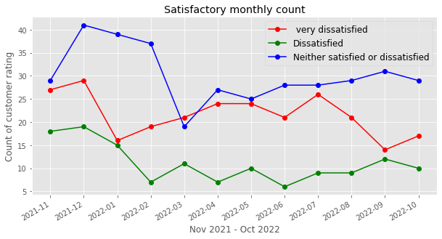

This line plot depicts the monthly satisfactory count from November 2021 to October 2022. I am using multiple line plots to represent the total number of customers who are very dissatisfied, dissatisfied, and neither satisfied nor dissatisfied.

The horizontal axis depicts the time span from 2021-11 to 2022-10, while the vertical axis depicts the number of customer ratings.

According to the line graph, the majority of customers in the given time range have given their rating as neither satisfied nor dissatisfied, with the exception of around March 2022, where the number of very dissatisfied customers is high, whereas the count of dissatisfied customers is significantly lower when compared to the rest. As the months pass, we can see a significant decrease in the number of customers who are extremely dissatisfied, dissatisfied, and neither satisfied nor dissatisfied.

**Stacked horizontal bar plot**

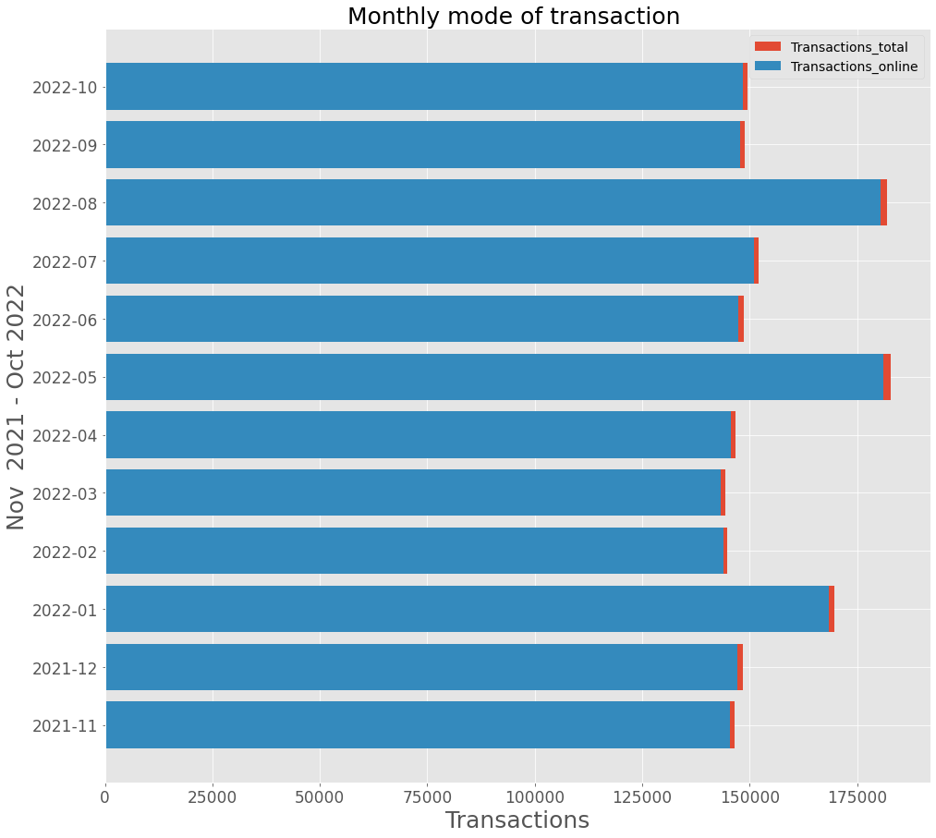

I used a Stacked bar plot to visualise the total number of transactions (Transaction total) and the number of online transactions (Transactions online) to compare and visualise the sharp changes between these two variables.

In the x-axis we have given the number of transactions and in the y-axis the time period from 2021-11 to 2022-10.

Every month, we can see that the majority of customers prefer online transactions to any other mode of transaction. Transactions are high in both May and August of 2022. In contrast, the lowest transaction occurs in March (2022).

**Scatter plot**

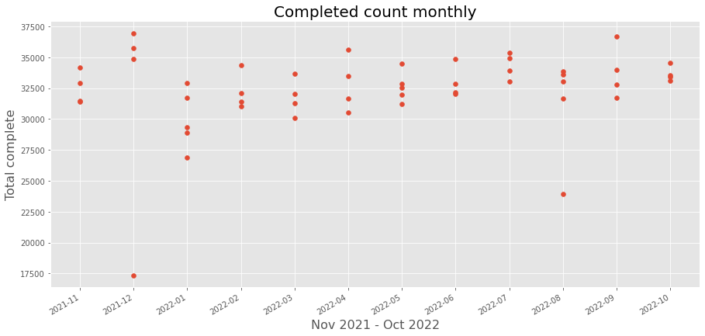

I used scatter plot to show how the total completed count changes over time.

The x-axis in this plot represents the time span from November 2021 to October 2022, and the y-axis represents the total number of completed people (total complete).

Looking from right to left in the plot, we can see that there is no clear upward or downward movement in the data points, so we can consider the value of correlation to be zero, indicating that the time period has no linear relationship with the total number of completed customers.

The highest number of completed customers is around 37500 during the weeks of December 2021 and September 2022, and the lowest is around 17500 during the week of December 2021.