COURSE OUTCOME 4

1.Create Rectangle class with attributes length and breadth and methods to find area and perimeter. Compare two rectangle objects by their area.

Program:-

#Create a Bank account with members account number, name, type of account and balance. Write constructor and methods to deposite at the bank and withdraw an amount from the bank.

class Rectangle:
def __init__(self,length,breadth):
self.len=length
self.brea=breadth
def area(self):
return self.len*self.brea

def perimeter(self):
return 2*(self.len+self.brea)

r1=Rectangle(2,4)
a1=r1.area()
p1=r1.perimeter()
print("Area of 1st rectangle:",a1)
print("Perimeter of 1st rectangle:",p1)

l=int(input("Enter the length of the rectangle:"))
b=int(input("Enter the breadth of the rectangle:"))
r2=Rectangle(l,b)
a2=r2.area()
p2=r2.perimeter()
print("Area of 2nd rectangle:",a2)
print("Perimeter of 2nd rectangle:",p2)

if (a1>a2):
print("Area of 1st rectangle is greater.....!")
elif(a1==a2):
print("Area of both rectangle is same.....!")
else:
print("Area of 2nd rectangle is greater....!")

Output:-

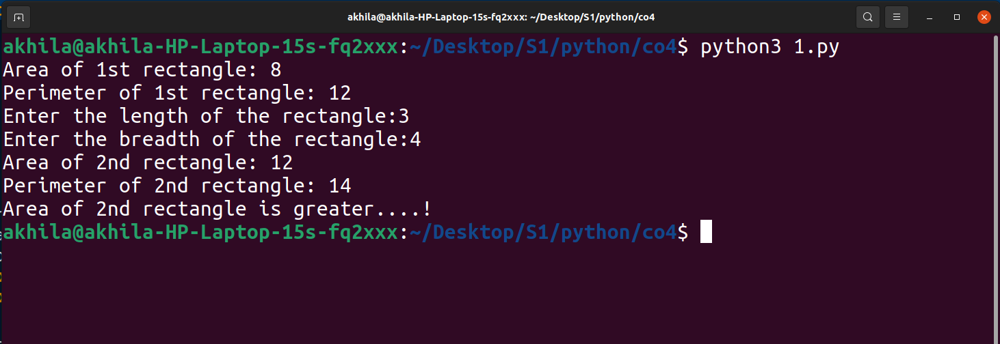

2.Create a Bank account with members account number, name, type of account and balance. Write constructor and methods to deposite at the bank and withdraw an amount from the bank.

Program:-

#Create a Bank account with members account number, name, type of account and balance. Write constructor and methods to deposite at the bank and withdraw an amount from the bank.
class Bank:
def __init__(self,acc_no,name,type_of_acc,balance):
self.acc_no=acc_no
self.name=name
self.type_of_acc=type_of_acc
self.balance=balance

def deposit(self,x):
return self.balance+x

def withdraw(self,y):
return self.balance-y

print('First Account')
acc1=Bank(111,"Emma","personal",5000)
w1=acc1.withdraw(1000)
d1=acc1.deposit(2000)
print('After withdraw:',w1)
print('After Deposit:',d1)
print('**************************')
print('Second Account')
acc2=Bank(222,"Emliy","personal",50000)
w2=acc2.withdraw(10000)
d2=acc2.deposit(20000)
print('After withdraw:',w2)
print('After Deposit:',d2)

Output:-

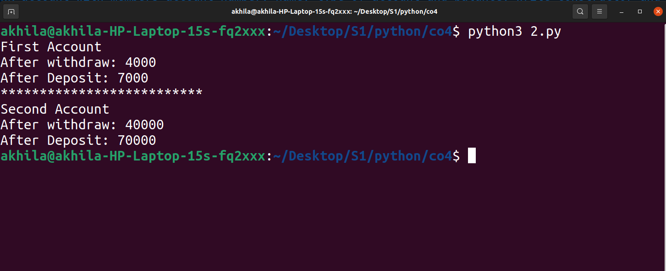
3.Create a class Rectangle with private attributes length and width. Overload ‘<’ operator to compare the area of two rectangles.

Program:-
Output:-

4.Create a class Time with private attributes hour,minute and second. Overload ‘+’ operator to find sum of two time.

Program:-
Output:-

5.Create a class Publisher(name). Derive class Book from Publisher with attributes title and author. Derive class python from Book with attributes price and no_of_pages. Write a program that displays information about a Python book. Use base class constructor invocation and method overreading.

Program:-
Output:-

