COURSE OUTCOME 1

2)Display future leap years from current leap to a finial year entered by the users.
Program code
#Program to find the Leap Year in between current and future year
currentYear=int(input("Enter the current year:"))
futureyear=int(input("Enter the future Year: "))
print("Leap Years in between the",currentYear,"and",futureyear)
for i in range(currentYear,futureyear):
if i%4==0:
print(i)
Output
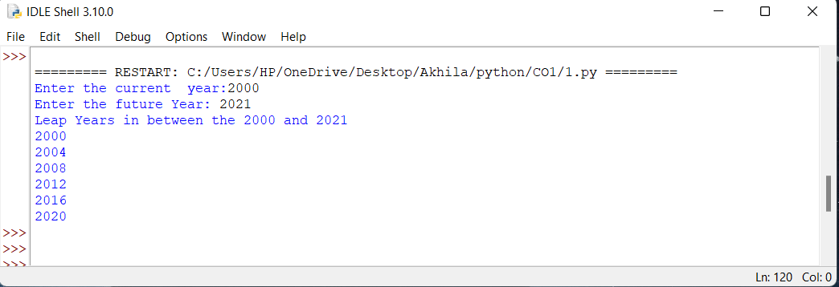
3)List comprehension:-
a. Generate positive list of numbers from a give list of integers.
b. square of N numbers.
c. Form a list of vowels selected from a give word.
d. List ordinal values of each elements of a word.
a.
Program code
#Generate positive list of numbers from a give list of integers.
print("The given list is ")
list=[19,2,-3,0,6,-9,4,10]
print(list)
print("The positive integers are \n ")
for i in list:
if i>0:
print(i)
Output
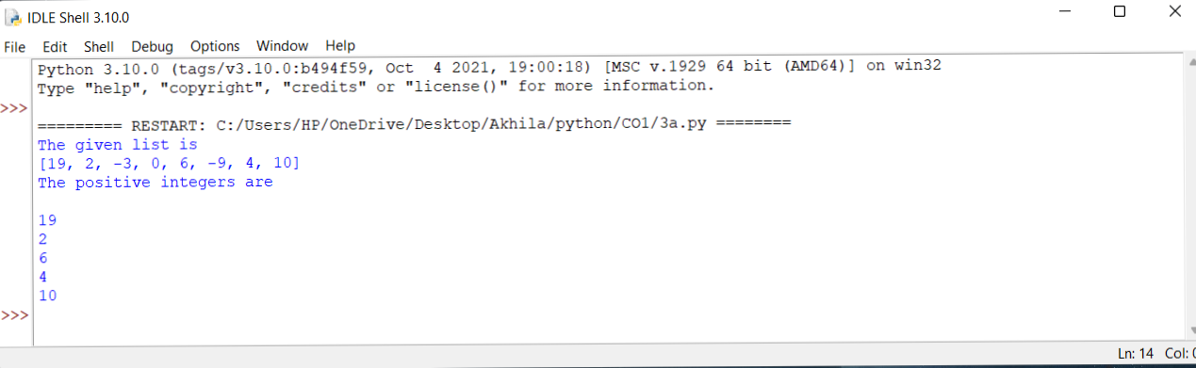
b.
Program code
#square of N numbers.
print("The given list is ")
list=[19,2,-3,0,6,-9,4,10]
print(list)
print("The square's of given list is ")
for i in list:
sqr=i*i
print(sqr)
Output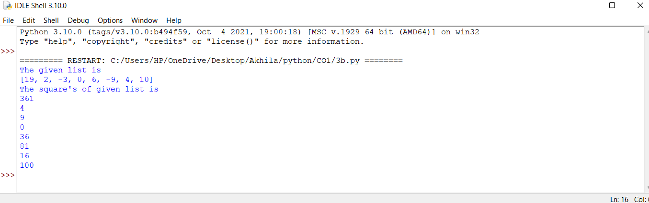
c.
Program code
# Form a list of vowels selected from a give word.
word=input("Enter a word:")
list=['A','E','I','O','U','a','e','i','o','u']
temp=[]
for i in word:
if (i in list and i not in temp):
temp.append(i)
print("The vowels in the word that you entered are ",temp)
Output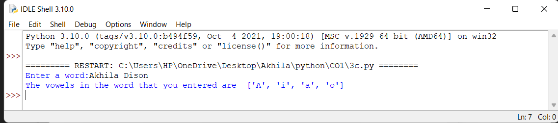
d.
Program code

word=input("Enter a word:")
temp=[]
print("The ordinal values of each element of the word is ")
for i in word:
x=ord(i)
temp.append(x)
print(temp)
Output
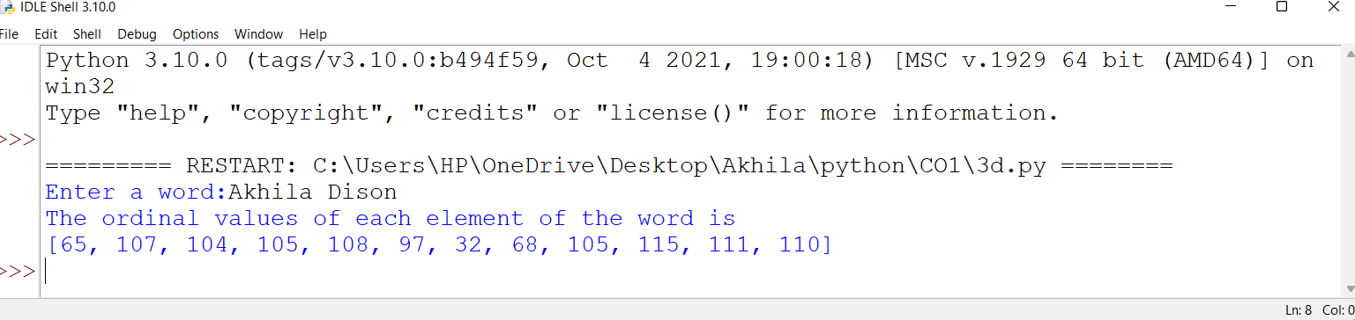

4)Count the occurrence of each word in a line of text.
Program code
#Count the occurrence of each word in a line of text.
k="In its most general sense, the term world refers to the totality of entities, to the whole of reality or to everything that is"
h=[]
for i in k.split(" "):
if i not in h:
h.append(i)
for i in h:
print(i,":",k.split(" ").count(i))

Output

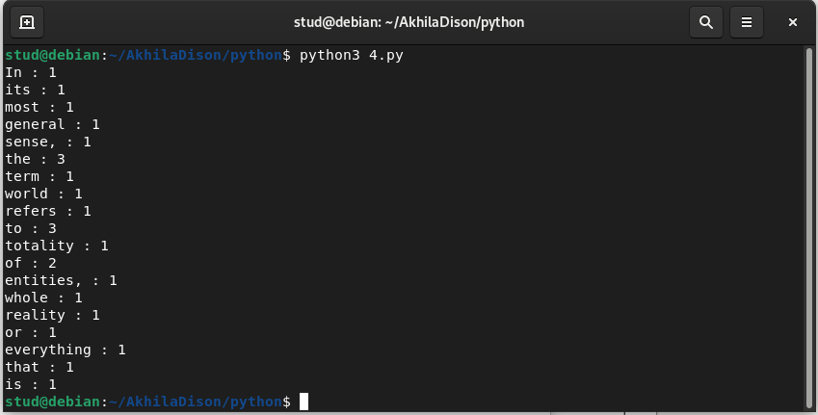
5)Prompt the user for a list of integers.For all values greater than 100,store ’over’ instead.
Program
#Prompt the user for a list of integers.For all values greater than 100,store ’over’ instead.
integers=int(input("Enter the limit:"))
temp=[]
over=0
for i in range(0,integers):
user=int(input("Enter a number:"))
if(user>=100):
temp.append(user)
else:
temp.append(over)
print("List elements are",temp)

Output
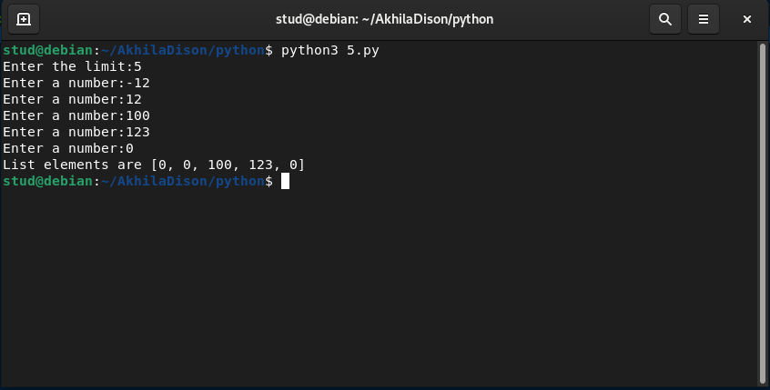

6) store a list of first names.count the occurence of “a” within the list.
Program
#store a list of first names.count the occurence of “a” within the list.
list= ['akhila','ashik','mary']
count=0
for i in list:
value= i.count('a')
count=count+value
print(list)
print(count)
Output
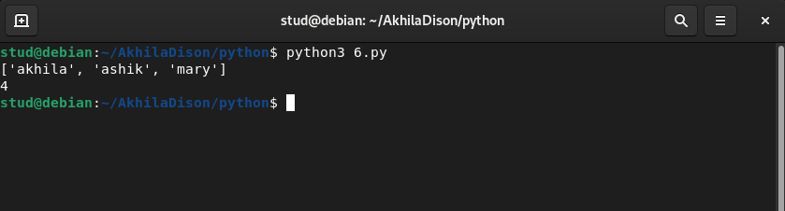
7)Enter 2list of first integers.Check
a.whether list are of same length.
b.Whether list sums to same value.
b.whether any value occur in both.
Program
#whether list are of same length.
list1=[1,2,3,4,5]
list2=[4,5,6,7,8]
print(list1)
print(list2)
x=len(list1)
y=len(list2)
if(x==y):
print("List is of same length.")
else:
print("List is not same length.")

#Whether list sums to same value.
sum1=0
sum2=0
for i in list1:
sum1=sum1+i
print("Sum of first list is:",sum1)
for j in list2:
sum2=sum2+j
print("Sum of second list is:",sum2)
if(sum1==sum2):
print("The sum is same....")
else:
print("The sum is not same...")
#whether any value occur in both.
for i in list1:
if i in list2:
print(i,"occur in both list")

Output

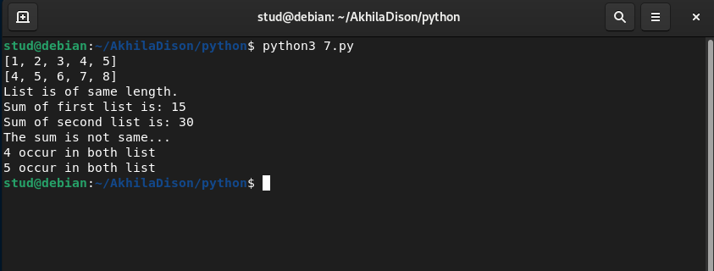
8)Get a stringfrom an input string where all occurrence of first charater replace with ‘$’,except first charater.
[eg:-onion->oni$n]

Program
#Get a stringfrom an input string where all occurrence of first charater replace with ‘$’,except first charater.
#[eg:-onion->oni$n]
s=input("Enter a string:")
print("Original string",s)
char=s[0]
s=s.replace(char,'$')
s=char+s[1:]
print("replaced string:",s)

Output

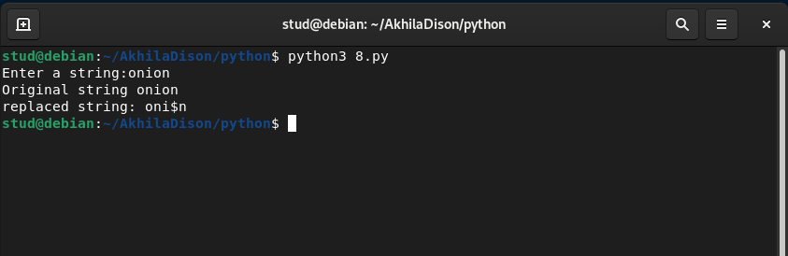

9)Create a string from give string where first and last charater exchanged.[eg:-python->nythop]

Program
#string from give string where first and last charater exchanged.[eg:-python->nythop]
s=input("Enter a string:")
print("Original string:",s)
sf=s[0]
sl=s[-1]
n=len(s)
ns=sl+s[1:n-1]+sf
print(ns)
Output
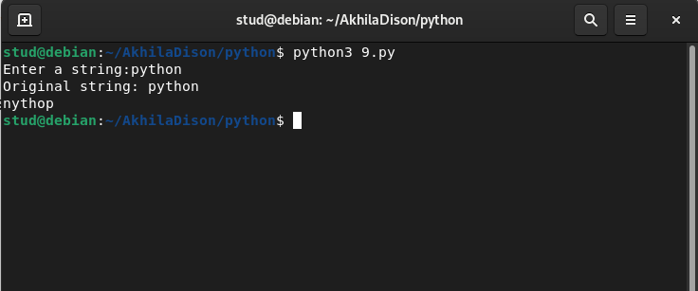

10)Accept the radius from the user and find the area of circle.
Program
#Accept the radius from the user and find the area of circle.
y=int(input("Enter the radius of the circle:"))
a=3.14*y*y
print("The area of the circle is",a)

output
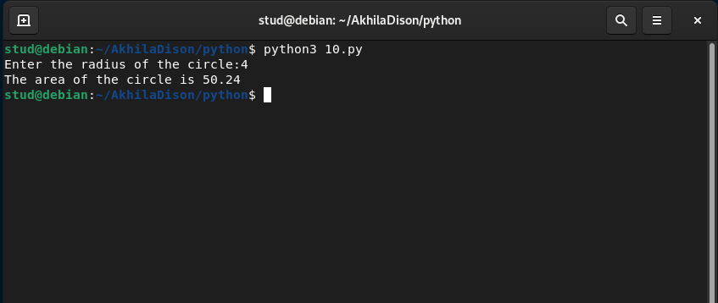
11)find the greatest of 3 entered.
Program
#greatest amoung 3
print("Enter three numbers: ")
a=int(input())
b=int(input())
c=int(input())
if a>b and a>c:
print("The biggest of three numbers: ",a)
if b>a and b>c:
print("The biggest of three numbers: ",b)
if c>a and c>b:
print("The biggest of three numbers: ",c)
Output

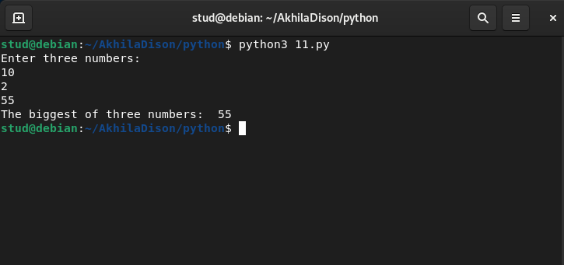
12)Acept file name from user and print extention of that.
Program
#Acept file name from user and print extention of that.
import os
a=input("Enter file name:")
print("The extension of file",a,"is",os.path.splitext(a))

Output

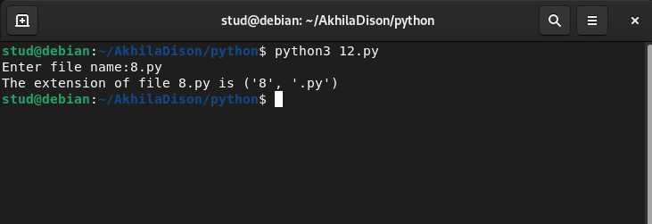
13)Create a list of colours from comma seperated color names entered by users.Display first and last color.
Program
#Create a list of colours from comma seperated color names entered by users.Display first and last color.
n=int(input("Enter the size:"))
lt = []
l=[]
print("Enter the color:")
for i in range(0,n):
lt = input()
l.append(lt)
print("The first color: ",l[0])
print("The last color: ",l[n-1])
Output
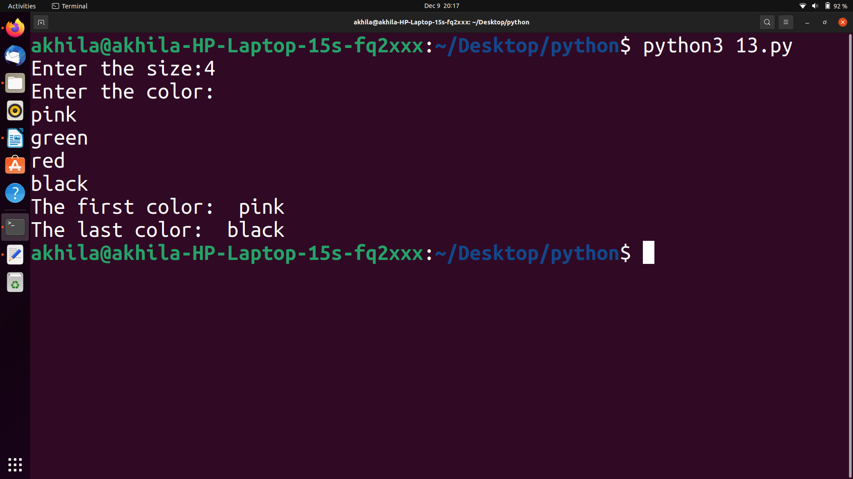
14)Accept an integer and compute n+nn+nnn.
Program
#Accept an integer and compute n+nn+nnn.
i=int(input("Enter a number:"))
value=i+((i*10)+i)+((i*100)+(i+10)+i)
print("The value is",value)
Output

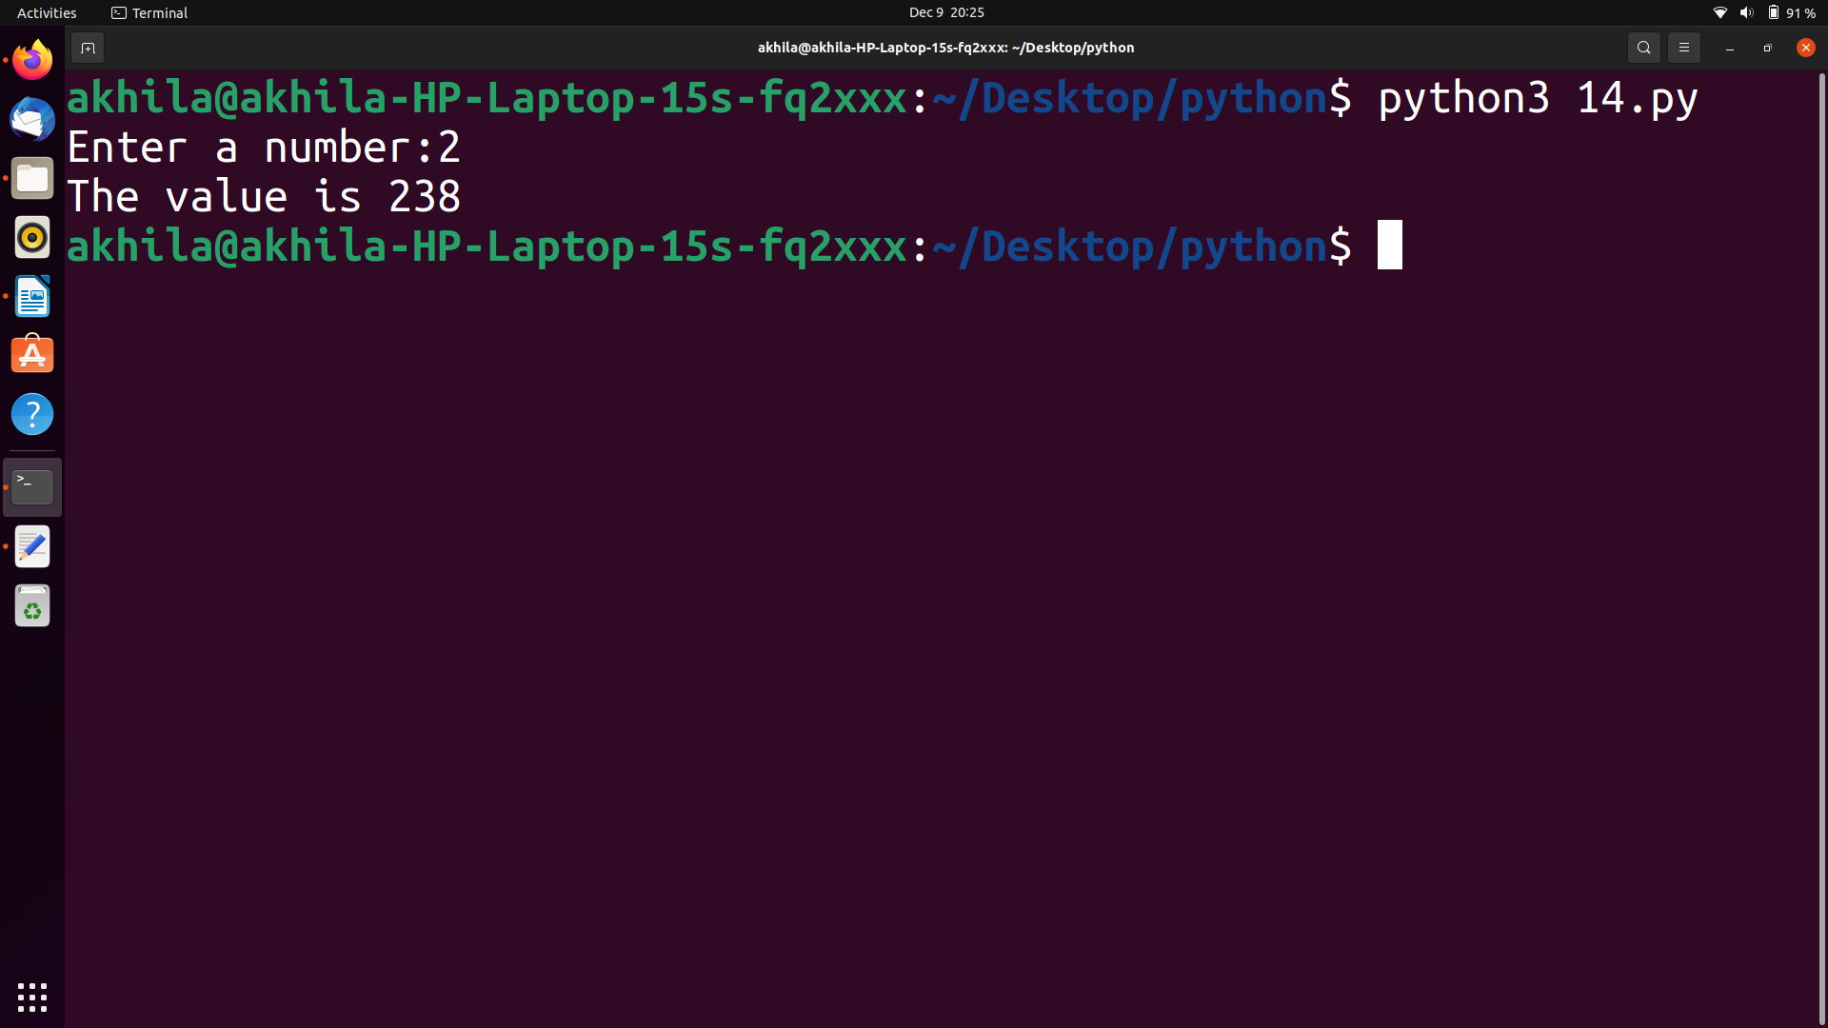
15)Print out all colors from color-list 1 not contained in color-list2
program
#Print out all colors from color-list 1 not contained in color-list2
list1= ['red', 'violet', 'black']
list2= ['blue', 'pink', 'red']
list3=[]
for i in list1:
if i not in list2:
list3.append(i)
print(list3)

output

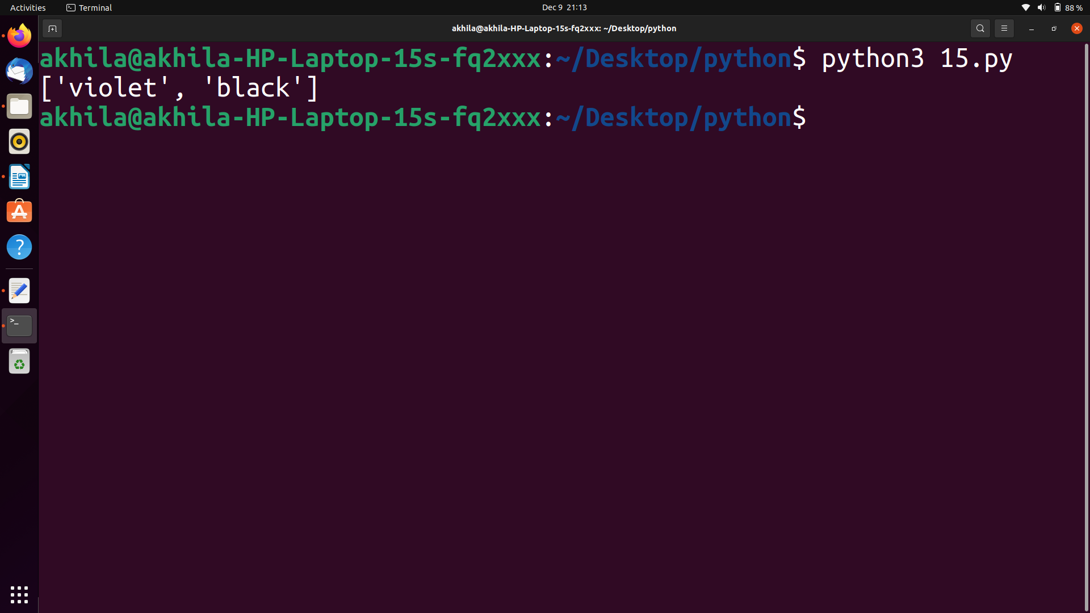
16)Create a single string seperated with space from two strings by swapping the charater at position 1.
Program
#Create a single string seperated with space from two strings by swapping the charater at position 1.
a=input("Enter string 1:")
b=input("Enter string 2:")
a1=b[0]+a[1:]
b1=a[0]+b[1:]
c=a1+' '+b1
print(c)
Output
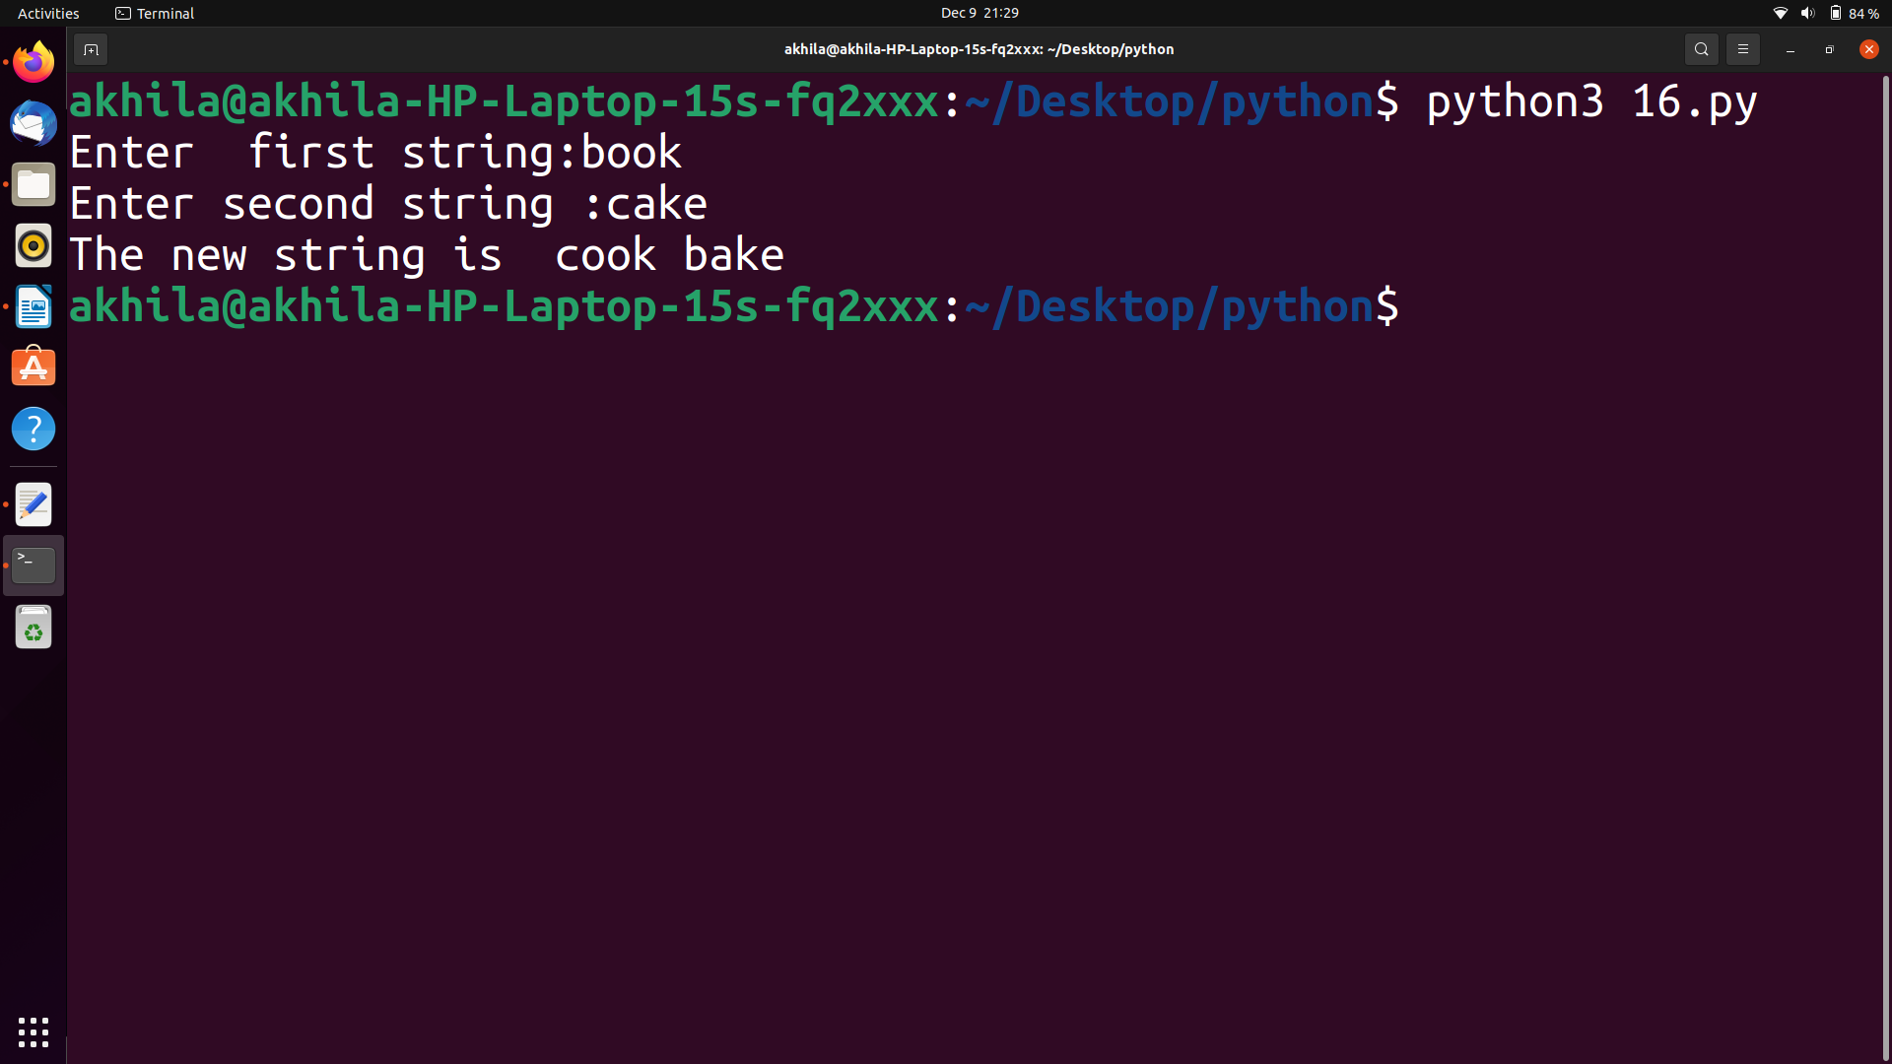

17)Sort dictionary in asending and decending order.
Program
#Sort dictionary in asending and decending order.
d1={"name":"Akhila","age":"21"}
d2={"sex":"F","qualification":"gradution"}
d1.update(d2)
print(d1)
Output
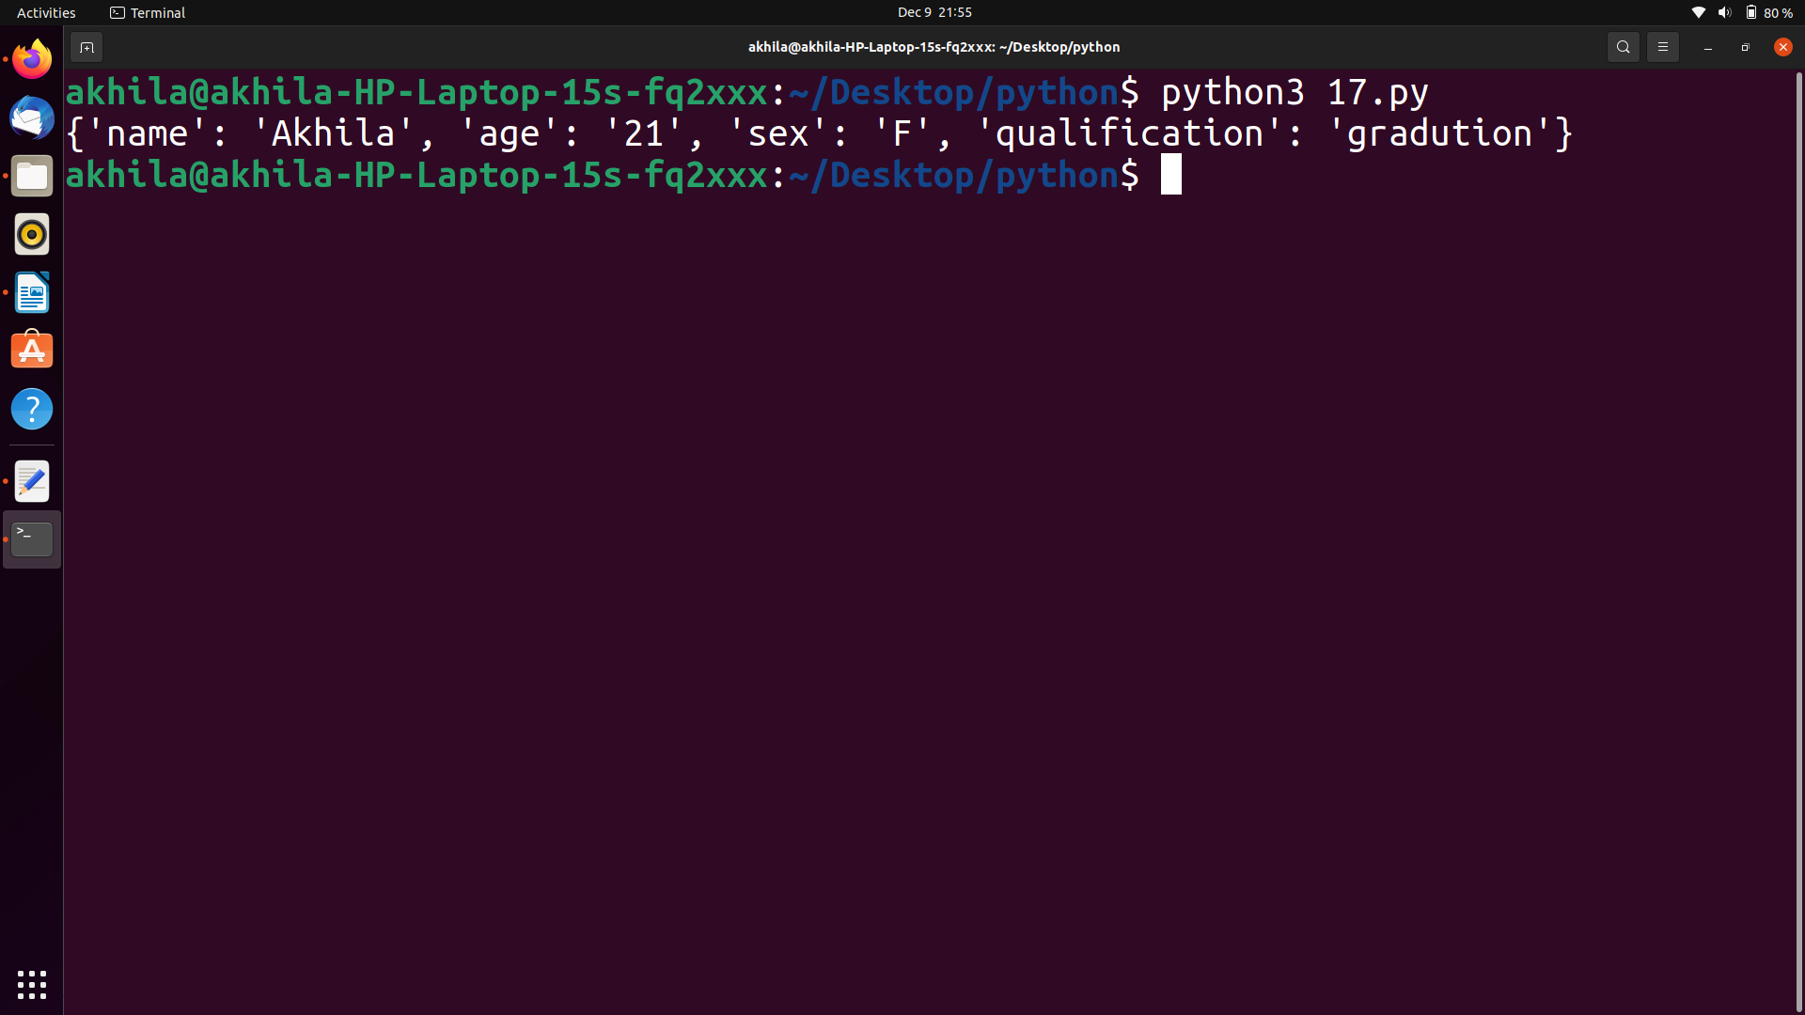

18)merge two dictionary
Program
#merge two dictionary
thisdict ={
"Name": "Akhila",
"age": 21,
"dob": "02/005/2000"
}
d={"College Name":'FISAT' , "rollno":'09'}
d.update(thisdict)
print(d)
Output

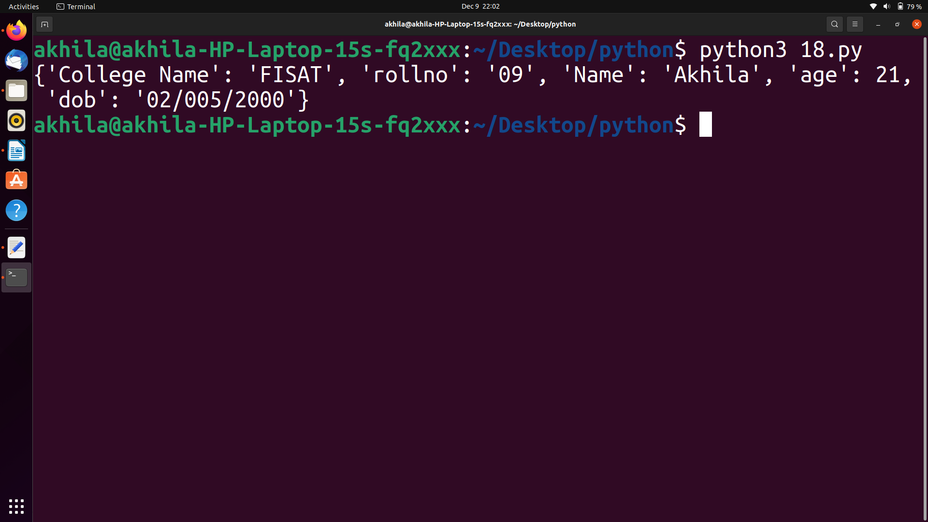
19)find GCD of 2 numbers
Program
#gcd of 2 numbers
x=int(input("Enter the first number:"))
y=int(input("Enter the second number:"))
z=max(x,y)
for i in range(1,z+1):
if(x%i==0) and (y%i==0):
gcd=i
print("The gcd of the given two numbers is ",gcd)
Output

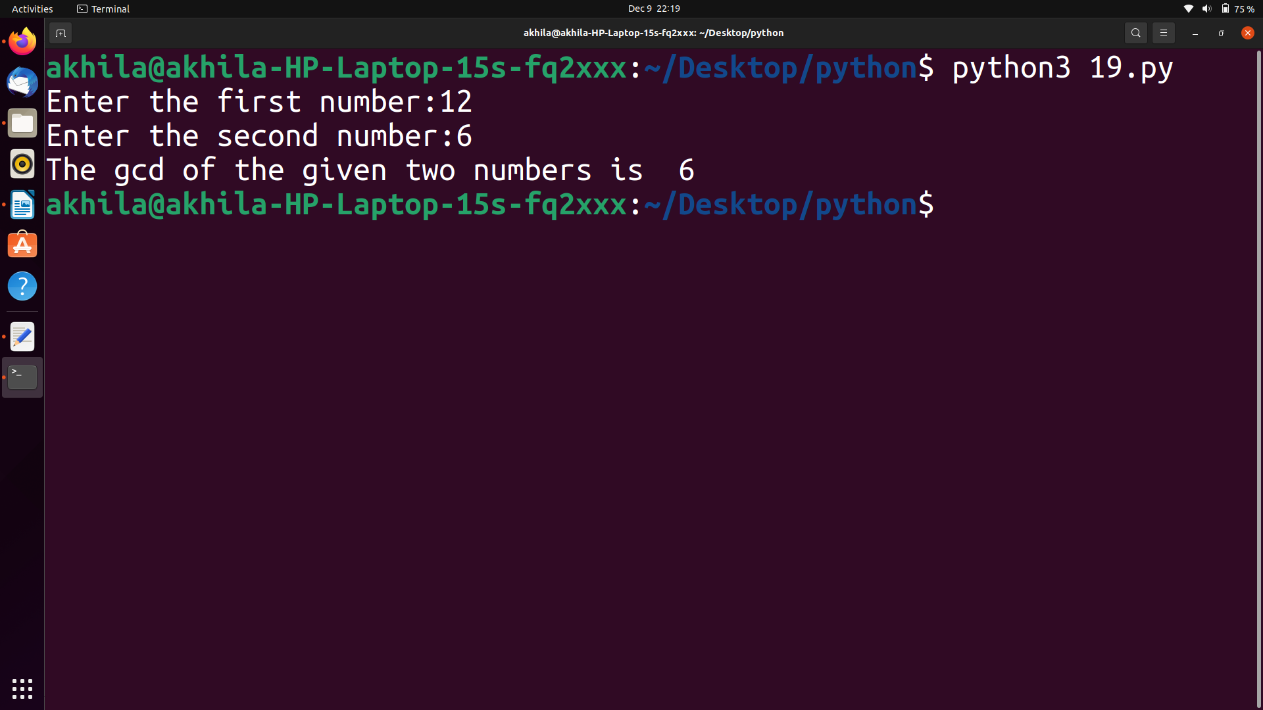

20)From a list of integers ,create a list removing even numbers
Program
From a list of integers ,create a list removing even numbers
l=[0,1,2,3,4,5,6,7,8,9]
print(l)
li=[]
print("List of Even Numbers:")
for i in l:
if(i%2==0):
li.append(i)
print(li)
Output

