COURSE OUTCOME 2

1)Program to find the factorial of a number.
Program
#Program to find the factorial of a number.
num=int(input("Enter the number: "))
fact=1
for i in range(1,num+1):
fact=fact*i
print("Factorial of the number is ",fact)
Output

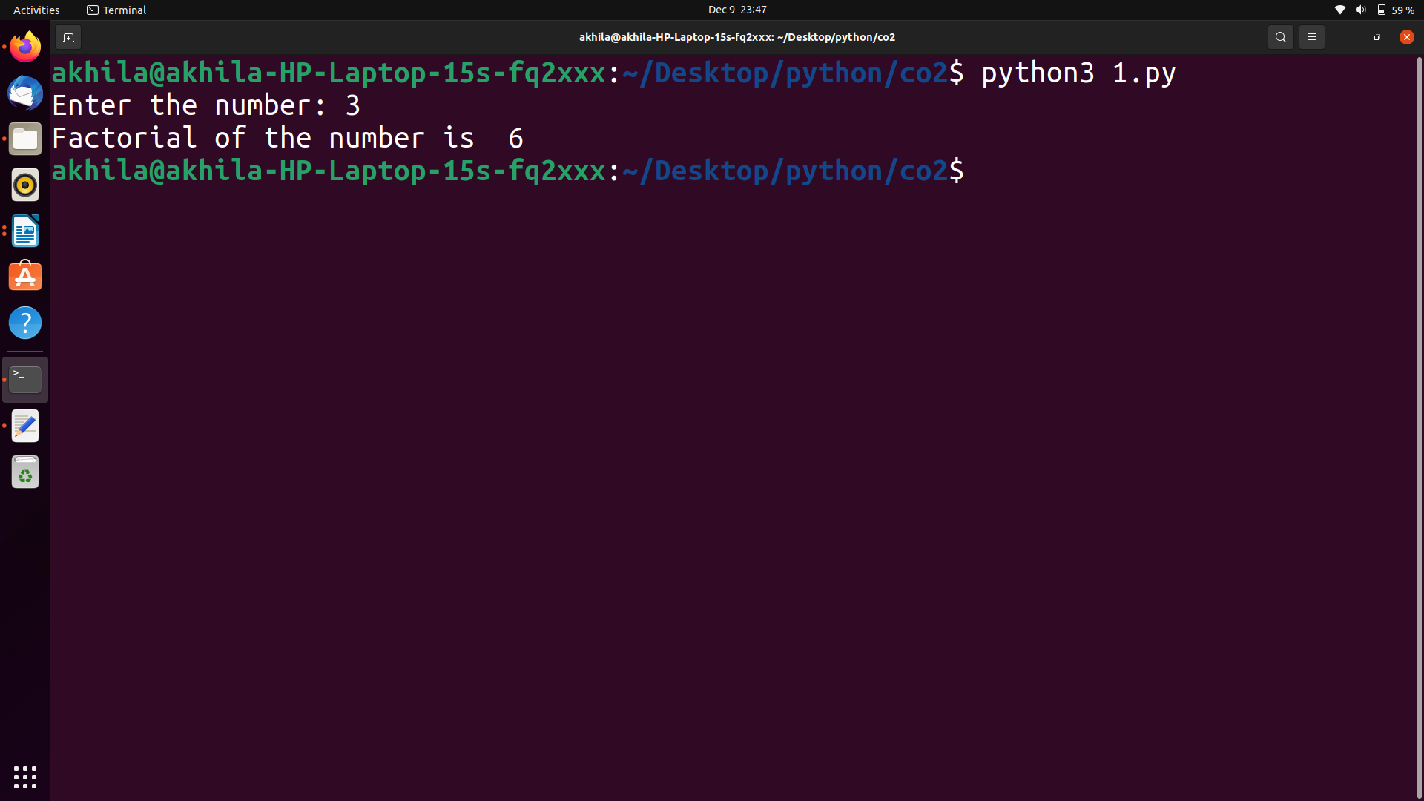

2)Generate Fibonacci series of N terms.
Program
#Generate Fibonacci series of N terms.
n=int(input("Enter the limit: "))
a=0
b=1
c=0
print("Fibonacci Series:")
print(a)
print(b)
for i in range(3,n+1):
c=a+b
print(c)
a=b
b=c
Output

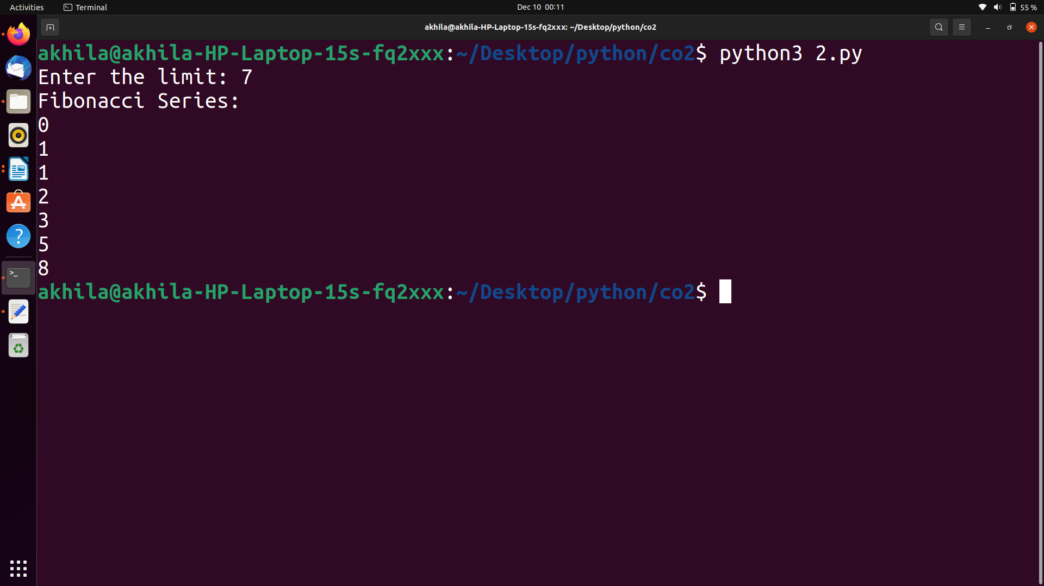
3)Find the sum of all items in a list.
Program
#Find the sum of all items in a list.
def sum_of_list(l):
total = 0
for val in l:
total = total+val
return total
my_list = [3,5,7,9,2]
print("The sum of my list is", sum_of_list(my_list))

Output

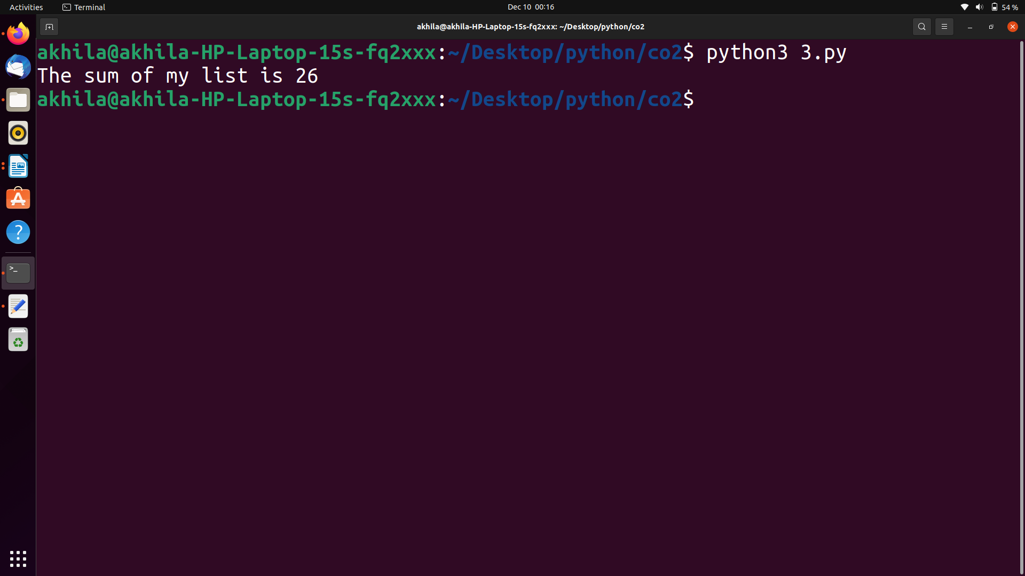

4)Generate a list of 4 digit number in a give range with all their digits even and the number is a perfect square.
Program
#Generate a list of 4 digit number in a give range with all their digits even and the number is a perfect square.
limit1=4286
limit2=8642
list1=[]
for i in range(limit1,limit2):
j=i
digit=[]
while(i!=0):
digit.append(i%10)
i=int(i/10)
count=0
for n in digit:
if n%2==0:
count=count+1
if count==4:
for k in range(31,100):
if((k**2)==j):
list1.append(j)
print(k)
print(list1)

Output

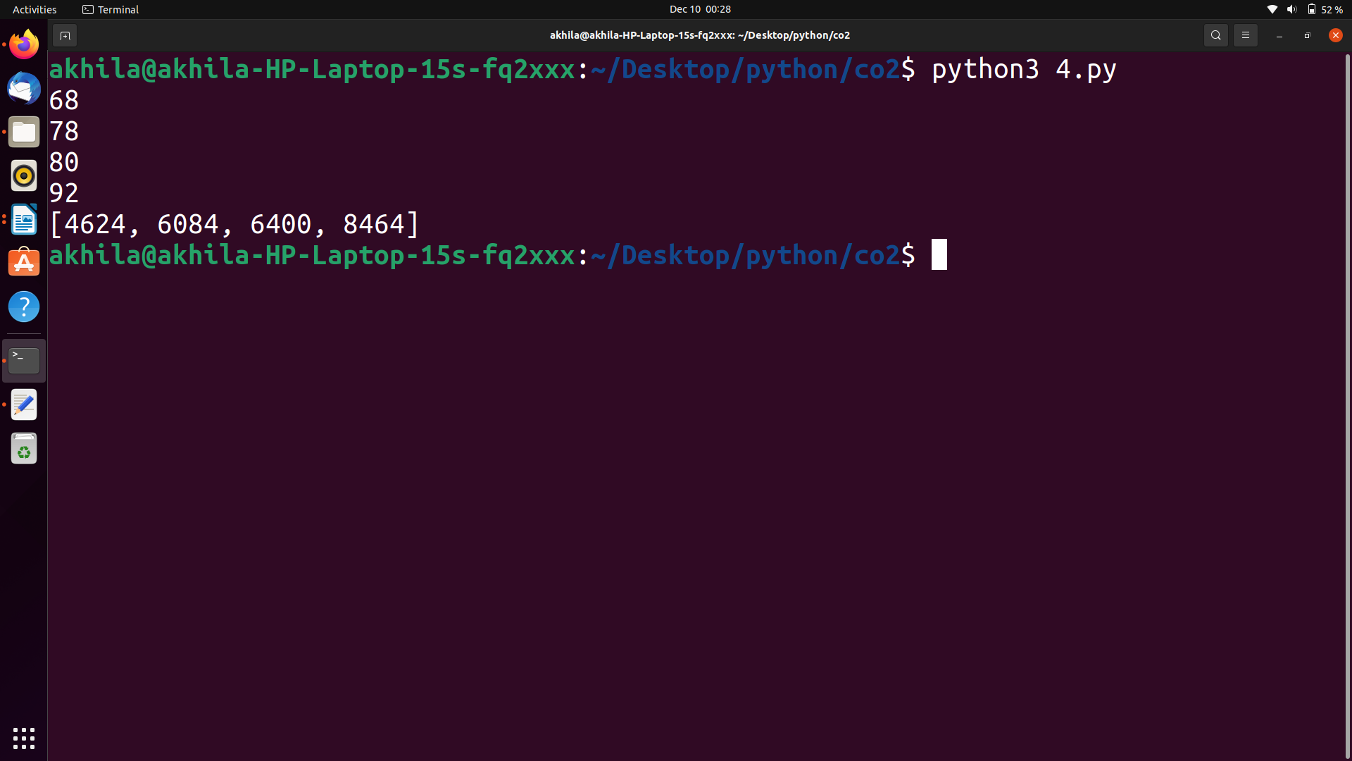

5)Display the given pyramid with step number accepted from user.
Eg=4
1
2 4
3 6 9
4 8 12 16
Program
#Display the pyramid with step number accepted from user.
for i in range(1,5):
for j in range(1,i+1):
print(i*j,end=" ")
print("\n")
Output

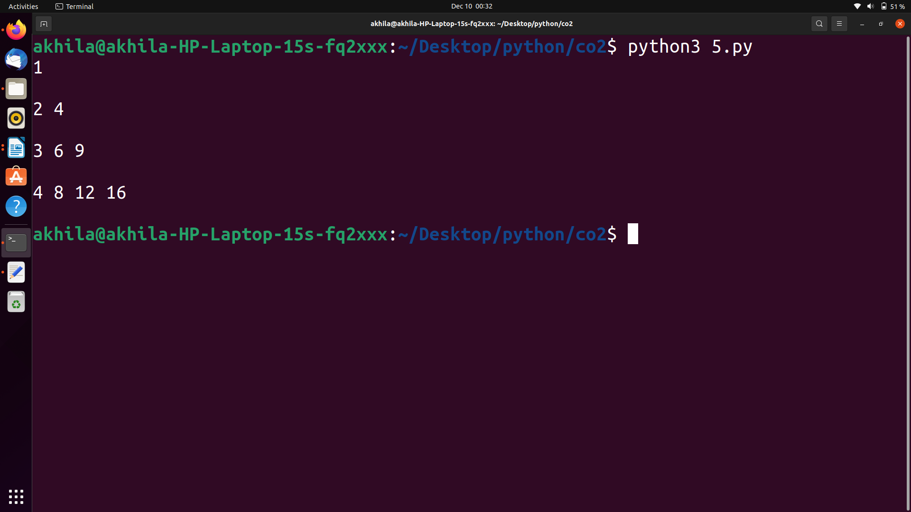

6)Count the number of charater in a string.
Program
#Count the number of charater in a string.
string = "hello world";
count = 0;
for i in range(0, len(string)):
if(string[i] != ' '):
count = count + 1;
print("Total number of characters in a string: " + str(count));
Output
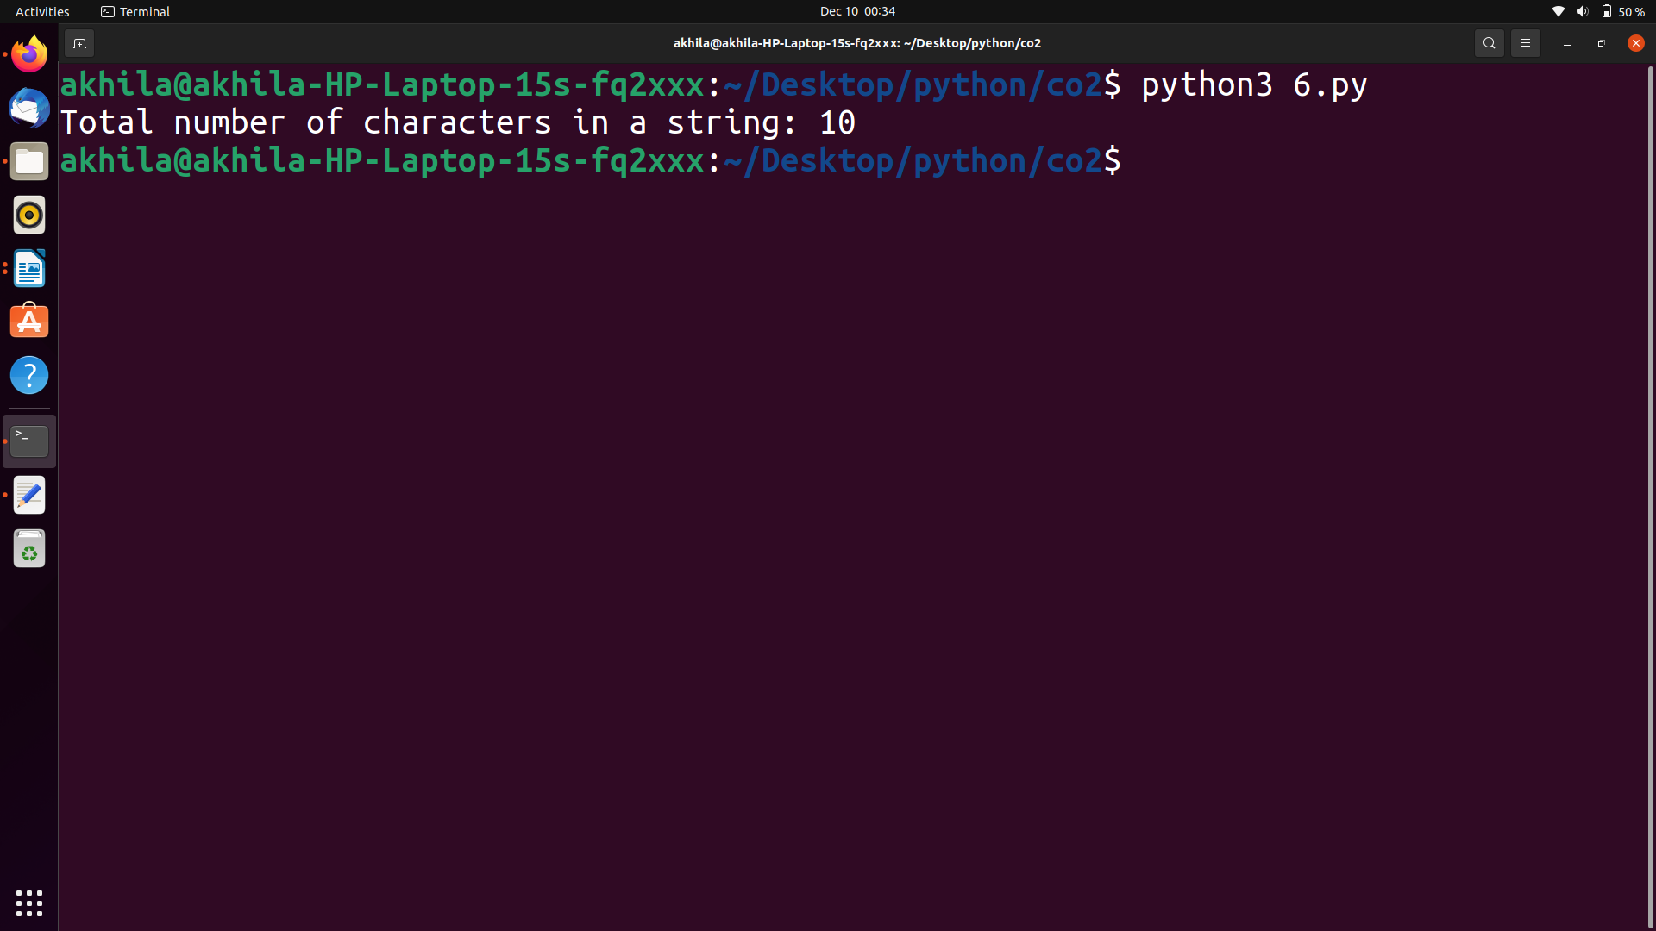

7)Add ‘ing’at the end of a given string.If it already end with ‘ing’,then add
’ly’.
Program
#Add ‘ing’at the end of a given string.If it already end with ‘ing’,then add ’ly’.
s=input("Enter a string:")
if s[-3:]=='ing':
s=s+'ly'
else:
s=s+'ing'
print("New string:",s)

Output

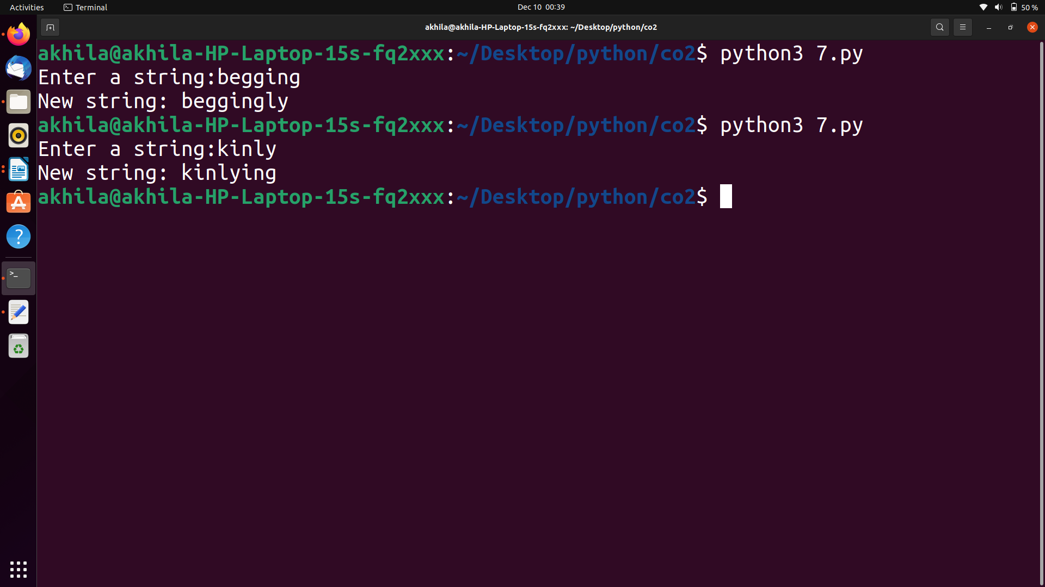

8)Accept a list of words and return length of longest word.
Program
#Accept a list of words and return length of longest word.
l1=[]
num=int(input("Enter the range:"))
print("Enter the words:")
for i in range(0,num):
l1.append(input(""))
longest=l1[0]
for i in range(1,num):
if(len(l1[i])>len(longest)):
longest=l1[i]
print("Length of longest word is",len(longest))

Output

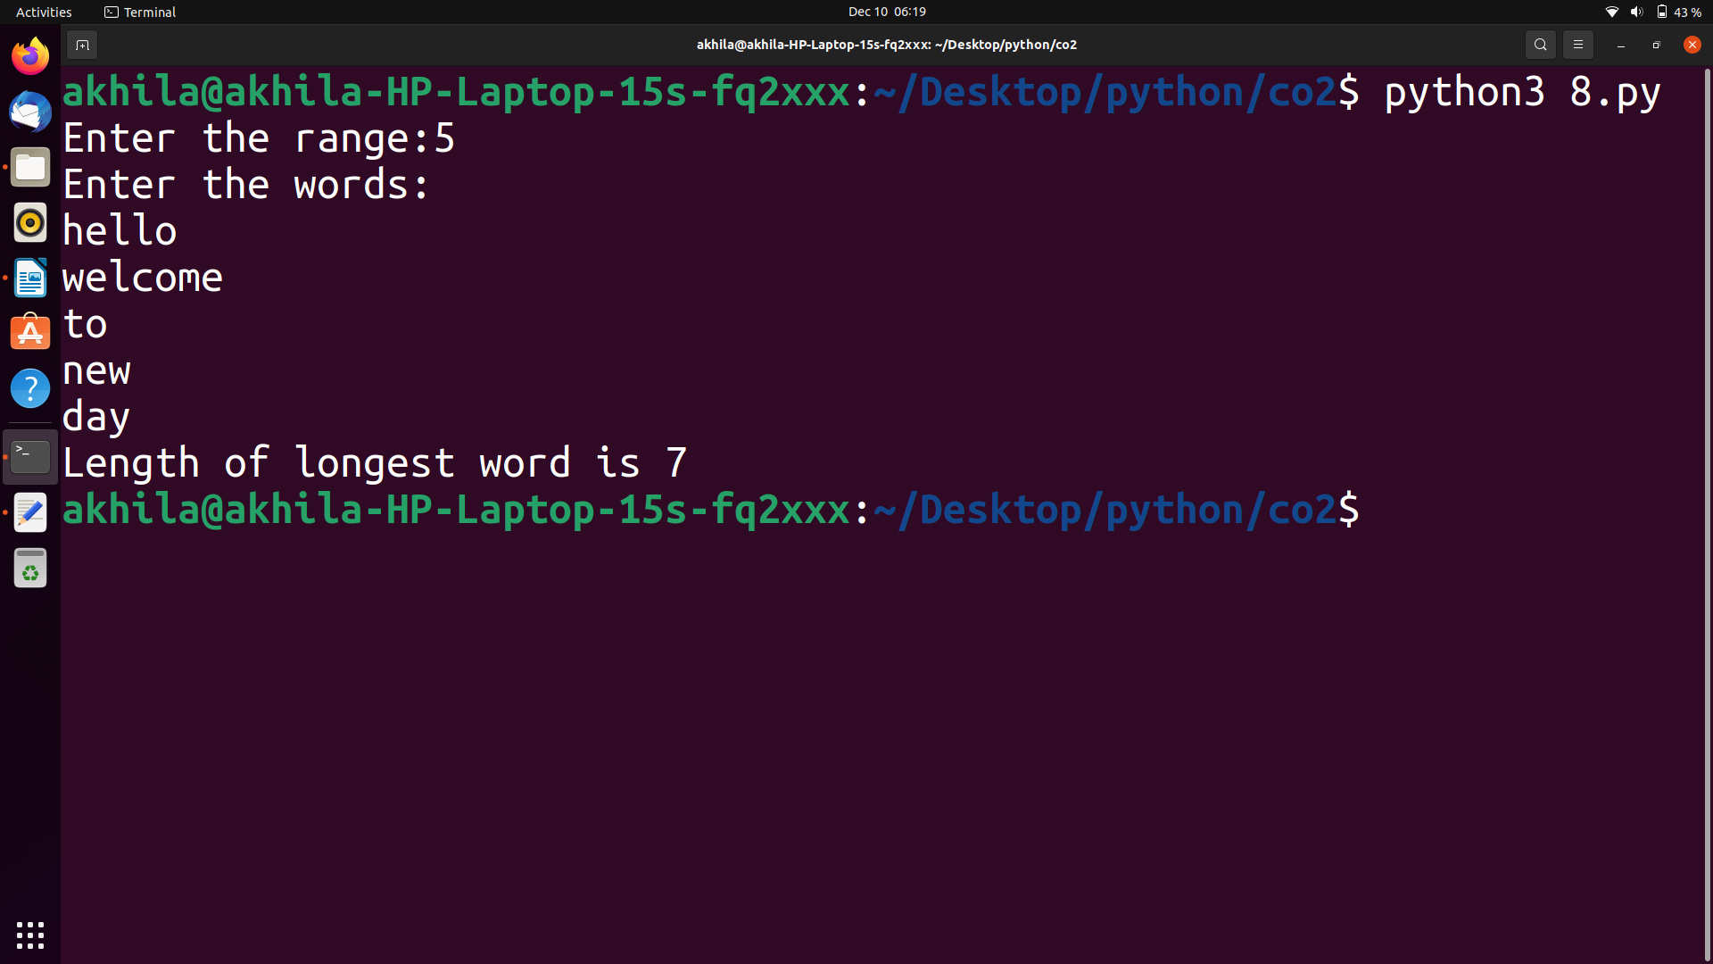

9)Construct the pattern using nested loop.
*
* *
* * *
* * * *
* * * * *
* * * *
* * *
* *
*
Program
#pattern using nested loop.
for i in range(0,5):
for j in range(0,i):
print("*",end=" ")
print("\n")
for i in range(5,0,-1):
for j in range(0,i):
print("*",end=" ")
print("\n")
Output

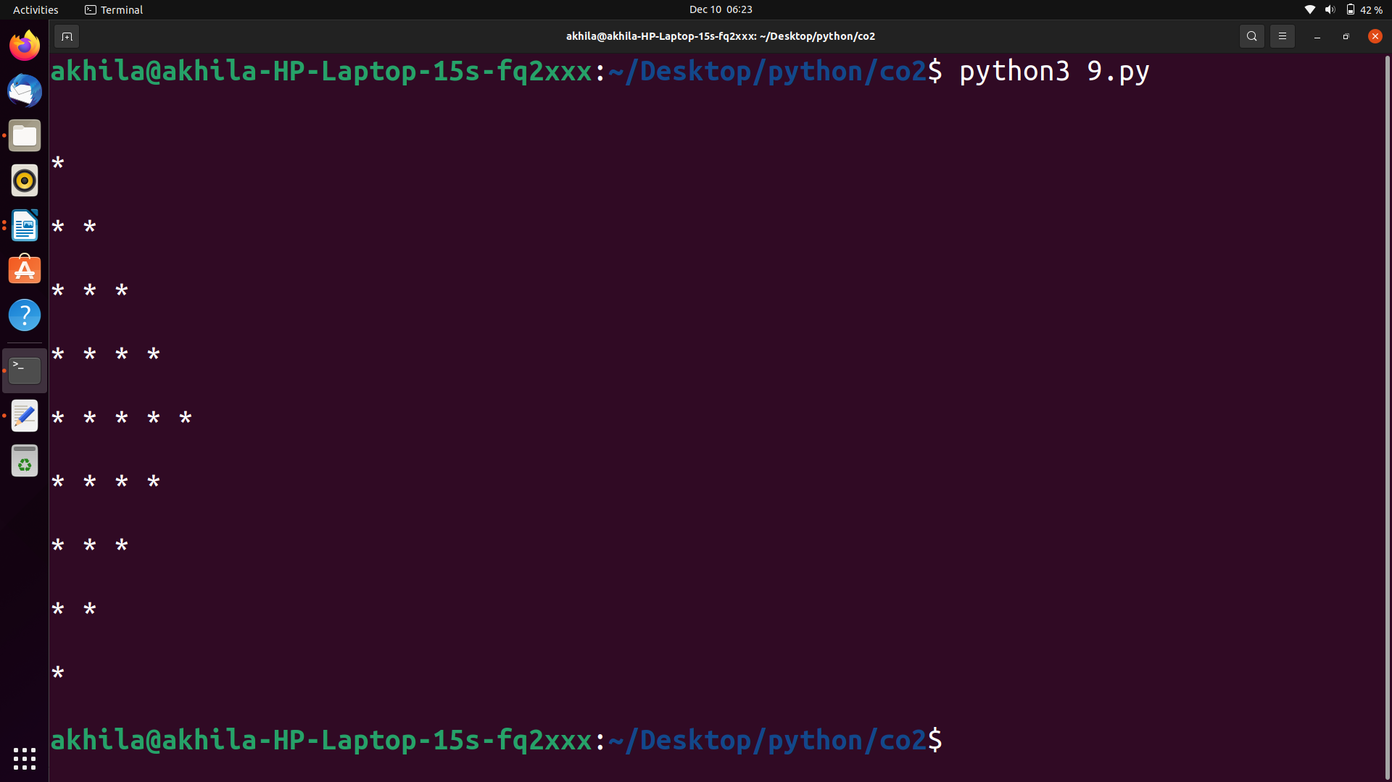

10)Generate all factors of a number.
Program
#all factors of a number.
n=int(input("Enter the number: "))
i=2
print("The factors of ",n)
while i<=n:
if (n % i==0):
print(i)
i = i + 1
Output

