README

Dataset description according to (link):

“Slashdot is a technology-related news website known for its specific user community. The website features user-submitted and editor-evaluated current primarily technology oriented news. In 2002 Slashdot introduced the Slashdot Zoo feature which allows users to tag each other as friends or foes. The network contains friend/foe links between the users of Slashdot. The network was obtained in November 2008.”

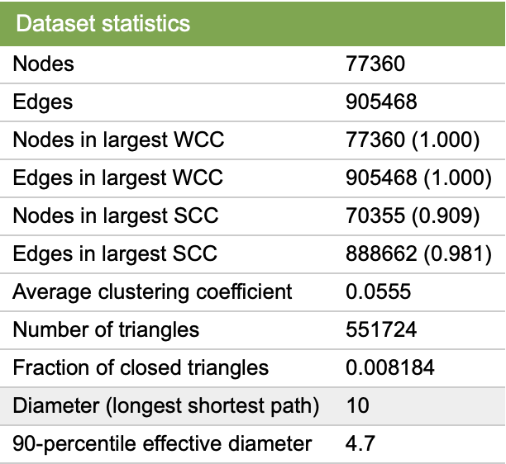

Dataset URL: https://snap.stanford.edu/data/soc-Slashdot0811.html

Code execution steps:

- Import the Databricks Notebook into your Databricks environment
- Download the Slashdot0811 dataset from the link above
- Make sure all required packages are installed with the correct library versions (for graphframes, install it from the list of spark libraries in Maven)
- Run all the cells in the notebook
- The output for each query will be displayed after its respective cell
- The results are saved in the file paths mentioned at the end of each sub section

Dataset Source:
J. Leskovec, K. Lang, A. Dasgupta, M. Mahoney. Community Structure in Large Networks: Natural Cluster Sizes and the Absence of Large Well-Defined Clusters. Internet Mathematics 6(1) 29--123, 2009.

References:

https://graphframes.io/docs/_site/index.html
https://github.com/graphframes/graphframes
https://docs.databricks.com/aws/en/integrations/graphframes/
https://stackoverflow.com/questions/65480804/how-to-get-connected-component-with-graphframes-in-pyspark-and-raw-data-in-spark
https://stackoverflow.com/questions/52663424/graphframes-pagerank-performance-pyspark-vs-sparklyr

