Summary

1. Environment Setup and Graph Preparation:
The initial steps of the analysis involve preparing a social network dataset (Slashdot) for graph processing. After installing the graphframes package, the dataset is loaded as an edge list where each line represents a directed connection from one user to another. The columns are renamed to src and dst to meet the requirements of GraphFrames, which expects source and destination columns for edges.
Duplicate edges are then removed to avoid redundant connections that could bias algorithmic results. From the cleaned edge list, a list of unique vertices is created by unifying the src and dst nodes. These vertices, along with the cleaned edges, are used to construct a GraphFrame, the core structure that allows running advanced graph queries and algorithms on large-scale data.

2. About the results:
The results of the connected components analysis make sense. Social networks naturally form communities or clusters—groups of users that are more interconnected among themselves than with others. The appearance of several large components and many small ones is typical of real-world networks, where a few communities dominate in size while others are more isolated

3. Insights from the Analysis:
- Community Detection: The connected components algorithm reveals natural groupings of users in the Slashdot network, helping to identify social clusters or subcommunities.
- Network Structure: The varying sizes of components highlight the scale-free nature of the network—many small nodes and a few highly connected hubs.
- Scalability of GraphFrames: The ability to handle large graphs efficiently with Spark and GraphFrames demonstrates the practicality of distributed graph analytics for real-world applications.

Outputs

a. Top-5 out-degree nodes:
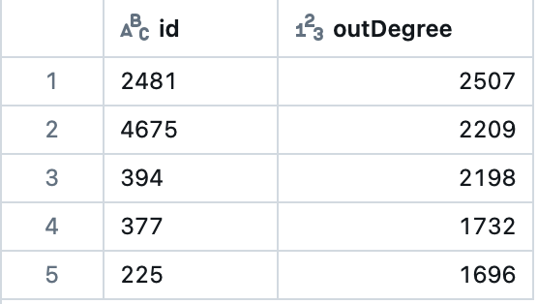

b. Top-5 in-degree nodes:

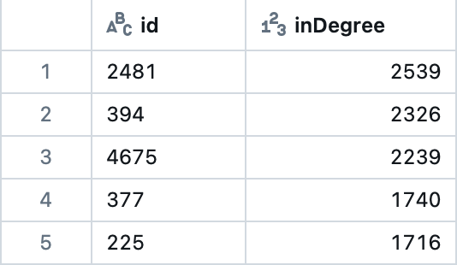

c. PageRank (top-5):

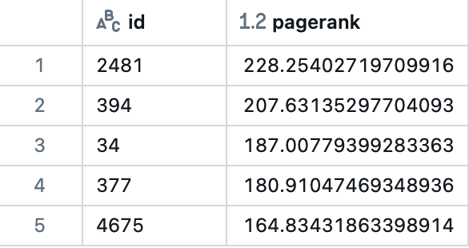

d. Connected components (top-5 largest):

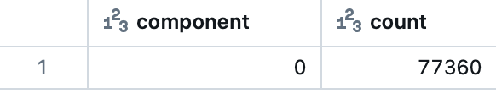

e. Triangle count (top-5 vertices):
