Week 7 – Data Backup System Documentation

Internship: Developers Arena
Inventory Management System

Programming Language: Java
IDE: Eclipse IDE

Submitted By:
email: akhilathirumani42@gmail.com
ID Number: EMP20260710-8070

1. Project Overview
Project Description
The Data Backup System is a Java-based application developed to create, store, manage, restore, and protect backup data using different file formats.
The main objective of the project is to demonstrate practical Java concepts such as file handling, object serialization, CSV and JSON processing, compression, version management, file comparison, recovery points, and scheduled backups.
Key Objectives
- Create and store backup data using Java serialization.
- Export and import backup data using CSV.
- Serialize and deserialize backup data using JSON.
- Compress backup files using GZIP.
- Manage multiple backup versions.
- Compare and merge files.
- Create recovery points for backups.
- Support scheduled backup operations.
- Use reusable and modular Java classes.
- Handle file resources safely using try-with-resources.

2. Setup Instructions
Prerequisites
- Java JDK installed
- Eclipse IDE installed
- Gson JAR library
Installation Steps
Step 1 – Open the project
Open the BackupSystem project in Eclipse.
Step 2 – Configure Java
Make sure the project is configured with a compatible Java JDK.
Step 3 – Add Gson
3. Code Structure
The project follows a modular package structure where each class has a specific responsibility.
BackupSystem
│
├── src
│ │
│ ├── compression
│ │ └── CompressionUtils.java
│ │
│ ├── data
│ │ ├── BackupData.java
│ │ └── RecoveryPoint.java
│ │
│ ├── io
│ │ ├── BackupManager.java
│ │ ├── CSVHandler.java
│ │ ├── JsonHandler.java
│ │ ├── FileUtils.java
│ │ └── VersionManager.java
│ │
│ ├── scheduler
│ │ └── BackupScheduler.java
│ │
│ ├── utility
│ │ └── FileComparisonUtils.java
│ │
│ └── Main.java

4. Visual Documentation
- Project structure
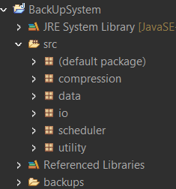

- Main System
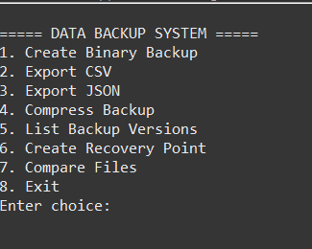

- Binary Backup
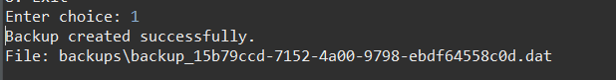

- Backups
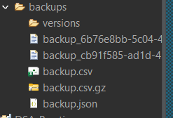

- JSON Backup
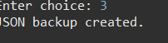

- Backup Versions
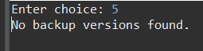

- Recovery points
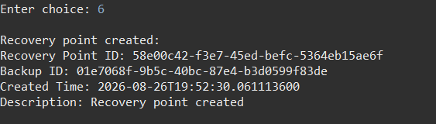
- Comapre files
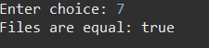
5. Technical Details
Architecture
The project uses a modular architecture where responsibilities are divided across packages.
Main
│
▼
BackupManager
/ | \
▼ ▼ ▼
CSV JSON Version
Handler Handler Manager
│
▼
BackupData

Compression → CompressionUtils

Recovery → RecoveryPoint

Comparison/Merge → FileComparisonUtils

Scheduling → BackupScheduler
6. Testing Evidence
The application was tested by executing the implemented features through the main application.
Test Case | Expected Result | Result
Create binary backup | .dat file created | ✅ Passed
Export CSV | backup.csv created | ✅ Passed
Export JSON | backup.json created | ✅ Passed
Compress backup | .gz file created | ✅ Passed
List/manage versions | Backup versions handled | ✅ Passed
Create recovery point | Recovery point generated | ✅ Passed
Compare files | Comparison result displayed | ✅ Passed

