Marketing Campaign Effectiveness

**A. AKHILA**

**Batch: DA-01**

Name: Marketing Campaign Effectiveness.

Domain: E-Commerce.

Focused on: Revenue, ROI, Campaign _Type, Company, Channel _Used, Acquisition_ Rate.

Objective: Marketing effectiveness is the measurement of how effectively your marketing strategy achieves its dual primary goals, increasing the company's revenue and decreasing its cost of customer acquisition.

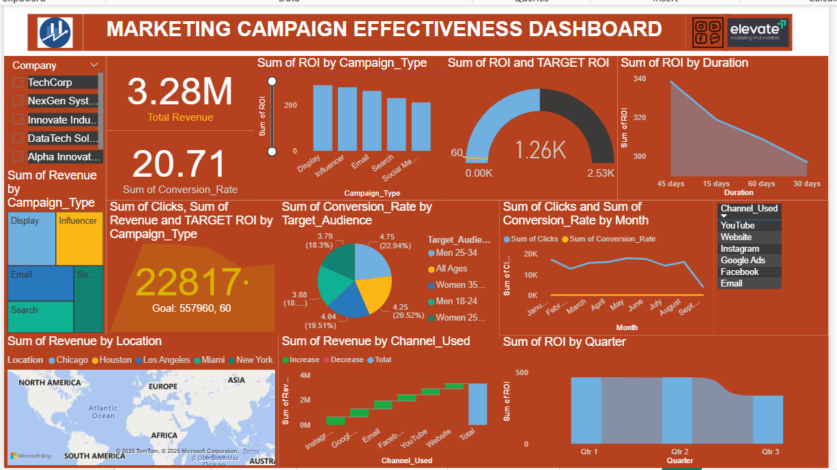

Data Collection: Data is collected from Kaggle.com and downloaded a CSV file and import from the Excel.

Data Preparation:

**Clean Data**: Ensure the Data is Consistent formatting for that, Removed blank cells, Duplicates and Null values.

**Organize Data:** Use tables to structure your data for better analysis.

Analyze Data: Analyzed using Microsoft Excel.

1. **Using Functions**

* Sum function i.e.=sum () to calculate sum of all in the required Column.
* Proper function i.e.=proper () is used to capitalize the first letter of each word in a text string.
* Average function i.e.=Average () calculates the arithmetic mean of a group of numbers.
* VLOOKUP function i.e. =VLOOKUP (lookup_ value, table_ array, col_index_num, [range _lookup]) is used to search for a value in the first column of a table and return a value in the same row from another column.

1. **Using Pivot tables**

Pivot Tables in Excel are a powerful tool to summarize, analyse, explore, and present your data.

* **How to Create a Pivot Table:**

Select your data (including headers).

Go to the Insert tab → Click PivotTable.

Choose: The range/table.

Whether to place the Pivot Table in a new worksheet or the same one.

Click OK.

These are the Analysis used in the Pivot tables which are mentioned below

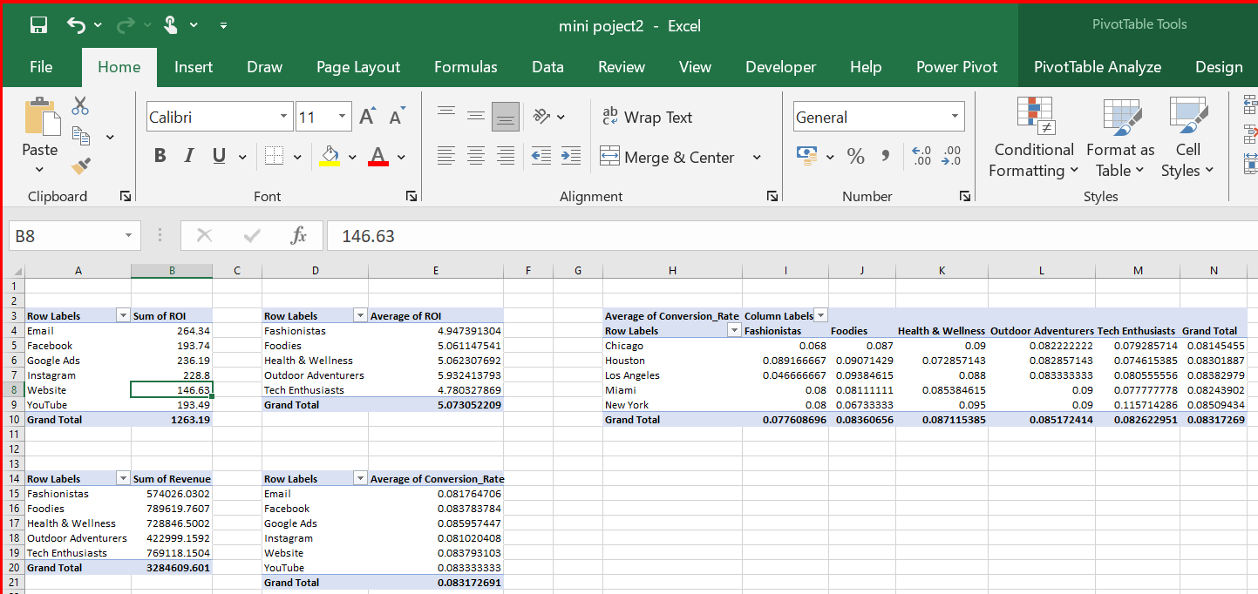

1. **Using Charts and graphs**

Charts and graphs in Excel help visualize your data to make trends and comparisons easier to understand**.**

* **How to Insert a Chart or Graph**

Select your data (including headers).

Go to the Insert tab on the ribbon.

Choose a chart type from the Charts group.

Excel will insert a chart you can then customize**.**

For this data set some of the useful chats and graphs are Column, line, pie chart which are mentioned below

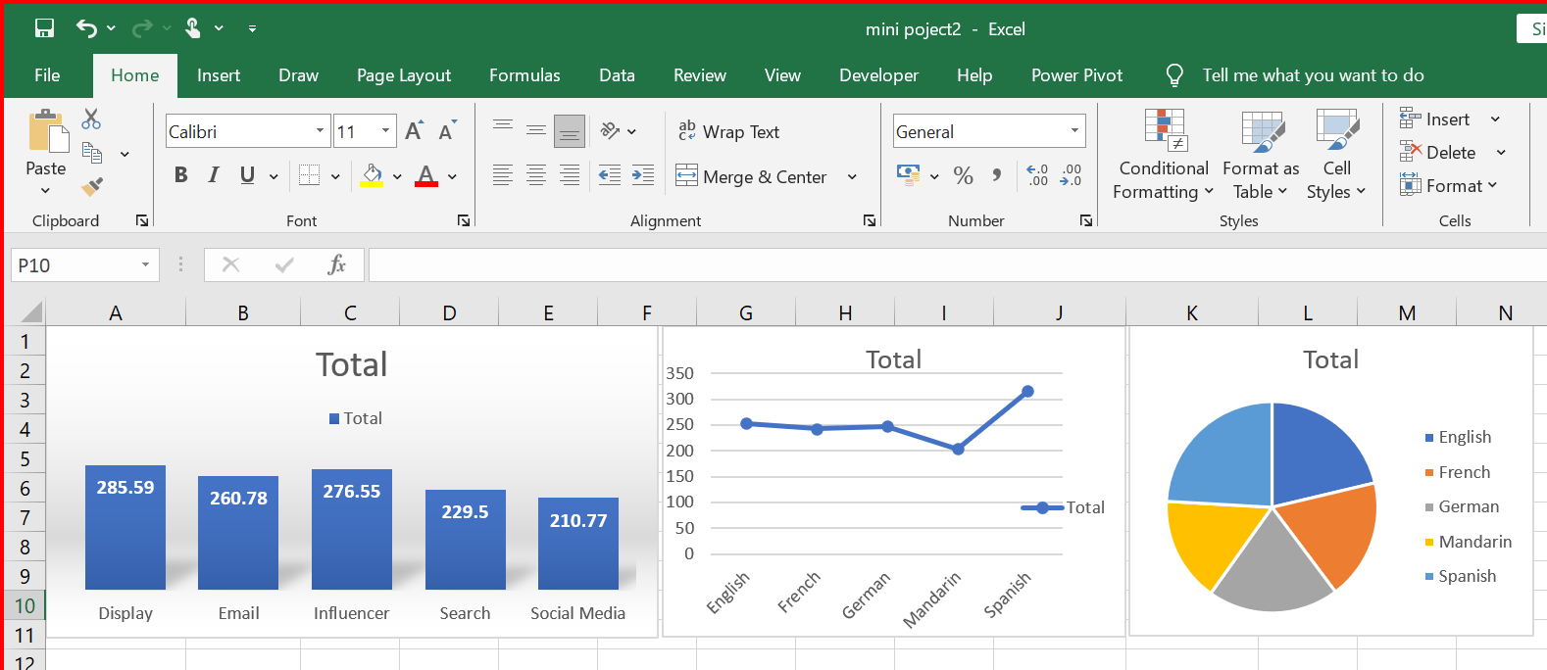

* Column based on Revenue and Campaign-type
* Line chart based on ROI and Language
* Pie chart based on Acquisition and Language.

**Analyze Data:** Analyzed using power BI

* Open Power BI and select “Get Data” to connect to your data source from Excel file

Create Data Model:

Creating Data Model is nothing but Establishing Relationship between different tables.

From the dataset we got some relations that are between:

* Channel: In E-Commerce table for channel_id to channel table channel_id relation one-on-one relationship.
* Segment: In E-Commerce table for segment_id to segment table segment_id relation one- on -one relationship
* Language: In Channel table for channel_id to language table language_id relation one_on _one relationship
* Location: In location table for location_id to language table language_id relation one_on _one relationship

This relationship can be view on Model view in power BI which can be seen below

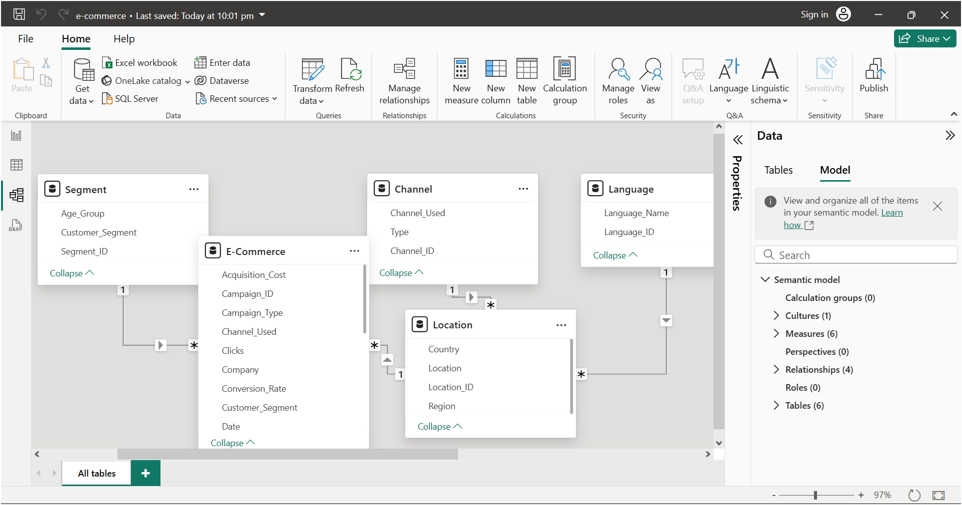

Creating Calculated columns, Measures using DAX Functions

For this Dataset there are some columns are created using DAX functions like

a) CTR = 'E-Commerce'[Clicks] / 'E-Commerce'[Impressions]

Here CTR stands for Click-Through Rate. It’s a key digital marketing metric that shows how often people who see your ad or link actually

b)Costperacquisition= SUM('E-Commerce'[Acquisition_Cost])/COUNT ('E- Commerce'[Campaign_ID])

Cost Per Click (CPC) is a digital marketing metric that tells you how much you're payingfor each individual click on your ad or campaign.

**DAX Functions** used for this data are:

* Total Revenue = Sum('E-Commerce'[Revenue])
* Conversion_Rate%=DIVIDE(SUM('E-Commerce'[Conversion_Rate]),COUNT('E-Commerce'[Campaign_ID]))
* Average of ROI = AVERAGE('E-Commerce'[ROI])
* Conversion_Rate%=DIVIDE(SUM('E-Commerce'[Conversion_Rate]),COUNT('E-Commerce'[Campaign_ID]))

Visualize Data:

For visualization there are some of the charts and graphs which are given below based on the dataset

**1.** Which campaign had the **highest ROI**

For this stacked column chart can be used for that drag

Compaign_type to X-axis

Sum of ROI to Y-axis. Then the tallest column is the Campaign with the **highest ROI.**

**2.** Which campaign generated the **most revenue**

For this Tree Map can be used for that drag

Campaign_id

Revenue to values

Campaign_type to Details. The bigger the rectangle, the **higher revenue.**

**3.**What is the **average conversion rate** across all campaigns

For this card visual can be used for that drag

Use the **Average Conversion Rate (%)** measure

**4**.Is there a relationship between **Clicks and Revenue**

For this Scatter chart can be used for that drag

Clicks to X-axis

Revenue to Y-axis

Campaign _ id to details.

Channel_type to Legend. Based on the scatter chart, there is a moderate positiverelationship between Clicks and Revenue. Campaigns with more clicks generally tend to generate higher revenue.

**5.**How does **Engagement Score impact Conversion Rate**

For this Scatter chart can be used for that drag

Date to X-axis

Engagement_Score and Conversion Rate to Y-axis as two separate this shows how they rise and fall together or not over time.

**6.** Which **Channel_Used** had the **best performance** in terms of ROI

For this bar chart can be used for that drag

Channel_used to Axis

ROI to values the channel with the best performance in terms of ROI is **[e.g., social media]**, achieving an average ROI

7. What is the **conversion rate by channel**

For this Clustered Column Chart can be used for that drag

Channel_used to Axis

Conversion rate to Values. The channel with the highest conversion rate is **[e.g., Email]**, with a rate of **4.17%**, followed by **[e.g., google Ads]** with **4.07%**, etc.

8. Which channels are **most cost-effective** in terms of acquisition

For this Bar Chart can be used for that drag

Channel_Used to Axis

CPA (Cost per Acquisition) to values. The most cost-effective channel is **Email**, with a **Cost per Acquisition.**

**9.** Which **Target_Audience** segment converts the most

For this Pie Chart can be used for that drag

Target_Audience to Legend

Conversion Rate% to Values. This shows the Target_Audience which are women (25-34) followed by men (25-34).

**10.** How does campaign performance vary by **Customer_Segment**

For this line chart can be used for that drag

Date on Axis

Customer_segment on Legend

Clicks on Values. This will show the comparison based on the month.

**11.** Do certain **locations** perform better in terms of revenue

For this Map chart can be used for that drag

Location to location

Revenue to values. Shows revenue distribution geographically.

**12.** Which campaigns had the **highest acquisition cost**, and were they worth it

For this scatter chart can be used for that drag

Acquisition_cost to X-axis

ROI to y-axis

Conversion_rate to size

Campaign_type to Legend. Helps spot high-cost, high-return vs. high-cost, low-return campaigns.

**13**. Are shorter or longer **campaign durations** more profitable

For this Area chart can be used for that drag

Duration to Axis

Average of ROI to Values. Shows a **trend** between duration and performance.

**14.** Are there any **seasonal trends** in campaign success.

For this waterfall chart can be used for that drag

Conversion_Rate to Axis

Date to Category. Campaigns tend to perform better in **Q4**, particularly in November andDecember, suggesting a strong impact from holiday season promotions. In contrast, July and August show lower engagement, possibly due to summer holidays.

**Share insights:**

Using Power BI’s share capabilities to distribute dashboards



|  |
| --- |
|  |

|  |  |
| --- | --- |
|  |  |
|  |  |
|  |  |

|  |  |
| --- | --- |
|  |  |
|  |  |
|  |  |