A Major Project Phase II Report On

CALORIE ESTIMATION OF FOOD AND BEVERAGES USING DEEP LEARNING

Submitted to

JAWAHARLAL NEHRU TECHNOLOGICAL UNIVERSITY, HYDERABAD

Submitted in partial fulfillment of requirements for the award of the degree of

BACHELOR OF TECHNOLOGY
in

COMPUTER SCIENCE AND ENGINEERING

Submitted by

M AKHILA 226P1A0593

Under the guidance of

Mrs P. Shobha Rani
Assistant professor, Department of CSE



DEPARTMENT OF COMPUTER SCIENCE AND ENGINEERING
2022-2026


DEPARTMENT OF COMPUTER SCIENCE AND ENGINEERING



CERTIFICATE
This is to certify that the project entitled “CALORIE ESTIMATION OF FOOD AND BEVERAGES USING DEEP LEARNING” being submitted by

M AKHILA 226P1A0593
In partial fulfillment of the award of degree of Bachelor of Technology in Computer Science and Engineering at Rishi MS Institute of Engineering & Technology for women, affiliated to the Jawaharlal Nehru Technological University, Hyderabad during the year 2025-2026. It is a record of bonafied piece of work, undertaken by the supervision of the undersigned.

INTERNAL GUIDE HEAD OF THE DEPARTMENT
Mrs. P. Shobha Rani , MTech Dr. Archana Baburao Patil, B.Tech, M.Tech, Ph.D
Assistant Professor Associate Professor & HOD
Department of CSE Department of CSE

Submitted for Viva Voice Examination held on

External Examiner

ACKNOWLEDGEMENT

This report will certainly not be completed without the acknowledgements paid to all those what have helped us in doing our Major Project work.

I would like to express our sincere thanks to our Secretary Ms. Rajasree & Academic Director Mrs. Madhavi latha for their constant supervision and encouragement, which helped us in completing this work successfully.

I am expressing my sincere gratitude to our Principal Dr. SK Altaf Hussain Basha For his timely suggestions, which helped us to complete this work successfully.

It's my privilege to thank Dr. Archana Baburao Patil, Head of the Department for her encouragement during the progress of this work.

I derive a great pleasure in expressing our sincere gratitude to our Project Co- Ordinator Dr. K. Ramakrishna & Ms. Gowri for their encouragement and timely suggestions during the progress of this work.

I express my sincere thanks to our Guide Mrs P. Shobha Rani, for giving us moral support, kind attention and valuable guidance to us throughout this work.

I am thankful to our Rishi MS Institute of Engineering and Technology for Women for providing the required facilities during the Major Project work.

I would like to thank our parents and our friends for being supportive all the time, and we are very much obliged to them.

M AKHILA 226P1A0593



Vision & Mission of the Institution

VISION
- To be a center of excellence in producing women engineers and scientists who are professionally competent social leaders to face multi-disciplinary global environment by imparting quality technical education, values and ethics through innovation methods of teaching and learning.

MISSION
- To promote women technocrats capable enough to resolve the problems faced by the society using the knowledge imparted.

- To prepare self-reliant women engineers for technological growth of the nation and society by laying strong theoretical foundation accompanied by wide practical training.

- To equip the young women with creative thinking capabilities and empowering them towards innovation.



B. Tech CSE – Major Project
Course Outcomes (COs)

CO | Course Outcome Description
CO1 | Identify and analyze a real-world problem and define project objectives and scope.
CO2 | Apply engineering knowledge and modern tools to design an appropriate solution.
CO3 | Implement the designed solution using suitable programming languages and technologies.
CO4 | Test, evaluate, and validate the developed system for performance and reliability.
CO5 | Demonstrate teamwork, project management, documentation, and effective communication skills.

CO – PO – PSO Mapping Table
(1 – Low, 2 – Medium, 3 – High)

COs \ POs | PO1 | PO2 | PO3 | PO4 | PO5 | PO6 | PO7 | PO8 | PO9 | PO10 | PO11 | PO12 | PSO1 | PSO2
CO1 | 2 | 3 | 2 | – | 2 | – | – | – | 2 | – | 2 | 2 | 2 | –
CO2 | 3 | 2 | 3 | 2 | 3 | – | – | – | 2 | – | 2 | 2 | 3 | 2
CO3 | 3 | 2 | 3 | – | 3 | – | – | – | 2 | – | 2 | 2 | 3 | 3
CO4 | 2 | 2 | 2 | 3 | 2 | – | – | – | 2 | – | 2 | 2 | 2 | 2
CO5 | 2 | 2 | 2 | – | 2 | – | – | 2 | 3 | 2 | 3 | 2 | – | –



COMPUTER SCIENCE AND ENGINEERING

Vision & Mission of the Department

Vision of the Department
To promote center of excellence in sustainable academic environment to impart technical skills and strong research platform to prepare global leaders

Mission of the Department
- To create good academic platform with modern teaching and learning methodologies.
- To enhance leadership qualities with ethics, values and sense of teamwork for professional excellence.
- To inculcate research culture by encouraging projects in advanced technologies through industry interactions.

PROGRAM OUTCOMES(POs)
- Engineering knowledge: Apply the knowledge of mathematics, science, engineering fundamentals, and an engineering specialization to the solution of complex engineering problems.

- Problem analysis: Identify, formulate, reviewer search literature, and analyze complex engineering problems reaching substantiated conclusions using first principles of mathematics, natural sciences, and engineering sciences.

- Design/development of solutions: Design solutions for complex engineering problems and design system components or processes that meet the specified needs with appropriate consideration for the public health and safety, and the cultural, societal, and environmental considerations.

- Conduct investigations of complex problems: Use research-based knowledge and research methods including design of experiments, analysis and interpretation of data, and synthesis of the information to provide valid conclusions.

- Modern tool usage: Create, select, and apply appropriate techniques, resources, and modern engineering and IT tools including prediction and modelling to complex engineering activities with an understanding of the limitations.

- The engineer and society: Apply reasoning informed by the contextual knowledge to assess societal, health, safety, legal and cultural issues and the consequent responsibilities relevant to the professional engineering practice.

- Environment and sustainability: Understand the impact of the professional engineering solutions in societal and environmental contexts,and demonstrate the knowledge of, and need for sustainable development.

- Ethics: Apply ethical principles and commit to professional ethics and responsibilities and norms of the engineering practice.

- Individual and teamwork: Function effectively as an individual, and as a member or leader in diverse teams, and in multidisciplinary settings.

- Communication: Communicate effectively on complex engineering activities with the engineering community and with society at large, such as, being able to comprehend and write effective reports and design documentation, make effective presentations, and give and receive clear instructions.

- Project management and finance: Demonstrate knowledge and understanding of the engineering and management principles and apply these to one’s own work, as a member and leader in a team, to manage projects and in multidisciplinary environments.

- Life-long learning: Recognize the need for, and have the preparation and ability to engage in independent and life-long learning in the broadest context of technological change.



Department of Computer Science and Engineering

Program specific outcomes (PSO’s)&Programme Educational objectives (PEO’S)

Program specific outcomes (PSO’s)
PSO 1: Improve the student’s ability to decipher the basic principles and methodology of computer systems. Improve the students’ ability to absorb facts and technical ideas in order to build and develop software.
PSO 2: The capacity to create novel job routes as an entrepreneur using modern computer languages and evolving technologies like SDLC, Python, Machine Learning, Social Networks, Cyber Security, Mobile Apps etc.

Programme Educational objectives (PEO’S)
PEO – 1: Engineering graduates with excellent fundamental and technical skills will have successful careers in industry, meeting the needs of Indian and worldwide firms.
PEO – 2: With determination, development, self-reliance, leadership, morality, and moral principles, engineering graduates will become successful entrepreneurs who will leverage employability.
PEO – 3: To support personal and organizational progress, engineering graduates will pursue higher education and engage in lifelong learning.

CALORIE ESTIMATION
OF FOOD AND
BEVERAGES USING
DEEP LEARNING

TABLE OF CONTENTS

S.NO | CONTENTS | PG.NO
i | Abstract | i
ii | List of Figures | ii
iii | List of Acronyms | iii
1. | INTRODUCTION  1.1 Problem Statement  1.2 Scope of research  1.3 Existing System  1.3.1 Disadvantages of existing system  1.4 Proposed System  1.4.1 Advantages of proposed system  1.5 Organization of the report | 1 - 11
2. | LITERATURE REVIEW | 12 - 14
3. | METHODOLOGIES  3.1 System Architecture  3.2 Algorithms | 15 - 20
4. | SOFTWARE REQUIREMENTS SPECIFICATIONS  4.1 Functional Requirements  4.2 Performance Requirements  4.3 Software Requirements  4.4 Hardware Requirements  4.5 Languages/Technologies Used | 21 - 26
5. | SYSTEM DESIGN  5.1 Introduction To UML  5.2 UML diagrams  5.2.1 Use-Case Diagram  5.2.2 Sequence Diagram  5.2.3 Activity Diagram  5.2.2 Class Diagram  5.2.5 Data flow Diagram | 27 - 36
6. | IMPLEMENTATION  6.1 Code | 37 - 43
7. | TESTING  7.1 System Testing  7.2 Types of testing  7.2.1 Unit Testing  7.2.2 Integration Testing  7.2.3 Black Box Testing  7.2.4 White Box Testing  7.3 Test Cases | 44 - 47
8. | RESULTS | 48 - 51
9. | CONCLUSION | 52 - 53
10. | FUTURE ENHANCEMENT | 54 - 56
11. | REFERENCES | 57

ABSTRACT

The project titled “Calorie Estimation of Food and Beverages Using Deep Learning” focuses on developing an intelligent, automated, and user-friendly system to enhance dietary monitoring and promote healthier lifestyle choices. The primary objective of this work is to eliminate the need for manual calorie calculation by leveraging deep learning techniques to accurately recognize food items and estimate their nutritional content in real time. The system is implemented using the Python programming language and is built on the MobileNet architecture, a lightweight and computationally efficient convolutional neural network well-suited for image classification tasks, especially in resource-constrained environments. The model is trained on a diverse dataset of food and beverage images to ensure accurate classification across multiple categories. When a user uploads an image through the web-based application, the system performs preprocessing, feature extraction, and classification to identify the food item, followed by mapping it to a predefined nutritional database to estimate calorie values. The application is designed with a responsive and intuitive interface, allowing users to seamlessly upload images and receive instant feedback within seconds. Additionally, the system can be extended to include features such as portion size estimation, multi-food detection, and personalized diet recommendations based on user profiles and health goals. By providing real-time insights into calorie intake, the system enables users to track their eating habits, analyze consumption patterns, and make informed dietary decisions. Overall, this project demonstrates the effective integration of deep learning, computer vision, and web technologies to create a scalable and accessible solution for smart nutrition management, thereby contributing to improved health awareness and preventive healthcare practices.

LIST OF FIGURES

FIG NO | FIGURE NAME | PG NO
3.1 | System Architecture | 15
5.2.1 | Use Case Diagram | 29
5.2.2 | Sequence Diagram | 31
5.2.3 | Activity Diagram | 32
5.2.4 | Class Diagram | 34
5.2.5 | Data Flow Diagram | 36
8.1 | Home Page | 49
8.2 | Image Upload Page | 49
8.3 | Result Page | 50

LIST OF ACRONYMS

S.NO | ACRONYM | FULL FORM
1 | AI | Artificial Intelligence
2 | ML | Machine Learning
3 | CNN | Convolutional Neural  Network
4 | DL | Deep Learning
5 | API | Application Programming  Interface
6 | UI | User Interface
7 | DB | Database
8 | GPU | Graphics Processing Unit
9 | CPU | Central Processing Unit
10 | SQL | Structured Query  Language
11 | HTTP | HyperText Transfer  Protocol
12 | JSON | JavaScript Object Notation

CHAPTER 1

INTRODUCTION

The rapid evolution of technology, particularly in the domains of Artificial Intelligence (AI) and Machine Learning (ML), has brought about transformative changes in numerous aspects of everyday life. From healthcare and fitness tracking to personalized recommendations and smart monitoring systems, these technologies have enabled more efficient, accurate, and user-friendly solutions. One of the most impactful applications of AI and ML is in the field of food recognition and calorie estimation, which plays a crucial role in helping individuals maintain a balanced and healthy lifestyle.
The project titled “Calorie Estimation of Food and Beverages using Deep Learning” focuses on developing an intelligent and automated system capable of identifying food items from images and estimating their nutritional values. The primary objective of this system is to assist users in understanding their dietary intake by providing detailed information such as calorie count, protein content, fats, carbohydrates, calcium, and essential vitamins. This eliminates the need for manual tracking and calculation, which can often be time-consuming and inaccurate.
At the core of this system lies a deep learning model, specifically a Convolutional Neural Network (CNN), which is trained on a large dataset of food images. CNNs are highly effective in image classification tasks due to their ability to automatically learn spatial hierarchies of features such as edges, textures, and shapes. By training the model on diverse food categories, the system can accurately recognize various types of food items from uploaded images. Once the image is processed, the model predicts the food category, which is then mapped to a structured nutritional database containing detailed information about that particular food.
The application is developed using the Flask web framework, which provides a lightweight and efficient backend for handling user requests. The user interface is designed to be simple and intuitive, allowing users to easily upload images of their meals. Upon uploading, the backend processes the image, performs classification using the trained CNN model, and retrieves the corresponding nutritional details. The results are then displayed in a clear and organized format, making it easy for users to understand their food intake.
This system offers numerous benefits across different user groups. Fitness enthusiasts can use it to track their daily calorie consumption and maintain their workout goals. Individuals following specific dietary plans, such as weight loss or medical diets, can monitor their nutrient intake more effectively. In healthcare settings, this tool can assist doctors and dieticians in analyzing patient diets and recommending appropriate nutritional plans. Additionally, nutritionists and diet planners can leverage this system for quick and automated analysis of food composition, saving time and improving accuracy.
Beyond individual use, the project also contributes to promoting awareness about healthy eating habits. By making nutritional information readily accessible, users are encouraged to make informed dietary choices. The system bridges the gap between advanced technology and practical daily use, making health monitoring more convenient and engaging. Furthermore, the system can be enhanced by incorporating advanced features to improve accuracy, usability, and scalability. One such improvement is the integration of portion size estimation, which plays a crucial role in determining precise calorie values. By using techniques such as depth sensing, reference objects, or multiple image inputs, the system can estimate the quantity of food more accurately rather than relying on standard assumptions.
Another potential enhancement is the inclusion of real-time food recognition using mobile cameras. This would allow users to instantly analyze their meals without the need to manually upload images, making the application more interactive and convenient. Integration with mobile applications can further expand accessibility, enabling users to track their daily intake on the go and maintain a continuous log of their eating habits.
The system can also be extended by incorporating personalized recommendations based on user profiles. By analyzing user data such as age, weight, fitness goals, and medical conditions, the application can suggest suitable dietary plans and healthier alternatives. This adds a layer of intelligence to the system, transforming it from a simple recognition tool into a comprehensive dietary assistant.
In addition, the use of Natural Language Processing (NLP) can enable users to input food items through text or voice commands.
In conclusion, this project demonstrates the powerful integration of deep learning techniques and web technologies to create a real-world application that supports smart dietary management. It highlights how AI-driven solutions can simplify complex tasks such as food recognition and nutritional analysis, ultimately contributing to healthier lifestyles and improved well-being.

1.1 PROBLEM STATEMENT
In the modern era, rapid urbanization and busy lifestyles have significantly influenced dietary habits, leading to an increased dependence on processed, fast, and convenience foods. As a result, there has been a noticeable rise in health-related issues such as obesity, diabetes, cardiovascular diseases, and nutritional deficiencies. Maintaining a balanced diet requires individuals to have a clear understanding of the nutritional content of the food they consume, including calorie intake and essential nutrients such as proteins, fats, carbohydrates, vitamins, and minerals. However, most people lack the knowledge, time, or motivation to accurately track and analyze their daily food consumption.
Existing methods for calorie estimation and dietary tracking are largely manual and inefficient. Users are typically required to enter food items, estimate portion sizes, and calculate nutritional values using predefined databases. This process is not only time-consuming but also highly prone to inaccuracies due to incorrect estimations and incomplete information. Moreover, many current applications provide limited functionality, often focusing only on calorie counting without offering a comprehensive nutritional breakdown or intelligent insights. These limitations reduce user engagement and hinder the effectiveness of such systems in promoting healthy eating habits.
Another major challenge lies in the diversity and complexity of food items. Variations in cooking styles, ingredients, presentation, and portion sizes make it difficult to accurately identify and analyze food using traditional methods. Mixed dishes and visually similar food items further complicate the process, requiring more advanced and intelligent solutions. Additionally, in many real-world scenarios, users may not have the time or willingness to manually input food details, creating a demand for automated systems that minimize user effort while maximizing accuracy.
With the advancements in Artificial Intelligence, particularly in Deep Learning and Computer Vision, it has become possible to develop systems that can automatically recognize objects from images with high precision. Convolutional Neural Networks (CNNs), in particular, have demonstrated remarkable performance in image classification tasks. Leveraging these technologies, it is feasible to build a system that can analyze images of food and beverages, identify the type of food, and estimate its nutritional content based on a structured dataset.
Therefore, the core problem addressed in this project is the lack of an efficient, accurate, and automated solution for food recognition and nutritional analysis. The aim is to design and develop a deep learning-based system that can take an image of food as input, accurately classify the food item, and provide detailed nutritional information including calories, proteins, fats, carbohydrates, and other essential nutrients. The system should minimize manual intervention, reduce estimation errors, and provide a seamless user experience.
Furthermore, the solution must be scalable, user-friendly, and adaptable to different types of cuisines and dietary patterns. It should be capable of assisting a wide range of users, including fitness enthusiasts, individuals managing specific diets, healthcare professionals, and nutritionists. By addressing these challenges, the proposed system seeks to bridge the gap between technology and daily health management, enabling users to make informed dietary choices and adopt healthier lifestyles.
In conclusion, the problem revolves around overcoming the inefficiencies of traditional calorie tracking methods by introducing an intelligent, automated, and reliable system that leverages deep learning for food recognition and nutritional estimation, ultimately contributing to improved health awareness and better dietary management.

1.1 SCOPE OF RESEARCH
The scope of this research is centered on the design, development, and implementation of an intelligent and automated system for food recognition and calorie estimation using advanced deep learning techniques. The primary focus is on leveraging Convolutional Neural Networks (CNNs) to analyze food images and accurately classify different types of food and beverages. This research explores how computer vision and machine learning can be effectively utilized to solve real-world problems related to dietary monitoring and nutritional awareness.
The system involves training a deep learning model on a comprehensive dataset of food images that represent a wide variety of food categories. The dataset includes diverse samples with variations in lighting conditions, angles, backgrounds, and presentation styles to improve the robustness and generalization capability of the model. Once trained, the model is capable of identifying food items from user-uploaded images with a high degree of accuracy.
In addition to classification, the research extends to nutritional analysis by mapping the predicted food item to a structured nutritional database. This database contains detailed information about various nutrients such as calories, proteins, fats, carbohydrates, vitamins, and minerals. The system retrieves and presents this information in an organized manner, enabling users to understand the nutritional value of their food quickly and efficiently.
The application layer of this research is developed using the Flask web framework, which facilitates seamless interaction between the user and the backend model. The web interface is designed to be simple, intuitive, and accessible, allowing users to upload images and receive instant results. This integration demonstrates how deep learning models can be deployed in real-world applications to provide practical solutions.
The scope also includes the evaluation of the model’s performance using various metrics such as accuracy, precision, recall, and loss. This helps in understanding the effectiveness of the model and identifying areas for improvement. The research further explores techniques for optimizing model performance, such as data augmentation, hyperparameter tuning, and regularization.
Moreover, the project has significant potential for expansion and future enhancements. One important extension is increasing the number and diversity of food categories, including regional and international cuisines, to make the system more versatile and globally applicable. The use of advanced deep learning techniques such as transfer learning with pre-trained models like ResNet, MobileNet, or EfficientNet can further improve classification accuracy and reduce training time.
Another important area within the scope is the integration of real-time image capture through mobile devices or camera systems. This would enable users to instantly analyze their meals without manual uploads, enhancing usability and user engagement.

1.2 EXISTING SYSTEM
The existing systems for calorie estimation and food monitoring are mostly based on manual input methods, where users are required to enter the name or quantity of food items to calculate their nutritional values. Many mobile applications and websites provide calorie tracking features, but they rely heavily on user knowledge and accurate data entry, which can be time consuming and prone to errors. Users often struggle to correctly identify portion sizes or ingredients, leading to inaccurate nutritional estimations and reduced reliability of the results.
Some advanced systems use basic image recognition techniques; however, they often lack accuracy and are limited to a small set of food categories. These systems may not perform well under real-world conditions where images vary in lighting, angle, background, and presentation. They also face difficulties in identifying complex or mixed dishes, where multiple ingredients are combined, making it challenging to provide precise nutritional analysis.
Additionally, many existing solutions depend on constant internet connectivity and centralized databases for processing and retrieving information. This reliance can result in slower response times, increased latency, and reduced accessibility in areas with limited or unstable internet connections. Furthermore, such systems may raise concerns regarding data privacy and security, as user data and food images are often stored and processed on external servers.
Another limitation is the lack of personalization in most current applications. They typically provide generic nutritional information without considering individual user needs such as age, weight, health conditions, dietary preferences, or fitness goals. As a result, users do not receive tailored recommendations that could help them make more informed and effective dietary decisions.
Moreover, many existing systems do not offer a comprehensive breakdown of nutrients. While calorie counting is commonly available, detailed information about micronutrients such as vitamins and minerals is often missing or insufficient. This limits the system’s usefulness, especially for individuals who require specific nutritional monitoring, such as patients, athletes, or people following specialized diets.
User experience is another area where current systems fall short. Complex interfaces, excessive manual steps, and lack of automation reduce user engagement and make it difficult for individuals to consistently track their dietary habits. Without ease of use and quick results, users are less likely to adopt these systems in their daily routines.

1.2.1 DISADVANTAGES OF EXISTING SYSTEM

Manual Input Dependency
Most systems require users to manually enter food details, which is time-consuming and inconvenient.
Prone to Human Errors
Incorrect data entry or estimation can lead to inaccurate calorie and nutrition calculations.

Limited Accuracy in Food Recognition
Existing image-based systems often fail to correctly identify food items, especially complex or mixed dishes.

Restricted Food Categories
Many applications support only a limited number of food items, reducing their usefulness in real-life scenarios.
Time-Consuming Process
Users need to search and select food items manually, which is not efficient for daily use.

Restricted Food Categories
Many applications support only a limited number of food items, reducing their usefulness in real-life scenarios.
Time-Consuming Process
Users need to search and select food items manually, which is not efficient for daily use.

1.3 PROPOSED SYSTEM
The proposed system aims to develop an intelligent, automated, and efficient solution for food recognition and calorie estimation using advanced deep learning techniques, specifically a Convolutional Neural Network (CNN). The primary goal of this system is to minimize manual effort in dietary tracking while providing accurate and real-time nutritional analysis to users.
In this system, users can upload an image of a food item through a user-friendly and interactive web interface developed using the Flask framework. The interface is designed to be simple and accessible, allowing users with minimal technical knowledge to easily interact with the system. Once the image is uploaded, it is preprocessed to ensure consistency in size, format, and quality before being passed to the trained CNN model.
The CNN model, trained on a diverse dataset of food images, analyzes the input image and extracts important visual features such as shape, color, texture, and patterns. Based on these features, the model classifies the food item into a predefined category with high accuracy. The use of deep learning enables the system to handle variations in image conditions such as lighting, background, and orientation, making it robust and reliable in real-world scenarios.
After the food item is successfully identified, the system maps the predicted class to a structured nutritional database. This database contains comprehensive information about various nutrients, including calories, proteins, fats, carbohydrates, vitamins, and minerals. The system retrieves the relevant data and presents it to the user in a clear and organized format. Additionally, the prediction confidence score is displayed, giving users an indication of the reliability of the classification result.
Furthermore, the system is designed with scalability and flexibility in mind. It can be easily extended to include a larger number of food categories and more detailed nutritional information. Advanced techniques such as transfer learning can be incorporated to enhance model performance and reduce training time. The architecture also allows integration with mobile applications, enabling users to access the system anytime and anywhere.

1.3.1 ADVANTAGES OF PROPOSED SYSTEM

Automated Food Recognition
The system automatically identifies food items from images without requiring manual input. High Accuracy
Uses deep learning (CNN) to improve the accuracy of food classification and prediction.
Time Efficient
Provides instant results, saving time compared to manual calorie calculation methods.
User-Friendly Interface
Simple and easy-to-use web application built with Flask for smooth user interaction.
Real-Time Analysis
Quickly processes uploaded images and displays results immediately.

Nutritional Awareness
Provides detailed information such as calories, proteins, fats, carbohydrates, vitamins, and minerals.
Supports Healthy Lifestyle
Helps users track their diet and make better food choices.
Practical Real-World Application
Useful in healthcare, fitness tracking, and diet management systems.

1.4 ORGANIZATION OF THE REPORT

Chapter 1: Introduction
This chapter provides a comprehensive overview of the project titled “Calorie Estimation of Food and Beverages using Deep Learning.” It introduces the concept of Artificial Intelligence and Machine Learning in the domain of healthcare and nutrition. The chapter explains the growing need for automated food recognition systems due to increasing health awareness and busy lifestyles. It includes the background of the problem, motivation behind selecting this project, and clearly defines the problem statement. Additionally, it outlines the objectives and scope of the project, giving a clear understanding of what the system aims to achieve and its importance in real-world applications.

Chapter 2: Literature Survey / Existing System
This chapter presents a detailed review of existing research works and systems related to food recognition and calorie estimation. It discusses various approaches used by earlier researchers, such as traditional image processing techniques and basic machine learning models. The chapter highlights the working principles, advantages, and limitations of these systems. It also analyses current applications that rely on manual input or limited datasets. By identifying gaps in existing solutions, this chapter justifies the need for a more efficient and automated system based on deep learning techniques.

Chapter 3: Proposed System / Methodology
This chapter describes the proposed system in detail, focusing on the methodology used to solve the problem. It explains how a Convolutional Neural Network (CNN) is used for image classification and feature extraction. The chapter includes system architecture, data flow, and working process of the model. It describes how input images are pre-processed, passed through the CNN model, and classified into food categories. It also explains how nutritional information is retrieved from a dataset and displayed to the user. This chapter provides a clear step-by-step workflow of the system.

Chapter 4: System Implementation
This chapter explains the practical implementation of the proposed system. It describes the tools and technologies used, including Python programming language, TensorFlow/Keras for
deep learning, and Flask for web development. The chapter explains the structure of the project, including files such as app.py, model file (.h5), templates, and static folders. It also discusses how the model is loaded, how images are processed, and how predictions are generated. Screenshots of the application and code snippets may also be included for better understanding.

Chapter 5: Results and Evaluation
This chapter presents the results obtained from the system after implementation. It includes sample outputs of food image predictions along with confidence levels and nutritional values. The performance of the model is evaluated based on accuracy and prediction efficiency. The chapter may also include comparisons between expected and predicted results, highlighting the effectiveness of the system. Graphs, tables, or screenshots can be used to visually represent the results and improve clarity.

Chapter 6: Advantages, Applications, and Discussion
This chapter discusses the key advantages of the proposed system, such as automation, accuracy, and time efficiency. It explains various real-world applications, including healthcare, fitness tracking, diet management, and smart nutrition systems. The chapter also provides a discussion on system performance, challenges faced during development, and limitations such as dependency on dataset quality and restricted food categories. This section helps in critically analysing the system.

Chapter 7: Conclusion and Future Scope
This chapter concludes the project by summarizing the overall work and achievements. It highlights how the proposed system successfully addresses the problem of food recognition and calorie estimation using deep learning. The chapter also suggests future enhancements, such as increasing the dataset size, improving model accuracy using advanced techniques like transfer learning, and developing mobile applications for better accessibility.

CHAPTER 2

LITERATURE SURVEY
1.Authors: Ms. Priya A, Rohit Kumar S, Aswin S

Title: Food Classification & Calorie Estimation Using Deep Learning with InceptionV3 (2025)

Summary: Using the InceptionV3 architecture, this work presents a sophisticated system for food classification and calorie estimate that makes use of deep learning techniques to produce precise predictions. The system efficiently detects food items and calculates their caloric content by combining transfer learning, data augmentation, and a regression-based calorie prediction mechanism. The incorporation of sophisticated visualizations improves the model's interpretability and guarantees that its predictions are accurate.

2.Authors: Matthew Keller, Chi-en Amy Tai, Yuhao Chen, Pengcheng Xi, Alexander Wong

Title: Food Classification & Calorie Estimation Using Deep Learning with InceptionV3 (2025)

Summary: A vision transformer-based model designed to directly predict a meal’s nutritional content—including calories, mass, proteins, fats, and carbohydrates—from a single image. It uses multitask deep learning with multiple regression heads, reporting improved performance versus classic CNN baselines.

3.Authors: J. Panneerselvam, Asst. Prof. Mrs. K. Vasumathi Asst. Prof., Dr. S. Selva kani

Title: Food calorie estimation using deep learning (2024)

Summary: Food recognition and calorie estimation represent pivotal endeavors within the realms of computer vision and healthcare, holding substantial ramifications for dietary surveillance, weight regulation, and medical care. Recent strides in deep learning, notably leveraging convolutional neural networks, have yielded encouraging outcomes in precisely discerning food categories and gauging their caloric value based on images.

4.Authors: Naman Chauhan, Revathy S, Murali P

Title: Deep Learning-Based Approach for Calorie Estimation in Indian Food (2024)

Summary: People in the modern era are increasingly concerned with their diet and food choices to prevent developing chronic diseases like high blood pressure and diabetes. With the increasing usage of smartphones and technology, an application to automatically monitor their diet would be a great boon, especially for the younger generation. This research work investigates the process of estimating the calories present in the food images.

5.Authors: Kalivaraprasad B, Prasad M.V.D, Naveen kishore Gattim

Title: Deep Learning-based Food Calorie Estimation Method in Dietary Assessment (2024)

Summary: This study proposes an automated approach for dietary assessment using CNNs for food classification and portion estimation. The model learns food categories from thousands of images and uses reference objects to estimate portions. Caloric values are derived by matching identified food and portions with nutrition databases. The authors note this approach can significantly reduce manual effort in nutritional assessment while highlighting future areas for improvement.

6.Authors: Siddesh KT, Kotru Swamy

Title: Calorie estimation of food and beverages (2024)

Summary: This study deals with the important need for precise calorie estimations in today's fast-paced, health-conscious world, where existing measurement methods frequently fall short due to human error and approximation.

7.Authors: Takumi Ege, Keiji Yanai
Title: Image-Based Food Calorie Estimation Using Knowledge on Food Categories,

Ingredients and Cooking Directions (2017)

Summary: Proposes a multi-task CNN that jointly learns food calories, categories, ingredients, and cooking directions from images. The multi-task learning framework boosts performance for both calorie prediction and food classification compared to single-task learning. Two annotated datasets (Japanese and American recipes) are introduced for training and evaluation.

8.Authors: Y. Kawano, K. Yanai
Title: Food Image Recognition Using Deep Convolutional Neural Networks (2016)

Summary: This study focuses on recognizing food items using CNN models. It demonstrates that deep learning techniques can effectively classify food images and can be integrated with nutritional databases to estimate calorie values accurately.

CHAPTER 3

METHODOLOGIES

3.1 SYSTEM ARCHITECTURE:
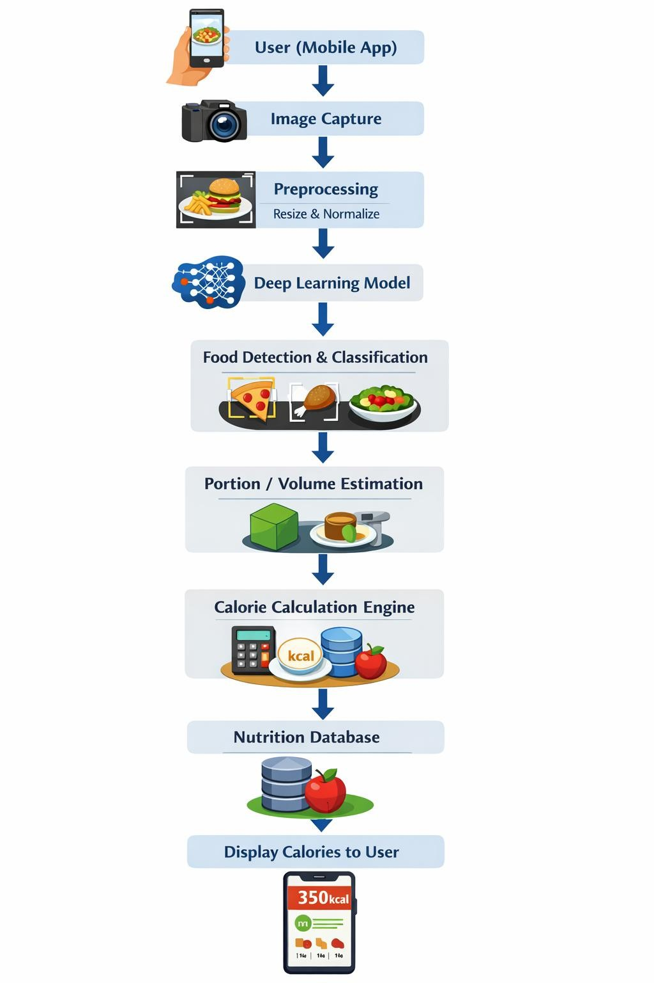

Fig 3.1 System Architecture

1. User (Mobile Application)
The entire process begins with the user interacting with the mobile application, which serves as the primary interface between the user and the system. The application is designed to be simple, intuitive, and user-friendly so that individuals of all technical backgrounds can use it. The user can either capture a new image of the food item using the device camera or select an existing image from the gallery. This flexibility ensures convenience and encourages regular usage. The selected image acts as the input to the system, initiating the food recognition and calorie estimation process.

2. Image Capture
In this stage, the image of the food item is obtained using the mobile device’s camera or through image upload functionality. The quality of the captured image plays a significant role in the accuracy of the system.
Users are encouraged to capture clear images with proper lighting and minimal background clutter. Once captured or selected, the image is transmitted to the backend processing module.
This step acts as the bridge between user input and system analysis.

3. Preprocessing
Before feeding the image into the deep learning model, it undergoes several preprocessing steps to ensure consistency and improve prediction accuracy.
The image is resized to a fixed resolution (commonly 224×224 pixels), which matches the input requirements of most CNN models. Pixel normalization is performed to scale the values into a standard range, which helps in faster and more stable model training and inference. Additional preprocessing techniques such as noise reduction, background filtering, and contrast adjustment may also be applied to remove irrelevant details and enhance important features.

4. Deep Learning Model
The pre-processed image is then passed into a trained deep learning model, typically a
Convolutional Neural Network (CNN). This model forms the core intelligence of the system. The CNN consists of multiple layers that automatically learn and extract meaningful features from the image. Early layers detect basic features like edges and textures, while deeper layers identify complex patterns such as shapes and object structures.
The model has been trained on a large dataset of food images, enabling it to recognize various food items accurately. This stage transforms raw image data into meaningful representations that can be used for classification.

5. Food Detection and Classification
Once features are extracted, the system proceeds to identify and classify the food item present in the image. The model compares the extracted features with learned patterns and assigns the image to one of the predefined food categories.
Examples of categories include pizza, burger, fruits, beverages, rice dishes, and more. The output is typically a probability score for each class, and the class with the highest probability is selected as the final prediction.
In more advanced implementations, object detection techniques can be used to identify multiple food items within a single image. This is particularly useful for complex meals containing multiple components.

6. Portion / Volume Estimation
After identifying the food item, the system estimates the portion size or quantity, which is essential for accurate calorie calculation.
This step uses computer vision techniques to analyze the size of the food item in the image. Methods include comparing the food object with known reference objects (such as a plate or spoon), estimating the area in pixels, or using geometric calculations to approximate volume. In some advanced systems, depth estimation techniques or multiple images can be used to improve accuracy.

7. Calorie Calculation Engine
The calorie calculation engine is responsible for computing the total calorie content of the identified food item. This calculation is based on both the type of food and the estimated portion size.

The formula used is:

Calories = Calories per unit × Portion size
For example, if a food item contains 100 kcal per 100 grams and the estimated portion is 200 grams, the total calorie value will be 200 kcal. This module ensures accurate and real-time computation of nutritional values.

8. Nutrition Database
The system relies on a structured nutrition database to retrieve accurate information about different food items. This database contains detailed nutritional profiles, including calorie values and macronutrients such as carbohydrates, proteins, and fats.
The database can be stored locally or accessed through cloud-based platforms. It is designed to be scalable, allowing the addition of more food items and updated nutritional data over time. This ensures that the system remains reliable and up-to-date.

9. Display Calories to User
Finally, the computed results are presented to the user through the mobile application interface. The output is displayed in a clear and organized manner to ensure easy understanding.
The results typically include:
- Name of the identified food item
- Estimated calorie value (e.g., 350 kcal)
- Nutritional breakdown (carbohydrates, proteins, fats, etc.)
- Prediction confidence score (optional)
Additional features such as visual charts, daily tracking, and recommendations can further enhance user experience. This final step completes the process by providing meaningful insights that help users make informed dietary decisions.

3.2 Algorithm :

Step1 : Image Acquisition (Mobile Application – Android/iOS, Camera API)
The process begins with the user providing an input image. The image is either captured using the mobile device camera or selected from the device gallery. The application interface facilitates this interaction using platform-specific tools such as Android or iOS development frameworks and camera APIs.

Step 2: Image Preprocessing (Python, OpenCV, NumPy)
The acquired image undergoes preprocessing to ensure it is suitable for analysis. This involves resizing the image to a fixed resolution, normalizing pixel values, and removing noise or distortions. Additional transformations such as cropping and scaling may be applied. These operations are performed using image processing libraries to enhance model performance and consistency.

Step 3: Model Initialization (TensorFlow / Keras / PyTorch)
A pre-trained deep learning model is loaded into the system. This model, typically developed using frameworks such as TensorFlow, Keras, or PyTorch, contains learned weights and architecture optimized for image recognition tasks. The model is prepared to accept the preprocessed image as input.

Step 4: Feature Extraction (Convolutional Neural Networks)
The pre-processed image is passed through the convolutional layers of the neural network. During this stage, the system automatically extracts relevant visual features such as edges, textures, shapes, and colour patterns. These features form a meaningful representation of the image, enabling accurate classification.

Step 5: Food Detection and Classification (Deep Learning and Computer Vision)
Using the extracted features, the model identifies and classifies the food item present in the image. The classification layer assigns the image to one of the predefined food categories. In cases where multiple food items are present, object detection techniques may be employed to identify and classify each item individually.

Step 6: Portion Size Estimation (Computer Vision Techniques)
After identifying the food item, the system estimates the portion size. This is achieved by analysing the dimensions and area of the food object in the image. Techniques such as reference object comparison, geometric analysis, or depth estimation may be used to approximate the quantity or volume of the food.

Step 7: Nutritional Data Retrieval (Database Systems – SQL/Firebase)
The identified food item is used to query a nutritional database. The database contains information such as calories per unit weight or volume for various food items. The system retrieves the relevant nutritional values required for calorie computation.

Step 8: Calorie Calculation (Backend Processing – Python)
The total calorie content is computed by combining the portion size with the nutritional information obtained from the database. The calculation is based on standard nutritional formulas, ensuring an accurate estimation of calorie intake.

Step 9: Result Presentation (Frontend Interface – Mobile/Web Application)
The final output is presented to the user through the application interface. The results typically include the name of the detected food item, estimated portion size, and total calorie value.
Additional nutritional details may also be displayed for better user understanding.

CHAPTER 4

SOFTWARE REQUIREMENTS SPECIFICATIONS

4.1 FUNCTIONAL REQUIREMENTS
- Image Input Handling – The system shall allow users to capture food images using a camera or upload images from device storage through a user-friendly interface. The system shall provide an efficient and user-friendly interface for capturing or uploading food images. Users can either take a real-time photo using the device camera or select an existing image from the gallery. The interface should be simple and intuitive, allowing users of all technical backgrounds to interact easily with the system. Additionally, the system may include features such as image preview, retake option, and basic guidelines (like proper lighting and angle) to ensure high-quality input images. This module acts as the entry point for the entire process.

- Image Preprocessing – The system shall resize, normalize, and enhance the input image to ensure it is suitable for accurate analysis by the model. The system shall preprocess the input image to make it suitable for analysis by the deep learning model. This includes resizing the image to a standard resolution (e.g., 224×224 pixels), normalizing pixel values, and enhancing image quality. Techniques such as noise reduction, contrast adjustment, and background filtering may be applied to remove unwanted elements and highlight important features. Proper preprocessing ensures consistency in input data and significantly improves the accuracy and performance of the classification model.

- Food Detection and Classification – The system shall identify and classify the food item(s) present in the image using a trained deep learning model. It should support detection of single or multiple food items. The system shall identify and classify the food item(s) present in the image using a trained deep learning model, typically a Convolutional Neural Network (CNN). The model analyzes the input image and predicts the most probable food category based on learned patterns. The system should support both single-item detection and multiple food item detection in more advanced implementations. It may also provide confidence scores for predictions, indicating the reliability of the results. This module is the core component responsible for recognizing food items accurately.

- Feature Extraction – The system shall extract important visual features such as shape, texture, and colour from the image to improve classification accuracy. The system shall extract important visual features from the input image to assist in accurate classification. These features include shape, texture, color, edges, and patterns of the food item. Feature extraction is performed automatically by the deep learning model through its multiple layers. Early layers capture basic visual elements, while deeper layers identify complex structures and relationships. This process transforms raw image data into meaningful representations that improve the model’s ability to distinguish between similar food items.

- Portion Size Estimation – The system shall estimate the quantity or portion size of the detected food using image-based analysis techniques. The system shall estimate the portion size or quantity of the detected food item, which is essential for accurate calorie calculation. This can be achieved using image-based analysis techniques such as pixel area measurement, comparison with known reference objects (like plates or utensils), or geometric estimation methods. In advanced systems, depth estimation or multiple images may be used for better accuracy. Although exact estimation is challenging, even approximate portion size calculation significantly improves the reliability of calorie estimation.

- Calorie Calculation – The system shall retrieve nutritional data from a database and calculate the total calorie content based on the estimated portion size. The system shall calculate the total calorie content of the identified food item using data retrieved from a nutrition database. The calculation is based on the formula:
Calories = Calories per unit × Portion size
The system may also compute additional nutritional values such as proteins, fats, and carbohydrates. This module ensures that users receive accurate and meaningful dietary information based on the detected food and estimated quantity.

- Result Display and Interaction – The system shall display the identified food item, portion size, and calorie estimation clearly, and allow users to view results efficiently. The system shall display the final results in a clear and user-friendly format. The output includes the predicted food name, confidence score, estimated portion size, calorie value, and nutritional details. The interface should present the information in an organized and readable manner, allowing users to quickly understand the results. Additional features such as result history, user feedback, or option to re-analyze images may also be included to enhance user interaction and overall experience.

4.2 PERFORMANCE REQUIREMENTS

- Response Time – The system should process an input image and display results within a few seconds (typically 2–5 seconds.. Fast response time ensures a smooth user experience and encourages regular usage. Efficient model design and optimized backend processing help in reducing delays.
- Accuracy – The model should provide high accuracy in food classification and reasonable precision in calorie estimation. The system should provide high accuracy in identifying food items and reasonable precision in estimating calorie values. The accuracy depends on the quality of the trained model and dataset. Proper training and preprocessing techniques improve the reliability of predictions.
- Scalability – The system should handle multiple users or requests without significant performance degradation. The system should be capable of handling multiple users or requests simultaneously without affecting performance. It should support future expansion, such as adding more food categories or increasing the number of users, without major changes to the system architecture.
- Resource Efficiency – The system should efficiently utilize CPU, GPU, and memory, especially for mobile or real-time usage. The system should be capable of handling multiple users or requests simultaneously without affecting performance. It should support future expansion, such as adding more food categories or increasing the number of users, without major changes to the system architecture.
- Reliability – The system should operate consistently with minimal errors or failures during repeated usage. The system should perform consistently under different conditions and provide stable results with minimal errors. It should handle repeated usage without crashes or failures, ensuring user trust and system dependability.

4.3 SOFTWARE REQUIREMENTS

1. Operating System
- Windows 10/11, Linux (Ubuntu), or macOS
- Android / iOS (for mobile application)

2. Programming Languages
- Python (for backend and model development)
- Java / Kotlin (for Android application)
- Swift (for iOS application)
- HTML, CSS, JavaScript (for web interface, if applicable)

3. Development Tools and Frameworks
- TensorFlow / Keras or PyTorch (for deep learning model development)
- OpenCV (for image processing)
- NumPy and Pandas (for data handling and preprocessing)
- Flask or Django (for backend development and API integration)

4. Database Management System
- MySQL / SQLite (for storing nutritional data)
- Firebase (for real-time database and cloud storage, optional)

5. IDEs and Tools
- Visual Studio Code / PyCharm (for Python development)
- Android Studio (for mobile app development)
- Jupyter Notebook (for model training and experimentation)

6. Libraries and Dependencies
- Scikit-learn (for evaluation and preprocessing support)
- Matplotlib / Seaborn (for visualization)
- TensorFlow Lite (for mobile deployment, optional)

7. Web/Cloud Services (Optional)
- AWS / Google Cloud / Microsoft Azure (for deployment and scalability)
- REST APIs for communication between frontend and backend

4.4 HARDWARE REQUIREMENTS

1. Development System
- Processor: Intel i5 or higher (or equivalent)
- RAM: Minimum 8 GB (16 GB recommended for training models)
- Storage: Minimum 256 GB HDD/SSD (SSD preferred for faster performance)

2. GPU (Optional but Recommended)
- NVIDIA GPU with CUDA support (for faster deep learning training)
- Minimum 4 GB VRAM (higher preferred for large datasets)

3. Mobile Device (for Application Testing)
- Android or iOS smartphone with camera
- Minimum 3 GB RAM recommended
4. Camera
• Built-in mobile camera or external camera for capturing food images

4.5 LANGUAGES AND TECHNOLOGY

- Python – Used for implementing deep learning models, backend processing, and image analysis. Python is the primary programming language used in the implementation of this system due to its simplicity, readability, and extensive support for machine learning and data processing. It is used to develop the backend logic, implement deep learning models, and perform image analysis tasks. Python provides a wide range of libraries and frameworks that simplify complex operations such as data preprocessing, model training, and prediction. Its flexibility allows seamless integration with web frameworks and databases, making it highly suitable for building end-to-end applications like calorie estimation systems.

- TensorFlow / Keras – Used for building and training Convolutional Neural Network (CNN) models for food classification. TensorFlow and Keras are powerful deep learning frameworks used for building and training Convolutional Neural Network (CNN) models. TensorFlow acts as the backend engine, while Keras provides a high-level API that simplifies model design and experimentation. These frameworks are used to train the model on large datasets of food images, enabling it to learn patterns and features required for accurate classification. They support advanced functionalities such as transfer learning, optimization algorithms, and performance tuning, which improve the accuracy and efficiency of the model.
Once trained, the model is deployed for real-time prediction in the application.

- OpenCV & NumPy – Used for image preprocessing, resizing, normalization, and
handling image data. OpenCV and NumPy are used for image preprocessing and numerical computations. OpenCV is a computer vision library that provides tools for handling imagerelated operations such as resizing, filtering, cropping, and color conversion. NumPy is used for efficient array manipulation and mathematical operations on image data. Together, these tools help in preparing the input image before feeding it into the deep learning model. Preprocessing steps such as normalization, noise reduction, and pixel scaling are performed using these libraries, which enhances the model’s prediction accuracy and consistency.

- Flask / Django – Used for backend development and API integration between the model and user interface. Flask and Django are web frameworks used for backend development and integration of different components of the system. Flask is a lightweight framework that is commonly used for building APIs and connecting the frontend with the deep learning model. It handles user requests, processes uploaded images, and returns prediction results. Django, on the other hand, is a full-stack framework that provides built-in features like authentication and database management. These frameworks ensure smooth communication between the user interface, machine learning model, and database, enabling real-time processing and response.

- MySQL / Firebase – Used for storing and retrieving nutritional and calorie-related data. MySQL and Firebase are used for storing and managing nutritional data required for calorie estimation. MySQL is a relational database that organizes data in structured tables, making it suitable for handling large datasets of food items and their nutritional values. Firebase, a cloud-based platform, provides real-time database services and easy integration with mobile applications. The database stores information such as calories, proteins, fats, and carbohydrates for different food items. During prediction, the system retrieves relevant data from the database and uses it to calculate the final calorie value, ensuring accurate and efficient results.

CHAPTER 5

SYSTEM DESIGN

5.1 INTRODUCTION TO UML
The Unified Modelling Language (UML) is a standardized visual modelling language used to describe, design, and document the structure and behaviour of software systems. It provides a set of graphical notations that help developers, analysts, and stakeholders understand complex systems clearly and consistently. By using UML diagrams such as use case diagrams, class diagrams, sequence diagrams, and activity diagrams, teams can plan and communicate the system design more effectively Overall, UML acts as a bridge between conceptual ideas and actual implementation, ensuring that the system is well-structured, maintainable, and scalable.

5.2 UML DIAGRAMS
Unified Modeling Language (UML) diagrams are standardized visual tools used to design, understand, and communicate the structure and behaviour of a software system. They provide a clear way to represent system components, interactions, data flow, and workflows before actual development begins. UML diagrams help developers, designers, and stakeholders visualize complex processes, identify system requirements, and ensure that all parts of the system work together effectively. By offering both structural and behavioural views of a system, UML improves clarity, reduces development errors, and supports efficient, well organized software design.

5.2.1 Use Case Diagram
A Use Case Diagram is a type of UML (Unified Modelling Language) diagram used to represent the functional requirements of a system. It shows the interaction between external users, known as actors, and the system through various use cases. Each use case represents a specific functionality or service provided by the system. The main purpose of a use case diagram is to provide a simple and understandable view of how users interact with the system. It helps in identifying system functionalities, user roles, and the overall system behaviour without going into technical details.
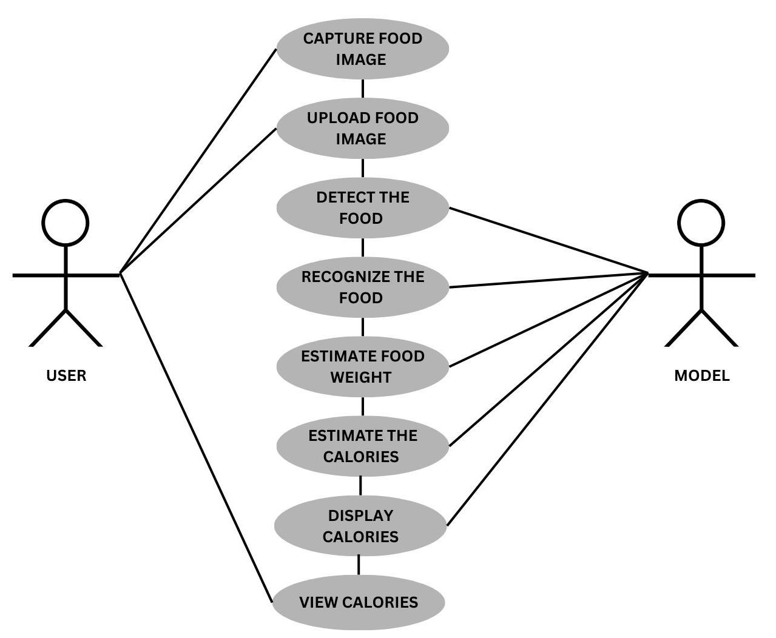
Fig 5.2.1 Use Case Diagram

Main Workflow
The vertical sequence of ovals shows the step-by-step process:
- Capture Food Image o The user takes a photo of their food using a camera.
- Upload Food Image o The image is sent to the system for processing.
- Detect the Food o The model identifies where the food is in the image (object detection).
- Recognize the Food o The model classifies what the food is (e.g., pizza, rice, salad).
- Estimate Food Weight o The model approximates portion size or weight based on the image.
- Estimate the Calories o Using food type + estimated weight, the system calculates calories.
- Display Calories o The system shows the calorie information to the user.
8.View Calories
The user views the final result.

Relationships
- User interactions:
  - The user directly performs:
    - Capturing the image
    - Uploading the image
    - Viewing the results
- Model interactions:
  - The model handles the core processing steps:
    - Detection
    - Recognition
    - Weight estimation
    - Calorie estimation
    - Display preparation
- The arrows indicate which actor is responsible for each use case.

5.2.2 Sequence Diagram
A Sequence Diagram is a type of UML diagram that shows how different components of a system interact with each other in a specific sequence of time. It represents the flow of messages exchanged between objects or actors to perform a particular function. The main purpose of a sequence diagram is to describe the dynamic behavior of a system by showing the order in which operations are executed. It helps in understanding how a process works step-by-step from start to end.
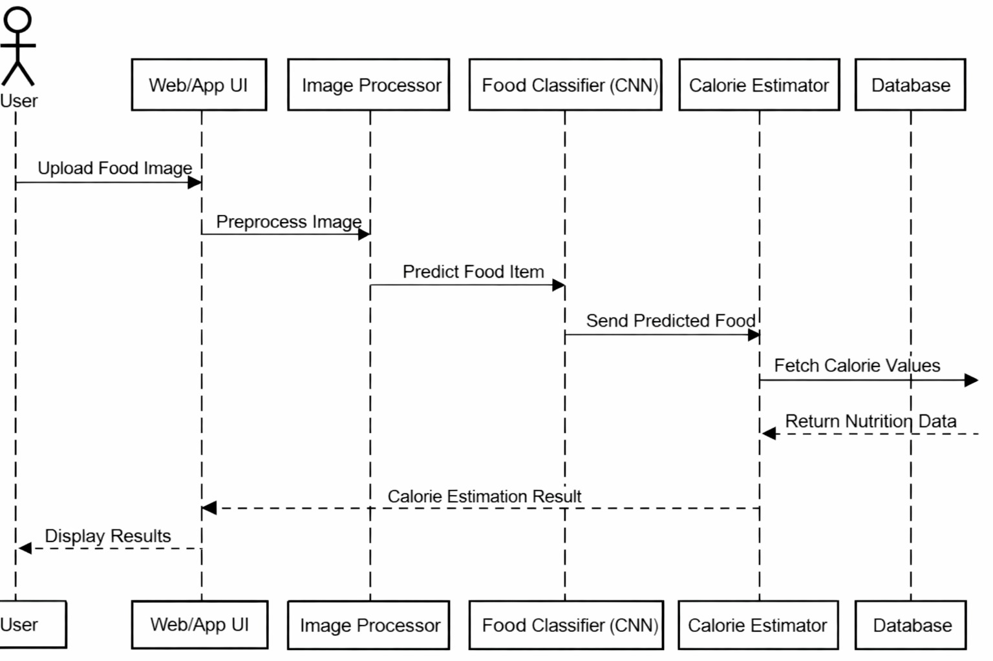

Fig 5.2.2 Sequence Diagram

Participants (Left → Right)
Each vertical dashed line represents a component:
- User – initiates the process
- Web/App UI – interface where the user interacts
- Image Processor – prepares the image for analysis
- Food Classifier (CNN) – identifies the food using a deep learning model
- Calorie Estimator – calculates nutritional values
- Database – stores calorie and nutrition data

Key Concepts
- Sequential flow: Each step happens in order, from left to right.
- Arrows:
  - Solid arrows = requests/actions o Dashed arrows = responses/returns
- Separation of concerns:
  - Image processing, classification, and calorie estimation are handled by different components.

5.2.3 Activity Diagram
An Activity Diagram is a type of UML (Unified Modeling Language) diagram that represents the flow of activities or actions in a system. It shows how different tasks are performed stepby-step, including decision points, parallel processes, and the overall workflow. The main purpose of an activity diagram is to model the dynamic behavior of a system by illustrating the sequence of operations from start to end. It helps in understanding the process logic, identifying dependencies, and improving system design.
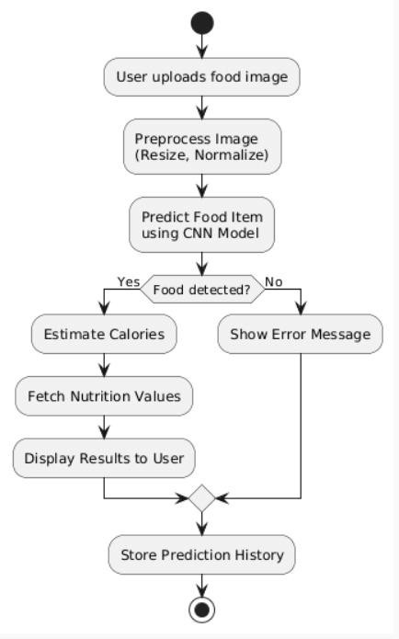

Fig 5.2.3 Activity Diagram

Step-by-Step Explanation
- Start
  - The process begins (black dot at the top).
- User uploads food image
  - The user provides an image of food to the system.

3. Preprocess Image
- The system prepares the image:
o Resize o Normalize
- This ensures the image is suitable for the model.

4. Predict Food Item using CNN Model
- A Convolutional Neural Network (CNN) analyzes the image.
- It tries to identify what food is present.
5. Decision: “Food detected?”
• This is a branching point: o Yes → continue with calorie estimation o No → handle error
If YES (Food detected)
6.Estimate Calories
- Calculate calories based on the detected food.
7.Fetch Nutrition Values
- Retrieve detailed nutrition info (e.g., protein, carbs, fats).

8.Display Results to User
o Show the final output to the user.
If NO (Food not detected)
Show Error Message o Inform the user that the system couldn’t recognize the food.

Merge Point
- Both paths (success and error) rejoin at a diamond node.
- This ensures the process continues regardless of outcome.

9. Store Prediction History
- The system saves:
o The prediction (or failure) o Possibly the image and results
- Useful for tracking, analytics, or user history.
10. End
• The process finishes (final circle).

5.2.4 Class Diagram
A Class Diagram is a type of UML (Unified Modeling Language) diagram that represents the static structure of a system. It shows the system’s classes, their attributes (data), methods (functions), and the relationships between them. The main purpose of a class diagram is to model the design of a system by organizing its components in a structured way. It helps developers understand how different parts of the system are connected and how data flows between them.

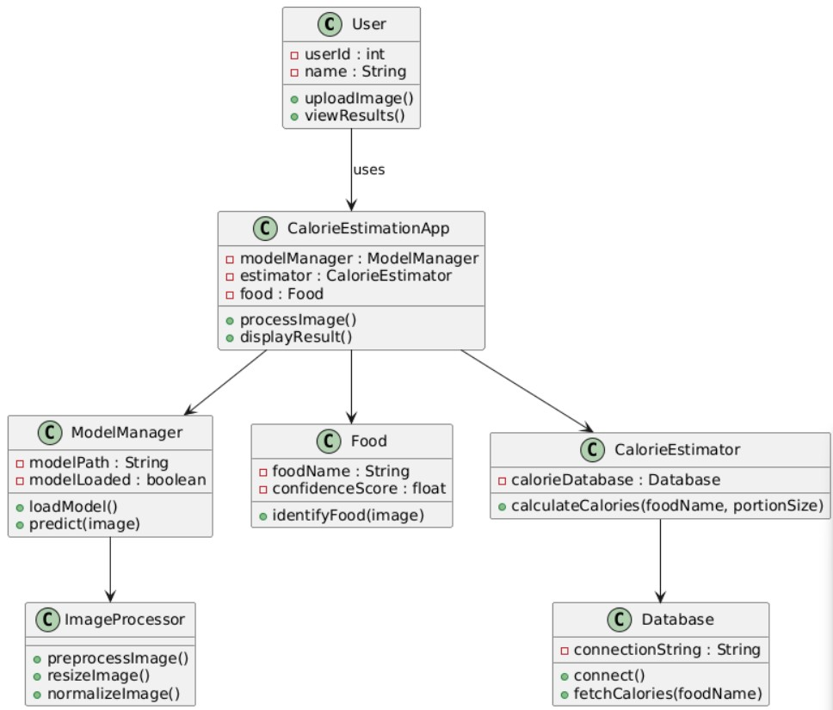

Fig 5.2.4 Class Diagram

The class diagram represents the structural design of the Calorie Estimation System, highlighting the main class and its relationships with other components.
The central class in this diagram is Calorie Estimation App, which acts as the core controller of the application. It is responsible for coordinating the overall workflow, including image processing, food recognition, calorie estimation, and result presentation.
The relationship labelled “uses” indicates a dependency relationship. This means that other components or modules in the system rely on the functionality provided by the Calorie Estimation App class. In object-oriented design, such a relationship implies that one class invokes methods or services of another without owning it.
In the complete system, the Calorie Estimation App typically interacts with multiple supporting classes, such as:
- Image processing modules for preprocessing input images
- Machine learning models for food classification
- Calorie estimation components for nutritional analysis
- Database modules for retrieving and storing nutrition data
This design promotes modularity and separation of concerns, where each component handles a specific responsibility while the main application class integrates all functionalities into a cohesive system.

Key Points
- The design follows object-oriented principles, ensuring modularity and reusability of components.
- Each class has a single responsibility, improving maintainability and scalability.
- The system demonstrates separation of concerns, where image processing, prediction, and data retrieval are handled independently.
- The relationships between classes (association and dependency) enable efficient communication between different modules.
- The architecture supports extensibility, allowing new features (e.g., additional nutrients or improved models) to be added without major changes.
- Encapsulation is maintained by keeping data (attributes) and behaviour (methods) within their respective classes.

5.2.5 Data Flow Diagram

A Data Flow Diagram (DFD) is a graphical representation that shows how data moves through a system. It illustrates the flow of information between different processes, data stores, and external entities. DFD focuses on the logical flow of data rather than the technical details of implementation. The main purpose of a DFD is to help understand how data is input, processed, stored, and output in a system. It uses symbols such as processes (circles), data flows (arrows), data stores (open rectangles), and external entities (squares).
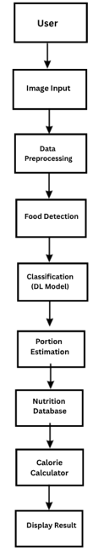

Fig 5.2.5 Data Flow Diagram

The diagram illustrates the end-to-end workflow of the food calorie estimation system, showing how input data is processed step-by-step to generate nutritional information. The process begins with the User, who provides an image of the food item through the application interface (Image Input). This image is then passed to the Data Preprocessing stage, where it is prepared for analysis by performing operations such as resizing, normalization, and noise reduction.
After preprocessing, the system performs Food Detection, where the relevant food object is identified within the image. Once the food is detected, it moves to the Classification (Deep Learning Model) stage. Here, a trained deep learning model (such as a CNN) classifies the food item (e.g., rice, pizza, salad).
Following classification, the system carries out Portion Estimation, which approximates the quantity or serving size of the detected food. This step is essential for accurate calorie calculation.
Next, the Calorie Calculator uses the identified food type and estimated portion size to compute the total calorie content. To ensure accuracy, the system retrieves nutritional information from a Nutrition Database, which contains predefined calorie and nutrient values for various food items.
Finally, the computed results are presented to the user in the Display Result stage, where the calorie count and possibly other nutritional details (such as proteins, fats, and carbohydrates) are shown.

CHAPTER 6

IMPLEMENTATION

The implementation of the Calorie Estimation of Food and Beverages using Deep Learning system involves integrating mobile application development, image processing techniques, deep learning models, and a nutrition database to provide accurate results. The system is designed in a modular manner, where each component performs a specific task, ensuring efficiency and scalability. The overall workflow starts from capturing the food image and ends with displaying the estimated calorie information to the user in a user-friendly format.

The front-end of the system is developed as a mobile or web application that allows users to upload or capture images easily. The interface is designed to be simple and interactive so that users can quickly provide input without technical difficulty. Once the image is selected, it is transmitted to the backend server through APIs. The backend is typically implemented using frameworks like Flask, which handle requests, process data, and return results efficiently.

In the backend, image preprocessing is performed to standardize the input before feeding it into the deep learning model. This includes resizing the image to a fixed dimension, normalizing pixel values, and optionally applying noise reduction or filtering techniques. These preprocessing steps ensure that the input image matches the format expected by the trained model, thereby improving prediction accuracy and reducing computational errors.

The core functionality of the system lies in the deep learning model, which is trained using convolutional neural networks (CNNs). The model is trained on large datasets of food images to learn distinguishing features of various food categories. Once trained, the model is integrated into the system and used to classify new input images. It predicts the food item along with a confidence score, indicating the reliability of the prediction. Additional logic such as label mapping and filtering is applied to improve the correctness of the output.

After identifying the food item, the system calculates the calorie content using a nutrition database. This database contains predefined values for calories and other nutritional components for different food items. Based on the predicted label, the system retrieves the corresponding data and computes the total calorie value, considering an estimated portion size. Finally, the results, including food name, calorie value, and confidence score, are displayed to the user through the application interface, completing the implementation process.

6.1 Code

App.py
from flask import Flask, render_template, request import numpy as np import os
from tensorflow.keras.preprocessing import image
from tensorflow.keras.applications.mobilenet_v2 import MobileNetV2, preprocess_input, decode_predictions

app = Flask(__name__)

# Load model
model = MobileNetV2(weights="imagenet")

# Upload folder
UPLOAD_FOLDER = "static/uploads"
app.config["UPLOAD_FOLDER"] = UPLOAD_FOLDER

# Calorie Database (basic) calorie_db = {
"pizza": {"calories": 266, "protein": 11, "fat": 10, "carbs": 33},
"burger": {"calories": 295, "protein": 17, "fat": 12, "carbs": 30},
"noodles": {"calories": 138, "protein": 5, "fat": 2, "carbs": 25},
"pasta": {"calories": 131, "protein": 5, "fat": 1, "carbs": 25},
"rice": {"calories": 130, "protein": 2, "fat": 0.3, "carbs": 28},
"salad": {"calories": 33, "protein": 2, "fat": 0.2, "carbs": 6},
"cake": {"calories": 257, "protein": 3, "fat": 9, "carbs": 38},
"ice cream": {"calories": 207, "protein": 3.5, "fat": 11, "carbs": 24},
"banana": {"calories": 89, "protein": 1, "fat": 0.3, "carbs": 23},

"apple": {"calories": 52, "protein": 0.3, "fat": 0.2, "carbs": 14}
}

@app.route("/", methods=["GET", "POST"]) def index(): if request.method == "POST": file = request.files["file"]
if file:
filepath = os.path.join(app.config["UPLOAD_FOLDER"], file.filename) file.save(filepath)

# Load image
img = image.load_img(filepath, target_size=(224, 224)) img_array = image.img_to_array(img) img_array = np.expand_dims(img_array, axis=0) img_array = preprocess_input(img_array)

# Prediction Logic preds = model.predict(img_array) decoded = decode_predictions(preds, top=5)[0]

food = None confidence = 0

# Food keywords food_keywords = [
"pizza","burger","sandwich","hotdog","pasta","spaghetti","carbonara",
"noodle","ramen","rice","fried_rice","biryani",
"salad","omelette","egg","soup",
"cake","ice_cream","chocolate","donut",
"apple","banana","orange","grape","watermelon",
"coffee","tea","juice"
]
# Mapping food_map = {
"carbonara": "pasta",
"spaghetti": "pasta",
"ramen": "noodles",
"chow_mein": "noodles",
"fried_rice": "rice",
"ice_cream": "ice cream",
"hotdog": "hot dog"
}

# Step 1: Find food label for d in decoded: label = d[1].lower()

if any(k in label for k in food_keywords): food = label
confidence = round(d[2] * 100, 2) break

# Step 2: fallback if not food:
food = decoded[0][1].lower() confidence = round(decoded[0][2] * 100, 2)

# Step 3: clean name food = food.replace("_", " ")

# Step 4: mapping fix for key in food_map: if key in food:
food = food_map[key] break

# Step 5: get nutrition nutrition = calorie_db.get(food, { "calories": "Not Available",
"protein": "Not Available",
"fat": "Not Available",
"carbs": "Not Available"
})

return render_template("result.html", image=filepath, food=food, confidence=confidence, nutrition=nutrition)

return render_template("index.html")

if __name__ == "__main__": app.run(debug=True)

index.html
<!DOCTYPE html>
<html>
<head>
<title>Food Calorie Estimator</title>
</head>
<body>
<h2>Upload Food Image</h2>
<form method="POST" enctype="multipart/form-data">
<input type="file" name="file" required> <button type="submit">Predict</button>
</form>
</body>
</html>

Recognize.html
<!DOCTYPE html>
<html>
<head>
<title>Recognize Food</title>
</head>
<body style="text-align:center; font-family: Arial;">

<h2>Image Uploaded Successfully</h2>

<img src="{{ img }}" width="300"><br><br>

<form action="/predict" method="POST">
<input type="hidden" name="filepath" value="{{ img }}">
<button type="submit">Predict Calories</button>
</form>

</body>
</html>

Results.html
<h1>Result</h1>
<img src="{{ image }}" width="300">
<h2>{{ food }}</h2>
<p>Confidence: {{ confidence }}%</p>
<p>Calories: {{ nutrition.calories }}</p>
<p>Protein: {{ nutrition.protein }}</p>
<p>Fat: {{ nutrition.fat }}</p>
<p>Carbs: {{ nutrition.carbs }}</p>
<a href="/">Go Back</a>

Nutrition_data.json
{
"rice":{
"calories":130,
"protein":2.7,
"fat":0.3,
"carbs":28,
"calcium":0.01, "vitamins":0.02
},

"vegetables":{ "calories":50,
"protein":2,
"fat":0.5,
"carbs":10,
"calcium":0.03, "vitamins":0.07
},

"banana":{
"calories":96, "protein":1.3,
"fat":0.3,
"carbs":27,
"calcium":0.01, "vitamins":0.04
}
}

CHAPTER 7

TESTING

7.1 SYSTEM TESTING
System testing evaluates the complete, integrated system to ensure it meets functional and non-functional requirements.
System testing in the Calorie Estimation of Food and Beverages Using Deep Learning project ensures that the entire system functions correctly as an integrated unit. It verifies that all components—such as the user interface, deep learning model, and backend processing—work together smoothly to provide accurate calorie estimations from food images. It ensures that the system can correctly process user inputs, generate reliable outputs within an acceptable time, and handle errors like invalid or unclear images without crashing. Additionally, system testing confirms that the application is user-friendly, performs efficiently, and works consistently across different devices and platforms, thereby ensuring overall reliability and effectiveness in real-world usage.

7.2 TYPES OF TESTING

7.2.1 Unit Testing

1. Image Input Module
- Tests image upload functionality
- Validates file format (JPG, PNG)
- Checks image preprocessing (resize, normalization)
Ensures images are correctly prepared for the model

2. Food Classification Model
- Tests the deep learning model separately
- Verifies correct food item prediction
Example: Apple image → “Apple” detected

3. Calorie Calculation Module
- Tests logic for mapping food item to calorie value
- Ensures correct calorie database retrieval
- Example: “Banana” → correct calorie value returned

4. Database Module
- Tests storage and retrieval of food and calorie data
- Ensures no data inconsistency

5. Output Display Module
- Tests result display on UI
- Checks formatting of calorie output

7.2.2 Integration Testing
Integration testing ensures that data flows correctly between modules and that the combined system produces accurate and consistent results without errors.
Modules Integrated in This Project

1. Image Input and Preprocessing Module
Ensures that the uploaded image is properly passed to the preprocessing stage and prepared correctly for the model.

2. Preprocessing and Deep Learning Model
Checks whether the processed image is correctly fed into the model and the prediction is generated without errors.

3. Model and Calorie Calculation Module
Verifies that the predicted food item is correctly sent to the calorie calculation module to fetch accurate calorie values.

4. Calorie Calculation and Database
Ensures proper communication with the database to retrieve correct nutritional information.

5. Backend and User Interface
Checks whether the final output (food name and calories) is correctly displayed to the user.

7.2.3 Black Box Testing

Black box testing focuses on testing the system without knowing the internal code. It checks whether the system meets user requirements based on inputs and outputs.

What It Tests
- Image upload functionality
- Food recognition output
- Calorie estimation results
- User interface behavior

Example Test Cases
- Upload food image → correct food name displayed
- Display calorie value → accurate output shown
- Upload invalid image → proper error message
- Check system response time

What It Ensures
Black box testing ensures that the system functions correctly from the user’s perspective and meets all functional requirements.

8.2.4 White Box Testing
White box testing is performed by examining the internal structure, logic, and code of the system. It ensures that all code paths, conditions, and loops work correctly.

What It Tests
- Internal logic of preprocessing functions
- Neural network implementation and layers
- Calorie calculation algorithms
- Database queries and data handling

Example Test Cases
- Check if image resizing function works correctly
- Verify normalization values are applied properly
- Test conditions in calorie mapping logic
- Ensure loops and functions execute correctly without errors

What It Ensures
White box testing ensures that the internal code is correct, efficient, and free from logical errors, leading to a reliable system.

7.3 Test Cases

Test  Case  ID | Description | Input | Expected Output | Actual Output | Status
TC01 | Verify upload of valid food image | Valid food image (e.g., apple.jpg) | Image should upload and process successfully | Image uploaded and processed successfully | Pass
TC02 | Verify upload of invalid file  (non-image) | PDF/TXT  file | System should display error message | Error message displayed | Pass
TC03 | Check handling of blurry image | Blurry food image | System should warn or handle low-quality image | No proper warning given | Fail
TC04 | Test simple food classification | Image of apple | Correct food item should be identified | Correct food item identified | Pass
TC05 | Test complex food classification | Image of mixed dish  (e.g., biryani) | System should classify accurately | Incorrect classification | Fail
TC06 | Verify calorie estimation for known food | Image of banana | Accurate calorie value should be displayed | Accurate calorie value displayed | Pass
TC07 | Test calorie estimation for mixed food items | Image of multiple food items | Combined/approximate  calorie value should be shown | Incorrect calorie value | Fail
TC08 | Validate nonfood image handling | Image of car/object | System should reject input with message | Invalid input message displayed | Pass
TC09 | Test complex food classification | Image of mixed dish  (e.g., biryani) | System should classify accurately | Classification is correct | Pass
TC10 | Verify database retrieval | Recognized food item | Correct calorie data should be fetched | Correct calorie data fetched | Pass
TC11 | Check UI display of results | Any valid processed image | Output should be displayed clearly on UI | Output shown properly | Pass
TC12 | Check handling of blurry image | Blurry food image | System should warn or handle low-quality image | Proper warning is given | Pass

CHAPTER 8
RESULTS

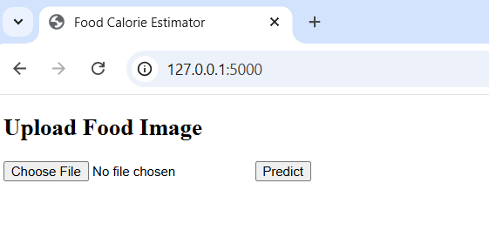

Fig 8.1 Home Page

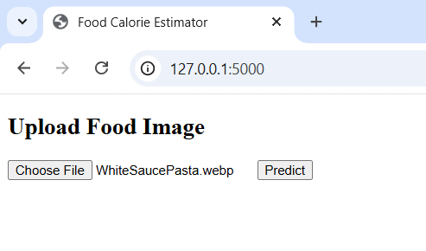

Fig 8.2 Image Upload Page
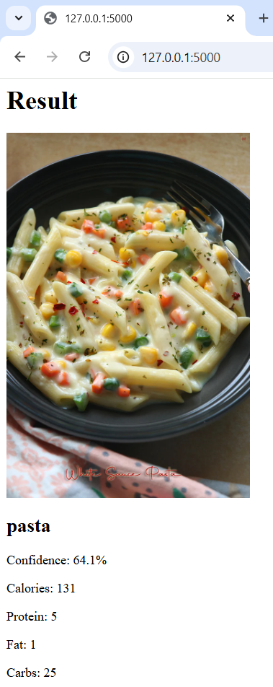

Fig 8.3 Result Page

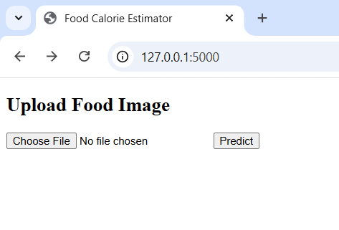

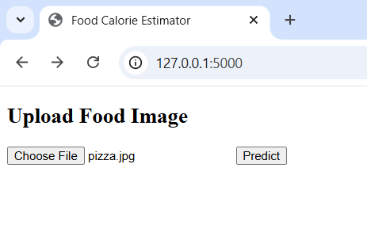

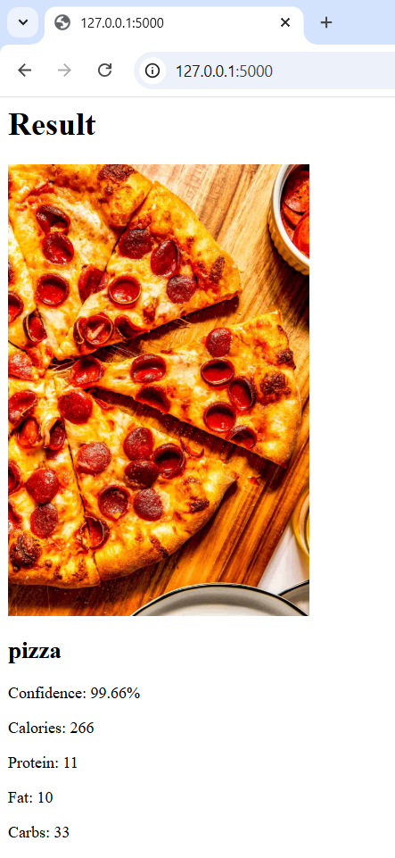

CHAPTER 9

CONCLUSION

The project titled “Calorie Estimation of Food and Beverages Using Deep Learning” effectively demonstrates how modern advancements in computer vision and artificial intelligence can be applied to address real-world challenges in the domain of health and nutrition. By leveraging powerful deep learning techniques, particularly Convolutional Neural Networks (CNNs), the system is capable of automatically analyzing food images, identifying the type of food, and estimating its calorie content with a reasonable level of accuracy. This significantly reduces the need for manual intervention and simplifies the process of dietary tracking.

Throughout the development and implementation of this project, it becomes clear that the performance and reliability of the system are highly dependent on the quality and diversity of the dataset used for training. A well-structured dataset with properly labeled images, balanced class distribution, and representation of various cuisines, food styles, and portion sizes plays a crucial role in enhancing model accuracy. Incorporating diverse real-world scenarios such as different lighting conditions, backgrounds, and image angles further strengthens the model’s ability to generalize effectively.

The use of pretrained models through transfer learning, such as architectures like ResNet and MobileNet, proves to be highly beneficial. These models, having been trained on large-scale datasets, provide a strong foundation for feature extraction and significantly reduce both training time and computational requirements. This allows the system to achieve higher accuracy even with relatively smaller domain-specific datasets, making the development process more efficient and scalable.

Despite its promising results, the project also brings attention to several challenges and limitations that need to be addressed for real-world deployment. One of the primary challenges is accurate portion size estimation from a single 2D image. Since calorie calculation depends heavily on quantity, even small errors in portion estimation can lead to noticeable inaccuracies in the final output. Additionally, variations in lighting, camera angles, occlusion, and complex backgrounds can affect the model’s prediction capability.

Another significant challenge arises from the presence of mixed or multi-ingredient dishes, which are common in many cuisines. Identifying individual components within such dishes and estimating their respective nutritional values remains a complex task. Furthermore, adapting the system to handle a wide variety of regional and cultural food items requires continuous dataset expansion and model retraining.

From a practical perspective, deploying the system in real-world environments also involves considerations such as computational efficiency, scalability, and user accessibility. Ensuring that the system performs efficiently on mobile devices or low-resource environments is essential for widespread adoption.

In conclusion, this project successfully demonstrates the feasibility, effectiveness, and practical value of applying deep learning techniques to automated dietary assessment. While certain challenges remain, the results highlight the immense potential of AI-driven solutions in transforming how individuals monitor and manage their nutrition. With further improvements and advancements, this system can evolve into a comprehensive, intelligent platform for smart dietary management, paving the way for future innovations in health technology.

CHAPTER 10

FUTURE ENHANCEMENTS

Future advancements in the field of calorie estimation of food and beverages using deep learning are expected to significantly enhance the system’s accuracy, intelligence, and realworld applicability. As research in artificial intelligence, computer vision, and data science continues to evolve, these systems will become more sophisticated, adaptive, and capable of understanding complex dietary scenarios.
One of the most important areas of improvement is accurate portion size estimation. Current systems primarily rely on 2D images, which lack depth information and often lead to incorrect quantity estimation. Future approaches can incorporate depth-sensing technologies such as stereo vision, LiDAR sensors, or multiple image inputs to reconstruct a 3D representation of food. This will allow the system to measure volume more precisely and significantly improve calorie estimation accuracy.
Another promising direction is the use of advanced model architectures. Traditional CNNs, while effective, may struggle with highly complex or mixed dishes. Emerging architectures such as Vision Transformers (ViTs) and attention-based models can capture global relationships within an image, enabling better recognition of overlapping or multicomponent foods. These models can focus on important regions of an image, improving classification performance in challenging conditions.
The integration of ingredient-level analysis is also a key improvement area. Instead of treating a dish as a single entity, future systems can use semantic segmentation techniques to identify and separate individual ingredients within a meal. For example, in a dish like a salad or curry, the system can detect each component separately and calculate nutritional values more accurately by combining the contributions of all ingredients.

Key Future Enhancements (Points)

1. Accurate Portion Size Estimation
- Use depth sensors (LiDAR, stereo cameras) for 3D understanding
- Apply multi-image input for better volume estimation
- Use 3D reconstruction techniques to measure food quantity
- Improves precision in calorie calculation

2. Advanced Model Architectures
- Implement Vision Transformers (ViT) and attention-based models
- Improve recognition of complex and mixed dishes
- Enhance feature extraction beyond traditional CNNs
- Increase overall classification accuracy

3. Ingredient-Level Analysis
- Use semantic segmentation to identify individual ingredients
- Break down mixed dishes into components
- Calculate nutrition for each ingredient separately
- Provides more precise calorie and nutrient estimation

4. Multimodal Learning Integration
- Combine image data with:
o Text input (food name)
o Voice commands
o Context (time, location)
- Reduces ambiguity in predictions
- Improves system intelligence and flexibility

5. Personalized Nutrition Estimation
- Use user data such as:
O Age, weight, height
o Activity level
o Health conditions
- Provide customized calorie and diet recommendations
- Acts as a personal diet assistant

6. Large and Diverse Datasets
- Include regional and international cuisines
- Add homemade meals and street foods
- Improve dataset balance and labeling quality
- Enhances model generalization and real-world performance

7. Real-Time Mobile Deployment
- Optimize models for smartphones and edge devices
- Use lightweight architectures (e.g., MobileNet)
- Enable instant calorie estimation without delay
- Reduce dependency on cloud processing

8. Continuous Learning Systems
- Enable models to learn from new data over time
- Use incremental and online learning techniques
- Adapt to new food items and trends
- Avoid complete retraining of the model

9. Privacy-Preserving Techniques
- Implement federated learning
- Keep user data on local devices
- Improve model without compromising privacy
- Increase user trust and data security

10. Explainable AI (XAI)
- Show how predictions are made
- Highlight important image regions (heatmaps)
- Display calculation steps for calories
- Improves transparency and user confidence

11. Integration with Wearables and IoT
- Connect with smart devices:
o Fitness trackers
o Smartwatches
- Combine calorie intake with calories burned
- Provide complete health monitoring

12. Improved Beverage Recognition
- Detect transparent and mixed liquids
- Analyze container type (glass, bottle, cup)
- Use contextual clues for better prediction
- Improve calorie estimation for drinks

CHAPTER 11
REFERENCES

1. Bossard, L., Guillaumin, M., Van Gool, L.
“Food-101: Mining Discriminative Components with Random Forests” (2014)
🔗 Food-101 ECCV Paper

2. Kawano, Y., Yanai, K.
“Food Image Recognition with Deep Convolutional Features” (2014)
🔗 Food Image Recognition Paper (UbiComp)

3. Meyers, A., Johnston, N., Rathod, V., et al.
“Im2Calories: Towards an Automated Mobile Vision Food Diary” (2015)
🔗 Im2Calories ICCV Paper

4. Fang, S., Liu, C., Zhu, F., et al.
“Single-View Food Portion Estimation Using Geometric Models” (2018)
🔗 Food Portion Estimation Research Overview

5. Christodoulidis, S., Anthimopoulos, M., Mougiakakou, S.
“Food Recognition for Dietary Assessment Using Deep CNNs” (2015)
🔗 CNN Food Recognition Paper Reference

6. Martínel, N., Piciarelli, C., Foresti, G. L.
“A Dataset for Food Recognition and Segmentation” (2016)
🔗 CNN Food Recognition Paper Reference

7. Mezgec, S., Koroušić Seljak, B.
“NutriNet: A Deep Learning Food and Drink Image Recognition System for Dietary Assessment” (2017)
🔗 NutriNet Paper (Nutrients Journal)

8.Ciocca, G., Napoletano, P., Schettini, R.
“Food Recognition: A New Dataset, Experiments, and Results” (2017)
🔗 Food Recognition IEEE Paper

