Q12. connect to database using PostgreSQL and get the details of participants in test 1 and age > 50

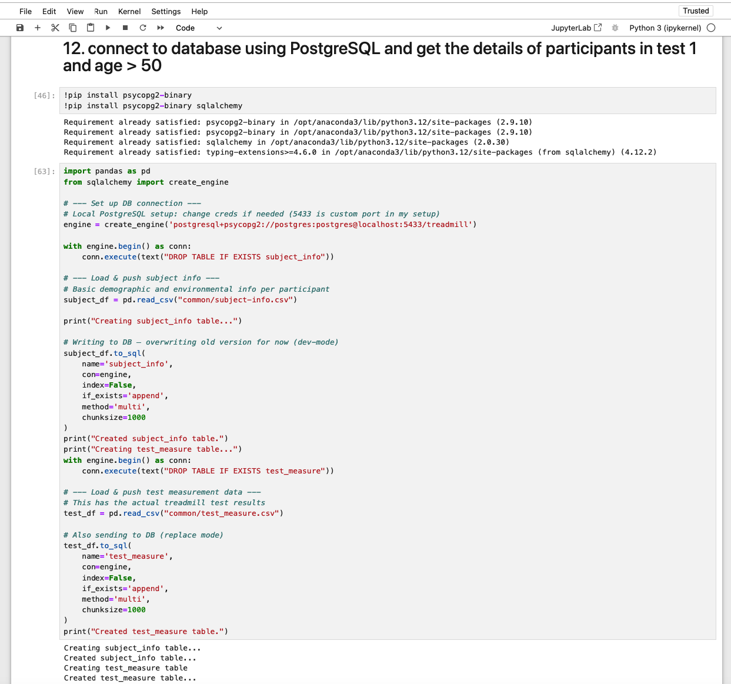

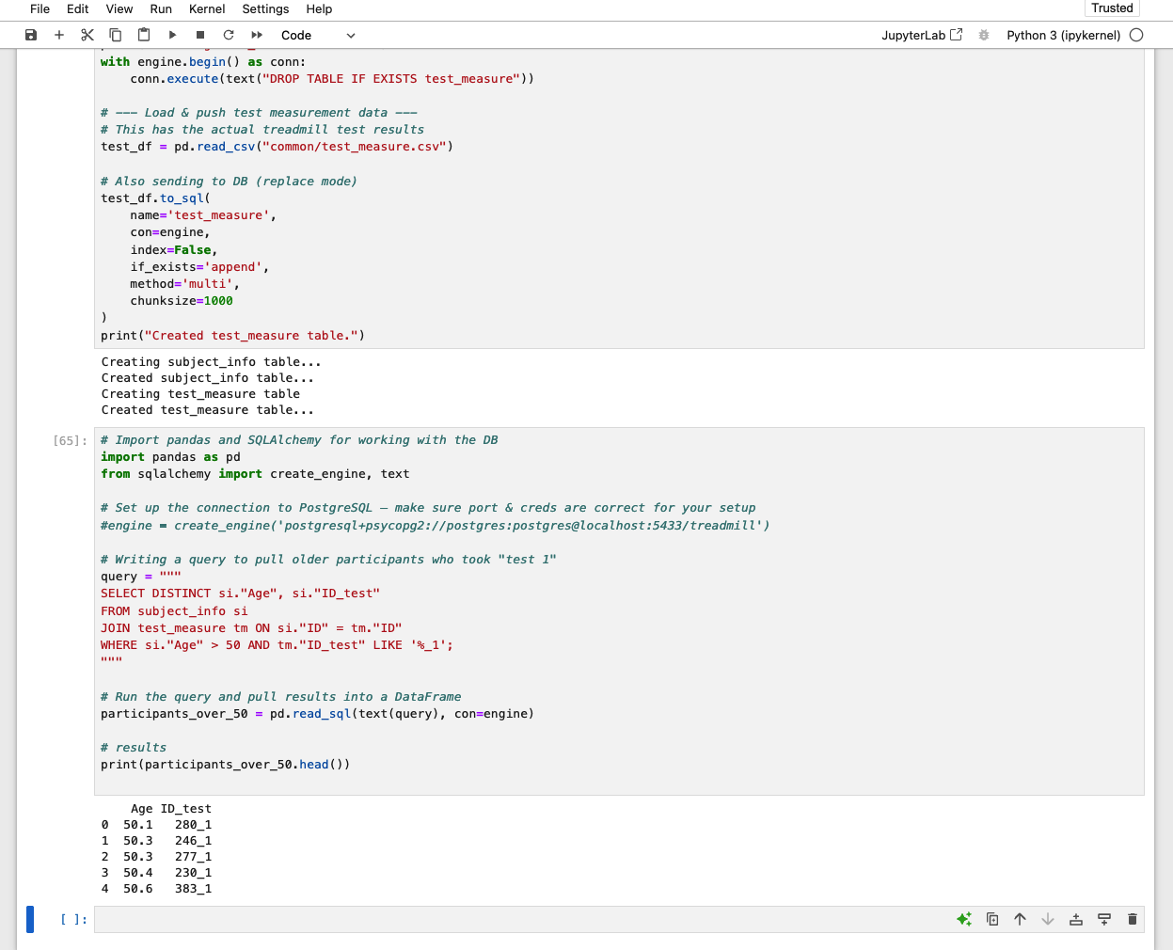

PostgreSQL DB and table

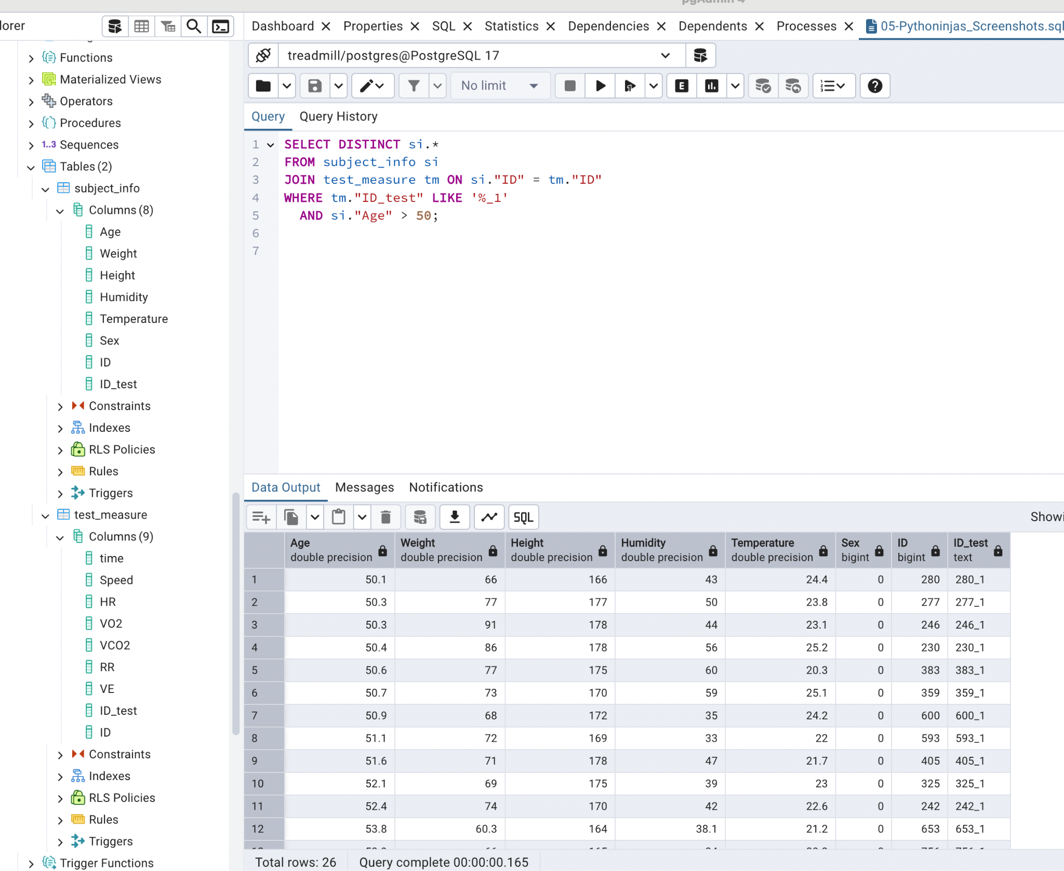

# 

# Q33. Connect to database using PostgreSQL and increase the temperature 2 degrees for participant with maximum humidity and display the result

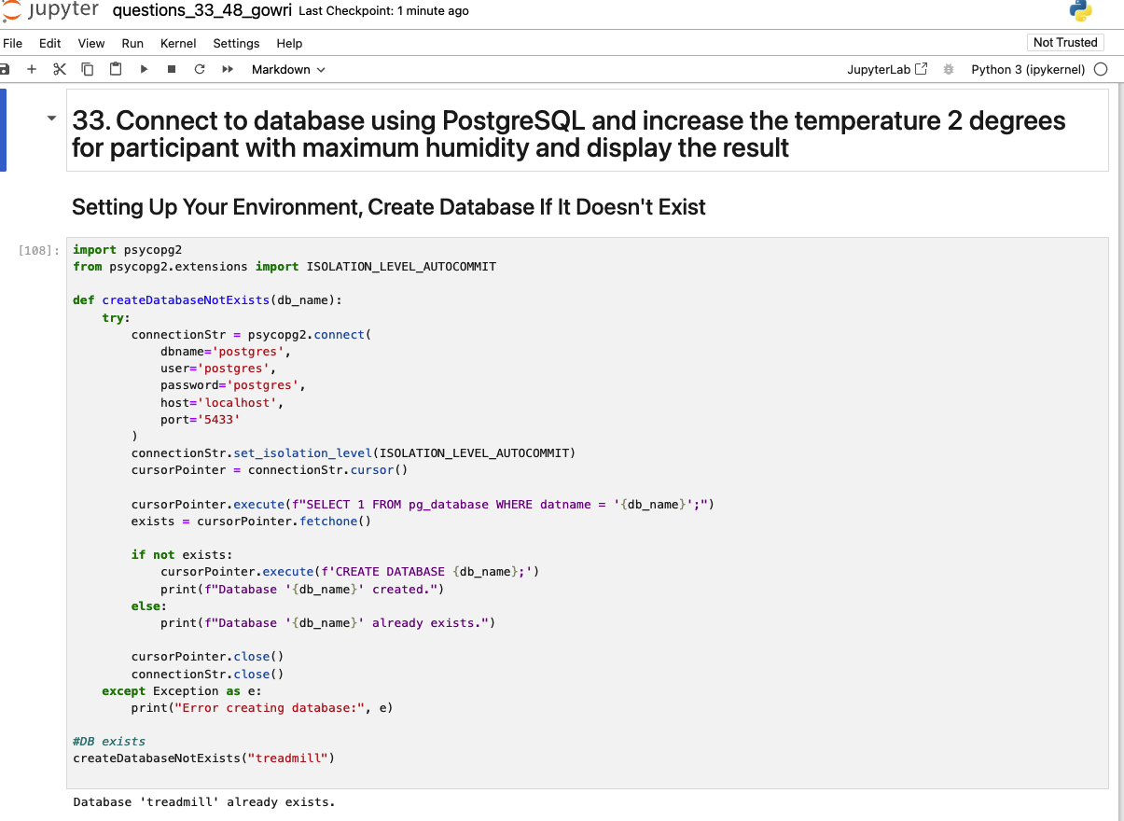

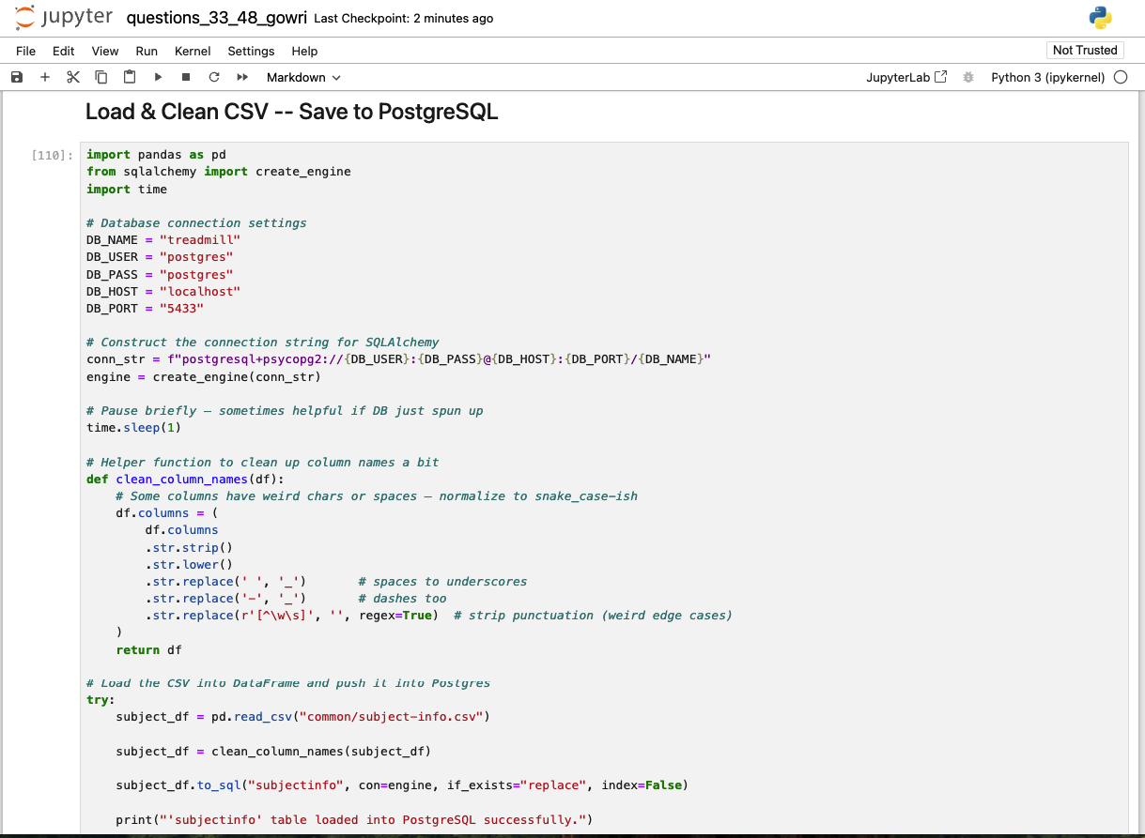

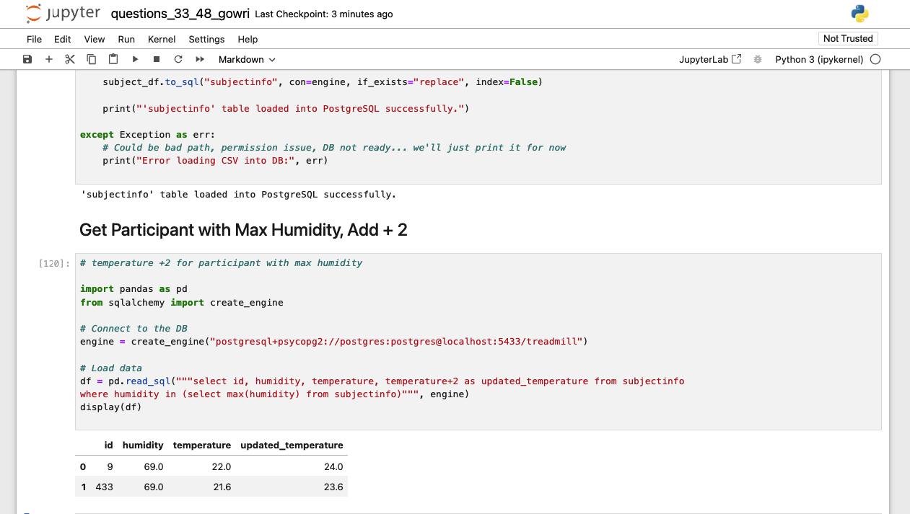

PostgreSQL DB and table

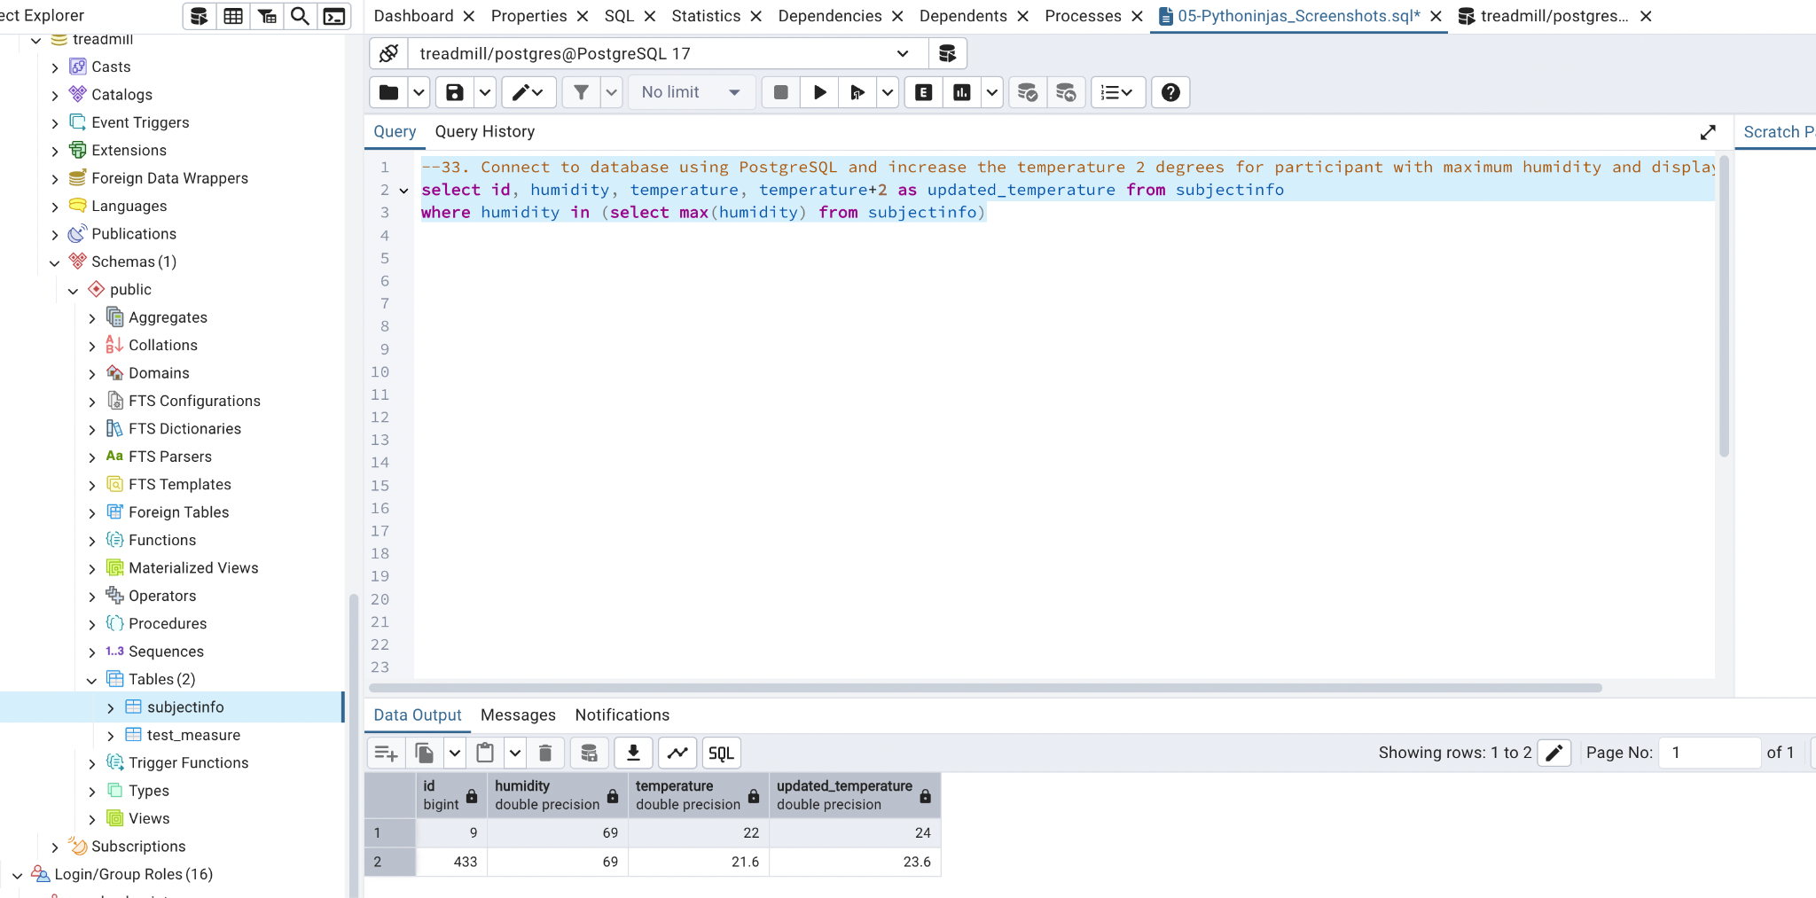

# **05_Pythoninjas_AddnlQuestions**

# Q6. How do we store encrypted subject data and decrypt it only when needed — using Python or PostgreSQL?

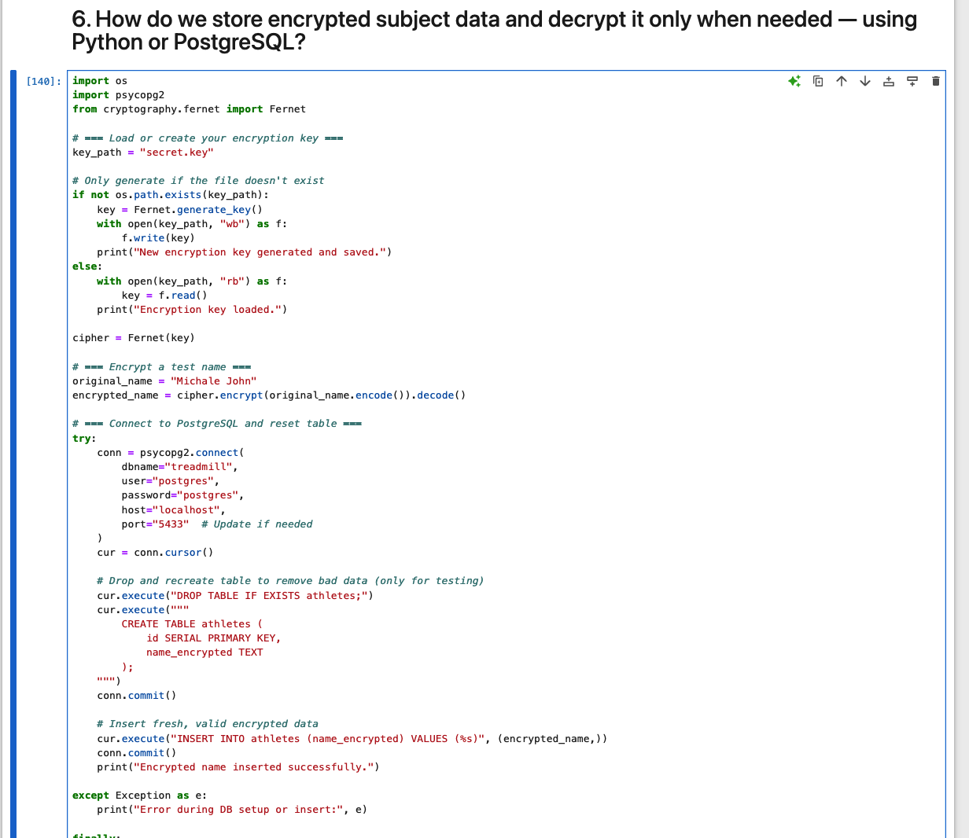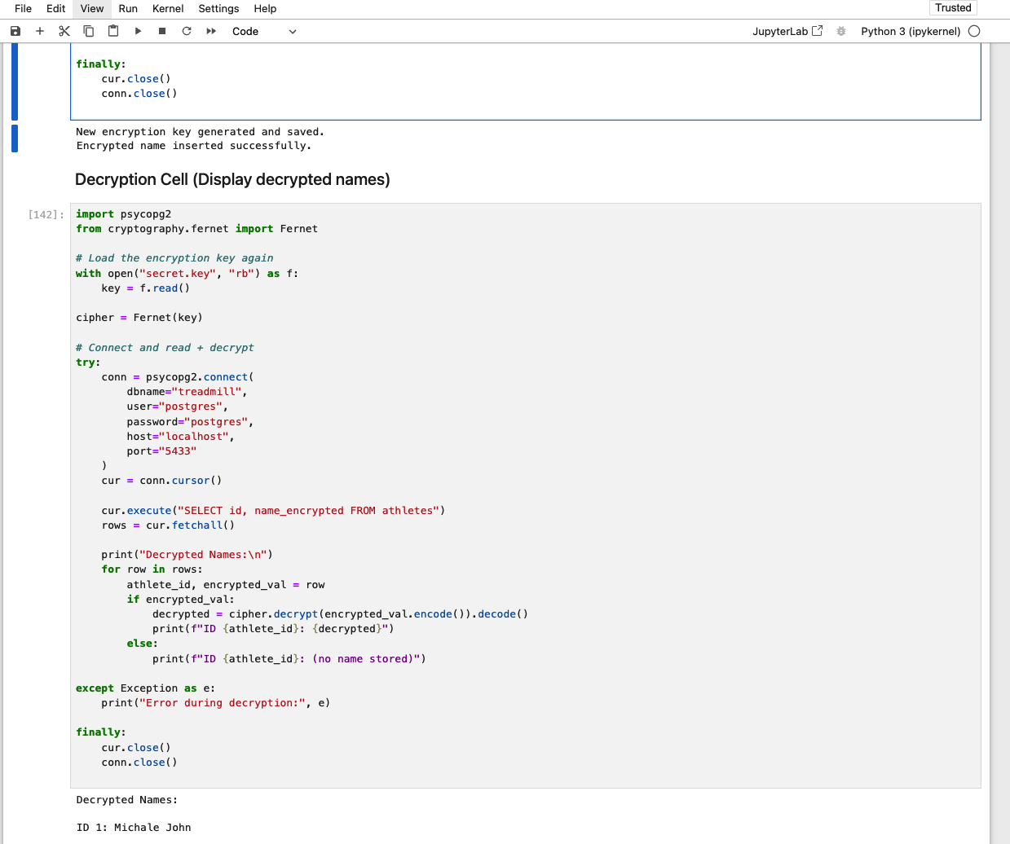

PostgreSQL DB and table

