**Assignment DAY 10**

1)Write a function to Calculate the total stock value for a given category: '''(Stock value=ROUND(SUM(unit_price *''' units_in_stock)::DECIMAL, 2) Return data type is DECIMAL(10,2)

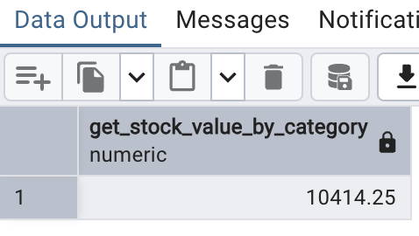

2)Try writing a cursor query which I executed in the training.

