----------------------------------------------Assignment Day2---------------------------------------- --

1)Alter Table: ----Add a new column linkedin_profile to employees table to store LinkedIn URLs as varchar.

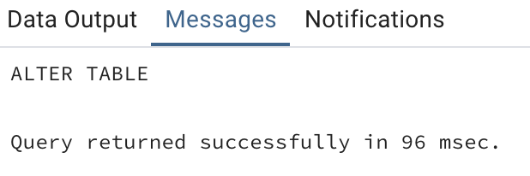

----Change the linkedin_profile column data type from VARCHAR to TEXT.

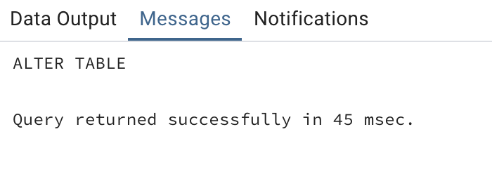

----Add unique, not null constraint to linkedin_profile

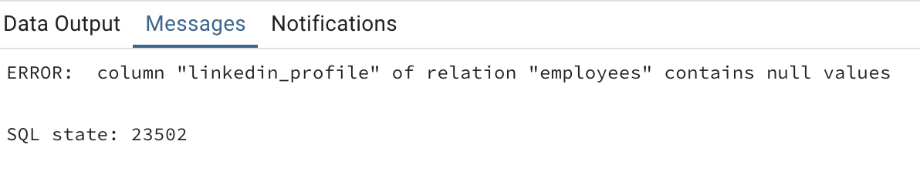Throws error because this is unique column and unique columns cannot contain NULL VALUES.

----Drop column linkedin_profile

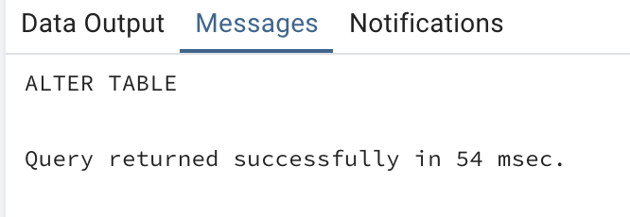

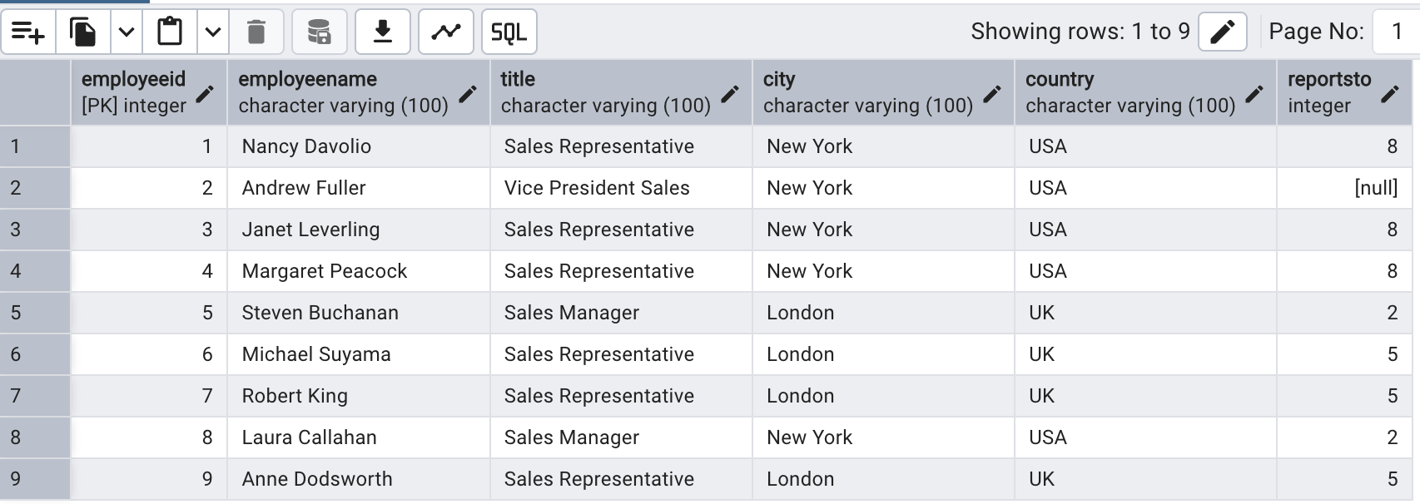---2)Querying (Select) -----Retrieve the employee name, and title of all employees

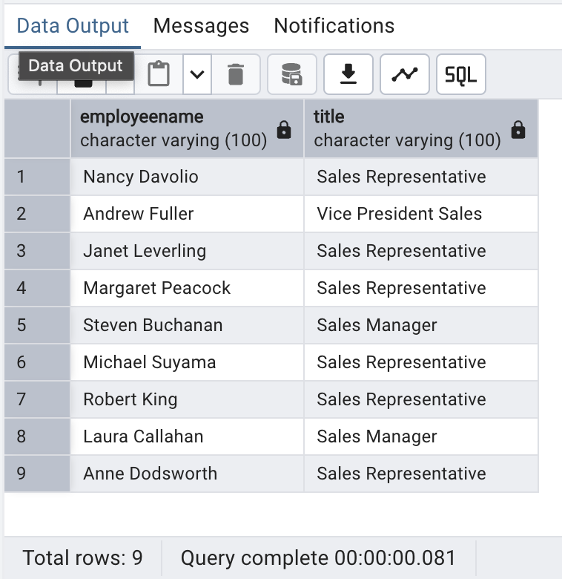

-----Find all unique unit prices of products

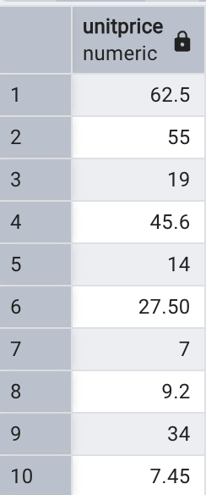

-----List all customers sorted by company name in ascending order

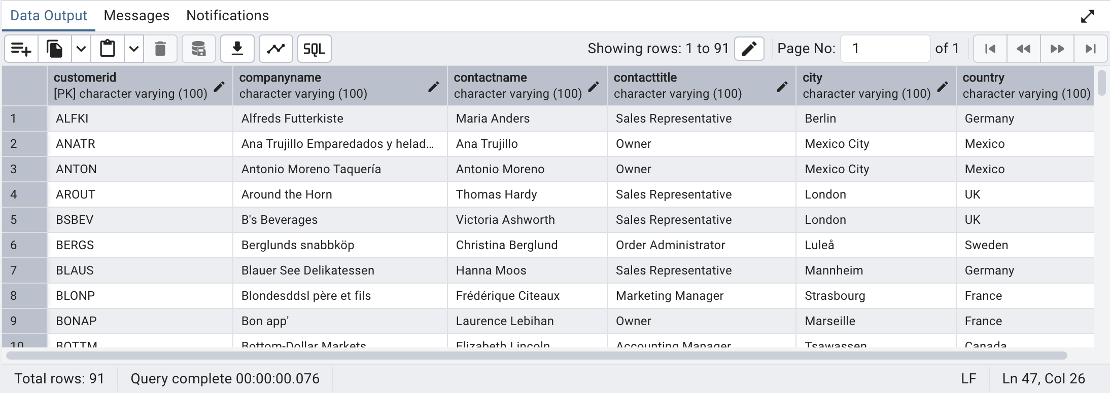

-----Display product name and unit price, but rename the unit_price column as price_in_usd

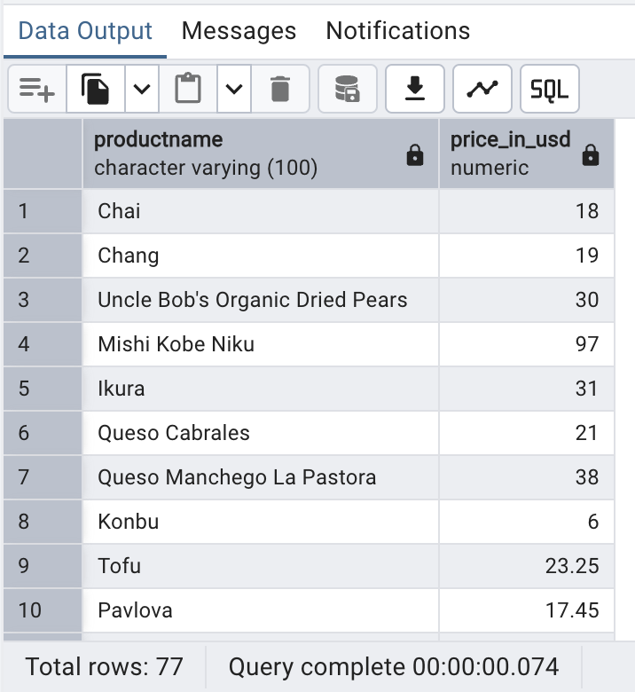

--3)Filtering ----Get all customers from Germany.

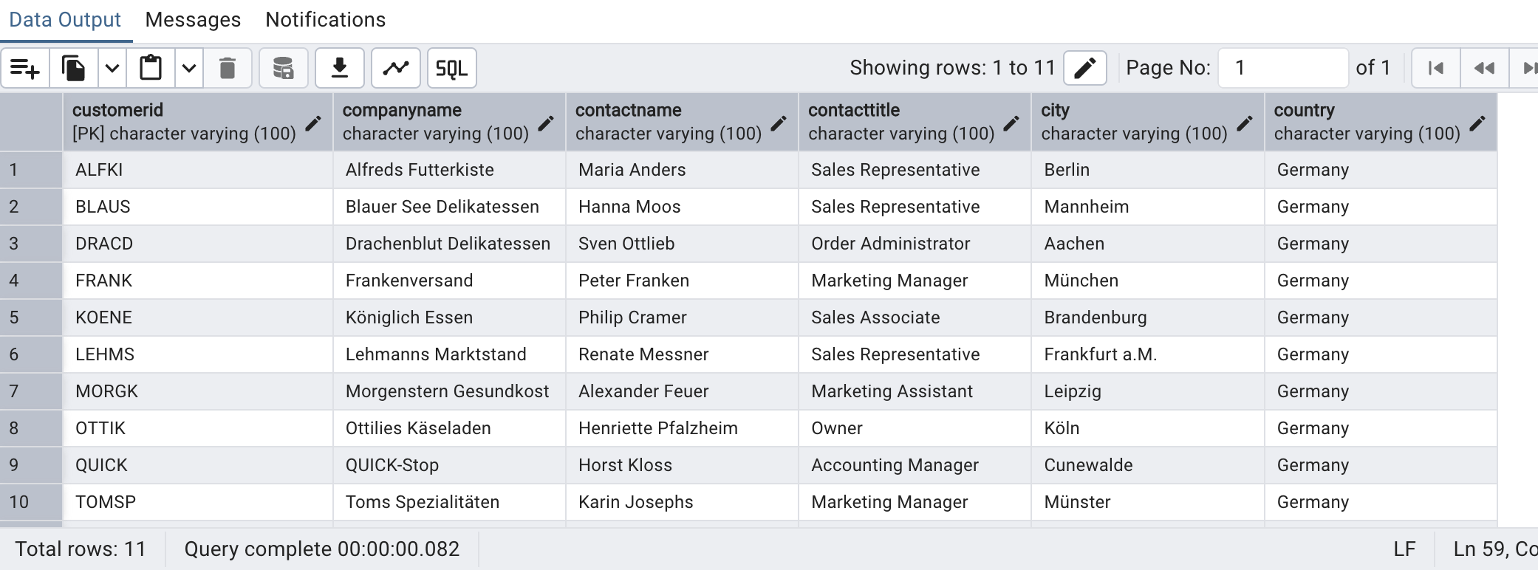

----Find all customers from France or Spain

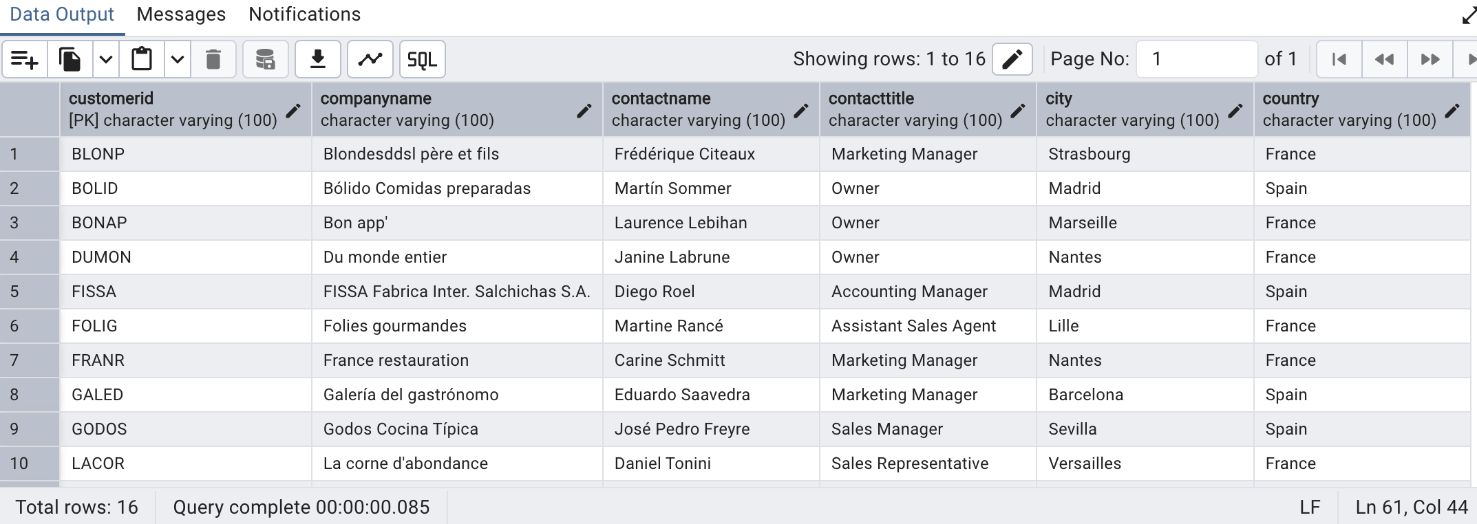

----Retrieve all orders placed in 2014 (based on order_date), and either have freight greater than 50 or the shipped date available (i.e., non-NULL) (Hint: EXTRACT(YEAR FROM order_date)) It returned 0 rows as there are no orders place in year 1997. 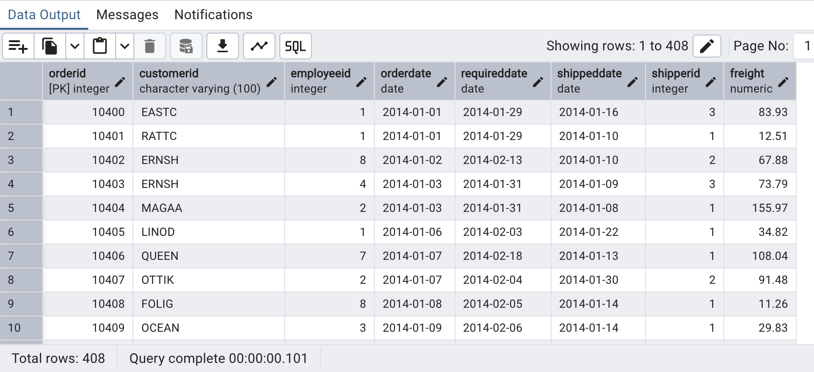

---4)Filtering -----Retrieve the product_id, product_name, and unit_price of products where the unit_price is greater than 15.

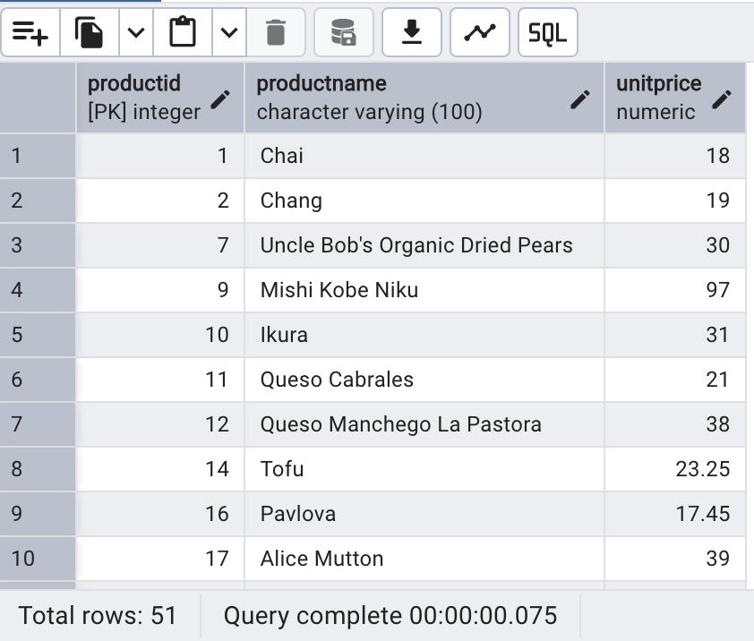

-----List all employees who are located in the USA and have the title "Sales Representative".

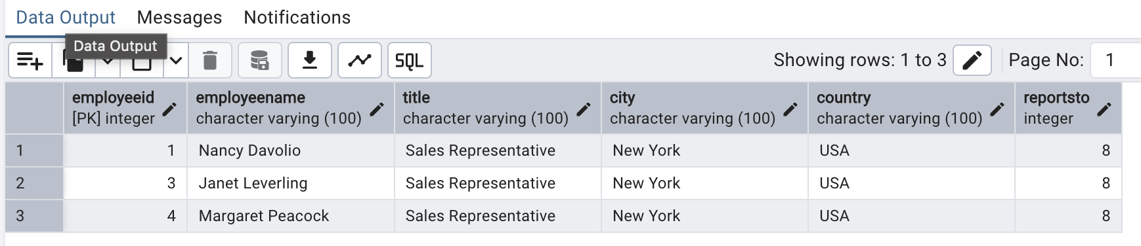

----Retrieve all products that are not discontinued and priced greater than 30.



---5) LIMIT/FETCH -----Retrieve the first 10 orders from the orders table.

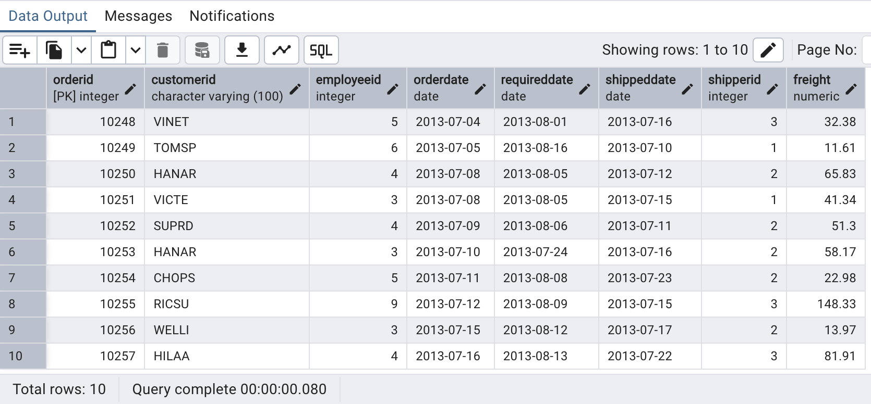

-----Retrieve orders starting from the 11th order, fetching 10 rows (i.e., fetch rows 11-20) 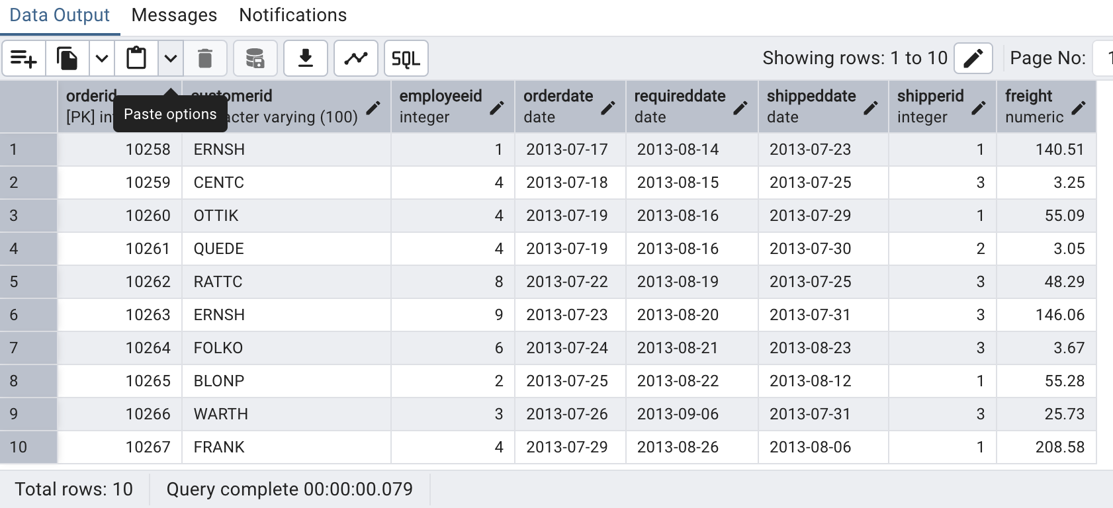

---6)Filtering (IN, BETWEEN)

-----List all customers who are either Sales Representative, Owner

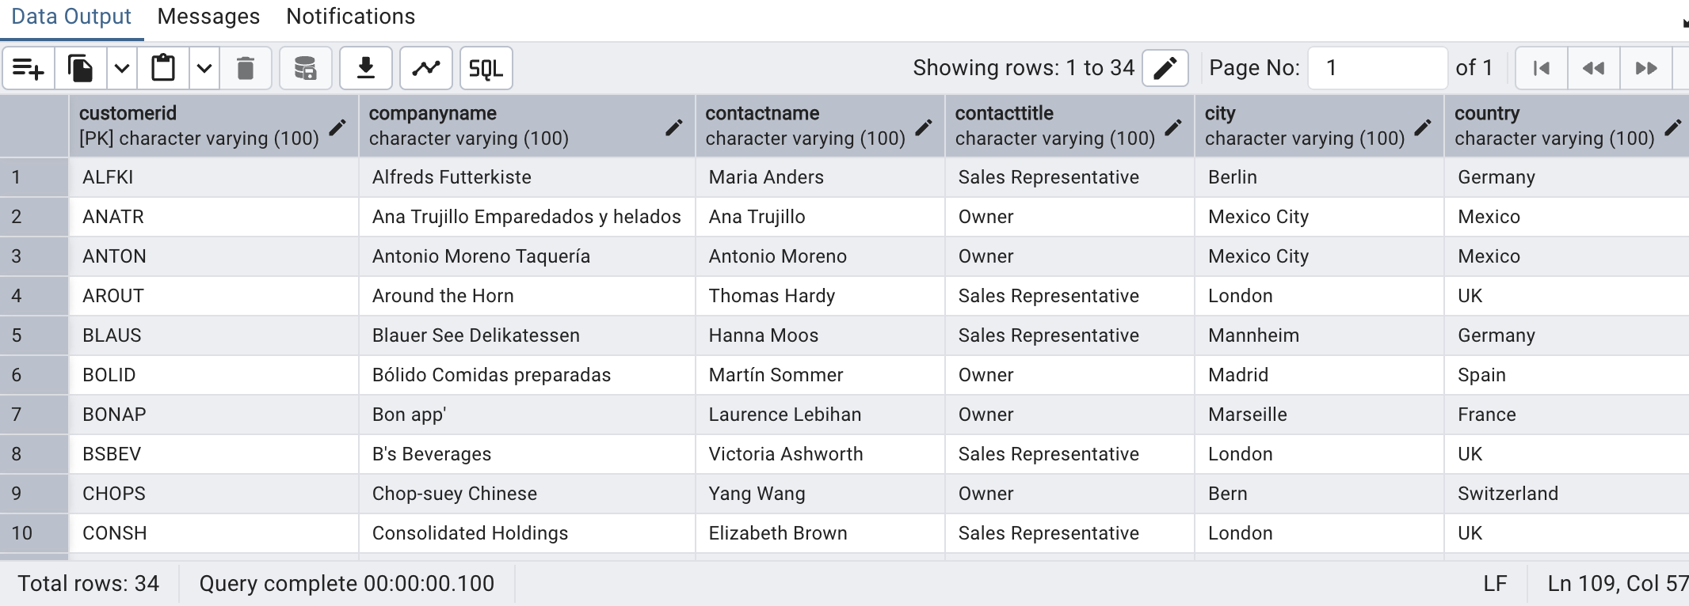

-----Retrieve orders placed between January 1, 2013, and December 31, 2013.

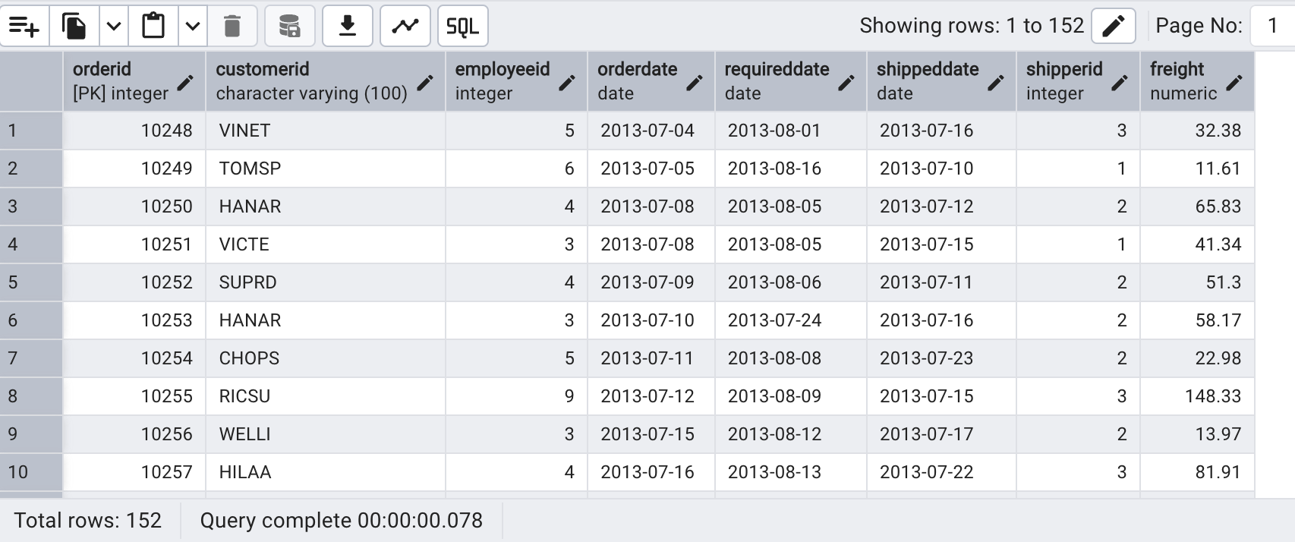

---7)Filtering -----List all products whose category_id is not 1, 2, or 3.

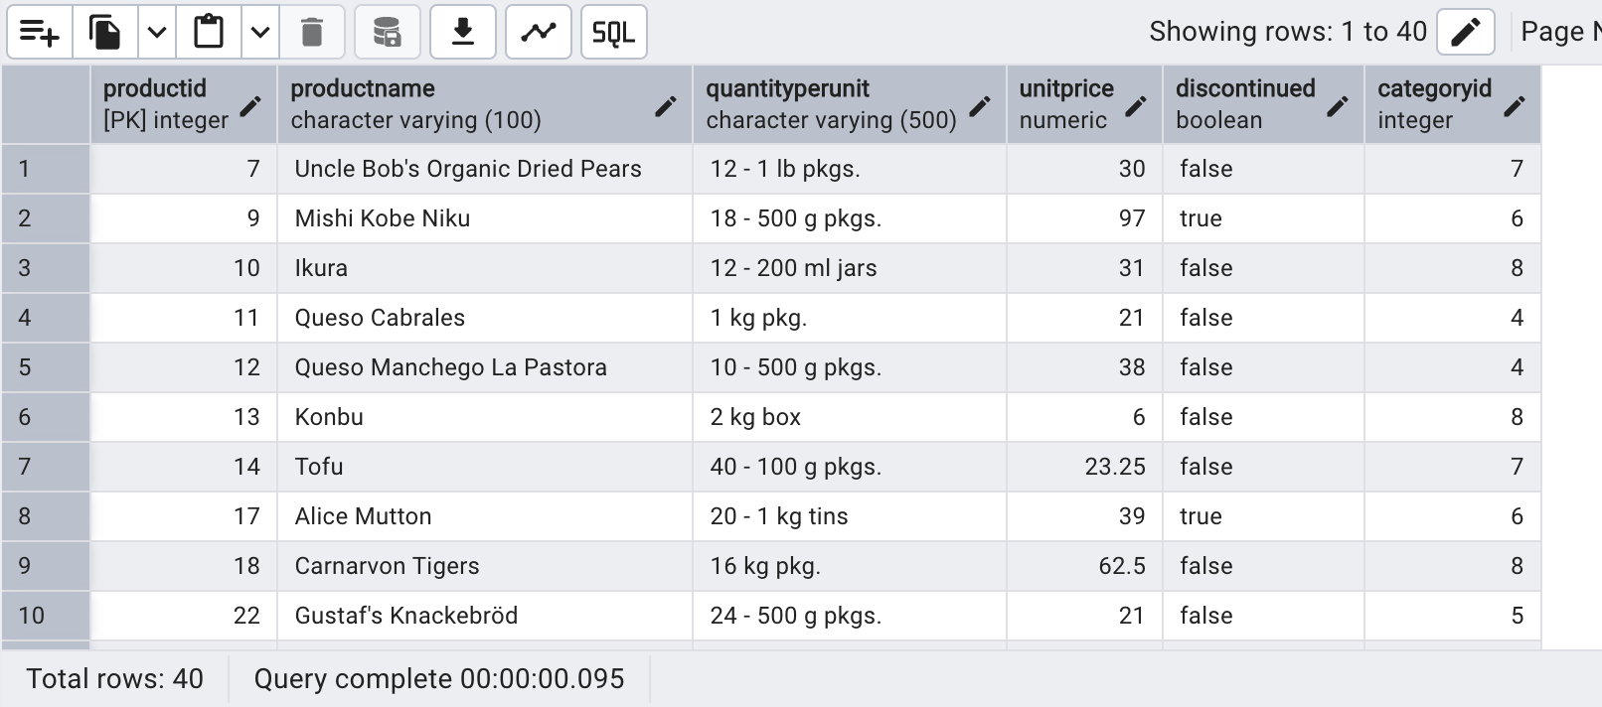-----Find customers whose company name starts with "A".

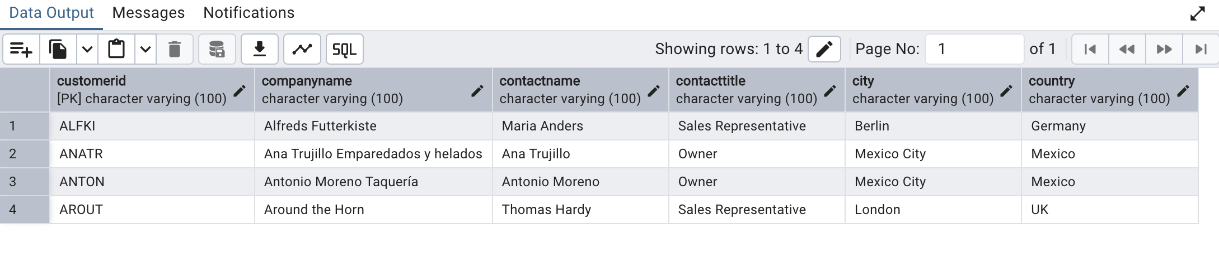---INSERT into orders table: ---8)Task: Add a new order to the orders table with the following details: /*Order ID: 11078 Customer ID: ALFKI Employee ID: 5 Order Date: 2025-04-23 Required Date: 2025-04-30 Shipped Date: 2025-04-25 shipperID:2 Freight: 45.50*/

---9)Increase(Update) the unit price of all products in category_id =2 by 10%. /*(HINT: unit_price =unit_price * 1.10)*/